**CURRICULUM VITAE**

Name : Samiul Alim Pratik 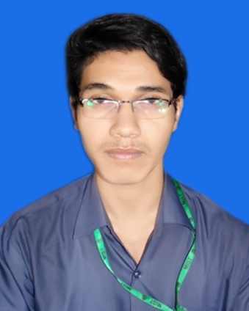   
Phone No : 01689583182  
Email :pratik.anwar@gmail.com

**Personal Information**  
  
Father Name : Anwar Pasha  
Mother Name : Shahana Parvin  
Date of Birth : 27-03-1995  
Nationality :Bangladeshi  
Religion : Islam   
Permanent Address: House: 44, Road-03, Sector-11, Uttara,Dhaka.   
Present Address : House: 44, Road-03, Sector-11, Uttara,Dhaka.

|  |  |  |  |  |
| --- | --- | --- | --- | --- |
| SSC | Name of Institute | Board | Year | GPA |
| Uttara High School | Dhaka | 2011 | 5.00 |
| HSC | Rajuk Uttara Model College | Dhaka | 2013 | 5.00 |

**Educational Information**University Name: Military Institute of Science and Technology  
 Currently Studying in Level-3

Department : Computer Science and Engineering (CSE)