**Full -Duplex Ethernet :**

One of the limitations of 10Base5 and 10Base2 is that communications is half-duplex. A station can either send or receive, but may not do both at the same time. That’s why the concept of full-duplex Ethernet came . The full-duplex mode increases the capacity of each domain from 10 to 20 Mbps.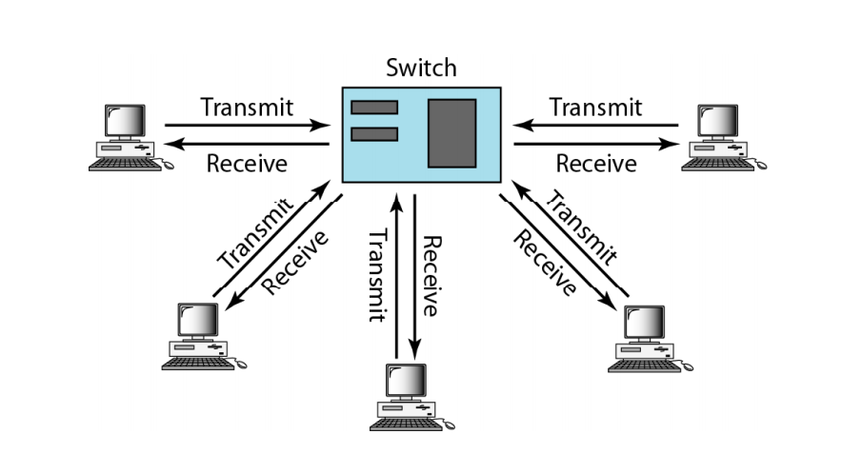

Fig: Full - Duplex Ethernet

In full-duplex switched Ethernet, there is no need for the CSMA/CD method. Here each station is connected to the switch via two separate links. Each station or switch can send and receive independently without worrying about collision. Each link is a point-to-point dedicated path between the station and the switch. There is no longer a need for carrier sensing; there is no longer need for collision detection.