I successfully deployed a static multi-page website to AWS using S3 for hosting and CloudFront for global distribution, including correct bucket policy configuration and validation.

Github link to static webfiles:
GitHub - owuorviny109/bonkers: This project is a responsive multi-page website for Bonkers Cat Food, a premium Kenyan brand. The site focuses on a clean, professional design built entirely with pure HTML5 and CSS3 (no external frameworks). · GitHub

Create a public S3 Bucket
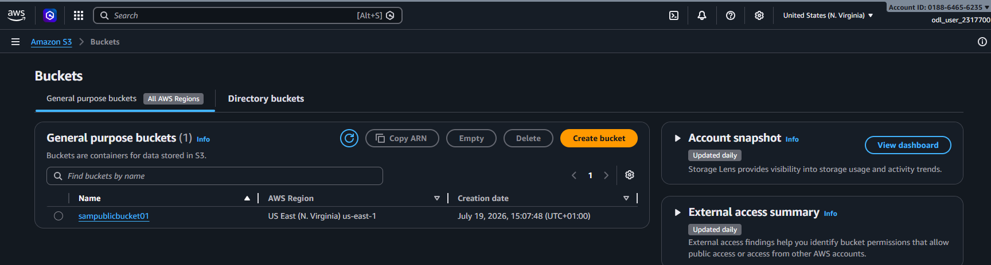

Add Bucket Policy
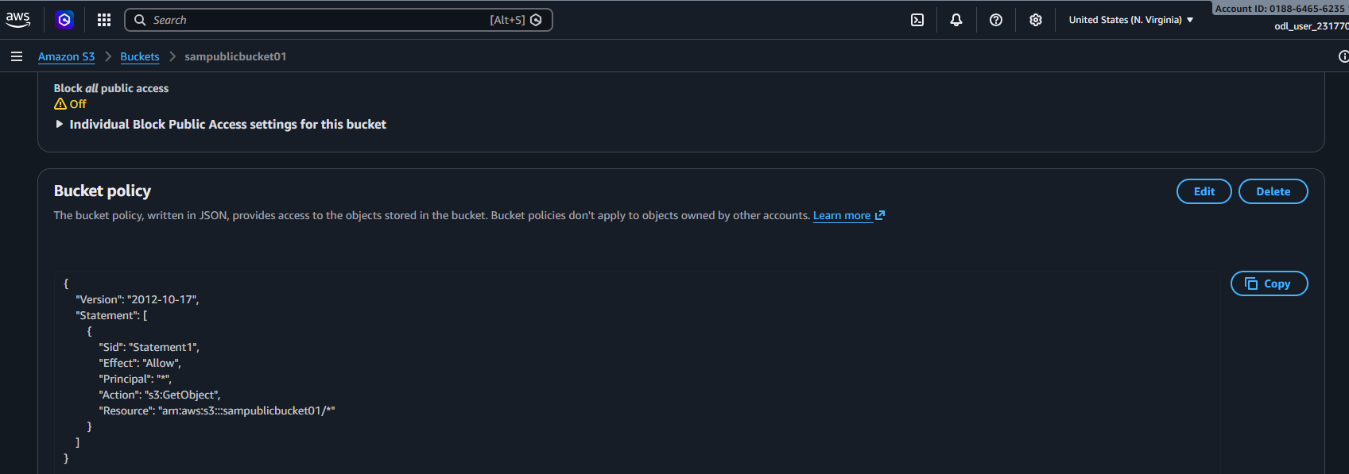
Download the static Website data into the bucket and check working
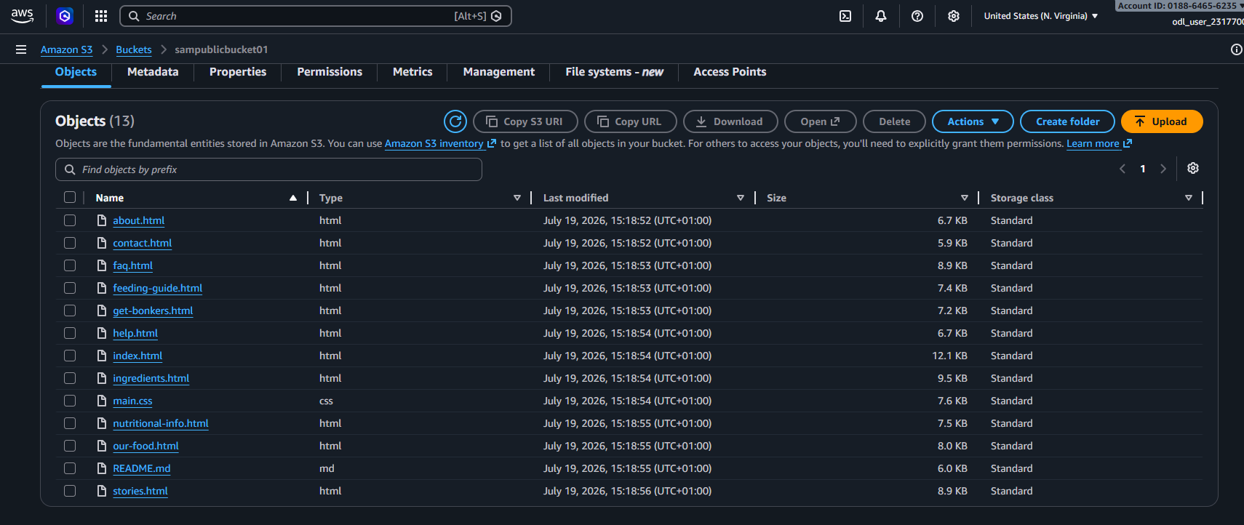
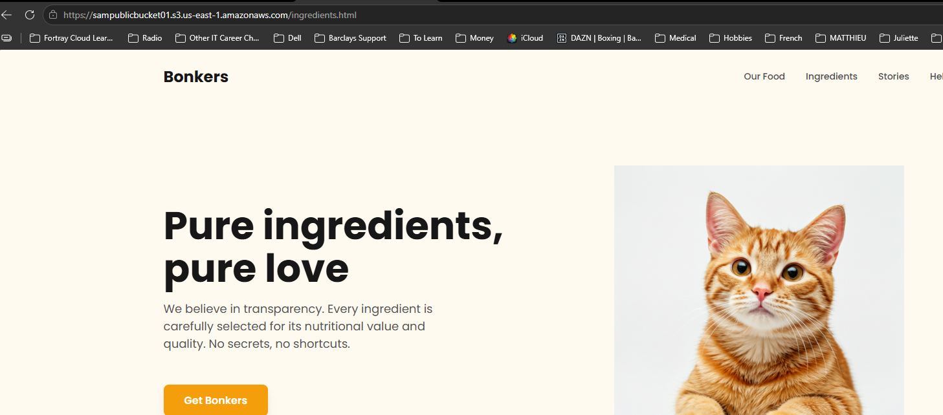

Create A free CloudFront Distribution 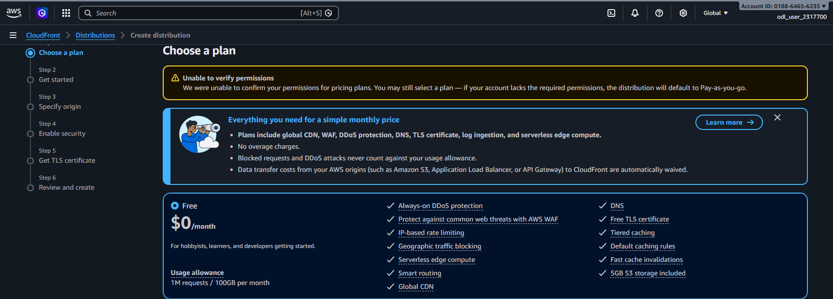

Give Distribution a name
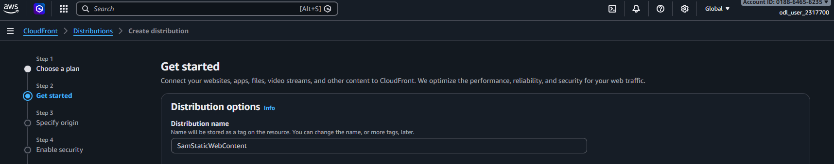

Note we don’t have Route53 in Lab but can attach to endpoint after if needed (note cost involved)

Choose Amazon S3 are Origin Type and select S3 bucket created above with files
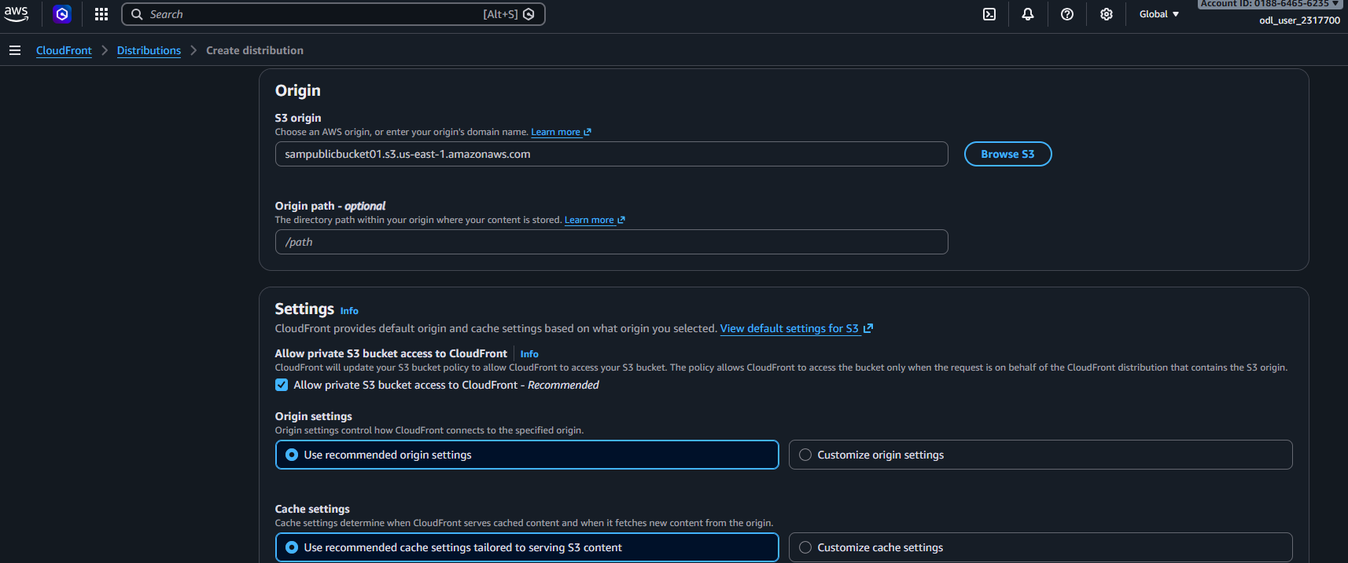
Leave recommended settings
Create Distribution
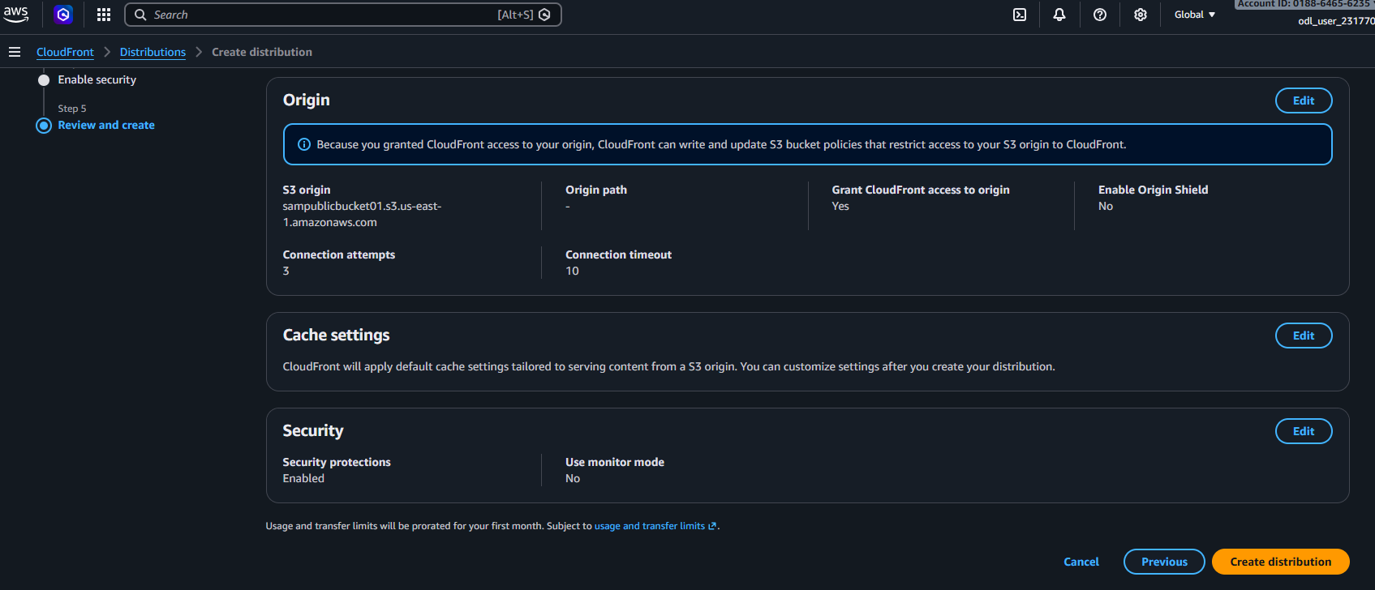

Note S3 Bucket policy has been updated with CloudFront Permissions
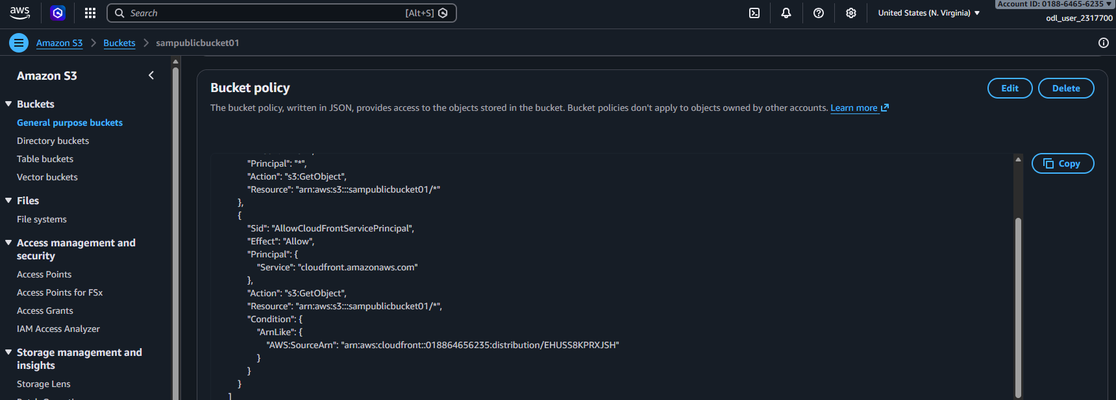

Select CloudFront Distribution domain name
e.g. d38pyeh2weccaq.cloudfront.net and add /index.html
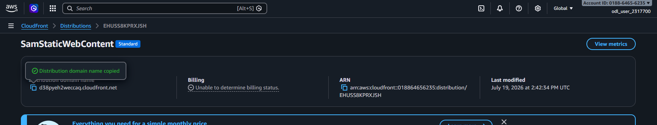

Then it works!
