**ComS 363 Fall 2022**

**Class Participation for Week 4**

**Topic: Subtlety of ER diagrams**

**Learning objective:** Understand subtlety involving weak entity sets, 2-way relationships or 3-way relationship sets, aggregation, and ISA hierarchy.

**Reference materials:**

[1] <http://pages.cs.wisc.edu/~dbbook/openAccess/thirdEdition/solutions/ans3ed-oddonly.pdf> Raghu Ramakrishnan and Johannes Gehrke. Database Management Systems, 3rd Edition 3rd Edition. McGraw-Hill Higher Education, 2003.

1. Given the ER diagram below taken from the open material from Reference [1].

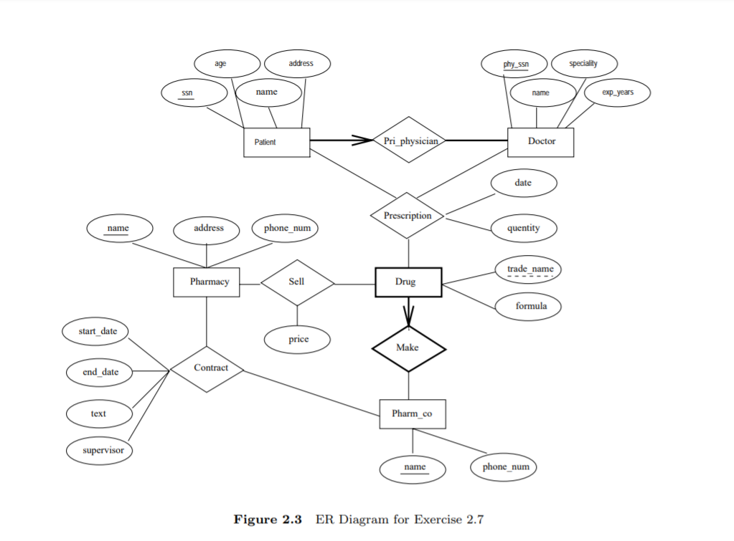

* 1. Name the identifying relationship set of the weak entity set “Drug”.
     1. Make
  2. What makes each relationship in the “Prescription” relationship set unique?
     1. SSN, phy_ssn, trade_name, name(pharm_co), name(pharmacy)
  3. Identify all the three-way relationship sets in the diagram.
     1. Prescription
  4. Could we store a history of prescriptions made to the same patient, same doctor, and same drug, but on different dates?
     1. No, it would have to be part of the primary key(s)

1. In the ER diagram below, each sponsorship must be monitored by at most one employee. If a sponsorship must be monitored, but can be monitored by more than one employee,



* 1. What do you have to change in the ER diagram to model the new requirement?
     1. Keep the bold line between the aggregate of the sponsors relationship set and the monitors relationship set, but remove the arrow
  2. What makes each relationship in the Monitors relationship set unique?
     1. Employees SSN, Projects pid, Departments did
  3. If a new requirement is added such that each employee must monitor a sponsorship, what change needs to be made to the above ER diagram.
     1. Bold the line between the employees entity set and the monitor relationship set

3. **Test your understanding of Entity-Relationship Model**

Given the ER diagram below, answer the following questions. **IMPORTANT:** Use the ER diagram notations that we have been using. Other ER diagram notations will not be graded.

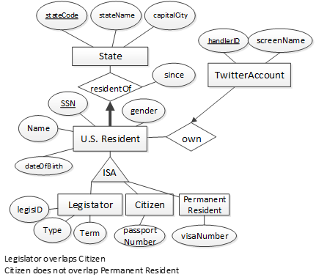

Figure 1: ER diagram for modeling US state policies influenced by Twitter social network

1. Add attributes, entity sets, relationship sets, and necessary constraints to the ER diagram in Fig. 1 to capture the following database requirement.

* The latest date in which a U.S. resident opens a Twitter Account.
* Each tweet has a unique tweet id value. A tweet must be tweeted from at most one Twitter account. The information about the posted date/time of a tweet, the tweet text, and whether it has been retweeted must be kept. A tweet contains zero or more hashtag. Each hashtag has a unique hashtag name. A hashtag must appear in at least one tweet, but can appear in several tweets.
* A Twitter account must follow at least one other Twitter account and may have no follower or have some Twitter account(s) following it. Maintain the most recent date in which the follow relationship is established.

Image Below

