**ComS 363 Fall 2022**

**Class Participation Week 5**

**Topic: Mapping of the ER diagram to relational schemas**

**Learning objectives:** Be able to design a good relational database from a given ER diagram.

**Instruction:** Do all the questions. Use the method discussed in class to convert ER notations to relation schemas while minimizing unnecessary redundancy and unnecessary relations. Implement as many constraints given in the ER diagram as possible. Indicate all the constraints that cannot be enforced by a good schema design.

**Example**: R1(A,B,C not null, D, primary key(A), foreign key(C) references R2(A).

1.

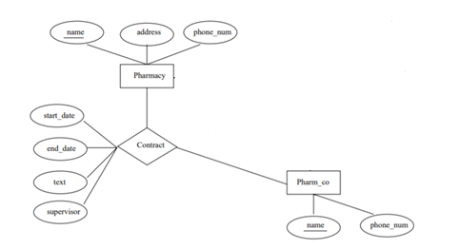

Pharmacy(name,address, phone_num, primary key(name))

Pharm_co(name,phone_num, primary key(name))

Contract(start_date,end_date,text,supervisor, pharmname, companyname, primary key(pharmname,companyname), foreign key(pharmname) references pharmacy(name), foreign key (companyname) references Pharm_co(name))

2. The lines connecting entity sets and relationship set are bold lines.

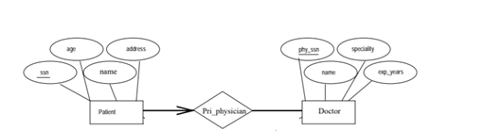

Doctor(name,exp_years,speciality, primary key (phy_ssn))

Patient(dob,name,address, primary_physsn not null ,primary key(ssn),foreign key(primary_physsn) references Doctor(phy_ssn);

Need to define a trigger for the total participation of doctor into the Pri_physician relationship set

//bolded arrow means at most one relationship

3.



Course(CID, Name, primary key (CID))

Student(univID,fname,lname,address,primary key (univID))

Section_course(CID, sectionID, primary key(CID,sectionID))

Assist(sid,cid,sectioned,semester,primary key(sid,cid,sectioned), foreign key(sid) references student (univID), foreign key (cid, sectioned) references section_course(CID,sectionID))

4.



Course(CID, Name, primary key (CID))

Semester(SemesterName, primary ley (semesterName))

Student(univID,fname,lname,address,primary key (univID))

Section_course(CID, sectionID, primary key(CID,sectionID))

Assist(sid,cid,sectioned,semesterName,primary key(sid,cid,sectioned, semesterName), foreign key(sid) references student (univID), foreign key (cid, sectioned) references section_course(CID,sectionID), foreign key (SemesterName) references Semester(SemesterName))

5.

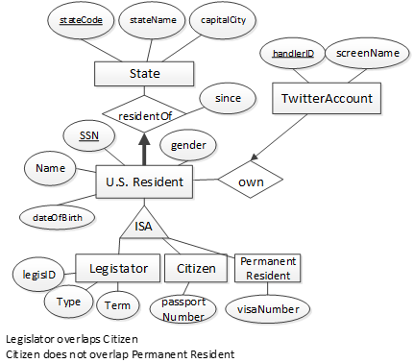

state(stateCode, stateName, capitalCity, primary key(stateCode)) correct!!!

TwitterAccount(handlerID, screenName, userSsn, primary key(handlerID), foreign key(userSsn) references USResident(SSN))

– design for the parent class and each subclass

Permanent resident(visaNumber, PRSSN, primary key(PRSSN), foreign key(PRSSN) references USResident(SSN) on delete cascade)

USResident(SSN, Name, DOB, Gender, StateCode not null, Primary Key(SSN), foreign key(StateCode) references state(stateCode))

Legislator(residentssn, type, term, lid, primary key(residentssn), foreign key(residentssn) references USResident(SSN) on delete cascade)

Citizen(passNum, residentSSN, primary key(residentSSN), foreign key (residentSSN) references USResident(SSN) on delete cascade)