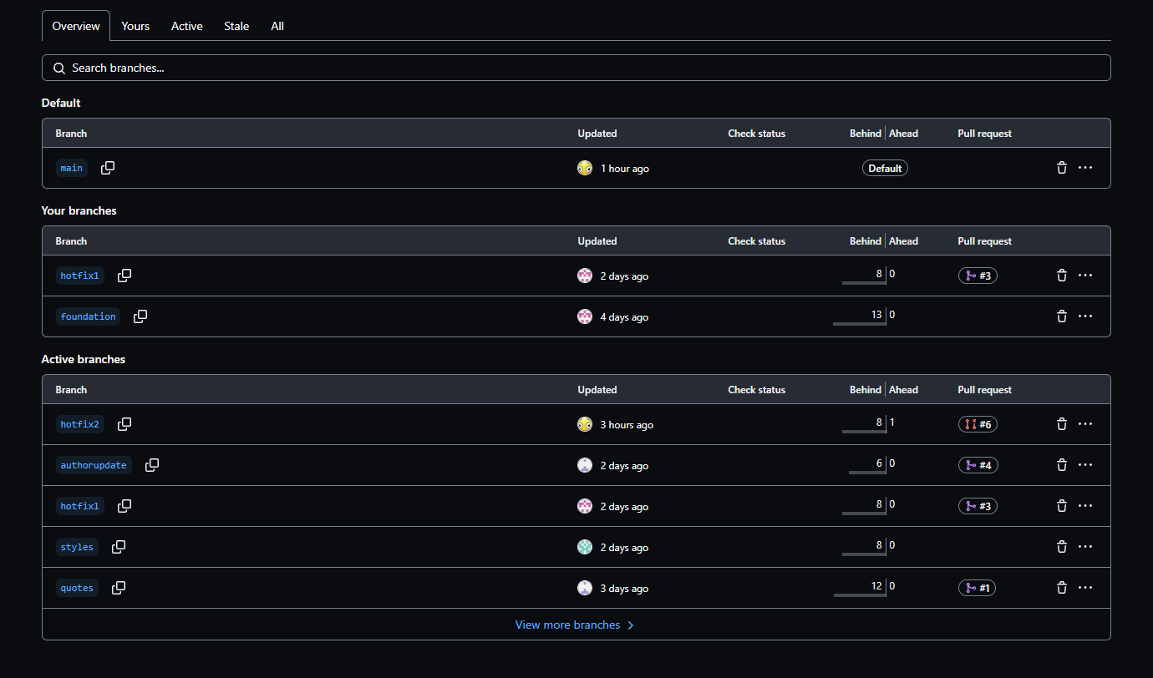<https://github.com/Mbrand95/GroupAlpha/>

Username: SamSegars