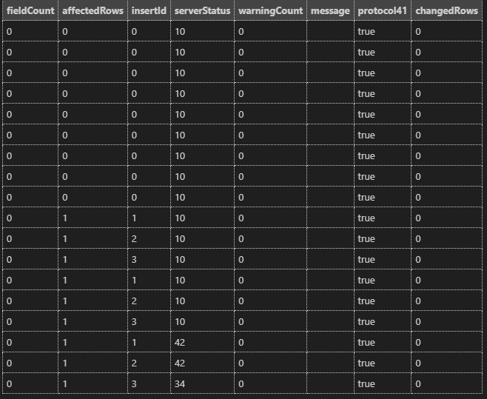

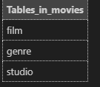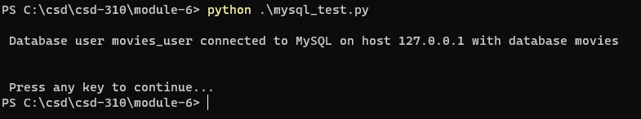

Github link

https://github.com/SamSegars/csd-310/tree/main/Module-6