Chapter 4: Software Development for Embedded Systems

Learning Objectives
In this chapter we will learn:
- Functionalizing Code
- Hardware Abstraction Layers
- Software State Machines
- System Clocks
- Interrupts

Developing code for embedded Systems
We now have the knowledge to write C code, control the peripheral hardware, and utilize the existing libraries and tools for developing code for embedded systems. However, due to an embedded system’s relationship with the system that it is integrated within, we often have concerns that do not manifest when writing code for a desktop computer. These concerns are often related to the real-time nature of an embedded system.

Functionalizing Code
The most basic aspect of writing clean, bug-free C code is proper functionalization. Functionalizing code refers to using functions to group related code segments. Since C isn’t an object-oriented language, we do not have classes or other complex structures to abstract our code, so we must very carefully organize our code into functions.
Most embedded systems programmers will create initialization routines for their programs. Since the peripherals often need to be configured on start-up, and often only once (such as setting a GPIO pin direction), it makes sense to group everything into an initialization routine. That way at the start of the main function, we aren’t bombarded with hundreds of lines of peripheral initialization code. This makes the code much easier to read. Using our example from the end of Chapter 3, let’s look at what an initialization function might look like:
void init(){
// Stop the watchdog timer
WDTCTL = 0x5A80;

// Disable the GPIO power-on default high-impedance mode
PM5CTL = 0xFFFE;

// Button configs
// Set P2.3 as input (all others as input due to being 0)
P2DIR &= ~BIT3;
// Enable P2.3 pull-up resistor
P2REN |= BIT3;
// Set P2.3 as high to configure pull-up
P2OUT |= BIT3;

// LED configs
// Set P1.0 as output (all others as input due to being 0)
P1DIR |= BIT0;
}

Another goal of functionalizing your code is to create layers of abstraction. Abstraction will hide the details of the underlying hardware so that your function names relate to the application. For instance, if we want to change the state of the red LED on the board, we might create a function such as:
void setRedLed(bool enable){
if(enable){
P1OUT |= BIT0;
} else {
P1OUT &= ~BIT0;
}
}

Where the function’s name indicates its purpose, and the details regarding the pin connection of the LED are buried away behind the function.

Hardware Abstraction Layers
Embedded programmers will often take this concept a step further and create what is known as a hardware abstraction layer (HAL). A HAL is typically a header file that provides define macros that describe the GPIO connections of a certain component, such as port and pin numbers. For instance, we could create a header file that contains the following define macros for representing the red LED connections:
#define LED_PIN 0
#define LED_DIR_REG P1DIR
#define LED_OUT_REG P1OUT

Then, we would use the port and pin numbers here in the functions that perform manipulation of the LED:
void setRedLed(bool enable){
if(enable){
LED_OUT_REG |= 1 << LED_PIN;
} else {
LED_OUT_REG &= ~(1 << LED_PIN);
}
}

What this provides us is flexibility and modularity. Say some design change came through that required us to use the green LED rather than the red. Now, all I have to change is the port and pin number in the hardware abstraction layer, and all of my code has no adapted to that change!
#define LED_PIN 6
#define LED_DIR_REG P6DIR
#define LED_OUT_REG P6OUT

HALs can also provide modularity when switching between different microcontrollers as well. If some requirement in the project requires that we switch to a different type of MSP430 with more memory, or some peripheral that was available on the MSP43FR2355, then all we have to do is change the HAL to the appropriate new hardware connections and our code instantly adapts.

Software State Machines
Another common method of abstraction in embedded systems is the usage of state machines. A state machine is a program or machine that organizes its functionality into different “states”. The machine will then transition between the states as it receives inputs from sensors or users. Almost any problem can be organized into a state machine, which helps abstract complex problems by dividing them up into finite states which are easier to define.
Let’s consider a simple example application where a microcontroller turns an LED on or off based on a button press. If we wanted to organize this application into a state machine, we would want to consider the behaviors of this application and how we can organize them into states, which are the system’s behaviors. In this simple application, we can easily identify two behaviors: turning the LED on, and turning the LED off. We would organize these two behaviors into separate states, then we would need to describe how the system moves between states. The button press is to turn the LED on or off, so we would draw arrows indicating the transitions between states with a label indicating what caused that transition. This example state machine can be seen in the diagram of Figure 4.1.
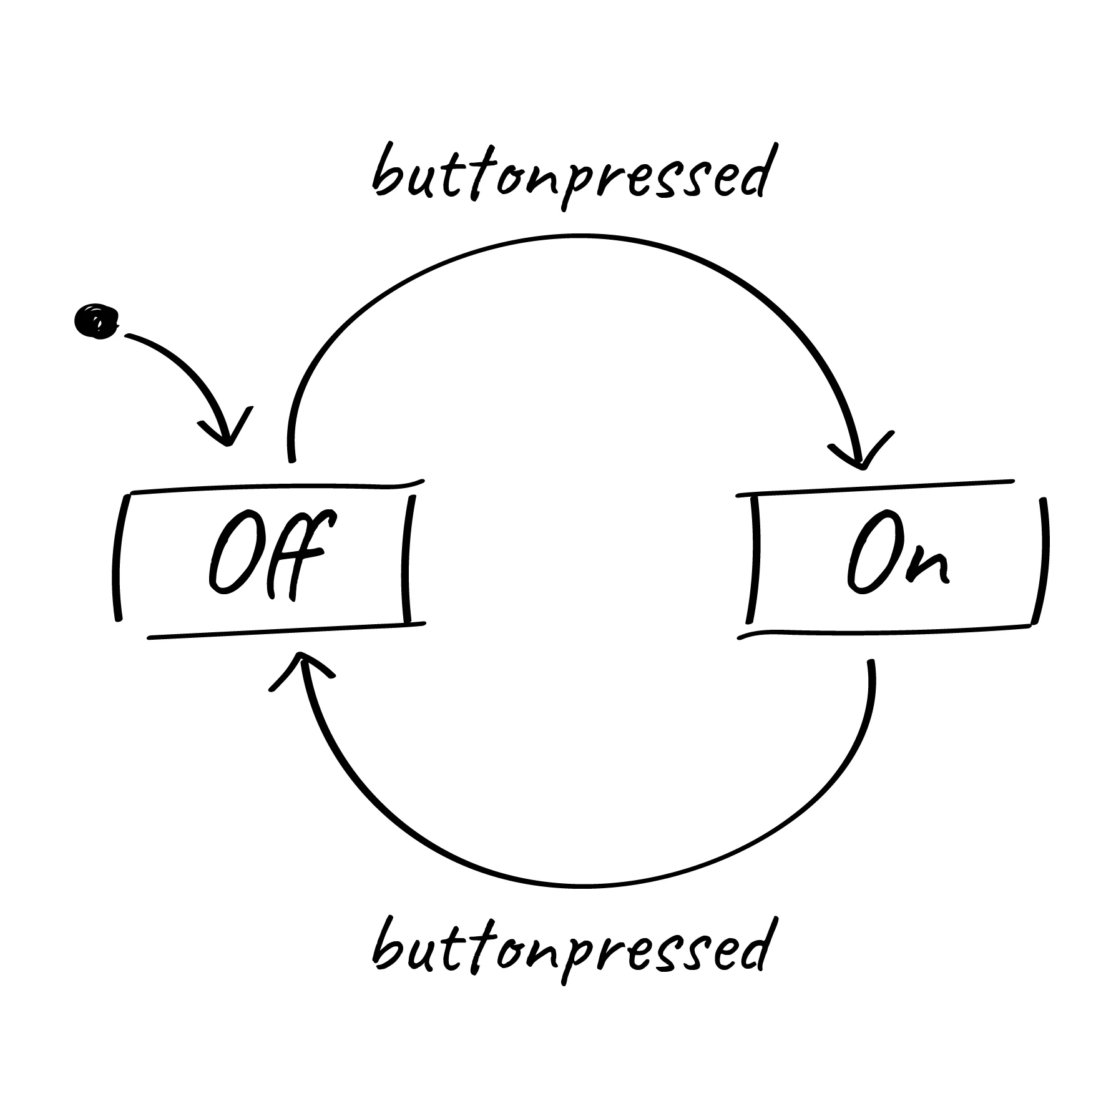
Figure 4.1: State Machine Diagram for turning an LED on and off

Anatomy of a State Machine
There are several important components that need to be present in every state diagram, such as the one in Figure 4.1:
- States – A circle or box containing the state label and the behavior (outputs and actions) the state. Sometimes if the behavior of the state is too complex, it will be omitted and described elsewhere.
- Transitions – An arrow indicating when to transition from one state to another. These arrows will also include the condition the prompts the transition.
- Initial State – A dot with an arrow is drawn on the diagram to indicate which state is the initial state.

Implementing a Software State Machine
Once diagrammed, software state machines are easy to implement. Ultimately, the behavior of each state simply needs to be grouped together with some branching conditions to separate them based on a variable which represents the current state. In C, this can be done with a series of “if-else” statements, but more commonly the switch statement is used. Switch statements are easier to read for many different states. For example, a state machine can simply be represented with the following:
while(1){
int state = 0;
switch(state){
case 0:
// some behavior for state 0
if(/* transition condition */){
state = 1;
}
break;
case 1:
// some behavior for state 1
if(/* transition condition */){
state = 2;
else if(/* transition condition*/) {
state = 0;
}
break;
case 2:
// some behavior for state 1
if(/* transition condition */){
state = 2;
else if(/* transition condition*/) {
state = 0;
}
break;
default:
// catch potential errors here
break;
}
}

Where the variable, state, contains a numeric value that represents the current state. Each iteration of the while loop will run the current state, whose behavior is selected by the switch condition. At the end of each state, some condition will be tested to determine if the state will transition to a new state or run the same state again.
In this template code example, the behavior of each state is represented with just a comment, as the state’s behavior is dependent on whatever the application is supposed to do. These behaviors can be quite long, so in order to keep the state machine readable, it is common to functionalize the state’s behavior. When functionalized, the behavior is neatly organized and the next state the machine should transition to can be returned by that funciton:
while(1){
int state = 0;
switch(state){
case 0:
state = runState0(/* pass state inputs */);
break;
case 1:
state = runState1(/* pass state inputs */);
break;
case 2:
state = runState2(/* pass state inputs */);
break;
default:
// catch potential errors here
break;
}
}

With the functionalized structure, no matter how complex the state’s behaviors become, this template will not change as all the complexity is hidden behind the functions.

Example: Traffic Light
As a simple example, we’ll implement a traffic light using the MSP430FR2355 using a state machine to model the behavior. To begin, we’ll present the circuit diagram for the traffic light. We’ll use three LEDs, red, yellow, and green, interfaced to GPIO pins of the microcontroller as shown in Figure 4.2.

Figure 4.2: Traffic light schematic diagram

In this Figure 4.2, we can observe that we have connected the green, yellow, and red LEDs to Port 5 pins 0, 1, and 2, respectively. To create the traffic light behavior, we will organize the behavior into induvial states that control the output (the LED that should be illuminated) based on inputs (the amount of time that should each color should be illuminated for) and transition conditions (when the lights should change colors).

Creating Interface Functions
We will create functions for initializing and manipulating the LEDs, which will be set by the current state:
void setGreenLed(bool enable){
if(enable){
P6OUT |= BIT0;
} else {
P6OUT &= ~BIT0;
}
}

void setYellowLed(bool enable){
if(enable){
P6OUT |= BIT1;
} else {
P6OUT &= ~BIT1;
}
}

void setRedLed(bool enable){
if(enable){
P6OUT |= BIT2;
} else {
P6OUT &= ~BIT2;
}
}

void init(){
// Stop the watchdog timer
WDTCTL = 0x5A80;

// Disable the GPIO power-on default high-impedance mode
PM5CTL = 0xFFFE;

// LED configs
P6DIR |= BIT0 | BIT1 | BIT2;
}

Capturing Behavior with a State Diagram
Before creating a state machine, we first need to model its behavior using a state diagram. Now that we have the functions needed for manipulating our traffic light, we need to create a state diagram to describe the behavior of the traffic light. This diagram can be seen in Figure 4.3.
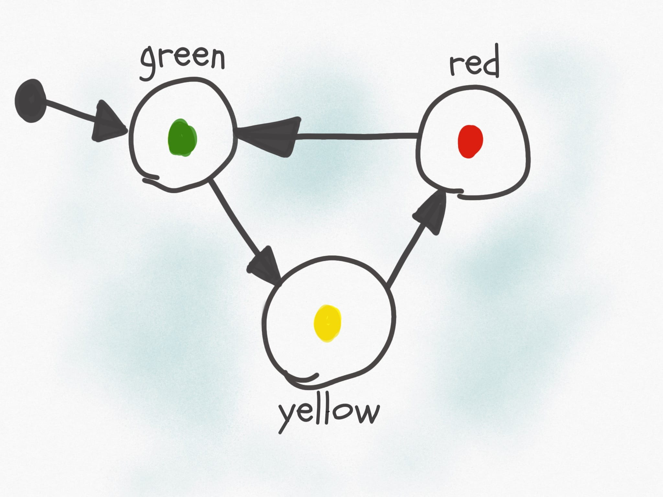
Figure 4.3: Traffic light state diagram

The outputs of this state are simply the illuminated LED and the input to the state machine is time in seconds. Every 50 seconds, the green state will transition to the yellow state, after 30 seconds the yellow will transition to red, and after 50 seconds red will transition back to green. We can see that the input to this system is real-world seconds, we need some way to create a function that will give us a delay in seconds.

Building Delay Functions
To build a delay function to stall the processor, we can use the MSP430’s built-in __delay_cycles() function. This is a function that will insert “no-ops” (no operation) instructions into the processor. As its name implies, a no-op does nothing but wastes time as it moves through the processor – perfect for creating delays. What we must understand now is: how much time is wasted with a single no-op? The MSP430 completes one instruction each clock cycle. The clock is an oscillating square-wave signal which provides synchronization for digital circuits. If one instruction is completed each clock cycle, then each no-op will take the same amount of time as the period of the clock signal. In the MSP430FR2355 documentation, we can learn that by default, the processor clock speed is 1 MHz, so 1,000,000 cycles per second. Therefore, each instruction takes 0.000001 seconds to execute.
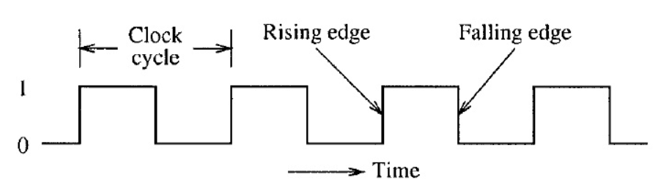
Figure 4.4: Clock period

Using this information, we can create a delay function that consumes as many seconds as we desire, by passing 1,000,000 to the __delay_cycles() function.
void delay_s(uint16_t seconds){
volatile uint16_t i;
for(i = 0; i < seconds; i++){
__delay_cycles(1000000);
}
}

We can use this to create a delay that will increment our state machine’s input value in seconds.

Creating State Functions
We now have everything we need to implement the traffic light diagram in 4.3: functions to set the LEDs and a function to create a delay in seconds. All we have to do next is create the state machine itself. We will begin by creating the functions that will represent our states:
uint16_t runRedState(uint16_t seconds){
uint16_t nextState = 2;

// set output
setRedLed(true);
setGreenLed(false);
setYellowLed(false);
// next state logic
if(seconds > 50){
nextState = 0;
}

return nextState;
}

uint16_t runYellowState(uint16_t seconds){
uint16_t nextState = 1;

// set output
setRedLed(false);
setGreenLed(false);
setYellowLed(true);
// next state logic
if(seconds > 20){
nextState = 2;
}

return nextState;
}

uint16_t runGreenState(uint16_t seconds){
uint16_t nextState = 0;

// set output
setGreenLed(true);
setRedLed(false);
setYellowLed(false);
// next state logic
if(seconds > 50){
nextState = 1;
}

return nextState;
}

Note that these functions are constructed in the same functionalized format presented in the previous section: each function contains the behavior of the state, each function is passed the state inputs, and returns what the next state should be on the following iteration based on the current inputs.

Implementing the State Machine
Next, we will construct the state machine within our main function and while(1) loop:
int main(void) {
volatile uint16_t seconds = 0;
uint16_t currentState = 0;
uint16_t nextState = currentState;

init();

while(1) {
switch(currentState){
case 0: // Green State
nextState = runGreenState(seconds);
break;
case 1: // Yellow State
nextState = runYellowState(seconds);
break;
case 2: // Red State
nextState = runRedState(seconds);
break;
default:
break;
}

if(currentState != nextState) seconds = 0;

// Update state
currentState = nextState;

// Update seconds
delay_s(1);
seconds++;

}
}

Note that we use two variables for tracking the state each iteration: currentState and nextState. Each loop, currentState is what the switch statement selects, but is updated with nextState by the end of the loop. The nextState variable is updated by the return from each state function call. Our inputs to each state are tracked by a seconds variable that is incremented after a 1 second delay each iteration. Since each state is tracking time relative to the start of each new state, we added some logic to the loop to identify when the state changes to reset the seconds variable back to 0. That way the next state logic in each state function will work properly.

Enumerating States
While the implementation we just described is a complete solution, there are several improvements that can be mode. The first aspect that can be improved is the usage of an integer to represent the states. Rather than using an integer, we can create an enumeration to represent the states:
enum{
GREEN, YELLOW, RED
} state;

The enum keyword will enumerate the values encapsulated by the following curly braces. GREEN will take on the value of 0, Yellow will take on 1, and RED will take on 2; The same integer values we had used prior. However, with the usage of the enum will allow us to use these terms rather than the integer values of the states. We can also use enum as a custom datatype by including the keyword “typedef”.
typedef enum{
GREEN, YELLOW, RED
} state_t;

The rest of the state machine can be updated as such:
int main(void) {
volatile uint16_t seconds = 0;
state_t currentState = 0;
state_t nextState = currentState;

init();

while(1) {
switch(currentState){
case GREEN:
nextState = runGreenState(seconds);
break;
case YELLOW:
nextState = runYellowState(seconds);
break;
case RED:
nextState = runRedState(seconds);
break;
default:
break;
}

if(currentState != nextState) seconds = 0;

// Update state
currentState = nextState;

// Update seconds
delay_s(1);
seconds++;

}
}

In the same way, the state functions can also be updated:
state_t runGreenState(uint16_t seconds){
state_t nextState = GREEN;

// set output
setGreenLed(true);
setRedLed(false);
setYellowLed(false);
// next state logic
if(seconds > 50){
nextState = YELLOW;
}

return nextState;
}

With this improvement, the code becomes much easier to read and write, as the programmer no longer needs to remember which integer value is associated with each state. By using the enum as a custom datatype, it becomes more clear when we are evaluating or returning a state rather than an integer value.

Function Tables
Another improvement that can be made is utilization of a function table. A function table is an array of pointers to functions. A function table has the following structure:
(int) *(func_table[3])(int, int) = {func0, func1, func2};

Where func0, func1, and func2 have the following prototypes:
int func0(int a, int b);
int func1(int a, int b);
int func2(int a, int b);

We can observe that each of these functions have the same parameters and return types, which is required if we are to point to each of these in a function table. Function tables can only hold with identical parameters and return types. We can see the function table is the array named “func_table” which is declared with three indices. The table is dereferenced with the “*” keyword, preceded by the return type in parenthesis, and followed by the parameter types in parenthesis. In this example, the table is initialized by declaring the function names within curly braces.
To use a function table, we simply call it like any other function with the addition of the index contained within brackets:
int x = func_table[1](5, 10);

In this example, we index element 1 of the function table, therefore calling func1 and passing it 5 and 10 as integer parameters. The integer result of the function is returned and stored in x.
We can create a function table to store our state functions:
state_t (*state_table[3])(uint16_t) = {runGreenState, runYellowState, runRedState};

Then, inside the main loop, we can simply use our currentState to index the correct state function:
while(1) {
nextState = state_table[currentState](seconds);
// Update state
if(currentState != nextState) seconds = 0;
currentState = nextState;

// Update seconds
delay_s(1);
seconds++;
}

Since the state enum values correlate to integers, as long as the sequence of states listed in the enum matches the sequence they are listed in the state table, the correct state will be called from the state table based on the currentState enum value as the index.
However, using a state table can introduce some new hazards that must be accounted for, such as the potential to call a function from an index not in the table (e.g., calling index 4 from an array/function table with only 3 elements). This needs to be checked for in the while loop to ensure that the index is within range of the state table. This is usually managed by adding an additional enum to the state enumeration which indicates the maximum index:
typedef enum{
GREEN, YELLOW, RED, MAX_STATES
} state_t;

The MAX_STATES value will take on the number of states that precede it. In this case, MAX_STATES will be assigned the value of 3, which is the number of states in our state machine, and therefore the number of indices in the state table. We can update the rest of the code to utilize this value:
state_t (*state_table[MAX_STATES])(uint16_t) = {runGreenState, runYellowState, runRedState};

while(1) {
if(currentState < MAX_STATES)
nextState = state_table[currentState](seconds);

// Update state
if(currentState != nextState) seconds = 0;
currentState = nextState;

// Update seconds
delay_s(1);
seconds++;
}

Now if we add additional states, only the enum and the state table need to be updated, as the length of the array and the if condition guarding the function table call are all controlled by the MAX_STATES enum value.

Clock Sources and Signals
When we created the delay function earlier in this chapter, we created a delay using knowledge of the clock frequency. It was stated that from the documentation we knew that the default clock speed was 1 MHz. To be able to derive this information from the documentation, we need to understand how clocking works in the MSP430FR2355, but also how it works in general for most microcontrollers.
Microcontrollers very commonly have multiple clocks. This is because the microcontroller might have different timing requirements for various aspects of the systems in which they are integrated. For instance, the system clock may need to run at a fast speed for processing requirements, while the analog to digital converter peripheral might need to sample a signal at a slower rate. While its possible to have one clock be able to control all of these aspects, often many clocks are made available for better flexibility and precision.
The MSP430FR2355 has multiple clock sources. A clock source is where the oscillation that drive the clock signals originate. These sources are given names associated with what generates them:
- DCOCLK – internal digitally controlled oscillator
- MODCLK – internal high-frequency oscillator (5 MHz typically)
- VLOCLK – Very low power, low-frequency oscillator
- REFOCLK – Low Frequency reference clock
- XT1CLK – The external clock source
Each of these clock sources have different ranges and are designed for specific purposes. These clock sources can then be configured to be connected to various clock signals. Clock signals refer to the internal circuitry that carries and connects the clock sources to different peripherals and components.
- MCLK – Main clock, which drives the processor
- SMCLK – Subsystem main clock, which can be used to drive peripherals
- ACLK – Auxiliary clock, which also is used to drive peripherals
Clock signals must be configured to be driven by a clock source, as shown in Figure 4.5. Once a clock signals has been assigned a source, it can then be configured to drive the processor or some other peripheral.
Figure 4.5: Clock sources and signals

The clocking system is configured through the use of control registers, just as peripherals are. Except this time, we will observe that the control registers bits don’t correspond to enabling features on pins, but rather individual bits and bit ranges will be responsible for enabling, disabling, or selecting different features and settings for the system.

Example: Using the External Clock Source
When writing embedded applications that require specific timing, which is in general most applications, we will often utilize the clocking system to configure the system and peripheral clocks ourselves, so we know exactly which clock rates are being specified. Using the MSP-EXP430FR2355, we’ll create an initialization function for the clock to configure the main clock to utilize an external oscillator that comes prepopulated and connected to our microcontroller.
In Figure 3.8, on the microcontroller pinout diagram, we can observe on pins 7 and 8 the labels, XIN and XOUT. These are connections for an external oscillator source that can be selected and connected by the embedded system designer when using this microcontroller, allowing the selection of an oscillator of any desired frequency (so long as it’s within the tolerances specified in the datasheet). Our development board already has an external oscillator interfaced on these pins for us, which can be seen in Figure 4.6 as the component labeled Q1. These oscillators often come in a rectangular or oval shaped metallic package and contain within some sort of piezoelectric material, such as a piece of quartz, which will oscillate when exposed to an electromagnetic field. We will use this external oscillator as our system’s clock.
Figure 4.6: The external 32.768 kHz oscillator

To use an external oscillator, we’re going to need to configure some control registers. There are many control registers for configuring the clock system, but here we’re only going to focus on the control registers relevant for configuring the external oscillator source as the main clock signal.

CSCTL4
The CSCTL4 register stands for Clock System Control 4 and is one of 8 clock system control registers. This register is used to specify the clock source for various clock signals. The User’s Guide for the MSP430FR2355 provides the following table which describes the features configured by each bit in the register.
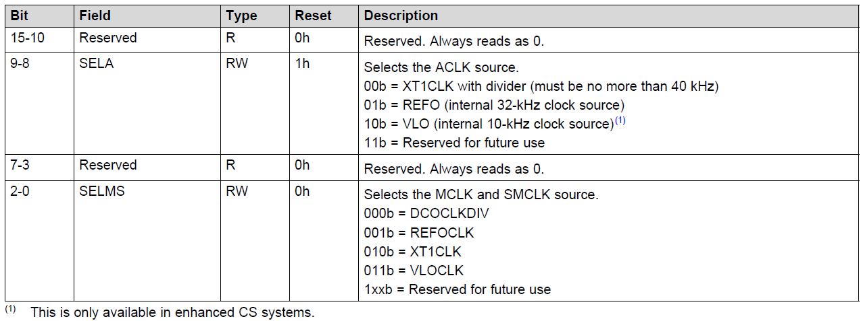
Table 4.1: The CSCTL4 Register

In this table, if we wish to configure to specify the MCLK (the main clock, which drives the processor) source as XT1CLK (the external oscillator), we have to write “010” to bits 2-0 in that register. This can be seen in the last row of Table 4.1. The other features controlled by this register can be ignored for the time being, as it also controls clock sources for the ACLK signal, which I have no interest in configuring in this example.

CSCTL6
The CSCTL6 register provides various configuration settings for the external oscillator. Some of these settings involve signal drive voltages, amplification, and other electrical properties. We are only interested in configuring two properties in this registers: XTS and XT1BYPASS. The XTS property is controlled by a single bit and will select between “Low-frequency Mode” and “High-frequency Mode”. The User’s Guide indicates that anything frequency less than 40 kHz should be ran in “Low-frequency Mode”. XT1BYPASS controls where the XT1CLK source comes from. XT1CLK can be sourced from other internal sources, but we want it to come from the external pins on the microcontroller, which this property controls.
…
…
Table 4.2: Select Bits of the CSCTL6 Register

Table 4.2 shows a few excerpts from the CSCTL6 register contents table from the User’s Guide. From this, we can see that bit 4 needs to be set to 0 to enable “Low-frequency Mode” and bit 5 needs to be set to 1 to source XT1CLK from the external pins.

CSCTL5
The CSCTL5 register is used to configure clock dividers and enable and disable different clock sources. A clock divider is used to divide the clock frequency by some factor. For this example, we are not interested in slowing the clock down, so we will set the clock division to 1 (Since the frequency divided by 1 is equal to itself).
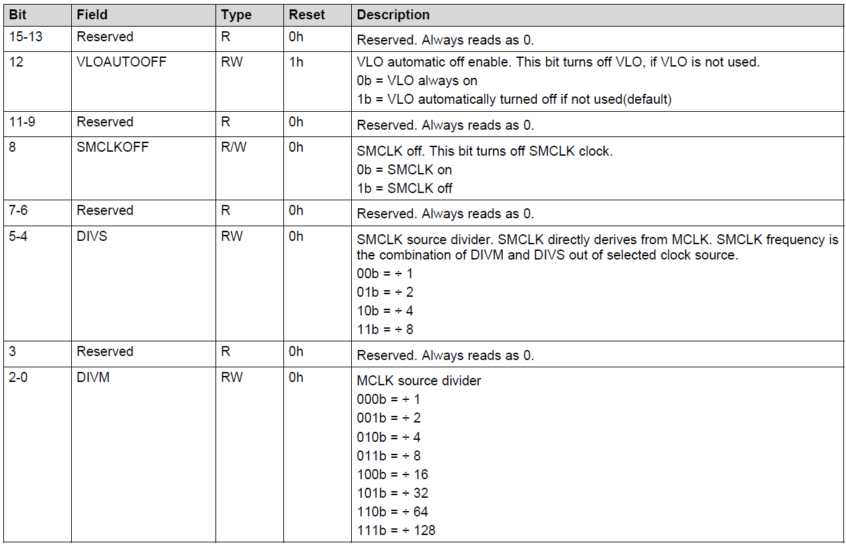
Table 4.3: The CSCTL5 Register

According to the bit ranges for CSCTL5 described in Table 4.3, we need to set bits 2-0 to “000” to enable a divider of 1. There are many other parameters we can configure in this register, but none of them are of any concern to us for this example, so we’ll ignore them.

Writing the Code
Here we’ll write a function that initializes the main clock (MCLK) signal using the external oscillator as the clock source using the configuration just described in the sections above.
void initClocks(){
CSCTL4 |= SELMS__XT1CLK;
CSCTL6 |= XT1BYPASS_1 | XTS_0;
CSCTL5 |= DIVM_0;
}

Rather than individually assigning the bits by creating our own bit masks according to the tables above, we’ll use the predefined bit masks that are macro’d in the “msp430.h” header file. For example, the XT1BYPASS_1 is defined as:
#define XT1BYPASS_1 (0x0010) /* XT1 sources externally from pin */

From this macro, we can see that a 1 is placed in the bit 4 position (The 5th position – remember we start counting at 0), which selects the external clock source. Rather than manually creating the bit mask to place the 1’s in the desired positions, it’s more desirable to use the pre-defined macros to add readability to our code. It’s also worth noting that the line,
CSCTL5 |= DIVM_0;

Actually assigns no 1’s to the CSCTL5 register, since a clock divider of 1 is configured with all 0’s. Even though this seems like a worthless line of code, it communicates to other embedded systems engineers that the assignment of 0’s to this register is intentional. That way if someone reads this line knows that this parameter has already been intentionally configured for some task in the software without having to understand the rest of the code, and should not be changed.
In many embedded projects, it is common practice to include a clock initialization routine that configures all the clock signals and sources initially, so for timing purposes we have full control and knowledge of the system’s timing.

Interrupts
Now that the problem of creating a delay for a specific period of time has been solved, a new problem has been introduced. While we are in the delay function, we can no longer be reactive to any external events, such as button press es. If the user presses the button and releases it while we are in the middle of a long delay function, we will have no way to detect that button press! Figure 4.7 illustrates this condition with a diagram.

Figure 4.7: Missing a button press while in a delay function

We need some way to instantly react to events that occur real time in an embedded system. These events can come from user interaction through buttons or switches, but they can also come from external sensors or even conditions in the program. Whatever the source of the event, we often cannot predict when these events will occur, so we need the ability to pause whatever the program is doing and handle the event. The way we achieve this in almost every processor architecture is through “interrupts”.
Interrupts are triggered by random, external events and they allow us to pause the computer’s program execution and temporarily run some other code to handle the event. The code we call to handle the event is known as the interrupt handler or also the interrupt service routine (ISR). Once the ISR has concluded, the program will pick back up where it left off before the interrupt occurred.
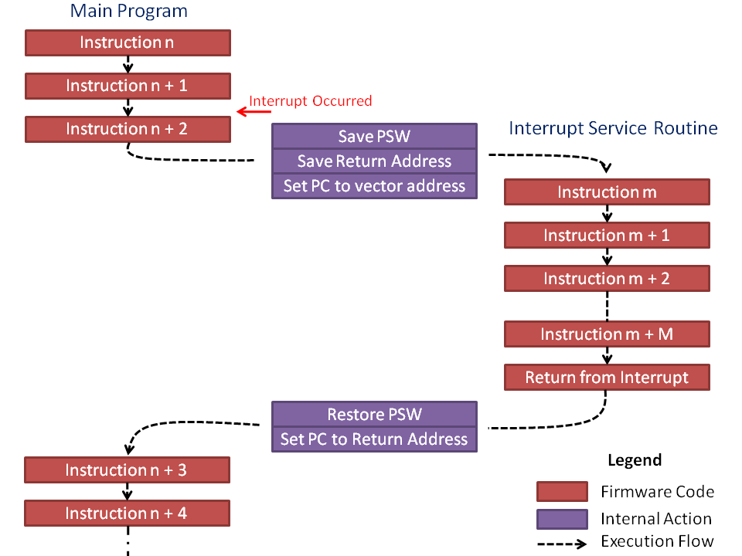
Figure 4.8: Pausing the code to handle the interrupt

How Interrupts Work
An interrupt is triggered by an event that the hardware acknowledges. The hardware will save the current state of the processor (what line of code it was executing at the time and various other conditions and properties) then jump to a memory location that will lead to a user-defined function.
There are two ways interrupts are implemented: vectored and non-vectored. We’ll start by discussing the vectored implementation, as it is the method used in our MSP430 microcontroller. In vectored interrupts, a section of memory is blocked off to serve as the interrupt vector table. The table has a start address, and from that address are indexed memory locations associated with each interrupt source. Each of these indexed memory locations can be filled with the address of the function that will be called when the interrupt event occurs (the interrupt service routine!).
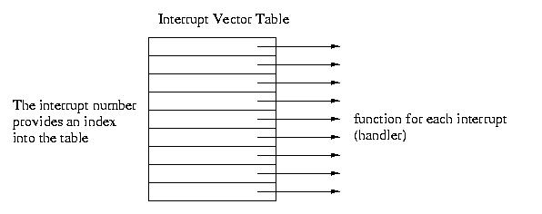
Figure 4.9: Interrupt Vector Table

For instance, say we have an interrupt that triggers when a button is pressed (the voltage on one of the GPIO changes from a 1 to a 0). This hardware event may be associated with, say, index 45 of the interrupt vector table. The processor will pause, retrieve the address of the ISR at memory location <vector table base address> + 45, then start executing the code at that function’s memory location.
Non-vectored interrupts function in a similar way but have less hardware support. When an interrupt trigger occurs, the processor will pause and then go to a single interrupt ISR which will then determine in the software what type of event occurred and what function to call. This eliminates the need for a dedicated vector table in the microcontroller’s memory map, but it also is a little slower to access the ISR because it has to run additional lines of code. In vectored interrupts, the interrupt condition has a known memory location where it’s ISR address is stored, and it will jump to that location without any prior computations.

Example: Traffic Light Crosswalk Button
Let’s say we wish to add a crosswalk button to our traffic light state machine. The crosswalk button should add an additional state to the application which sets the red light and a blue light which represents a “walk sign” that gives time for pedestrians to cross the street. If the crosswalk request button is pressed at any time, it will cause the state machine to transition to a crosswalk state after the next yellow light, then transition to the red light state after the crosswalk state ends. The updated state machine diagram is shown in Figure 4.10.
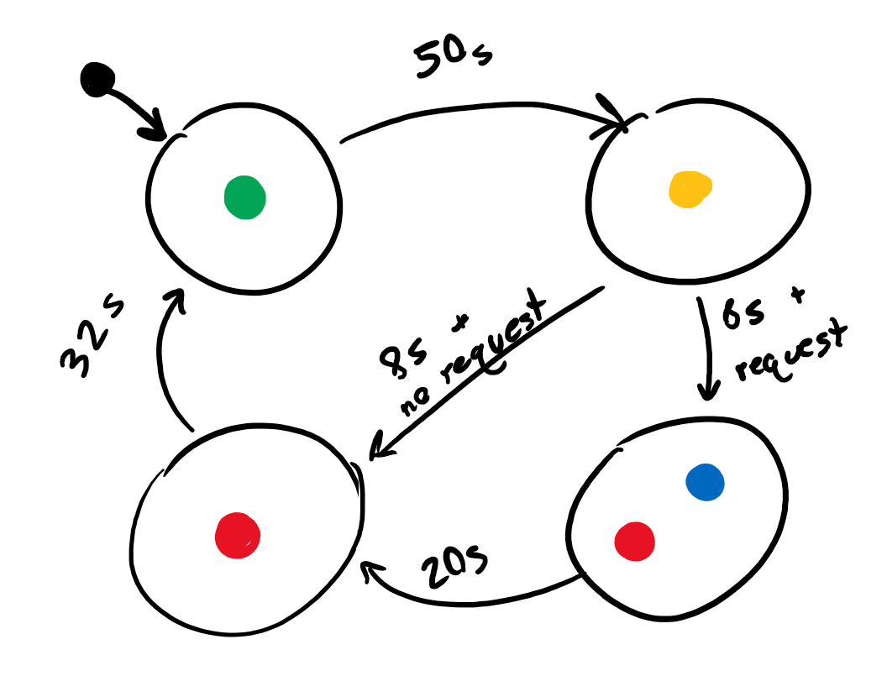
Figure 4.10: Traffic Light with Crosswalk State Machine Diagram

Since our state machine depends on one second delays, it is possible that the user presses the button and releases it during the delay period. In order to catch this button press, we will want to attach it to an interrupt that will acknowledge the button press no matter where we are during the code’s execution.
Interrupts are usually configured through the associated peripheral’s registers. For GPIO, we can enable interrupts using registers that enable various interrupt conditions. For GPIO, each port has several registers that enable and configure the interrupt conditions.

PxIE
The first register is the PxIE register, which enables interrupts on the pins 0 through 7 of the port. For example, writing a 1 to bit 3 in this register will enable an interrupt on pin 3 of the GPIO port. Conversely, writing a 0 to bit 3 will disable the interrupt on pin 3. This register’s description from the user’s manual can be found in Figure 4.11.
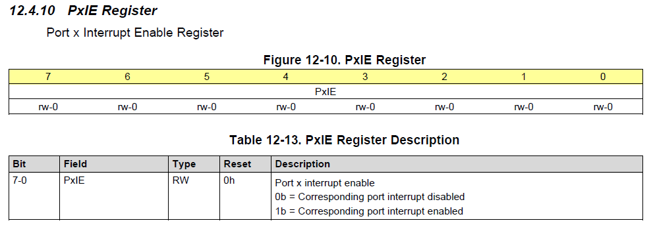
Figure 4.11: The PxIE register

PxIES
The next register is the PxIES register. This register selects the interrupt source. Interrupts are often triggered by various conditions related to the peripheral that’s generating them. In the case of GPIO, interrupts can be configured to trigger when the voltage on the pin transitions from a digital high to digital low voltage, or vice versa. The PxIES register allows us to select which condition we want an individual pin to generate an interrupt. For example, writing a 1 to bit 3 of this register will enable high-to-low interrupts on pin 3, and writing a 0 to bit 3 will enable low-to-high interrupts on pin 3. This register’s description from the user’s manual can be found in Figure 4.12.
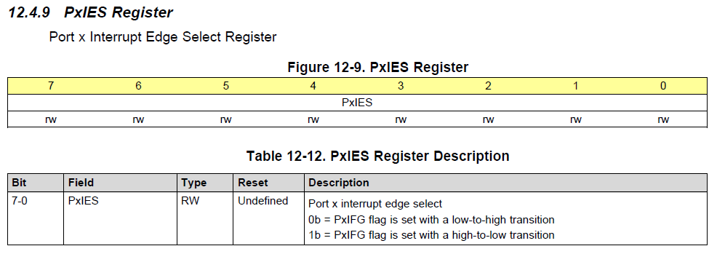
Figure 4.12: The PxIES register

With these two registers, we can configure an interrupt on a GPIO pin. In our example, we want an interrupt to be triggered anytime a button is pressed. We have a button that is connected to ground on P2.3, so we’ll configure this button with a pull-up resistor and a falling-edge triggered interrupt. That way, when the user presses the button, it will go from a digital high voltage provided by the pull-up resistor to a digital low voltage when the button connects to ground. Initialization of this register may look like the following:

// Button Configuration (P2.3 as input with pull-up resistor)
P2DIR &= ~BIT3;
P2REN |= BIT3;
P2OUT |= BIT3;

// Enable high-to-low interrupts on P2.3
P2IES |= BIT3;
P2IE |= BIT3;

// Enable global interrupts
__enable_interrupt();

An interesting point regarding this code example is the “__enable_interrupt" line. This function is an internal compiler function for the MSP430 that enables all interrupts. Very commonly, microcontrollers will include a way to globally enable or disable interrupts. This feature exists so that if you have some important chunk of code that needs to execute without the possibility of a random interrupt breaking it’s flow, you can turn off all interrupts prior (using “__disable_interrupt()”) and then enable them when you’re done. By default, global interrupts are disabled, so we need to turn them on before using them!
Now that we’ve configured the interrupt, how do we use an interrupt service routine? For the MSP430 compiler, we have to define a function and then associate it with the interrupt condition we want it to be called from. An example interrupt for reading a button press may appear as follows:
#pragma vector=PORT2_VECTOR
__interrupt void Port2_ISR(){
buttonPressed = true;

// Clear bit3 flag
P2IFG &= ~BIT3;
}

This function has a lot of new things, so let’s take each aspect of the function bit by bit. First of all, notice that the function takes no parameters and returns void. This is true for all interrupt service routines. Since they are called when an event occurs, they can’t pass data and they can’t return data; all due to the unpredictability of when they might be called. The only way to get data in and out of an ISR is through global variables. In this example, “buttonPressed” is a global variable that is set by the ISR. This data will be evaluated later in the main loop.
The next item to note is the #pragma line. Since this line of code begins with a hash symbol, that indicates that it is a preprocessor directive. The #pragma directive provides additional information not the compiler beyond what is contained with the language itself. The pragma directive can be used to force dependencies or throw custom warnings and errors when compiling. For this specific MSP430 compiler, it’s being used to associate the following function with it’s position within the interrupt vector table. The MSP430 compiler understands that “vector=PORT2_VECTOR” as an association with interrupts generated by the GPIO Port2 peripheral. This also means that if we had multiple interrupts on port 2, they would all have to share this same interrupt service routine.
Preceding the function return type we see the line “__interrupt”. Again, this is a compiler-specific keyword that simply indicates that the following function is an interrupt service routine.
Finally, the line of code “P2IFG &= ~BIT3”. This line of code is clearing a flag bit that is set by the interrupt hardware. Many microcontrollers will include a flag register that will set bits that indicate the source of the interrupt. This register needs to be cleared at the end of each ISR call – otherwise, it will re-trigger the interrupt service routine, creating an infinite loop!

PxIFG
This

