Looking at the map we can see that the most popular bike stations reside in the lower middle part of the peninsula, the usage of each of the stations seems to grow steadily at the beginning of the year with a sharp drop off in May.

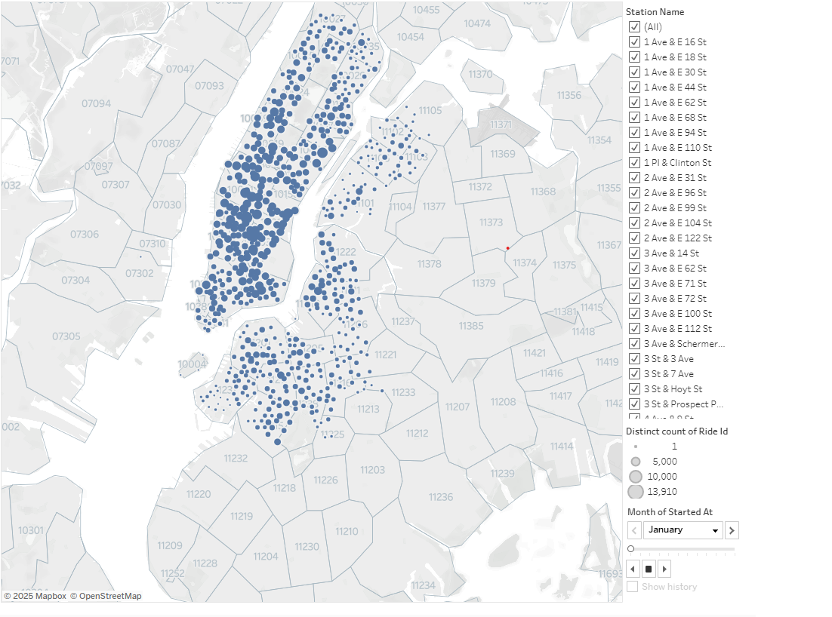

Looking at the first graph roughly ⅔ of riders prefer electric bikes to classic bikes, the second graph shows a breakdown of non-member riders and member riders, it looks pretty similar with members preferring classic bikes more than non-members. Looking at the bottom graph we can see a similar trajectory of both the classic and electric bikes meaning the time of year doesn't affect which kind of bikes are preferred by riders.  
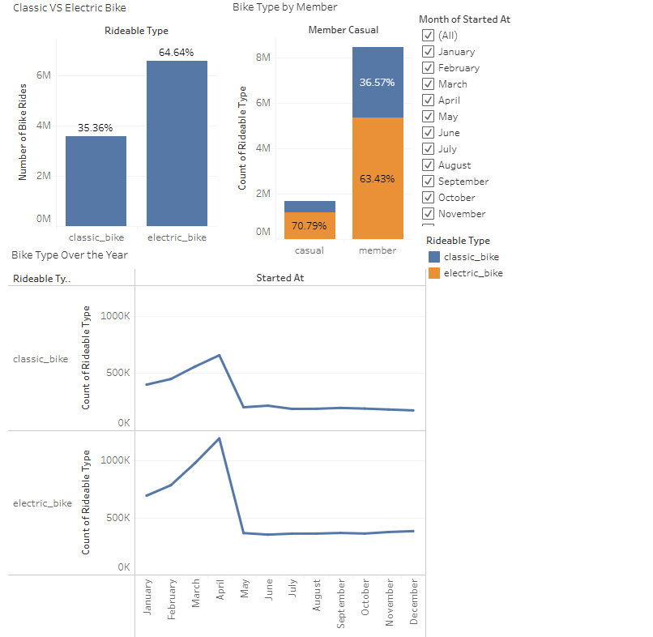

Taking a look at each of the stations individually we can see that most of them follow the same trend of 2/3s usage of electric bikes to classic bikes with some being closer to 50/50, however there are a couple of them where riders prefer the classic bikes to electric bikes

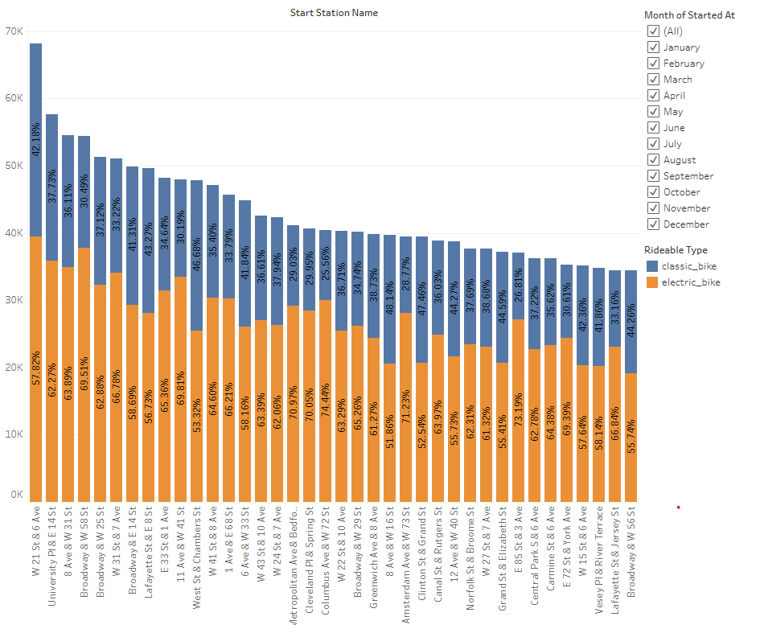

This dashboard gives a look the usage of station over different time periods such as day of the week, time of the day, and time of year.In the first graph we can see that there is a higher usage from members during weekdays than there is on the weekends, whereas non-member riders prefer to ride on the weekends. Looking at the second graph we can see where the bikes get the most usage, the highest usage times of the day are around 8 in the morning and between the hours of 2 and 7 pm, with moderate usage in between. The last graph shows that usage increases at the start of the year, peaking in April and starts to go down heading into May.

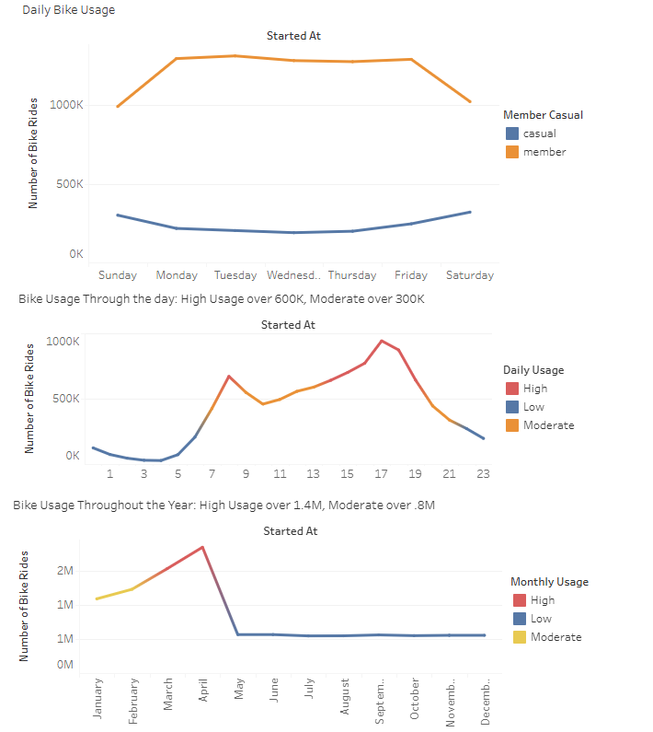

<https://github.com/SamSims/tableau-challenge.git> contains the file I used to consolidate the data.

Data came from the first csv of each month of the 2024 year data as well as the entirety of the 2018 data to get an accurate list of stations and their lat and longs. <https://s3.amazonaws.com/tripdata/index.html>