Chrome does not allow access to local file:

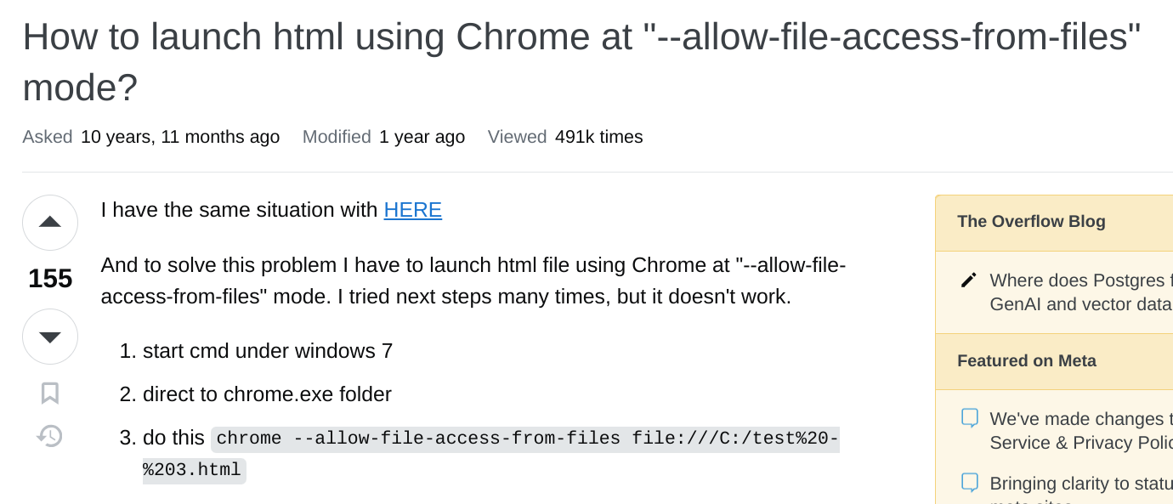

To enable data.json, upload all to github.io:

https://samtan20240527.github.io/TestDataJson/

or cmd:

chrome.exe - - allow-file-access-from-files file:///C:/(folder)

https://apexcharts.com/docs/update-charts-from-json-api-ajax/

## **Business Problems**

The following are the questions we want to answer to uncover insights.

1. How does sale performance vary across the product category?
2. Are there any seasonal patterns or trends in sale?
3. Which sales representatives have the highest sales performance?
4. Are there opportunities for cross-selling and Up-selling?
5. Which products have the highest units sold?
6. Which territory generated the highest revenue?
7. Are there any differences in purchasing behavior between regions?
8. Product popularity across regions
9. Who are the top spending customers?
10. What are the most common sales channels used by customers?
11. Most profitable products?
12. What is the overall sales performance across the four years?

1. Open source - No license cost, no subscription fee

2. Platform-independent - Run on any browser

3. Connect to existing data sources - SQLServer, MySQL,JSON, CSV, etc.

https://akzy1991.github.io/CI_project2/

https://github.com/Kern000/project-one?tab=readme-ov-file

https://github.com/public-apis/public-apis?tab=readme-ov-file

https://github.com/Tayboonsiang90/bitcoin-eli5?tab=readme-ov-file

https://muhdarifrawi.github.io/foursquare_mapboxgl/

https://paddlepop25.github.io/trent-project-2-dengue/#aboveZones

https://github.com/Tayboonsiang90/bitcoin-eli5?tab=readme-ov-file

https://henryheyhey92.github.io/FlatRespository/

https://leetcode.com/problems/fizz-buzz/

https://drive.google.com/drive/folders/1vy5oV0sRRfNyx_7pwJrlrSdbWdtNa1KP?usp=drive_link

Wide World Importers

| https://learn.microsoft.com/en-us/sql/samples/wide-world-importers-what-is?view=sql-server-ver16 |
| --- |