Time Series Analysis Using R

by Steve Raper and Chris Chatfield

This document is a free appendix to the 6th edition of
The Analysis of Time Series
By Chris Chatfield, published in 2004 by Chapman & Hall/CRC in the Texts in Statistical Science series.

The examples in this time-series text were mostly carried out using Minitab and S-Plus (see Chapter 14 and Appendix D). Since the time the book was written, a software package called R has become the software choice of many students and staff and is now used extensively by the academic statistical community for statistical modelling, including time-series modelling. R is a free updated version of S-Plus. Of course, many statistical software packages, including SPSS, SAS and Minitab, also contain Time Series Analysis modules which allow the analyst to model time series as they see fit. Microsoft Excel even contains a command within its Data Analysis add-in to carry out exponential smoothing! However, the R language and environment arguably provide greater depth and flexibility in many situations. Since R is used within a command-line interface, this may impose a steeper learning-curve for the new user, but the range of time series analysis packages available in R, together with its publication-quality graphical capabilities, mean that it is increasingly the favoured package amongst serious time series analysts.
We assume the reader is familiar with the basic use of R and indicate how to extend this to time-series analysis. The key extension is that the time-series commands act on data called a ts object which are not just a set of numbers but have an order and a position in a cycle. For example, if the series is monthly, we may know that a particular observation is say the value in the 4th month of the second year.

What is R?
R is an open-source (i.e. free!) statistical software package, maintained by the user community themselves. It is distributed by CRAN ("Comprehensive R Archive Network") and is available for download for Linux, MACOS X and Windows from the CRAN web-site at http://cran.r-project.org. R uses the S language and environment, developed at Bell Laboratories (now Lucent Technologies) by John Chambers and colleagues, and much of the code written for S can run under R.

Resources in R for Time Series Analysis
A lot of resources for time series analysis are available to the R community including:
- several useful individual functions (such as plotting the sample autocorrelation and sample partial autocorrelation functions, fitting an ARIMA Model etc. for regularly spaced time series) included with the base R infrastructure
- additional packages for more extensive time series analysis, and for state-space models and spectral analysis
- time series datasets available directly in base R and in other time series packages
- books, on-line tutorials, and other on-line resources

Time-series functions available in the base R package
Several commonly-used analysis tools for time series are available within the base R package, including (amongst others):
acf produces the sample autocorrelation function. User can specify maximum lags, or a vector of required lags. Can also produce sample autocovariance function and sample partial autocorrelation function.
pacf as acf above, but produces just the sample partial autocorrelation function
arima fits a SARIMA model of order (p,d,q)x(P,D,Q), with period s. Method can be chosen from:
ML Maximum Likelihood
CSS Minimising conditional sum of squares
CSS-ML Using conditional sum of squares to find starting values, then maximum
likelihood to fit the model
predict predicts n steps ahead, from any fitted model, including a time series fitted using the command arima (see above)
arima.sim simulates an ARIMA model of stated length of the order (p,d,q), with innovations having a stated variance
tsdiag produces 3 standard diagnostic charts for a fitted ARIMA model:
- plot of residuals from the model
- sample autocorrelation function of the residuals from the fitted model
- Ljung-Box portmanteau statistic for stated maximum number of lags.
spectrum produces a spectral density using one of two methods:
- "periodogram" – using Fast Fourier transforms, optionally smoothed with Daniell Smoothers to be specified
- "autoregressive" – fits an AR model, and computes the spectral density of the fitted model.
Alternatively, the command spec.prgrm can be used.

Time series packages in R
In addition to the functions in base R, several time series analysis packages are available for specialised models, including:
zoo infrastructure for both regularly- and irregularly-spaced time series
tseries contains many specialised time series functions e.g. GARCH (Generalised AutoRegressive Conditional Heteroscedastic) model fitting
cts continuous-time AutoRegressive models
dse Dynamic Systems Estimation – tools for multivariate, time-invariant models including state-space representations
dlm Bayesian and likelihood analysis of Dynamic Linear Models
sspir tools for the specification of formulae to define and fit state-space models

Datasets
There are several datasets available with base R for time series analysis, including some already featured in this text. Within base R, such datasets have often already been formulated into a "ts" (time series) class object, and the data can be recalled simply by inputting the dataset name. For example, the Box-Jenkins Monthly Airline Passenger Numbers (1949-1960) can be invoked as follows:

> AirPassengers

Jan Feb Mar Apr May Jun Jul Aug Sep Oct Nov Dec
1949 112 118 132 129 121 135 148 148 136 119 104 118
1950 115 126 141 135 125 149 170 170 158 133 114 140
1951 145 150 178 163 172 178 199 199 184 162 146 166
1952 171 180 193 181 183 218 230 242 209 191 172 194
1953 196 196 236 235 229 243 264 272 237 211 180 201
1954 204 188 235 227 234 264 302 293 259 229 203 229
1955 242 233 267 269 270 315 364 347 312 274 237 278
1956 284 277 317 313 318 374 413 405 355 306 271 306
1957 315 301 356 348 355 422 465 467 404 347 305 336
1958 340 318 362 348 363 435 491 505 404 359 310 337
1959 360 342 406 396 420 472 548 559 463 407 362 405
1960 417 391 419 461 472 535 622 606 508 461 390 432

As can be seen, the data has been referenced by month and by year.
Similarly, Monthly Sunspot data from 1749 to 1997 can be invoked using:
> sunspot.month
Jan Feb Mar Apr May Jun Jul Aug Sep Oct Nov Dec
1749 58.0 62.6 70.0 55.7 85.0 83.5 94.8 66.3 75.9 75.5 158.6 85.2
1750 73.3 75.9 89.2 88.3 90.0 100.0 85.4 103.0 91.2 65.7 63.3 75.4
1751 70.0 43.5 45.3 56.4 60.7 50.7 66.3 59.8 23.5 23.2 28.5 44.0
1752 35.0 50.0 71.0 59.3 59.7 39.6 78.4 29.3 27.1 46.6 37.6 40.0
… … … … … … … … … … … … …
1993 59.3 91.0 69.8 62.2 61.3 49.8 57.9 42.2 22.4 56.4 35.6 48.9
1994 57.8 35.5 31.7 16.1 17.8 28.0 35.1 22.5 25.7 44.0 18.0 26.2
1995 24.2 29.9 31.1 14.0 14.5 15.6 14.5 14.3 11.8 21.1 9.0 10.0
1996 11.5 4.4 9.2 4.8 5.5 11.8 8.2 14.4 1.6 0.9 17.9 13.3
1997 5.7 7.6 8.7 15.5 18.5 12.7 10.4 24.4 51.3 22.8 39.0 41.2

Other regular time series can be read into R and turned into a ts object using the ts command – for example:
> ts(x, frequency = 4, start = c(1959, 2))

transforms the vector x into a quarterly time series object (frequency = 4), starting in Quarter 2 of the year 1959.
Time series packages have their own inherent datasets and time series -objects.
On-line and off-line resources
Several Springer Texts in Statistics cover Time Series Analysis using R, including:

Time Series Analysis & Its Applications: With R Examples (3rd ed)– Robert Shumway and David Stoffer, Springer (2011)
(In addition Stoffer's own web-site includes a useful R Time Series Tutorial at http://www.stat.pitt.edu/stoffer/tsa2/R_time_series_quick_fix.htm)

Introductory Time Series with R Examples – Paul Cowpertwait and Andrew Metcalfe, Springer (2009)

Time Series Analysis in R Examples (2nd ed) – Jonathan Cryer and Kung-Sik Chan, Springer (2009)

Three Examples
Three examples have been selected to illustrate the use of R in time series analysis and to provide further guidance for the reader. They correspond to Examples 14.1, 14.2, and 14.3 in the book. This appendix concentrates on the R commands. For further discussion of the modelling process, see the book.

Example 1. Monthly Air Temperature at Recife
Table 14.1 in the book shows the air temperature at Recife in Brazil in successive months over a 10-year period. The objective of our analysis is to describe and understand the data.

The first step is to import the data into R and to produce an object of class ts:
recife=ts(read.csv("E:\\Recife.csv",header=FALSE),start=1953,frequency=12)
recife
Jan Feb Mar Apr May Jun Jul Aug Sep Oct Nov Dec
1953 26.8 27.2 27.1 26.3 25.4 23.9 23.8 23.6 25.3 25.8 26.4 26.9
1954 27.1 27.5 27.4 26.4 24.8 24.3 23.4 23.4 24.6 25.4 25.8 26.7
1955 26.9 26.3 25.7 25.7 24.8 24.0 23.4 23.5 24.8 25.6 26.2 26.5
1956 26.8 26.9 26.7 26.1 26.2 24.7 23.9 23.7 24.7 25.8 26.1 26.5
1957 26.3 27.1 26.2 25.7 25.5 24.9 24.2 24.6 25.5 25.9 26.4 26.9
1958 27.1 27.1 27.4 26.4 25.5 24.7 24.3 24.4 24.8 26.2 26.3 27.0
1959 27.1 27.5 26.2 28.2 27.1 25.4 25.6 24.5 24.7 26.0 26.5 26.8
1960 26.3 26.7 26.6 25.8 25.2 25.1 23.3 23.8 25.2 25.5 26.4 26.7
1961 27.0 27.4 27.0 26.3 25.9 24.6 24.1 24.3 25.2 26.3 26.4 26.7
Table 14.1:

We now plot the data, as seen below:
plot(recife,ylab='Temperature (degree C)', xlab='Year',main='Recife, Brazil Temperature Data')
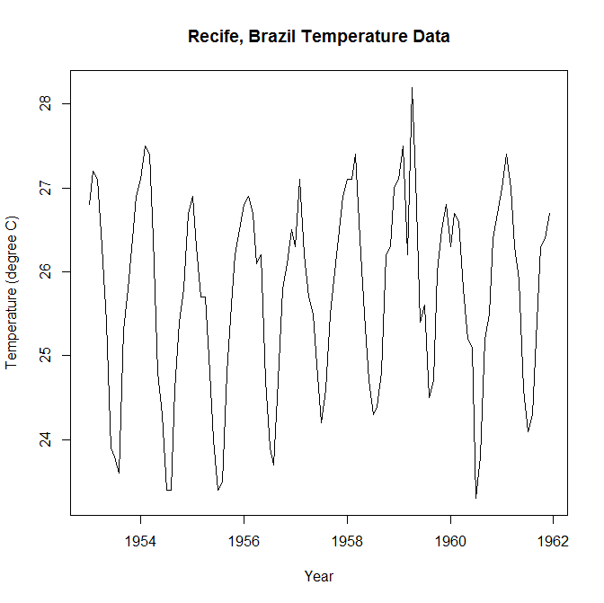
The plot exhibits regular seasonal variation with little or no trend, as we would expect a priori.
The correlogram is produced using the R command:
> acf(ts(recife,freq=1),lag.max=40,main="Autocorrelation Function for Recife Data",ylim=c(-1,1))

(Note that the R function acf's default plot gives an X-axis in terms of the frequency (in this case 12) of the time series object recife. The autocorrelation function for lag 12 months is then labelled 1 year. Re-stating the frequency as 1 allows a plot of the autocorrelation function as we would expect it)
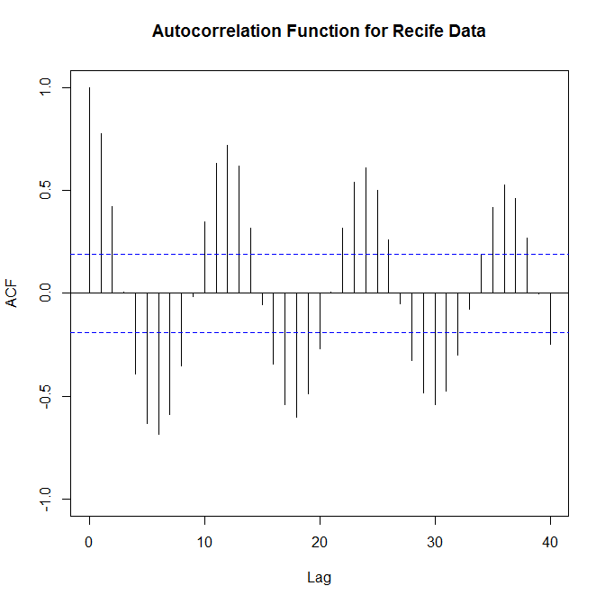
The correlogram identifies the obvious seasonal variation, with high positive autocorrelations at lags 12, 24, …
We can remove the seasonality in the data by calculating monthly averages (see table below) and subtracting them from the raw data:

Month | Av. Temp. 1953-161 (ºC)
January | 26.82
February | 27.08
March | 26.70
April | 26.32
May | 25.60
June | 24.62
July | 24.00
August | 23.98
September | 24.98
October | 25.83
November | 26.28
December | 26.74

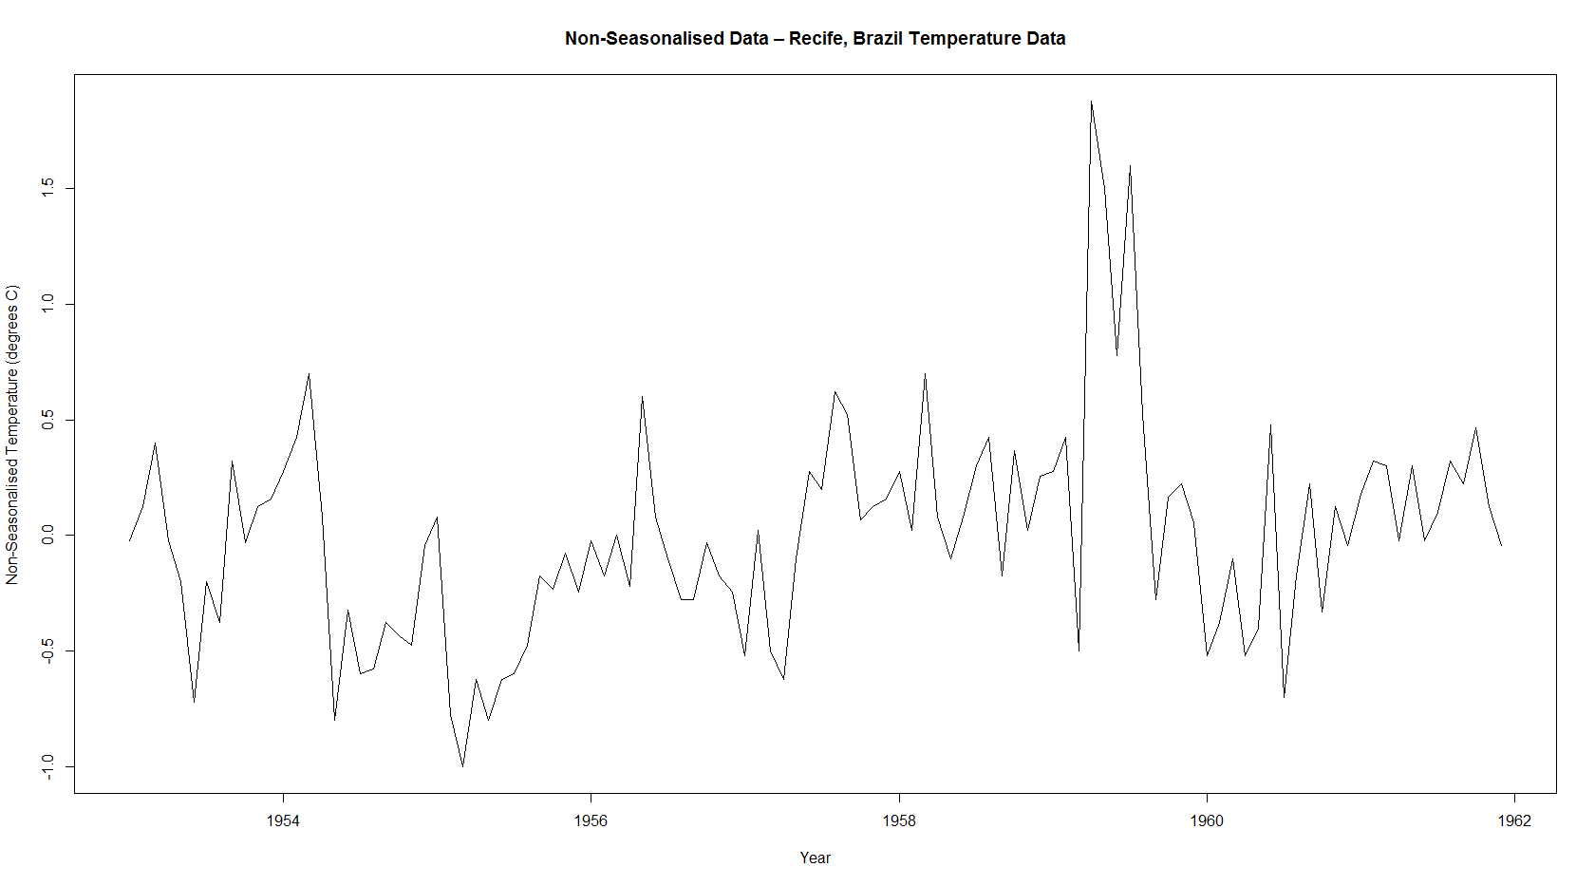
The resulting, deseasonalised data is shown below:

with the above (plot of the) sample ac.f (ignore the word periodogram in the title)

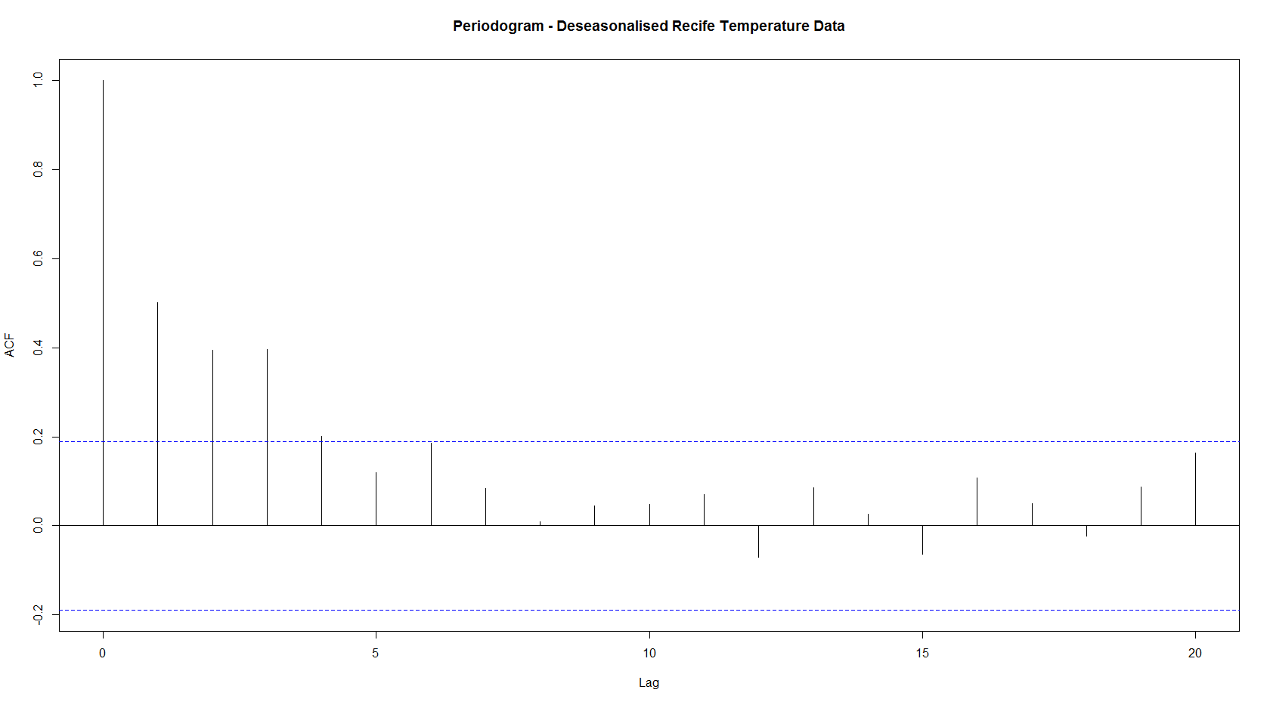
The raw periodogram for the deseasonalised data is given below followed by three examples of smoothed periodograms using different Daniell filters (3,3), (5,5), and (7,7) to illustrate the smoothing effect::

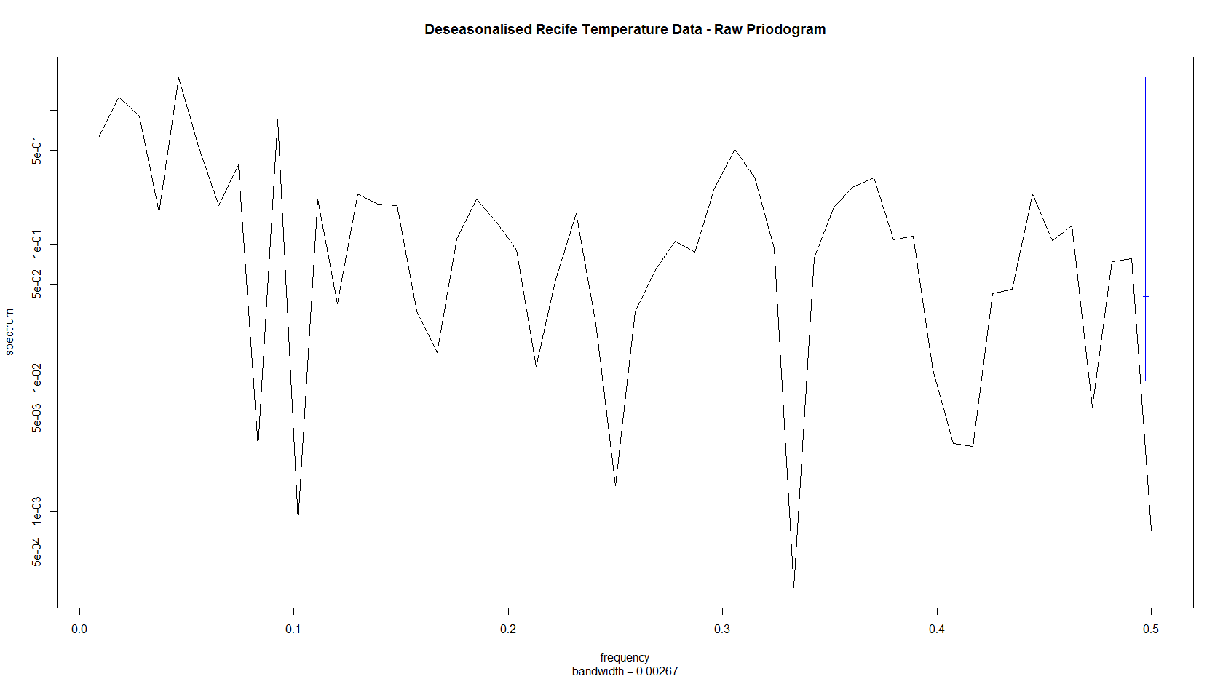
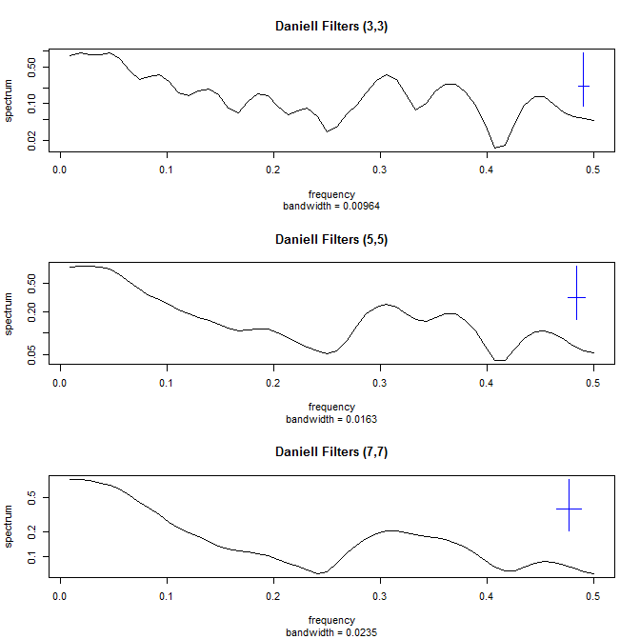

Example 2 Yield on short-term government securities
We first import and plot the data:

yield1<-read.csv("F:\\MA30085 50085 Time Series\\Chatfield Data Files\\yield.csv",header=FALSE)
yield<-ts(yield1,start=c(1950,1),frequency=12)
plot(yield,main="Monthly Yield from British Short-Term Government Securities",ylab="Percent",xlab="Year",ylim=c(0,10))

> yield
Jan Feb Mar Apr May Jun Jul Aug Sep Oct Nov Dec
1950 2.22 2.23 2.22 2.20 2.09 1.97 2.03 1.98 1.94 1.79 1.74 1.86
1951 1.78 1.72 1.79 1.82 1.89 1.99 1.89 1.83 1.71 1.70 1.97 2.21
1952 2.36 2.41 2.92 3.15 3.26 3.51 3.48 3.16 3.01 2.97 2.88 2.91
1953 3.45 3.29 3.17 3.09 3.02 2.99 2.97 2.94 2.84 2.85 2.86 2.89
1954 2.93 2.93 2.87 2.82 2.63 2.33 2.22 2.15 2.28 2.28 2.06 2.54
1955 2.29 2.66 3.03 3.17 3.83 3.99 4.11 4.51 4.66 4.37 4.45 4.58
1956 4.58 4.76 4.89 4.65 4.51 4.65 4.52 4.52 4.57 4.65 4.74 5.10
1957 5.00 4.74 4.79 4.83 4.80 4.83 4.77 4.80 5.38 6.18 6.02 5.91
1958 5.66 5.42 5.06 4.70 4.73 4.64 4.62 4.48 4.43 4.33 4.32 4.30
1959 4.26 4.02 4.06 4.08 4.09 4.14 4.15 4.20 4.30 4.26 4.15 4.27
1960 4.69 4.72 4.92 5.10 5.20 5.56 6.08 6.13 6.09 5.99 5.58 5.59
1961 5.42 5.30 5.44 5.32 5.21 5.47 5.96 6.50 6.48 6.00 5.83 5.91
1962 5.98 5.91 5.64 5.49 5.43 5.33 5.22 5.03 4.74 4.55 4.68 4.53
1963 4.67 4.81 4.98 5.00 4.94 4.84 4.76 4.67 4.51 4.42 4.53 4.70
1964 4.75 4.90 5.06 4.99 4.96 5.03 5.22 5.47 5.45 5.48 5.57 6.33
1965 6.67 6.52 6.60 6.78 6.79 6.83 6.91 6.93 6.65 6.53 6.50 6.69
1966 6.58 6.42 6.79 6.82 6.76 6.88 7.22 7.41 7.27 7.03 7.09 7.18
1967 6.69 6.50 6.46 6.35 6.31 6.41 6.60 6.57 6.59 6.80 7.16 7.51
1968 7.52 7.40 7.48 7.42 7.53 7.75 7.80 7.63 7.51 7.49 7.64 7.92
1969 8.10 8.18 8.52 8.56 9.00 9.34 9.04 9.08 9.14 8.99 8.96 8.86
1970 8.79 8.62 8.29 8.05 8.00 7.89 7.48 7.31 7.42 7.51 7.71 7.99
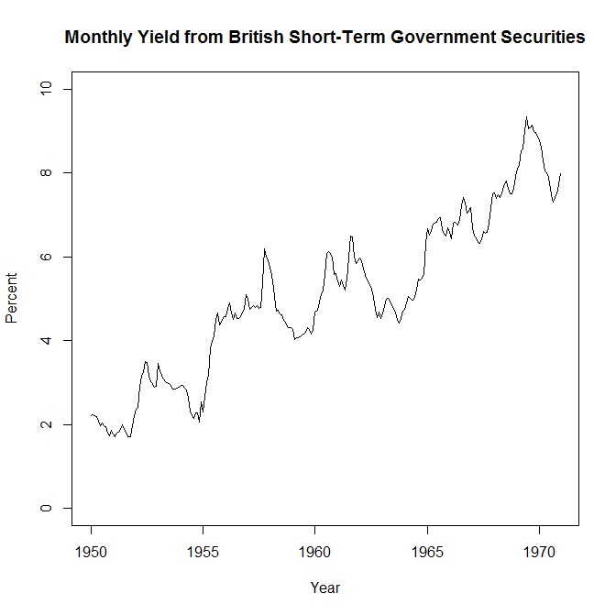
The sample ac.f is produced using the command:

yieldacf<-acf(yield1,lag.max=50,main="Correlogram for Monthly Yield from British Short-Term Government Securities",ylim=c(-1,1))
yieldacf

Values of the ac.f are listed below, because they differ from the values quoted in Chatfield 6th edition, namely

lag | Chatfield | This analysis
1 | 0.97 | 0.99
2 | 0.94 | 0.97
3 | 0.92 | 0.95
4 | 0.89 | 0.93
5 | 0.85 | 0.91
24 | 0.34 | 0.52
:

[1,] 1.0000000
[2,] 0.9855462
[3,] 0.9680912
[4,] 0.9506049
[5,] 0.9317940
[6,] 0.9126326
[7,] 0.8922248
[8,] 0.8707009
[9,] 0.8495946
[10,] 0.8295792
[11,] 0.8091585
[12,] 0.7883945
[13,] 0.7674418
[14,] 0.7448678
[15,] 0.7221408
[16,] 0.7007511
[17,] 0.6792762
[18,] 0.6585582
[19,] 0.6390719
[20,] 0.6178117
[21,] 0.5960464
[22,] 0.5748645
[23,] 0.5544772
[24,] 0.5366236
[25,] 0.5195864
[26,] 0.5045678
[27,] 0.4920921
[28,] 0.4837040
[29,] 0.4772615
[30,] 0.4714335
[31,] 0.4661908
[32,] 0.4609946
[33,] 0.4554735
[34,] 0.4500169
[35,] 0.4440147
[36,] 0.4375333
[37,] 0.4302790
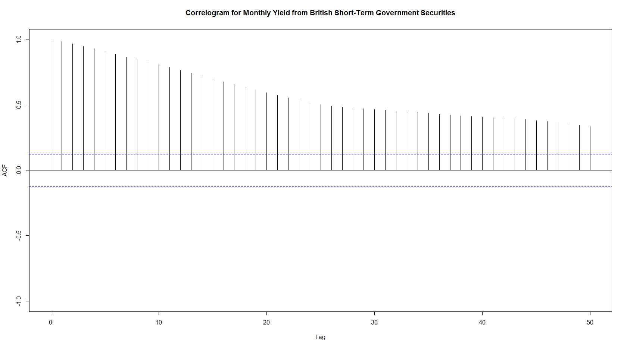
These differences are being investigated by the author and are thought to be caused by an error in the data as originally listed. The correlogram is plotted below and shows the slow decay typical of a non-stationary series.

We now take first differences of the data and plot the differenced series:
diffyield=diff(yield, lag=1)
plot(diffyield,main="Differenced Monthly Yield from British Short-Term Government Securities",ylab="Percent",xlab="Year",ylim=c(-1,1))

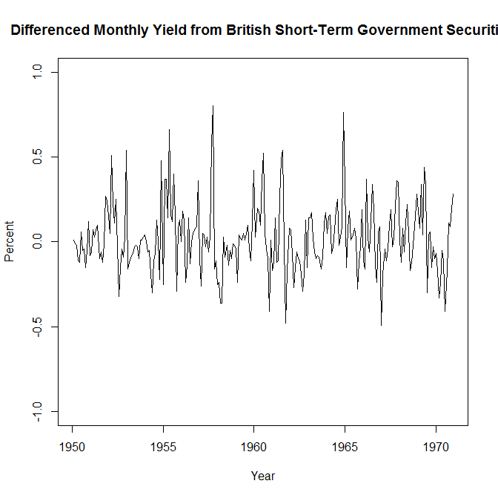
The sample ac.f of the first differences is produced via:

diffyieldacf<-acf(diffyield,lag.max=50,main="Correlogram for Differenced Monthly Yield from British Short-Term Government Securities",ylim=c(-1,1))
diffyieldacf

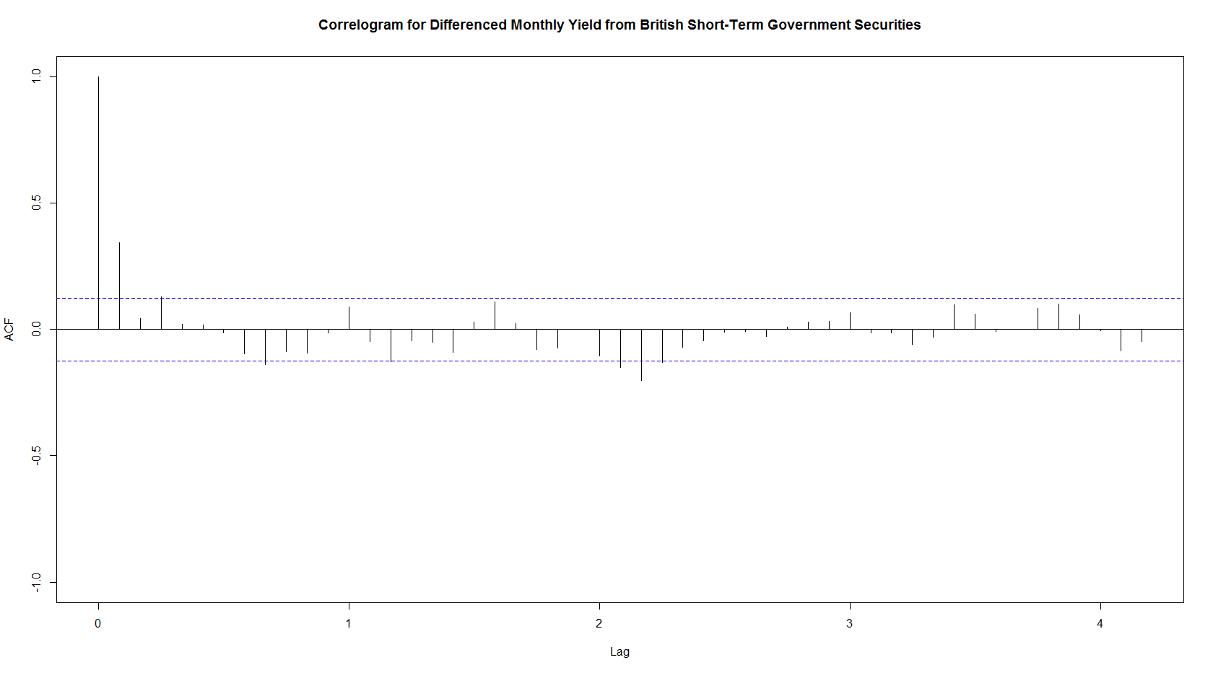

Values of the sample ac.f are listed below, as the values differ from those in the book. Note = 0.1262. Significant values are highlighted.
> diffyieldacf$acf
, , 1

[1,] 1.000000e+00
[2,] 3.424154e-01
[3,] 4.511240e-02
[4,] 1.285514e-01
[5,] 2.119021e-02
[6,] 1.943120e-02
[7,] -1.224694e-02
[8,] -9.657781e-02
[9,] -1.381191e-01
[10,] -8.739276e-02
[11,] -9.216505e-02
[12,] -1.436796e-02
[13,] 8.897098e-02
[14,] -4.771946e-02
[15,] -1.274294e-01
[16,] -4.375536e-02
[17,] -4.926974e-02
[18,] -8.955549e-02
[19,] 3.081316e-02
[20,] 1.091890e-01
[21,] 2.312124e-02
[22,] -7.968747e-02
[23,] -7.428385e-02
[24,] 4.312129e-05
[25,] -1.045158e-01
[26,] -1.503248e-01
[27,] -2.002343e-01
[28,] -1.303668e-01
[29,] -7.093623e-02
[30,] -4.409803e-02
[31,] -9.224070e-03

Fitting an ARIMA(0,1,1) model to the original data, using the CSS-ML and CSS methods:

fit<-arima(yield,order=c(0,1,1), method="CSS-ML")
Call:
arima(x = yield, order = c(0, 1, 1), method = "CSS-ML")

Coefficients:
ma1
0.4350
s.e. 0.0652

sigma^2 estimated as 0.03576: log likelihood = 61.76, aic = -119.52

fit<-arima(yield,order=c(0,1,1), method="CSS")
Call:
arima(x = yield, order = c(0, 1, 1), method = "CSS")

Coefficients:
ma1
0.4373
s.e. 0.0653

sigma^2 estimated as 0.03576: part log likelihood = 61.86

Note that the results are very similar in this case.

Example 3 Airline passenger data
Monthly totals of international airline passengers in the US are available as a time series object (named AirPassengers) within the R base package, and are tabulated in Table 14.3 in the book.
We start by plotting the data, using the command:
plot(AirPassengers,ylab='Number of Passengers (in thousands)', xlab='Year')
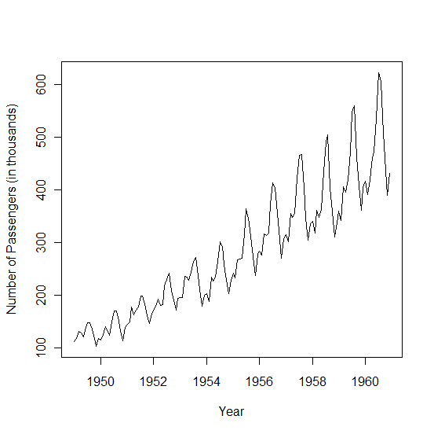

The seasonal pattern and positive trend in the data is clear. The magnitude of the seasonal variation increases at a similar rate to the yearly mean levels, indicating a multiplicative seasonal model is appropriate.

We attempt to fit an ARIMA model to the data, using R.

Firstly, the multiplicative seasonality of the data suggests we transform the data by taking logarithms, in order to make the seasonality additive.

logap<-log(AirPassengers)
plot(logap,ylab='Logarithm of Number of Passengers (in thousands)', xlab='Year')

Following the log transformation, the plot (not shown here) shows the size of the seasonal variation is now roughly constant. We can now plot the ac.f of the raw logged data, together with those for the first differences of the logged data and the seasonal differences at lag 12.

dlogap<-diff(logap); d12logap<-diff(logap,lag=12)
par(mfrow=c(3,1))
acf(ts(logap,freq=1),main="Logged Raw Data",lag.max=40)
acf(ts(dlogap,freq=1),main="Differenced Logged Raw Data",lag.max=40)
acf(ts(d12logap,freq=1),main="Logged Raw Data – Differenced at lag 12",lag.max=40)

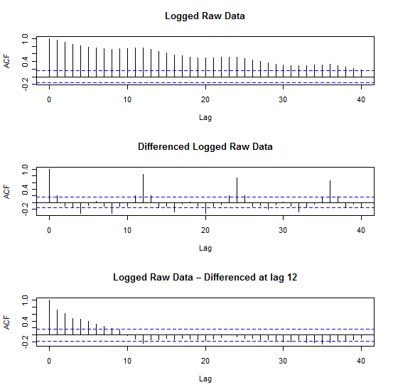

The acf for the logged data has positive values for all of the first 40 coefficients as a result of the obvious trend in the data. The other two correlograms also show signs of non-stationarity as coefficients decline slowly. This suggests taking 1st and seasonal differences of the logged data. Letting denote the logarithms of the observed data, the correlogram (below) suggests (see discussion in book) fitting a SARIMA (0,1,1)x(0,1,1) with period =12, to the data. We do this using the ML and CSS methods:

par(mfrow=c(1,1))
dd12logap<-diff(dlogap,lag=12)
acf(ts(dd12logap,freq=1),main="Logged Raw Data – Differenced at lags 1 and 12",lag.max=40)
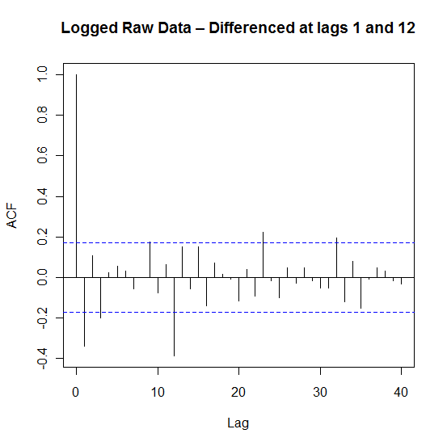
fit<-arima(logap,order=c(0,1,1), seasonal=list(order=c(0,1,1),period=12))

Call:
arima(x = logap, order = c(0, 1, 1), seasonal = list(order = c(0, 1, 1), period = 12))

Coefficients:
ma1 sma1
-0.4018 -0.5569
s.e. 0.0896 0.0731

sigma^2 estimated as 0.001348: log likelihood = 244.7, aic = -483.4

fit<-arima(logap,order=c(0,1,1), seasonal=list(order=c(0,1,1),period=12),method="ML")

Call:
arima(x = logap, order = c(0, 1, 1), seasonal = list(order = c(0, 1, 1), period = 12),
method = "CSS")

Coefficients:
ma1 sma1
-0.3772 -0.5724
s.e. 0.0883 0.0704

sigma^2 estimated as 0.001389: part log likelihood = 245.07

Diagnostics for the ARIMA model fitted using CSS are obtained via:

tsdiag(arima(x = logap, order = c(0, 1, 1), seasonal = list(order = c(0, 1, 1), period = 12),method="CSS")

