
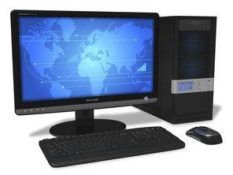
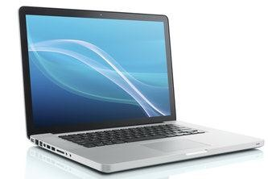
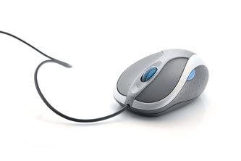
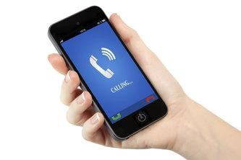
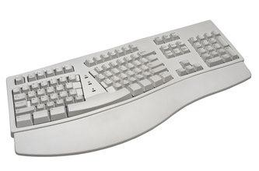
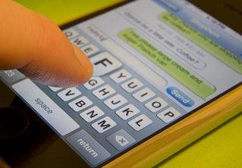

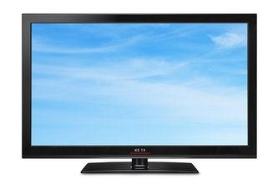
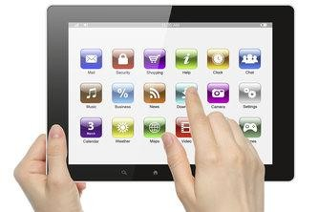


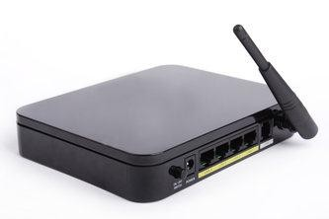
Vocabulary: Technology

Do these exercises to help you learn words for technology.

1. Check your vocabulary: picture matching
Write the correct words in the boxes below the pictures.
laptop | Wi-Fi | computer | touchscreen | game
email | mouse | mobile | keyboard | website

Computer | Laptop | Mouse | Mobile
Keyboard | Text message | Game | Screen
Touchscreen | Website | Email | Wifi

Vocabulary: Technology

2. Check your vocabulary: matching
Match the vocabulary with the correct definition and write a–j next to the numbers 1–10.
1g | An electronic machine. You use it for going on the internet, storing information and playing games. |  | a.
2e | An electronic letter. |  | b.
3b | You can play this on the computer for fun. |  | c.
4c | You use this to write on a computer. It has letters or characters on. |  | d.
5a | A computer that you can travel with. |  | e.
6d | Your personal telephone. |  | f.
7j | You use this to move and click on a computer. |  | g.
8f | The part of your computer where you see the pictures or words. |  | h.
9h | Google, YouTube and Wikipedia are types of … |  | i.
10i | Internet connection without wires or cables. |  | j.

Discussion
Which of the things in these vocabulary exercises do you use most?

I think the ones I use the most in my day to day are:
- Email
- Game
- Laptop
- Mobile (in Spanish tho)
- Wi-Fi

