  - HEIZÖLRÜCKSTOßABDÄMFUNG
  - 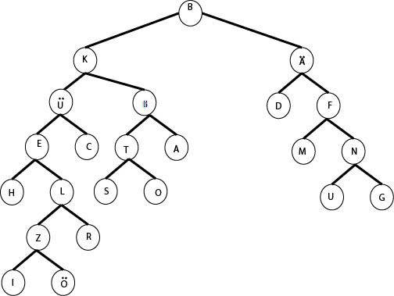
  - Citation: hw-questions discord channel and project 5 from java 2 with Prof. Duke
- A game with n terminals ends after (n – 1) moves so to win the game you should go first if n is even and second if n is odd.
  - A game with two open terminals in the same section is the winning state. n is how many terminals there are that can be connected to another terminal. The base case is n = 2. Using 2 for n in (n – 1) returns 1 meaning that the game will end after 1 move which it will so the base case is true. For the induction hypothesis I assume that the formula (n – 1) will hold for every integer k such that 2 <= k < n. For the induction step I’ll show that it holds for k + 1. After the first player draws their curve, the board is split into two sections with r and s many terminals in each. r + s = n. The formula should hold for both of those sections. The r section has a formula (r – 1). The s section has a formula (s – 1). Adding those two sections together plus 1 for the move that is used to split the first section is 1 + (r – 1) + (s – 1) which equals (r + s) + 1 – 2 which equals (r + s) – 1. r + s is n so the final step says (n – 1) = (n – 1). So the induction step holds
  - Citation: classwork from 1/18/22

  - Citation: https://proofwiki.org/wiki/Fibonacci_Number_with_Negative_Index
    - The base case is n = 1. Using 1 in f(n) = (-1)^(n+1)*f(n) is equal to f(1) = (-1)^(1+1)*f(1). We know that f(1) is 1 because that is one of the base cases for the Fibonacci sequence. So 1 = (-1)^(2)*1 which is the same as 1 = 1*1 so 1 = 1 which is true and the base case is valid.
    - The induction hypothesis will be based on the backward Fibonacci sequence f(-n) = f(n+2) – f(n+1). If (k+1) is used in place of n, then by the backward Fibonacci sequence it will be equal to f(-(k+1) + 2) – f(-(k+1) + 1). Which simplifies to f(-(k-1)) – f(-k). The formula f(-n) = (-1)^(n+1)*f(n) should hold for all of the other elements of the sequence and by extension to the values that are created by using (k+1) in place of f(-n). So the induction hypothesis is that f(-(k-1)) equals (-1)^((k-1)+1)*f(k-1) which is the same as (-1)^(k)*f(k-1) and f(-k) equals (-1)^(k+1)*f(k).
    - The induction step is that f(-(k+1)) = (-1)^(k+1+1)*f(k+1) = f(-(k-1)) – f(-k). As shown before in the induction hypothesis stage f(-(k-1)) – f(-k) can be simplified to (-1)^(k)*f(k-1) - (-1)^(k+1)*f(k). The second part of that equation can be changed to be (-1)^k instead to make it be added to the first part instead of subtracted. Then (-1)^k can be factored out of both sides leaving (-1)^(k)*(f(k) + f(k-1)). In relation to (k+1), f(k) + f(k-1) is the formula for the Fibonacci sequence. So f(k) + f(k-1) can be replaced with (k+1). This leaves (-1)^(k)*(f(k+1)) which is the same as (-1)^(k+1+1)*(f(k+1)) because adding two doesn’t change the outcome at all. So the induction step is valid and f(-n) = (-1)^(n+1)*f(n) is valid for every positive integer n.

    - The base case is n = 1. This is proven by 3^0 = 1
    - Assume that the k and k+1 can be written as the sum of positive or negative three to some power i. Say k = a1*3^(i1) + a2*3^(i2) + … + am*3^(im) where a{x} is either 1 or -1 and i{x} are distinct nonnegative integers. In the case where i1 is 0, n is one less than n+1. So, n can be expressed as n = (n + 1 – 3^0). Otherwise, n can be written as n = (n + 1 +- 3^i1) which is recursive. So, every nonzero integer can be written in the form of a sum of +-3^i where the exponents i are distinct non negative integers

