On 2009/3/8
- Create Title.txt and SortedPairs.txt as follows:
10 : 10筆 :
20 : 7筆 :
30 : 6筆 :
40 : 5筆 :
50 : 4筆 :
Title.txt ^ and
0 1 0.5
0 2 0.5
0 3 0.5
0 4 0.5
1 2 0.2929
1 3 0.0
1 4 0.2929
2 3 0.2929
2 4 0.0
3 4 0.2929
SortedPairs.txt =>

- Under D:\demo\STPIWG\src>, run
perl -s Term_Trend.pl -Omap MDS_Test1
It takes 0 seconds to cut tree having 0 records and 0 internal nodes
mds.exe 2 MDS_Test1\SimPairs.txt > MDS_Test1\Coordinate.txt
Number of title: 5, extra title: 0, coordinates: (5, 5). It takes 0 seconds for MDS mapping
The graph is correct and the SimPairs.txt is:
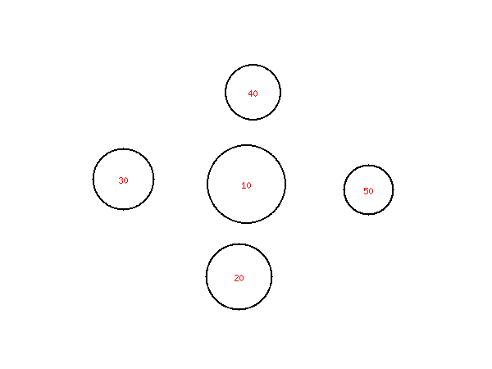
5
10 : 10筆 :
20 : 7筆 :
30 : 6筆 :
40 : 5筆 :
50 : 4筆 :
0.5 <= (1,0)
0.5 <= (2,0)
0.7071 <=(2,1)
0.5 <= (3,0)
1.0 <= (3,1)
0.7071 <=(3,2)
0.5 <= (4,0)
0.7071 <=(4,1)
1.0 <= (4,2)
0.7071 <=(4,3)

- Now remove node ID=10 and see if it is correct or not. Under D:\demo\STPIWG\src>, run
perl -s Term_Trend.pl -Omap -Ounwant=10 MDS_Test1
It takes 0 seconds to cut tree having 0 records and 0 internal nodes
mds.exe 2 MDS_Test1\SimPairs.txt > MDS_Test1\Coordinate.txt
Number of title: 4, extra title: 0, coordinates: (4, 4). It takes 0 seconds for MDS mapping
The result is correct:
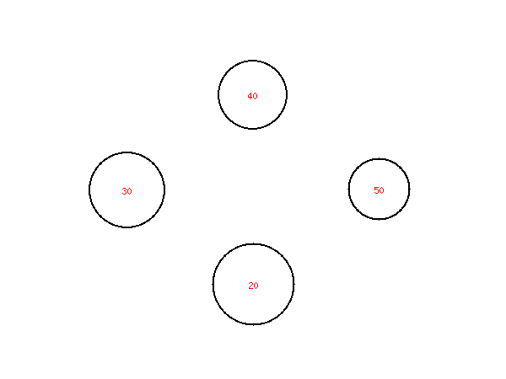
4
20 : 7筆 :
30 : 6筆 :
40 : 5筆 :
50 : 4筆 :
0.7071 <= (1,0)
1.0 <= (2,0)
0.7071 <=(2,1)
0.7071 <= (3,0)
1.0 <= (3,1)
0.7071 <=(3,2)

- Now remove node ID=50 and see if it is correct or not. Under D:\demo\STPIWG\src>, run
perl -s Term_Trend.pl -Omap -Ounwant=50 MDS_Test1
The result is correct:
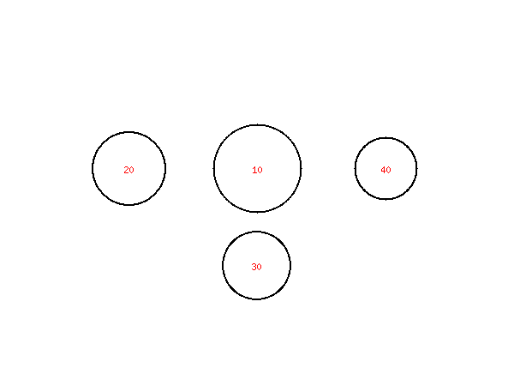
4
10 : 10筆 :
20 : 7筆 :
30 : 6筆 :
40 : 5筆 :
0.5 <= (1,0)
0.5 <= (2,0)
0.7071 <=(2,1)
0.5 <= (3,0)
1.0 <= (3,1)
0.7071 <=(3,2)

- Now remove node ID=20 and see if it is correct or not. Under D:\demo\STPIWG\src>, run
perl -s Term_Trend.pl -Omap -Ounwant=20 MDS_Test1
The result is correct:
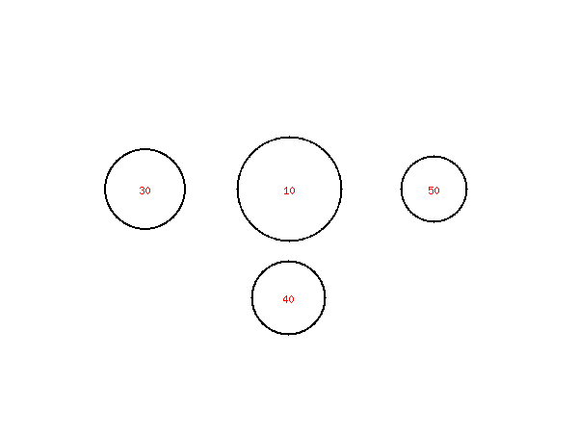
4
10 : 10筆 :
30 : 6筆 :
40 : 5筆 :
50 : 4筆 :
0.5 <= (1,0)
0.5 <= (2,0)
0.7071 <=(2,1)
0.5 <= (3,0)
1.0 <= (3,1)
0.7071 <=(3,2)
- The following commands all lead to correct results:
D:\demo\STPIWG\src>perl -s Term_Trend.pl -Omap -Owant="10 20 30 40 50" MDS_Test1
D:\demo\STPIWG\src>perl -s Term_Trend.pl -Omap -Owant="20 30 40 50" MDS_Test1
D:\demo\STPIWG\src>perl -s Term_Trend.pl -Omap -Owant="10 20 30 50" MDS_Test1

