Milestone 1 Initial Report: Predicting Potentially Hazardous Asteroids
CAI 4105 Machine Learning, Fall 2026 · Team 1 · Members: Samuel T, Ishita C, Sebastian A · October 7, 2026

1. Executive Summary
Our team will build a binary classifier that predicts whether an asteroid is a Potentially Hazardous Asteroid (PHA) from its orbital and physical characteristics, following the CRISP-DM process taught in this course.
Project overview and objectives. NASA labels an asteroid a PHA when its minimum orbit intersection distance (MOID) with Earth is at most 0.05 AU and its absolute magnitude (H) is at most 22.0, which corresponds roughly to objects larger than about 140 meters. Observing and tracking every candidate is costly, so a model that ranks objects by hazard likelihood could help astronomers decide where to point limited telescope time. We have three objectives:
- Build and compare several classification models for the PHA label, with recall on hazardous objects as the priority.
- Identify which orbital features carry the most predictive signal once label-defining variables are controlled for.
- Report performance with metrics that suit a rare-event problem, since hazardous objects are expected to be a small minority.
Dataset. We use the Kaggle "Asteroid Dataset" (sakhawat18), a NASA JPL Small-Body Database export. It contains 958,524 observations and 45 columns, mixing numerical orbital elements (for example semi-major axis, eccentricity, inclination) with categorical fields such as orbit class. The target is the pha column (Y or N), and only 2,066 of the 938,603 labeled objects (0.22 percent) are hazardous. This meets the course minimums of 1,000 rows, 10 features, and both numerical and categorical variables.
Proposed approach. We will explore and clean the data, remove identifier columns and any variable that defines the label, engineer a small set of orbit-based features, and split the data with stratification so the rare class is represented in every subset. We will train a majority-class baseline, logistic regression, LDA, QDA, KNN, and a tree-based ensemble, tune them with stratified cross-validation, and compare them using precision, recall, and area under the precision-recall curve rather than accuracy. The final test set stays untouched until model selection is finished.

2. Business Understanding
The business problem is deciding which asteroids deserve scarce follow-up observation, and our model supports that decision by estimating the probability that an object is a Potentially Hazardous Asteroid.

2.1 Problem definition and motivation
NASA counted 39,123 known near-Earth asteroids as of December 2025, and new ones are found every year. Of those larger than 140 meters, 11,343 have been found and an estimated 14,000 remain undiscovered (NASA, 2025). Most are harmless, but a small group comes close enough to Earth's orbit and is large enough to matter. Organizations that track these objects have limited telescope time and analyst attention, so triage matters. A missed hazardous object is far more costly than a false alarm that gets a second look.
There is also a design issue we want to state openly. Under NASA's definition, the PHA label is computed from MOID and absolute magnitude H. A model given those two columns could recover the label almost perfectly, but it would only be re-learning a rule and would add no scientific or practical value. We therefore frame the project at two levels:
- Reference model (with label-defining features): uses all usable columns, including MOID and H. We expect near-perfect scores and will report them only to demonstrate the leakage effect.
- Primary model (leakage-controlled): excludes moid, moid_ld (MOID in lunar distances), H, and diameter (which is computed from H and albedo), and learns from the remaining orbital elements. This is the model we evaluate and recommend.
The EDA in Section 3 confirms the concern: the rule reproduces the label for 99.994 percent of labeled objects, and the 56 exceptions all sit at the H = 22 boundary (Section 3.4, Figure 7).
The EDA adds one caution. Perihelion distance q is almost perfectly correlated with MOID in this data (Pearson 0.9997), because for most objects MOID is close to q minus 1 AU (median q minus MOID is 0.99 AU; Figure C5). We keep q in the primary model because orbit geometry is the legitimate scientific signal, but strong scores should be read as "orbit geometry predicts hazard status" and not as independent evidence. We will also run an ablation without q and report how much performance drops.

2.2 Business objectives and success criteria
Objective | Success criterion (proposed) | How we measure it
Catch hazardous objects | Recall on the PHA class of at least 0.90 on the test set | Confusion matrix, recall
Keep false alarms manageable | Precision on the PHA class of at least 0.25 at the chosen threshold | Precision, precision-recall curve
Beat trivial approaches | Average precision of at least 0.30, and above the majority-class and logistic regression baselines | Average precision (PR-AUC)
Be explainable | Top features explained in plain language and consistent with orbital mechanics | Feature importance, coefficients
Be reproducible | Notebook reruns end to end with a fixed random seed | Restart kernel and run all cells
The targets apply to the leakage-controlled primary model. To check they are realistic, we ran one untuned gradient-boosting model with class weights on the primary feature set (85/15 stratified split). It reached a PR-AUC of 0.23 and about 0.17 precision at 0.90 recall, so the targets require real gains from tuning and feature engineering rather than being met by default. The reference model, which can reproduce the rule, is expected to exceed 0.99 recall and precision, and we report it only for comparison.

2.3 Stakeholder analysis
Stakeholder | Interest | What they need from the model
Planetary defense and near-Earth object tracking programs | Prioritize follow-up of risky objects | High recall, ranked probabilities
Survey telescopes and observatories | Allocate limited observing time | A short, ranked candidate list
Astronomers and researchers | Understand which orbit types tend to be hazardous | Interpretable feature effects
General public and policymakers | Trust in how risk is communicated | Clear, non-alarmist reporting of limits
Course instructor and our team | Demonstrate the CRISP-DM lifecycle | Documented, reproducible work

2.4 Expected impact and value proposition
A reliable ranking could let analysts review a few hundred high-probability objects instead of the whole catalog, saving observation time. Even if the model does not beat the official rule, the analysis shows which orbital characteristics are most associated with hazard status, which is useful context for non-specialists. Our value proposition is a transparent, leakage-aware model whose limits are documented.

2.5 Risks and assumptions
- Assumption: the NASA PHA definition (MOID at most 0.05 AU and H at most 22.0) is the ground truth for the label.
- Assumption: the Kaggle file is a faithful snapshot of the JPL database at the time it was exported.
- Risk: severe class imbalance can make accuracy look high while the model misses hazardous objects. We mitigate this with class weights, stratified splits, and recall and PR-AUC as primary metrics.
- Risk: label leakage through MOID, H, or columns derived from them. We mitigate this with the two-level design above.
- Risk: the dataset is a snapshot, so orbits of objects with few observations may change. Conclusions apply to this data version only.

3. Data Understanding
The dataset is large, mostly numerical, and well suited to classification, but three issues shape everything that follows: the label is defined by two of its own columns, hazardous objects are rare, and several columns are mathematically redundant.

3.1 Dataset description and source
- Name: Asteroid Dataset (Kaggle, author sakhawat18), described on Kaggle as the NASA JPL Asteroid Dataset.
- Original source: NASA Jet Propulsion Laboratory (JPL) Small-Body Database, which publishes orbital and physical parameters for asteroids and comets.
- Size: 958,524 rows by 45 columns; 35 numerical (33 float and 2 integer) and 10 categorical or text columns.
- Target variable: pha, a Yes or No flag for Potentially Hazardous Asteroid. Class balance: 2,066 Y (0.22 percent), 936,537 N (97.71 percent), and 19,921 missing (2.08 percent). Among the 938,603 labeled rows, about 1 in 454 is hazardous.

3.2 Data collection methodology
The values originate from telescope observations submitted to the Minor Planet Center and processed by JPL, which fits an orbit to each object's observations. Orbital elements therefore have measurement uncertainty, and objects with few observations have less certain orbits. Physical properties such as diameter and albedo are measured for only a subset of objects, usually through infrared or radar observations. The Kaggle file is a one-time export, so values may differ from the live JPL database. 94.9 percent of objects share one orbit epoch, 31 May 2020 (epoch_cal 20200531), which suggests the export was made around that time.

3.3 Key variables
The table lists the main variable groups and their planned role. Names and types were checked against df.columns and df.dtypes in the notebook (Section 2 of the notebook).
Variable | Meaning | Type | Planned role
pha | Potentially hazardous asteroid flag (Y or N) | Nominal (binary) | Target
neo | Near-Earth object flag (Y or N) | Nominal (binary) | Candidate feature, check redundancy with perihelion distance
H | Absolute magnitude, a brightness measure tied to size | Continuous | Excluded from primary model (defines label)
moid | Minimum orbit intersection distance with Earth, in AU | Continuous | Excluded from primary model (defines label)
diameter, albedo | Estimated size in km, reflectivity | Continuous | Excluded from primary model (computed from H and albedo, 86 percent missing)
a | Semi-major axis in AU | Continuous | Feature
e | Eccentricity, 0 is circular | Continuous | Feature
i | Inclination in degrees | Continuous | Feature
q, ad | Perihelion and aphelion distance in AU | Continuous | Derived from a and e, redundant
per, per_y, n | Orbital period (days, years) and mean motion | Continuous | Derived from a, redundant
om, w, ma | Longitude of ascending node, argument of perihelion, mean anomaly (degrees) | Continuous (circular) | Feature, angular
class | Orbit class (for example Apollo, Aten, Amor, main belt) | Nominal | Feature, one-hot encode
rms, sigma_* | Orbit fit quality and parameter uncertainty | Continuous | Possible features, uncertainty indicators
id, spkid, full_name, pdes, name, prefix, orbit_id | Identifiers and labels | Nominal or text | Dropped

3.4 Exploratory data analysis
The table summarizes each analysis in the notebook. The second column records what we expected before running it, so each finding confirms or corrects a hypothesis. Figures 1 to 3 follow the table, and the remaining EDA figures are in Appendix C.
Analysis | What we expect and why | Finding from notebook
Summary statistics (mean, median, standard deviation, min, max, quartiles) | Right-skewed distances and sizes, with a few extreme values | Strongly right-skewed. Semi-major axis a has a median of 2.65 AU but a maximum of about 33,489 AU, and orbital period per_y has a median of 4.3 years against a maximum of about 6.1 million years. H has a mean of 16.9 (range -1.1 to 33.2). The sigma columns are near zero for most rows (sigma_a is below 0.001 for 92 percent of rows) yet reach values near 8.8e11.
Target distribution | Strong imbalance, with PHA a small minority | 2,066 Y (0.22 percent) versus 936,537 N (97.71 percent), with 19,921 rows (2.08 percent) unlabeled. A model that always predicts N would be about 99.78 percent accurate on labeled rows and find no hazardous objects.
Distributions of a, e, i, diameter, H (histograms, box plots) | Most objects in the main belt, a long tail of near-Earth objects | The middle 50 percent of objects have a between 2.39 and 3.00 AU, e between 0.09 and 0.20, and i between 4.2 and 12.4 degrees, consistent with a main-belt majority (855,954 objects, 89.3 percent, are in class MBA). diameter is known for only 136,209 objects (median 3.97 km). e and i are right-skewed with long upper tails, a sits in a narrow main-belt band, and H is roughly symmetric around 17 (Figure C2).
Features by class (box plots of each feature split by pha) | PHAs have smaller perihelion distance, and different a, e, and i | Confirmed. Hazardous objects have median q of 0.82 versus 2.23 AU, e of 0.56 versus 0.15, a of 1.73 versus 2.65 AU, and i of 9.8 versus 7.4 degrees (Figure 2). All 2,066 PHAs belong to four near-Earth classes: APO 1,768 (13.9 percent of that class), ATE 174, AMO 118 and IEO 6; no other class has any. Within the 22,894 labeled NEOs, 9.0 percent are PHAs (Figure C3).
Missing values (count and percent per column, bar chart) | diameter and albedo mostly missing, other fields mostly complete | prefix is 100 percent missing and name 97.7 percent. diameter, diameter_sigma, and albedo are 85.8 to 85.9 percent missing. pha and moid are each missing in 19,921 rows (2.08 percent), and the sigma columns in almost the same number, which suggests the same objects. H is missing in 6,263 rows (0.65 percent). All other columns are complete or nearly so.
Correlation analysis (heatmap of numerical features) | Very high correlation among a, per, per_y, n, ad, and q | Many columns are exact duplicates of each other in different units: per and per_y, a and ad, moid and moid_ld, and epoch with epoch_mjd and epoch_cal (all about 1.000), tp and tp_cal (0.998), and a with per (0.982). Perihelion distance q and moid are also correlated at about 1.000. Spearman rank correlation on a 100,000-row sample, which resists the extreme values, shows the same clusters (Figure C4). Each single feature correlates only weakly with pha (absolute Spearman at most 0.08), so hazard depends on a combination of variables rather than any one column.
Label dependence (cross-tab or plot of pha against moid and H) | pha equals Y only when moid is at most 0.05 and H is at most 22 | Confirmed with exceptions. No Y has moid above 0.05, and 2,047 Y satisfy both conditions. Another 19 Y have moid at most 0.05 but H not at most 22 (this includes any rows where H is missing), and 37 N satisfy both conditions. That is 56 exceptions among 938,603 labeled rows (about 0.006 percent), so the rule explains the label almost perfectly. All 56 exceptions have H between 21.9 and 22.4, right at the size threshold, which points to rounding of H in the export rather than a different rule (Figure 3).
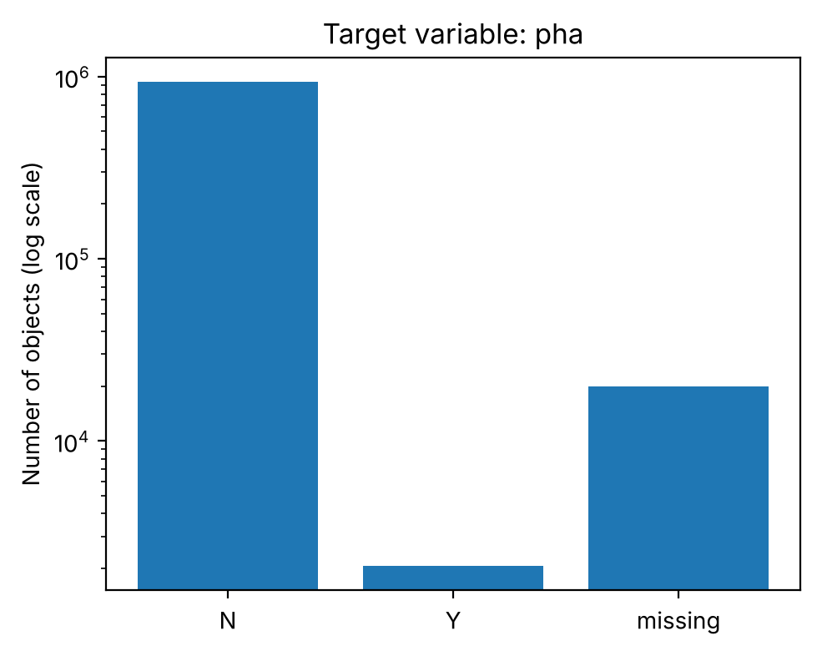
Figure 1. Class balance of pha (log scale): 936,537 N, 2,066 Y, 19,921 missing.
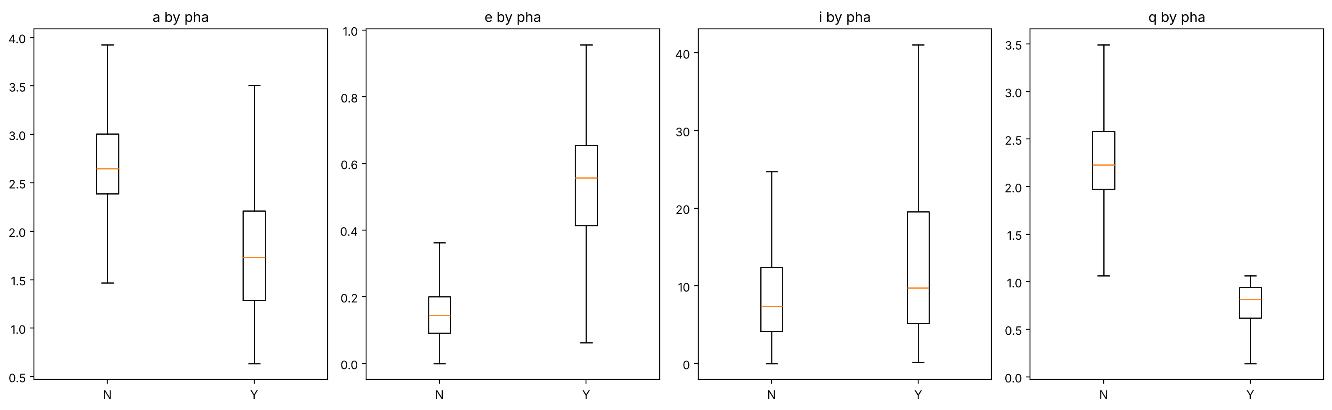
Figure 2. Orbital features by hazard class (outliers hidden). PHAs have small q and high e.
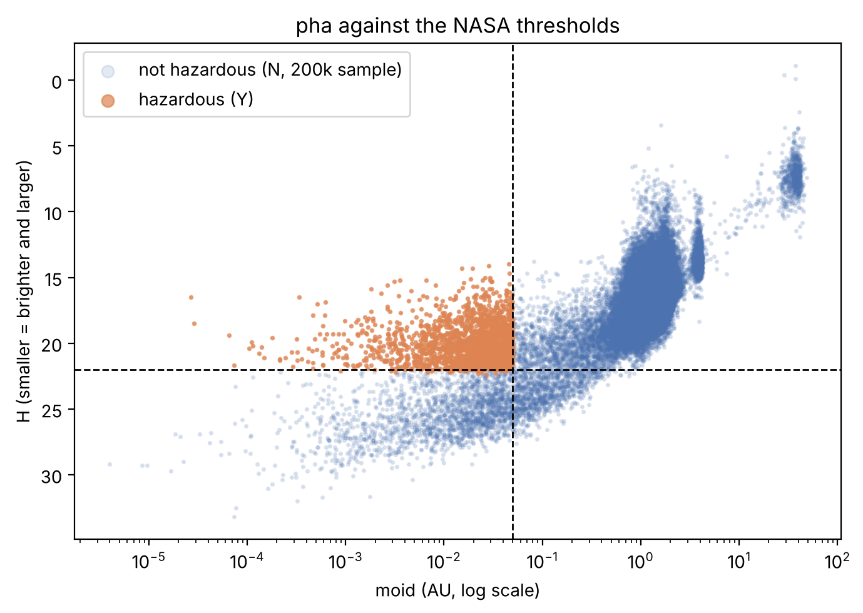
Figure 3. pha against the NASA thresholds (dashed lines). Hazardous objects fill the moid ≤ 0.05, H ≤ 22 corner.

3.5 Data quality assessment
We checked each item below in the notebook (Section 8 of the notebook).
- Missing values: share of missing values per column, and whether the target itself has missing entries, which would make those rows unusable for supervised training. In this data, 19,921 rows (2.08 percent) have no pha label.
- Duplicates: repeated id or full_name values. There are 0 duplicate id values among 958,524 rows; there are also 0 duplicate full_name values and 0 fully duplicated rows.
- Outliers and impossible values: negative distances, eccentricity of 1 or more (not a closed orbit), inclination outside 0 to 180 degrees, extremely large diameters. Eccentricity reaches 1.855 and semi-major axis reaches -14,702 AU, which are valid hyperbolic (unbound) orbits rather than errors (4 objects). Mean anomaly ma ranges from -70.7 to 491.6 degrees, outside the expected 0 to 360 range for 95 rows, which we will wrap into 0 to 360. Fit error rms has a median of 0.57 but reaches 2,686.6, so a few orbit fits are very poor (3 rows above 10). Inclination (0.008 to 175.1 degrees) and diameter (0.002 to 939.4 km) are plausible.
- Data types: numbers stored as text, mixed types in one column, inconsistent Y and N coding. The file has 10 text columns and 35 numeric columns. The pha and neo flags are stored as text and must be encoded, and epoch_cal and tp_cal are numbers in YYYYMMDD form, not true dates. The epoch, epoch_mjd, and epoch_cal columns are nearly constant (94.9 percent of rows share one value), so they carry almost no information.
- Redundant columns: the relationships in the block below make several columns exact functions of others.
q = a(1 − e) ad = a(1 + e) P² = a³ (P in years, a in AU)
The first two equations give perihelion and aphelion distance from the semi-major axis a and eccentricity e. The third is Kepler's third law, which ties the period to a. Any model that includes q, ad, per, and n alongside a and e is receiving the same information several times, which hurts coefficient interpretation in linear models.

3.6 Identified challenges and limitations
- Label leakage. pha is computed from moid and H, so these must be handled deliberately (Section 2.1).
- Class imbalance. Only 0.22 percent of labeled objects are hazardous, so accuracy will be misleading. We use recall, precision, and PR-AUC instead.
- Heavy missingness in physical properties. diameter and albedo are measured for only about 14 percent of objects, so they may be dropped or imputed with an indicator.
- Multicollinearity. Redundant orbital columns inflate variance in linear models.
- Skewed scales. Features span very different ranges, so some models need scaling or log transforms.
- Snapshot data. Orbits improve over time, so results describe this export only.
- Dataset size. A large file can make cross-validation slow, so we may tune on a stratified subsample. With 958,524 rows, this is a real concern.

4. Data Preparation Plan
Our preparation plan removes identifiers and label-defining columns first, then handles missing values and skewed scales, and finishes with a stratified split so that every transformation is learned from training data only.

4.1 Data cleaning strategy
Issue | Planned handling | Reason
Identifier and text columns (id, spkid, full_name, pdes, name, prefix, orbit_id, equinox, the near-constant epoch, epoch_mjd, and epoch_cal columns, and the timestamp columns tp and tp_cal) | Drop | They identify objects and carry no general signal
Rows with a missing target | Remove from training and keep aside as unlabeled (19,921 rows, 2.08 percent) | A supervised model needs a label
Label-defining columns (moid, moid_ld, H) | Exclude from the primary model, keep for the reference model only | Prevents label leakage
Heavily missing diameter, albedo, and their sigma columns | These columns are 85.8 to 85.9 percent missing, above our 50 percent cutoff, so we drop them from the primary model. Diameter is also computed from H and albedo. We may test a median-imputed version with a missing-value indicator as an experiment | Avoids inventing data while keeping the fact that a value was absent
Lightly missing numeric columns | Median imputation fit on the training set | Medians resist the skew and outliers seen in orbital data
Out-of-range and extreme values (eccentricity of 1 or more, negative semi-major axis, mean anomaly outside 0 to 360) | Keep hyperbolic orbits (they are valid) but log-transform or cap extreme values; wrap ma into 0 to 360 degrees or review it; document each decision | Keeps the analysis scientifically valid
Duplicate objects | No duplicate id values were found; confirm there are no fully duplicated rows | Duplicates could leak between train and test
Redundant orbital columns (q, ad, per, per_y, n) | Keep one representative set, for example a and e, in linear and discriminant models; test the full set in tree models | Removes multicollinearity where it causes harm

4.2 Feature engineering approach
- Perihelion-based flag: an indicator for whether the orbit comes inside Earth's orbit region (perihelion distance below about 1.3 AU is the usual near-Earth cutoff). We will check that it adds information beyond q itself.
- Orbit shape and size: eccentricity, semi-major axis, and inclination as core features, plus log versions where skewed.
- Angular variables: om and w are angles, so we will test sine and cosine encodings so that 359 degrees and 1 degree are treated as close.
- Orbit class: one-hot encode class, grouping rare categories into an "other" level.
- Uncertainty signals: orbit fit error (rms) as a feature, to test whether poorly known orbits behave differently. The sigma columns are near zero for most rows and reach about 8.8e11, so we will drop them from the primary model or use log1p versions in an ablation.
- Feature selection: drop near-constant columns, review correlation clusters, and compare permutation importance from tree models with logistic regression coefficients.

4.3 Data transformation plans
- Log transform (log1p) for strongly right-skewed positive variables such as distances and diameter.
- Standardization (zero mean, unit variance) for logistic regression, LDA, QDA, and KNN, because KNN uses distances and regularized linear models are scale-sensitive. Tree-based models do not need scaling.
- Encoding: one-hot for nominal variables, binary 0 and 1 coding for Y and N flags.
- Pipelines: every step (imputation, scaling, encoding) will sit inside a scikit-learn Pipeline so it is fit on training folds only. Fitting a scaler on the full dataset before splitting would leak information from the test set.

4.4 Train, validation, and test split
Subset | Share | Purpose
Training | 70 percent | Fit models and run cross-validation
Validation | 15 percent | Choose the decision threshold and compare tuned models
Test | 15 percent | One final, untouched evaluation of the selected model
- The split is stratified on pha so each subset keeps the same class proportion, with a fixed random_state for reproducibility.
- Imbalance is handled with class weights or resampling inside training folds only. Oversampling before splitting would copy rare objects into the validation and test sets and inflate scores.
- If the dataset is too large for repeated cross-validation, we will tune on a stratified subsample of the training set and refit the chosen model on the full training set.
With 938,603 labeled rows and 2,066 hazardous objects, the validation and test sets will each contain roughly 310 hazardous objects and the training set roughly 1,446. With so few positives in the validation and test sets, recall estimates will be noisy, so we will report them with confidence intervals. The notebook already confirms the split: 1,446, 310 and 310 hazardous objects, 0.22 percent in each subset. Because every PHA is a near-Earth object and the 915,705 non-NEOs are all negatives, we will also report metrics on the 22,894-object NEO subset (9.0 percent hazardous), where the comparison between models is harder and more informative.

5. Modeling Approach
We will compare five classification methods, starting with the course methods (logistic regression, LDA, QDA, KNN) and adding a tree-based ensemble as a flexible benchmark, and judge them mainly on recall and PR-AUC for the hazardous class.

5.1 Algorithm selection and justification
Model | Why we include it | Main limitation here
Majority-class baseline | Shows what accuracy alone achieves by predicting "not hazardous" for every object | Detects no hazardous objects
Logistic regression | Interpretable coefficients and probability outputs; the standard first model for a binary target | Linear boundary; needs scaling and low multicollinearity
Linear discriminant analysis (LDA) | Course method; stable when classes are well separated, where logistic regression estimates can become unstable | Assumes roughly normal predictors with equal covariance, which skewed orbital data may violate
Quadratic discriminant analysis (QDA) | Allows a curved boundary by estimating separate covariances per class | Needs enough rare-class observations to estimate covariances reliably
K-nearest neighbors (KNN) | Non-parametric, no boundary assumption | Slow on large data, weak with many predictors, gives no coefficients
Random forest or gradient boosting | Captures non-linear interactions and handles mixed scales and skew with little preprocessing; gives feature importance | Less interpretable, more hyperparameters
Our reasoning follows the course comparison: if the true boundary is close to linear, logistic regression and LDA should do well; if moderately non-linear, QDA; if more complicated, KNN or tree ensembles. Because the PHA label is a threshold rule on two variables, we expect non-linear models to do better once those variables are removed. We will test that expectation rather than assume it.

5.2 Evaluation metrics
Accuracy is not a suitable primary metric because a model that always predicts the majority class could score very high. We will report:
- Confusion matrix at the chosen threshold, from which we read true positives (hazardous objects found) and false negatives (hazardous objects missed).
- Recall (sensitivity) for the PHA class, our priority because a missed hazardous object is the costliest error.
- Precision for the PHA class, to control how many false alarms analysts must review.
- F1 and F2 scores: F1 balances precision and recall; F2 weights recall more heavily, which matches our priorities.
- Average precision (area under the precision-recall curve): the main model-comparison metric under imbalance.
- ROC-AUC as a secondary, threshold-free summary.
- Decision threshold: chosen on the validation set to reach the recall target in Section 2.2, rather than using the default 0.5.

5.3 Cross-validation strategy
- Stratified k-fold cross-validation on the training set with k = 5, keeping the PHA proportion in every fold. Lecture material covers the validation-set approach, leave-one-out, and k-fold; we choose k-fold because leave-one-out is too expensive on a large dataset and stratification protects the rare class.
- Hyperparameter tuning by randomized or grid search inside cross-validation, scored by average precision. Examples: regularization strength for logistic regression, the number of neighbors for KNN, tree depth and number of trees for ensembles.
- Pipelines ensure scaling, imputation, and any resampling are refit inside each fold.
- Final check: the selected model is evaluated once on the held-out test set, and we report the gap between cross-validated and test scores as a check for overfitting.

5.4 Expected challenges and mitigation plans
Challenge | Mitigation
Extreme class imbalance | Stratified splits, class weights, PR-AUC and recall as primary metrics
Label leakage from moid and H | Two-level design: leakage-controlled primary model and a labelled reference model
Multicollinearity among orbital columns | Use a reduced feature set for linear and discriminant models; regularization
QDA instability with few rare-class samples | Check class counts per fold; fall back to LDA or regularized discriminant analysis if covariance estimates fail
Long training time with a large dataset | Stratified subsample for tuning, then refit on the full training set
Skewed predictors violating LDA and QDA assumptions | Log transforms and a comparison with non-parametric models
Overfitting | Cross-validation, a simple model as a baseline, and a final untouched test set

6. Project Timeline
The schedule below covers the remaining work from this milestone to the final report on November 21 and the presentation on November 23, with a built-in buffer week before the deadline.

6.1 Schedule for remaining work
Dates (2026) | Phase | Deliverable | Owner
Oct 8 to Oct 14 | Data preparation | Cleaning pipeline, missing-value handling, leakage columns removed | Samuel T
Oct 15 to Oct 21 | Feature engineering | Engineered features, scaling and encoding inside pipelines, stratified split saved | Ishita C
Oct 22 to Nov 4 | Modeling | Baseline, logistic regression, LDA, QDA, KNN, tree ensemble trained and tuned with 5-fold cross-validation | Sebastian A, with all members each owning at least one model
Nov 5 to Nov 11 | Evaluation | Metrics on validation set, threshold selection, model comparison, one test-set evaluation | Samuel T and Ishita C
Nov 12 to Nov 17 | Report drafting | Draft of all Milestone 2 sections, figures, data dictionary, appendices | Each member drafts the sections for the models they built
Nov 18 to Nov 20 | Review buffer | Team read-through, notebook rerun from a fresh kernel, peer evaluation forms | All members
Nov 21 | Submission | Milestone 2 report, notebooks and PDF, zip file uploaded to Canvas | Samuel T submits
Nov 22 to Nov 23 | Presentation | 15-minute slides with Q&A rehearsal; presentation held Nov 23 | All members present

6.2 Team responsibilities
All members are expected to contribute equally to every phase, so the owners above lead a phase rather than do it alone. The team will:
- Meet at least once a week and keep short notes of decisions and tasks.
- Use a shared repository or folder for the notebook, data, and report drafts, with a GitHub repository (github.com/SamTusick/Predicting-Potentially-Hazardous-Asteroids).
- Review each other's code before it enters the main notebook.
- Keep a record of which parts of the work used AI assistance (Appendix A).
Member | Primary roles | Models owned
Samuel T | Data preparation lead; repository and notebook maintainer | Majority baseline, logistic regression, LDA
Ishita C | Feature engineering and pipelines; report editing | Random forest and gradient boosting
Sebastian A | Modeling and evaluation lead; threshold selection | QDA, KNN

6.3 Risk assessment and contingency plans
Risk | Likelihood | Impact | Contingency
Large dataset makes tuning slow | High | Medium | Tune on a stratified subsample, run long jobs early, limit grid size
Leakage discovered late | Medium | High | Review all features against the NASA definition in Week 1; keep the reference model clearly labelled
A model such as QDA fails because of singular covariance | Medium | Low | Replace with LDA or regularized discriminant analysis, documenting why
Team member unavailable | Medium | Medium | Each phase has a backup owner; shared notebook and notes
Merge conflicts or lost work | Medium | Medium | Version control, regular commits, no one edits the main notebook without review
Running short on time before Nov 21 | Medium | High | Fix the minimum scope now (baseline, logistic regression, LDA, one non-linear model) and treat QDA and KNN as extensions

Appendix A: AI Usage Disclosure
The course project policy allows AI tools with explicit documentation of their use. The table records how AI was used in this milestone.
Part of the work | AI tool | How it was used | Team review
Report draft (Sections 1 to 6) | Claude (Anthropic) | Drafted the text and structure from the project outline, the course slides, and our choice of dataset and target. In a second pass, Claude ran the team notebook on the full dataset, filled the data-dependent values from its output, and checked every figure against the data. | All members read and edited the final text
Choice of dataset and target variable | None | Chosen by the team (asteroid dataset, target pha) | Team decision
Exploratory analysis notebook | Claude (Anthropic) | Reviewed the team notebook, added the moid versus H plot and NEO cross-tab, filled the notes cells from the outputs, and ran a one-off untuned model to calibrate the targets in Section 2.2. | Team reran the notebook from a fresh kernel and checked the outputs

Appendix B: References
- Kaggle, "Asteroid Dataset" by sakhawat18: https://www.kaggle.com/datasets/sakhawat18/asteroid-dataset
- NASA JPL Solar System Dynamics, Small-Body Database Query: https://ssd.jpl.nasa.gov/tools/sbdb_query.html (accessed October 7, 2026).
- NASA JPL Center for Near-Earth Object Studies (CNEOS), NEO Basics: NEO Groups (definition of Potentially Hazardous Asteroids): https://cneos.jpl.nasa.gov/about/neo_groups.html (accessed October 7, 2026).
- NASA Planetary Defense Coordination Office, Near-Earth Asteroids as of December 2025: https://science.nasa.gov/science-research/planetary-science/planetary-defense/near-Earth-asteroids/ (accessed October 7, 2026).
- James, G., Witten, D., Hastie, T., Tibshirani, R., and Taylor, J., An Introduction to Statistical Learning with Python, Springer, 2023 (course text for logistic regression, LDA, QDA, KNN, and cross-validation).
- Chapman, P. et al., CRISP-DM 1.0: Step-by-step data mining guide, 2000.
- Course lecture slides: Data Science, Introduction to Statistical Learning, Data Preparation, Model Accuracy, Model Building, and Classification Methods.

Appendix C: Additional EDA Figures
These figures come from the team notebook (Team1_Project_Milestone1.ipynb) and support the findings in Section 3.4.
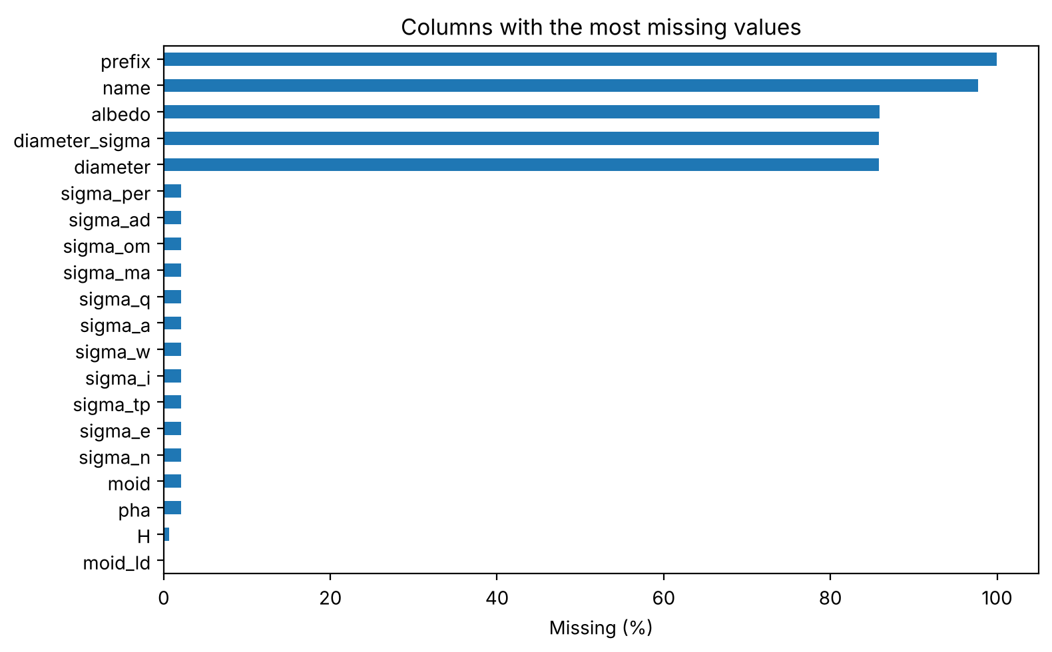
Figure C1. Columns with missing values. Physical measurements are about 86 percent missing; the 19,921 unlabeled rows also lack moid and all sigma columns.
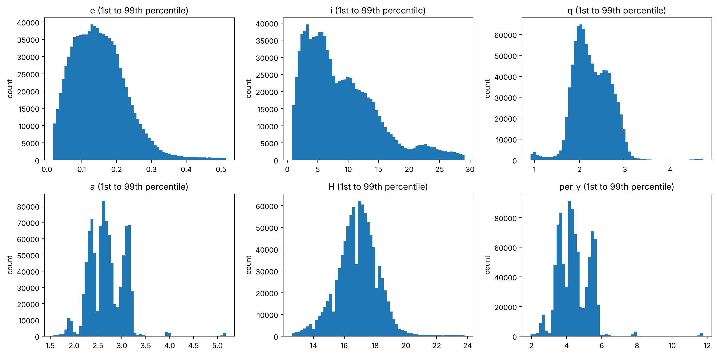
Figure C2. Distributions of key orbital variables (1st to 99th percentile).
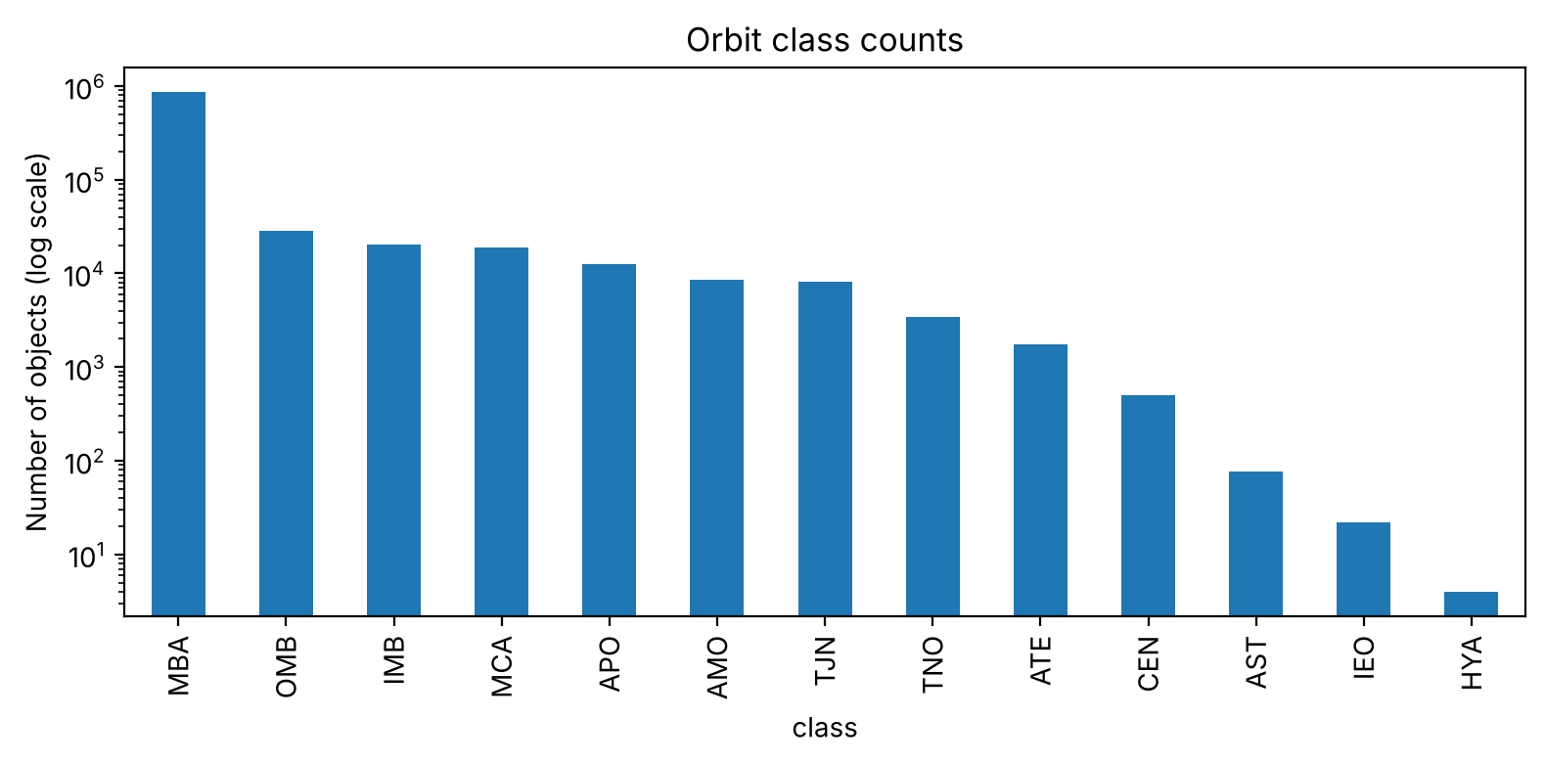
Figure C3. Orbit class counts (log scale). Only APO, ATE, AMO and IEO contain PHAs.
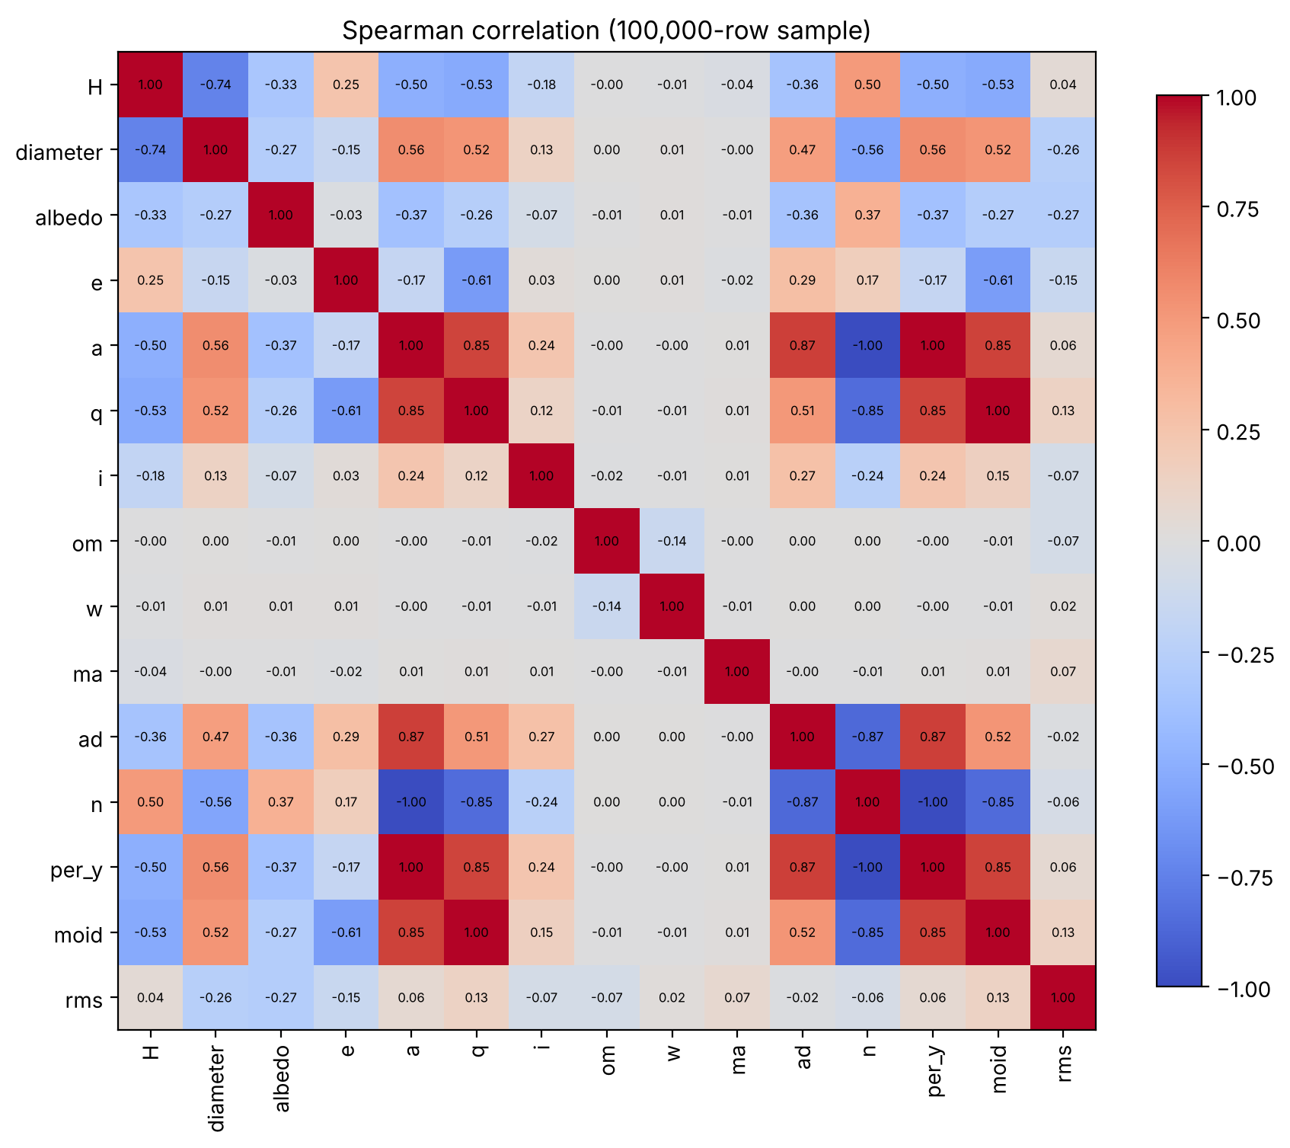
Figure C4. Spearman correlation of key numeric features (100,000-row sample).
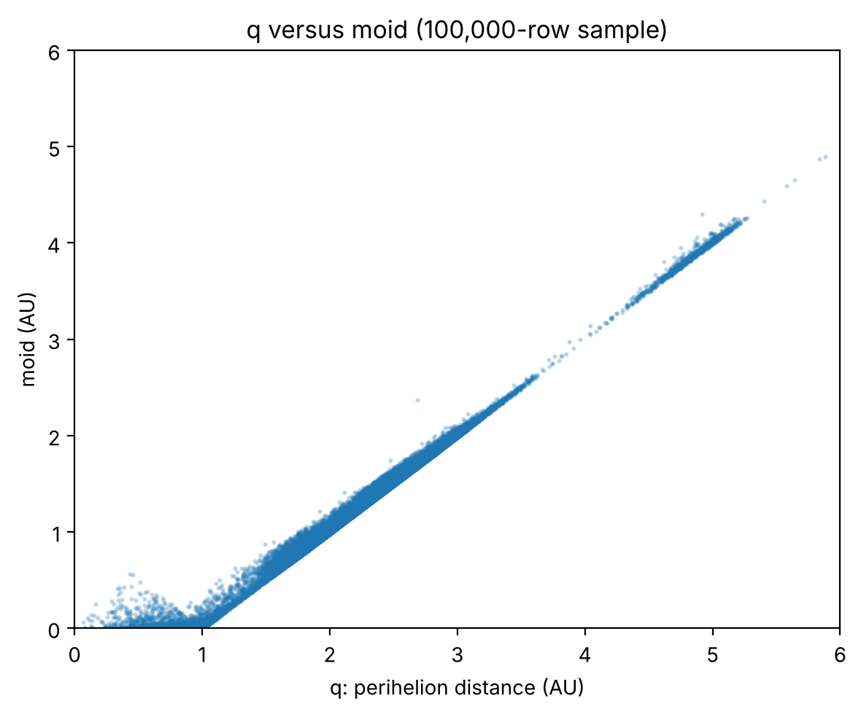
Figure C5. Perihelion distance q against moid. q carries most of moid's information.

