Dictionary

A
Aggressive – high risk
Annuitant – a person who receives annuity payments
Arbitrage – involves buying and selling the same investment or security to make an instant profit

B
Bear market – a market that generally declines over an extended period of time
Bearish – expectation of falling values
Beneficiary – person(s) and/or entities designated to receive the death benefit upon the passing of the insured person
Blue chip companies - large and successful companies that have been in business for several years
Bond – a debt security that allows investors to loan funds to organizations in return for interest
Bond point – 1 bond point = $10
Bull market – a market that generally increases over an extended period of time
Bullish – expectations of rising values

C
Capital appreciation – growth, capital gains
Capital gain – return received when selling an investment at a higher price than its original cost; making a gain on a sale
Capital risk – the risk of experiencing a loss on invested assets
Cash dividend – represents profit made by the company that is then distributed to its shareholders
Central bank – an organization operating as a country’s centralized financial institution; often directly connected to that country’s government
Common carrier – a person or company that provides transportation services for goods or people and is responsible for any potential loss of the goods during transport
Conservative – low risk
Convertible security – a security that is convertible into common stock of the same issuer
Coupon – a fixed dividend rate
Credit – money received to sell an investment
Cyclical stocks -shares that tend to follow the movements of the broader business cycle (perform well during periods of economic expansion)

D
Death benefit – benefit (money) received by beneficiaries in the event of the insured person’s death
Debit – money paid to purchase an investment
Defensive stock – hold their value through all business cycles as these companies operate in industries that provide essential goods/services
Diminished capacity – inability to perform regular duties or responsibilities due to mental conditions

E
Electronic Municipal Market Access (EMMA) – an MSRB website containing information relating to municipal securities, including official statements, trade data, and market statistics
Equity – formal term for ownership
Estate administrator – person appointed by the probate court to reside over the estate of someone who died intestate
Estate executor – person appointed in a will to handle a decedent’s estate
Exercise – using the right that an option provides; only holders (purchasers of options) can exercise

F
FINRA – Financial Industry Regulatory Authority; a self regulatory organization (SRO), which means they are empowered to enforce laws and regulations in finance. They regulate finance professionals and exchange markets.
Full faith and credit loans – promises to pay back money without collateral

G
Going long – finance jargon for purchasing ownership in a security

H
Hedge – protection from risk
Hybrid – something made up of two or more distinct pieces

I
Institutional investor – a single entity investing on behalf of a group of clients
Institutional investor – a single entity investing on behalf of others as a business activity (a professional investor)
Insured person – the person with their life insured; payout made upon their death
Interest – the cost of borrowing money
Intestate – not having a valid will before death
Investment club – a group of friends, neighbors, business associate, or others that pool their money to invest in stock or other securities and are collectively responsible for making investment decisions
Issuer – an organization that distributes and sells securities to investors

L
Letters of administration – official court document confirming a person’s role as estate administrator
Letters testamentary – official court document confirming a person’s role as estate executor
Leverage – investing with borrowed funds, which amplifies gain and loss potential
Lien – the right to property if a loan cannot be repaid
Liquidation – the sale of all company assets, including buildings, factories, inventory, equipment, and vehicles
Liquidity – the ability to buy or sell a security easily and quickly
Listed – when a stock is capable of being traded on a stock exchange
Load – a synonym for sales charge
Long – finance jargon for owning a security

M
Marginal tax bracket – the tax bracket applied to the last dollar earned
Market capitalization – the total market value of outstanding shares
Market maker -a financial organization outside of the exchange that trades with the public. They buy securities from investors at marked-down prices and then sell them to other investors at marked-up prices.
Material information – any information that would influence an investment decision; important information about an investment
Member firm – firms in the securities industry that are registered with FINRA
Municipal Securities Rulemaking Board (MSRB) – a self-regulatory organization responsible for creating rules for financial professionals within municipal securities markets

O
Outstanding shares – the number of shares held by the company’s shareholders
Outstanding shares – the number of shares held by the company’s shareholders
Over-the-counter – when a trade of a security takes place between two parties but not on an exchange

P
Policyholder – the person owning the life insurance; could be the insured person or a third party
Pre-emptive right – gives you the right to buy newly-issued shares before they’re publicly offered
Preferred stock – represents ownership and is an equity security like common stock, but it acts like a fixed-income security
Premium – cost of life insurance; typically takes the form of monthly payments to the insurance company
Price elasticity – an economic concept describing the relationship between the prices of goods and services and their demand
Primary distributions – occur when a security is sold, and the issuer receives the sales proceeds
Principal – original loan amount; the face value
Private placements -this type of offering involves selling securities privately to wealthy individuals and institutional investors

Q
Quote – provides trading information for a security

R
Redeemed - occurs when an issuer takes back outstanding securities from investors in return for payment of some form
Registration revocation – registration status is removed by FINRA due to an unethical or illegal action
Reinvestment risk – occurs when reinvested funds obtain an investment with a lower rate of return
Reserve currency – a currency commonly utilized by the world’s central banks and largest financial institutions
Retail investor – an individual investing for themselves or their household
Retail investor – an individual personally investing for themselves, family members, or other related parties (a non-professional investor)
Retained earnings – profits retained by a company, often used to expand and reinforce business operations; earnings that are not paid to investors by dividend (used by growth companies)
Round lot – 100 shares of stock; common denomination for stock trading

S
Secondary distributions – occur when a security is sold, but a party other than the issuer receives the sales proceeds
Secondary market – where stocks trade after they’re initially sold in the primary market (initial public offerings) aka the stock market
Secured creditors – have loaned money to the company, and their loans are backed by a specific form of collateral
Securities and Exchange Commission (SEC) – a federal agency that regulates and oversees the financial markets and its participants
Security – legal term for a specific type of investment
Selling short – allows investors to bet against an investment and make money if market values fall
Short – the sale of borrowed securities
Sophisticated investor – an investor with the market knowledge and the ability to withstand large losses, typically due to their high net worth (wealthy investor)
Spread – the difference between the buy price and the sell price
Stock exchange – a specific place where stocks trade
Stock index – a basket of stocks whose performance is averaged to determine the performance of a market
Suitability – relates to a security’s benefits and risks, and it used to determine if a n investment is appropriate for a particular investor

T
Tender offer – a direct proposal to purchase stock from current investors, typically at premium prices
Testate – having a valid will in place prior to death
Ticker symbol – a set of characters that represent an investment. Every publicly traded stock has a unique ticker symbol, making it easy to track without typing out the full business name.

U
Unsecured creditors – lent the company money but didn’t have a lien on a specific asset

Y
Yield – the rate of return an income-producing security provides; based on fluctuating market price

Dump Sheet: Regulators, Laws, & Rules
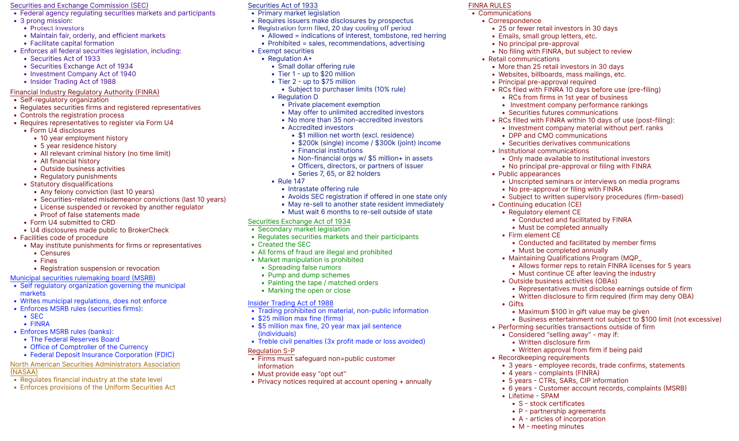

Dump Sheet: General Formulas
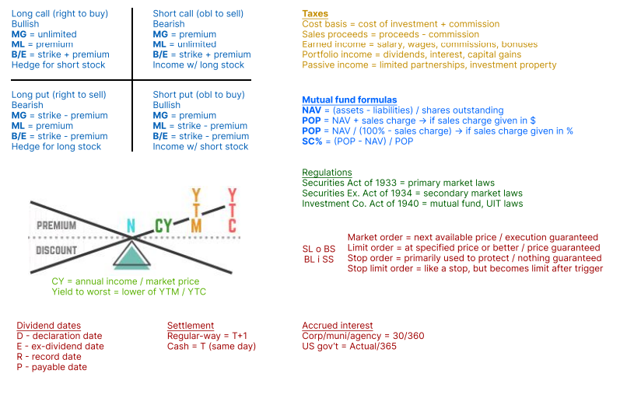

Key Points

Common Stock

Basic Characteristics
- Equity
  - Represents ownership
  - Examples
    - Common stock
    - Preferred stock
- Capital appreciation
  - Also known as growth, realized as capital gains
  - Occurs when stock prices rise
  - Stock prices are driven by supply and demand
- Retained earnings
  - Profits retained by the company
- Cyclical stock
  - Perform well during periods of economic expansion
  - Associated with industries that produce discretionary goods and services that consumers can delay purchasing in tough times
  - Examples include automobiles, manufacturing hotels, clothing, furniture, and restaurants
- Defensive stock
  - Provide essential goods and services that consumers continue to buy even during economic downturns
  - Outperform during economic contractions or recessions
  - Examples include healthcare, utilities, food and beverages, and tobacco.

Rights of Common Stockholders

Pro-Rata Share of Dividends
- Dividends
  - Can be paid in one of three forms
    - Cash
    - Stock
    - Product
  - Cash dividends are usually paid quarterly
  - Only the issuer’s board of directors approves dividend payouts
- Stock dividend consequences
  - More shares outstanding
  - Lower price per share
  - Same overall value
- How to find stock dividends:
  - Our example question: an investor owns 100 shares of stock at $20/share. The investor receives a 25% stock dividend. What changes?
    - Step 1: find stock dividend factor
      - Add the stock dividend percent (in decimal form) to 1
      - SD factor = SD (decimal form) + 1
      - SD factor = 0.25 + 1
      - SD factor = 1.25
    - Step 2: to find the new number of shares, multiply the original numbers of shares by the “stock dividend factor”
      - New shares = old shares x SD factor
      - New shares = 100 x 1.25
      - New shares = 125
    - Step 3: to find the price per share adjustment, divide the original price per share by the “stock dividend factor”
      - New price = old price/SD factor
      - New price = $20/1.25
      - New price = $16

Board of Directors
- Board of directors
  - Responsible for the general direction and success of a company
  - Stockholders control who serves
- Proxies
  - Voting materials used by investors unable to attend the annual meeting
- Statutory voting structure
  - Applies votes on a per position basis
  - More beneficial for large stockholders
  - Example
    - An investor has 100 shares and 300 votes (3 open board positions). 100 shares x 3 open positions. The investor can only apply up to 100 votes per open position.
- Cumulative voting structure
  - Can apply all votes to one position
  - More beneficial for small stockholders
  - Example
    - An investor has 100 shares and 300 votes (3 open board positions). 100 shares x 3 open positions. The investor can apply up to 300 votes in any manner.

Inspection of Books and Records
- Financial reporting
  - Publicly traded companies must file ongoing financial disclosures
  - Enforced by SEC
- 10-K annual report
  - Audited financial report
- 10-Q quarterly report
  - Unaudited financial report

Maintaining Proportionate Ownership
- Characteristics of rights
  - Right to purchase new shares at a fixed price
  - Intrinsic value exists at issuance, immediate benefit
  - Low time value at issuance
  - Short-term (typically 60-90 days or less)
  - Can be exercised, traded, or expire
  - Stockholders receive one right for every share owned
  - 1 right per share owned
- Characteristics of warrants
  - Right to purchase new shares at fixed price
  - No intrinsic value at issuance
  - High time value at issuance
  - Long-term (typically 5 years or longer)
  - Can be exercised, traded, or expire
- Dilutive actions
  - Any action reducing percent ownership
  - Examples
    - Issuing new shares
    - Issuing convertible securities
  - Companies performing dilutive actions without offering the opportunity to maintain proportionate ownership generally must obtain majority shareholder approval first.

Stock Splits
- Stock splits
  - Legal method for issuers to manipulate stock prices
  - Shareholders maintain the same proportionate ownership
  - Require shareholder approval
- Forward stock splits result in:
  - More shares outstanding
  - Lower price per share
  - Same overall value
  - Example:
    - A stockholder owns 100 shares of ABC company at a current market price of $300 per share. How will a 2:1 forward stock split impact shareholders?
      - Step 1: each stockholder receives 2 shares for every 1 share owned. To find the stock split factor, divide the first number by the second number.
        - SS factor = first SS number/ second SS number
        - SS factor = 2/1
        - SS factor = 2
      - Step 2: to find the new number of shares, multiply the original number of shares by the stock split factor.
        - New shares = old shares x SS factor
        - New shares = 100 x 2
        - New shares = 200
      - Step 3: to find the price per share adjustment, divide the original price per share by the stock split factor.
        - New price = old price/SS factor
        - New price = $300/2
        - New price = $150
- Reverse stock splits result in:
  - Fewer shares outstanding
  - Higher price per share
  - Same overall value
  - Example:
    - An investor owns 100 shares of stock at current market price of $10. How will a 1:5 reverse stock split impact the position?
    - Step 1: each stockholder receives 1 share for every 5 shares owned. To find the stock split factor, divide the first number by the second number.
      - SS factor = first SS number/ second SS number
      - SS factor = 1/5
      - SS factor = 0.2
    - Step 2: the find the number of shares adjustment, multiply the original number of shares by the stock split factor.
      - New shares = old shares x SS factor
      - New shares = 100 x 0.2
      - New shares = 20
    - Step 3: to find the price per share adjustment, divide the original price per share by the stock split factor.
      - New price = old price/SS factor
      - New price = $10/0.2
      - New price = $50

Assets Upon Liquidation
- Liquidation priority
  - Unpaid wages
  - Unpaid taxes
  - Secured creditors (have first rights to the collateral backing the loan)
  - Unsecured creditors
  - Junior unsecured creditors
  - Preferred stockholders
  - Common stockholders

Transfer Ownership
- Transfer agent
  - Responsible for maintaining the book of stockholders
  - Transfers ownership from sellers to buyers after a trade
  - Issues and redeems shares when a transaction occurs
  - Distributes proxies (voting materials) to stockholders
  - Distributes dividend payments to stockholders
- Registration format
  - Securities are registered in book entry format
- Specific transfer agent procedures (happens T+1)
  - First: redeems seller’s shares
  - Second: adds buyer to the list of stockholders
  - Third: transfer agent will electronically issue shares to the buyer

Trading

Negotiable or Redeemable
- Negotiable securities
  - Trade in the secondary market between investors
  - Common stock is negotiable
  - Most securities are negotiable
- Redeemable securities
  - May only be bought and sold with the issuer
  - Common stock is NOT redeemable
  - Think mutual funds

The Primary & Secondary Market
- Primary market
  - Sale of securities where issuer keeps proceeds
  - Where initial public offerings occur
- Secondary market
  - Sale of securities where a party other than the issuer keeps proceeds
  - Where securities trade after their initial sale
- Subdivisions of the secondary market
  - First market
    - Listed stocks trading on exchanges
  - Second market
    - Unlisted stocks trading OTC
  - Third market
    - Listed stocks trading OTC
  - Fourth market
    - Institutions trading through Electronic Communications Networks (ECNs), without brokers
- Dark pool investments
  - Fourth market
  - Allow large institutional investors to buy and sell large blocks of securities anonymously
  - Offer limited price discovery since quotes are not publicly displayed
  - Once a trade is placed, must be reported to a Trade Reporting Facility

Settlement
- Broker dealers
  - Facilitate and perform securities transactions for customers
- Introducing broker
  - Broker-dealer that facilitates trades for customers
  - Does not maintain custody, process orders, or provide clearing services
  - Hires a clearing broker to perform the actions above
- Clearing broker
  - Broker dealer that maintains custody, processed orders
  - Acts as an intermediary (clearing service) between investors and clearinghouses
- Clearinghouse
  - Organization responsible for clearing trades
  - Ensures buyers deliver cash
  - Ensures sellers deliver securities
- Depository trust & clearing corporation
  - Largest clearinghouse in financial markets
  - Clears the vast majority of US trades
- Settlement rules for common stock
  - Regular-way settlement
    - One business day after the trade (T+1)
  - Cash settlement
    - Same day if executed by 2:30PM EST

Cash Dividends
- Cash dividends
  - Shared corporate earnings with investors
  - Paid by larger well-established companies
  - Smaller companies usually avoid paying
- Cash dividend dates
  - The board of directors determines:
    - Declaration date
    - Record date
    - Payable date
  - The NYSE determines:
    - Ex-dividend date for NYSE trades
  - FINRA determines:
    - Ex-dividend date for OTC trades
- Ex-dividend date (cash dividends)
  - Same day as the record date (regular way)
  - Dividend not received if buying
  - Dividend kept if selling
- Ex-dividend date (stock splits)
  - Day after the payable date
- Order of dividend dates
  - D – declaration date (date BOD publicly declares dividend)
  - E – ex-dividend date (the first day the stock trades without the dividend)
  - R – record date (day a stockholder must be officially on the books as a shareholder)
  - P – payable date (when dividend payment is made to stockholders)
- The ex-dividend date and record date are the same day for regular-way settlement trades
- The ex-dividend date is one business day after the record date for cash settlement.
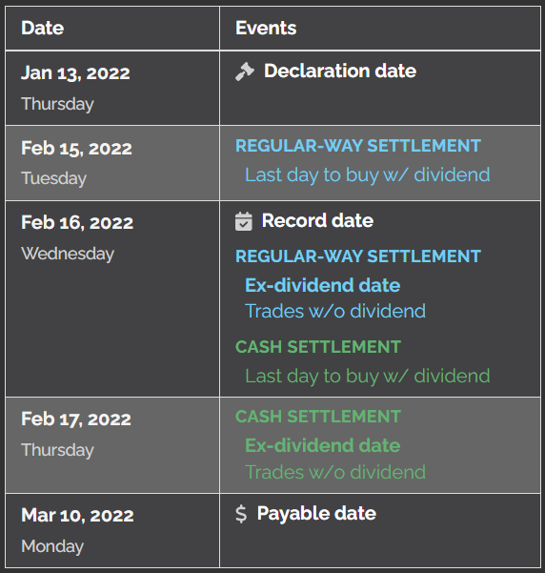

Selling Short
- Selling short
  - Involves selling borrowed securities
  - Only suitable for:
    - Sophisticated investors
    - High risk tolerance
  - Done in a margin account
- Short sellers
  - Bearish investors
  - Subject to unlimited risk
  - Must pay dividends on shares held short
- Only investors that have signed the loan consent form are eligible to have their securities lent out to other customers

American Depositary Receipts
- US-registered receipts for foreign investments
- Created by domestic financial firms with foreign branches
- Trade in US dollars in US markets
- Subject to currency exchange risk
- No voting or pre-emptive rights
- Foreign government tax withholding creates a US tax credit

Tender Offers & Buybacks
- Hostile takeover
  - An unwanted attempt from one party to take over an issuer’s business
  - Typically involves the outsider:
    - Purchasing significant stock positions
    - Instilling hand-picked individuals into BOD positions
    - New board structure bending to the will of the outsider
- Tender offers
  - Proposal to purchase security from current investors
  - Offered at a premium to market price
  - Participants must be long the security
  - Must be available for at least 20 business days
  - Must be available for an additional 10 business days if offer changes
- Stock buybacks
  - Issuer repurchases its shares from market
  - EPS increases with fewer shares outstanding
- Earnings per share (EPS)
  - Earnings/outstanding shares
  - Measures profitability on a per share basis
  - Manipulated by buybacks
  - Example:
    - Outstanding shares is 1,000,000 and 2022 annual earnings is $5m
    - EPS = annual earnings/outstanding shares
    - EPS = $5m/1m
    - EPS = $5.00

Suitability
- Benefits of common stock
  - Capital appreciation
  - Income from cash dividends
- Capital appreciation
  - Investment value rises above the cost
  - Also known as
    - Growth
    - Capital gains
- Unrealized capital gain
  - Current gain on an investment
  - Investment has not been sold
  - Gains at risk if the market declines
- Realized capital gain
  - Locked-in gain on an investment
  - Investment has been sold
  - Gains are not at risk
- Growth stock
  - Company with expanding business model
  - Typical for smaller companies
  - High capital appreciation potential
  - Little or no dividend potential
- Income
  - Dividend payments from common stock
  - Paid by larger, successful companies
- Diversification
  - Investing in multiple asset classes and investments
  - Cannot diversify out of systematic risk
- Systematic risk
  - Occurs when an event or circumstance negatively affects the entire market
- Market risk
  - An investment is negatively affected by a general downturn in the stock market
- Inflation risk
  - Also known as purchasing power risk
  - General prices rise more than expected
  - Common stock tends to outpace inflation over long-term periods
  - Measured through CPI (consumer price index)
- Non-systematic risk
  - Affects specific investment or sector
  - Can be reduced by diversification
- Concentration risk
  - Lack of diversification
  - Amplifies relevant non-systematic risks
- Financial risk
  - High debt levels negatively affect company performance
- Business risk
  - Products or services in low demand due to competition or mismanagement
- Regulatory risk
  - Potential or current government regulation negatively affects an investment
- Legislative risk
  - New domestic law or regulation negatively affects a security
- Political risk
  - Foreign government instability negatively affects a security
- Liquidity risk
  - Also known as marketability risk
  - Inability to sell a security without dropping price dramatically
- Market capitalization
  - MC = shares outstanding x market price
  - Large cap stocks are less risky than small cap stocks
  - Mega-cap = $200 billion or more
  - Large cap = between $10 billion - $200 billion
  - Mid-cap = between $2 billion - $10 billion
  - Small-cap = between $250 million - $2 billion
  - Micro-cap = less than $250 million

Fundamental Analysis
- Fundamental analysis
  - Inspection of a company’s products/services, management, and finances
- Balance sheet
  - Compares company assets and liabilities
  - Indicates a company’s net worth
- Net worth
  - Determines overall value of a company or person
  - NW = assets – liabilities
- Income (cash flow) statement
  - Displays company income and expenses
- Footnotes
  - Provides additional context for the information in financial statements
- PE ratio (price to earnings)
  - Used by investors to determine if a company is overvalued or undervalued
  - PE = market price/earnings per share
- High PE ratios
  - May indicate an overpriced investment
  - Typical of growth companies
- Low PR ratios
  - May indicate an underpriced investment
  - Typical of value companies (large, well-established, and with a long track record of profits)
- Current assets include cash and any item expected to be turned into cash easily within one year
- Current liabilities include any bills or payments due to be paid within one year
- Fixed assets
  - Long-term tangible assets that are expected to be utilized for at least one year
- Intangible assets
  - Long-term intangible assets that are expected to be utilized for at least one year

Preferred Stock

Basic Characteristics
- Preferred stock characteristics
  - Form of ownership (equity)
  - Market prices
    - Heavily influenced by interest rates
    - Do not fluctuate as actively as common stock prices
  - Considered a fixed income security
- Preferred stock dividends
  - Must be approved by the BOD
  - Typically paid on a quarterly basis
- Par value
  - Also known as face value
  - Typically $100 for preferred stock
    - Could also be $25 or $50
  - Never fluctuates
  - Dividend rate based on par
- Dividend rate
  - Based on par
  - Never changes
  - DR = dividend annual income/par
- Yield
  - Represents overall rate of return
  - Based on market price and dividend rate
  - Continually fluctuates
  - Yield and market price are inverses
    - Low market price = high yield
    - High market price = low yield
- Current yield formula
  - CY = dividend annual income/market price
  - Also known as dividend yield
- Market price
  - Discount = trading below par; yield > dividend rate
  - Premium = trading above par; yield < dividend rate
- Interest rate fluctuations vs. fixed income
  - Interest rates up, market prices down
  - Interest rates down, market prices up
- Rising interest rates
  - Fixed income market prices decline
- Falling interest rates
  - Fixed income market prices increase

Features
- Preferred stock features
  - Added characteristics or functions
  - Applied at issuance, stay through stock’s life
  - Features beneficial to stockholders result in:
    - Lower dividend rates
    - Higher market prices
    - Lower yields
  - Features beneficial to the issuers result in:
    - Higher dividend rates
    - Lower market prices
    - Higher yields
- Preferred stock dividends
  - Must be approved by BOD
  - Must be paid before common stock dividends
- Cumulative preferred stock
  - Issuers must eventually pay skipped dividends
  - Beneficial feature for investors
  - Associated with:
    - Lower dividend rates
    - Higher market prices
    - Lower yields
- Straight (non-cumulative) preferred stock
  - Issuer does not pay skipped payments
  - Beneficial feature for the issuer
  - Associated with:
    - Higher dividend rates
    - Lower market prices
    - Higher yields
- Participating preferred stock
  - Eligible to receive more than the stated dividend rate
  - Issuers pay more in profitable years
  - Beneficial feature for the investor
  - Associated with:
    - Lower dividend rates
    - Higher market prices
    - Lower yields
- Call features
  - Allow issuers to end an investment by paying back a specified amount
  - Typically exercised when interest rates fall (refinance)
  - Beneficial feature for the issuer
  - Associated with:
    - Higher dividend rates
    - Lower market prices
    - Higher yields
- Call protection
  - Number of years before security can be called
- Call premium
  - Amount above par required to call shares
- Convertible preferred stock
  - Convertible into common stock of the same issuer
  - Beneficial feature for investors
  - Associated with:
    - Lower dividend rates
    - Higher market prices
    - Lower yields
- Conversion ratio
  - Determines how many common shares received at conversion
  - Set at issuance and stays fixed

Suitability
- Benefits of preferred stock
  - Fixed dividend rate provides income
  - Potential for capital gains (especially if convertible)
- Preferred stock risks
  - Dividends are not guaranteed
  - No legal recourse for skipped dividends
  - Lower liquidation priority
  - Subject to:
    - Interest rate risk
    - Reinvestment risk
    - Call risk
    - Inflation risk
- Preferred stock typical investors
  - Seeks income as the primary benefit
  - Accepts moderate risk in return for higher income
  - Long-term horizons

Debt Securities

Basic Characteristics
- Bond features
  - Debt security
  - Allows issuers to borrow from investors
- Principal
  - Original loan amount; the face value
  - Also known as the par value
- Interest
  - Cost of borrowing money
- Par value
  - Known as a bond’s “face value” or principal
  - Typically $1k for bonds
  - Typical sale price for new issue bonds
  - Bond interest payments based on par
  - Stays fixed for the life of the bond
- Maturity date
  - Date the issuer pays:
    - One final interest payment
    - Principal (par value)
- Interest rate (coupon)
  - Represents annual interest paid to bondholders
  - Based on the bond’s par value
  - Largely dependent on market interest rates at the time of issuance
  - Also known as the stated rate
- Interest payments
  - Legal obligations of the issuer
  - Typically made semi-annually
- Bearer bonds
  - Owned by whoever physically possesses them
  - No longer issued in the US
- Book-entry bonds
  - Ownership tracked electronically by a transfer agent
  - All modern securities issued in this format
- Zero coupon bonds
  - Do not make regular interest payments
  - Issued at a discount and mature at par
  - Longer maturities = deeper discounts
- Short-term maturities
  - Safer than long-term bonds
  - Lower rates of return
- Money markets
  - Debt securities with one year or less to maturity
- Long-term maturities
  - Riskier than short-term bonds
  - Higher rates of return

Issuance & Underwriting
- Term issuance
  - All bonds issued and mature on the same day
  - Typical issuers:
    - Corporations
    - US government
  - Type of quote
    - Price quotes
    - Dollar quotes
    - Percentage of par quotes
    - Term quotes
- Serial issuance
  - All bonds are issued on the same day, but mature on different days
  - Typical issuers:
    - Municipalities
  - Type of quote:
    - Yield quote
    - Basis quotes
    - Serial quotes
- Series issuance
  - Bonds are issued on different days, but all mature on the same day
  - Typical issues:
    - Construction-related projects
- Basis points
  - Formal measurement of percent
  - 1 basis point = 0.01%
  - 100 basis points = 1%
- Firm commitment underwritings
  - Underwriter keeps unsold securities
  - Riskier for underwriter
  - Larger fees for underwriters
- Best efforts commitment underwritings
  - Issuer keeps unsold securities
  - Riskier for the issuer
  - Smaller fees for underwriter
- Balloon maturities
  - All bonds are issued on the same date, but different sets of bonds mature at various times in the future
  - Unique because of the number of bonds maturing at the very end
  - The largest portion matures at the final redemption

Trading
- Primary market
  - Where issuers initially sell their securities to the public
- Secondary market
  - Where investors trade securities after sold in the primary market
- Bond transactions
  - IPOs occur in the primary market
  - Trade in the secondary market
- Bond market prices
  - Influenced primarily by interest rates
  - Interest rates up, market prices down
  - Interest rates down, market prices up
- Discount bond
  - Trades below par
- Premium bond
  - Trades above par
- Price volatility
  - Measures how fast bond prices move
  - Bonds with the most price volatility:
    - Long maturities
    - Low coupons
- Rate volatility
  - Short-term rates
- US government bond trades
  - Settle one business day after the trade
  - Settle through the federal funds system
- Municipal and corporate bond trades
  - Settle one business day after the trade
  - Settle through the clearing house system
- Accrued interest
  - Paid by the buyer to the seller during a bond transaction
  - Interest accrues up to, but not including the settlement date
- 30/360 method
  - Assumes 30 days in each month “counted over”
  - Utilized for corporate U& municipal bonds
- Actual/365 method
  - Counts actual days in months
  - Utilized for US government bonds
- Trading flat
  - Bonds that trade without accrued interest
  - Examples of flat bonds:
    - Zero coupon bonds
    - Bond trades settling on the payment date

Features
- Secured bonds
  - Collateral backs the bond
  - Safer investments vs. unsecured bonds
- Unsecured bonds
  - Also known as full faith and credit bonds
  - No collateral backing
  - Backed by a promise
  - Riskier investments vs secured bonds
- Call feature
  - Allows issuers to end a bond before maturity
  - Requires the payment of accrued interest, par, plus any call premium
  - Typically utilized when interest rates fall
- Call risk
  - Occurs when a bond is called in an unfavorable environment
  - Typically results in reinvestments at lower rates
  - Type of reinvestment risk
- Call premium
  - Amount above par issuer must pay to call the bond
- Call protection
  - Number of years before a bond may be called
- Tender offer
  - Formal offer to buy a security from current investors
- Put feature
  - Allows bondholders to end a bond before maturity
  - If exercised, the issuer must pay accrued interest plus par to the bondholder
  - Generally utilized when interest rates rise

Yield
- Nominal yield
  - NY = annual income/par
  - Measures the interest paid annually to the investor
  - Never changes over the life of the bond
  - Also known as:
    - Coupon
    - Interest rate
    - Stated rate
- Current yield
  - CY = annual income/market price
  - Measures overall rate of return based on the current market price
  - Discount bonds CY > coupon
  - Premium bonds CY < coupon
- Yield to maturity
  - Measures overall rate of return if the bond is held to maturity
  - Also known as the bond’s basis
  - Discount bonds YTM > coupon
  - Premium bonds YTM < coupon
- Yield to call
  - Measures overall rate of return if the bond is held until call (only applies to callable bonds)
  - Discount bonds YTC > coupon
  - Premium bonds YTC < coupon
- Discount bond yield relationships
  - Current yield, YTM, and YTC are higher than the coupon
  - Order of all yields (lowest to highest)
    - Nominal yield (coupon)
    - Current yield
    - Yield to maturity
    - Yield to call
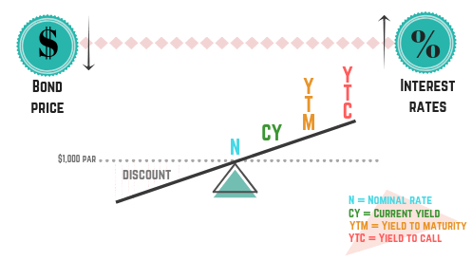
- Premium bond yield relationships
  - Current yield, YM, and YTC are lower than the coupon
  - Order of all yields (lowest to highest)
    - Yield to call
    - Yield to maturity
    - Current yield
    - Nominal yield (coupon)
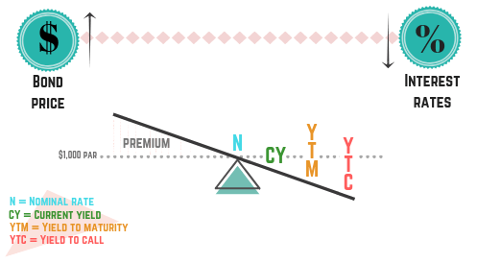
- Par bond yield relationships
  - All yields are the same
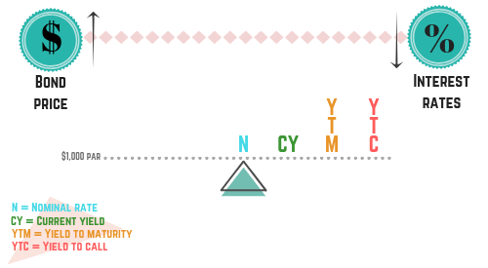

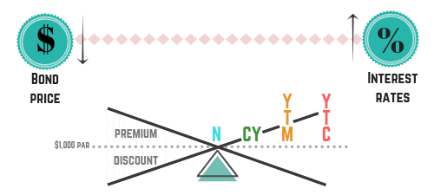

Suitability
- Bond benefits
  - Primary benefit is interest income
  - Interest payments are legal obligations of the issuer
  - Capital appreciation may occur, especially if interest rates fall
  - No approval from BOD is required to make an interest payment
- Interest rate risk
  - Interest rates rise, forcing bond market prices down
  - Type of systematic risk
  - Most susceptible bonds:
    - Long maturities
    - Low coupons
  - Avoided by variable rate bonds
- Inflation (purchasing power) risk
  - Prices of goods and services rise, forcing bond prices down
  - Typically results in higher interest rates due to Federal Reserve actions
    - Fed raises rates when inflation rises
  - Avoided by short-term securities
- Reinvestment risk
  - Market returns reinvested at lower rates
  - Occurs when interest rates fall
  - High coupon bonds are most susceptible
  - Avoided by zero coupon bonds
- Call risk
  - Bond called when interest rates fall
  - The worst form of reinvestment risk
- Default risk
  - Also known as credit or repayment risk
  - Issuer unable to make required interest and/or principal payments
  - Cannot be fixed through diversification
- Bond ratings
  - Only consider default risk
  - Three bond rating organizations:
    - Standard & Poors (S&P)
    - Moody’s
    - Fitch
  - Investment grade bonds
    - BBB or above
    - Low default risk
  - Speculative (junk) grade bonds
    - BB or below
    - High default risk
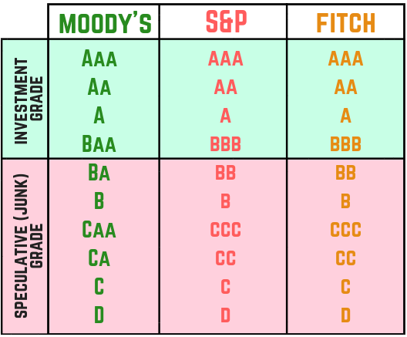
- Liquidity (marketability) risk
  - Security is difficult to sell or requires a large discount to sell
  - Inactive trading, lack of demand
  - Avoided by short maturities
- Legislative risk
  - New domestic law or regulation negatively affects a security
- Political risk
  - Foreign government instability negatively affects a security
- Bond typical investors
  - Seeking income
  - Generally older, risk-averse (conservative)

Corporate Debt

Short-Term Products
- Commercial paper
  - Short-term zero coupon corporate debt
  - Unsecured
  - Issued at a discount and matures at par
  - 270-day maximum maturity
  - Exempt from SEC regulation
  - Typically sold in large denominations ($100,000+)
    - Most suitable for institutional investors
    - Avoided by small retail investors
  - Issued to raise short-term capital

Long-Term Products
- Funded debt
  - Long-term corporate debt
- Debentures
  - Long-term unsecured (naked) corporate bonds
  - Also known as full faith and credit bonds
  - Riskier than secured bonds
  - Typically issued with higher coupons and trade at higher yields than similar secured corporate bonds
- Guaranteed bonds
  - Backed by a third party’s promise to pay interest and/or principal in case of default
  - Typical third parties:
    - Parent companies
    - Insurance companies
  - Considered unsecured bonds
- Income (adjustment) bonds
  - Issued after company defaults on debt
  - Only pay interest when the issuer meets the earnings test
  - High-risk securities
  - Almost always the wrong answer on a test
- Mortgage bonds
  - Secured by corporate real estate
  - Commonly used by utility companies
- Liquidation priority
  - First mortgage bondholders receive liquidation proceeds first
  - Second mortgage bondholders receive leftover liquidation proceeds
- Equipment trust certificates (ETCs)
  - Secured by corporate equipment
  - Issued in serial form
- Collateral trust certificates
  - Bonds secured by marketable corporate assets

Convertible Products
- Convertible bonds
  - Converts to common stock of the same issuer
  - Investors eligible to make capital gains on stock
  - Lower rates of return (vs. non-convertible bonds)
  - Must get voter approval
  - Return potential: interest from bond, capital gain from stock
- Conversion ratio
  - CR = par/ conversion price
- Conversion price
  - CP = par/ conversion ratio
- Stock parity price
  - Describes the equivalent stock cost if a bond is bought and converted
  - SPP = bond market price/ conversion ratio
- Bond parity price
  - BPP= stock price x conversion ratio
- Mezzanine debt
  - Long-term corporate debt
  - Placed between senior debt and equity for liquidation purposes
  - Usually done by smaller corporations and start-ups
  - In addition to typical debt security features, may include:
    - PIK interest
    - Warrants
    - Conversion features
- Payment in kind (PIK) interest
  - Payable interest is added to security’s principal value
  - Only payable at redemption or maturity

Liquidation Policy
- Liquidation priority
  - Unpaid wages
  - Unpaid taxes
  - Secured creditors collateralized bonds
  - Unsecured creditors unsecured bonds (full faith and credit bonds)
  - Junior unsecured creditors (subordinate debenture holders)
  - Preferred stockholders
  - Common stockholders
- Creditors
  - Person or organization lending money
  - Bondholders are creditors

The Market & Quotes
- OTC Trade
  - One that takes place outside of an exchange
- Corporate bond market
  - Most trades occur in the OTC markets
  - A small number of trades occur on exchanges
- Corporate bond quotes
  - Provided in the percentage of par format
  - Must be in eighths or reduced from eighth
  - M = $1,000 par unit when used in quotes
    - 5M = $5,000 par bond
  - s = coupon (interest rate)
    - 10s = 10% coupon
  - Zr = zero coupon bond
  - M’ = references maturity year
    - M’40 matures in the year 2040

Bank Issues
- Certificates of deposit (CDs)
  - Pay a fixed amount of interest based on principal
  - The “bank version” of a bond
- Jumbo CDs
  - Large bank deposits made for short periods
  - $100k minimum denominations
  - $1 million denominations are common
  - Trade in the secondary market
  - Sometimes called negotiable CDs
- FDIC insurance
  - Covers up to $250k of bank deposits
  - Coverage provided per bank, per customer, and per ownership category (e.g., individual vs. joint accounts)
  - Savings account at a bank is guaranteed by FDIC
- Banker’s acceptances
  - Used to facilitate international trade
  - Considered money markets
  - 270 days or less to maturity

Eurodollars & Eurobonds
- Eurodollar deposits
  - US dollars held in foreign banks
- Reserve currency
  - A currency commonly utilized by the world’s central banks and largest financial institutions
  - US Dollar is considered the world’s reserve currency
- Central bank
  - An organization operating as a country’s centralized financial institution
- Eurobond
  - Debt security paying interest and principal in a denomination other than the currency of the country it was issued in
  - Not subject to SEC jurisdiction or registration
- Currency (exchange rate) risk
  - Risk of loss due to a currency conversion
  - Occurs when:
    - Converting into a strong currency
    - Converting out of a weak currency
- Spot rate
  - Exchange rate for currency exchanged today
- Forward rate
  - Exchange rate for currency exchange in the future
  - Utilized to hedge against currency risk
- Eurodollar bonds
  - Debt security issued outside of the US that pays interest and principal in US dollars
  - Issued by:
    - US corporations
    - US municipalities
    - Foreign corporations
    - Foreign governments
  - No currency risk for US organizations
  - Currency risk applies to foreign issuers and investors
  - Not subject to SEC jurisdiction or registration

Municipal Debt

Foundations & Taxation
- Municipality
  - State, city, or local government
- Corporate bond interest
  - Subject to federal, state, and local taxes
- Municipal bond interest
  - Exempt from federal taxes
  - Subject to state and local taxes
- US territory bond interest
  - Tax-free regardless of residence
- US Government bond interest
  - Subject to federal taxes
  - Exempt from state and local taxes
- General obligation bonds are issued to finance non-self supporting projects
- Revenue bonds are issued to finance self-supporting projects
- Short-term notes are issued to finance activities that can be paid off in a short period
- US Territory bonds are considered municipal bonds and are an exception to the residence tax rule

General Obligations (G.O.) Bonds
- Non-self-supporting projects
  - Do not make revenue
- General obligation bonds
  - Fund non-self-supporting projects
  - Paid off with property (ad valorem) taxes
  - Backed by the full faith, credit, and taxing power of the municipality
  - Typically issued in serial form
- Used to analyze GO bonds
  - Economic diversity
  - Population trends
  - Municipal obligations
  - Tax collection figures
- Municipal bond registration status
  - Exempt from SEC regulation
- Municipal advisers
  - Help structure bond issues
  - Cannot act as the underwriter
- Bond counsel
  - Group of specialized lawyers
  - Provides legal opinion on a bond’s:
    - Validity
    - Legality
    - Tax-status
  - Unqualified opinions are optimal
    - Means the bond is valid, legal, and tax-free without qualifiers
  - Qualified opinions make bonds less marketable
- GO bond requirements
  - Subject to voter approval
  - Subject to debt limits
  - Sold on a firm commitment basis
    - GO bond commitments are always firm, meaning the underwriter pays the municipality for the entire bond issuance up-front
- Official notice of sale
  - Notifies underwriters of a municipal bond sale
  - Found in the Bond Buyer
- Competitive bids
  - How GO bonds are sold
  - Awards bonds to cheapest underwriter
- Official statements
  - Disclosure document for municipal securities
  - Issuers are not required to create them
  - Underwriters must deliver them by settlement (if created)
  - Information disclosed includes:
    - The bond’s interest rate
    - Timing of interest payments
    - Length of the bond (maturity)
    - Specific features of the bond (e.g., call features)
    - Source of repayment funds (e.g., property taxes)
    - The municipality’s finances
    - Legal matters, including the legal opinion
- Limited tax bonds
  - Considered a type of GO bond
  - Only have access to predetermined tax allotments
  - Riskier than typical GO bonds

Revenue Bonds
- Self-supporting ventures
  - Make revenue to pay off borrowed funds
- Revenue bonds
  - Paid off with revenues from municipal ventures
    - Some revenue bonds are paid off with special excise taxes, which are taxes on specific “vice” goods
  - Finance self-supporting municipal ventures
  - No voter approval is required
  - Not subject to debt limits
- Feasibility studies
  - Forecast profitability of a municipal venture
  - Created by independent consultants

Short-Term Notes
- Anticipation notes
  - Short-term municipal debt
  - If a municipality wants to utilize funds before they’ve been collected
  - Paid off with future municipal cash flows
- Tax anticipation notes (TANs)
  - Paid off with future tax collections
  - Typically property tax-related
- Revenue anticipation notes (RANs)
  - Paid off with future revenues from municipal ventures
- Tax and revenue anticipation notes (TRANs)
  - Combination of TANs and RANs
  - If a municipality wants to spend money on multiple projects but only wants to issue one form of debt
- Bond anticipation notes (BANs)
  - Paid off with money raised by a future bond issue
- Grant anticipation notes (GANs)
  - Paid off with future federal grants
- Variable rate demand notes (VRDNs)
  - Long-term municipal debt with short-term redemption options
  - Resetting interest rates on a periodic schedule
  - Contain a put option at par

Trading
- Municipal bond market
  - Higher levels of liquidity risk
  - Generally speaking is illiquid
  - No short sales
  - OTC
- Yield (basis) quotes
  - Typical for municipal bonds
  - Provide yield, not price
- Municipal dollar bonds are quoted like corporate bonds as a percentage of par in 1/8ths

Suitability
- Municipal bond suitability
  - Best for wealthy investors at high tax brackets
  - Not suitable for retirement plans
- Municipal bonds maintain low interest rates and yields
- TFEY = CY x (100%-TB)
  - TFEY = tax-free equivalent year
  - CY = corporate yield
  - TB = tax bracket

US Government Debt

Foundations
- US Government Debt
  - Considered virtually default risk-free (AAA) rated
  - Directly backed by US Government
  - Largest securities market in the world
  - Virtually no liquidity risk
  - Lack of default risk

Treasury Products
- US Department of Treasury
  - Runs finances of the US Government
- US government debt denominations
  - Minimum of $100
- Treasury bills
  - Short-term zero coupon debt
  - Are money market debt securities
  - Generally issued weekly
    - Weekly auction
  - Issued at discounts and mature at par
  - Available maturities:
    - One month (4 weeks)
    - One and a half months (6 weeks)
    - Two months (8 weeks)
    - Three months (13 weeks)
    - Four months (17 weeks)
    - Six months (26 weeks)
    - One year (52 weeks)
- Treasury notes
  - 2-10 year maturities
  - Pay interest semi-annually
  - Generally issued monthly
  - Can be issued at discount or premium depending on how the US Treasury structures the offering
- Treasury bonds
  - Up to 30-year maturities
  - Pay interest semi-annually
  - Generally issued monthly
- Separate Trading of Registered Interest and Principal of Securities (STRIPS)
  - Issued by US government
  - Long-term, zero coupon bonds
  - Not suitable for investors seeking income
- Treasury receipts
  - Issued by financial institutions
  - Long-term, zero coupon bonds
  - Do not have the same default risk-free status as US gov bonds
- STRIPS and treasury receipts
  - Not suitable for investors seeking income
  - Subject to phantom taxes
    - Are subject to annual taxation even though their investors won’t receive interest until maturity
  - High price volatility
  - Very susceptible to interest rate risk
- Treasury inflation protected securities (TIPS)
  - Inflation-adjusting debt securities
  - Payments rise when inflation rises
  - Principal (par) value adjusts to CPI
  - Coupon stays fixed
  - Issued in 5, 10, and 30-year maturities
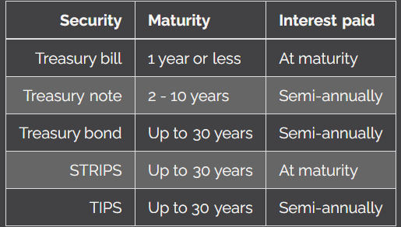
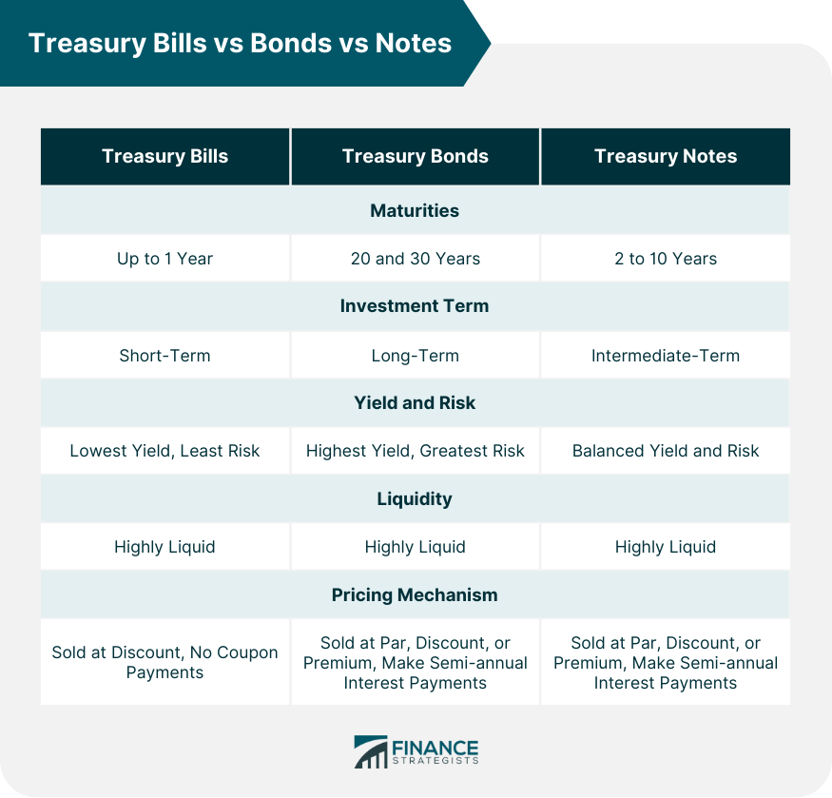

Federal Agency Products
- Agency bonds
  - Indirectly backed by US government
  - Subject to some default risk
- Federal farm credit system
  - Provides financing to American farmers
- Mortgage agencies
  - Issue mortgage-backed securities
    - Common type is pass-through certificate
      - Typically maintain a denomination of $25,000
  - Buy mortgages from financial institutions
- Ginne Mae (GNMA)
  - Guarantees VA and FHA insured mortgages
  - Directly backed by US government
- Fannie Mae (FNMA)
  - Purchases insured (VA, FHA) and conventional mortgages
  - Indirectly backed by US Gov
  - Publicly owned and traded
- Freddie Mac
  - Purchases conventional mortgages
  - Indirectly backed by US gov
  - Publicly owned and traded
- Mortgage-backed securities
  - Make monthly payments of interest and principal
  - Subject to prepayment, extension, and reinvestment risk
  - Interest is fully taxable by federal, state, and local
- Prepayment risk
  - Occurs when interest rates fall
  - Homeowners pay off mortgages earlier than expected
- Extension risk
  - Occurs when interest rates rise
  - Homeowners pay off mortgages later than expected
- MBS taxation
  - Subject to full taxation (fed, state, local)
- Sallie Mae (SLMA)
  - Former federal agency in the student loan business
  - Publicly owned and traded

The Market
- Treasury auction
  - Where treasury securities are initially offered
  - Investors bid on new issue treasuries
- Competitive bids
  - Typically submitted by institutional investors
  - Only the bidders with the best bids win
  - Highest winning bid yield sets the yield for the entire offering
- Non-competitive bids
  - Typically submitted by retail investors
  - All non-competitive bids are filled
- US government debt quotes
  - Percentage of par quotes (generally)
  - Quoted in 32nds using a:
    - Dash
    - Colon
    - Period
  - There is no reduction of the fraction
- Bid-ask quotes
  - Provides both sides of dealer prices
  - Bid = dealer buys, customer sells
  - Ask = dealer sells, customer buys
  - Difference between the bid and ask is the spread
- Treasury bill quotes
  - Discount yield form

The Federal Reserve

Monetary Policy
- Monetary policy
  - Controls money supply levels
  - Executed by Federal Reserve Board
  - Two goals:
    - Economic growth (low unemployment)
    - Manageable inflation levels
- Loosening policies
  - Encourage economic growth
  - More currency placed in the economy
  - Goal: drive interest rates down
  - Typically pursued in recessions
- Tightening policies
  - Manages inflation levels
  - Less currency in the economy
  - Goal: drive interest rates up
  - Typically pursued during high inflation
  - Response to high CPI
- Monetarist theory
  - Fed’s actions are the most significant economic influence

Rates
- Federal funds rates
  - Rate for bank-to-bank loans
  - Average rate banks charge when lending to other banks
  - All banks are subject to reserve requirements
    - Require a certain amount of deposits to be kept in their vaults
    - Created to reduce possibility of “runs on the bank”
  - Overnight time period
  - Typically lower than the discount rate
- Discount rate
  - Rate for fed loans to banks
- Broker loan rate
  - Also known as the call money market rate
  - Rate for bank-to-broker-dealer loans
- Prime rate
  - Rate for large bank customer loans
  - Typically only available to institutions

Tools of the Federal Reserve
- Tools of the federal reserve
  - D -discount rate
  - O -open market operations
  - R -reserve requirements
  - M -margin requirements (Reg T)
- Discount rate
  - Rate for fed loans to banks
  - Results of lowering:
    - Loosens money supply
    - Decreases interest rates
  - Result of raising
    - Tightens money supply
    - Increases interest rates
- Open market operations
  - Fed buys and sells securities with banks
  - Conducted by the FOMC
    - Federal Open Market Committee
    - Oversees open market operations, part of the Fed
    - Buys and sells treasury securities and banker’s acceptances
  - Typical securities traded:
    - Government securities
    - Prime banker’s acceptances
  - Most actively used tool
- Repurchase agreements
  - Fed buys securities from banks
  - Result:
    - Loosened money supply
    - Decreasing interest rates
- Reverse repurchase agreements
  - Fed sells securities to banks
  - Result:
    - Tightened money supply
    - Increasing interest rates
- Reserve requirements
  - Banks must hold a portion of deposits in reserves
  - Result of lowering:
    - Loosens money supply
    - Decreases interest rates
  - Result of raising:
    - Tightens money supply
    - Increases interest rates
- Margin requirements
  - 50% deposit for margin transactions
  - Leveraging
    - Borrowing money to invest in market
    - Amplifies gains and losses
  - Result of lowering:
    - Loosens money supply
    - Decreases interest rates
  - Result of raising:
    - Tightens money supply
    - Increases interest rates
  - Regulation T
    - Created to prevent investors from borrowing too much money
    - Requires investors to deposit 50% of initial margin transactions
    - Fed loosening money supply: lower Reg T below 50%
    - Fed tightening money supply: raise Reg T
- Loosening (growing) money supply
  - Lower the discount rate
  - Pursue repurchase agreements
  - Lower reserve requirements
  - Lower margin requirements
- Tightening (shrinking) the money supply
  - Raise the discount rate
  - Pursue reverse repurchase agreements
  - Raise reserve requirements
  - Raise margin requirements

Economic Factors
- Gross domestic product (GDP)
  - Measure of goods and services produced and sold domestically
  - Reported in constant (inflation-adjusted) dollars
  - Tracks economic growth
- Gross national product (GNP)
  - Similar to GDP
  - Also measures goods and services produced by residents of a country, including those made outside of the country
- Recession
  - Two quarters (six months) of GDP decline
- Depression
  - Six quarters (a year and a half) of GDP decline
- Elastic good or service
  - Demand falls drastically as price rises
  - Is not a necessity or has competition
  - Think uber and lyft
- Inelastic good or service
  - Demand is generally not affected as price rises
  - Is a necessity with little or no competition
  - Think epipens
- Inflation
  - Measured by CPI
  - Fed tightens the money supply (increase interest rates) if levels rise
- Economic cycles
  - When GDP rises it reflects an expansionary or expanding economy
  - Economic peak involves:
    - Low interest rates
    - High GDP/GNP levels
    - Low unemployment levels
  - Economic trough – when economy reaches lowest point; involves:
    - High interest rates
    - Low GDP/GNP levels
    - High unemployment levels
  - Contraction aka recession
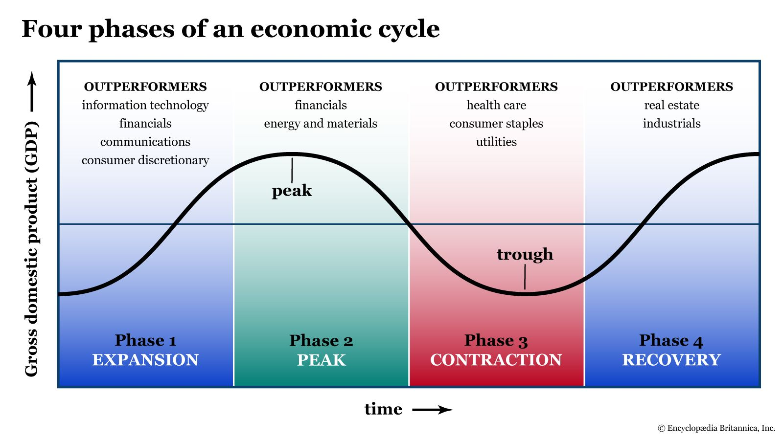
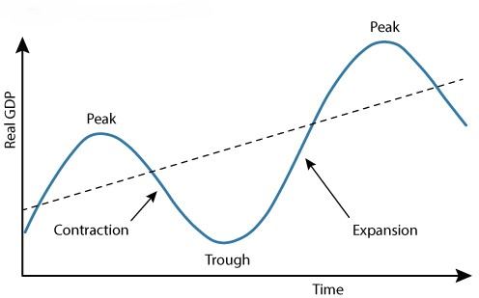
- Yield curve
  - Visual representation of bond yields
  - Typically covers similar quality bonds of varying maturities
- Normal (ascending) yield curve
  - Short-term securities have lower yields than long-term securities
  - Typical for normal economic conditions (expansion)
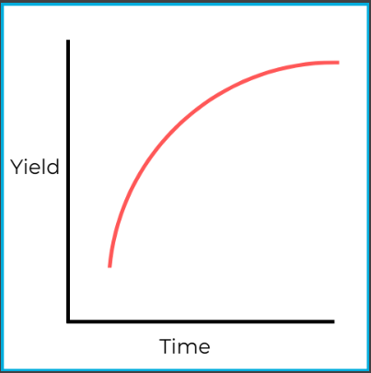
- Flat yield curve
  - Short-term securities have the same yields as long-term securities
  - Sign of uncertainty in the economy
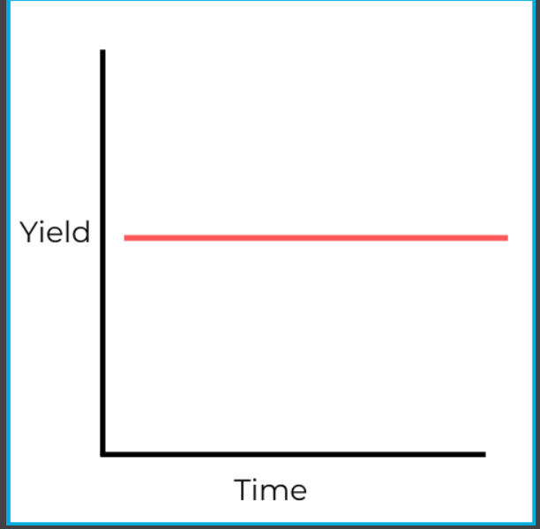
- Inverted (descending) yield curve
  - Short-term securities have higher yields than long-term securities
  - Sign of economic recession
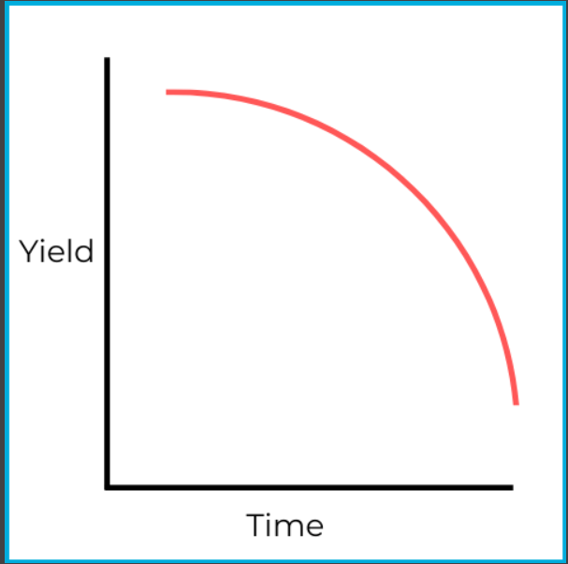
- Comparative yield curves
  - Compares yield curves of US government vs. corporate securities
  - Sometimes called credit yield spreads
  - Widening is a sign of recession
  - Narrowing is a sign of prosperity
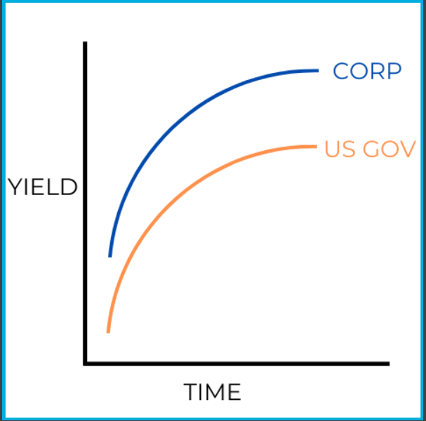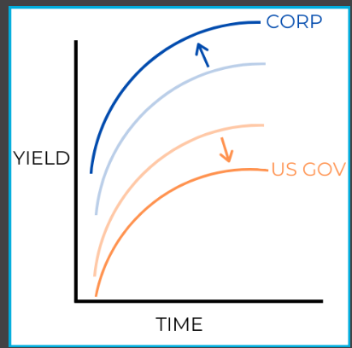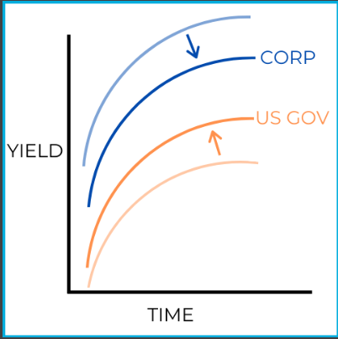
- Leading economic indicators
  - Indicate future economic strength
  - Included:
    - S&P 500
    - Average weekly initial claims for unemployment
    - Index of new manufacturing orders
    - Number of new building permits
    - Consumer confidence index
    - Interest rate spread between 10-year treasury notes and fed funds rate
- Coincident economic indicators
  - Indicate current economic strength
  - Included:
    - Number of employees on non-farm payrolls
    - Average hours worked
    - Personal income levels
    - Industrial production levels
    - Manufacturing sales
    - Unemployment rate
- Lagging economic indicators
  - Indicate past economic strength
  - Included:
    - Changes in CPI levels
    - Corporate profits
    - Change in labor cost per unit of output
    - Average duration of unemployment
- Perfect competition
  - Large number of buyers and sellers
  - Virtually identical goods/services
  - Price is the primary demand factor
  - Price manipulation is impossible
- Monopolistic competition
  - Large numbers of buyers and sellers
  - Similar products, but unique characteristics
  - Consumers maintain preferences for certain goods
  - Price manipulation is very difficult
- Oligopoly
  - Large numbers of buyers, but only 3-5 sellers
  - Consumers have limited choices
  - Significant barrier to entry as a vendor
  - Price manipulation is fairly easy
- Monopoly
  - Large numbers of buyers, only 1 seller
  - Consumers only have one choice
  - Price manipulation is very easy
  - Typically involve heavy government regulation

Fiscal Policy
- Fiscal policy
  - Relates to taxation and government spending
  - Controlled by congress and the president
- Internal revenue service
  - Government agency responsible for:
    - Collecting taxes
    - Providing assistance to taxpayers
    - Investigating instances of tax fraud
- Progressive tax systems
  - Higher taxes if more money involved
  - Examples:
    - Income taxes
    - Estate taxes
    - Gift taxes
- Regressive tax systems
  - Flat tax rates
  - Examples:
    - Sales taxes
    - Excise taxes
- Keynesian (demand-side) theory
  - Government spending and taxation influence the economy
  - In a recession:
    - Government spending increases
    - Tax rates fall
  - In an inflationary environment:
    - Government spending decreases
    - Tax rates rise
- Supply-side theory
  - Reduced government spending and taxation stimulate the economy

Investment Companies

Foundations
- Investment companies
  - Financial institutions that invest their customers’ money
  - Regulated by the Investment Company Act of 1940
    - Formally defined investment companies and regulated their activities
- Investment company classifications
  - Management companies
  - Unit investment trusts (UITs)
  - Face amount certificates
- Types of management companies
  - Open-end management companies (mutual funds)
  - Closed-end management companies (closed-end funds)
- Unit investment trusts (UITs)
  - Fixed portfolios of securities
  - Not managed continuously
  - At maturity, portfolio is liquidated and proceeds passed to investors
- Face amount certificates (FACs)
  - Periodic payment or lump sum contribution
  - Redeemable securities
  - Fixed payout at maturity
  - Fully paid FACs
    - Investor purchases a FAC today and is promised to receive a larger sum after a set number of years
    - Works similarly to zero coupon bonds

Types of Funds
- Growth funds
  - Seek capital appreciation
  - Primarily invest in common stock
  - Aggressive growth funds
    - Invests in common stock that provides a higher return potential, including small and micro-cap stocks from volatile or emerging industries
- Growth and income funds
  - Seek capital appreciation and income
  - Primarily invests in equity (stock) securities
- Balanced funds
  - Seek capital appreciation and income
  - Invest in stocks and bonds
  - Seeks a relatively even distribution between growth-focused common stock and income-producing securities
- Income funds
  - Seek income
  - Invest in stocks and bonds
    - Primarily bonds, preferred stocks, and dividend-paying common stocks
  - More conservative and less risky than growth-focused funds
  - Types include:
    - Corporate bond funds
    - Municipal bond funds
    - US gov bond funds
    - High yield bond funds -invest in riskier “junk” bonds with sizeable yields
    - Conservative bond funds -invest in investment-grade bonds with lower levels of risk and yield
    - International bond funds -invest in bonds from foreign companies and governments
- High yield bond funds
  - Seek income
  - Primarily invest in speculative (junk) bonds
- Conservative bond funds
  - Seek income
  - Primarily invest in investment grade bonds
- MBS agency funds
  - Seek income from mortgage-backed securities
  - Invest in MBS securities from:
    - Ginnie Mae (GNMA)
    - Fannie Mae (FNMA)
    - Freddie Mac (FHLMC)
- Money market funds
  - Seek income
  - Invest in debt securities with one year or less to maturity
  - Priced at a consistent $1.00 per share
  - Suitable for short-term time horizons
  - Usually make monthly dividend payments
  - Very liquid, provide a small amount of income
- Specialized funds
  - Invest in securities from specific industries or regions
  - Not specific to growth or income investments
- Sector funds
  - Invest in securities from specific industries
- Index funds
  - Seek the return of a specific index
  - Types:
    - Small-cap
    - Large-cap
    - Bond indexes
    - Specialized indexes
- Active management – involves picking and choosing the best investments within a market
- Passive management – involves tracking an index as closely as possible
- Asset allocation funds
  - Various asset mixes that may be static or fluid
- Life cycle funds
  - Type of asset allocation fund
  - Asset mix becomes more conservative over time
  - Also known as target date funds
- International funds
  - Invest in securities issued outside the US
  - Added layer of diversification
- Global funds
  - Invest in securities worldwide (including US)
  - Added layer of diversification

Open-end Management Companies

Characteristics
- Mutual funds
  - Legally classified as open-end management companies
  - Investors are known as shareholders
  - Manage and invest shareholder assets according to fund’s objective
  - “open-ended” (variable) amount of shares outstanding
  - Purchases are considered primary market transactions
  - Prospectus delivery required at sale
  - $100k minimum capital to launch
  - Provides diversification to investors
  - Purchasing new shares increases outstanding shares while redemptions (share sales) decrease outstanding shares
- Fund sponsor (underwriter)
  - Creates/establishes the fund’s structure
  - Registers the fund with the SEC
  - Develops marketing strategy
- Investment adviser
  - Hired by fund sponsor
  - Responsible for fund investments
  - Employs and appoints fund manager
- Fund manager
  - Investment adviser employee(s)
  - Implements investment strategy
- Diversification
  - Investing in many different securities
  - Reduces non-systematic risks
  - Instant diversification is provided by mutual funds
- Diversified funds
  - 75% invested with no more than:
    - 10% of an issuer’s voting power
    - 5% of its assets in one issuer
- Expense ratio
  - Represents total fund expenses
  - Includes:
    - Management fees -paid to the investment adviser for their services
    - Custodian fees -paid to the institution maintaining custody of the fund’s assets
    - Legal fees
    - Administrative fees
  - Efficient funds have low expense ratios
- Management fee
  - Cost of investment adviser’s services
  - Typically is the largest part of the expense ratio
- Custodian fee
  - Paid to financial firm holding fund assets
- Mutual fund transaction limitations
  - Cannot be purchased on margin
  - Cannot be sold short

Shareholder Rights
- Shareholder rights
  - Right to vote for board of directors
  - Right to approve investment adviser contract
  - Right to vote on fund-specific matters, including:
    - Fund’s objective
    - Changes to fund structure
    - Changes to fee schedule
    - Changes to diversified status
  - Right to receive pro-rata share of dividends
  - Right to fund disclosures
    - Prospectus (aka statutory prospectus)
    - Statement of additional information
    - Annual SEC filing
    - Semi-annual shareholder report
- Board of directors (mutual fund)
  - Represents shareholder interests
  - Oversees overall operation of the fund
  - 40% must be independent (non-interested) per Investment Company Act of 1940
    - No more than 60% “interested”
    - To ensure BOD is as unbiased as possible
  - Approve dividend and capital gain distributions
  - In charge of overseeing the fund’s investment adviser
    - Investment adviser contract can last no longer than 2 years
- Statutory prospectus
  - Primary fund disclosure document
  - Must be delivered when:
    - Financial professionals solicit investors
    - An investor purchases shares unsolicited
  - Information disclosed includes:
    - The investment objective
    - Shareholder fees
    - Past performance (at least 1, 5, and 10-year returns)
    - Details on investment adviser and fund manager
    - Related risks
    - Fund policies
      - Minimum required investment
      - Availability of shares
      - Excessive trading policies
    - Financial highlights
      - Fund’s historical income and expenses
- Summary prospectus
  - Condensed version of the prospectus
  - May be delivered instead of statutory prospectus
- Statement of additional information (SAI)
  - Provides micro-details on fund operations
    - Fund policies
    - Investment-making decisions
    - Fund’s financials
    - Board member backgrounds
- Annual SEC report
  - Required disclosure report to regulators, which includes:
    - Market recaps over the previous year
    - Fund manager comments
    - Investment summary (details on fund portfolio)
    - Financial statements (balance sheet, income statement)
    - Financial highlights (income, expenses, returns)
- Semi-annual shareholder report
  - Required disclosure report to shareholders, which includes:
    - Investment summary (details on fund portfolio)
    - Financial statements (balance sheet, income statement)
    - Financial highlights (income, expenses, returns)

Transactions
- Mutual fund transactions
  - Mutual funds are redeemable (whereas stocks and bonds are negotiable)
  - Transactions only occur with the issuer
  - Completed through forward pricing
    - Mutual funds only allow transactions to occur once daily at the market close
  - Mutual fund shares can be purchased in fractional form in thousandths (up to 3 decimal places)
- Net asset value (NAV)
  - NAV = net assets / shares outstanding
  - Fund value on a per share basis
  - Calculated once per trading day
  - Purchase price for no-load funds
  - Most significant factor influencing the NAV is the current market value of the portfolio’s securities
- Public offerings price (POP)
  - If sales charge given in percent
    - POP = NAV / (100% -SC%)
  - If the sales charge is given in dollars
    - POP = NAV + SC
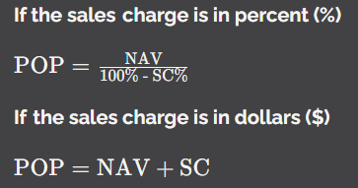
- Loaded fund transactions
  - Bought at POP, sell at NAV
  - POP is also known as the ask price
  - NAV is also known as the bid price
  - Max load = 8.5% of POP per FINRA rules
  - SC% = (POP-NAV) / POP
  - Front-end load – is assessed when customers purchase shares
    - Class A shares
  - Back-end load – charged when customers liquidate their shares
  - Conversion (exchange) privilege – no new sales charge is assessed if an investor sells their shares and uses the proceeds to purchase a new fund within the same fund family
- Mutual fund distributions
  - Capital gains distributions may only occur once per year
  - The BOD sets the ex-dividend date
- Mutual fund redemptions
  - Must be fulfilled within seven days

Returns
- Mutual fund return potential
  - Capital gains (growth)
  - Dividend distributions
  - Capital gains distributions
- Total return
  - Measures overall rate of return on a security or portfolio
- Total return formula
  - Total return = all gains and or losses / original cost

Share Classes
- Class A shares
  - Front-end loaded funds
  - Sales charge assessed at purchase
  - Subject to breakpoint schedules
    - Funds must offer breakpoint schedules if they assess the maximum sales charge of 8.5%
  - Low or no 12b-1 fees
  - Suitable for:
    - Longer-term investors
    - Larger investments of money
- Letter of intent (LOI)
  - Pledge to deposit breakpoint shortfall
  - Lower sales charge assessed
  - Lasts 13 months
  - Can be backdated up to 90 days
  - Retroactive charge if not fulfilled
  - Financial firms will typically require a small portion of the investor’s shares to be held in escrow for LOI
  - Rights of accumulation
- Breakpoint sales
  - Failure to notify investors of breakpoint
  - FINRA violation subject to penalties
- Combination privilege
  - Allows merger of multiple purchases for lower sales charge
- Class B shares
  - Back-end loaded funds (contingent deferred sales charge - CDSCs)
  - Sales charges assessed at redemption
  - Moderate 12b-1 fees
  - Suitable for:
    - Longer-term investors
    - Smaller investments of money
- Class C shares
  - No sales charge or a 1-year CDSC
  - High 12b-1 fees
  - Level load
  - Suitable for:
    - Short-term investors
- 12b-1 fees
  - Marketing and promotion fees used to reduce expense ratio by bringing more investors into the fund
  - Distribution fees pay for marketing and promotional services, including advertisements and payments to brokers that place customers into these funds
  - Service fees pay representatives to answer questions and discuss attributes of these funds as all advertisements include contact information
  - Maximum fee of 1%
    - Distribution fee max = 0.75%
    - Service fee max = 0.25%
  - Funds limited to 7.25% loads if charging maximum 12b-1 fee
  - Cannot market fund as “no load” if charging higher than 0.25%
  - Typically assessed quarterly

Subchapter M
- Subchapter M
  - Tax regulation for certain securities
  - Taxable income passed to investors
  - Also known as the “conduit” rule
  - Funds in subchapter M are called regulated funds
  - Must pass 90% of net investment income to qualify

Closed-End Management Companies
- Closed-end management companies
  - During primary offering:
    - Sold in the primary market
    - Prospectus delivery required
  - After primary offering:
    - Traded in the secondary market (negotiable)
    - No prospectus delivery is required
    - Can be bought on margin
- Closed-end fund transactions
  - Purchased at market price
  - Subject to commissions
  - NAV represents the fund’s book value
  - Market price could be:
    - Higher than NAV
    - Same as NAV
    - Lower than NAV

Exchange Traded Products

Passive ETFs
- Exchange-traded funds (ETFs)
  - Structured as open-end management companies
  - Negotiable securities
  - Maintain daily calculated NAVs
  - Can be bought on margin, sold short, and commissions are involved
- Passive management
  - Track the performance of indexes
  - Pursues the return of the overall market
- Passive ETFs
  - Aim to match the returns of a benchmark index
  - Low expense ratios
  - Avoids investing in only a limited number of stocks, bonds, or other securities within a market
- Active management
  - Picking the best individual securities in the market
  - Attempts to outperform indexes
- Specific ETFs
  - “Spyders” = S&P 500 ETF
  - “DIAmonds” = Dow Jones Industrial Average ETF
  - “Qubes” = Nasdaq 100 ETF
- ETFs vs. mutual funds
  - Trade status:
    - ETFs are negotiable
    - Mutual funds are redeemable
  - ETFs have lower expense ratios
  - ETFs are more tax efficient

Other ETFs
- Active management
  - Picking the best individual securities in the market
  - Attempts to outperform indexes
- Active ETFs
  - Aim to outperform the returns of a benchmark index
  - Higher expense ratios than passive ETFs
- Inverse ETFs
  - Provide an opposite return of the index
  - Only suitable for sophisticated investors
- Leveraged ETFs
  - Provide amplified gains and losses
  - Amplify at 200% and 300% rates
  - Only suitable for sophisticated investors
- Leveraged inverse ETFs
  - Provide an opposite return of index with amplified gains and losses
  - Amplify at 100% and 300% rates
  - Only suitable for sophisticated investors

Exchange Traded Notes
- Exchange traded notes (ETNs)
  - Debt instruments
  - Promise to pay the return of an index
  - Maintain maturity date
  - Subject to default risk
  - Negotiable securities
    - Secondary market
  - Can be bought on margin
  - Can be sold short
  - Tax efficient

Unit Investment Trusts
- Unit investment trusts
  - Fixed portfolios of securities
  - No ongoing portfolio management
  - No management fees
    - They do impose sales charges, operating expenses, and creation & development fees
  - Maintain maturity date
  - Redeemable with the issuer
  - Some UITs may trade in the secondary market
  - Required to be registered with the SEC
  - Required in prospectus:
    - Investment objective
    - Investor fees
    - Related risks
    - Guidelines for trust sponsor (issuer) to follow
- UIT & mutual fund similarities
  - Registered investment companies
  - Prospectus provides key disclosures
  - Redeemable with the issuer
- UIT & mutual fund differences
  - UITs may trade in the secondary market
    - Mutual funds are only redeemable (no secondary market)
  - UITs maintain fixed portfolios
    - Mutual fund portfolios are managed
  - UITs have no management fee
    - Virtually all mutual funds have management fees

Alpha and Beta (lightly tested on SIE)
- Alpha
  - Measures over or underperformance of a portfolio or security
  - Alpha = actual return – expected return
  - Positive alpha = overperformance
  - Zero alpha = meeting expectations
  - Negative alpha = underperformance
- Beta
  - Volatility measure as compared to the market (benchmark index)

Alternative Pooled Investments

Real Estate Investment Trusts (REITs)
- Real estate investment trusts (REITs)
  - Typically invest in commercial real estate properties and mortgages
    - REIT investments in single-family home and associated mortgages have increased, these are residential REITs
  - Negotiable securities
  - Qualify for conduit rule
  - Legally structured as a trust
  - Easy way to diversify
  - Trade in secondary market
- Equity REITs
  - Invest directly in commercial real estate properties
  - Primarily seek capital appreciation
  - Two general ways equity REITs make money: leases and selling property
    - Money also made through property values rising
- Mortgage REITs
  - Invest directly in commercial real estate mortgages
  - Primarily seek income
  - Make money from owned mortgages. Owners of commercial properties make monthly mortgage payments to the REIT.
- Hybrid REITs
  - Combination of equity and mortgage REIT
  - Invest directly in commercial real estate properties and mortgages
- Non-listed REITs
  - Trade solely in the OTC markets
    - Less active than exchanges
  - Can be subject to liquidity risk
- Private REITs
  - Offered to select investors
  - Avoids SEC oversight
  - High level of liquidity risk
- Subchapter M (conduit rule) for REITs
  - To qualify:
    - 75%+ invested in real estate
    - 75%+ income from real estate
    - 90%+ net investment income distributed

Hedge Funds
- Hedge funds
  - Unregulated investment funds
    - Little SEC oversight
    - Not required to be registered
  - Only wealthy investors participate
    - Typically require a minimum investment of $1m
  - High risk and high gain potential
  - Subject to lock-up periods
  - 2 and 20 fee structure
    - 2% annual management fee on AUM
    - 20% performance fee on profits earned
  - Mutual funds cannot take part in this kind of investing per the Investment Company Act of 1940
  - Subject to legislative risk

Direct Participation Programs
- Direct participation programs (DPPs)
  - Pass through business returns and losses to investors
  - The defining feature of a DPP is the ability to pass through losses to its owners
  - Provide exposure to non-correlated assets
  - Investor suitability:
    - Seeking tax benefits
    - Comfortable with liquidity risk
- Limited partnerships
  - The most common form of DPP
  - Must contain:
    - At least one general partner -effectively the issuer
    - At least one limited partner -no management capabilities
  - Considerable liquidity risk
- General partners
  - Similar role as an issuer or fund sponsor
  - Sets up, manages, and runs the business
  - Have unlimited liability
- Limited partners
  - Provide funding for the business
  - Have limited liability
- Real estate limited partnerships (RELPs)
  - Invest in commercial properties
  - Various investment goals:
    - Capital appreciation
    - Income
    - Tax benefits
  - Tax credits available for:
    - Low-income housing
    - Historic rehabilitation
- Oil and gas programs
  - Seek profits and tax benefits
  - Gain tax deductions through:
    - Intangible drilling costs (IDCs)
    - Depletion allowances
- Income (stripper) wells
  - Proven oil fields
  - Intermediate potential:
    - Low risk
    - Low return
    - Low IDCs
  - High mineral rights
    - Fees charged by the owner of the land
- Developmental (step-out) wells
  - Drill near proven oil fields
  - Investment potential:
    - Intermediate risk
    - Intermediate return
    - Intermediate IDCs
- Exploratory (wildcat wells)
  - Drill in unproven lands
  - Investment potential:
    - High risk
    - High return
    - High IDCs

Options

Fundamentals
- Options contracts
  - Derivative securities
  - Provide the right to perform a transaction at a fixed price
  - Can be used for:
    - Speculation (betting)
    - Protection
    - Income
- Derivative securities
  - Obtain value from the underlying asset
  - Options are derivative securities
- Options expiration
  - Standard options have expirations of up to 9 months
  - Typically expire at 11:59pm EST on the third Friday of expiration month
    - Options primarily trade in Chicago on the CBOE (Chicago Board Options Exchange) WATCH FOR TIME ZONES
- Option buyers
  - Obtain the right to perform a transaction at a fixed price
- Option sellers
  - Have an obligation to perform a transaction at a fixed price
- LEAPS
  - Long-term equity anticipation securities
  - Long-term options of up to three years
- Equity (stock) options
  - Derive value from stock prices
- Index options
  - Derive value from index levels
- Long options
  - Right to exercise the contract
    - When an investor goes long on an option, they are buying a contract that gives them a specific right
  - Bought option contract (debit)
  - Investors are “holders”
  - Seek intrinsic value
    - The profit the holder makes when an option is exercised
    - Options without intrinsic value are referred to as “out of the money” (OTM)
    - Options with intrinsic value are known as “in the money” (ITM)
  - Cost of an option is known as its premium
- Short options
  - Obligation to do the transaction if assigned (exercised)
  - Sold option contract (credit)
    - Option sellers are credited a premium when they go short
  - Investors are “writers”
  - Want to avoid intrinsic value

Contracts and the Market

Issuance & the Market
- Options clearing corporation (OCC)
  - The only issuer with options
  - Is a clearinghouse (sometimes called clearing agent)
  - Responsible for each of the following:
    - Standardizing options
      - Maintaining similar characteristics, rules, & presentation
      - Ensures the options markets are liquid by making trading easy
    - Issuing options
    - Guaranteeing option performance – clearing trades
- Options trades
  - Occur on Chicago board options exchange (CBOE)
  - Trade in secondary market
  - Premiums are determined by supply and demand
  - Settle in one business day (T+1)
- Option exercises
  - Settle in one business day (T+1)
- Option expiration
  - Third Friday of the month at 11:59pm EST
  - Trade cutoff is 4:00PM EST -when options market closes
  - Exercise cutoff is 5:30PM EST
- Opening transactions -represent the beginning of a contract between two parties
  - Start option positions
  - Two types:
    - Opening purchases -establishing long options
      - Only way to obtain a right
    - Opening sales -establishing short options
      - Only way to gain a premium
- Closing transactions
  - End option positions
  - Two types:
    - Closing purchases -bought an option to exit the contract
    - Closing sales -selling contract to another investor
- When an investor buys or sells an option as an initial transaction, they can close the position out before exercise or expiration. Option holders (the long side) sell their contracts to close their positions, while option writers (the short side) buy their contracts to close their positions.

Options Contracts
- Options contracts
  - Cover 100 shares of stock
  - Strike price is the fixed exercise price
  - Premium is in multiples of 100
    - $5 premium is really $500
- Call options
  - Holders have the right to buy
  - Writers have the obligation to sell
  - In the money (ITM) when the market rises above the strike price
  - Out of the money (OTM) when the market falls below the strike price
  - Holders seek ITM options
  - Writers seek OTM options
- Put options
  - Holders have the right to sell
  - Writers have the obligation to buy
  - In the money (ITM) when the market falls below the strike price
  - Out the money (OTM) when the market rises above the strike price
  - Holders seek ITM options
  - Writers seek OTM options

Premiums & Exercise
- Option premiums
  - Premium = intrinsic value + time value
  - Longer expiration, higher time value
  - Time value – the time left until an option expires
- Call options
  - In the money (ITM) when the market rises above the strike price
  - Out the money (OTM) when the market falls below the strike price
- Put options
  - In the money (ITM) when the market falls below the strike price
  - Out the money (OTM) when the market rises above the strike price
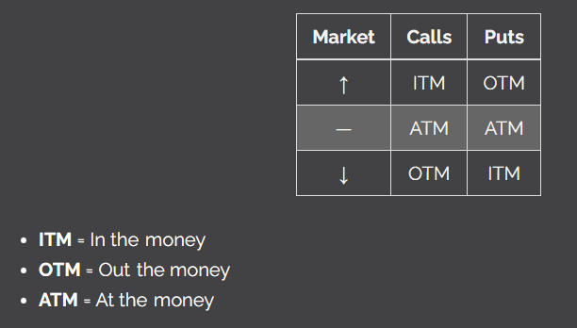
- American style options
  - Can be exercised at any time
  - Typical for stock (equity) options
- European style options
  - Can only be exercised at expiration
  - Typical for index options

Stock Split & Dividend Adjustments
- Option contract adjustments
  - Required for stock dividends or splits
- Even forward stock splits
  - Stock splits with a ratio ending in 1
  - Option contract adjustments:
    - More contracts
    - Lower strike price
    - Same shares delivered at exercise (per contract)
- Uneven forward stock splits
  - Stock splits with a ratio not ending in 1
  - Option contract adjustments:
    - Same number of contracts
    - Lower strike price
    - More shares delivered at exercise (per contract)
- Reverse stock splits
  - Option contract adjustments:
    - Same number of contracts
    - Higher strike price
    - Fewer shares delivered at exercise (per contract)
- Stock dividends
  - Option contract adjustments:
    - Same number of contracts
    - Lower strike price
    - More shares delivered at exercise
- Cash dividends
  - Options are not adjusted for regular cash dividends
  - Options are adjusted for special cash dividends (unexpected dividend payments)
    - Same number of contracts
    - Strike price reduced by the amount of dividend
    - Same shares delivered at exercise

Strategies
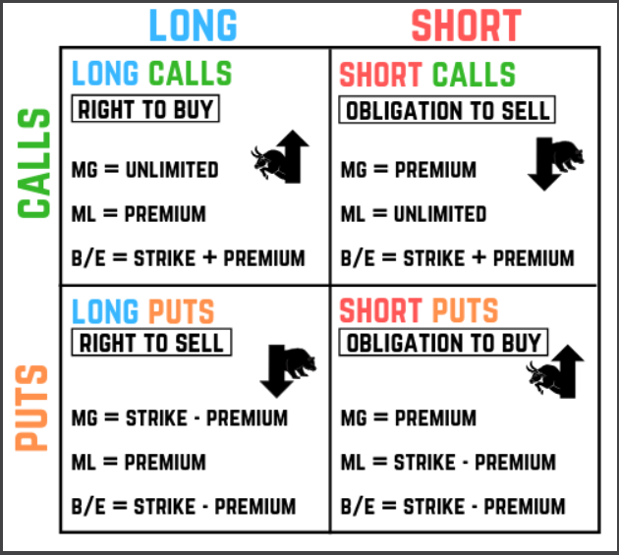

Long calls
- Long calls
  - Bullish investments
    - Expectations of rising values
  - Right to buy the stock at the strike price
- Long call formulas
  - Maximum gain = unlimited
  - Maximum loss = premium
  - Breakeven = strike + premium

Short calls
- Short calls
  - Bearish investments
  - Obligation to sell stock at the strike price
  - Considered “naked” without a hedge
- Covers a short call
  - Long shares
  - Long call
  - Rights or warrants
  - Convertible securities
  - CASH CANNOT COVER SHORT CALL BECAUSE RISK IS UNLIMITED
- Short call formulas
  - Maximum gain = premium
  - Maximum loss = unlimited
  - Breakeven = strike + premium

Long puts
- Long puts
  - Bearish investments
  - Right to sell stock at the strike price
- Long put formulas
  - Maximum gain = strike-premium
    - Obtained if the market price falls to zero
  - Maximum loss = premium
  - Breakeven = strike-premium

Short puts
- Short puts
  - Bullish investments
  - Obligation to buy the stock at the strike price
  - Considered “naked” without a hedge
  - Short puts can be covered by:
    - Short shares
    - Long put
    - Cash
- Short put formulas
  - Maximum gain = premium
  - Maximum loss = strike – premium
  - Breakeven = strike – premium

Hedging strategies
- Hedging strategies
  - Long option with a stock position
  - Long option protects stock from risk
- Long stock hedge
  - Long stock & long put
  - Market sentiment: bullish
  - Put shields long stock from risk
- Short stock hedge
  - Short shares & long call
  - Market sentiment: bearish
  - Call shields short stock from risk

Income strategies
- Income strategies
  - Short option with a stock position
  - Short option provides income in a flat market
  - Short call
    - Pro: the option’s premium provides the investor added income
    - Con: the option limits the stock’s upside potential
- Covered call
  - Long shares & short call
  - Market sentiment: bull/neutral
  - Short call acts as a partial hedge
  - Generally considered safe options strategies because an investor doesn’t introduce more loss potential with the short call
- Covered put
  - Short shares & short put
  - Market sentiment: bear/neutral
  - Short put acts as a partial hedge
  - Maximum loss is unlimited
- Opportunity cost
  - A missed opportunity to profit

Index options
- Index options
  - Derive value from index fluctuations
  - Most are European style
    - Can be exercised only at expiration
  - OEX is the only American style option
    - Can be exercised at any time
  - Can be used to hedge against market risk (systematic)
    - Cannot diversify out of market risk
    - Can hedge by going long an option
  - All index option exercises settle in cash
- Common indices
  - SPX -S&P 500
  - OEX -S&P 100
  - DJX -Dow Jones Industrial Average
  - RUT -Russell 2000
  - VIX -Volatility Index

10. Taxes

Dividends
- Cash dividends
  - Taxable income received from equity investments
  - Dividend-paying investments include:
    - Common stock
    - Preferred stock
    - Mutual funds
    - REITs
  - Reported on tax form 1099-DIV
  - Taxable in the year received
  - Only reportable to IRA upon payable date
  - Rate paid is determined by an investor’s annual taxable income
    - Includes:
      - Salary
      - Wages
      - Commissions
      - Bonuses
      - Royalties
  - Typically taxed at lower rates than other forms of investment income
- Qualified dividends
  - Taxed at lower rates than non-qualified dividends
  - Tax rates
    - 0% (low income)
    - 15% (moderate income)
    - 20% (high income)
  - To be considered qualified:
    - Distributed by a US corporation or qualified foreign corporation
      - To be considered a qualified foreign corporation, must meet one of the following:
        - Incorporated in a US possession (including territories like Puerto Rico)
        - Subject to a US tax treaty
        - The dividend-paying security trades on an established stock exchange in the US
    - The investor must meet a specific unhedged holding period
- Non-qualified (ordinary) dividends
  - Tax rate equal to federal marginal income tax bracket (up to 37%)
  - REITs pay non-qualified dividends (will never pay qualified)
- Stock dividends and splits
  - New shares received are not taxable until sold
- 1099-DIV reports:
  - Cash dividends
  - Product dividends
  - Capital gains distributions from mutual funds

Interest
- Interest
  - Potentially taxable income from debt securities
  - Reported on tax form 1099-INT
  - Tax rate equal to federal marginal income tax bracket (up to 37%)
  - Taxed the same as non-qualified dividends
- US Government debt tax status
  - Subject to federal taxes
  - Exempt from state and local taxes
- Municipal debt tax status
  - Exempt from federal taxes
  - Subject to state and local taxes
  - 100% tax-free if:
    - Resident
    - Territory bond
- Corporate debt tax status
  - Subject to federal, state, and local taxes
- Mortgage-backed securities tax status
  - Subject to federal, state, and local taxes

Capital Gains
- Capital gain
  - Securities sold for more than the basis
  - Reported on tax form 1099-B
    - B stands for brokerage proceeds, not bapital bains
- Capital loss
  - Selling a security below basis
- A gain or loss is realized upon a position being closed out
  - Sales proceeds – cost basis
- Cost basis represents the overall amount paid to buy the security, including any commission
- Sales proceeds represents the overall amount received to sell a security, minus commission
- Long-term capital gain
  - Gain on security held more than 1 year
  - Tax rate: 0%, 15%, or 20%
- Short-term capital gain
  - Gain on security held for 1 year or less
  - Tax rate: up to 37%
- Inherited securities
  - Cost basis is stepped up to the value on the date of death
  - Holding period is always long term, regardless of length held by original owner
- Returns made from investments (capital gains, dividends, or interest) are considered portfolio income
- Any money earned from a job or career (salary, commission, bonus, royalty) is considered earned income
- Returns made from rental properties or direct participation programs are considered passive income
- Dividends are not tax-deductible

11. The Primary Market

Roles
- Primary market
  - Initial sale of a security by the issuer to investors
  - Proceeds always go to the issuer
- Issuers
  - Sell securities to raise capital
- Underwriters
  - Hired by issuers to sell new issues
    - When an issuer hires an underwriter, they’re really hiring a lead underwriter
    - Lead underwriter forms a group called the syndicate
      - Syndicate is made up of several financial firms that will assist the lead underwriter with the sale
  - Also known as investment banks
- Securities Exchange Commission (SEC)
  - Requires issuers to register securities unless an exemption exists
  - Goal of registration is to confirm the issuer and underwriter are providing the public with enough information to make an informed investment decision

Underwriting Commitments
- Firm underwriting commitments
  - Underwriter liable for unsold shares
  - Also known as:
    - Principal transactions
    - Dealer transactions
- Best efforts underwriting commitments
  - Issuer liable for unsold shares
  - Also known as agency transactions
- Mini-max commitments
  - Type of best efforts commitment
  - Minimum shares must be sold, up to a maximum
- All or none commitments
  - Type of best efforts commitment
  - All shares must be sold

Types of Offerings
- Initial public offerings (IPOs)
  - First public sale of a security
- Additional public offerings (APOs)
  - Also known as a follow-on offering
  - Public sale of security after initial sale
  - Still in primary market
- Private placement
  - Security sales to private audiences
  - Type of primary market sale
  - Can qualify for an exemption from SEC registration
    - Regulation D
- Primary offerings
  - Sales proceeds go to the issuer
  - Examples:
    - IPOs
    - APOs
    - Private placements
- Secondary offerings
  - Sales proceeds go to a party other than the issuer
  - Typically involve officers or directors selling personally-owned shares
- PIPES (Private Investment in Public Equity)
  - Private placement of public equity
  - Offered to accredited investors only
  - Typically at a discount to market value
  - Most common during market downturns
  - Lock-up period of 6-12 months (investors cannot sell shares during this time)

The IPO Process

Overview
- Securities Act of 1933
  - Governs the primary market
  - Requires disclosures on new issues
- Exemptions
  - “Exempt” securities and transactions don’t have to follow the regulations
  - “Non-exempt” securities and transactions must follow the regulations

Preparing for the sale
- Registration form
  - Issuers file with SEC prior to IPO
  - Details issuer’s background and financials
  - SEC checks for completeness
  - SEC does not check the accuracy
- Prospectus
  - Created with registration form info
  - Gives investors details on security
- 20-day cooling off period
  - Begins when the registration form is filed
  - Legal activities:
    - Distribute preliminary prospectus
    - Take indications of interest
    - Publish a tombstone
  - Illegal activities:
    - Recommend the new issue
    - Advertise the new issue
    - Sell the new issue
    - Take a deposit for the new issue
  - SEC registration form is transformed into a “preliminary” prospectus
    - Sometimes referred to as the red herring
- Indications of interest
  - Collected to forecast demand
  - Allowed during cooling off period
  - Not binding on customer or firm
- Tombstones
  - Legal advertising in cooling off period
  - Contain this information:
    - Name of issuer
    - Type of security
    - # of shares or units to be sold
    - Gross proceeds of the offering
    - Name of lead underwriter
    - Name of syndicate members
    - Estimated public offering price
- Deficiency letter
  - Issued by SEC
  - Pauses the cooling off period
  - Provided if the registration form is incomplete

Effective registration
- Effective date
  - The first day the new issue can be legally sold
  - SEC provides when the registration form is reviewed and deemed complete
- Common stock IPO investor restriction
  - Industry insiders may not purchase common stock IPOs
  - Industry insiders are known as “restricted persons”
  - FINRA rule 5130 requires underwriters to avoid IPO sales of common stock to industry insiders
- Restricted persons
  - Member firms
  - Member firm employees, and:
    - Immediate family members
    - Dependents
- Exception to common stock IPO restriction
  - Accounts not exceeding 10% ownership by a restricted person
    - Investment clubs
- Public offering price (POP)
  - Sale price of new issues
- Prospectus
  - Provided to investors buying IPOs
  - Delivery is required by the Securities Act of 1933
  - Must be delivered in its original, unaltered form
- Access equals delivery
  - Prospectus considered delivered if available publicly online
  - Issuers post prospectuses to EDGAR (Electronic Data Gathering, Analysis, and Retrieval system)

Exemptions
- Exempt securities
  - Not required to register in any circumstance
  - List:
    - Government securities (fed and municipal)
    - Insurance company securities (unless a variable contract)
    - Bank securities (not bank holding company securities)
    - Non-profit securities
    - Commercial paper and banker’s acceptances
    - Railroad ETCs
- Bank holding companies
  - Companies that own banks
  - Not exempt from SEC registration
- Exempt transactions
  - Security is exempt only if sold in a specific way
  - List:
    - Regulation A+
    - Regulation D
    - Rule 147
- Regulation A+
  - Small-dollar offering rule
  - Sell up to $75 million in 12 month period
  - Disclosures made in offering circular
  - Two tiers of regulation A+ offerings:
    - Tier 1:
      - Up to $20 mil can be offered
      - Subject to SEC and state review
      - Audited financial statements are not required
      - No purchase limits for investors
    - Tier 2
      - Up to $75 mil can be offered
      - Subject to SEC review only
      - Audited financial statements
      - Purchase limits for investors
- Regulation D
  - Private placement rule
  - Unlimited sales to accredited investors
  - No more than 35 non-accredited investors
  - Disclosures made in offering memorandum
- Accredited investors
  - Income-based (annual)
    - Single: $200k income for 2+ years
    - Joint: $300k income for 2+ years
  - $1 million of net worth, excluding residence
  - Holding the series 7, 65, or 82 licenses
  - Officer or director of the issuer
  - Institution with $5 million+ in assets
  - Any entity where all owners are accredited investors
- Rule 147 offerings
  - Avoid SEC registration if sold intrastate
  - No holding period for resale within the state
  - 6-month holding period for resale out of state
    - Investor must be resident of the state
  - Company must be primarily in within a specific state
    - 80% of the issuer’s business revenues collected in that state
    - 80% of the issuer’s assets in that state
    - 80% of offering proceeds will be spent in that state
    - Headquarters must be within state offering will occur
  - Blue sky laws
    - State laws have their own registration process defined and explained under the Uniform Securities Act
  - The equivalent to the SEC at the state level is known as the state administrator
  - 3 types of registration at the state level
    - Registration by filing (notice filing)
    - Registration by coordination
    - Registration by qualification
- Registration by filing (notice filing)
  - Federal-covered securities
    - Exchange-listed securities and investment company issues qualify to be registered only with the SEC
    - Issuer does a notice filing
      - A notification that their security will be trading in the administrator’s state (but will be regulated by SEC)
  - Larger, well-established issuers
- Registration by coordination
  - Securities registered with SEC and state administrator
  - Reserved for companies that trade in multiple states
  - Smaller and lesser-known entities
- Registration by qualification
  - Registration with the state administrator only and does not include SEC registration
  - Issuers selling their securities in one state only

Rule 144
- Rule 144
  - Rule covering sale of restricted and control stock
- Restricted stock
  - Stock not registered with the SEC
  - Subject to a 6 month holding period
- Control stock
  - Stock owned by an affiliate (insider)
  - Subject to volume limitations
- Affiliate
  - Officer, director, or 10% shareholder
  - Security sales subject to volume limitations
  - Allowed to sell the greater 1% of the outstanding shares or the four-week trading average, four times a year
- Form 144
  - Filed if control or restricted stock intended to be traded in the next 90 days
  - Ony must be filed if more than
    - 5,000 shares, or
    - $50,000 total value sold
- Form 4
  - Filed if an insider trades control stock
  - Must be filed within 2 business days of the trade
  - Reports beneficial change in ownership for insiders
- EDGAR
  - Electronic filing system for SEC forms
  - Form 144 and Form 4 are filed on this system
- QIB (qualified institutional buyer)
  - $100 million or more of investable assets
- Rule 144A
  - QIBs are not subject to rule 144
  - QIBs avoid holding periods and volume limitations
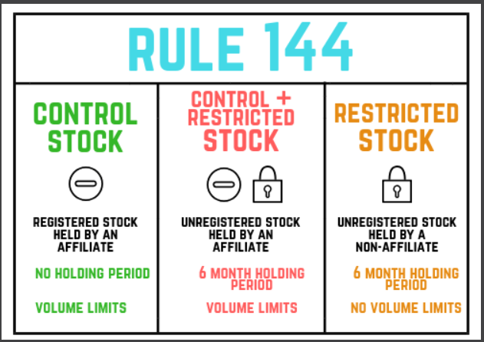

Other Rules
- Shelf registration rule
  - Allows issuers to quickly offer securities
  - Issuer files “blank” registration form
    - Reviewed by the SEC
    - Granted as effective if all required disclosures provided
  - The security may be sold quickly within the next 3 years
  - When the security is ready to be sold:
    - Issuer contacts SEC, provides information left “blank”
    - The security can then be sold 48 hours later
    - Allows avoidance of the 20 day cooling off period
- Stabilizing bids
  - Underwriter buys IPO securities back from the market
  - Bids must be at or below POP
  - Only one bid placed at a time
    - Other syndicate members cannot stabilize at different prices separate from the lead underwriter
  - Possibility of stabilization must be disclosed in the prospectus
  - Penalty bid
    - Assessed to a syndicate member when they buy back IPO shares immediately from the investor
    - Results in the syndicate member relinquishing the selling concession they earned when selling the shares

12. The Secondary Market

Agency vs. Principal Capacity
- Agency capacity
  - Firms matching buyers & sellers
  - Commission earned
  - Associated terms
    - Brokers
    - Agents
- Principal capacity
  - Firms buying and selling with inventory
  - Mark-ups and mark-downs earned
  - Associated terms:
    - Dealer
    - Market maker

Roles
- Traders
  - Buy and sell securities for clients
  - Typically work on behalf of large portfolios (e.g. mutual funds, hedge funds)
- Broker-dealers
  - Buy and sell securities for clients or for their own account
  - May act in an agency or principal capacity
  - Can act as principals in one of two ways
    - Can act as market makers and trade with the public on a principal basis
    - Can act as dealers while taking part in underwriting syndicates
- Market makers
  - Buy and sell securities with the public
  - Acts only in a principal capacity
  - Maintain ongoing bid & ask spreads
  - Provide much-needed liquidity for the securities they trade
- Agency capacity
  - Firms matching buyers & sellers
  - Commission earned
  - Associated terms
    - Brokers
    - Agents
- Principal capacity
  - Firms buying and selling with inventory
  - Mark-ups and mark-downs earned
  - Associated terms:
    - Dealer
    - Market maker

Bid & Ask
- Bid/ask spreads
  - Maintained by market makers
  - Provide best buy & sell prices
- Bid
  - Market makers buy at the bid
  - Customers sell at the bid
- Ask (offer)
  - Market makers sell at the ask
  - Customers buy at the ask
- Round lot
  - 100 shares of stock
- Efficient market
  - A large number of market participants
  - Small spreads and active trading

The Markets

The New York Stock Exchange
- New York stock exchange
  - Auction market
  - DMM acts as the NYSE auctioneer
  - All trades occur in the first market
  - World’s largest stock exchange
- Trading ahead
  - DMM places principal trade in front of a public order
  - Prohibited action
  - Does not apply to:
    - Executions at better prices
    - Institutional orders
- Designated market maker (DMM)
  - Also known as the ‘specialist’
  - Facilitates trading in NYSE stocks
  - May act in an agency or principal capacity
- Dual-listed stock
  - Listed on a national and regional exchange

NASDAQ
- NASDAQ
  - Negotiated market
  - Made up of numerous market makers
    - Trade only in a principal capacity
  - Considered an OTC market
    - Lacks physical trading floor
- Self-regulatory organizations (SROs)
  - Granted the power to regulate markets
- FINRA
  - A self-regulatory organization (SRO)
  - Regulates financial professionals

Other OTC Markets
- OTC Markets Group
  - Second market trades
  - OTC market trading non-listed stocks
  - Made of three sub-markets:
    - OTCQX
    - OTCQB
    - OTC Pink Market
- OTCQX
  - Highest listing standards of OTC Markets Group
  - Financial and reporting requirements exist
  - Companies listed cannot be bankrupt or penny stocks, and must have their financial disclosure documents audited
- OTCQB
  - Also known as a venture market
  - The trading market for smaller developing companies
  - Companies listed cannot be bankrupt, must have at least 50 shareholders, and are required to be audited
- OTC Pink Market
  - Least prestigious of OTC Markets Group
  - No listing or financial requirements
  - Market for bankrupt and distressed companies or companies that want to avoid reporting their financials to investors

Chicago Board Options Exchange
- The Chicago Board Options Exchange (CBOE) is where most options trade. The CBOE is also a self-regulatory organization (SRO) that maintains regulatory power over the options market.

The Securities Exchange Act of 1934
- Securities Exchange Act of 1934
  - Regulates the secondary market
  - Applies to non-exempt securities
  - Applies to market participants
  - Required broker-dealers to provide:
    - Balance sheets (semi-annually)
    - Net capital computations (semi-annually)
  - Created SEC
- Anti-fraud rule
  - Part of the Securities Exchange Act of 1934
  - Applies to all securities
  - Applies to all market participants
  - Rule 10b-5
- Insider (affiliate) rules
  - Cannot sell short company stock
    - Removes any incentive to work against the company’s best interests
  - Must return short swing profits
- Short swing profit
  - Capital gain made within 6 months
- Penny stock
  - Non-listed stock trading for less than $5
  - Investors must receive:
    - Risk disclosure document
    - Monthly statements
- Penny stock suitability statement
  - Required for solicitations
  - Not required for established customers
  - Established customer:
    - Account open for 1+ year
    - 3 unsolicited penny stock trades

Customer Orders

Market Orders
- Market orders
  - Transaction request at the next possible price
  - Guarantees execution, not price
  - Always day orders
  - For investors seeking immediate executions
- Day orders
  - Cancelled at end of day if not executed
- GTC (good-til-canceled) orders
  - Cancelled when customer requests

Limit Orders
- Limit orders
  - Seek better prices for investors
  - Guarantee price, but not execution
  - Day or GTC orders
- Buy limit orders
  - Execute when the price falls to or below the limit price
- Sell limit orders
  - Execute when the price rises to or above the limit price

Stop Orders
- Stop orders
  - Typically utilized to “stop losses” on stock
  - Do not guarantee price or execution
  - Trigger (elect) first, then execute
  - Become market orders after trigger
  - Day or GTC orders
- Sell stop orders
  - Trigger when the price falls to or below the stop price
- Buy stop orders
  - Trigger when the price rises to or above the stop price
  - Investors with short positions usually utilize buy stops to prevent losses

Stop Limit Orders
- Stop limit orders
  - Normal stop orders up until the trigger
  - After the trigger, becomes a limit order
  - Day or GTC orders
- Sell stop limit orders
  - Trigger when the market falls to or below stop price. After the trigger, the sell limit kicks in and the order fills as long as the price is at or above the limit price.
- Buy stop limit orders
  - Trigger when the market price rises to the stop price or higher. After the buy limit kicks in, the order fills as long as the price is at or below the limit price.

Summary of the Order Types
- Orders placed above current market
  - Sell limits
  - Buy stops
  - Not adjusted for cash dividends
- Orders placed below current market
  - Buy limits
  - Sell stops
  - Adjusted for cash dividends
- Cash dividend adjustments
  - Orders below the market adjusted downward by the amount of the dividend
- DNR (do not reduce) orders
  - Never adjusted for cash dividends

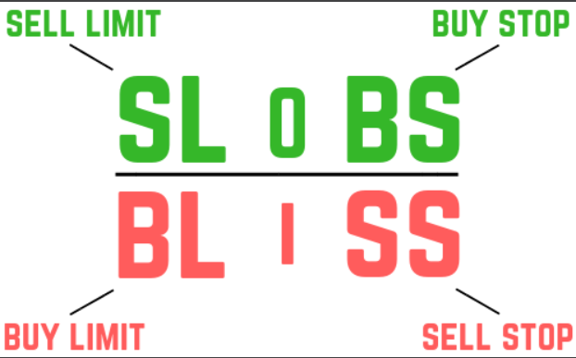

Additional Order Specifications
- All or none (AON)
  - Fill all shares or none at all
  - Multiple attempts allowed
- Immediate or cancel (IOC)
  - Fill as many shares as possible
  - One attempt allowed
- Fill or kill (FOK)
  - Fill all shares immediately
  - One attempt allowed

Customer Order Rules
- Order tickets
  - Must be prepared prior to order entry
  - Promptly reviewed by principals (supervisors)
  - Changes subject to principal approval
- Unsuitable customer orders
  - Must be placed if the customer insists
  - Marked unsolicited
  - Should note interaction in the customer file

13. Brokerage Accounts

Fundamentals

Statements
- Quarterly statements
  - Can be sent by mail or electronically
- Monthly statements
  - Sent if penny stocks held in account
  - Can be sent by mail or electronically
- Holding mail
  - Can hold customer mail for up to 3 months
  - May be held indefinitely for legitimate reason (e.g., safety, security)

Trade Confirmations
- Trade confirmations
  - Provides trade details after the transaction
  - Sent by completion of the transaction
  - Can be sent by mail or electronically

Customer Complaints
- Complaint
  - Dissatisfaction submitted in writing, including:
    - Letters
    - Emails
    - Texts
    - Instant messages
  - Forwarded to a principal for review
  - Representative and principal work together to resolve
  - Must be kept on file for 4 years at OSJ (Office of Supervisory Jurisdiction)

New Accounts

Required Customer Information
- Four critical pieces of information
  - List:
    - Name
    - DOB
    - Address
    - SSN/TIN
  - Must be collected as per Patriot Act
  - Must be verified through:
    - Valid government-issued ID
    - Credit bureau database
- Customer occupation
  - Must confirm if the customer is:
    - An affiliate of a publicly traded company
    - A registered financial representative
- Insider trading occurs when a trade is made because of material, non-public information.

Optional Customer Information
- Suitability questions
  - Not required to be answered
  - Firms cannot make recommendations without this information
    - Trades must be submitted unsolicited and without firm’s guidance if suitability not provided

Account Opening
- Cash accounts
  - Require full payment for transactions
- Signatures on new account form
  - Customer does not sign
  - Registered representative may sign if servicing account
  - Principal must sign to approve the account
- Required firm actions
  - Must confirm customer info within 30 days of account opening
  - Must confirm customer info every 3 years
- Arbitration agreements
  - Forces customer disputes to binding arbitration facilitated by FINRA
  - Customer will be unable to sue the firm in court

Account Registrations

Individual Accounts
- Individual accounts
  - Accounts owned by one party
  - Subject to probate without TOD
- Transfer on death (TOD)
  - Account with a listed beneficiary
  - Avoids probate
  - TOD designation supersedes wills
- Probate court
  - Determines the distribution of estate assets
  - All beneficiary needs to provide to claim assets is a certified death certificate and an account to receive the inherited assets
- Dying testate
  - A person dies with a valid will in place
  - Will appoints estate executor
  - Executor petitions probate court for letters testamentary
  - Letters testamentary confirm executor’s status to firm maintaining custody
- Dying intestate
  - A person dies without a valid will in place
  - Probate court appoints estate administrator
  - Letters of administration confirm administrator’s status to firm maintaining custody
- Death reporting to firm
  - All open orders canceled
  - Account marked as deceased and restricted
  - Firm awaits death certificate and estate documents (if necessary)
- Typical document requirements to claim accounts
  - Certified death certificate
  - Letters testamentary (if no TOD and died testate)
  - Letters of administration (if no TOD and died intestate)
  - Inheritance tax waiver (if decedent resided in state with estate tax)
- Numbered accounts
  - Account owner or account referred to by string of numbers
  - Allows the customer to maintain anonymity
  - Customer must provide written attestation of ownership

Joint Accounts
- Joint WROS accounts
  - Provide equal ownership to all parties
  - Surviving owner(s) inherit the account
  - Avoids probate
- Joint TIC accounts
  - Provide specific ownership allotments
  - Deceased owner portions go to the estate
  - Subject to probate
- Joint accounts
  - Any joint owner can:
    - Trade
    - Receive mail
    - Manage the account
  - All joint owner names must be on checks
  - Tenants by entirety and community property can only be opened by married couples

Power of Attorney
- Power of attorney (POA)
  - Allows a third party to act on behalf of account owner(s)
  - Referred to as trading authorization
  - Ceases at account owner’s death
  - Can be revoked at any time
- Limited POA
  - Third party can place trades in the account
  - Third party cannot request withdrawals
- Full POA
  - Third party can place trades
  - Third party can request withdrawals
- Non-durable POA
  - Ceases at account owner incapacitation
- Durable POA
  - Survives account owner incapacitation

Discretionary Account
- Discretionary accounts
  - Provide POA to financial professionals
  - Type of fiduciary account
    - Must put their client’s interest before their own and act in their best interest
  - All suitability questions must be answered
- Discretionary trade
  - Involves professional choosing one of:
    - Asset: what security is being bought or sold
    - Action: if the security is being bought or sold
    - Amount: how many shares or units are being bought or sold
  - Not discretionary trade (if same day):
    - Price
    - Time
  - Must be reviewed promptly by a principal
- Fiduciaries
  - Act in the best interest of the account owner
- Wrap accounts
  - Type of discretionary account
  - All fees wrapped into one
  - Investment adviser product
  - Usually charges as AUM fees

Custodial Accounts
- UGMAs and UTMAs
  - Custodial accounts set up for minors
  - Type of fiduciary account
  - One custodian per account
  - One minor per account
  - Taxes reported under the minor’s SSN
  - Contributions are irrevocable gifts to minor
    - Withdrawals can be made to spend money on items that will directly benefit the child
      - Withdrawals may not be used for essential living expenses
  - Account may not be transferred to another beneficiary
  - Custodians cannot pursue risky investment strategies
    - Short sales, margin, some options strategies are prohibited
- UGMA
  - Requires custodians to give control of the assets to the minor at the age of majority
- UTMA
  - Allow custodians to delay the transfer of assets (up to age 25 depending on the state)

Guardianship Accounts
- Guardianship accounts
  - Accounts for the incapacitated
  - Managed by court-appointed guardians
  - Type of fiduciary account
  - Must avoid risky investment strategies

Trust Accounts
- Trust accounts
  - Set up for the benefit of a specific party
  - Type of fiduciary account
  - Eligible for margin if specifically authorized in the trust agreement
- Grantor
  - Creates and funds the trust
  - Creates trust agreement
    - Specifies objectives, management styles, and beneficiaries
- Trustees
  - Manages the trust for beneficiaries

Business Accounts
- Partnership account
  - Business account for a partnership
  - Requires a partnership agreement
  - Not considered joint accounts
  - General partnership
    - Only contains two or more general partners, no limited partners
- Corporate account
  - Business account for a corporation
  - Required to open:
    - Corporate resolution
    - Corporate charter with a corporate seal
      - Confirms legal status
  - S and C corp
- Corporate resolution
  - Names employees who can act on behalf of the business account

Primer Brokerage Accounts
- Prime brokers
  - Provide services to large customers:
    - Maintain custody
    - Record keeping
    - Send trades to various firms
  - One central broker for a customer with many other brokers actually executing trades
  - Lower interest charges on borrowed funds

Margin Accounts

Overview
- Margin accounts
  - Borrow money for investment (leverage)
  - Only suitable for risk-tolerant investors
  - Required for short sales and any other strategy involving unlimited risk

Opening a Margin Account
- Margin agreement components
  - Hypothecation agreement
  - Credit agreement
  - Loan consent form
- Hypothecation agreement
  - Investor pledges securities as collateral
  - Must be signed by the customer
  - Firms rehypothecate securities to the bank
- Regulation U
  - Governs B/D to bank relationship
  - B/Ds can rehypothecate 140% of debit
- Credit agreement
  - Margin loan details and specifics
  - Must be signed by the customer
- Loan consent form
  - Allows B/D to lend out securities
  - Does not have to be signed
- Commingling securities
  - Allowed for margin account securities
  - Prohibited for cash account securities

Deposit Requirements
- Regulation T
  - Requires 50% deposit for margin trade
  - May deposit 2x Reg T requirement in fully-paid securities
  - Rule within Securities Exchange Act of 1934
  - Rules are mandated by the Federal Reserve Board
- Regulation T settlement
  - 2 business days after regular-way settlement (T+3)
- FINRA margin requirement
  - Minimum equity of $2,000
  - Margin initial deposit rules for long accounts:
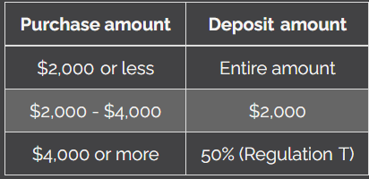
- Marginable securities
  - Exchange-listed stocks
  - Federal Reserve approved OTC stocks
  - Debt securities
  - Primary offerings after 30 days of ownership
  - LEAPS options with more than 9 months to expiration
  - Warrants
- Non-marginable securities
  - OTC stocks not approved by the Federal Reserve
  - Primary offerings held less than 30 days
  - Any option with 9 months or less to maturity
  - Insurance products
  - Rights
- Frozen accounts
  - Implemented if the customer missed Reg T settlement
  - Purchases only occur if cash is in the account
  - Lasts for 90 days
- Only non-retirement margin accounts can utilize margin. The following account types cannot utilize margin:
  - Custodial accounts
  - Guardianship accounts
  - Trust accounts (unless specifically authorized in the trust agreement)
  - Education plans
  - Retirement accounts

Equity
- Long equity formula
  - LMV – debit = equity
  - LMV is the long market value
    - Overall value of all (long/owned) securities held in the account
  - Debit is the amount borrowed and owed back to the broker-dealer
  - Equity is the account’s net worth
- Short equity formula
  - Credit – SMV = equity
  - Credit is the amount sold short plus the amount deposited
  - SMV is the short market value
  - Equity is the account’s net worth
  - Any purchase of shares to close a short position is funded with the credit balance
- Combined equity formula
  - LMV + credit – SMV – debit = equity

Minimum Maintenance (more likely to be tested on concepts instead of math)
- Minimum maintenance for long accounts
  - 25% equity requirement
  - If falling below must:
    - Deposit cash
    - Deposit fully paid securities
    - Sell securities
  - Enforced by FINRA
- Restricted accounts
  - Below 50% equity
  - Half of sales proceeds must pay down debit balance
- Minimum maintenance for short accounts
  - 30% equity requirement
  - If falling below, must:
    - Deposit cash
    - Close short position

Options Accounts
- Five steps to open an options account per FINRA Rule 2360
  - Customer fills out the new account form
  - Financial representative provides ODD
  - Account is approved by an options supervisor (Registered Options Principal or General Securities Sales Supervisor)
  - First trade “opens” the account
  - Customer returns signed options agreement within 15 days
- Customer information and suitability
  - Firm must request background and financial information
  - Information will be used to determine if:
    - Account will be approved
    - What level of option trading will be allowed
  - Information is confirmed by a negative confirmation letter
    - Sent to the customer within 15 days
    - Customer only responds if the information is incorrect
  - Options disclosure document (ODD)
    - Discloses characteristics, risks, and benefits of options
    - Must be delivered prior to options discussion with retail investors
  - Options agreement
    - Confirms the investor:
      - Received the ODD
      - Will abide by OCC rules
    - Signed & returned within 15 calendar days of account opening
    - Closing transactions only if not returned within 15 calendar days
  - Registered options principal (ROP)
    - Series 4 license holder
    - Principal supervisor overseeing options activity
    - May approve options accounts
  - General securities sales supervisor
    - Series 9/10 license holder
    - Principal supervisor overseeing general brokerage activity
    - May approve options accounts

Other Account Specifications

SIPC Insurance
- SIPC (Securities Investor Protection Corporation) Insurance
  - Coverage in case of broker-dealer failure
  - Coverage:
    - Up to $500k per registration
    - No more than $250k in cash
    - Only equity is covered in a margin account
  - Confirmation of SIPC insurance required:
    - At account opening
    - Annually after account opening

Business Continuity Plans
- Business continuity plans (BCPs)
  - Protocols during business disruptions
  - Provided to customers:
    - Upon account opening
    - Upon written request
    - On the firm’s website

14. Retirement & Education Plans

Generalities
- Tax-deferred growth
  - Avoid taxation until money is distributed
    - Distributions are taxable as ordinary income
  - Securities transactions within a retirement plan are non-tax reportable and not subject to taxation in any way
  - Central benefit of:
    - Retirement plans
    - Education savings plans
- Retirement account contributions
  - Must be made in cash
  - Deductible contributions
    - Provide immediate tax benefits
    - Lower overall tax liabilities
  - Non-deductible contributions
    - Made with after-tax funds
    - Have no immediate tax benefits
- Retirement account suitability
  - Avoid strategies with unlimited risk
  - Cannot utilize short sales
  - Cannot utilize margin
  - Cannot invest in collectibles or art
  - Municipal bonds are unsuitable
  - Investors can invest in:
    - Stocks (common and preferred)
    - Bonds
    - Mutual funds
    - Unit investment trusts (UITs)
    - US government issued coins
- Excess contribution penalty
  - 6% on the amount over-contributed
- Early withdrawal penalty
  - Retirement distributions before 59 ½
  - Subject to a 10% penalty
  - Exceptions:
    - Disability
    - Death
    - First-time home purchase
    - Educational expenses
    - Certain medical expenses
- Required minimum distributions (RMDs)
  - Retirement withdrawal requirement
  - Applies at age 73
  - Year-end account balance divided by life expectancy
  - Annual amount must be distributed year-end
  - First RMD can be postponed to April 1st of the following year
  - 25% penalty if not taken (10% if taken within 2 years)

Rules
- ERISA (Employee Retirement Income Security Act)
  - Legislation governing qualified plans
- General ERISA requirements
  - Minimum participation standards/non-discrimination
    - Must offer the plan to all full-time employees
      - To be considered full-time, an employee must be:
        - Age 21 or older
        - Working 1,000+ hours annually
    - Cannot offer the plan to executives only (this would be discrimination)
  - Reporting and disclosure
    - Details of retirement plan available in writing
    - Employees provided annual updates
  - Funding
    - Defined benefit plans must be funded appropriately
  - Vesting
    - Employees must earn employer-provided benefits in a reasonable amount of time (five years or less)
    - Employee contributions are always 100% vested
- Plan document
  - Governs an ERISA plan
  - Must be created before plan is offered to employees
  - Identifies rules:
    - Who can contribute
    - Employer-provided benefits
    - Vesting schedules
    - Investment options
    - Beneficiary designation rules
    - Distribution guidelines

Workplace Plans
- Defined benefit plans
  - Varying contributions made over time
  - Defined retirement benefit
  - Most beneficial for employees:
    - With higher salaries
    - Closest to retirement age
  - Most common form is a pension
  - Defined benefit plan payouts are 100% taxable to the retiree as ordinary income
- Pensions
  - Common form of defined benefit plan
  - Pay retirement income until death
- Unfunded pension liabilities
  - Payouts exceed assets (forecasted)
- Defined contribution plans
  - Defined contributions
  - Unknown benefit at retirement
  - General tax structure:
    - Pre-tax contributions
    - Tax-deferred growth
    - Distributions taxable as ordinary income
- 401k plan
  - Qualified retirement plan
  - For private (non-government) companies
- Solo 401k plan
  - Qualified retirement plan
  - For private (non-government) self-employed businesses with no employees
    - Working spouses do not count
- 403b plan
  - Qualified retirement plan
  - For non-profit organizations
  - Also known as tax-sheltered annuities
- Keough (HR-10) plans
  - Qualified retirement plan
  - For self-employed businesses
  - 2026 contribution limit is lesser of:
    - $73,500
    - 25% of income
- Profit-sharing plans
  - Qualified retirement plan
  - Employer shares a portion of profits
  - Employer under no obligation to contribute
- Money purchase plans
  - Qualified retirement plan
  - Employer must contribute a fixed percentage of salary annually
  - Not based on company profitability
- SEP (Simplified Employee Pension) and SIMPLE (savings incentive match for employees) IRAs
  - Qualified retirement plans
  - For small businesses
  - Higher contribution limits than traditional or Roth IRAs
- Non-qualified plans are not governed by ERISA
  - Non-qualified plans have the ability to discriminate
- Deferred compensation plan
  - Non-qualified retirement plan
  - Allows senior employees to defer compensation, invest it, and receive it in retirement
- 457 plan
  - Government & certain non-profit retirement plan
  - Allows pre-tax contributions and tax-deferred growth
  - No early withdrawal penalty

Individual Retirement Accounts
- Traditional IRAs
  - Non-qualified retirement plan
  - Potentially deductible contributions
  - 100% taxable distributions
- Traditional IRA contributions
  - 2026 contribution limit is lesser of:
    - $7,500
    - Annual earned income
  - Age 50+ can contribute $1,100 more
    - Aka catch-up provision
  - Spousal IRA allows non-working spouse contribution
  - Can contribute until tax-filing deadline of following year
  - Investors making non-deductible contributions to a traditional IRA are only taxed on the growth when a distribution is taken. The basis (amount contributed) returns to the investor tax-free upon withdrawal.
- Deductible traditional IRA contributions
  - Always allowed if not covered by a qualified plan
  - If covered by a qualified plan:
    - Deductible if mid-low income
    - Non-deductible if high income
- Roth IRAs
  - Non-deductible contributions
  - 100% tax-free distributions if:
    - Age 59 ½ or older
    - Roth IRA is aged 5 years
      - The five year aging period starts on the first day of the tax year of the first contribution
  - Not subject to RMDs
- Roth IRA contributions
  - 2026 contribution limit is lesser of:
    - $7,500
    - Annual earned income
  - Contribution limits apply to both Roth and traditional IRAs combined
  - Cannot contribute if high income
  - Age 50+ can contribute $1,100 more
  - Spousal IRA allows non-working spouse contribution
- Roth 401(k)s
  - Qualified workplace plan
  - Similar tax structure to a Roth IRA
  - Contributions are after-tax, assets grow on a tax-sheltered basis, distributions are tax free in retirement

Variable Life Insurance
- Variable life insurance
  - Coverage for the entire life of the policyholder
  - Fixed premiums
  - Guaranteed death benefit
  - Cash value invested in the separate account
  - Cash value grows based on investment performance
  - Policyholder subject to investment risk
  - Cash value may be:
    - Withdrawn or borrowed
    - Returned to the insurance company upon death
    - Kept upon surrender of the policy
    - Retained and potentially paid with a death benefit
  - Considered a security
  - If the policyholder wants to stop paying premiums, 3 options:
    - Keep death benefit for shorter period
      - Can take cash value and purchase the equivalent of term life insurance
      - Term insurance not available for those 80+
    - Retain insurance with a lower death benefit
    - Surrender and receive the cash value minus any surrender fees
      - Cash value contributed to a separate account

Variable Annuities
- Variable annuities
  - Type of investment company product (regulated by Investment company Act of 1940)
  - Considered non-qualified retirement plans
  - Unlimited non-deductible contributions
  - Contribution options:
    - Lump sum
    - Periodic contributions
  - Offers tax-deferred growth
  - Distributions taxable above basis
- Immediate annuity
  - Investor contributes a large lump sum
  - Immediately annuitizes and receives payments
  - Single premium immediate annuity – if lump sum is made in one big payment
  - Benefits
    - Receive retirement income immediately
    - Provides income for life
    - No need for a lengthy accumulation phase to build-up
  - Risks
    - Typically requires a large lump sum to qualify
    - The lump sum is generally inaccessible without significant fees once deposited
    - Low or negative return if death occurs earlier than expected
    - Likely subject to a substantial amount of up-front fees and/or sales charges
- Deferred annuity
  - Investor contributes over time
  - Takes withdrawals or annuitizes later in retirement
  - Benefits
    - Longer accumulation period allows for higher growth potential of contributions
    - Provides income for life if annuitized
    - No need for a significant lump sum to qualify
  - Risks
    - Assets may not grow as much or lose value if investments perform poorly
    - Income is typically not received for years or decades
    - Low or negative return if death occurs earlier than expected (once annuitized)
    - Likely subject to a substantial amount of up-front fees and/or sales charges
- Accumulation phase
  - When contributions are made
  - Death benefit applies
  - Measure of the customer’s ownership in the separate account is accumulation units
- Death benefit
  - Beneficiary keeps GREATER of:
    - Amount invested
    - Account value
  - Applies if the account owner dies during the accumulation phase
- M&E (mortality & expense) charges
  - Mortality risk – when the account owner dies earlier than expected
  - Insurance companies face expense risk
    - Running an insurance company is costly due to claims, regulatory costs, and general business expenses
- Variable annuity insurance company risks
  - Mortality risk
    - Investor dies earlier than expected, triggering the death benefit
  - Expense risk
    - Business expenses rise
  - Longevity risk
    - Investor lives longer than expected, forcing annuity payments to be paid longer
- Separate account
  - Where assets are held
  - When contributions are placed into separate accounts, the investor purchases accumulation units
    - Provide a measurement of investor’s basis (amount invested)
  - Customer in control of investing
  - Assets grow tax-deferred
  - Investment choices:
    - Equity-based portfolios
      - Hedge against inflation
    - Debt-based portfolios
      - Subject to inflation risk
- Distribution phase
  - Investor receives income in retirement
  - Non-annuitization options
    - Lump sum
    - Periodic payments
  - Annuitization options (giving ownership of the separate account in return for payments for life)
    - Straight life annuity
      - Pays them for life
      - After death, the payments stop and the insurance company keeps the assets in a separate account
      - Subject to longevity risk – when the investor lives longer than expected
    - Life with period certain
      - Payments are made for the longer of the annuitant’s life or the period certain timeframe
    - Joint and last survivor
    - Unit refund
      - Makes payments for life but “refunds” the account owner’s beneficiary if they pass away before receiving the basis
- Non-qualified annuity taxation
  - Growth is taxable as ordinary income
  - Withdrawals (non-annuitization)
    - Growth is distributed first (LIFO)
  - Annuitization
    - Basis and growth distributed simultaneously
    - Taxed on a “pro-rata” basis (aka exclusion ratio)
      - Aka being taxed on an exclusion ratio basis
  - Not subject to RMDs
- Qualified annuity taxation
  - All distributions taxed (growth and basis) as ordinary income
  - Subject to RMDs starting at age 73
- Fixed annuities
  - Like a variable annuity but:
    - Not a security
    - General account instead of a separate account
    - More exposed to inflation risk
  - Pros
    - Money grows at a guaranteed rate of return
    - Investor need not concern themselves with investment related risks
  - Cons
    - Variable annuities may grow more over time and the fixed rate of return is subject to inflation risk

Education & Other Plans
- Coverdell ESAs
  - Savings accounts for child’s educational expenses
  - Cover virtually all types of education
  - Assets grow tax-deferred
- Coverdell ESA contributions
  - $2,000 per person per year limit
  - Non-deductible
  - Can no longer be made at age 18
  - High income earners are prohibited from contributing
- Coverdell ESA distributions
  - Not taxable if used for education
  - Full distribution or rollover by age 30
  - Rollovers only to family members
  - Penalties if not used for education:
    - Ordinary income taxes on gains
    - Additional 10% penalty
- 529 plans
  - Also known as qualified tuition programs (QTPs)
  - State-sponsored education savings plans
  - Assets frow tax-deferred
  - Assets invested in state-approved funds
    - Plan participant may make two changes annually
  - Cover college expenses
  - Cover up to $10,000 of non-college tuition expenses annually
  - Can only make two changes to investment allocations per calendar year
  - May move to another state plan once per calendar year
  - No age requirement
- 529 plan parties
  - Plan participant
    - Controls and manages plan for beneficiary
  - Beneficiary
    - Person receiving plan assets to pay for education
    - Beneficiary changes can be made without tax consequences if the new beneficiary is a family member
- Prepaid tuition plans
  - Pays for future tuition costs at today’s rates
- College savings plans
  - Assets grow tax-deferred in funds
  - Many are target fund dates
  - Many evolve into money market funds when the target date is reached
- 529 plan contributions
  - Subject to gift taxes
    - $19,000 annual gift tax exemption
  - Generally non-deductible
  - Some states allow for state tax deduction
- 529 plan distributions
  - Tax-free if used for education expenses
  - Penalties if not used for education:
    - Ordinary income taxes on gains
    - Additional 10% penalty on gains
- ABLE (Achieve a Better Life Experience) accounts
  - Savings plans for people with disabilities
  - Must be disabled by age 26 to qualify
  - After-tax contributions
  - Tax-sheltered growth
  - Qualified distributions are tax-free

15. Rules & Ethics

The Regulators
- Securities and Exchange Commission (SEC)
  - Prominent securities industry regulator
  - Regulates the primary and secondary markets
  - Enforces:
    - Securities Act of 1933
    - Securities Exchange Act of 1934
    - Investment Company Act of 1940
  - Main goals:
    - Protect investors
      - Specifically retail
    - Maintain fair, orderly, and efficient markets
      - Ensuring confidence within secondary markets
    - Facilitate capital formation
      - Maintaining and regulating a system that allows issuers to raise capital by selling securities
- Financial Industry Regulatory Authority (FINRA)
  - Regulates the financial industry and its participants
- U-4
  - Registration form for persons in finance
  - Filled out and filed when joining a firm
  - Requires extensive background information
  - Must be updated if information changes
  - Arbitration agreement is embedded
  - Information on U4:
    - 5-year residential history
    - 10-year employment history
    - Outside business activities
    - Financial disclosures (bankruptcies and compromises with creditors)
    - Any felony history (including charges)
    - Any securities-related misdemeanor history (including charges)
    - Items subject to statutory disqualification
  - Submitted to FINRA’s Central Registration Depository (CRD)
- Fingerprinting
  - All applicants must submit fingerprints during the registration process
  - Fingerprints used in FBI background checks
  - Fingerprints must be submitted within 30 days of U4 submission
- Statutory disqualifications
  - Events that may prevent or revoke a registration
  - Most commonly cited:
    - Any felony conviction in the past 10 years
    - Securities-related misdemeanor in the past 10 years
    - Punishment from other regulators
- Eligibility proceeding
  - A request for an exception of prior felony
  - Filed with FINRA then forwarded to SEC
- U4 updates
  - General updates -filed within 30 days
  - Statutory disqualification event -filed within 10 days
- U5
  - Removes registration status
  - Filled out and filed when leaving a firm within 30 days
- U6
  - Reports the following:
    - Disciplinary actions
    - Reportable events
    - Arbitration results
- Municipal Securities Rulemaking Board (MSRB)
  - Self-regulatory organization governing the municipal markets
  - Writes municipal regulations, does not enforce
  - Enforces MSRB rules (securities firms):
    - SEC
    - FINRA
  - Enforces MSRB rules (banks):
    - The Federal Reserve Board
    - Office of Comptroller of the Currency
    - Federal Deposit Insurance Corporation (FDIC)
- Municipal finance professional
  - Firm employee involved in municipal:
    - Research
    - Advising
    - Underwriting
    - Communications
  - Not an MFP if limited to retail sales only
- Political contributions by firms and MFPs
  - $250 contribution limit for campaigns
  - 2-year ban is imposed if the limit is surpassed
  - Any amount given to a non-local campaign automatically creates a ban
- North American Securities Administrators Association (NASAA)
  - Regulates financial industry at the state-level
  - Enforces provisions of the Uniform Securities Act

Prohibited Activities

Market Manipulation
- Market manipulation
  - Artificially influencing security prices
- Painting the tape
  - Creating a false appearance of trading activity
  - Also known as:
    - Matched orders
    - Wash trades
- Marking the open
  - Placing orders prior to market open solely to influence the price
- Marking the close
  - Placing orders prior to market close solely to influence the price
- Spreading rumors
  - Spreading misinformation in order to manipulate a security price
- Pump and dump
  - Spreading information in order to manipulate a security price upwards
  - Once the price rises, the culprit sells and “cashes in”
- Free riding
  - Buying a security and selling it before making payment with settled funds
  - Violates Regulation T

Unethical Activities
- Interpositioning
  - Creating an unnecessary middleman
- Backing away
  - Providing firm quote, but not fulfilling it
    - A firm quote is a legitimate quote provided by a market maker for a security
- Frontrunning
  - Placing a personal order just prior to a large customer order
- Trading ahead
  - Placing a personal order just prior to a research report release
- Guaranteed security
  - Security with backing from a third party
  - Guaranteed by the third party:
    - Interest
    - Dividends
    - Principal
- Performance guarantees
  - Always unethical and prohibited
  - Must never:
    - Guarantee a client will make a return
    - Guarantee a client will not lose money
    - Refund any transaction or advisory fees for bad performance
- Churning
  - Excessive trading to generate commissions rather than to serve the client’s investment goals
  - Whether the client realizes a profit or loss is not a valid factor in determining whether churning has occurred

Insider Trading
- Insider trading
  - Trade based on material non-public info
  - Both tipper and tippee liable for penalties
  - Subject to treble damages in civil court
    - Perpetrators can be sued for up to three times the profit achieved or loss avoided
  - Contemporaneous trader – an investor in the security at the time of a trade
  - Individual criminal penalties:
    - Up to a $5 million fine
    - Up to 20 years in jail
  - Firm criminal penalties:
    - Up to a $25 million fine
- SEC Fair Fund
  - Collected fines are distributed here
  - Holds and distributes money to victims of financial fraud

Ethical Duties

Protecting Vulnerable Investors
- Specified adult
  - Any person age 65 or older
  - Any person age 18 or older who the member firm believes has a mental or physical impairment that renders the individual unable to protect their own interests
- Trusted contact person
  - Close friend or family members of the investor
  - May be contacted if the representative suspects exploitation, fraud, or diminished capacity
  - Must be at least 18 years old
- Fund disbursement holds
  - Firm may restrict transactions & withdrawals if suspecting fraud or exploitation
  - Trusted contact must be contacted within two business days if hold is placed
  - Original hold is 15 business days
  - May extend hold another 10 business days if additional time is needed
  - May extend hold another 30 business days if authorities are notified
- “Red flag” investments
  - Investments with:
    - High risk
    - Low liquidity
    - Complex components
  - Generally avoid recommending these to senior investors
  - These recommendations will always catch FINRA’s attention:
    - Using a mortgage for investment purposes
    - Recommending variable insurance products
    - Recommending complex products
    - Products with limited or no liquidity
    - Using retirement savings for risky investments
- Unethical activities with senior investors
  - Creating fake designations
- Elder abuse
  - Abuse of a senior citizen in some form
  - Must be reported if suspected

Recognizing Illegal Activities
- Money laundering
  - Concealing the source of illegal funds
  - Money orders are frequently used in money laundering
  - Stages:
    - Placement
      - The funneling of illegal money into the financial system
    - Layering
      - Performing dozens of transactions into multiple accounts
    - Integration
      - Transferring the funds into legitimate sources
- Bank Secrecy Act
  - Requires firms to implement anti-money laundering programs
- Anti-money laundering (AML) programs
  - Trains professionals to identify money laundering
  - Firms must appoint an AML officer
- Currency transaction reports (CTRs)
  - Filed if more than $10,000 cash is involved in a transaction within 15 days
  - Filed with FinCEN
- Structuring
  - The illegal act of transferring funds just under $10,000 to avoid CTR reporting
- Suspicious activity reports (SARs)
  - Filed if suspicious activity is identified
  - Within 30 days
  - Filed with FinCEN
- Specifically designated nationals (SDN) list
  - List of people identified as:
    - Controlled by hostile countries
    - Terrorists
    - Drug traffickers
  - Maintained by OFAC (office of foreign assets control)
    - Part of US Treasury Department

Other Laws & Regulations

Regulations
- Regulation S-P
  - Safeguards non-public customer info
  - Firms must disclose when giving non-public info to third parties
  - Privacy notices provided:
    - At account opening
    - Annually after
  - Firms must provide easy “opt-out”
- Regulation M
  - Prevents market manipulation during the offers of new securities
  - Prohibits activities that could artificially inflate the price of a security before and during an offering
  - Goal is fair market

Telephone Consumer Protection Act
- Telephone Consumer Protection Act (TCPA)
  - Prevents unwanted phone calls
  - Covers phone transmissions, including:
    - Phone calls
    - Robo-calls
    - Faxes (facsimile)
  - Financial professionals must check do-not-call lists prior to calling
  - Calls must be made between 8am and 9pm in the time zone of the prospect
  - Financial professionals must disclose:
    - Name
    - Firm’s name
    - Phone number or address
  - Does not apply to:
    - Exiting relationships (18 months)
    - Non-profits
    - Non-business ventures

Public Communications
- Correspondence
  - Written communication sent to 25 or fewer retail investors in 30 days
  - Not filed with FINRA
  - No principal pre-approval is required
  - Subject to review
- Retail communications
  - Written communication sent to more than 25 retail investors in 30 days
  - Filed with FINRA
  - Principal pre-approval required
- Institutional communications
  - Written communications with institutions
  - Not filed with FINRA
  - No principal pre-approval is required

Proxy Rules
- Proxy disbursement
  - Requirement for firms if securities held in street name
  - Firms are reimbursed for forwarding costs
  - Firms may vote on minor issues if proxy not returned
  - Firms will vote according to issuer’s recommendation if signed proxy returned with no votes
- When the broker-dealer is the owner on record for the stock, this is known as holding the security in “street name”
  - Most of the time the broker dealer is reflected as the stockholder

Licenses & CE
- Regulatory Element CE
  - Facilitated by FINRA
  - Educates and tests the rep’s understanding of ethics and compliance
  - Must be completed annually
  - If not completed on time, the rep’s registration becomes inactive
- FinPro
  - FINRA’s Financial Professional Gateway
  - Provides individuals and firms access to resources and tools to manage their registration status
- Firm Element CE
  - Facilitated by member firms
  - Educates and tests the rep’s understanding of ethics and compliance
  - Specifically focuses on the firm’s products and services
  - Must be completed annually
- FINRA’s Financial Professional Gateway (FinPro)
  - Online registration resource platform, which allows:
    - Access to CRD information
    - Scheduling of qualification exams
    - Enrollment in the Maintaining Qualifications Program (MQP)
    - Taking required Regulatory Element CE
    - Review and downloading of Form U5
- Financial license lapse
  - Occurs if out of the industry for more than 2 years (most licenses)
  - SIE exam license lapses after 4 years out of the industry
- Maintaining Qualification Program (MQP)
  - Extends lapse period on FINRA licenses to 5 years
  - Requirements:
    - Must be registered for at least one year before termination
    - Must participate within two years of termination
    - CE must be completed by due dates
  - NASAA exams ineligible
  - SIE alone ineligible, must also have Series 6 or 7

Registered Representative Rules
- Outside brokerage accounts
  - Must be disclosed to firm within 30 days of association
  - Includes accounts the representative maintains a “beneficial interest” in
- Outside business activities
  - Agents must inform their employer if making money outside of the firm
  - Firm can bar an employee from activity if a conflict of interest exists
- Private securities transaction
  - Securities transaction facilitated by rep outside of employing firm
  - Requirements:
    - Must notify firm in writing
    - Firm must keep a record of the transaction
    - Written approval is required if the rep is compensated
- Selling away
  - Performing a private securities transaction without notifying the firm
  - FINRA violation/prohibited action
- Business gifts
  - Limited to $100 per person, per year
- Business entertainment
  - Costs related to entertaining clients
  - May exceed the $100 gift limit
  - Cannot be excessive
- Lending arrangements with customers
  - Reps generally cannot borrow from or lend money to customers
  - Does not apply to:
    - Clients in the business of lending money
    - Personal relationships
- Sharing accounts with customers
  - Reps generally cannot share accounts with customers, unless:
    - Written approval granted by firm
    - Written approval granted by customers
    - Gains and/or losses are shared proportionately
  - Disputes with employing firms
    - Typically subject to arbitration
    - Workplace discrimination and sexual harassment may involve lawsuits
  - Payments to unregistered persons
    - Firms may continue to pay retired personnel
    - Written agreement must be in place
    - Former representative may not:
      - Solicit new business
      - Open new accounts
      - Service old accounts

Record Retention Requirements
- 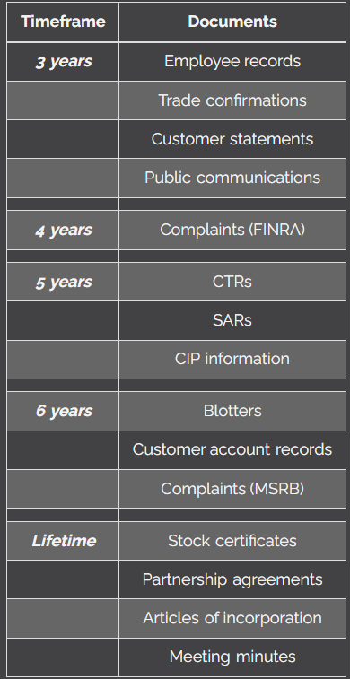
- Customer complaints
  - FINRA requires 4 years retention period
  - MSRB requires 6 years retention period
- Lifetime
  - SPAM
    - Stock certs, partnership agreements, articles of incorporation, meeting minutes

