
SEMESTER II
SESSION 2025/2026

WQD7013 STATISTICS FOR DATA SCIENCE
OCCURRENCE 1

MODULE LEADER: DR HAMZA H. M. ALTARTURI

GROUP 8
ASSIGNMENT 1

DATA EXPLORATION, PROBABILITY AND STATISTICAL DISTRIBUTIONS

No. | NAME | MATRIX NO.
1 | AIMI SOFIYAH BINTI UMAR | 25088138
2 | LEE RE XUAN | 24071969
3 | MOHAMAD ZIQRY BIN ZULKIFLI | S2153309
4 | NG ZHI WEI | 24231967
5 | SAM YEE THONG WAH | 24209652
6 | TAUFIQ HAIKAL BIN MOHAMAD SUFFIAN | U2103686
Table of Contents
Task A: Dataset Audit and Variable Classification 1
A1: Structural Inspection 1
A2: Variable Classification 2
A3: Missing Data Diagnosis 4
A4: Data Quality Narrative 6
Task B: Descriptive Statistics and Distribution Shape 6
Task C: Visualisation Audit and Storytelling 6
Task D: Probability Theory and Bayesian Reasoning 6
D2: Monte Carolo Simulation 9
D3: Bayesian Update on Real Data 10
Task E: Statistical Distributions and Model Fitting 11
Task F: The Central Limit Theorem and Sample Size Planning 13
F1 : CLT Demonstration 13
F2 : Sample Size Planning 16
Reference 20

Task A: Dataset Audit and Variable Classification

A1: Structural Inspection
The dataset contains information on 814 players across 18 attributes. An initial inspection of the data types inferred by pandas reveals that 11 columns are incorrectly classified, largely due to the presence of missing values and inconsistent formatting. Importantly, there are no duplicate rows, which confirms that each player record is unique.
Table 1: Summary of Missing Values
Variables | Missing Count | Missing Percentage (%)
National Team Kit Sponsor | 1 | 0.12
National Team Jersey Number | 1 | 0.12
Appearances | 153 | 18.80
Goals Scored | 230 | 28.26
Assists Provided | 230 | 28.26
Dribbles per 90 | 251 | 30.84
Interceptions per 90 | 251 | 30.84
Tackles per 90 | 259 | 31.82
Total Duels Won per 90 | 281 | 34.52
Save Percentage | 776 | 95.33
Clean Sheets | 776 | 95.33
Brand Sponsor/Brand Used | 1 | 0.12

Several misclassifications have significant implications for analysis. For example, FIFA Ranking was inferred as a continuous integer, but it is in fact an ordinal categorical variable. Treating ranks as continuous implies equal spacing between ranks, which is misleading for regression or averaging. Similarly, National Team Jersey Number was inferred as a float, though jersey numbers are discrete integers. Allowing fractional jersey numbers could cause confusion in grouping or plotting. Player DOB was identified as an object rather than a datetime, which prevents age calculations and time-based grouping.
The most critical misclassifications occur in the performance statistics (Appearances, Goals Scored, Assists Provided, Dribbles per 90, Interceptions per 90, Tackles per 90, Total Duels Won per 90, Save Percentage, Clean Sheets). Pandas inferred these as objects, but they should be numeric (either integers or floats depending on the variable). As text, these columns cannot be used to compute averages, correlations, or statistical models, which severely limits their analytical utility. Finally, Save Percentage was also inferred as an object because of the percentage symbol in the raw data. This should be a continuous numeric variable and leaving it as text blocks meaningful analysis of goalkeeper performance.
In summary, while the dataset is structurally sound with no duplicate rows, the incorrect data type assignments must be corrected before analysis. Converting dates to datetime, percentages to numeric proportions, and performance statistics to appropriate numeric types will ensure valid statistical summaries and modelling. Without these corrections, any downstream analysis risks being misleading or incomplete.
Table 2: Inferred Data Types
Variables | Pandas Inferred Type | Correct Data Type
Nationality | object | True. Categorical
FIFA Ranking | int64 | True. Numeric
National Team Kit Sponsor | object | True. Categorical
Position | object | True. Categorical
National Team Jersey Number | float64 | Misclassified. Integer, jersey number is whole number.
Player DOB | object | Misclassified. Datetime
Club | object | True. Categorical
Player Name | object | True. Categorical
Appearances | object | Misclassified. Integer
Goals Scored | object | Misclassified. Integer
Assists Provided | object | Misclassified. Integer
Dribbles per 90 | object | Misclassified. Float
Interceptions per 90 | object | Misclassified. Float
Tackles per 90 | object | Misclassified. Float
Total Duels Won per 90 | object | Misclassified. Float
Save Percentage | object | Misclassified. Float
Clean Sheets | object | Misclassified. Float
Brand Sponsor/Brand Used | object | True. Categorical

A2: Variable Classification
During the inspection of the dataset, two variables stand out as being misclassified by pandas due to their formatting and conceptual nature, for example FIFA Ranking and Save Percentage. Both require correction to ensure valid statistical analysis.
FIFA Ranking was inferred by pandas as a numeric variable (int64). While rankings are expressed as integers, they are not truly continuous numerical values. FIFA rankings are ordinal categorical, the order matters, like rank 1 is better than rank 10, but the differences between ranks are not equal intervals. For example, the gap between rank 1 and 2 may not represent the same performance difference as the gap between rank 50 and 51. If misclassified as continuous, analysts might compute averages or regression slopes that falsely assume equal spacing, leading to misleading conclusions. Correct classification as ordinal ensures appropriate methods are used, such as medians, rank-based tests, or non-parametric approaches, avoiding false assumptions about linearity.
Save Percentage was stored as text with a % sign, so pandas inferred it as an object. Conceptually, this variable is a continuous numerical proportion ranging between 0 and 100. If left as categorical text, averages, correlations, and visualizations cannot be computed properly, blocking quantitative analysis. Correct conversion to numeric allows calculation of mean save rates, comparison across goalkeepers, and inclusion in performance models. Misclassification here would distort summary statistics and prevent meaningful insights into goalkeeper performance.

Table 3: Classification Table
Variable | Measurement Type | Role | Summary Statistic | Visualisation
Nationality | Nominal categorical | Identifier | Frequency count | Bar chart
FIFA Ranking | Ordinal categorical | True feature | Median rank | Bar chart
National Team Kit Sponsor | Nominal categorical | Identifier | Mode | Bar chart
Position | Nominal categorical | True feature | Frequency count | Bar chart
National Team Jersey Number | Discrete numerical | Identifier | Range | Histogram
Player DOB | Continuous numerical | Identifier | Min/Max date | Histogram (ages)
Club | Nominal categorical | Identifier | Frequency count | Bar chart
Player Name | Nominal categorical | Identifier | N/A | N/A
Appearances | Discrete numerical | True feature | Mean | Histogram
Goals Scored | Discrete numerical | True feature | Mean | Histogram
Assists Provided | Discrete numerical | True feature | Mean | Histogram
Dribbles per 90 | Continuous numerical | True feature | Mean | Boxplot
Interceptions per 90 | Continuous numerical | True feature | Mean | Boxplot
Tackles per 90 | Continuous numerical | True feature | Mean | Boxplot
Total Duels Won per 90 | Continuous numerical | True feature | Mean | Boxplot
Save Percentage | Continuous numerical | Derived field | Mean | Histogram
Clean Sheets | Discrete numerical | Derived field | Sum | Bar chart
Brand Sponsor/Brand Used | Nominal categorical | Identifier | Mode | Bar chart

A3: Missing Data Diagnosis
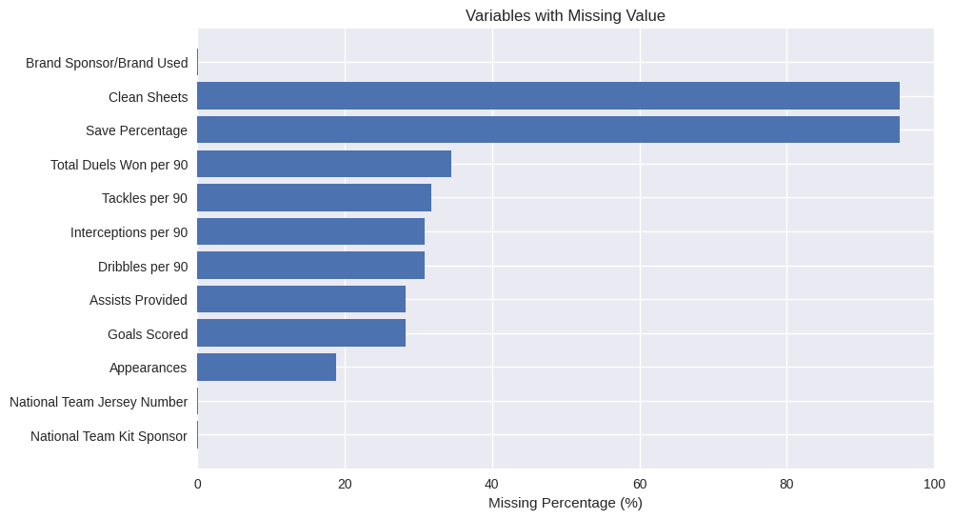
Graph 1: Variables with Missing Values
Based on Table 1 and Graph 1 show that missingness is structured rather than random. Two variables, Save Percentage and Clean Sheets, have extremely high missingness of about 95 percent. This pattern is expected because these statistics apply only to goalkeepers, meaning that for outfield players the absence of values reflects non-applicability rather than data errors. Several performance metrics, including Appearances, Goals Scored, Assists Provided, Dribbles per 90, Interceptions per 90, Tackles per 90, and Total Duels Won per 90, display moderate missingness ranging from 18 to 35 percent. This is consistent with match participation, as players who did not play have missing performance statistics. In such cases, imputing missing values with zero is logical, since it accurately represents non-participation. Finally, sponsorship and jersey information such as National Team Kit Sponsor, National Team Jersey Number, and Brand Sponsor/Brand Used show very low missingness of around 0.12 percent. These gaps are likely due to random data entry errors and can be handled with simple imputation or by dropping the few affected rows.
Taken together, the analysis confirms that missingness in this dataset is not random noise but reflects meaningful patterns tied to player roles and participation. Goalkeeper metrics should be treated separately or imputed with zero to represent non-applicability, performance statistics can be safely imputed with zero to reflect non-participation, and rare categorical gaps can be corrected with straightforward methods. Recognizing these patterns ensures that imputation strategies are chosen appropriately, avoiding bias and preserving the integrity of the analysis.
All the numeric variables in this dataset are more suitable for zero imputation rather than mean or median imputation. This is because missingness in these variables reflects non-participation or non-applicability rather than random data loss. For example, if a player did not appear in matches, their goals, assists, tackles, or duels are missing because they did not contribute, and imputing with zero correctly represents “no contribution.” Using mean or median imputation would artificially inflate values by assigning performance statistics to players who never played, which misrepresents reality. Similarly, goalkeeper-specific metrics such as Save Percentage and Clean Sheets are missing for outfield players because they are not applicable; imputing with zero is a logical way to encode this absence. Deleting rows with missing values is also not suitable, as it would remove large portions of the dataset and bias the analysis toward only those players with complete statistics, ignoring the fact that data may have been collected specifically for goalkeepers or outfield players. Zero imputation therefore preserves the dataset size, maintains the integrity of player roles, and provides a more accurate reflection of overall squad contribution.
Table 4: Type of Missingness
Type of Missingness | MCAR  Missing Completely at Random | MAR  Missing at Random | MNAR  Missing Not at Random
Definition | Missingness is unrelated to any variable in the dataset | Missingness depends on observed variables | Missingness depends on unobserved variables or the value itself
Example in Dataset | Random data entry errors (Kit Sponsor, Jersey Number, Brand Sponsor) | Performance stats missing because player did not appear in matches (Goals, Assists, Tackles, Duels) | Goalkeeper stats missing for outfield players (Save Percentage, Clean Sheets)
Pros | Random gaps do not bias analysis | Missingness tied to participation, which we can observe | Missingness reflects role-specific applicability
Handling Way | Drop affected rows or use simple imputation (mean/median/mode) | Logical imputation (zero imputation) | Stratify by player role (goalkeepers vs. outfield) or analyse separately

When we compare the three strategies for handling missing values, the differences in the mean and standard deviation become clear. If we delete rows with missing values, the averages are much higher because only players with complete records remain, but this approach is misleading since it ignores non-participants and often leaves too few rows to calculate variability. Median imputation produces moderate averages and smaller standard deviations because replacing missing values with the median smooths the data, but this artificially reduces variation and gives players who never played some performance statistics. Zero imputation, on the other hand, lowers the averages because missing values are replaced with 0, which correctly represents “no contribution” for players who did not participate or for statistics that do not apply to them. It also keeps all rows in the dataset and maintains variability, especially for goalkeeper metrics where missingness is role-specific. Overall, zero imputation is the most suitable strategy here because it reflects the true meaning of missingness in this dataset, avoids bias toward active players, and preserves the full dataset for analysis.

A4: Data Quality Narrative
The FIFA WC 2022 player dataset contains 814 rows and 18 attributes, offering a broad view of player performance and sponsorship details. Overall, the dataset is fit for statistical analysis once key data quality issues are addressed. The structure is sound, with no duplicate rows, and categorical variables such as nationality, club, and position are complete. However, numeric variables require careful handling due to systematic missingness.
The two most serious quality issues are misclassified data types caused by missing values and formatting inconsistencies, and high missingness in role-specific variables. Many numeric performance statistics (goals, assists, tackles etc.) are stored as text objects, preventing direct computation. Save Percentage and Clean Sheets are missing for about 95% of players because they apply only to goalkeepers. These issues were addressed by converting performance statistics to numeric types and applying zero imputation, which correctly represents non-participation or non-applicability. Zero imputation was chosen over mean or median imputation because it preserves the semantics of the data and avoids inflating averages for players who did not contribute.
A key decision that affects the validity of subsequent analysis is the choice of zero imputation as the default strategy. While this lowers averages compared to deletion or median imputation, it ensures that the dataset reflects the entire squad rather than only active players. Analysts must interpret results with this in mind, recognizing that averages represent squad-level contribution rather than performance of participants only.

Task B: Descriptive Statistics and Distribution Shape
Sam

Task C: Visualisation Audit and Storytelling
Ziqry

Task D: Probability Theory and Bayesian Reasoning
D1: Analytical Probability
In this subsection, the statistical independence between variables will be tested. Therefore, a question was formulated to test this, which is “Does a player assigned role (Position) significantly change the probability of the event (Scoring)?”
We will work on the original dataset as to compute the probability of events in the World Cup, and get an accurate P(Scoring), we need to include all 814 players who were there, not just the tiny subset that had perfect data across every single column. To get the counts, we will use the the dataframe after column names were cleaned, but before the rows were deleted.

Categorical Variables (A),
let,
Forward position, (A=a1)
Other positions, (A=a2)
Binary Indicator (B),
let,
Scored a Goal, (B=1)
Did not Score, (B=0)

We then establish our contingency table of observed counts as shown in Table D1.
Table D1: Contingency Table for Position & Scoring
 | Did Not Score (B=0) | Scored (B=1) | Total
Forward (A=a₁) | 136 | 64 | 200
Other (A=a₂) | 563 | 51 | 614
Total | 699 | 115 | 814

Marginal Probabilities,
Probability that the player is a Forward (A=a₁),
$$P\left(A=a_{1}\right)\text{= }\frac{n\left(A=a_{1}\right)}{n\left(B=1\right)}$$
$$\text{= }\frac{200}{814}$$
$$\text{= }0.2457$$
Probability that the player scored a goal (B=1),
$$P\left(B=1\right)\text{= }\frac{n\left(B=1\right)}{N}$$
$$\text{= }\frac{115}{814}$$
$$\text{= }0.1413$$

Joint Probability
probability is a Forward AND Scored, P(A=a₁ AND B=1),
$$P\left(A=a_{1}∧B=1\right)\text{= }\frac{n\left(B=1\right)}{N}$$
$$\text{= }0.0786$$

Conditional Probabilities,
Probability of scoring GIVEN the player is a Forward P(B=1 | A=a₁),
$$P\left(B=1\text{|}A=a_{1}\right)=\frac{n\left(B=1\right)}{n\left(A=a_{1}\right)}$$
$$\text{= }\frac{64}{200}$$
$$\text{= }0.3200$$
Probability of player being a Forward Given the Player Scored P(A=a₁ | B=1),
$$P\left(A=a_{1}\text{|}B=1\right)\text{= }\frac{n\left(B=1\right)}{\sum{n}\left(B=1\right)}$$
$$\text{= }\frac{64}{115}$$
$$\text{= }0.5565$$

Verifying the Bayes’ Theorem
Bayes' theorem uses conditional probabilities to update the probability of a hypothesis as more evidence or information becomes available. It relates the conditional and marginal probabilities of random events. It is expressed as;
$$P\left(A\text{|}B\right)\text{= }\frac{P\left(B\text{|}A\right)×P\left(A\right)}{P\left(B\right)}$$

From the Python implementation code, we have calculated P(B|A) to be 0.5565, which is the left side of the equation. Now, to verify, we can calculate the right side of the equation,
$$P\left(B\text{|}A\right)\text{= }\frac{P\left(B\text{|}A\right)×P\left(A\right)}{P\left(B\right)}$$
$$\text{= }\frac{\left(0.3200\right)×\left(0.2457\right)}{\left(0.1413\right)}$$
$$\text{= }0.5564$$
We found that the probability of a player being a Forward given that they scored (0.5565) is equal to the probability of a Forward scoring (0.3200) multiplied by the baseline probability of being a Forward (0.2457), divided by the baseline probability of anyone scoring (0.1413).

D2: Monte Carolo Simulation

The Law of Large Numbers
The Law of Large Numbers states that as the number of trials increases, the empirical (observed) probability converges to the theoretical true probability. In the plot for D2a, the running proportion of heads fluctuates wildly at n=10 and n=100. However, by n=100,000, the line stabilizes and rests exactly on the red dashed line representing the true probability of 0.35. This visualization shows the adherence to the Laws of Large Numbers.

The Role of Sampling with Replacement
In D2(b), P(Scoring∣Forward) was estimated using the Monte Carlo Bootstrap method. Sampling with replacement is crucial here because it treats our single dataset of Forwards as if it were the entire population. By randomly drawing rows and allowing the same player to be picked more than once, we simulate thousands of parallel 'alternate' datasets. Averaging these 50,000 sample realities yielded an estimate (≈0.3200) that perfectly aligns with our analytical finding from D1, demonstrating the reliability of resampling techniques.

Why the Birth Month Probability Rises Quickly
Your Justification: "The simulated probabilities in D2c show that the chance of a shared birth month increases remarkably fast, reaching nearly 100% by a group size of 20. This happens because we are not comparing individuals to one specific person; we are comparing every possible pair in the group. The number of possible pairs grows exponentially as k increases $\left(\frac{k\left(k-1\right)}{2}\right)$, meaning the opportunities for a match multiply extremely rapidly.
Analytical calculation for $k=\left(1-\left(\frac{12}{12}\right)×\left(\frac{11}{12}\right)×\left(\frac{10}{12}\right)×\left(\frac{9}{12}\right)×\left(\frac{8}{12}\right)≈0.618\right)$ assumes two things, first, that there are exactly 12 discrete months, and second, that births are uniformly distributed (meaning every month is equally likely to be a birth month). In the real world, this is slightly violated because some months have 31 days while February has 28, and certain seasons have higher birth rates.

D3: Bayesian Update on Real Data

Terms in Context
The Prior P(H) represents our initial belief about the probability of an event before seeing any new evidence. In this context, it is the probability that a randomly selected player from the World Cup is a Forward, which is 0.2457.
The Likelihood P(E∣H) measures how likely we are to see the evidence if our hypothesis is true. Here, it is the probability that a player scored a goal given that they are a Forward (0.3200).
The Posterior P(H∣E) is the updated belief after accounting for the new evidence. If we are told that a specific player scored a goal, Bayes' theorem updates the probability of that player being a Forward from 0.2457 to 0.5565.

Prior Sensitivity
Prior sensitivity evaluates how much our final answer (the Posterior) changes if we start with different initial assumptions (the Prior), while keeping the observed evidence (Likelihoods) constant.
From the plotted graph, As the prior increases from 0.1 to 0.9 along the x-axis, the posterior curve also moves up. Because the blue curve sits strictly above the dashed diagonal line, it shows that "Scoring a goal" is strong positive evidence that always boosts the probability that a player is a Forward, regardless of where our prior started.

When the Prior Dominates vs. When Data Swamps the Prior
The prior dominates the posterior when the new evidence is weak or uninformative. Mathematically, this happens when the likelihood of the evidence is nearly the same whether the hypothesis is true or false (P(E∣H)≈P(E∣¬H)). It also happens when the prior is extremely dogmatic (very close to 0 or 1); if you are 99.9% certain of something, minor evidence won't change your mind.
The data swamps the prior when the evidence is extremely compelling. In our dataset, the likelihood of a Forward scoring (0.3200) is vastly different from a Non-Forward scoring (0.0831). Because this difference in likelihoods is so sharp, the data strongly tugs the posterior upward. Even if we had started with an artificially low prior belief (e.g., a prior of just 10%), the strong evidence from the dataset still pulls the posterior up significantly (to around 30%).

Task E: Statistical Distributions and Model Fitting
E1: Normality Assessment
The Q-Q plot compares our dataset's empirical quantiles (y-axis) against the theoretical quantiles of a perfectly normal distribution (x-axis), which forms a straight diagonal line. Right-skew appears as points curving upwards above the diagonal line on the right side. Left-skew appears as points curving downwards below the line on the left side. Heavy tails appear as points deviating significantly from the line at both extreme ends. For Total Duels Won per 90, the middle quantiles follow the diagonal closely, though zero-imputation creates a vertical stack at the bottom. Conversely, Interceptions per 90 is heavily right-skewed.
For the Shapiro-Wilk test, the null hypothesis (H₀) is that the data is drawn from a normally distributed population, and the alternative hypothesis (H₁) is that it is not. Both variables yielded a p-value < 0.05, leading us to reject H₀. Because our sample size is very large (over 800 players), the standard error becomes extremely small. Consequently, the Shapiro-Wilk test possesses immense statistical power, meaning it will flag even trivial, non-practical deviations from perfect normality (like our zero-imputed values) as statistically significant.

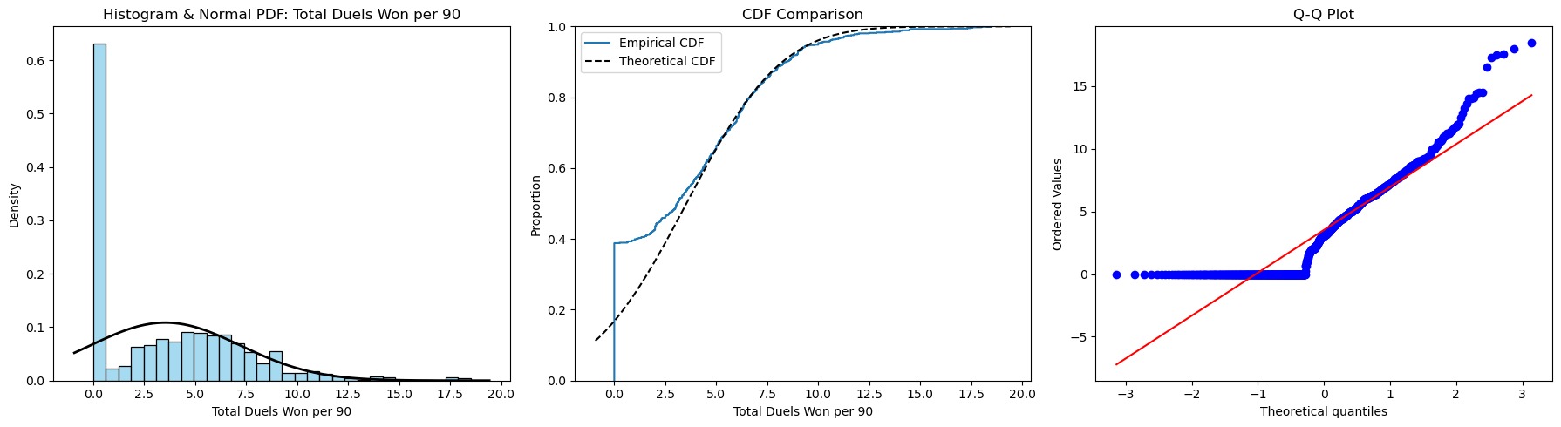
Graph E1-1: Histogram, CDF, Q-Q Plot for Total Duels
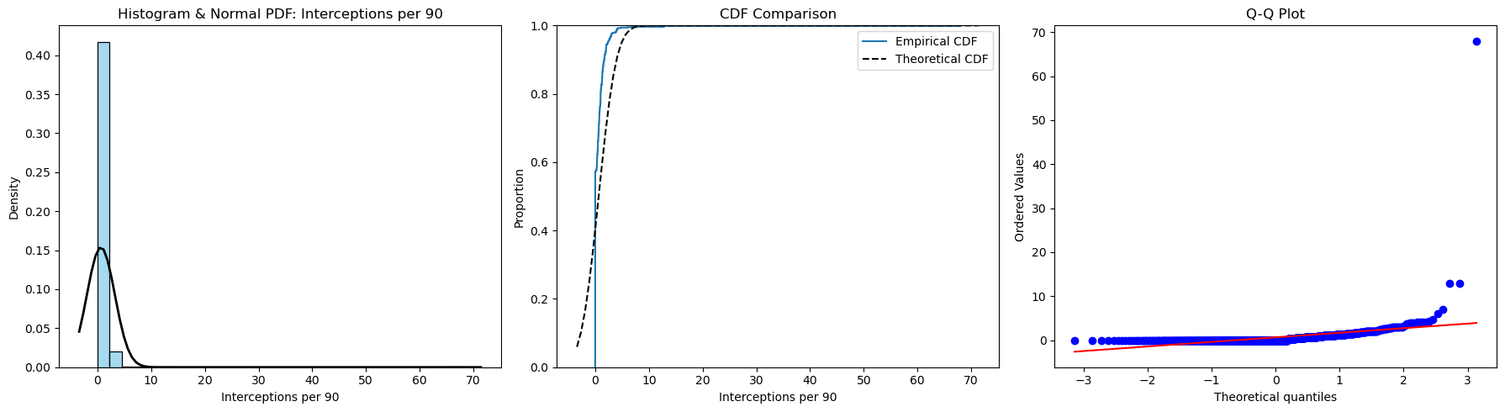
Graph E1-2: Histogram, CDF, Q-Q Plot for Interceptions

E2: Normality Assessment
A Poisson model requires four theoretical conditions: 1) Events must occur independently, 2) The average rate of events (λ) is constant, 3) Two events cannot occur at the exact same instant; 4) The probability of an event in a given interval is proportional to the interval's length. In the context of football goals, these assumptions are violated. Goals are not strictly independent, and the scoring rate varies drastically between players.
The Poisson model dictates that mean equals variance (Dispersion Ratio = 1). Our empirical dispersion ratio was heavily > 1, indicating severe over-dispersion. Poisson fails here because it cannot accommodate this excess variance. The Negative Binomial distribution is a natural generalisation because it introduces a second parameter that explicitly models the over-dispersion, allowing the variance to safely exceed the mean and fitting our empirical data much better.

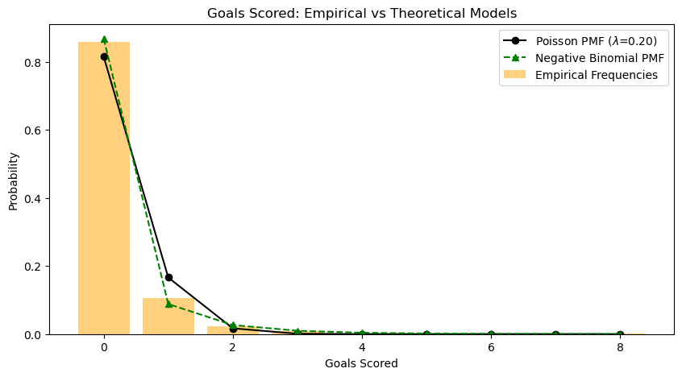
Graph E2: Bar Chart showing Poisson and Negative Binomial PMF lines

E3: Normality Assessment
Mathematically, the Normal Probability Density Function relies exclusively on two parameters: the mean (μ) and the standard deviation (σ). All other terms in the equation are mathematical constants (π and e). Therefore, μ perfectly defines the exact location of the centre, and σ completely defines the spread or width of the bell curve, allowing us to calculate any exact area under the curve.
Using our fitted normal model, we verified the empirical rule: the calculated probability mass within one standard deviation is approximately 68.27%, and within two standard deviations is approximately 95.45%. Additionally, the maximum z-score indicates exactly how many standard deviations the highest value lies above the mean. Under a normal model, an extreme z-score implies the probability of observing such a high value by random chance is infinitesimally small, marking it as a severe outlier.

E4: Normality Assessment
Mathematically, a variable X is lognormally distributed if its natural logarithm, Y = ln(X), is normally distributed. Lognormal data is typically generated by multiplicative, compounding processes rather than additive ones.
However, since our Interceptions per 90 variable contains exact zero values, ln(0) is mathematically undefined. Thus, we applied a square-root transformation, which is standard practice for zero-inflated data. After transformation, the interpretation changes from a linear scale of "interceptions" to a compressed scale. The heavy right tail is pulled inward, making the distribution symmetrically bell-shaped, which satisfies the assumptions of parametric statistical models.

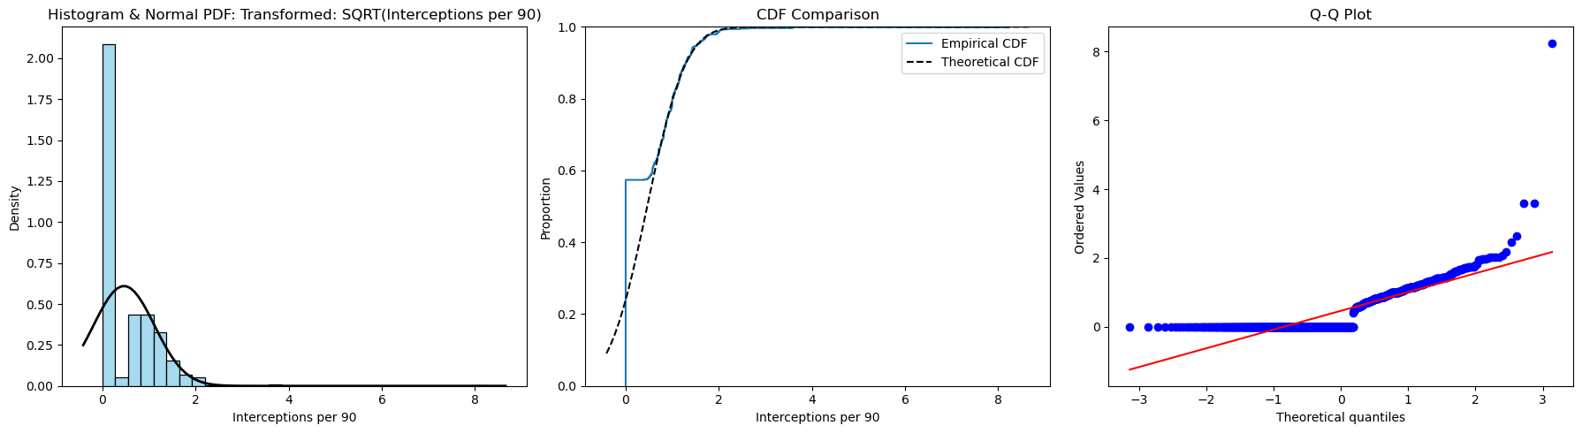
Graph E4: Histogram, CDF, Q-Q Plot for transformed Square-Root data

Task F: The Central Limit Theorem and Sample Size Planning

F1 : CLT Demonstration
For this task, 'Interceptions per 90' as the non-normal numerical variable is selected. Preliminary exploratory data analysis conducted in Task B1 confirmed that this variable deviates substantially from normality, exhibiting extreme right-skewness (skewness = 21.911389) and extremely heavy tails (excess kurtosis = 559.108665). A Shapiro–Wilk test formally rejected the null hypothesis of normality (𝑝 < 0.001).
Given the absence of a known theoretical population, the empirical distribution of all 814 players with valid observations prepared during the data cleaning and imputation procedures of Task E was treated as the finite population for resampling. The population parameters were computed directly from this cleaned dataset:
- Population size, $N = 814$
- Population mean, $μ = 0.6414$
- Population standard deviation, $σ = 2.5930$
To examine the behaviour of the sampling distribution under repeated sampling, a bootstrap resampling procedure was implemented. For each predetermined sample size $n ∈ \left\{2, 5, 15, 30, 100\right\}$, 5,000 independent samples were drawn with replacement from the empirical population. The arithmetic mean was calculated for each replication, yielding an empirical sampling distribution of ${\overline{X}}_{n}$ for each$n$.
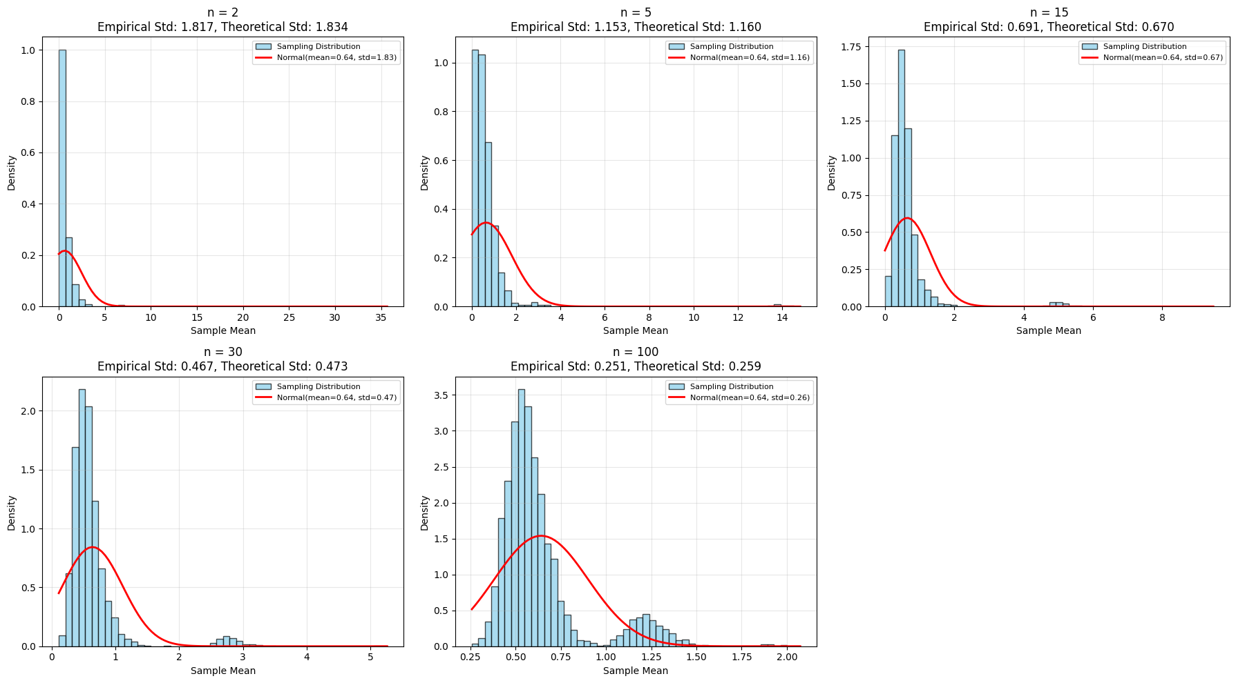
Figure F1: Histograms of sampling distributions for $n=2, 5, 15, 30, 100$ with overlaid CLT normal curves
Table F1: Empirical vs Theoretical Comparison
$$n$$ | Empirical Mean,  $$\overset{̿}{x}$$ | Theoretical Mean,  $$μ$$ | Empirical Std. Error,  $$s_{\overline{x}}$$ | Theoretical Std. Error,  $$\left(\frac{σ}{\sqrt{n}}\right)$$ | Ratio,  $$\left(\frac{s_{\overline{x}}}{\left(σ/{\sqrt{n}}\right)}\right)$$
2 | 0.631198 | 0.6414 | 1.739200 | 1.833556 | 0.948539
5 | 0.622290 | 0.6414 | 1.006015 | 1.159643 | 0.867521
15 | 0.620707 | 0.6414 | 0.633060 | 0.669520 | 0.945543
30 | 0.637608 | 0.6414 | 0.472874 | 0.473422 | 0.998843
100 | 0.644532 | 0.6414 | 0.261578 | 0.259304 | 1.008771

Formal Statement of the Central Limit Theorem
Let $X_{1}, X_{2}, … , X_{n}$ be independent and identically distributed (i.i.d.) random variables drawn from a population with finite mean, $μ$ and finite variance, $σ^{2}$. Define the sample mean as ${\overline{X}}_{n} = \frac{1}{n}\sum_{i = 1}^{n}{X_{i}}$. Then, as $n → ∞$, the standardized sample mean converges in distribution to a standard normal random variable:
$$Z_{n} = \frac{{\overline{X}}_{n} - μ}{σ/{\sqrt{n}}} → N\left(0,1\right)$$
Equivalently, the sampling distribution of ${\overline{X}}_{n}$ approaches a normal distribution with mean $μ$ and variance $\frac{σ^{2}}{n}$, irrespective of the shape of the underlying population distribution, provided that the sample size is sufficiently large and the population moments are finite.

Interpretation of $\frac{σ}{\sqrt{n}}$ & Numerical Verification of the Square Root Law
The term $\frac{σ}{\sqrt{n}}$ represents the standard error of the mean, which quantifies the expected variability of sample means around the population mean $μ$. The Square Root Law describes the inverse-square-root relationship between sample size and sampling variability. As $n$ increases, the standard error decreases proportionally to $\frac{1}{\sqrt{n}}$. This relationship was verified numerically using the simulation results presented in Table F1. Theoretical standard errors were calculated as $\frac{σ}{\sqrt{n}}$ using the population standard deviation $σ = 2.5930$, derived from the cleaned dataset prepared in Task E. Illustrative calculations include:
  - At $n = 2$:
$$\frac{σ}{\sqrt{2}} = \frac{2.5930}{1.4142} = 1.8336$$
- At $n = 100$:
$$\frac{σ}{\sqrt{100}} = \frac{2.5930}{10} = 0.2593$$
The final column of Table F1 reports the ratio of the empirical standard deviation of the sample means $\left(s_{\overline{x}}\right)$ to the theoretical standard error $\left(\frac{σ}{\sqrt{n}}\right)$. Across all sample sizes, this ratio remains tightly clustered around $1.0$( range : $0.8675$to $1.0088$). The convergence of this ratio toward unity as $n$increases provides strong numerical evidence that the empirical sampling variability aligns with the theoretical $\frac{σ}{\sqrt{n}}$ relationship. This result confirms the Square Root Law within the bootstrap sampling framework and demonstrates that the simulated sampling distributions behave as predicted by asymptotic theory.

Convergence to Normality and Critical Evaluation of the $n$ ≥ $30$Heuristic
Visual inspection of Figure F1 illustrates the progressive symmetrisation of the sampling distribution as sample size increases:
- $n = 2$ and$n = 5$:
Distributions are heavily right-skewed with probability mass concentrated near zero. The theoretical normal curve provides a poor fit, confirming that the Central Limit Theorem has not yet taken effect at these small sample sizes.

- $n = 15$:
The distribution begins to spread, but pronounced right-skewness remains. The normal curve underestimates the sharp peak near zero and fails to capture the extended right tail.

- $n = 30$ :
Symmetry improves relative to smaller $n$, but the histogram still exhibits noticeable right-skewness and a secondary mode in the upper range. The normal curve approximates the central mass but does not adequately model the tail behaviour. Contrary to the common heuristic, $n = 30$does not yield a convincingly normal sampling distribution for this variable.

- $n = 100$:
The distribution is substantially more symmetric and bell-shaped. While a minor rightward extension persists, the normal curve now provides a reasonable approximation across most of the range, indicating that convergence is approaching practical adequacy.

Evaluation of the $n$≥ $30$Rule
Given the extreme skewness and heavy tails of the parent population, the widely cited heuristic that $n$≥ 30 ensures approximate normality is inadequate for this variable. At $n = 30$, the sampling distribution remains visibly non-normal, demonstrating that the rule of thumb breaks down under conditions of severe distributional asymmetry. For reliable normal approximation in this context, a larger sample size ( $n$ ≥ $50 - 100$) is required. This result underscores that the $n$ ≥ $30$guideline should be applied cautiously and validated visually or via diagnostic tests when analysing highly skewed data.

F2 : Sample Size Planning
Conservative Sample Size Calculation
To guarantee the desired precision regardless of the true population proportion, we first apply the conservative bound $p = 0.5$, which maximises the variance term $p\left(1-p\right)$. The assignment specifies a target total confidence interval width of ≤ $0.06$. Since the margin of error $E$represents the half-width on either side of the point estimate, we have:
$$E = \frac{Total Width}{2} = \frac{0.06}{2} = 0.03$$
Using the standard normal critical value $z_{\frac{α}{2}} = 1.96$ for a $95$% confidence level :
$$n_{exact} = \frac{z_{α/2 }^{2}⋅ p\left(1-p\right)}{E^{2}} = \frac{{1.96}^{2} ⋅ 0.5 ⋅ 0.5 }{{0.03}^{2}} = 1067.0719$$
Rounding up to the nearest integer ensures the width requirement is strictly met, yielding
$n ≈ 1068$.

Sample Size Using Observed Proportion
When prior information about the population proportion is available, the required sample size can be reduced by substituting the empirical estimate $\hat{p}$ into the formula. From the cleaned dataset, the observed proportion of players with at least one goal scored is $\hat{p}=0.1413$. The required sample size is:
$$n= \frac{z_{α/2}^{2} ∙ \hat{p}(1-\hat{p})}{E^{2}}= \frac{{1.96}^{2} ∙0.1413 ∙(1-0.1413)}{{0.03}^{2}}=517.8213$$
Applying conservative rounding gives $n ≈518$. Compared to the conservative bound $\left( n ≈1068\right)$, this represents a reduction of 550 fewer observations. This efficiency gain demonstrates the practical value of incorporating reliable prior information into study design. When $p$ deviates from $0.5$, the variance term $p(1-p)$ decreases, thereby reducing the sample size required to achieve equivalent precision.

Sample Size Width Relationship & Elbow Point Analysis
The relationship between required sample size and confidence interval width follows a hyperbolic curve. Higher confidence levels 99% and 90% shift the curve upward, reflecting the larger critical values required to achieve greater coverage probability.
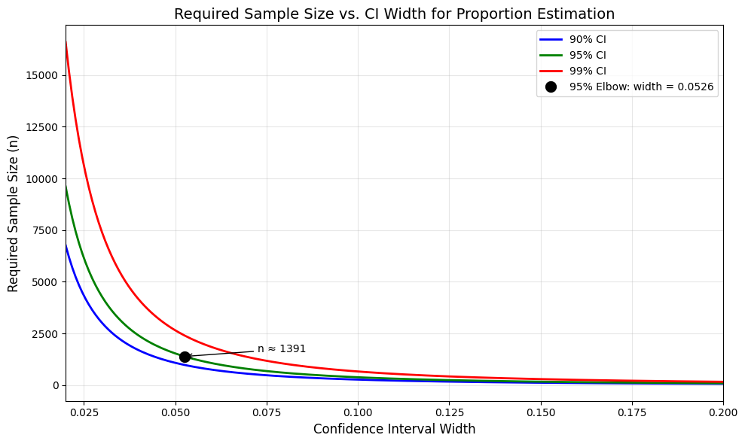
Figure F2 : Sample Size Requirements Across Confidence Levels and Interval Widths
Required sample size n as a function of confidence interval width of $0.02$ to $0.20$ for $90\%$, $95\%$, and $99\%$ confidence levels, assuming conservative proportion $p = 0.5$. The black dot indicates the elbow point for the $95\%$ confidence curve.
Using the maximum perpendicular distance method, the elbow point for the $95\%$ confidence curve occurs at width of $0.0526$, corresponding to an exact calculation of $n = 1390.3975$ and a conservative sample size of $n≈1391$. This point represents the optimal trade-off between precision and sampling cost: reducing the width below $0.0526$ requires exponentially larger sample sizes for diminishing returns in accuracy, while widening beyond this threshold sacrifices meaningful precision with minimal sample size savings. For practical study planning, this elbow provides a data-driven benchmark for balancing statistical rigour with resource constraints.

Origin of the $1.96$ Factor
The factor $1.96$ is derived from the standard normal distribution $Z∼N(0,1).$ For a $95\%$ confidence interval, the significance level is $α=0.05$, leaving $\frac{α}{2}=0.025$ in each tail. The critical value $z_{α/2}$ satisfies:
$$P\left( -{ z}_{α/2}<Z< z_{α/2}\right)=0.95$$
From standard normal tables or computational methods, the 97.5th percentile of the standard normal distribution is approximately $1.95996$, conventionally rounded to $1.96$ for practical use. This value scales the standard error to ensure that, under repeated sampling, approximately$95\%$ of constructed intervals will contain the true population proportion.

Why Sample Size Grows with the Square of 1/width
The margin of error is defined as $E= \frac{Width}{2}$. Substituting into the sample size formula for a proportion :
$$n= \frac{z_{α/2}^{2} ∙p(1-p)}{E^{2}}= \frac{z_{α/2}^{2} ∙p(1-p)}{{\left(\frac{Width}{2}\right)}^{2}}= \frac{4z_{α/2}^{2} ∙p(1-p)}{{Width}^{2}}$$
For a fixed confidence level and proportion estimate, all terms except width are constant. Therefore:
$$n ∝ \frac{1}{{Width}^{2}}$$
This inverse-square relationship explains the hyperbolic curve observed in Figure F2.

Practical Implication of Halving the Margin of Error
$n ∝ \frac{1}{E^{2}}$ halving the margin of error requires quadrupling the sample size. For example :
Margin of Error $(E)$ | Total Width | Required $n$  (Conservative, $95\%$ Cl) | Resource Impact
$$0.03$$ | $$0.06$$ | $$n≈1068$$ | Baseline
$$0.015$$ | $$0.03$$ | $$n≈4×1068=4272$$ | $4×$ more data, cost, and time

Increased precision comes at a steep, non-linear cost. Researchers must explicitly weigh whether the analytical benefit of a narrower interval justifies the exponential increase in data collection costs, time, and logistical complexity. The elbow point analysis provides a quantitative framework for making this trade-off explicit and defensible.

Reference
Data Source:
https://www.kaggle.com/datasets/rhugvedbhojane/fifa-world-cup-2022-players-statistics/data
Google Collab (Code): https://colab.research.google.com/drive/1lw9xZ7AjAiqwxZz2RTNIbxPF27n7bHC3?usp=sharing

