Searching database: IEEE

Searching keyword: pregnan\*

Then manually filtering applied.

1. Chanjira’s research mentioned an application called “Z-Baby”, which provides information about simulated baby development and calorie needs, as well as the locations of nearest hospitals (Sinthanayothin, Bholsithi, Wongwaen, & Xuto, 2014). The application is easy to operate and user-friendly, however the information provided might be limited, and the application does not provide user-interactions other than entering dates, which might not be used as an application for decision making, nor can it be used to provide joyful to pregnant women.
2. The application “IPUA” proposed by Nur considered the pregnancy surveillance needs for Islamic people. This application aims at providing surveillance information, such as “kicking” or “weight” during Islamic women’s pregnancy period and sending out emergency messages if necessary (Osman & Mohamed, 2016). However, it does not help to make women joyful, nor does it provide decision-supports in specific pregnant situations.
3. Shella proposed a decision-making system on drug management for pregnant women, and the system is based on PHP and database. And the system is able to drop the error rates of wrong drug use from 27.6% caused by human errors to 3.6% by automated detection (Wardhani, Richard, & Agung, 2016). However, the system is not able to be used on mobile devices as an application easily, which might limit its usage in pregnancy management.
4. Mohammed’s research explored a mobile-application based “Gestational Diabetes” management tool (Alotaibi & Albalawi, 2018), which is easy to use. But the accuracy and precision of such management is lacking.

Note: There are not many solutions yet proposed for managing “postpartum depression”. There are solutions to detect, but no solutions to make pregnant women happier yet.

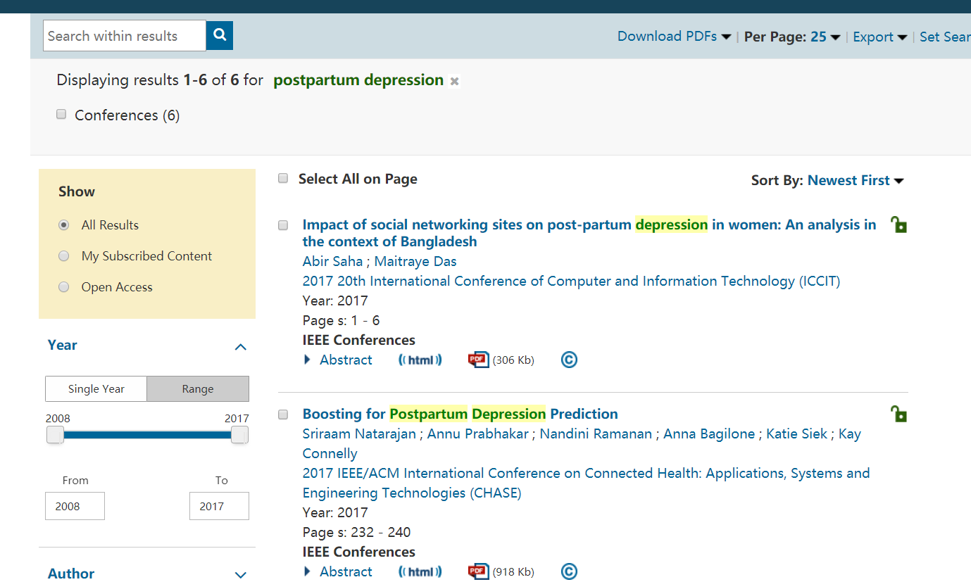

My idea is to try to design a pregnancy drug management system, and inform the pregnant women and care-givers to take managed drugs properly. To design the system, pre-recorded data about drug-reaction need to be available. The app forms an interactive processes between pregnant women, her care-givers and family members. And should able to detect:

1. Drug reactions between drugs from different practitioners.
2. Inform pregnant women to take drugs on time.
3. Auto-monitoring the women if a watch / monitor is available, and automatically alert if something is wrong.

References from my side

Alotaibi, M., & Albalawi, M. (2018). A Mobile Gestational Diabetes Management and Educational System for Gulf Countries: System Architecture. In *2018 9th IEEE Control and System Graduate Research Colloquium (ICSGRC)* (pp. 193–196). https://doi.org/10.1109/ICSGRC.2018.8657496

Osman, N. F., & Mohamed, H. H. (2016). Islamic pregnancy mobile learning application. In *2016 IEEE Conference on e-Learning, e-Management and e-Services (IC3e)* (pp. 150–155). https://doi.org/10.1109/IC3e.2016.8009057

Sinthanayothin, C., Bholsithi, W., Wongwaen, N., & Xuto, P. (2014). ZBaby: Android application for pregnancy due date, fetus development simulation and weight gain during pregnancy. In *2014 International Computer Science and Engineering Conference (ICSEC)* (pp. 62–66). https://doi.org/10.1109/ICSEC.2014.6978130

Wardhani, S., Richard, M., & Agung, S. (2016). Design of drug-pregnancy alerting system to prevent harmful drug effect for pregnant women. In *2016 6th International Conference on System Engineering and Technology (ICSET)* (pp. 67–71). https://doi.org/10.1109/ICSEngT.2016.7849625