|  |  |
| --- | --- |
| 弯道和树的图片  **Major Report on Mobile Application to Direct People to Appropriate Medical Care** | Sam Yan, 886958  e-Health Department  University of Melbourne  [jiangyuey@student.unimelb.edu.au](mailto:jiangyuey@student.unimelb.edu.au) |

Table of content

Part I: System and functional data points 3

1.1 Problem Scenario 3

1.2 Application objectives 3

1.3 Function Specifications 3

1.3.1 Data establishment 3

1.3.2 Data capture 4

1.3.3 Data check and correction 5

1.3.4 Data retrieval and process 5

1.3.5 Function rule requirements and Potential issues identified 6

1.4 Data Required for the Application 7

Part II: System and functional data points 8

Data element 1: Body Part ID 8

Definition 8

Why this definition was chosen 8

Collection of data 8

Use of data 9

Value sets 10

Identified issues 10

Data element 2: Symptom Name 10

Definition 10

Why this definition was chosen 10

Collection of data 11

Use of data 11

Value sets 11

Identified issues 11

Data element 3: Question 12

Definition v1 (Original) 12

Why this definition was chosen 12

Collection of data 12

Use of data 13

Value sets 13

Identified issues 13

Data element 4: Precise Symptom 13

Definition 13

Why this definition was chosen 14

Collection of data 14

Use of data 14

Value sets 14

Identified issues 15

Data element 5: Service type 15

Definition 15

Why this definition was chosen 15

Collection of data 15

Use of data 16

Value sets 16

Identified issues 16

References 16

Part III: Existing Standards applying to the system or data 17

Implementation Plan 17

Implementation Requirements 17

Intended Implementation Processes 18

Potential Benefits of the system bringing to clinical workflow 19

User Interface and Workflow Requirements 19

Knowledge and System Governance 20

Knowledge Management 20

Project Governance 20

Evidence Base and Feedback 21

System Improvement Important Issues 21

Change Adaptation Issues 21

Issues Identified 22

# Part I: System and functional data points

## Problem Scenario

* 1. Due to lack of medical knowledge, some people do not know when to seek medical care and which medical service is appropriate for their needs. This results in unnecessary calls to emergency services, false alarms and in appropriate use of these emergency facilities, which might mean that those with a greater need do not receive urgent care. This can also result in people failing to save themselves from suffering acute situations.
  2. In this project, a software application that can direct people to proper medical services is proposed, to help those lacking medical knowledge to decide the proper type of medical service they can refer to.

## Application objectives

1. Give patients proper advice according to the symptoms they are suffering.
2. Recommendation to patients about medical services based on the information they provided.
3. As an additional outcome, the application is able to tell the patient about the closest spot they can get the corresponding type of recommended medical service.

## Function Specifications

### Data establishment

To build this application, several data sources are required:

1. **Data about typical symptoms**: Data about typical symptoms, actions that are proper to those symptoms and services types that are able to deal with those symptoms should be collected. But this needs to be checked by a clinical team to ensure its accuracy.
2. **Data about medical organizations**: Data about type of each medical organization (ED, GP, Specialist, Poison center, Public hospital or Private hospital...) should be gathered. As a second point, information about clinicians in charge of medical services in the organization should be gathered, in terms of clinicians’ names and type of symptoms they are able to react to.
3. **Data about the patient:** Data of the age and sex of each patient should be given. Also, data about what advice given to which patients at what time should also be recorded.

After the establishment of the application, in order to target at the problem, the application should have certain inputs for capturing user inputs. It should also have certain checking mechanisms and the response to user inputs according to the retrieved data.

### Data capture

After a user starts the application, users’ data about symptoms, age and sex should be captured:

1. The application starts by asking a question “Are you entering data for yourself”, aiming at checking whether the patient is conscious or old enough for entering the data. If the answer is yes, then it is assumed that the patient is conscious and then the application displays user information input page as its first function. It accepts 2 user inputs, namely user’s age and sex. If the answer is not, a quick button on the starting page named “UNCONSCIOUS” will pop up, if user click the button, the application will direct patient to “000” page, so the user can click the button and call an ambulance.

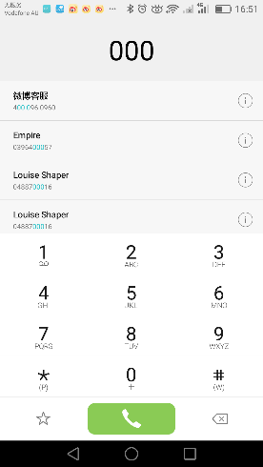

Fig 1.2-1: Demonstrated interface for calling ambulances, from my Android screen shot, for demonstration purposes only.

1. Self-diagnostic input page: A graph of anatomic human bodies of male or female, based on the sex input from function 1.

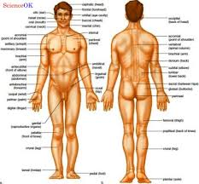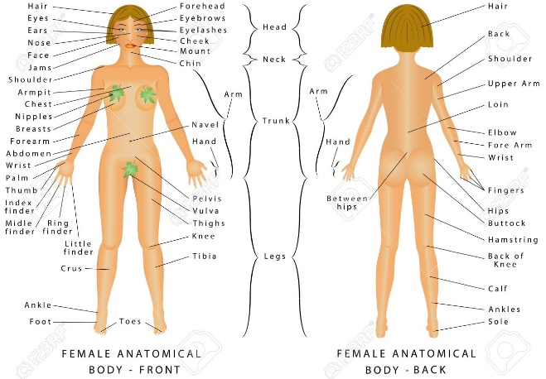

Fig 1.2-2: Front and back side of human bodies, of types of both sex, obtained from Google Image, for demonstration purposes only.

1. Users can click on the corresponding body parts displayed by the system from the figure 1.2-2 that he or she feels uncomfortable.
2. The application equates the parts that user clicked to specific coded body parts.
3. For each equated body part, the application looks for the knowledge base and retrieves possible symptoms for each of the body parts.
4. User sees the symptom lists for each body part, and is able to indicate which of these symptoms are present. If user cannot find the corresponding symptom in the list, the system can then link to its consultation service during the day, or link to the National’s 13 SICK system at nights.

### Data check and correction

1. For each of the symptom chosen by user, the application checks the symptom table:
   1. If the symptom has action advice and service type that associated with that symptom, the system fetches action advice and service type data and returns the advice and service type to users.
   2. If the chosen symptom does not have action advice and service type associated with it, the system checks what questions to ask in order to update the symptom to a more specific one; For the updated symptom, it still checks whether there is a piece of advice and service associated with it, and ask questions if needed. The system loops this procedure until the symptom is associated with a piece of advice and service, and go to step 7.1.

### Data retrieval and process

1. The advice is given based on rules defined in step 7, however, to retrieval those data and proceed results to patients, a table storing symptoms and a table storing what questions to ask when the symptom is too general need to be finished before the application runs, the formats of two tables are shown as below. An identified issue here is that those tables need to be filled up by clinicians, to ensure that the symptoms, actions, services and questions to ask can correspond to each other in the context of the system.

Table 1-8-1: Sample of data table of symptoms

|  |  |  |  |
| --- | --- | --- | --- |
| Symptom ID | Symptom | Action advice | Service type |
| 195967001 | Asthma |  |  |
| 704098003 | Asthma with an inhaler | Use the inhaler, and if you still have problems, seek help at the emergency department | Emergency Department |
| No specific code for this, have to make up own ID for this system. | Asthma without an inhaler | Go to the emergency department to obtain treatment | Emergency Department |
| 21522001 | Abdominal pain |  |  |
| …and etc. |  |  |  |

Table 1-8-2: Sample of questions should be asked to specify symptoms

|  |  |  |  |  |
| --- | --- | --- | --- | --- |
| General symptom | Question | Numerical answer | Answer content | Precise symptom |
| Asthma | Do you have an inhaler? | 1 | Yes | Asthma with an inhaler |
| 2 | No | Asthma without an inhaler |
| Abdominal pain | 21522001 | 1 | Upper right | Upper right abdominal pain |
| 2 | Upper left | Upper left abdominal pain |
| 3 | Lower right | Lower right abdominal pain |
| 4 | Lower left | Lower left abdominal pain |
| … and etc. |  |  |  |  |

### 1.3.5 Function rule requirements and Potential issues identified

1. The whole application needs a clinical team to support its data establishment and running, which is the first identified issue of the application. During data establishment, it needs clinical person to help collect enter the data and check the correctness of the data, while it is put into usage, it potentially needs clinical people to work as the “day-time consultants”.
2. The system needs to be linked to the national’s 13 SICK service. The trigger will be the time at each day when the “day-tie consultants” leaving their jobs.
3. In terms of checking the locations for the services, the application should be able to link to Google Map services (by using Google Map API, for instance).
4. In the case of users being (nearly) unconscious (suggested by user clicking the “UNCONSCIOUS” button or selecting certain acute symptoms in some body parts, e.g. a cut in artery / losing blood for more than a cup) or in an emergency situation, it is obvious that the system need to link them to the emergency system. But in order to prevent false-alarm in due to users’ accidents or kids playing with the application, users still have to press the green button to call the ambulance. This is the second identified potential issue of the system.
5. Data maintenance issues: The governance needs to constantly check the update of medical knowledge data stored in the database. Namely, those data needs to be constantly maintained, checked and updated:
   1. Australia National Data about clinicians and medical organizations, and type of treatment services they can provide.
   2. A professional collage of clinicians who check about medical knowledge about diseases and their treatments. Also, they should check types of questions to ask to decide possible disease types.
6. In order to enhance user experiences (Ux) in the future, the system might need to be linked to My Health Record, using patient’s ID provided by that system. But till this stage, in order to control the scale and budget of the system, this requirement can be implemented later.

## Data Required for the Application

* 1. Data elements required for this application are shown in fig 1.3-1. The figure demonstrates data entities and data elements that are associated with each data entity.

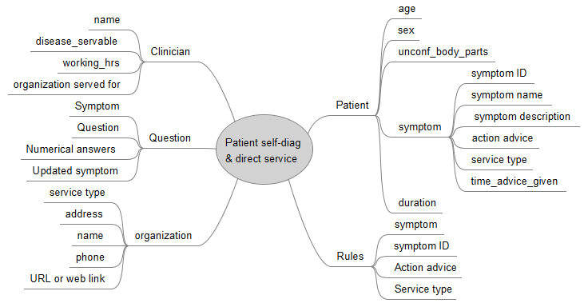

Fig 1.3-1: Mind map of data elements needed for this application, made by FreeMind on Windows 10, for demonstration purposes

* 1. According to the functions specified in part 1.2, patient data is collected for the systems to that the patient suffers, and what advice to give in term of actions and types of services. Since users’ age and sex can be input by each user at the time when the application starts, so actual data does not need to be stored in the database of this application is demonstrated in fig 1.3 – 2.

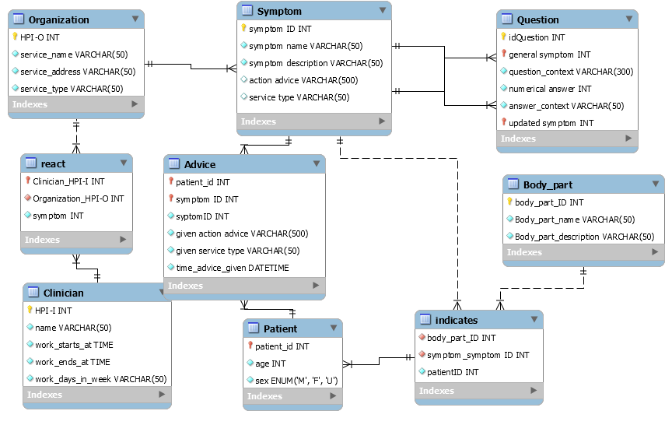

Fig 1.3-2: Data model of the database for the application to run, made by MySQL on Windows 10, for demonstration purposes. Note that the system does not users to actually input username or an id, the patient id is identified by the devices they are using. The key here is to record what the system did at what time and given advice shown on which device, as forensic evidences.

# Part II: Data required and specification

## Data element 1: Body Part ID

### Definition

Anatomical section of a person represented by a unique integer.

### Why this definition was chosen

The original definition of “body parts” from METeOR is “An anatomical part of a person's body such as organs, limbs or their components. ” [1], which is a synonym to this is “body structure”. However, in the context of this system, I would like to adapt it to representing the integer ID of that part. The ID should describe “anatomical partssuch as organs, limbs and their components.” The diagram should have a linkage to each body part ID.

### Collection of data

Clinical groups have to be involved in collecting this data and its related data elements, including body part name, body part description, symptoms can happen on this body part and distinguishing questions to be asked. Multiple resources have been checked and it is decided that the “Code” column in “Identifier Systems 4.2.13.550HL7 Version 2 Table 0550” standards should be collected as the dataset for body part IDs in this system, for several reasons:

* In the scale of this application, it is only designed for giving very basic suggestions to patients. In this case, the application has to control the scopes to avoid “scope creep” in collecting data. However, it still needs parameters and images to certain level of granularity.
* As a comparison to this collection, SNOMED-CT term “body structures” and “body parts” have been searched, also, ICF-browser version 2017 English has been looked up, they all do not fit the scope of the purpose of collection.
* ICF-Browser provides a too detailed structure in the purpose of this application, similar as “body structures” specified by SNOMED-CT. However, definitions of terminologies of “body parts” in SNOMED-CT does not meet the meaning in this context. [1], [2]

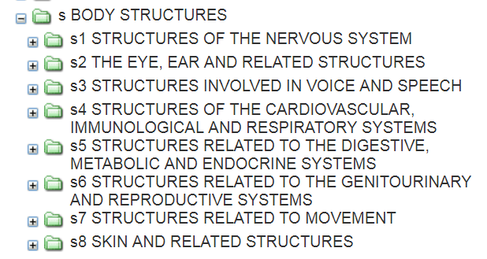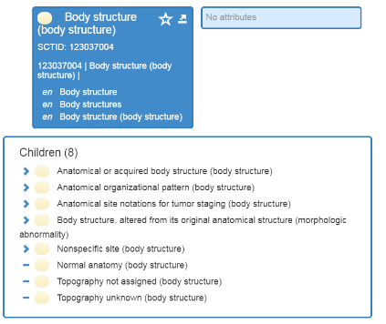

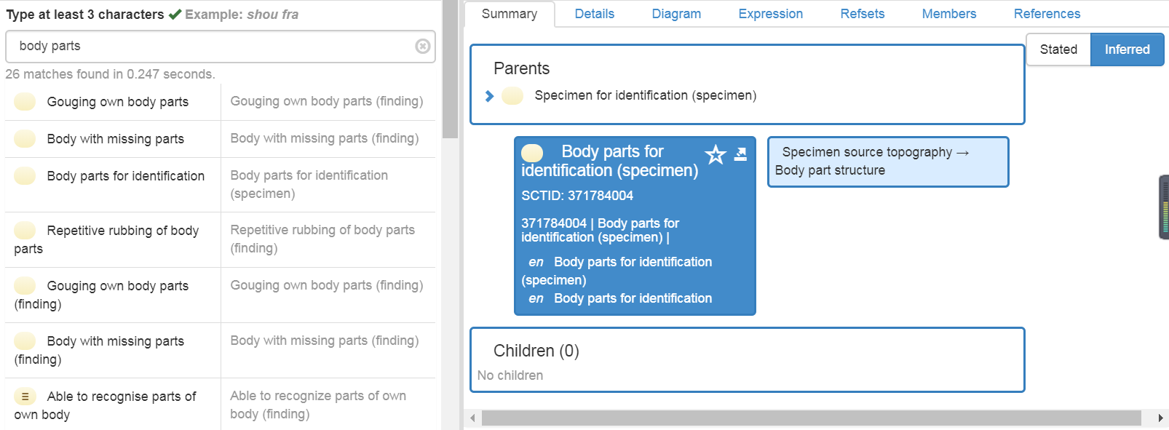

### Use of data

#### Correct use of this data

This ID IS ONLY USED IN THIS APPLICATION FOR 3 PURPOSES:

1. In searching the name and description of the body part, according to its HL7 v2 Table 0550 identifier.
2. To equate users’ chosen part in image into coded anatomical body parts that may indicate various symptoms.
3. To uniquely identify symptoms associated with chosen body parts in the knowledge system.

To use this data correctly, it is suggested that clinicians shall work with HL7 coding professions to correctly collect and use the piece of data.

#### Misuse of this data

Any other purposes specified out of the correct use are misuses of this data. For example, this data element is **NOT** used for linking patients’ treatment of certain diseases on certain body parts; it is **NOT INTENDED TO** be used to map record clinical anatomical data stored by other standards; **NEITHER** can it be used for other administrative purposes or billing purposes. General developers having no ideas about clinical terminologies and coding systems **SHALL NOT** try to use the data during the development phases themselves.

### Value sets

Including all the code sets of the data set: <http://hl7.org/fhir/v2/0550/index.html>

### Identified issues

Needs clinical governance to review the definitions of collected data, as well as a clinical team to help categorize body parts.

## Data element 2: Symptom Name

### Definition

A brief nomination of “an apparent physical or mental feature which is regarded as indicating a condition of disease”. [3]

### Why this definition was chosen

Symptom name might mean various things from findings, observations to signals. After checking OpenEHR, LONIC, ICD-11 browser and SNOMED-CT, I decided in this context “symptom name” should be meaning a brief description of an “OBSERVATION” of “the already presented or observed primary signs that lead to uncomforted or indicate a disease of the patient. ” [4], [5] Definition from LONIC is not proper because it repeats the word “symptom” in its definition, and the standard is used for laboratory purposes, which does not suit the content of this application. Definition from Oxford nearly fits the purposes, but it needs further specification that the information about the name, namely the nomination of the symptom. Definition from OpenEHR nearly fits my purpose, especially the “disturbance in an individual” part, but it is not a clinical reporting system that I aim to design, so the definition needs to be modified to fit my purpose.

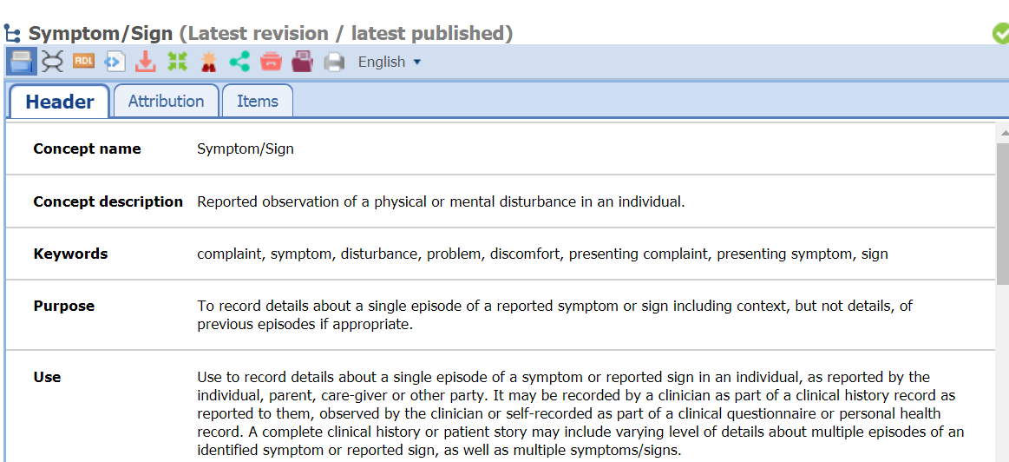

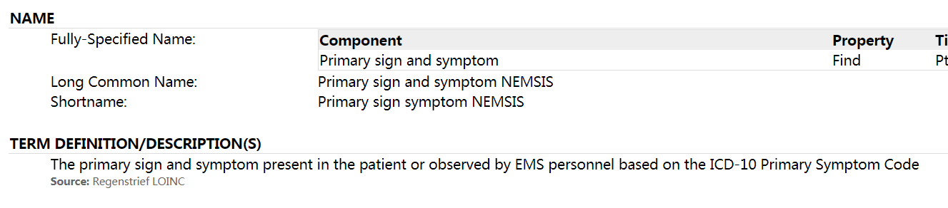

### Collection of data

Some of the data is available from the SNOMED-CT “manifestation-or-symptom” dataset, which is recorded on the website of HL7 of “manifestation-or-symptom”, which is available at: <https://www.hl7.org/fhir/valueset-manifestation-or-symptom.html>. However, due to the requirements of detailed granularity to associate symptoms to help associate to questions to ask (see table 1-8-1 and 1-8-2), this data set needs to be expanded by clinicians in this domain.

### Use of data

#### Correct use of this data

This data is only used to combine with the body part information that the user inputs into the system, to query about distinguishing questions that should be put forward. Namely, after user clicks a body part, only certain symptom names displayed as defined will be shown to the user for choose, and the system takes user entered choices, combine with body part, age and sex of the user to query about distinguishing questions to help to give corresponding suggestions about proper referring this user.

#### Misuse of this data

Any other usages of this data element other than specified in the correct use are regarded as misuse of the data.

### Value sets

The value sets contains 2 parts, one is all the symptoms of the “display” column at URL: <https://www.hl7.org/fhir/valueset-manifestation-or-symptom.html> for the coding of the symptoms, the data is originally from SNOMED-CT. Another part is the set of symptoms combined with actions and service types entered by clinicians. (see table 1-8-1 and 1-8-2)

### Identified issues

This data column contains manifests (the display of symptom names) as well as displayed symptoms, so the data collection needs clinical help to make sure only data related to symptoms are collected, rather than the whole set of data. Secondly, I need to work with clinical person to ensure that the displays are in plain English for ordinary users of this application.

## Data element 3: Question

### Definition v1 (Original)

“Interrogative sentences” used to probe and clarify the type and severity of a symptom in order to deduce and refine advice and services. [6] (Dr. Francis Martin, 2018)

### Why this definition was chosen

I have searched METeOR, HL7, SONMED-CD, ICF, Oxford English Dictionary, and LONIC using key words such as “question”, “questions”, “clinical question(s)” and “differential diagnosis”, but cannot find any exact definition about this this word. HL7 proposed a description of elements should be asked in a question that is slightly helpful for defining this word in this context, but it is not a proper definition. The “identifying and analyzing” piece from ICF-browser, which talks about “solving problems” is slightly helpful, but it is also not a proper definition in this content. Based on my content, questions are entered by clinicians in order to infer more detailed symptoms or to respond corresponding advices and services. Therefore, this definition is finally chosen by combining pieces from different sources and considering the usage in my content.

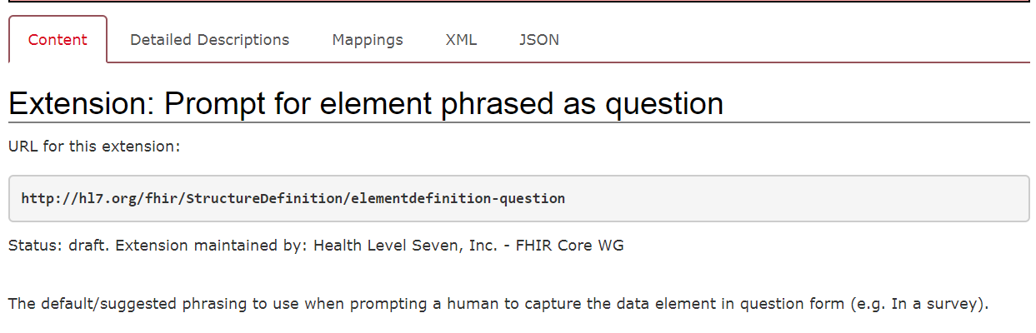

### Collection of data

I have searched METeOR, HL7, ICD-11, openEHR, SONMED-CD and ICF, by using key words such as “question”, “questions”, “questionnaire”, and “surveys”, and unfortunately, none of the data fits my purpose in my context. No standard found out that is related to ask what questions by what symptoms reflected, it is really professional clinical knowledge from various sources of clinical guidelines and clinical textbooks. Therefore, I decided that in terms of this application, question data have to be manually collected and entered by clinicians. The questions should be organized in ways such that they are able to be understood by non-medical people, and those questions should be short. No repetitive questions related to patient inputs should be asked. For example, if the patient is already detected as symptom “asthma”, then the question “Are you having an asthma” should obviously not be asked.

### Use of data

#### Correct use of this data

Data collected in this scenario can only be used when user input symptoms are not detailed enough to put forward actions and find types of services proper, to decide a more detailed symptom associated with proper actions and services. Any other use of this data is deemed as misuse.

#### Misuse of this data

Any other uses of this piece of data other than specified in “correct use” are regarded as misuse. For instances, this data is NOT used for asking further questions in the chronic disease management life cycle. NOR could it be used for gathering detailed conditions of a patient (e.g. types of microbes that cause inflection)

### Value sets

In this scenario, the value sets need to be manually made up. The format of the value set is similar to what is shown in table 1-8-2. During the development phase, enough time (e.g.3 months) should be given for clinicians to enter those data.

### Identified issues

The issue for collecting data for this data element is obvious. Tremendous amount of work should be done by clinicians to enter data based on their professional knowledge. Medical guidelines and textbooks might need to be checked to ensure quality of data being entered.

Also, a simple error made during the entering of data could lead to a fatal error to the advice given to patients (as proposed by Dr. Francis Martin). Therefore, after each round of data entering, clinicians should take time to check and to ensure the entered data elements are correct.

## Data element 4: Precise Symptom

### Definition

A “physical or mental feature being regarded as indicating a condition of disease” that is decided by the answers to a series questions having more details than the general symptoms.

### Why this definition was chosen

This element is the updated symptom, which belongs to the question entity, after patients already come up with symptom(s) but is / are still not sufficient to give them advices and referred services. Therefore, in terms of this definition, components of “symptoms” have to be thought about, but it is one step further in the context of this system from original “symptoms” chosen by users, and it should be displayed as a SNOMED-CT symptom code to fit the model design. And the definition is changed from last submission according to Dr. Francis Martin’s suggestion that it is actually “a series of questions”.

### Collection of data

This data elements includes the codes of all the symptom sets of SNOMED-CT, plus other identified situations that SNOMED-CT does not include (e.g. negation of situations, such as asthma without an inhaler). Hence, clinicians who are familiar with SNOMED-CT codes should help to fill the forms, and leave those codes they cannot find as blank and the system will be able to assign unique identifiers to those symptoms whose IDs cannot be found in SNOMED-CT.

### Use of data

#### Correct use of this data

This data is only used in the context of this system, under the conditions that an original symptom or list of original symptoms are already entered by user, and more detailed symptoms are needed to make suggestions on advices and services. It is associated with the rule management of the system, and is only related to the original symptom(s) entered by users or detected through a series of questions.

#### Misuse of this data

Any other uses except the specified correct use are misuses. For example, this data is NOT used for pharmacy purposes to link symptoms to medications. It can NOT be used as the disease / disorder formally recorded in patients’ EHR or EMR. NOR can it be used for administrative or billing purposes.

### Value sets

The value sets contains 2 parts, one is all the symptoms of the “code” column at URL: <https://www.hl7.org/fhir/valueset-manifestation-or-symptom.html> for the coding of the symptoms, the data is originally from SNOMED-CT. Another part is the set of symptoms combined with actions and service types entered by clinicians. (see table 1-8-1 and 1-8-2) And the set excludes those already in the original symptoms that users can choose from the image that loaded on the running of the application. The final symptom determined by questions is the one that induces advice and service types.

### Identified issues

This data element needs manual clinical checking to exclude those original symptoms that are not specific enough to give advices and service types. According to Dr. Martin Francis, other issues could include wrong record of symptoms and misuse of SNOMED-CT systems required for this data element.

## Data element 5: Service type

### Definition

Category of the Australian healthcare organizations that should be contacted for a person with symptoms and situations they have chosen through the portal from the system. [7]

### Why this definition was chosen

To define this data element, in the context of this application, I actually mean the category (level ‘A’, ‘B’, private, local GP, phone-base services, such as poison center, baby center and so on…) that a hospital belongs to. Therefore, the idea of the definition came from AIHW’s document describing how different types of Australia work. METeOR has definitions about “support service type”, but this definition cannot replace the word in my context. Plus, it might not be a good definition fitting my purposes, because it uses “type of services” to define “service type”. HL7 provides a service type value set, but it tends to be too detailed for the aim of my application (I do not need to know exactly whether it is an aged care organization, Maternal & Child Health or what, I just need to know level of services it can provide). Therefore, this also does not fit my purpose.

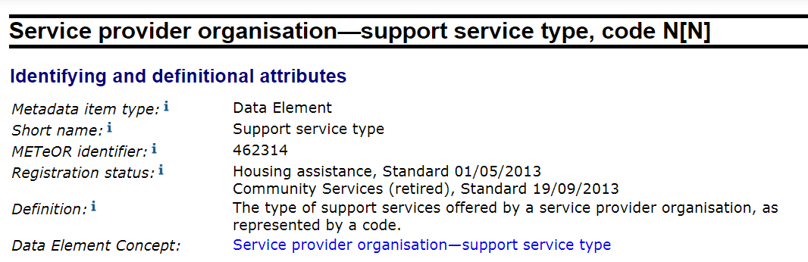

### Collection of data

Information of types of various hospitals as well as their categories should be collected for each state in Australia, this information is available on the website “Healthcare Identifiers Service for health professionals”, and the collected data should be put in a quality assurance process.

### Use of data

#### Correct use of this data

The data of register of healthcare organization Australia here is only used as an element of other information about a service type that are returned for users to look at, it is associated with the HPI-O of the healthcare organization. Also, once been collected, medical services and their types can be checked from this data element. Other uses of this data element are all treated as misuses.

#### Misuse of this data

Other purposes other than specified correct use of this data are all misuses. For example, this data should NOT be linked to trace patients’ preferences of services. Also, it should NOT be used for administrative or billing purposes according to the levels provided.

### Value sets

Value sets of categories of healthcare organizations from: <https://www.humanservices.gov.au/organisations/health-professionals/services/medicare/healthcare-identifiers-service-health-professionals> should be collected and under quality assessed.

### Identified issues

This data element is subjective to change, as service types of different hospitals may change as the hospitals develop or shrink. Hence, the system should be able to check update of this data element constantly.

## References

[1] “Person—body structure, code (ICF 2001) AN[NNNN].” [Online]. Available: http://meteor.aihw.gov.au/content/index.phtml/itemId/320147. [Accessed: 04-Sep-2018].

[2] “ICF Browser.” [Online]. Available: http://apps.who.int/classifications/icfbrowser/. [Accessed: 05-Sep-2018].

[3] “symptom | Definition of symptom in English by Oxford Dictionaries.” [Online]. Available: https://en.oxforddictionaries.com/definition/symptom. [Accessed: 12-Sep-2018].

[4] “67774-0.” [Online]. Available: https://s.details.loinc.org/LOINC/67774-0.html?sections=Comprehensive. [Accessed: 05-Sep-2018].

[5] “Clinical Knowledge Manager.” [Online]. Available: https://www.openehr.org/ckm/. [Accessed: 05-Sep-2018].

[6] “Question | Definition of Question by Merriam-Webster.” [Online]. Available: https://www.merriam-webster.com/dictionary/question. [Accessed: 12-Sep-2018].

[7] “ah16-2-1-how-does-australias-health-system-work.pdf.pdf.” .

# Part III: Existing Standards applying to the system or data

## Implementation Plan

### Implementation Requirements

1. **Requirements about who should be involved:** In order to develop and deliver this application, a clinical team and a mobile software development team are needed. Also, business information consultants, business marketing and medical law people are needed after the application is implemented and put into use.
2. **Medical service directory advice given to users should be reliable:** One of the objectives of this application, and the key towards the success of this application, is that the application should be able to return accurate advice based on users’ input medical conditions and its knowledge base. Therefore, the advice of which medical service the user under a medical condition shall be accurate and reliable. The project leader shall have a training day for the whole team on the proposed workflow.
3. **The user interface (UI) should correspond to the workflow:** For the developed application, workflow of using the application should correspond to what is proposed in Part I, from steps 1 – 8. Some users need to confirm the workflow throughout the design processes.
4. **Questions proposed by the application should be easy to understand and answer:** Since the application might ask users questions under the situations that an advice is not available under general symptoms, those questions (entered by professional clinicians) should be easy to understand and easy and quick to answer. Therefore, the questions should better be designed as multiple-choice questions. Some users shall involve in writing and checking those questions.
5. **Data recording patients’ symptoms and the given advices should be transferred safely:** Taken into consideration of protecting users’ privacies, the transferred data containing patient symptoms and advice being given, from server to patients’ portal, should be kept safe. Those data shall be encrypted when being transferred in the transferring channel.
6. **A UI collecting users’ market feedbacks should be designed:** The application should contain a UI which users can enter their suggestions about the application. These suggestions should be taken into consideration when the agile processes of improving the application are conducted.
7. **Knowledge data entered and information about health services and personnel for the application requires constant checking:** Due to the changing nature of healthcare, the knowledge base which the application queries to give patients advice should be checked constant for the accuracy of advice it gives. As a second point, the personnel and organizations that provide medical services should also be checked regularly.
8. **A UI for clinicians to enter/update data at the background:** At the background of this application (this does not present to users), UIs should be there so that clinicians can issue a request to update / add new pieces of data, and the application needs to record who updated what at when.

### Intended Implementation Processes

Taken into consideration that the scale of data collection and number of users might grow, the implementation processes are suggested to be conducted in an agile manner.

* Phase 1: Initial data entering and software architecture design:

Clinicians participated in this project should be given 3 months to enter data into the knowledge base about symptoms and suggestions in the format of table 1-8-1 and 1-8-2. Also, medical associations and societies (such as Australian Medical Association, AMA) should be conducted for gaining data about current medical services and personnel available in Australia. The IT people and the clinical team should confirm the design before implementation. The design should be updated by those teams before they start implementation.

At the meanwhile, the development team needs to start working on the initial architecture of the application, taken into considerations of the knowledge base designed in Part-I and the user interfaces for users to interact with, especially how the designed interfaces can fit the clinical workflow.

* Phase 2: Execute the implementation and testing

The governance team should be trained about how to use the system to enter data before they beginning to enter actual data, by IT teams. Based on the data entered at the end of the 3rd month, the development team then actually develops the application, which is proposed to take approximately one month. After that, the team runs the application test and check the presented data again with the clinical team to ensure that the advices given to the users corresponds the advice from clinical professions. They have to have inductions to new team members. training processes and develop training documentations. A member of the team will be given responsibility for those processes, at the times that the change same. The IT team need to develop the software user on-screen live user-guidance.

At the meanwhile, the clinicians can keep entering data. Also, they might update the data they entered, but those updates must be recorded properly as well.

* Phase 3: Design agile processes of maintenance and improvements

After first 2 phases, the version 1.0 of the application can be put into market, to at least serve patients with some symptoms. During this time, the developer team should discuss with clinical professions and gather marketing feedbacks about the application, to prepare for further maintenance works. Together, the two teams should design maintenance strategies, guidelines and sign off the agreements, marketing, law and business people might also be involved in this process

Then the whole application is ready for entering an agile process of keeping improving, following those steps:

Step 1: Developers / IT managers make a backup each time before the agile improvement starts, to prevent possible data loses.

Step 2: Clinicians / professional clinical teams update the knowledge base and service data, and notifies the developers that the update is done. If they found the architecture of the data model needs to be updated for the next phase so that they can enter different forms of data, they should document their requirements and pass it to the IT/development teams responsible for stage 3.

Step 3: The developers design and develop new architecture (application UI, database and web structures) based on the updates by clinical professions and feedbacks from the markets.

And those 3 steps loop each time more data / updated data needs to be added to the application. Therefore, the application can be scalable after it is initially developed, in terms of the advice given to users and handling growing number of users. The decisions of when to update the application and when clinicians should hand raw materials to developers, are in responsible of business administrative.

### Potential Benefits of the system bringing to clinical workflow

As for patients, this system might bring following benefits:

* Their potential risks can be accurately dealt with by proper medical services and dealt in time.
* They might discover the closest medical services to them that they previously are not aware of.
* They might learn some tips to deal with some of the symptoms based on the advice provided.

As for clinicians, the system might bring following benefits:

* Time spent on deciding the correct triage category for each patient could be less, leading to the improve of clinical work efficiency.
* Clinicians’ error rates in triaging could be significantly reduced.
* The quality of service especially for patients with serious conditions could be better and quicker.

## User Interface and Workflow Requirements

Below are the user interface and workflow requirements for this system that needs to be taken into consideration during the design of the application:

1. The data collection should minimize its affect to the clinical workflow, namely, key tasks for clinicians at ED is to safe patients, rather than busy entering data.
2. Based on the above statement, the UI should support automatic arriving time recording, and breaking-point continue. Also, it should be able to automatically save information already entered by clinicians.
3. Respond time after user clicked the button should be designed in a proper manner, so that it can respond to users’ clicks in a short time.
4. The picture and texts for clinicians to enter body part and symptom data should be clear and easy-to-interact.
5. The final triage results should be presented clearly, with alarms available for potential emergency patients.

## Knowledge and System Governance

### Knowledge Management

During the initial implementation stages, knowledge about the correctness of triage should be properly managed – the NN method should be fed with both properly triaged examples and improperly triaged examples – this piece work needs help from the clinical team.

Also during the development stage, the algorithm knowledge about machine learning model(s) that are proper for this purpose should be managed by the machine learning expert team and the IT team, the knowledge about proper design of interface should be managed by the IT team.

Then after the development stage, because the applied machine learning technology should be able to conduct knowledge management itself, no further manual intervention is expected.

The business analysis team need to work with the consumer health forum to get the response from emergency clinical professional after the development stages, and work on recommending this system to the market after development stage.

### Project Governance

The project team shall include:

* A health informatician who supports the initiative and implementation of this application, who is in charge of the overall design, implementation and communications between medical groups, business and marketing groups and development / IT groups.
* 2 teams of professional clinicians, of which:
  + One team is responsible for collecting and entering data especially for symptoms and given advices.
  + Another team is responsible for gathering and entering health organization information and personnel.
* A team of professional IT developers, which is responsible for design and implement the database structure, web structure and the application structure needed for this application. Also, in later agile maintains stages, these people need to deal with any changes from the application perspectives (e.g. backup data before each update and change application / database / webserver structure if needed after clinicians update their data).
* A team of marketing and business consulting people, and they are responsible for designing strategies to push this application into markets into real use, and design its market and business strategies and models. Also, they need to gather marketing feedbacks that can be passed to the development team to improve the architecture.
* A team of professional medical application/project lawyers, they are responsible for discovering potential legitimate problems during implementation stages, and are also responsible for other emerging legal problems during the maintaining and marketing phases.
* The project leader shall allocate work for individuals and make sure to manage all the work are done in time.

## Evidence Base and Feedback

### System Improvement Important Issues

The system is designed as an on-going agile project after its initial development, as mentioned in the section “Intended Implementation Processes” in this part. During each improving phase containing multiples, the key issues worth noticing include:

* Before each time the clinicians need to update data, a representor from the team needs to inform the people from IT / development team to back up the database and open the entries for them to do the update work. The development team should be developing in a development environment.
* During the update, they should record what has been updated, who updated it and when it is updated. The knowledge base should be updated to suit the most recent research results in healthcare, so that the medical evidence shall also be documented. Then they need to inform IT / development team that the update finishes and they might consider to re-design the architecture. Also, the requirements of changing the data model (if have) should be passed to the IT / development teams.
* The IT / development teams need to take into consideration the requirements from clinicians as well as the markets when at each phase of system improvement. They need to think about the user experiences improvements from market feedbacks and the portal provided for users to enter their advice. **It is better that the system can automatically gather usage information of the system (e.g. where they put in data and change it), to improve the workflows.**

### Change Adaptation Issues

Due to the agile design of this project, the improvement and change process of the project is kept on an on-going basis. Therefore, the change management plan proposed in session “Phase 3: Design agile processes of maintenance and improvements” should be followed, while the application development project team should consider those factors:

1. For each phase, factors such as time, scope and budget should be taken into consideration. Especially a time limit should be set and agreed by people from clinical team to ensure the application can be pushed to the market quickly, because they can always add data in the next phase.
2. The application might grow to a very large scale that it can be assumed that all people in the Australia can use. So, IT / development should think of this system needs to be used by 30 million people and storing GB level of healthcare data. But at the beginning, they might choose a small architecture to control budget. So how to scale the project might be a challenge for the IT / development team.

## Issues Identified

1. The development process of the application requires work with professional clinical teams and organizations, such as AMA (Australian Medical Associations).
2. The system needs to think about how to control project time, budget and scope, because at the beginning there might be only a small number of people using it. But later on, if the system grows, the team might need to think about how to scale up the system. So, the key concerns are different at different stages of this agile implementation.
3. The development of the system involves communication between the IT / development people, business marketing people, law people and clinical people, therefore, how to ensure the IT / development understands the clinical requirements and how to ensure business and law people can prepare proper plans to push the project and to prepare for deal with legal issues need to be considered, and this work might fall heavily on the health informatician.
4. The system is to be used for the overall Australia and it involves inter-state health governance agencies. However, governance agencies and health informatics structures of each state might vary from each other, so in this case how the application architecture can fit those incompatibilities issues inter-states need to be taken into consideration.
5. Clinicians are not technical experts, so IT / development people might need to teach them how to properly enter data and how to design the questions to symptoms so that information can be processed by the application and used by users easily.