Journals being considered Geoderma, Global Change Biology

1. Collect weather data from available stations
2. Extract images to look at with sofie
3. Look at error things

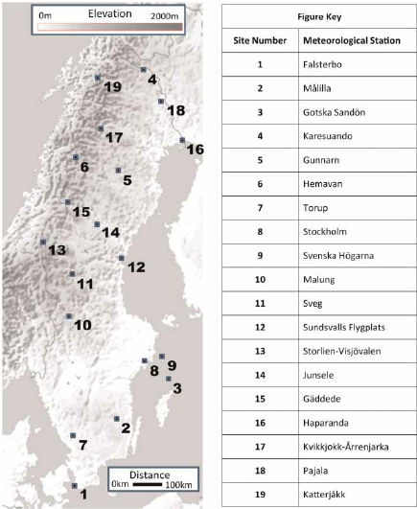

<https://www.smhi.se/data/meteorologi/ladda-ner-meteorologiska-observationer#param=snowDepth,stations=core,stationid=192830>

TEmperature

<https://www.smhi.se/data/meteorologi/ladda-ner-meteorologiska-observationer#param=airTemperatureMinAndMaxOnceEveryDay,stations=core>

Meeting with Sofie

* There is a percentage palsa graph in 100m2
* Palsa percentage vs subsidence all and for sites
* Atleast 2 percent palsa
* Matrix of sites
* Figure 1: map with water (Palsa sites – labelled 1-8) Insar –
* Table 9 – for us fig2/1
* Graph lines of snow – time vs depth
* January July temperature
* Mean annual, mean precipitation
* Pajala, Karesuando, KatterJarkk, abisko
* Line graph from 2000 to 2021
* Send in some format this week

Katterjåkk

Delineate exactly

Delineate and then judge roughness between

Threshold roughness to see if it delieneates these

Texture analysis – 5 – threshold analysis

10 sites 5 in each

Roughness etc

Elevation – range to show current state of palsa

Insar to show current change