This section will point you to the main places in the literature that indepth reviews of all the benefits that make up stage 0 exist. We will outline the clear positives but in order to understand the benefits accruable in the site you may be working in looking at the case study page and similar successes is the most important thing to do.

Price – more can be done for less when the constraints are taken off with strict goals e.g number of pools etc and more holistic goals are used in their stead (Hiers et al., 2016) variability increases resilience Hiers et al., 2016 – less long term maintence costs because banks do not need to be continually reinforced Normal restoration costs more and therefore less is done over time and less positive results occur (Bernhardt and Palmer, 2011) while this can still cost a lot to flatten a large area it is in a very different order of magnitude

It is worth reiterating that stage zero should not try to be fitted anywhere but where it is appropriate it can have massive positive benefits for ecology, in stream nutrients and ground water, ecosystem services and ecosystem resilience. The damage flood plain disconnection causes is clearly documented in the literature (Burges et al., 2013;;;) and reconnecting will improve many of these factors but the full process based restoration of a stage 0 site will create all the improvements listed below.

BENEFITS OF FLOOD PLAINS (Hauer et al., 2016) these are important for aquatic, terrestrial and avian communities more than most ecologists know. In fact the riparian zone can really be considered to stretch up to a km either side of the stream. More disturbance = higher bd** removing hydrological and geomorphic constraints is the best response**

Cluer and Thorne (2013) carried out a meta-analysis comparing papers which assessed ecosystem services for multiple different types of channel. The results are displayed below. The larger the pie chart the greater the total ecosystem service. It is clear to see that anastomosed channels can be seen to have vastly greater ecosystem services. Some large streams will not be able to be restored to a stage 0 channel because they have incised and created large terraces over very long periods of time. In these cases it is still obviously advantageous to carry out flood plain reconnection and valley floor resetting, which are the processes which constitute a stage zero reconnection, within the terraces to have a stage 8 valley.

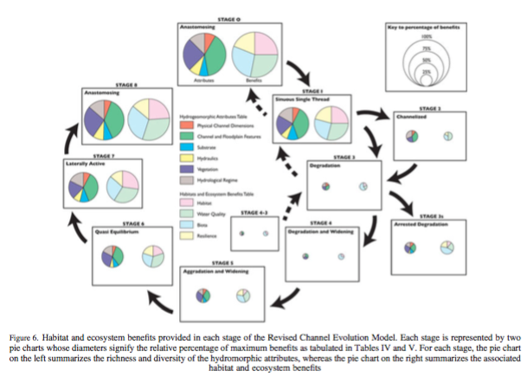

A lot of the benefits of stage 0 restoration can be found in papers and evidence for the ecosystem services provided by floodplains and wetlands. Stage 0 is essentially the process of allowing the river to fully connect to its flood plain and thus create a patchwork of channels and partially flooded wetlands. The ability of a stage 0 reach to remorph these channels is also what gives it the ability to be highly resilient to change. The quantities of instream wood and the larger area of ground mean that floods are disapated to some degree . This works in a similar way to natural flood management and releasing flow more steadily downstream (Guida et al., 2015). While flash flooding and extreme events may become more common as a result of climate change (REF) these will also include more droughts. It might seem intuitive that water temperatures would rise with when increasing the surface area but in fact after the first lot of vegetation has colonized the site there is often more shade than traditional incised channels. Moreover, it has been shown that it is not average stream temperature that is important at the patch scale to species but the heterogeneity of water temperatures and more precisely the presence of cold water refugees. This is where stage 0 projects come into their own, there are many deep shaded pools created by the river but also there is considerable more interconnection with groundwater which creates sites of positive cool water upwelling.

Many of the reports from stage 0 projects are surprised by the speed at which species return to these newly developed channels. However, floodplain reconnection in more traditional restoration projects has shown that just a few weeks’ post work fish start to inhabit the floodplain (Burges et al., 2013). The below imagine is from a study of salmon juveniles in California and clearly shows that fish reared on the flood plain have much higher growth rates (Jefferies et al., 2008). The study explicitly states that juveniles are often pushed out of the limited floodplain zones that do exist due to limited channel complexity during high flows. Therefore, not only does stage 0 provide better rearing habitat for wild fish but it provides refugees and multiple slower flow paths to reduce mortality during flood flows. There have been legitimate concerns raised by stakeholders over the risk of fish getting trapped in these wetland pools and channels when flows recede. However, so far there has been no evidence as to this being the case, possibly as a result of this being the fish’s natural habitat that they are still genetically wired to live in.
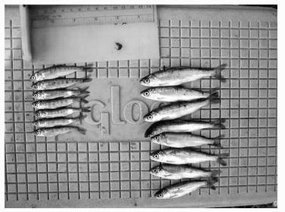
Stage zero restoration raises the water table and increases hyporheic connection between fluvial water and ground water. This provides the ability to recharge aquifers during high flows which in turn makes the whole region more resistant to drought. This groundwater recharge is a very important factor in proving the benefits to farmers who rely on increasingly depleted groundwater supplies during increasing periods of drought (ref). incised streams reduce groundwater infiltration and push water out of the system quicker which has further exacerbated drought issues in many sites. This is especially true of terrestrial vegetation in the vicinity of the restoration work which benefits from the raised water table which makes this vegetation less reliant on direct precipitation.

The hyporheic corridor which moves water between the surface and subsurface is very important for ecological condition and anastomosed channels increase the connectivity to this corridor. Firstly, ground water moving into the fluvial system contains bioavailable solutes which provide the building blocks for primary productivity (Stanford and Ward, 1993). Secondly, downwelling river water provides dissolved oxygen and organic matter to microbes and macroinvertebrates that exist in the hyporheic zone (Boulton et al., 1998).
From HAUSER et al 2016…….
One of the ways this anastomosed system is created and hyporheic connectivity is encouraged is through interactions with log jams and large woody debris. These collections of wood block the channel and push water out of any individual channel and into the topographically heterogeneous valley bottom. This is further enhanced by beaver in the PNW who construct wood into dams which slow the flow and spread water without completely blocking passages due to “leaking” and semi destruction during flooding. Wood and beavers may be natural phenomenon that would have historically controlled these systems but they will require the hydrographic and sedimental conditions to do so along with the biological such as the need for more trees.
This wood the decomposes creating habitat and resources for a multitude of species Moreover, the depositional sites which make up stage 0 restoration sites allow log jams to build up and recruit wood that floats from upstream during storm events. This means that as well as stage zero sites attenuating floods they reduce the risk of woody debris blockages downstream rather than the fear that some stakeholders held that they would increase the likelihood of wood washing downstream. Regardless, especially in the initial phases when trees have been felled but vegetation has not reestablished it is a risk that should be monitored (Bianco, 2018). As discussed in the technical section the risk of these dams building in the upstream sections of stage 0 reaches should be managed so as not to let water back up upstream.

Woody debris, complex channel systems, low slopes and low flows cause sediment to be deposited across stage zero reaches. This has multiple benefits including supplying many different species with nutrients required for growth and habitat creation. It also reduces turbidity downstream and the over concentration of sediment where it is less desirable. By storing sediment and increasing primary productivity at stage 0 sites it is possible for varied types of low intensity high margin farming to occur with specialized livestock. Therefore, sediment which washes off field and would usually be lost downstream is stopped and provides for livestock, hunting stock or fish shock all of which can be financially tapped to make stage 0 projects more economically incentivized.

By storing large woody debris, sediment and creating high levels of primary productivity in slow flow environments, carbon sequestration is maximized. At the first instance relatively dry and unproductive farmland is revegetated in multistory complex vegetation which sequesters high levels of carbon. In the second instance the depositional wetland nature of this environment means that a lot of this vegetation will only part rot and will be stored through the creation of peat like soils. Thus stage 0 can create a carbon sink which stores carbon progressively in the long term and plays a part in counteracting climate change. (REFS from wetland) while the evidence for this is provided by traditional wetland research there are current studies to confirm this is the case in stage 0 sites.
- [Benefits] Beaver can create pools which supply riparian vegetation to the extent that it acts as a fire break in forest fires (Randall, 2018)

