Structural Design of a Power Distribution Unit for Four-Wheel Drive Hybrid Electric Vehicles
English translation of the undergraduate thesis
Lufei Wang
Harbin Institute of Technology
School of Mechatronics Engineering
Mechanical Design, Manufacturing and Automation
Student ID: 2021112613
Supervisor: Hongliang Yang, Associate Professor
Defense date: May 2025
Classification: Public

Contents
Chapter 1 Introduction
1.1 Background and research objectives and significance
1.2 Research in China and abroad
1.2.1 Research abroad
1.2.2 Research in China
1.2.3 Analysis of current research
1.2.4 Summary of research in China and abroad
1.3 Main research tasks
Chapter 2 Overall Powertrain Layout and Power Distribution Strategy
2.1 Introduction
2.2 Design calculations for basic parameters
2.2.1 Required power calculations
2.2.2 Torque distribution calculations
2.3 Selection of the design concept
2.3.1 Overview of the power-distribution strategy
2.3.2 Overall powertrain layout
2.4 Chapter summary
Chapter 3 Structural Design of the Power Coupler
3.1 Power transmission in the coupler
3.2 Selection of the planetary gear configuration
3.3 Material selection and surface treatment
3.4 Power-coupler design parameters
3.5 Planetary gear design calculations
3.5.1 Planetary gear dimensions
3.5.2 Torque distribution calculations
3.5.3 Gear strength checks
3.5.4 Output-shaft design calculations
3.6 Manufacturing and assembly considerations
3.7 Balancing cost and performance
3.8 Chapter summary
Chapter 4 Design of the Four-Wheel-Drive Transfer Case
4.1 Transfer-case operating principle
4.2 Transfer-case design parameters
4.3 Transfer-case gear design and calculations
4.3.1 High- and low-range input gears
4.3.2 Front-axle output and rear-axle input and output gears
4.3.3 Transfer-case input and output shaft diameters
4.4 Chapter summary
Chapter 5 Driveline Design
5.1 Drive-shaft transmission design
5.2 Design loads for the universal-joint drive shaft
5.3 Cross-type universal-joint design calculations
5.3.1 Universal-joint structure
5.3.2 Universal-joint yoke-arm strength check
5.3.3 Angular compensation check
5.3.4 Universal-joint lubrication and durability
5.4 Drive-shaft body design
5.5 Chapter summary
Conclusions
References
Innovative Achievements During Undergraduate Study
Originality Declaration and Use Permissions
Acknowledgments

Abstract
With the increasing urgency of global energy conservation and emission reduction, hybrid electric vehicles (HEVs) have become an important development direction of the automotive industry due to their fuel economy and low emission characteristics. Four-wheel drive (4WD) technology further improves the vehicle's dynamics and adaptability to complex road conditions. At the same time, the combination of hybrid and four-wheel drive systems puts forward higher requirements for the structural design and control strategy of the power distribution device. In this paper, the four-wheel drive hybrid vehicle is taken as the research object, and the structural design and optimization of the power distribution device are studied, aiming to realize the efficient coordination of multiple power sources and the rational distribution of energy.
Firstly, based on the design parameters of the total vehicle mass of 3270 kg and the maximum speed of 180 km/h, the demand analysis of the power system and the selection of key components were completed. Through theoretical calculation and simulation analysis, the power distribution ratio between the engine and the electric motor (60% on the front axle and 40% on the rear axle) is determined, the dynamic control strategy under the composite hybrid mode (series and parallel) is proposed, and the mechanical structure of the planetary gear power coupler and transfer case is designed. Secondly, in view of the lightweight and reliability requirements of the power distribution device, 18CrNiMo7-6 alloy steel and carbon fiber composite materials were used to optimize the design of the transmission shaft.
The results show that the designed power distribution device can effectively coordinate the output of the engine and the electric motor, and realize the efficient energy management of the four-wheel drive hybrid electric vehicle. The lightweight design reduces the weight of the drivetrain by 30%-50% while meeting the requirements of strength and fatigue life. This design provides design application and engineering realization for the development of power distribution system of hybrid electric vehicles, and is of practical significance for promoting the development of new energy vehicle technology and reducing carbon emissions.
Keywords：hybrid electric vehicles, Four-wheel drive, Power distribution device

Chapter 1 Introduction

1.1 Background and research objectives and significance
As the global energy crisis and environmental pollution intensify, the high energy consumption and emissions of conventional fuel-powered vehicles are increasingly incompatible with sustainable development. According to International Energy Agency (IEA) statistics, transportation accounted for 24% of global carbon emissions in 2022, with passenger vehicles contributing more than 40% of that amount. In this context, hybrid electric vehicles represent a transition from conventional fuel-powered vehicles to battery electric vehicles. They generally have two propulsion systems: an electric drive and a conventional engine-driven mechanical system. Combining the high specific power of internal-combustion vehicles with the high specific energy and low emissions of electric vehicles, HEVs have become a major research topic for automotive engineers worldwide [1]. Meanwhile, 4WD technology improves mobility and driving stability through optimized power distribution, particularly on snow, ice and mud. However, combining hybrid propulsion and four-wheel drive introduces challenges including low power-coupling efficiency, structural complexity and incomplete control strategies. Efficient, reliable power distribution units are therefore needed to coordinate multiple power sources.

1.2 Research in China and abroad

1.2.1 Research abroad
Research on hybrid technology began relatively early in the automotive industries outside China. Many prominent vehicle manufacturers and research institutions have made important advances in four-wheel-drive hybrid electric vehicles [2].
(1) Toyota. Toyota is a global leader in hybrid technology. Its Toyota Hybrid System (THS) has been widely used in models such as the Prius. THS combines an internal-combustion engine and electric motor to manage energy and distribute driving power efficiently, reducing fuel consumption and emissions while maintaining vehicle performance. Toyota has also made substantial progress in hybrid four-wheel drive, introducing vehicles such as the RAV4 with an electronically controlled rear-axle motor. This arrangement simplifies the mechanical structure of conventional four-wheel drive. By 2023, cumulative sales of Toyota hybrid vehicles had exceeded 15 million across multiple markets [3].
(2) Honda. Honda's 2013 Intelligent Multi-Mode Drive (i-MMD) hybrid system has also achieved market success. It improves fuel efficiency through primarily electric propulsion assisted by the engine. For four-wheel-drive hybrids, Honda uses separate front- and rear-axle propulsion: the front axle is driven jointly by the engine and motor, and the rear axle by a separate motor, allowing flexible responses to road conditions. Although Toyota dominates the hybrid market, Honda has gained market share through technological advantages and product diversity. Honda aims to electrify its product range by 2030 and emphasizes the role of hybrid technology in the transition to full electrification.
(3) Ford. Ford has invested heavily in hybrid technology, particularly four-wheel-drive hybrid models such as the Escape Hybrid. Its hybrid systems emphasize integration with all-wheel drive to improve mobility and stability under different road conditions. Research focuses mainly on optimizing power distribution and improving energy-recovery efficiency [4].
(4) General Motors. General Motors' Volt and other plug-in hybrid models use advanced architectures combining electric propulsion with engine-driven generation. Their four-wheel-drive versions use a separate motor to drive the rear axle, integrating hybrid propulsion with four-wheel drive.
(5) European manufacturers. Premium European brands such as BMW, Mercedes-Benz and Audi have also conducted extensive research on four-wheel-drive hybrids. Integrating BMW's xDrive with hybrid propulsion enables real-time adjustment of power distribution according to road and driving conditions. Combining Audi's quattro system with electric motors provides strong power output while conserving energy and reducing environmental impact.

1.2.2 Research in China
China began research on hybrid propulsion and four-wheel drive later, but domestic manufacturers and research institutions have made advances in recent years, supported by new-energy vehicle policies.
(1) BYD. BYD, a relatively recent entrant in China's automotive industry, joined the competition in electric vehicles and made new-energy vehicles its development objective. It now holds a leading position in hybrid and new-energy vehicle technology [5]. Its Dual Mode (DM) four-wheel-drive hybrid system combines an internal-combustion engine with electric motors and is used in models such as the Tang. BYD's system drives the front and rear axles separately: the engine and motor drive the front axle, while an independent motor drives the rear axle, providing strong output and high fuel efficiency [6].
(2) Geely. Geely is advancing rapidly in new-energy and hybrid-system research. Its Zhiqing hybrid system has been used in several four-wheel-drive hybrid models, improving economy and the driving experience through optimized power distribution and energy management. Geely is also researching intelligent electric four-wheel drive to improve the intelligence and electrification of hybrid 4WD systems.
(3) SAIC. SAIC's e-Drive intelligent drive system integrates four-wheel drive and hybrid propulsion and has been used in vehicles under the Roewe and MG brands. It distributes power intelligently according to road conditions and driver demand, improving overall efficiency and driving stability by coordinating the motor and engine.
(4) Great Wall. By 2024, Great Wall Motor had made notable progress in 4WD HEVs. Several of its brands, including Haval, Wey and Ora, had introduced a range of four-wheel-drive hybrid models. Great Wall developed dedicated hybrid platforms such as Lemon DHT (Dedicated Hybrid Technology). This platform supports combinations of conventional engines, electric motors and batteries and enables efficient four-wheel drive.
(5) Chery. Chery has developed hybrid platforms to support the development and production of its four-wheel-drive hybrids. These platforms integrate engines, motors and batteries to improve vehicle performance and fuel economy [7]. They distribute power intelligently between the front and rear wheels to improve handling and stability under different road conditions. During braking and deceleration, energy is recovered efficiently to further improve fuel economy and energy efficiency. Highly integrated design reduces powertrain volume and weight and improves space utilization.

1.2.3 Analysis of current research
(1) Technology trends. Research on four-wheel-drive hybrids in China and abroad is moving in several directions. Lightweight design reduces system weight and improves fuel economy by optimizing powertrain structures and using lightweight materials. Intelligent control uses artificial intelligence and big-data technologies to improve traction and energy management under challenging conditions. Efficient energy management involves continued optimization of regeneration and propulsion control strategies to increase system efficiency [8]. Finally, electrified integration is receiving greater attention: as motor performance improves, more research focuses on electrifying the front and rear axles to replace conventional mechanical transmission and reduce power losses.
(2) Challenges. Although four-wheel-drive hybrid technology is increasingly mature, challenges remain. First, complex hybrid architectures incur high development and production costs [9]. Reducing cost is essential to widespread adoption. Second, coordinating multiple power sources requires highly capable real-time control, increasing system-integration demands. Third, battery energy density and range remain bottlenecks for hybrid and electric vehicles. Advances in batteries will directly affect the market performance of four-wheel-drive hybrids.

1.2.4 Summary of research in China and abroad
Research on four-wheel-drive hybrids has progressed substantially both within and outside China. Overseas companies lead through extensive experience and accumulated expertise, while Chinese companies are developing rapidly in response to policy support and market demand. As technology matures and costs decline, four-wheel-drive hybrids are expected to see broader global use and support the automotive industry's transition toward electrification and intelligent systems [10].
This study focuses on the structural design of a power distribution unit for a four-wheel-drive hybrid vehicle and addresses three principal problems:
(1) Insufficient power-coupling efficiency. Conventional mechanical transfer cases struggle to meet the dynamic power-distribution requirements of hybrid systems.
(2) The conflict between lightweight design and reliability. High torque loads can cause drivetrain fatigue failure under demanding operating conditions.
(3) Limited energy-management strategies. Existing control methods adapt poorly to changing operating conditions, restricting improvements in fuel economy [11].
This research provides theoretical support and a technical reference for engineering development of four-wheel-drive hybrids. It has practical significance for advancing new-energy vehicle technology and supporting the carbon-peaking and carbon-neutrality goals [10].

1.3 Main research tasks
(1) Overall powertrain layout and power-distribution strategy. A suitable configuration is selected: a combined series-parallel hybrid arrangement that switches automatically according to operating conditions to improve efficiency. The power-distribution strategy addresses operating-mode selection and energy recovery. Operating-mode selection includes electric and hybrid modes; energy recovery considers regenerative braking and coasting energy management.
(2) Structural design of the power coupler. The power coupler is a key hybrid-system component that coordinates engine and motor power output. Its design includes the following aspects:
1) Mechanical design. Gear transmission, the clutch and motor must be coordinated with the planetary gear set. The planetary set enables flexible power coupling and distribution under different operating conditions.
2) Material selection. High-strength materials with low friction coefficients are selected to improve durability and efficiency, followed by verification calculations.
(3) Structural design of the four-wheel-drive transfer case. The transfer case is essential to four-wheel drive, distributing power proportionally to the front and rear axles. Its design focuses on power-transmission paths, including the input gear shaft, gear-meshing arrangements for front and rear output shafts, and associated calculations to achieve appropriate front/rear power distribution.
(4) Structural design of the driveline. This mainly involves designing the front and rear drive shafts to transmit and convert power efficiently while maintaining appropriate loading. Torque capacity and torsional strength are considered, lightweight high-strength materials are selected, and the structures are designed. An efficient final-drive arrangement is designed to provide smooth, efficient power delivery to the wheels.

Chapter 2 Overall Powertrain Layout and Power Distribution Strategy

2.1 Introduction
In designing a power distribution system for a four-wheel-drive hybrid vehicle, parameter calculations and the suitability of the structural concept directly determine the reliability and efficiency of vehicle performance. Coordinating multiple power sources (engine and motor), together with the complex power paths of a 4WD architecture, requires precise theoretical analysis and engineering design of component loads, material strength and energy-distribution strategies. Based on the design inputs of 3,270 kg gross mass and 180 km/h maximum speed, this chapter uses mechanical-design theory to analyze powertrain requirements, select components and develop the structure.
First, vehicle performance requirements and hybrid operating modes (electric and parallel propulsion) are used to calculate required power, torque distribution and energy-recovery efficiency and assess their suitability. A strategy framework for combined series-parallel operation is then established, covering electric mode, hybrid mode and energy recovery. The power sources, applicable operating conditions, characteristics and key parameters of each are studied. The planetary gear configuration and materials are also selected, and a feasible cooling concept is proposed.
This chapter covers theoretical calculations, structural design and parameter verification. Calculations ensure both theoretical rigor and engineering practicality. The objective is to establish a systematic design framework for the power distribution unit and provide a basis for the design and modeling in subsequent chapters.

2.2 Design calculations for basic parameters
Using the vehicle specified in the task brief, this section calculates required power and torque distribution. The vehicle has a gross mass of 3,270 kg, curb mass of 2,770 kg, length of 4,985 mm, width of 1,960 mm and height of 1,900 mm. Its design maximum speed is 180 km/h.

2.2.1 Required power calculations
(1) Basic parameters affecting performance. Data specified in the task brief are compiled, and typical automotive-design values are used for rolling resistance, aerodynamic drag coefficient, frontal area, air density, transmission efficiency and maximum acceleration. Table 2-1 summarizes these parameters.
Table 2-1 Powertrain parameters
Parameter | Symbol | Value
Gross vehicle mass | m | 3270kg
Maximum speed | $$u_{max}$$ | 180km/h(50m/s)
Rolling resistance coefficient | f | 0.015
Aerodynamic drag coefficient | $$C_{D}$$ | 0.3
Frontal area | A | 3.724$m^{2}$
Air density | $$ρ$$ | $$1.225kg/m^{3}$$
Transmission efficiency | $$η_{t}$$ | 0.9
Maximum acceleration | a | 2m/s2
(2) Vehicle power calculations. These include maximum total power at maximum speed (rated power), power when accelerating to 100 km/h at maximum acceleration, and power when climbing at a constant 60 km/h.
1) Maximum total power at the maximum speed of 180 km/h is obtained from Equation (2-1):
$P_{max1}=\frac{u_{max}}{3600η_{t}}(mgf+\frac{C_{D}Au_{max}^{2}}{21.15})$ (2-1)
Maximum vehicle speed (m/s): $u_{max}$
Transmission efficiency: $η_{t}$
Gross vehicle mass (kg): $m$
Rolling resistance coefficient: $f$
Aerodynamic drag coefficient: $C_{D}$
Frontal area (m²): $A$
Substituting the basic parameters in Table 2-1 gives the maximum total power during hybrid propulsion. The rated power of the powertrain is therefore taken as 125 kW.
$$P_{max1}=121.813kW≈121.8kW$$
2) Vehicle power when accelerating to 100 km/h at maximum acceleration is obtained from Equation (2-2):
$P_{max2}=\frac{u}{3600η_{t}}(mgf+\frac{C_{D}A}{21.15}u^{2}+δm\frac{du}{dt})$(2-2)
where u is the target vehicle speed (km/h);
Maximum acceleration (m/s²): $\frac{du}{dt}$
Rotating-mass conversion factor, taken as 1.3: $δ$
Substituting the basic parameters in Table 2-1 gives the following vehicle power when accelerating to 100 km/h at maximum acceleration: $P_{max2}=293.562≈293.6kW$
3) Vehicle power when climbing at a constant 60 km/h is obtained from Equation (2-3):
$P_{max3}=\frac{u_{p}}{3600η_{t}}(mgfcosα_{max}+mgsinα_{max}+\frac{C_{D}Au_{P}^{2}}{21.15})$(2-3)
where up is the climbing speed (km/h);
Climbing angle, based on a 30% gradient: $α_{max}$
Substituting the basic parameters in Table 2-1 gives the following power for climbing at a constant 60 km/h: $P_{3}=182.755kW≈185kW$
4) The maximum total power of the hybrid vehicle is determined by the highest power among these three conditions, as calculated using Equation (2-4).
$P_{total}≥max(P_{max1},P_{max2},P_{max3})=293.6kW$(2-4)
The resulting peak vehicle power is 300 kW.

2.2.2 Torque distribution calculations
(1) Basic torque-distribution parameters. A four-wheel-drive hybrid must balance performance and stability, accounting for axle loads and dynamic requirements. Because heavy components such as the engine and motor are located at the front, allocating more torque to the front axle matches the load distribution and avoids rear-wheel slip. During acceleration, rearward load transfer requires sufficient rear-axle torque to maintain stability and prevent torque steer. A slightly higher front-axle allocation also improves steering response and counteracts the oversteer tendency of four-wheel-drive vehicles, consistent with the passenger-car safety standard ISO 4138. Electronic stability control can more readily coordinate braking and driving forces with a 60:40 split. This ratio can reduce electronic intervention and improve stability. A front-to-rear torque split of 60:40 is therefore selected.
(2) Calculation of torque distribution
The total required torque is obtained from Equation (2-5):
$T_{total}=\frac{P_{max1}∙1000}{\frac{v}{r}}$(2-5)
Rated power of the powertrain (kW): $P_{max1}$
v is the target speed (m/s), taken as 50 m/s (180 km/h);
r is the wheel radius (m), taken as 0.35 m.
Substituting the data in Table 2-1 gives: $T_{total}=844.98Nm≈850N∙m$
With the selected front-to-rear torque split of 60:40, the front and rear torques are calculated using the following expressions:
$T_{front}=T_{total}×60\%$; $T_{rear}=T_{total}×40\%$
Substituting the total required torque from Equation (2-5) gives the front-axle torque and rear-axle torque:
$T_{front}=510N∙m$; $T_{rear}= 340N∙m$
This completes the basic design calculations, covering power under the three operating conditions and front/rear torque distribution. Table 2-2 summarizes the results.
Table 2-2 Basic parameters
Parameter | Calculated value
Required power under normal operating conditions | 125kW
Peak hybrid-vehicle power | 300kW
Power for constant-speed climbing | 185kW
Front-axle torque share | 60%
Rear-axle torque share | 40%
Torque allocated to the front axle | 510Nm
Torque allocated to the rear axle | 340Nm
Total output torque | 850Nm

2.3 Selection of the design concept
For combined series-parallel hybrid operation, this section establishes a power-distribution framework covering electric mode, hybrid mode and energy recovery.

2.3.1 Overview of the power-distribution strategy
The vehicle is designed to use combined series-parallel hybrid operation. This combines the advantages of both modes and coordinates the power sources efficiently through intelligent control. One primary objective is energy efficiency: the optimal source combination is selected dynamically according to operating conditions. Another objective is a better driving experience through smooth mode transitions and rapid response. A third is maximizing energy recovery during braking and coasting.
The framework has three parts: electric mode, series-parallel hybrid mode and energy recovery.

2.3.2 Overall powertrain layout
A P0 motor starts the engine. When engine speed reaches the optimum range, fuel injection and ignition start combustion. The engine and P2 motor then supply power jointly through the power coupler to propel the vehicle. The coupled output passes through the transfer case, which distributes power to the front and rear wheels in a 60:40 ratio to achieve four-wheel drive. Figure 2-1 shows the overall layout.
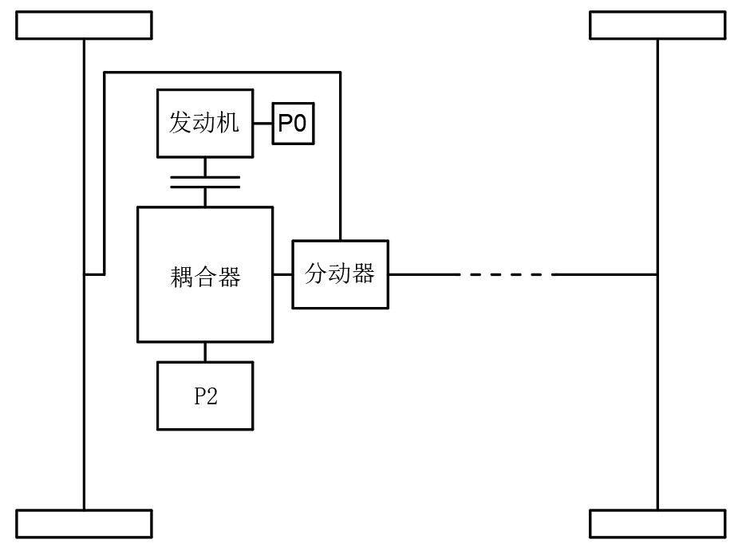
Figure 2-1 Block diagram of the overall powertrain layout
Figure 2-2 shows the detailed powertrain schematic, including the shaft connections between engine, motor and power coupler, the connection between the coupler and transfer-case housings, and the couplings between the drive shafts and the front and rear transfer-case output shafts.
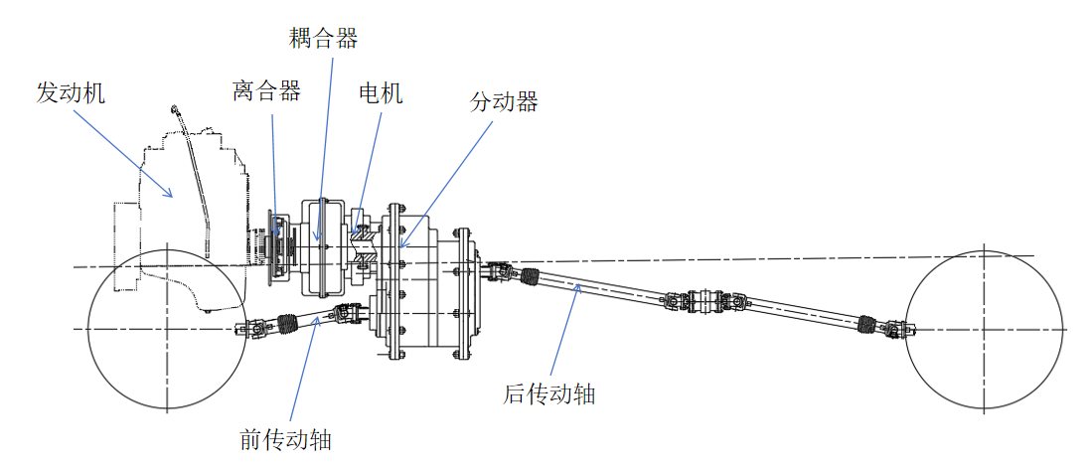
Figure 2-2 Schematic of the overall powertrain layout
(1) Electric mode. The engine is inactive. The P2 motor rotates forward and supplies power to the coupler. Its output shaft transmits power directly to the transfer-case input shaft, and the transfer case drives the wheels through its front and rear output shafts.
This mode applies at low speeds, no higher than 60 km/h, and under low loads such as congested urban driving or steady cruising. Battery state of charge (SOC) must be at least 30%.
Zero emissions and low noise make electric mode suitable for short commutes and everyday urban driving.
The maximum speed in electric mode is 60 km/h. With a 20 kWh battery, the range is to be no less than 50 km.
(2) Hybrid mode. The P2 motor rotates forward normally and supplies power to the coupler. Meanwhile, the P0 motor starts the engine and brings it to the target speed range. The clutch then transmits engine power to the coupler. The coupler combines the power and delivers it to the transfer-case input shaft, after which gears distribute it to the front and rear wheels.
This mode applies at medium and high speeds, at least 60 km/h, and during rapid acceleration or high-load operation such as overtaking and climbing. It is also used when battery SOC falls below 30%, preventing battery depletion or insufficient motor power.
In this mode, the engine operates continuously in its efficient range of 1,500–2,500 rpm, improving fuel economy. Joint engine and motor operation provides strong output, increasing maximum torque by approximately 40%.
(3) Energy recovery. This strategy applies during braking and coasting. Braking includes both light and emergency braking; coasting means deceleration after releasing the accelerator.
The control logic consists of regenerative braking and coasting recovery. During braking, the P2 motor operates as a generator, converting excess kinetic energy into electricity stored in the battery. Recovery power is proportional to brake-pedal travel, reaching up to 50 kW. During coasting, the motor supplies no driving power; wheel rotation drives the motor in reverse to recover energy at a lower power of 10–20 kW.
A graded recovery strategy adjusts regeneration intensity according to vehicle speed and battery SOC, increasing recovery when SOC is low. The electronic control system also simulates the pedal feel of conventional brakes to avoid abrupt sensations.
The design target for recovery efficiency is 72%. A single braking event from 50 km/h to rest is to recover 0.8–1.2 kWh.
Table 2-3 summarizes the strategy framework.
Table 2-3 Strategy framework
Mode | Core logic | Applicable conditions
Electric mode | Motor-only propulsion | Low speed, low load, high SOC
Hybrid mode | Combined engine and motor propulsion | Medium/high speed, medium/low SOC
Energy recovery | Kinetic-energy recovery during braking/coasting | Deceleration

2.4 Chapter summary
This chapter developed the power distribution system for a four-wheel-drive hybrid, covering detailed power-demand and torque-distribution calculations, strategy development and key-component design. Calculations established a system power requirement of 125 kW, a hybrid-mode peak of 300 kW and a front-to-rear torque split of 60:40, balancing performance and stability. A regenerative-braking strategy was designed with 72% recovery efficiency, demonstrating the system's energy-utilization advantages. The 125 kW demand falls within the 80–150 kW range for high-performance hybrids. Allocating 60% of torque to the front axle improves steering stability, while rear-axle assistance improves mobility.
The chapter also detailed the framework for electric mode, hybrid mode and energy recovery, enabling intelligent switching and optimal energy use under different conditions.

Chapter 3 Structural Design of the Power Coupler

3.1 Power transmission in the coupler
The engine is rigidly connected through a clutch to the carrier of the planetary reducer. Engine power is transmitted through the planet gears meshing with the sun gear and ring gear. The motor is rigidly connected to the sun gear, which meshes with the planet gears to transmit power to the ring gear. The two power sources are combined through the ring gear, which meshes with the output-shaft gear and transfers power to the transfer case. Figure 3-1 shows the principle.
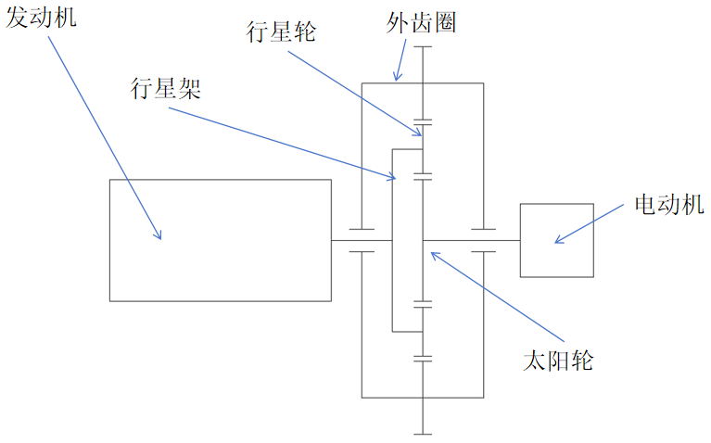
Figure 3-1 Power coupling principle of the planetary-gear coupler

3.2 Selection of the planetary gear configuration
(1) Selection criteria. The configuration must flexibly distribute engine and motor torque to the front and rear axles. It must also be compact because space in the hybrid system is limited. Finally, transmission efficiency must be maintained by minimizing friction losses, with a friction coefficient no greater than 0.1.
(2) Selected configuration. A single planetary set is selected, comprising a sun gear connected to the motor, a carrier connected to the engine and a ring gear connected to the output shaft. The transmission ratio is 2.5:1, enabling low-speed high-torque and high-speed efficient operation.
(3) Advantages. The sun gear, planet gears and ring gear have a concentric layout. Several planet gears share the load, producing a compact arrangement suitable for a space-constrained power coupler. The set can connect the engine, motor and generator simultaneously, enabling power splitting and combining and simplifying the layout. Sharing torque among several planets reduces stress on individual gears and extends service life. The sun, carrier and ring can each serve as input, output or stationary member, supporting electric propulsion, series-parallel hybrid propulsion and regeneration.
(4) Structural parameters. Table 3-1 lists the selected parameters.
Table 3-1 Planetary gear design parameters
Component | Parameter
Sun gear | 20 teeth
Planet gear | 15 teeth per gear; 3 planet gears
Ring gear | 50 teeth
Planet carrier | Speed range: 0–6,000 rpm
Tooth thickness | 20mm

3.3 Material selection and surface treatment
The base material is 20CrMnTi alloy steel, a carburizing structural steel with tensile strength of at least 1,200 MPa and hardness of HRC 58–62 after carburizing and quenching. Its high wear resistance suits high-load, high-speed operation. Its good machinability, with a relative machinability coefficient of 0.7–0.8, can substantially reduce manufacturing cost. It is also 15–20% less expensive than comparable carburizing steels such as 20CrNiMo and benefits from an established domestic supply chain.
Surface coating is used to limit the friction coefficient to 0.1 or less. A diamond-like carbon (DLC) coating 2–4 μm thick is selected. This can reduce the friction coefficient to 0.08–0.1 and improve wear resistance by 30%.
Surface heat treatment consists of carburizing and quenching followed by low-temperature tempering. Carburizing and quenching produces 1.2% surface carbon content and HRC 60 hardness. Low-temperature tempering relieves internal stress and improves toughness. The resulting hard surface layer of HRC 58–62 and tough core of HRC 30–35 suit the high contact stresses and impact loads experienced by coupler gears.

3.4 Power-coupler design parameters
(1) Input parameters. A Cummins ISF2.8 engine is selected with maximum torque of 300 Nm at 2,800 rpm. The motor is a Siemens 1FT7 induction motor with maximum torque of 200 Nm at 4,000 rpm. Table 3-2 summarizes the selection data.
Table 3-2 Power-coupler input parameters
Parameter | Symbol | Value
Maximum engine torque | $$T_{ice}$$ | 300Nm
Maximum motor torque | $$T_{motor}$$ | 200Nm
Table 3-2 continued
Parameter | Symbol | Value
Planetary gear ratio | i | 2.5 : 1
Gear module | m | 4
Gear pressure angle | $$α$$ | 20°
Single-stage gear efficiency | $$η$$ | 98%
Engine speed | $$n_{ice}$$ | 2800rpm
Motor speed | $$n_{motor}$$ | 4000rpm
(2) Gear parameters. Based on the selected planetary set, the module is m = 4. The pressure angle and single-stage transmission efficiency are given below. The gears use 20CrMnTi alloy steel with a carburized and quenched surface hardness of HRC 58–62.
$α=20°$; $η=98\%$

3.5 Planetary gear design calculations

3.5.1 Planetary gear dimensions
This section calculates planetary gear dimensions for the power-coupler engineering drawings. The pitch diameters of the sun, planet and ring gears are calculated from the selected tooth counts and module to complete the drawings. Figure 3-2 shows a section through the planetary gear set.
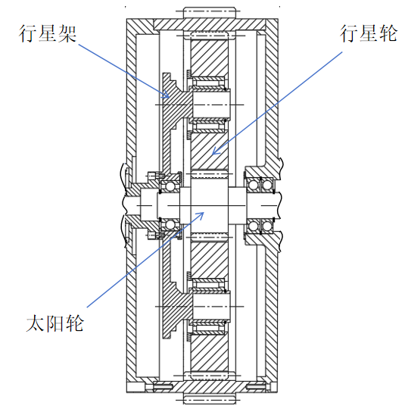
Figure 3-2 Section through the planetary gear set
(1) Sun gear (S). Its pitch diameter is obtained from Equation (3-1):
$d_{s}=m∙z_{s}$(3-1)
where m is the gear module;
Number of sun-gear teeth: $z_{s}$
Substituting the sun-gear tooth count from Table 3-1 and the selected module m = 4 gives the sun-gear pitch diameter: $d_{s}=80mm$
(2) Planet gear (P). Its pitch diameter is obtained from Equation (3-2):
$d_{p}=m∙z_{p}$(3-2)
where m is the gear module;
Number of planet-gear teeth: $z_{p}$
Substituting the planet-gear tooth count from Table 3-1 and the selected module gives the pitch diameter of each of the three planet gears: $d_{p}=60mm$
(3) Ring gear (R). Its pitch diameter is obtained from Equation (3-3):
$d_{r}=m∙z_{r}$(3-3)
where m is the gear module;
Number of ring-gear teeth: $z_{r}$
Substituting the ring-gear tooth count from Table 3-1 and the selected module gives its pitch diameter: $d_{r}=120mm$
(4) Planet carrier (C). The selected number of planet gears is: $n_{p}=3$

3.5.2 Torque distribution calculations
The torque transmitted by the coupler comprises contributions from the engine and motor. The engine contribution is obtained from Equation (3-4):
$T_{iceout}=T_{ice}∙i$(3-4)
Maximum engine torque: $T_{ice}$
i is the planetary gear ratio.
Substituting the maximum engine torque from Table 3-2 and the planetary gear ratio gives the transmitted engine torque: $T_{iceout}=750Nm$
Similarly, the transmitted motor torque is obtained from Equation (3-5):
$T_{motorout}=T_{motor}∙i$(3-5)
Maximum engine torque [the source uses this label in the motor-torque calculation]: $T_{motor}$
Substituting the maximum motor torque from Table 3-2 and the planetary gear ratio gives the transmitted motor torque: $T_{motorout}=500Nm$
The total torque transmitted by the planetary coupler is therefore the sum of the engine and motor contributions, as expressed by Equation (3-6):
$T_{total}=T_{iceout}+T_{motorout}$(3-6)
Substituting the results of Equations (3-4) and (3-5) gives the total output torque: $T_{total}=1250Nm$

3.5.3 Gear strength checks
Strength checks for the planetary set cover contact stress and bending stress, specifically contact stress between the sun and planet gears and bending stress in the sun gear.
(1) Contact stress. Contact stress between the sun gear and the three planet gears is calculated using Equation (3-7):
$σ_{H}=Z_{E}\sqrt{\frac{2T}{b∙d^{2}}∙\frac{u+1}{u}}$(3-7)
Elastic coefficient, taken as 189.8 for steel against steel: $Z_{E}$
T is the transmitted torque (Nm);
b is the tooth thickness (mm);
d is the sun-gear pitch diameter (mm);
Transmission ratio: $u$
Substituting the tooth thickness and planetary ratio from Table 3-1 and the transmitted torque from Equation (3-6) gives the sun–planet contact stress:
$$σ_{H}=396.7MPa$$
The allowable value is obtained from a reference table. The following comparison confirms suitability for operation:
$[σ_{H}]=1500MPa$; $σ_{H}=396.7MPa≤[σ_{H}]=1500MPa$
(2) Bending stress. Sun-gear bending stress is calculated using Equation (3-8):
$σ_{F}=\frac{2T∙Y_{F}∙Y_{S}}{b∙m∙d}$(3-8)
Tooth-form factor, taken as 2.5: $Y_{F}$
Stress-correction factor, taken as 1.6: $Y_{S}$
Substituting the planetary-set data from Table 3-1 and the transmitted torque from Equation (3-6) gives the sun-gear bending stress:
$$σ_{F}=250MPa$$
The allowable value is obtained from a reference table. The following comparison confirms suitability for operation:
$[σ_{F}]=400MPa$; $σ_{F}=250MPa≤[σ_{F}]=400MPa$

3.5.4 Output-shaft design calculations
The output-shaft gear has a 1:1 transmission ratio with the planetary ring gear and the same module, m = 4. Its pitch diameter therefore equals that of the ring gear. The output shaft uses 18CrNiMo7-6 alloy steel. The allowable shear stress is obtained from a reference table, accounting for a fatigue safety factor of n = 2.5.
$$τ_{allow}=100MPa$$
Output-shaft torque equals the total output torque: $T_{out}=T_{total}=1250Nm$
Output-shaft diameter is calculated using Equation (3-9):
$d={(\frac{16T∙K_{d}}{πτ_{allow}})}^{\frac{1}{3}}$(3-9)
Diameter correction factor (size factor): $K_{d}$
Allowable shear stress of 18CrNiMo7-6 alloy steel (MPa): $τ_{allow}$
Substituting the calculated torque and selected allowable shear stress gives the diameter below. Because this shaft is also the transfer-case input shaft, the larger of the two calculated diameters is selected: 65 mm.
$$d=50.3079mm$$
Figure 3-3 shows the detailed overall structure of the power coupler.
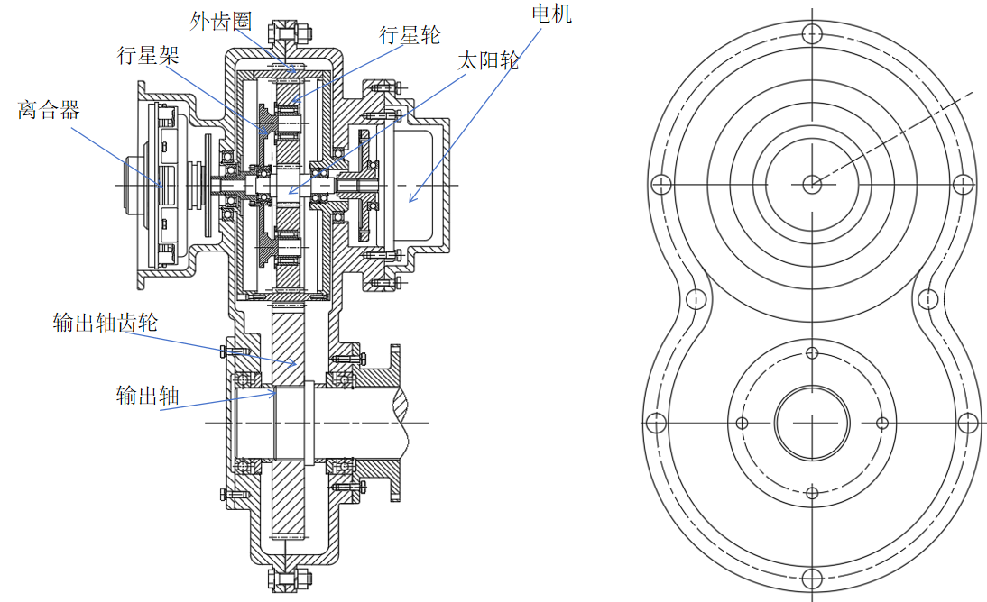
Figure 3-3 Structural design of the power coupler

3.6 Manufacturing and assembly considerations
The planetary gears are rough-turned, hobbed, carburized and quenched to a case depth of 0.8–1.2 mm, then finish-ground to DIN accuracy grade 6. The housing is sand-cast, after which the mating surface is milled to a flatness of 0.05 mm or better and used as a datum for machining the bearing bores. The stepped output gear shaft is milled on a CNC machining center.
During planetary-set assembly, differences in backlash between planet gears are limited to 0.03 mm and adjusted using shims. The carrier requires dynamic balancing, with residual unbalance no greater than 5 g·cm (grade G2.5). Cooling lines are also pressure-tested for sealing at no less than 0.5 MPa.

3.7 Balancing cost and performance
Comparing the cost and performance of specific manufacturing measures supports selection of the final process plan. Table 3-3 presents the comparison.
Table 3-3 Cost and performance comparison
Item | Cost share | Performance improvement
DLC coating | 15% | 30% lower friction
Liquid cooling system | 25% | 18% higher heat-dissipation efficiency
Precision machining | 20% | 5% higher transmission efficiency

3.8 Chapter summary
This chapter completed the powertrain design for a four-wheel-drive hybrid, focusing on the power coupler's structure and performance calculations. Gross mass, maximum speed and other basic vehicle parameters were used to calculate required power and torque distribution and establish the suitability and feasibility of the design. Selecting the planetary configuration and gear materials, checking strength and designing cooling ensured stable, efficient operation under high loads and speeds. The selected configuration uses high-strength alloy steel with a friction coefficient no greater than 0.1.

Chapter 4 Design of the Four-Wheel-Drive Transfer Case

4.1 Transfer-case operating principle
The power-coupler output shaft and transfer-case input shaft are designed as a single shaft. Power enters through this shaft, and a sliding spline engages the low- or high-range gear according to operating conditions. Power then passes through the intermediate shaft to the front-axle output shaft, delivering 60% to the front axle. An interaxle differential transfers power from the front-axle output shaft to the rear-axle input shaft. Gear meshing then transfers it to the rear-axle output shaft, completing the four-wheel-drive power distribution.

4.2 Transfer-case design parameters
(1) Input parameters. The power-coupler calculations give an output-shaft torque of 850 Nm. The transfer-case input torque and speed are specified below, with torque equal to the coupler output torque. Chapter 2 established a 60:40 front-to-rear split and calculated 510 Nm for the front axle and 340 Nm for the rear axle.
$T_{in}=850N∙m$; $n_{in}=3000rpm$
(2) Gear parameters. The gear pressure angle is specified below. The material is 20CrMnTi alloy steel, carburized and quenched to a surface hardness of HRC 58–62.
$$α=20°$$
(3) Transmission efficiency. The single-stage gear efficiency is: $η=98\%$

4.3 Transfer-case gear design and calculations

4.3.1 High- and low-range input gears
(1) Function. Switching between high and low range accommodates different operating conditions.
(2) Shift mechanism. A baulk-ring synchronizer is used. Roller bearings connect the high- and low-range input gears to the input shaft, allowing free rotation. To engage high range, the shift-fork cam swings and moves the synchronizer sleeve toward the high-range gear. The sliding blocks and baulk ring move with it, bringing the ring's cone into contact with the gear cone. Friction torque between the cones brings the sleeve-tooth ends into contact with the ring's locking faces, blocking sleeve movement. The increasing cone friction gradually synchronizes the gear and ring angular velocities. Once synchronized, friction torque disappears, the ring returns and the locking faces separate. Under the shift force, the sleeve teeth pass through the ring and engage the gear's clutch teeth, rigidly connecting the high-range gear to the input shaft. Power is then transmitted to the high-range output gear. Low-range engagement follows the same process with the cam swinging in the opposite direction. Figure 4.1 shows the synchronizer structure and principle.
(3) High-range gear parameters. Input and output gears are designed separately. Pitting is the main failure mode for soft tooth surfaces, so the gears are designed for surface fatigue strength. The high-range pitch diameter is determined by Equation (4-1):
$d_{\text{high_in}}≥\sqrt[3]{\frac{2K_{t}T_{in}}{ϕ_{d}}\frac{u_{h}+1}{u_{h}}{\left(\frac{Z_{E}Z_{H}Z_{ε}Z_{β}}{{\left[σ\right]}_{H}}\right)}^{2}}$(4-1)
Torque transmitted by the gear: $T_{in}$
Load factor, taken as 1.4: $K_{t}$
Face-width coefficient: $ϕ_{d}$
High-range transmission ratio, taken as 0.55: $u_{h}$
Elastic coefficient, taken as 189.8: $Z_{E}$
Zone factor, taken as 2.46: $Z_{H}$
Contact-ratio factor, taken as 0.78: $Z_{ε}$
Helix-angle factor, taken as 0.99: $Z_{β}$
Allowable contact stress: ${\left[σ\right]}_{H}$
Substituting the known data gives the calculated and selected high-range input-gear pitch diameters below. With 55 teeth selected, Equation (4-2) gives the module:
$d_{\text{high_in}}≥217.67mm$; $d_{high\text{_in}}=220mm$; $z_{high\text{_}in}=55$
$m=\frac{d_{\text{high_in}}}{z_{\text{high_in}}}$(4-2)
Substituting the calculated high-range input pitch diameter and selected tooth count gives m = 4. For u = 0.55, Equation (4-3) gives the high-range output-gear tooth count:
$z_{high\text{_}out}=z_{high\text{_}in}∙u$(4-3)
Substituting the high-range input tooth count and ratio gives the output tooth count below. Equation (4-4) gives the high-range output pitch diameter:
$$z_{high\text{_}out}=30$$
$d_{\text{high_out}}=m∙z_{\text{high_out}}$(4-4)
Substituting the module and high-range output tooth count gives its pitch diameter: $d_{high\text{_out}}=120mm$
(4) Low-range gear parameters. Input and output gears are again designed separately. The low-range pitch diameter is determined by Equation (4-5):
$d_{\text{low_in}}≥\sqrt[3]{\frac{2K_{t}T_{in}}{ϕ_{d}}\frac{u_{l}+1}{u_{l}}{\left(\frac{Z_{E}Z_{H}Z_{ε}Z_{β}}{{\left[σ\right]}_{H}}\right)}^{2}}$(4-5)
Low-range transmission ratio, taken as 1: $u_{l}$
Substituting the known data gives the input pitch diameter and selected value below. With 40 teeth selected, Equation (4-6) gives the input module. The source calls this the high-range input gear within its low-range calculation.
$d_{\text{low_in}}≥158.77mm$; $d_{\text{low_in}}=160mm$; $z_{high\text{_}in}=40$
$m=\frac{d_{\text{low_in}}}{z_{\text{low_in}}}$(4-6)
Substituting the input pitch diameter and selected tooth count gives m = 4. For u = 1, Equation (4-7) gives the output tooth count. The source again uses the high-range label within this low-range calculation.
$z_{high\text{_}out}=z_{high\text{_}in}∙u$(4-7)
Substituting the input tooth count and ratio gives the low-range output tooth count below. To avoid severe wear, the selected low-range output tooth count is adjusted as shown. Equation (4-8) then gives its pitch diameter:
$z_{\text{low_}out}=40$; $z_{\text{low_}out}=44$
$d_{\text{low_out}}=m∙z_{\text{low_out}}$(4-8)
Substituting the module and high-range output tooth count gives its pitch diameter: $d_{\text{low_out}}=120mm$
Figure 4-1 shows the high- and low-range input gears and the shift-fork sliding mechanism.
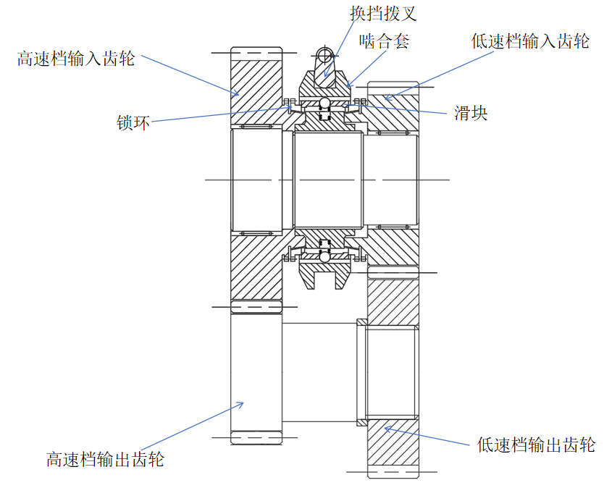
Figure 4-1 High- and low-range input and output gears
(5) Strength check. Gear contact stress is calculated using Equation (4-9).
$σ_{H}=Z_{E}\sqrt{\frac{F_{t}}{b∙d}∙\frac{u+1}{u}}$(4-9)
Material elastic coefficient, taken as 189.8 for steel against steel: $Z_{E}$
Tangential force and its expression: $F_{t}$; $F_{t}=\frac{2T}{d}$
b is the face width, taken as 20 mm.
Substituting the transfer-case input torque, material elastic coefficient and face width gives the high-range contact stress. Similarly, the low-range contact stress is calculated using Equation (4-2), as cited in the source. The allowable contact stress for 20CrMnTi gears is obtained from a reference table, completing the check:
$σ_{Hhigh}=977.5Pa$; $σ_{Hlow}=846.7Pa$; $[σ_{H}]=1500Pa$; $σ_{Hlow}{≤σ}_{Hhigh}≤[σ_{H}]$
(6) Intermediate gear shaft. This shaft transfers power from the input gear to the differential input gear. It carries the high- and low-range output gears. Its initial minimum diameter is determined by torsional strength using Equation (4-10):
$d_{min}=C\sqrt[3]{\frac{P}{n}}$(4-10)
where C is the coefficient determined by allowable torsional shear stress, taken as 106;
P is the power transmitted by the shaft;
n is the shaft speed.
Substituting the known data gives the minimum journal diameter. The selected intermediate-shaft diameter is 75 mm.
$d_{min}=74.33mm$; $d_{shaft} = 75 mm$
The maximum shear stress in the intermediate shaft is obtained from Equation (4-11):
$τ_{max}=\frac{16T}{πd^{3}}$(4-11)
Substitution gives the maximum shear stress: $τ_{max}=61.5MPa$
The allowable alloy-steel shear stress is obtained from a reference table, giving the following comparison:
$τ_{allow}=200MPa$; $τ_{max}≤τ_{allow}$

4.3.2 Front-axle output and rear-axle input and output gears
(1) Function. The front-axle output gear delivers power to the front axle and, through an intershaft coupling, to the rear-axle input shaft. Meshing rear input and output gears then transfer power to the rear output gear shaft.
(2) Design parameters. The front output gear meshes with the high-range output gear on the intermediate shaft. The module is again m = 4. Equation (4-12) determines the pitch diameter:
$d_{front}≥\sqrt[3]{\frac{2K_{t}T_{front}}{ϕ_{d}}\frac{u+1}{u}{\left(\frac{Z_{E}Z_{H}Z_{ε}Z_{β}}{{\left[σ\right]}_{H}}\right)}^{2}}$(4-12)
where u is the front-axle gear ratio, taken as 1.32.
Substituting the known data gives the front output pitch diameter. With 58 teeth selected, Equation (4-13) gives the pitch diameter:
$d_{front}≥230.50mm$; $z_{front}=58$; $d_{front}=232mm$
$d_{front}=m∙z_{front}$(4-13)
Similarly, Equation (4-14) gives:
$d_{rear}≥\sqrt[3]{\frac{2K_{t}T_{rear}}{ϕ_{d}}\frac{u+1}{u}{\left(\frac{Z_{E}Z_{H}Z_{ε}Z_{β}}{{\left[σ\right]}_{H}}\right)}^{2}}$(4-14)
Substituting the known data gives the rear input pitch diameter. The rear input-to-output ratio is designed as u = 1. To avoid accelerated wear from equal tooth counts, the input and output tooth counts are selected as shown below. Equation (4-15) gives their pitch diameters:
$d_{rear}≥210.45mm$; $z_{\text{rear_in}}=53$; $z_{\text{rear_out}}=54$
$d_{rear}=m∙z_{rear}$(4-15)
Substituting the rear gear data gives the rear input and output pitch diameters:
$d_{\text{rear_in}}=212mm$; $d_{\text{rear_out}}=216mm$
Figure 4-2 shows the front output gear, rear input and output gears, and their shafts.
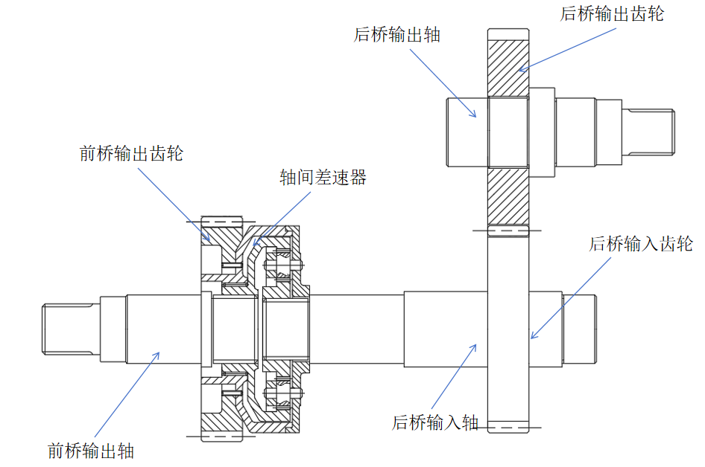
Figure 4-2 Front-axle output shaft

4.3.3 Transfer-case input and output shaft diameters
Using the coupler calculations, Equation (4-16) gives the transfer-case input torque:
$T_{trans}=T_{in}×i$(4-16)
Coupler output torque (Nm): $T_{in}$
Substituting the coupler results gives the maximum transfer-case input torque, corresponding to high-range output: $T_{trans}=2291.667≈2292Nm$
(1) Transfer-case input diameter. The shaft uses 18CrNiMo7-6 alloy steel with the following allowable shear stress:
$$T_{allow}=100MPa$$
The input diameter is therefore obtained from Equation (4-17):
$d={(\frac{16T∙K_{d}}{πτ_{allow}})}^{\frac{1}{3}}$(4-17)
Substitution gives the calculated and rounded values below. Since this shaft is also the coupler output shaft, the larger required diameter is selected: 65 mm.
$d_{in}=61.575mm$; $d_{in}=65mm$
(2) Front output and rear input diameters. The input torque is determined from the front-axle allocation of 60%. Substituting into Equation (4-5), as cited in the source, gives the calculated and rounded front output and rear input shaft diameters:
$T_{front}=1375.2Nm$; $d_{front-rear}=51.934mm$; $d_{front-rear}=55mm$
(3) Rear output diameter. The input torque is determined from the rear-axle allocation of 40%. Substituting into Equation (4-5), as cited in the source, gives the calculated and rounded rear output diameter:
$T_{rear}=916.8Nm$; $d_{rear}=45.369mm$; $d_{front-rear}=50mm$
Figure 4-3 shows the overall transfer-case structure.
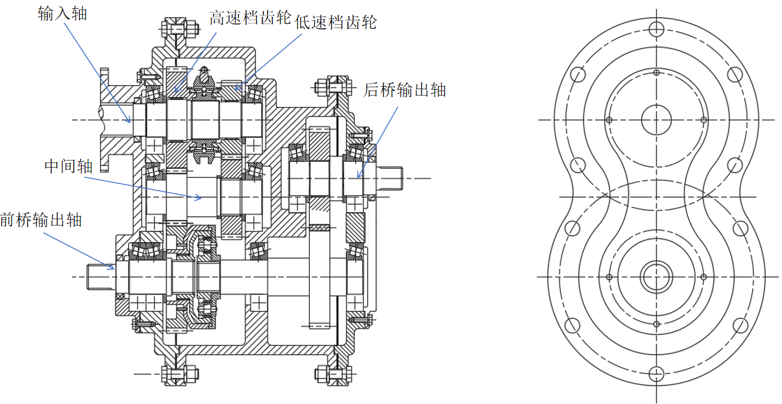
Figure 4-3 Structural design of the four-wheel-drive transfer case

4.4 Chapter summary
This chapter described the transfer-case concept and operating principle, design parameters, and design and strength checks for its gears and shafts. Calculating the parameters of high- and low-range gears, the intermediate shaft, differential input gear and front/rear output gears enabled effective power distribution in the 4WD system. Torque distribution and transmission efficiency were calculated. Shaft-diameter calculations ensured adequate strength and service life for critical components.

Chapter 5 Driveline Design

5.1 Drive-shaft transmission design
The driveline uses a double-Cardan arrangement with rigid cross-type universal joints. Because the angle between the shafts can change, constant-velocity conditions must be met so that the two shafts rotate at the same speed. A sliding spline connects to a hollow shaft, allowing the assembly to change length as the axle moves vertically and maintain power transmission to the front and rear axles. A dust boot protects the sliding-spline connection. The longer rear drive shaft also incorporates an intermediate support to prevent damage associated with the moment acting on an excessively long shaft.

5.2 Design loads for the universal-joint drive shaft
(1) Starting torque. Maximum input torque is obtained from the transfer-case output. Equation (5-1) gives the starting torque of the universal-joint driveline:
$$T_{in}=1250Nm$$
$T_{se}=\frac{k_{d}kT_{in}i_{1}i_{f}η}{n}$(5-1)
where kd is the dynamic-load factor for sudden clutch engagement, taken as 2;
k is the torque-converter multiplication factor, taken as 1;
Tin is the maximum input torque (Nm);
i1 is the transmission ratio, taken as 1;
if is the transfer-case ratio, taken as 1;
Efficiency from the power source to the universal-joint shaft, taken as 0.9: $η$
Substitution gives the starting torque: $T_{se}=1125Nm$
(2) Adhesion-limited torque. The torque acting on the driveline when the driven wheels slip is used as a design load. Equation (5-2) gives the adhesion-limited torque:
$T_{ss}=\frac{G_{2}m_{2}'φr_{r}}{i_{0}i_{m}η_{m}}$(5-2)
Static load on one driven axle at full vehicle load (N): $G_{2}$
Rear-axle load-transfer factor at maximum acceleration, taken as 1.3: $m_{2}'$
Tire–road adhesion coefficient, taken as 1: $φ$
Wheel rolling radius (m): $r_{r}$
i0 is the final-drive ratio, taken as 1;
im is the ratio between the reduction gear's driven gear and the wheels;
Efficiency from the final-drive driving gear to the wheels, taken as 0.92: $η_{m}$
Substitution gives the adhesion-limited torque: $T_{ss}=919.891Nm≈920Nm$
(3) Average torque in everyday driving. The torque acting on the driveline during normal driving is used as a design load. Equations (5-3) and (5-4) give the average torque:
$F_{t}=m_{a}g(f_{R}+f_{H}+f_{j})$(5-3)
$T_{sf1}=\frac{F_{t}r_{r}}{i_{0}i_{m}η_{m}n}$(5-4)
Average tractive force in everyday driving (N): $F_{t}$
Road rolling-resistance coefficient, taken as 0.025: $f_{R}$
Average climbing-capability coefficient in normal service, taken as 0.1: $f_{H}$
Performance coefficient: $f_{j}$
Substitution gives the average everyday-driving torque: $T_{sf1}=762.772Nm≈763Nm$

5.3 Cross-type universal-joint design calculations

5.3.1 Universal-joint structure
Wear of the needle bearings and cross journals requires particular attention. Excessive wear causes indentations and spalling on the working surfaces.
Needle-bearing contact stress must satisfy Equation (5-5):
$σ_{j}=272\sqrt{(\frac{1}{d_{1}}+\frac{1}{d_{0}})\frac{F_{n}}{L_{b}}}≤[σ_{j}]$(5-5)
Cross-journal diameter (mm): $d_{1}$
Needle diameter (mm): $d_{0}$
Effective needle length (mm): $L_{b}$
Maximum load on one needle under resultant force F: $F_{n}$
Allowable contact stress (MPa), taken as 3,000 MPa: $[σ_{j}]$
The main cross failure mode is fracture at the journal root. The force acting at the journal midpoint is obtained from Equation (5-6):
$F=\frac{T_{1}}{2rcosα}$(5-6)
Design torque of the universal-joint shaft (Nm), taken as min[Tss, Tse]: $T_{1}$
r is the distance from the line of action of resultant force F to the cross center (mm);
Maximum angle between the driving and driven yoke axes (degrees): $α$
Bending and shear stresses at the cross-journal root must satisfy Equations (5-7) and (5-8):
$σ_{w}=\frac{32d_{1}Fs}{π(d_{1}^{4}-d_{2}^{4})}≤[σ_{w}]$(5-7)
$τ=\frac{4F}{π(d_{1}^{2}-d_{2}^{2})}≤[τ]$(5-8)
Diameter of the cross lubrication passage (mm): $d_{2}$
s is the distance from the line of action of F to the journal root (mm);
Allowable bending stress (MPa), taken as 300 MPa: $[σ_{w}]$
Allowable shear stress (MPa), taken as 100 MPa: $[τ]$
Solving the equations together with the known data gives the cross diameter, selected as 28 mm, and the needle diameter, selected as 2 mm. Effective needle length is selected as 9 mm.
$d_{1}≥25.67mm$; $d_{0}≥1.6mm$; $L_{b} = 9 mm$

5.3.2 Universal-joint yoke-arm strength check
The bending stress in the yoke arm is obtained from Equation (5-9):
$σ_{b}=\frac{M∙c}{I}$(5-9)
where M is the bending moment on the yoke arm;
c is the distance from the section's neutral axis to its edge;
I is the second moment of area.
Substitution gives the yoke-arm bending stress. The selected material is 18CrNiMo7-6 alloy steel; its allowable bending stress and the resulting comparison are given below:
$σ_{b}=446.7MPa$; $[σ_{b}]=600MPa$; $σ_{b}=446.7MPa≤[σ_{b}]。$

5.3.3 Angular compensation check
To accommodate suspension movement and steering-angle changes, the maximum operating angle of the double-Cardan joint is designed as follows: $θ=15°$
For the speed-fluctuation check:
The speed fluctuation of the double-Cardan joint is given by Equation (5-10):
$ω_{out}=ω_{in}∙\frac{cos(θ)}{1-\sin^{2}(θ)∙\cos^{2}(φ)}$(5-10)
Equation (5-11) then gives the speed-fluctuation ratio:
$μ=\frac{ω_{out}-ω_{in}}{ω_{in}}×100\%$(5-11)
Substitution gives the fluctuation ratio below. It lies within the allowable range, so the angular-compensation check is satisfied. $μ=3.3\%≤5\%$

5.3.4 Universal-joint lubrication and durability
(1) Lubrication. High-temperature grease is applied between the cross and yoke to reduce friction and wear. Rubber seals prevent grease leakage and contaminant ingress.
(2) Durability check. Dynamic joint torque is calculated using Equation (5-12):
$T_{d}=2C_{d}\frac{r}{k_{t}}$(5-12)
Dynamic torque of the cross-type universal joint (Nm): $T_{d}$
Dynamic load-capacity coefficient (N), taken as 1.8 N: $C_{d}$
Effective working radius of the joint (m): $r$
Bearing factor, taken as 1.33: $k_{t}$
Substituting the design data gives the dynamic torque. Equation (5-13) then estimates cross-type universal-joint fatigue life:
$$T_{d}=162.406Nm$$
$L_{h}=\frac{1.5×{10}^{6}}{n_{x}α_{x}}{(\frac{T_{d}}{T_{x}})}^{10/3}$(5-13)
Operating speed (r/min), taken as 3,000 rpm: $n_{x}$
Angle between the driving and driven yoke axes (degrees): $α_{x}$
Operating torque (Nm): $T_{x}$
Substitution gives the joint fatigue life. The result indicates normal operation for 200,000 km at 40 km/h, satisfying the check.
$$L_{h}=4318.36h≈4320h$$

5.4 Drive-shaft body design
The shaft bodies use 18CrNiMo7-6 alloy steel. The front/rear torque split of the transfer case gives:
Front-shaft input torque: $T_{front}=2500Nm×60\%=1500Nm$
Rear-shaft input torque: $T_{rear}=2500Nm×40\%=1000Nm$
The transfer-case input torque is: $T_{in}=2500Nm$
(1) Shaft diameter. Equation (5-14) gives the outer diameters of the front and rear drive shafts:
$d={(\frac{16TK_{d}}{π[τ]})}^{\frac{1}{3}}$(5-14)
The front-to-rear transmitted torque ratio is 60:40, giving the input torques shown below. Substitution gives the outer diameters, rounded to 55 mm for the front shaft and 50 mm for the rear shaft.
$T_{front}=1500Nm$; $T_{rear}=1000Nm$; $D_{front}=53.5mm$; $D_{rear}=46.7mm$
With a designed tube wall thickness of 2.5 mm, the front and rear inner diameters are:
$d_{front}=50mm$; $d_{rear}=45mm$
(2) Critical-speed check. Using the calculated inner and outer diameters, Equation (5-15) gives the front and rear critical speeds:
$n_{k}=1.2×{10}^{8}\frac{\sqrt{D_{c}^{2}+d_{c}^{2}}}{L_{c}^{2}}$(5-15)
where Lc is the supported shaft length (mm);
Dc is the shaft-tube outer diameter (mm);
dc is the shaft-tube inner diameter (mm).
Substitution gives the front and rear critical speeds:
$n_{\text{cr_front}}≈7200rpm$; $n_{\text{cr_rear}}≈4800rpm$
These critical speeds give the front and rear safety factors:
$S_{front}≈5.28>2.5$; $S_{rear}≈3.52>2.5$
The shaft-tube section must also provide sufficient torsional strength. Torsional stress must satisfy Equation (5-16):
$τ_{c}=\frac{16D_{c}T_{1}}{π(D_{c}^{4}-d_{c}^{4})}≤[τ_{c}]$(5-16)
Design shaft torque (Nm): $T_{1}$
Allowable torsional stress (MPa), taken as 300 MPa: $[τ_{c}]$
Substituting the front and rear shaft data gives the respective torsional stresses below, satisfying the check.
$τ_{\text{c_front}}=144.655MPa≤[τ_{c}]$; $τ_{\text{c_front}}=118.475MPa≤[τ_{c}]$
(3) Sliding spline. A sliding yoke and rectangular external spline allow the drive shaft to change length. Based on shaft size, the rear external spline has an outer diameter of 50 mm and inner diameter of 46 mm; the front has an outer diameter of 55 mm and inner diameter of 51 mm. Equation (5-17) calculates torsional stress using the root diameter:
$τ_{h}=\frac{16T_{1}}{πd_{h}^{3}}$(5-17)
Design shaft torque (Nmm): $T_{1}$
dh is the external spline's inner diameter (mm).
Substitution gives 169.765 MPa torsional stress in the front external spline and the following rear-spline stress:
$τ_{\text{h_front}}=169.765 MPa$; $τ_{\text{h_rear}}=127.324MPa$
For static strength, the allowable stress is set to 180 MPa. The following comparison satisfies the check:
$\left[τ_{h}\right] = 180 MPa$; $τ_{h}≤[τ_{h}]$
Equation (5-18) gives the bearing stress on the sliding-spline tooth flanks:
$σ_{y}=\frac{T_{1}K'}{\frac{D_{h}+d_{h}}{4}\frac{D_{h}-d_{h}}{2}L_{h}n_{0}}$(5-18)
where K′ is the spline torque-distribution nonuniformity factor, taken as 1.3;
Lh is the effective spline working length (mm), designed as 40 mm;
n0 is the spline tooth count.
Substituting the design data gives the front and rear spline-flank bearing stresses below. For sliding splines with tooth-surface hardness above 35 HRC, allowable bearing stress is 25–50 MPa, so the check is satisfied.
$σ_{\text{y_front}}=37.657MPa$; $σ_{\text{y_rear}}=29.334MPa$; $\left[σ_{y}\right] = 25-50 MPa$
Figure 5-1 shows the overall drive-shaft arrangement.
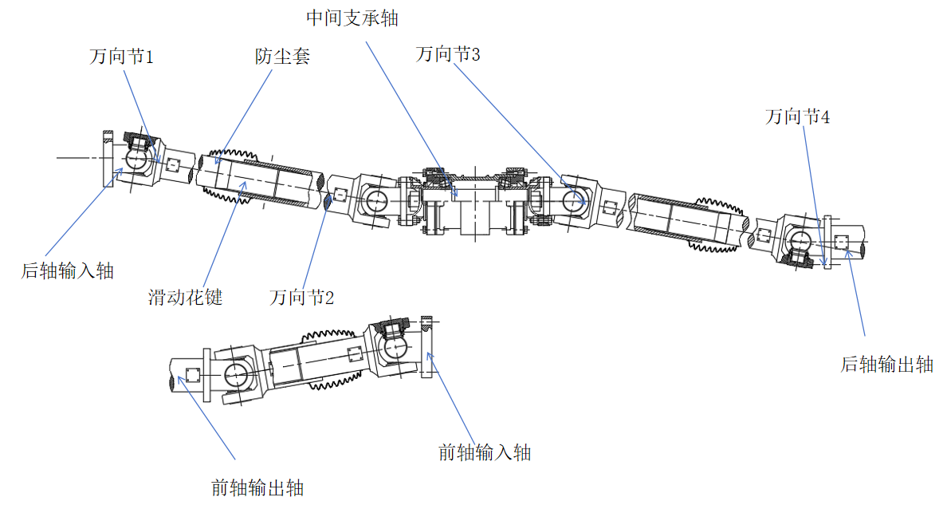
Figure 5-1 Structural design of the driveline

5.5 Chapter summary
This chapter addressed the overall driveline design, focusing on the operating principle and constant-velocity requirements of the double-Cardan arrangement. Design loads were calculated, including starting torque, adhesion-limited torque and average torque in everyday driving. The cross-type joint was then designed and checked for strength to ensure safety and durability under actual operating conditions. Combining theoretical calculations with material selection supported the suitability and service life of the structure.
The chapter also checked yoke-arm strength, angular compensation, lubrication and fatigue life to improve system reliability and stability. The shaft bodies were designed systematically, with checks on diameter, critical speed, spline torsional strength and spline-flank bearing stress, confirming compliance with torsional-strength and service-life requirements.

Conclusions
This thesis investigated the power distribution unit of a four-wheel-drive hybrid vehicle, focusing on the power coupler, transfer case and driveline to improve performance, stability and energy-management efficiency.
The main work is summarized below:
1. Vehicle performance requirements established a rated power of 125 kW and hybrid-mode peak power of 300 kW. The overall hybrid 4WD powertrain layout was completed, and a combined series-parallel control strategy was developed to coordinate power sources and recover energy efficiently. These measures improved fuel economy and response under different driving conditions while maintaining efficient operation.
2. The power coupler uses a planetary set with the engine connected to the carrier, the motor to the sun gear and combined output through the ring gear. This efficiently couples engine and motor power, with maximum output-shaft torque of 1,250 Nm. The coupler meets the need for flexible source coupling and supports power distribution in the 4WD system.
3. The transfer case uses a two-range arrangement. After high- or low-range selection, an interaxle differential distributes power to the front and rear shafts at a torque ratio of 60:40.
4. The driveline uses double-Cardan joints and telescopic shafts, with the longer rear shaft divided into sections. It transmits power from the transfer case to the front and rear driven axles. Transmission efficiency, load capacity and service life meet the vehicle performance requirements.
Several limitations remain. Coordinating multiple power sources while further simplifying the structure and improving integration and reliability requires additional research. In particular, the current energy-management strategy is basic. Future work could incorporate artificial intelligence to improve power distribution and energy recovery. Hybrid systems also remain expensive; reducing manufacturing cost while maintaining performance and safety is important for broader adoption.
Future research could optimize overall performance, particularly the balance between energy efficiency, reliability and cost. Intelligent control and system integration will be important directions. As the new-energy vehicle market develops, the role of four-wheel-drive hybrids in everyday transport warrants further investigation.
Overall, the proposed design addresses key power-distribution and energy-management problems in four-wheel-drive hybrids and offers an efficient, reliable and engineering-feasible powertrain solution. The unit has practical significance for developing new-energy vehicles and advancing energy-conservation and emission-reduction goals.

References
[1] Zhu Fentian. Research on an HEV multi-agent control system based on driving-condition recognition [dissertation]. Anhui University of Technology, 2022. [In Chinese; title translated.]
[2] Dai Zibing. Research on energy-distribution control strategies for hybrid logistics vehicles [dissertation]. Xiamen University of Technology, 2017. [In Chinese; title translated.]
[3] Wei Shuai. Toyota's poor harvest [journal article]. China Entrepreneur, 2023(06): 66–69. [In Chinese; title translated.]
[4] Liu Hanwu, Lei Yulong, Fu Yao, et al. Adaptive regenerative-braking control for range-extended electric vehicles based on multi-objective optimization [journal article]. Journal of South China University of Technology (Natural Science Edition), 2021, 49(07): 42–50+6. [In Chinese; title translated; pagination retained as supplied.]
[5] Xiao Lan. BYD launches its electric-vehicle dream [journal article]. Standard Living, 2010(10): 34–35. [In Chinese; title and publication name translated.]
[6] Chen Meiqi. Adaptive energy control for a novel dual-axle-coupled PHEV system [dissertation]. Shandong University of Technology, 2017. [In Chinese; title translated.]
[7] Sun Haoqing, Wang Jialin, Wu Jiquan. Current development and trends in hybrid-vehicle energy-management strategies [journal article]. Automobile Applied Technology, 2024(24): 118–121. [In Chinese; title translated.]
[8] Hu Haihua, Qian Zhenghua, Zhou Menglai. Review of energy-consumption optimization control architectures for battery electric buses [journal article]. Auto Electric Parts, 2024(06): 1–4+7. [In Chinese; title translated.]
[9] Huang Zhifeng. Principles and related technologies of new-energy vehicles [journal article]. Power & Energy, 2014(04): 505–508+512. [In Chinese; title translated.]
[10] Peng Zihan. Research on the legal framework for new-energy regulation under the dual-carbon goals [dissertation]. North China University of Technology, 2023. [In Chinese; title translated.]
[11] Jiang Tong. Adaptive equivalent-consumption-minimization energy management for PHEVs based on driving-condition recognition [dissertation]. Hefei University of Technology, 2019. [In Chinese; title translated.]
[12] Sun Shanfeng. Development and experimental study of control strategies for a 48 V system applied to light-truck diesel engines [dissertation]. Tianjin University, 2021. [In Chinese; title translated.]
[13] Chen D, Chen T, Li Z, et al. Energy management strategy for plug-in hybrid electric vehicles based on vehicle speed prediction and limited traffic information [J]. Energy, 2025, 326 136292-136292.
[14] Zhang Y, Fan P, Lu H, et al. Fuel consumption of hybrid electric vehicles under real-world road and temperature conditions [J]. Transportation Research Part D, 2025, 142 104691-104691.
[15] Benhammou A, Hartani A M, Tedjini H, et al. Breaking New Ground in HEV Energy Management: Kinetic Energy Utilization and Systematic EMS Approaches based on robust drive control [J]. ISA transactions, 2024, 147 288-303.
[16] Zexing W, Hongwen H, Jiankun P, et al. A comparative study of deep reinforcement learning based energy management strategy for hybrid electric vehicle [J]. Energy Conversion and Management, 2023, 293.
[17] Antunes M G, Falsarella M C, Pavan E M R, et al. Hybrid vigor: Why hybrids with sustainable biofuels are better than pure electric vehicles [J]. Energy for Sustainable Development, 2023, 76.
[18] Ziółkowski A, Fuć P, Jagielski A, et al. Comparison of the Energy Consumption and Exhaust Emissions between Hybrid and Conventional Vehicles, as Well as Electric Vehicles Fitted with a Range Extender [J]. Energies, 2023, 16 (12).
[19] Luan Yixuan. Research progress on hybrid-vehicle energy-management strategies [journal article]. Automobile Applied Technology, 2023, 48(24): 178–182. [In Chinese; title translated.]
[20] Wang Xue, Zhang Ning, Dong Lele. Construction of an HEV powertrain multi-agent system and vehicle performance analysis [journal article]. Construction Machinery Abstracts, 2024(01): 46–48. [In Chinese; title translated.]

Innovative Achievements During Undergraduate Study
Patent applications and granted patents
[1] Wang Lufei, Li Zhenghui, et al. A six-strut tensegrity robot: China, CN116713983A. 2023-06-29. [Title translated; identifier and date retained from the source.]
[2] Xu Le, Wang Lufei, et al. A tension–compression conversion spring: China, CN220101878U. 2023-06-28. [Title translated; identifier and date retained from the source.]

