___________________________________________________________________________

*Faculty of Information Technology and Engineering*

*Electrical Circuit Lab*

|  |  |
| --- | --- |
| Student ID: 202110795 | Student Name: Sama Haitham Sammar |
| Experiment #: 1 | Experiment Name: Familiarization & Ohm’s Low |
| Section: 3 | Supervisor Name: Dr Amjad Abu Jazar |
| Date: 28 March 2024 | Day: Thursday |

*Objective :-*

In this experiment, we shall study how to use the digital Multimeter, Power supplies and the oscilloscope. Then we shall examine Ohm’s low and perform some measurement.

*Apparatus Request :-*

* DC power supply and Function Generator (AC power supply).
* Digital Multimeter.
* Oscilloscope.
* Components (Resistors, Cables and Breadboard).

*Theory and Background:-*

**1.Power Supply**

A power supply is an electrical device that supplies electric power to an electrical load. All power supplies have a power input connection, which receives energy in the form of electric current from a source, and one or more power output connections that deliver current to the load. In our lab, we have a DC power supply and an AC power supply as a different equipment.

**2.Digital Multimeter**

We can use the digital Multimeter to measure dc voltage and current, AC as an RMS value of AC voltage and current, also we can use it as an ohmic Meter to measure directly or indirectly the value of a resistance in (Ω) or a conductance.

**3.Oscilloscope**

We can use the oscilloscope to measure the frequency of a wave, the peak - to - peak value and r.m.s of voltage (dc and ac), also to measure the phase between two waves.

If a DC wave is appeared on the screen of oscilloscope, with 2 division’s height value and the scale of ch1 is 5V/div.

The value of voltage = number of squares scale of ch.1 = 2*5 = 10 V.

If two sinusoidal waves appeared on the screen as in fig.1.3(c), where the scale of ch1 is 5V/Div, and the scale of ch2 is 3V/Div. where V1max=4 squares height, V2max=3 square height.

V1 max = 4*5 = 20V. V1 p-p = 2*20= 40V.

V1 rms = 40/(2√2) = 14V. V2 max = 3*3 = 9V.

V2 p-p = 9*2 = 18V. V2 rms = 18/(2√2) = 6.36 V.

* T (period) for each wave = 8*5 = 40 msec, where the complete cycle takes 8 squares.
* f (frequency) for each wave = 1/T = 1/(40 * 10 -3) = 25 Hz
* Each wave takes 360°for one period. Each division = 360°/8 = 45°
* Phase shift = 3(Div) *45°= 135°
* If you put time base on XY mode as in fig 1.3(b) you obtain a shape according to the type of the circuit.

*Experiment Procedure:-*

**First:-** Ohm’s Low

 Ohm’s Low states that the current through a conductor between two points is directly proportional to the potential difference across the two points.

I = \frac{V}{R},

* 1. **Connect the circuit shown in Fig 1. Using the Multimeter to fill in Table 1 as required.**



Fig 1

In Multisim:

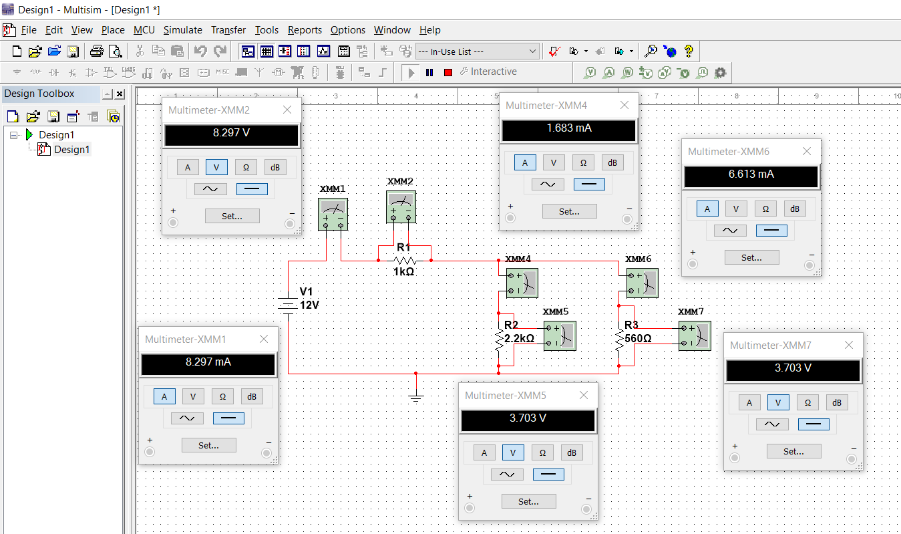

Table 1:-

|  |  |  |  |  |  |
| --- | --- | --- | --- | --- | --- |
| IR1 | IR2 | IR3 | VR1 | VR2 | VR3 |
| 8.297mA | 1.683mA | 6.613mA | 8.297V | 3.703V | 3.703V |

Note: Multimeter connected in parallel with component if you are measuring a voltage and in series if you are measuring a current.

* 1. **Use the previous circuit to find the relation between changing the voltage source value and the current through the R1 then tabulate your result in Table 2. After that draw the result and discuss it.**

For table 2 (this same circuit)

|  |  |
| --- | --- |
|  |  |
|  |  |
|  |  |

Table 2**:-**

|  |  |
| --- | --- |
| Voltage Source | IR1 |
| 2 | 1.383mA |
| 4 | 2.766mA |
| 6 | 4.148mA |
| 8 | 5.531mA |
| 10 | 6.914mA |
| 12 | 8.297mA |

The relationship between changing the voltage source value with the current value

x-axis represent the voltage values and y-axis represent the current values .

IR1

V

We noticed that this is A linear relationship.

***Second:- Resistor***

**Resistor color code**: The resistor color code used to indicate the resistor value. It used as shown below.

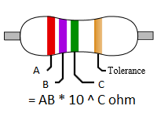

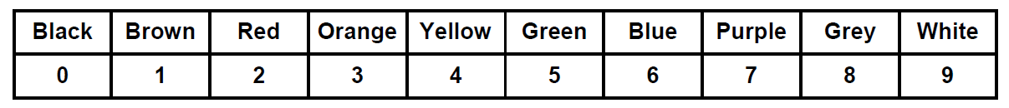

**Exercise:** you are given some unknown resistor; use the Multimeter to measure their value. Then use color code to confirm your result. Fill in your result in table 3.

Table 3:-

|  |  |
| --- | --- |
| Color code value | Measured value |
|  | 32 * 10 ^ 0 = 32 Ohm |
|  | 470 * 10 ^ 3 = 470 kOhm |

**Resistor Equivalent:**

you can find the equivalent resistor for different resistor combination as define below.

**Series and Parallel Connection:**

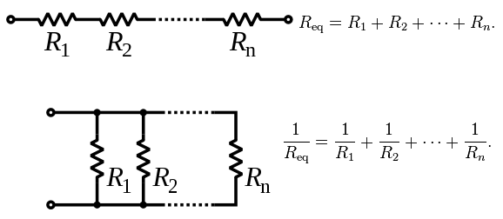

**Exercise:** Connect the circuit in the figure below, then use the multimeter to measure the equivalent resistor for different RX value. Fill in your result in Table 4 .

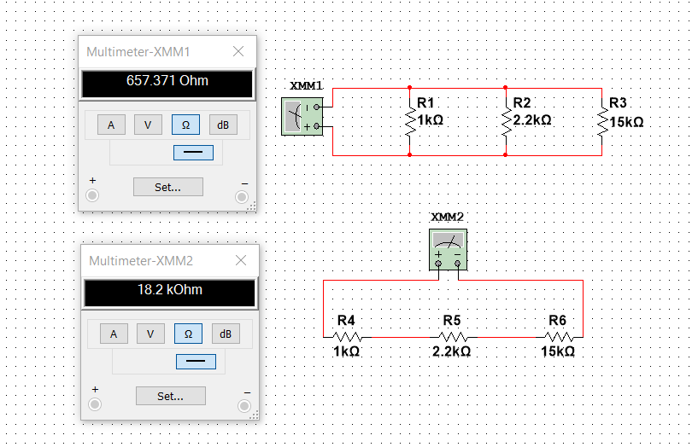

When Rx=15k in two methods

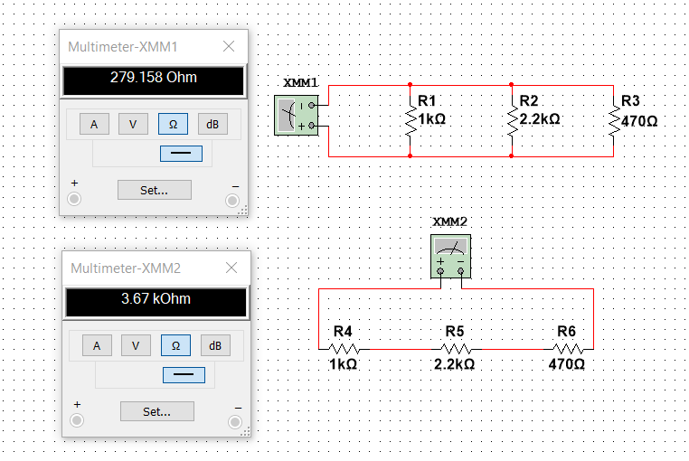

When Rx=470 in two methods

Table 4:-

Parallel

Series

|  |  |  |
| --- | --- | --- |
| Rx (Ohm) | Ra eq | Rb eq |
| 470 | 279.158 Ohm | 3.67 kOhm |
| 15k | 657.371 Ohm | 18.2 kOhm |

**Discussion:** Does the equivalent resistor value increase or decrease as RX increase?

**It increase**. Also, The value of the equivalent resistance when the resistance are connected in series is greater than the maximum resistance . However , The value of the equivalent resistance when the resistance are connected in parallel is less than the minimum resistance .

*Conclusion: -*

In this Lab we learned about how to use the MULTISIM for connecting electrical circuits , we also got to know about multimeter device to measure voltage , current and finding value of resistance , this is way to find the value of resistor , there is another ways like color code and Ohms Low.