___________________________________________________________________________

*Faculty of Information Technology and Engineering*

*Electrical Circuit Lab*

|  |  |
| --- | --- |
| Students ID: 202110795, 202112300, 202110451 | Students Name: Sama Haitham Sammar, Arein Zaid Alkilani, Yara Jehad Rabaya |
| Experiment #: 6 | Experiment Name: Step Response Analysis |
| Section: 3 | Supervisor Name: Dr Amjad Abu Jazar |
| Date: 30 May 2024 | Day: Thursday |

***Objective:***

* 1. Examine the behavior of first-order and second-order circuits in response to a step input.
  2. Examine the step-response in RLC circuit.
  3. Solving 1st and 2nd order differential equations to derive responses in various cases.

***Apparatus Required:***

* DC power supply.
* Digital Multimeter.
* Signal Generator.
* Oscilloscope.
* Components (Resistors, Capacitors, Inductors, Cables and Breadboard).

***Theory and Background:***

To solve the step response for the first order circuit, let us try to analyze the circuit in figure 1.

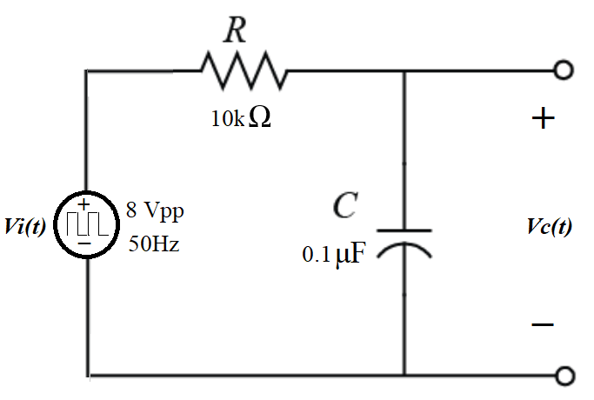

Figure 1

By doing KVL: -

Differentiating both sides of (1) yields:

This is a 1st order differential equation and its solution has the form:

, which is the time need for the output to fall to voltage of .

For a pulse input, the output *Vc(t)* would be as shown in figure 2.

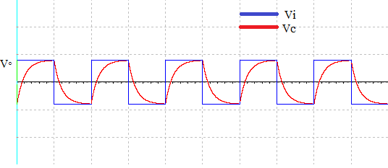

Figure 2

To solve the step response for the second order circuit let us try to solve circuit in figure 3

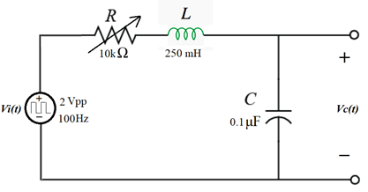

Figure 3

By doing KVL: -

Differentiating both sides of equation (4) yields:

This is a 2nd order differential equation and its solution is:

Solving equation (6):

* ***When α > w0 there are two real solution and this case is the overdamped solution.***
* ***When α < w0 there are two imaginary solution and this case is the underdamped solution.***
* ***When α = w0 there is one real solution and this case is the critically damped solution.***

For a pulse input, the output *Vc(t)* would be as shown in figure 4:

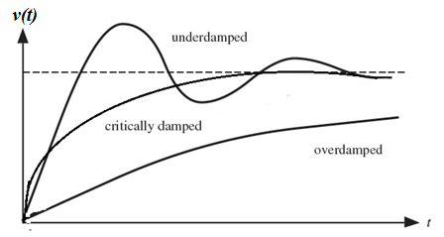

Figure 4

***Experiment Procedure:***

***Part One: Pulse response of first-order circuit***

* 1. **Connect the circuit shown below.**

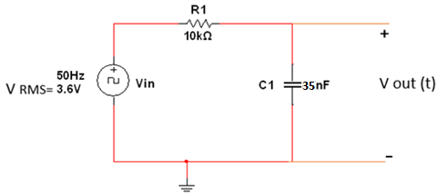

* 1. **Set the function generator to produce a square wave with a frequency of 50 Hz, no DC offset and RMS voltage of 3.6 V.**
  2. **Set the oscilloscope to display the waveform VOUT (t) produced by this circuit.**
  3. **Measure the circuit time constant τ charging and τ discharging.**
  4. **Change R1 to 15 KΩ and 27 KΩ, then measure time constant τ charging and τ discharging in each case.**
  5. **Tabulate your result in the Table (1):**

**Table 1:**

|  |  |  |  |  |
| --- | --- | --- | --- | --- |
| **R1** | **τ charging**  **(By MULTISIM)** | **τ charging**  **(Measured in lab)** | **τ discharging**  **(By MULTISIM)** | **τ discharging**  **(Measured in lab)** |
| **10kΩ** |  |  |  |  |
| **15 kΩ** |  |  |  |  |
| **27 kΩ** |  |  |  |  |

* 1. **Discuss the result in table 1 and support your answer by drawing VOUT (t).**

***Part Two: Pulse response of second-order circuit***

1. **Connect the circuit shown below.**

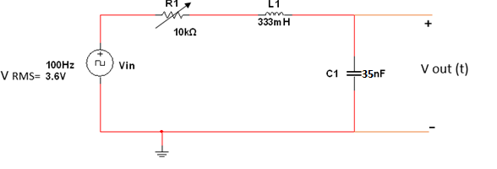

1. **Set the function generator to 100Hz square wave output, 3.6 V RMS.**
2. **Connect the oscilloscope across the capacitor and turn on the function generator. Vary the variable resistor over its entire range and note how the output waveform Vout(t) varies.**
3. **For each of the following cases, draw an accurate sketch of the resulting output waveform:**

* **Case A: Set the variable resistor to its maximum (10kΩ) and measure its value. Sketch Vout(t) as displayed by the oscilloscope. Measure the decay time constant (τ charging)**
* **(τ) charging in Multisim = 387 us**
* **(τ) charging in lab = 390 us**

* **Case B: Set the variable resistor so that the output waveform is in the critically damped case. Measure the value of R1 and then Sketch Vout(t) as displayed by the oscilloscope.**
* **In Multisim R=5k ohm .**
* **In lab R=3.87k ohm**

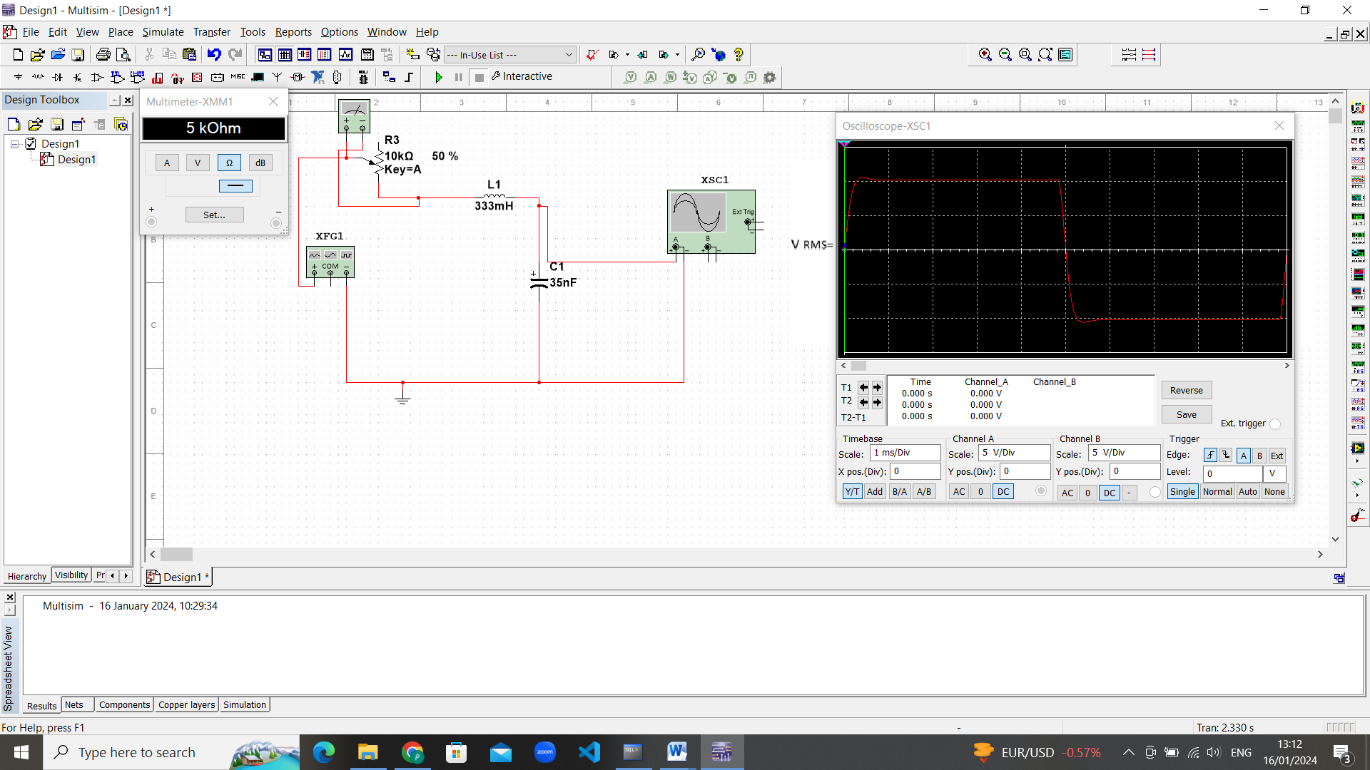

* **Case C: Remove the variable resistor from the circuit and replace it by a wire. Sketch Vout(t) as displayed by the oscilloscope. Measure the damped frequency (*fd*).**
* ***fd = 1.441 K Hz in multisim***
* ***fd = 1.786 K Hz in lab***

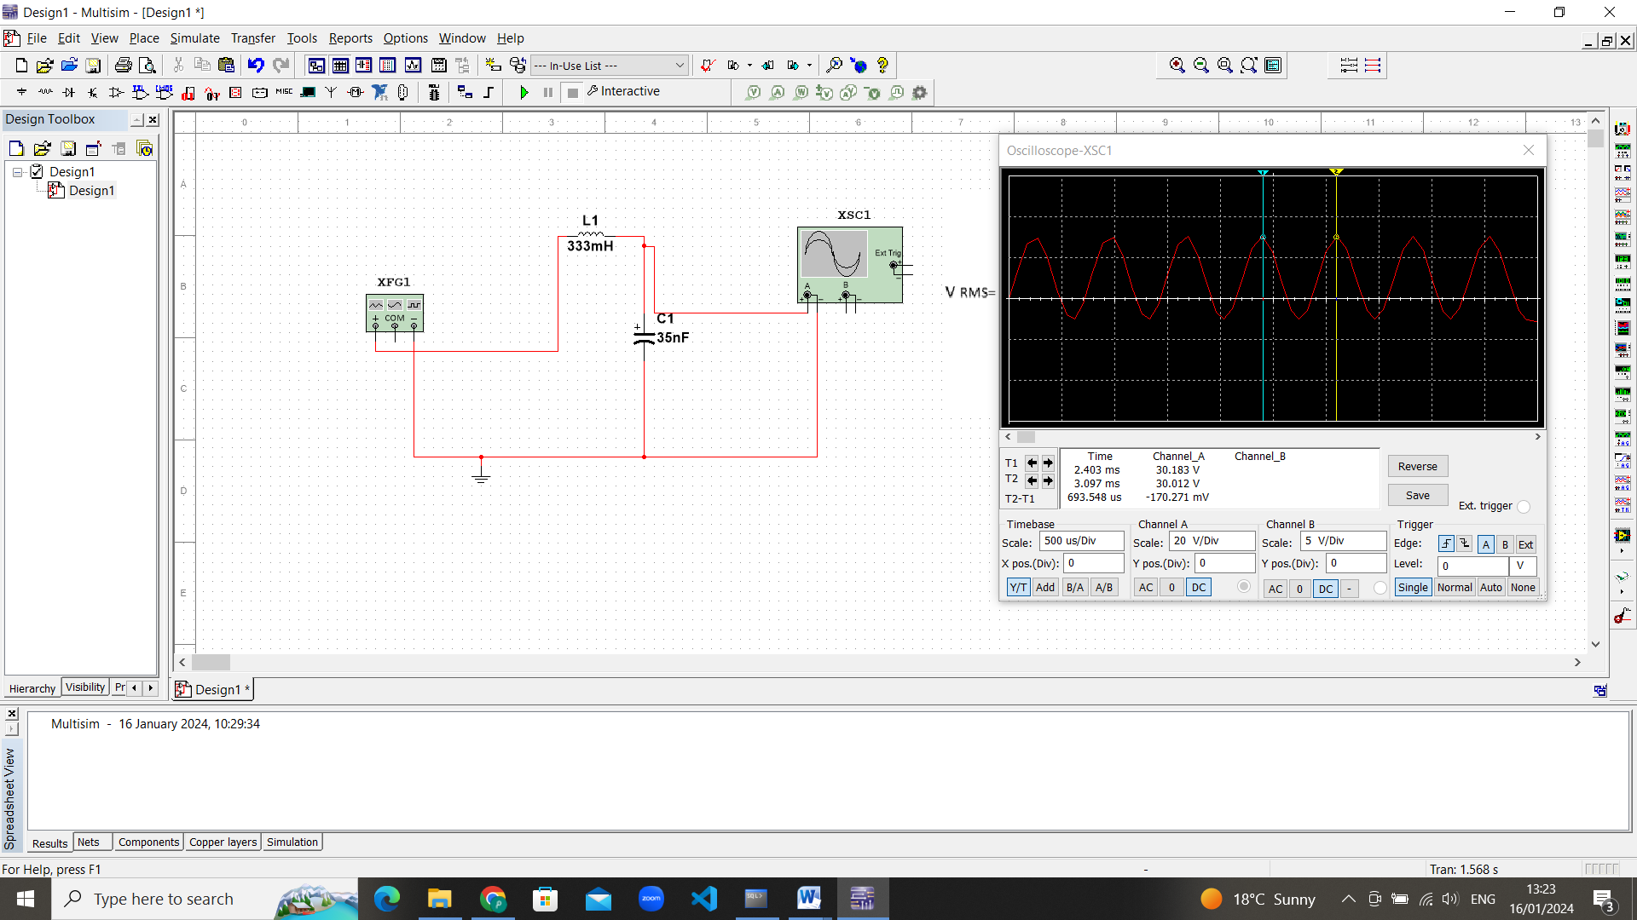

***Conclusion and Analysis:***

1. Compare measured values Discrepancies between the lab results and MULTISIM Discrepancies between the lab results and MULTISIM values arise due to the precision limitations of the devices.
2. Write down a comprehensive conclusion to sum up what you have learnt today

**I learn from this experiment the behavior of first order and second-order circuits in response to a step input and Examine the step-response in RLC circuit**

**I learn from this experiment about the forms of response in its different state**

**\* Over damped**

**\*And critical case**

**\* Under damped**

**in second order circuit which includes inductor, capacitor and resistor.**

**Also, I learn from this experiment how find τ value practically from the wave’s response and the relationship between maximum value of voltage and τ voltage in charging and discharging case.**

**The results in the practical laboratory differ slightly from the results on the Multisim program, because the wires have resistors and also the devices have an error rate, and the resistors are manufactured differently from one company to another.**