___________________________________________________________________________

*Faculty of Information Technology and Engineering*

*Electrical Circuit Lab*

|  |  |
| --- | --- |
| Students ID: 202110795 , 202112300 | Students Name: Sama Haitham Sammar , Arein Zaid |
| Experiment #: 3 | Experiment Name: Opens and Shorts in Electrical Circuits  and Voltage & Current Divisions |
| Section: 3 | Supervisor Name: Dr Amjad Abu Jazar |
| Date: 18 April 2024 | Day: Thursday |

***Objectives:***

I. To examine the effects of opens and shorts in electrical circuits.

II. To verify the voltage divider rule.

III. To verify the current divider rule.

***Apparatus Required:***

* DC power supply.
* Digital Multimeter.
* Components (Resistors, Cables and Breadboard).

***Theory and Background:***

1. **Open and Short resistors in the electrical circuit**

A short circuit (sometimes abbreviated to short or S.C.) is an electrical circuit that allows a current to travel along an unintended path, often where essentially no (or a very low) electrical impedance is encountered. The electrical opposite of a short circuit is an "open circuit", which is an infinite resistance between two nodes.

The major difference between an open in a parallel circuit and an open in a series circuit is that in the parallel circuit the open would not necessarily disable the circuit. If the open condition occurs in a series portion of the circuit, there will be no current because there is no complete path for current flow. If, on the other hand, the open occurs in a parallel path, some current will still flow in the circuit. The parallel branch where the open occurs will be effectively disabled, total resistance of the circuit will **increase**, and total current will **decrease**.

1. **Voltage Divider Rule: -.**

As we got to know that, a series circuit is known as a voltage divider circuit. It is a circuit which divides the voltage into minor parts. So, with a power source and two resistors, we can make an easy voltage divider circuit. Here we need to connect two resistors in series combination and then apply a voltage source across the series circuit.

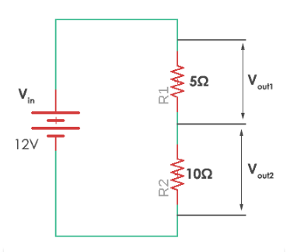

In this case, resistor R1 of 5 ohms and resistor R2 with 10 ohms resistance are connected. The voltages Vout1 and Vout2 are divided across the resistors R1 and R2. They can be calculated by a simple voltage dividing equation.

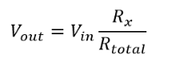

Where Rx is the resistor across which we need to find the voltage and Rtotal is the total resistance (R1+R2) in the circuit. It can be simply calculated by adding all of them as they are connected in series. Thus, in the given circuit, the values of the voltage across each resistor are

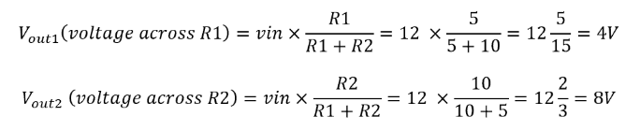

Therefore, voltage across R1 is 4V and voltage across R2 is 8V. Thus, here voltage is divided in the circuit across the resistors. Hence, this is called voltage divider circuit.

1. **Current Divider Rule: -**

A current divider is a circuit which divides the current into small parts. As we got to know that parallel circuits are current divider circuit. So, with a power source and two parallel resistors, we can make an easy current divider circuit. As in the current divider network, here we need to connect two resistors in parallel combination and then apply a current source across the parallel circuit.

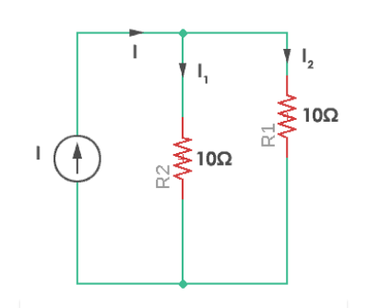

‘I1‘and ‘I2‘are the current divided across resistors R1 and R2. They can be calculated by a simple current dividing equation.

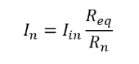

‘In‘ is the required current that flows through the resistor Rn. Req is the equivalent resistance of the parallel resistors. Equivalent resistance (Req) is given by

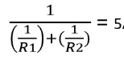



So, the current flowing through resistor R1 and R2 would be

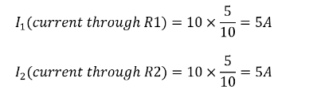

Here the resistors are of same value and so current will be divided in exactly half through each resistor. Thus, this is known as the current divider circuit.

***Experiment Procedure:***

***First: Open and Short resistor:-***

* 1. **Connect the circuit shown in Fig 1. Using the Multimeter to fill in Table 1 as required.**

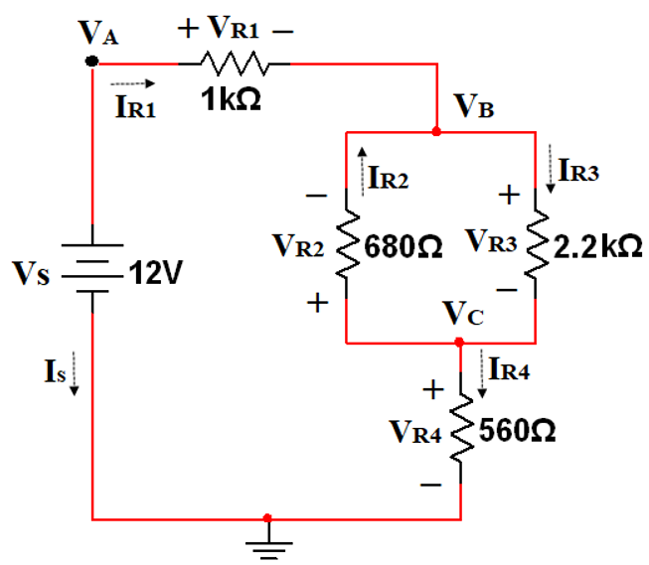

Fig 1

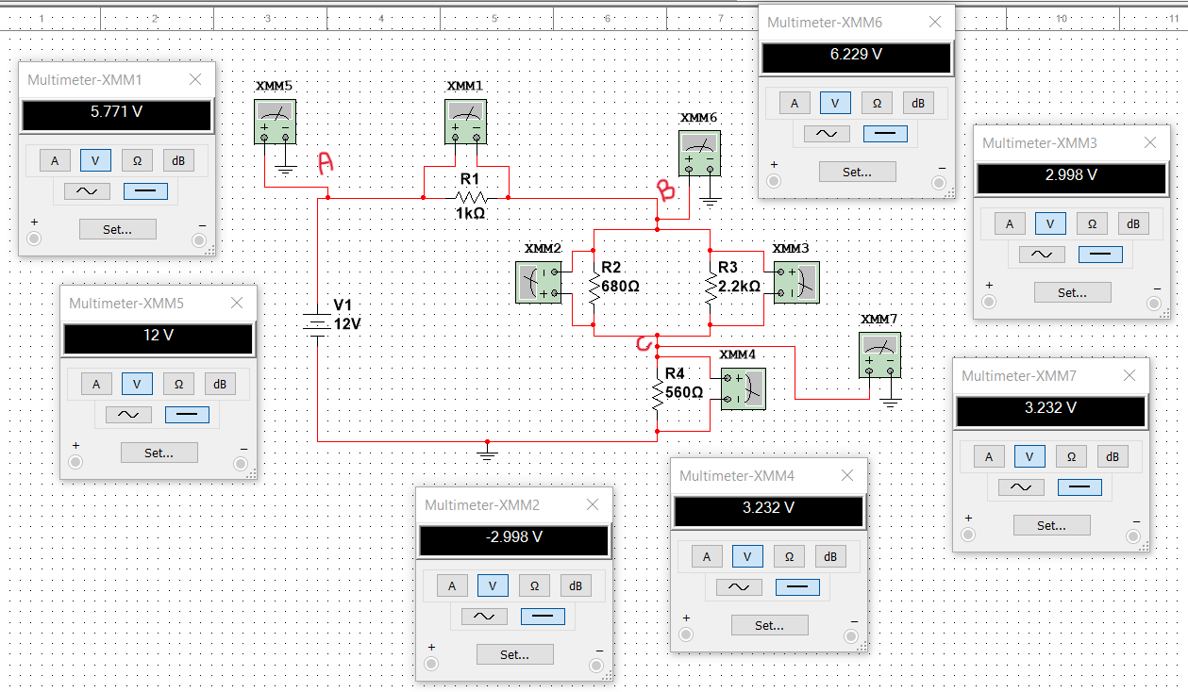

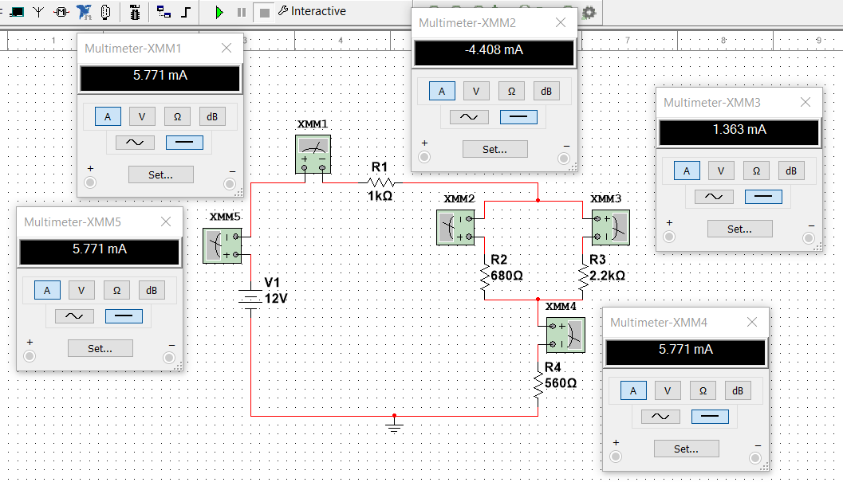

**Calculated by Multisim**

**Table 1-a:** fill the table as required.

|  |  |  |  |  |  |  |  |  |  |  |
| --- | --- | --- | --- | --- | --- | --- | --- | --- | --- | --- |
| **VR1** | **VR2** | | **VR3** | | **VR4** | **VA** | | **VB** | | **VC** |
| **5.771 v** | **-2.998 v** | | **2.998 v** | | **3.232 v** | **12 v** | | **6.229 v** | | **3.232 v** |
|  | | | | | | | | | | |
| **IS** | | **IR1** | | **IR2** | | | **IR3** | | **IR4** | |
| **5.771 mA** | | **5.771 mA** | | **-4.408 mA** | | | **1.363 mA** | | **5.771 mA** | |

**Measured in Lab:**

**Table 1-b:** fill the table as required.

|  |  |  |  |  |  |  |  |  |  |  |
| --- | --- | --- | --- | --- | --- | --- | --- | --- | --- | --- |
| **VR1** | **VR2** | | **VR3** | | **VR4** | **VA** | | **VB** | | **VC** |
| **5.9 v** | **2.93 v** | | **2.93 v** | | **3.18 v** | **12.01 v** | | **6.11 v** | | **3.18 v** |
|  | | | | | | | | | | |
| **IS** | | **IR1** | | **IR2** | | | **IR3** | | **IR4** | |
| **5.73 mA** | | **5.73 mA** | | **4.39 mA** | | | **1.34 mA** | | **5.73 mA** | |

* 1. **Fill the table below if the R1 is open.**

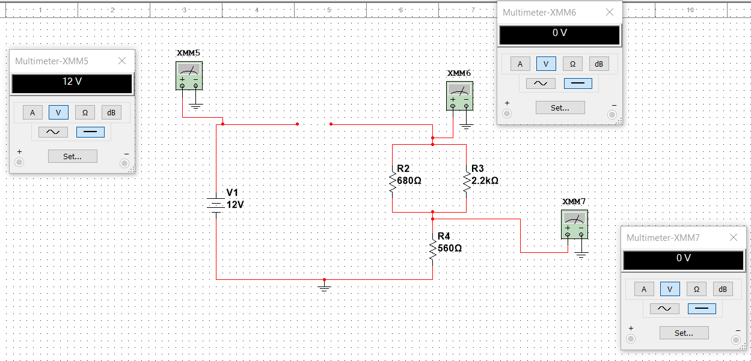

**Calculated by Multisim:**

**Table 2-a**: fill the table as required.

|  |  |  |  |  |  |  |
| --- | --- | --- | --- | --- | --- | --- |
| **VA** | **VB** | **VC** | **IR1** | **IR2** | **IR3** | **IR4** |
| **12 v** | **0** | **0** | **177.636 pA** | **0** | **0** | **0** |

**Measured in Lab:**

**Table 2-b**: fill the table as required.

|  |  |  |  |  |  |  |
| --- | --- | --- | --- | --- | --- | --- |
| **VA** | **VB** | **VC** | **IR1** | **IR2** | **IR3** | **IR4** |
| **12.01 v** | **0** | **0** | **0** | **0** | **0** | **0** |

* 1. **Fill the table below if the R1 is Short.**

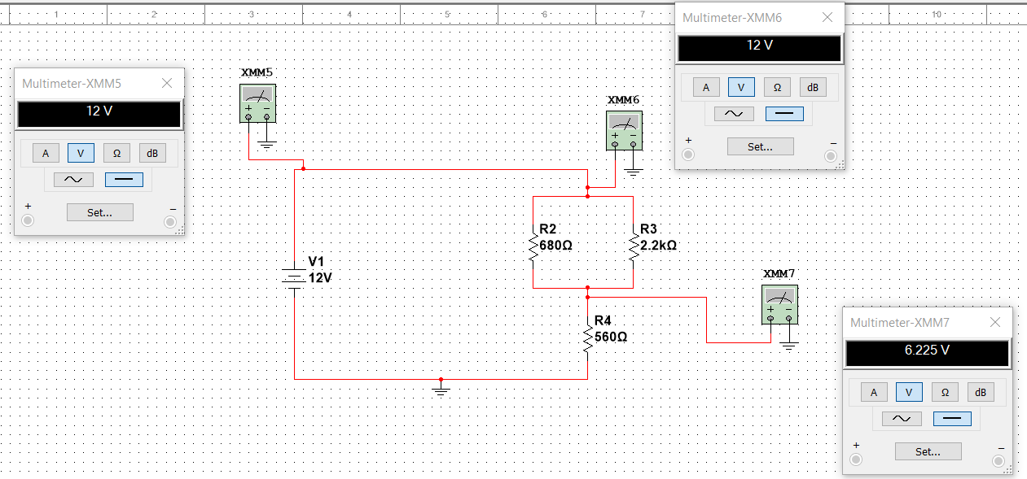

**Calculated by Multisim:**

**Table 3-a**: fill the table as required.

|  |  |  |  |  |  |  |
| --- | --- | --- | --- | --- | --- | --- |
| **VA** | **VB** | **VC** | **IR1** | **IR2** | **IR3** | **IR4** |
| **12 v** | **12 v** | **6.225 v** | **11.117 mA** | **8.492 mA** | **2.625 mA** | **11.117 mA** |

**Measured in Lab:**

**Table 3-b**: fill the table as required.

|  |  |  |  |  |  |  |
| --- | --- | --- | --- | --- | --- | --- |
| **VA** | **VB** | **VC** | **IR1** | **IR2** | **IR3** | **IR4** |
| **12.01 v** | **12.01 v** | **6.24 v** | **11.22 mA** | **-8.61 mA** | **2.61 mA** | **11.22 mA** |

* 1. **Fill the table below if the R2 is open.**

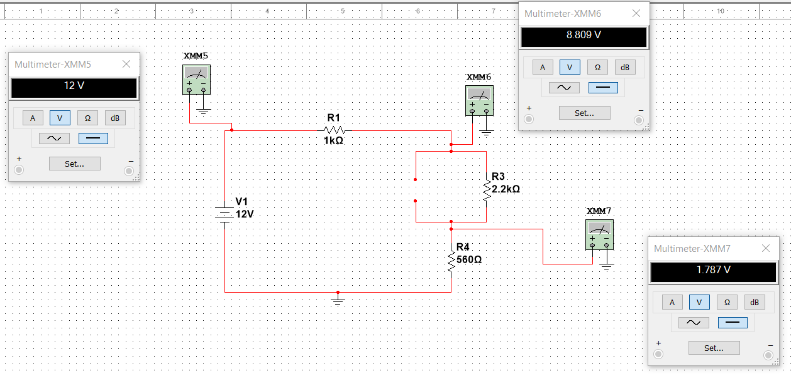

**Calculated by Multisim:**

**Table 4-a**: fill the table as required.

|  |  |  |  |  |  |  |
| --- | --- | --- | --- | --- | --- | --- |
| **VA** | **VB** | **VC** | **IR1** | **IR2** | **IR3** | **IR4** |
| **12 v** | **8.809 v** | **1.787 v** | **3.191 mA** | **-177.636 mA** | **3.191 mA** | **3.191 mA** |

**Measured in Lab:**

**Table 4-b**: fill the table as required.

|  |  |  |  |  |  |  |
| --- | --- | --- | --- | --- | --- | --- |
| **VA** | **VB** | **VC** | **IR1** | **IR2** | **IR3** | **IR4** |
| **12.01 v** | **8.74 v** | **1.76 v** | **3.18 mA** | **0** | **3.18 mA** | **3.18 mA** |

* 1. **Fill the table below if the R2 is Short.**

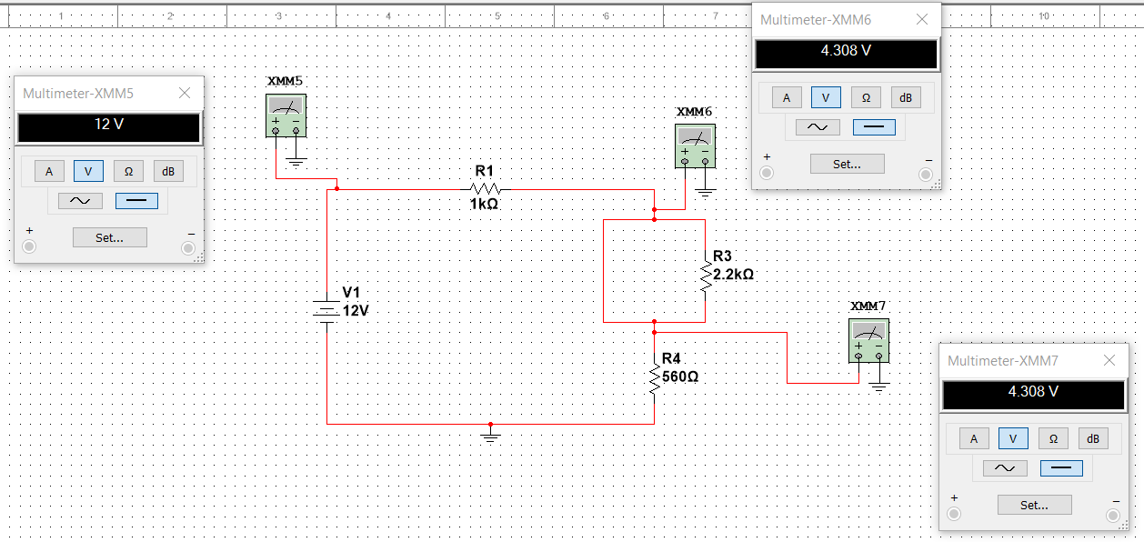

**Calculated by Multisim:**

**Table 5-a**: fill the table as required.

|  |  |  |  |  |  |  |
| --- | --- | --- | --- | --- | --- | --- |
| **VA** | **VB** | **VC** | **IR1** | **IR2** | **IR3** | **IR4** |
| **12 v** | **4.308 v** | **4.308 v** | **7.692 mA** | **-7.692 mA** | **0** | **7.692 mA** |

**Measured in Lab:**

**Table 5-b**: fill the table as required.

|  |  |  |  |  |  |  |
| --- | --- | --- | --- | --- | --- | --- |
| **VA** | **VB** | **VC** | **IR1** | **IR2** | **IR3** | **IR4** |
| **12.01 v** | **4.21 v** | **4.21 v** | **7.58 mA** | **7.58 mA** | **0** | **7.58 mA** |

**Discuss the result for the tables.**

1. An open resistor has zero current and non-zero voltage.
2. A short-circuited resistor carries all the current but has zero voltage.
3. Also, when the negative sign appears in Multisim, it indicates that the terminals are reversed, and this negative sign is used as a reference or ground point in the circuit.
4. We observed how the voltage at the points and currents change with each modification.

***Second: Voltage Divider Rule & Current Divider Rule: -***

**Fill the tables as required.**

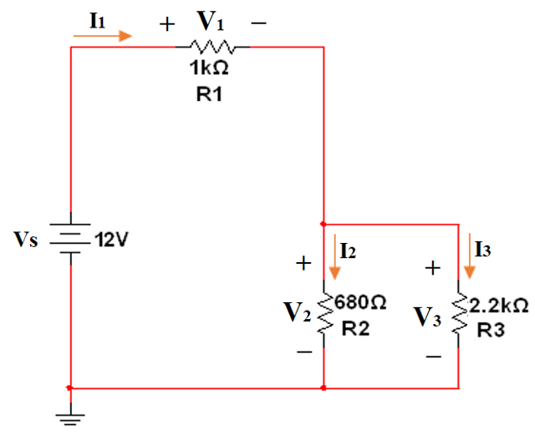

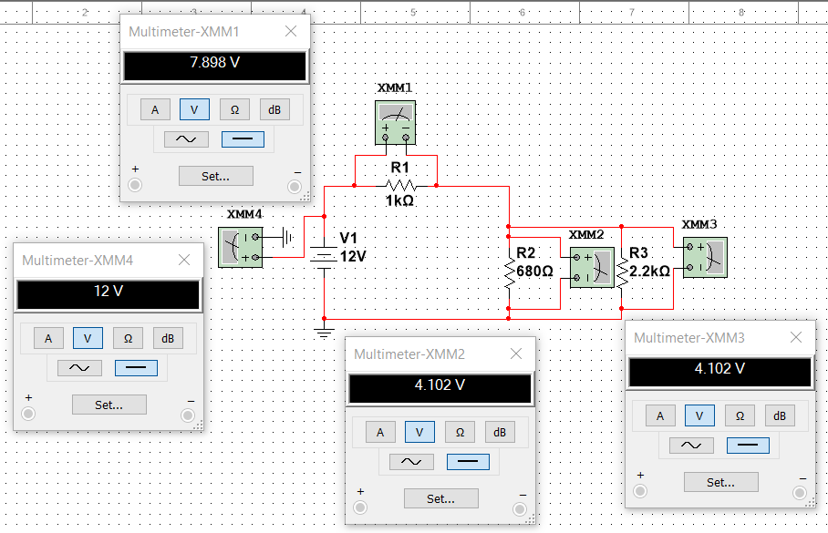

**Calculated by Multisim:**

**Table 6-a:** Measure the voltages.

|  |  |  |  |  |  |
| --- | --- | --- | --- | --- | --- |
| **Vs** | **V1** | **V2** | **V3** | **V1 + V2** | **V1 + V3** |
| **12 v** | **7.898 v** | **4.102 v** | **4.102 v** | **12 v** | **12 v** |

**Measured in Lab:**

**Table 6-b:** Measure the voltages.

|  |  |  |  |  |  |
| --- | --- | --- | --- | --- | --- |
| **Vs** | **V1** | **V2** | **V3** | **V1 + V2** | **V1 + V3** |
| **12 v** | **7.898 v** | **4.102 v** | **4.102 v** | **12 v** | **12 v** |

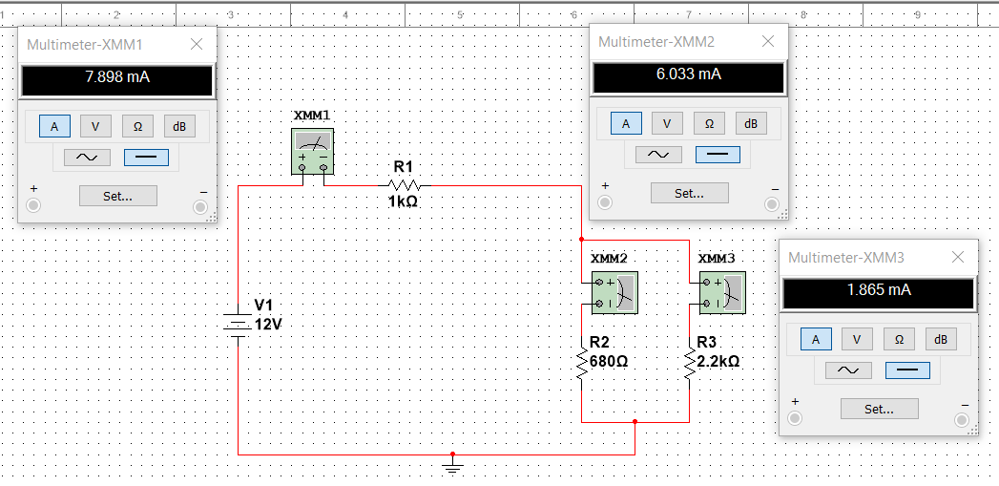

**Calculated by Multisim:**

**Table 7-a:** Measure the currents.

|  |  |  |  |
| --- | --- | --- | --- |
| **I1** | **I2** | **I3** | **I2 + I3** |
| **7.898 mA** | **6.033 mA** | **1.865 mA** | **7.898 mA** |

**Measured in Lab:**

**Table 7-b:** Measure the currents.

|  |  |  |  |
| --- | --- | --- | --- |
| **I1** | **I2** | **I3** | **I2 + I3** |
| **7.898 mA** | **6.033 mA** | **1.865 mA** | **7.898 mA** |

**Exercise#1: Change the R3 in the previous circuit to 0, 10kΩ, 15KΩ, and and measure the voltage V3.**

|  |  |  |  |  |
| --- | --- | --- | --- | --- |
|  | **R3 = 0** | **R3 = 10 k**Ω | **R3 =15 k**Ω | **R3 = ∞** |
| **V3 (Calculated by Multisim)** | **12 fV** | **4.668 V** | **4.73 V** | **4.857 V** |
| **V3 (Measured in Lab)** | **12 fV** | **4.668 V** | **4.73 V** | **4.857 V** |

**Exercise#2: Change the R3 in the previous circuit to 0, 10 kΩ, 15 kΩ, and and measure the current I3**

|  |  |  |  |  |
| --- | --- | --- | --- | --- |
|  | **R3 = 0** | **R3 = 10 k**Ω | **R3 =15 k**Ω | **R3 = ∞** |
| **I3 (Calculated by Multisim)** | **12 mA** | **466.824 uA** | **315.306 uA** | **4.885 nA** |
| **I3 (Measured in Lab)** | **12 mA** | **466.824 uA** | **315.306 uA** | **4.885 nA** |

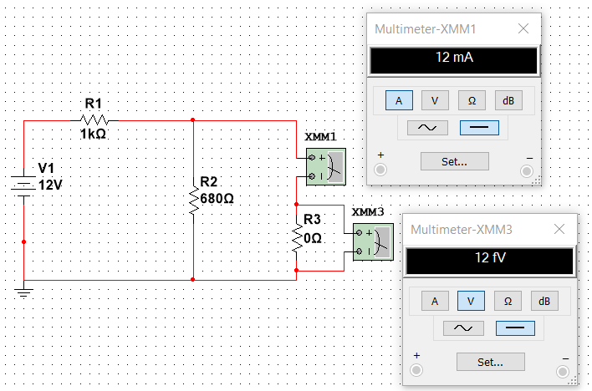

***Discuss the results:***

1. **When the V3 is Max and Min, why?**

When *R3* approaches infinity, *V*3 reaches its maximum value .

When *R3* is zero *V*3 is minimum value .

This is due to Ohm's law, which states that voltage *V* increases with

resistance *R* when current *I* is constant (*V*=*IR*).

1. **When the I3 is Max and Min, why?**

When *R*3 is zero, *I*3 reaches its maximum.

When *R*3 approaches infinity, *I*3 is at its minimum.

This is because of the inverse relationship between resistance and current, as in Ohm's law (*V*=*IR*). An increase in resistance leads to a decrease in current.

***Conclusion :***

In this experience, We learned about the effects of short and open circuits on different circuits, and we measured the values of currents and voltages that resulting from them.

And we noticed that voltage divider and current divider are good method to calculate the currents and voltages.

Finally, I conclude that: principles of voltage and current division, is essential for understanding electronic systems. An open circuit disrupts the flow of current due to an incomplete pathway, often represent by open switches or broken wires.

On the other hand, a short circuit creates an unintended low-resistance path, potentially leading to high currents and system failures.

Together, these concepts form the foundation for maintaining reliability, safety, and optimal performance in diverse electrical applications.