___________________________________________________________________________

*Faculty of Information Technology and Engineering*

*Electrical Circuit Lab*

|  |  |
| --- | --- |
| Students ID: 202110795, 202112300 | Students Name: Sama Haitham Sammar, Arein Zaid |
| 4Experiment #: | Experiment Name: Proportionality and Superposition Theorems |
| Section: 3 | Supervisor Name: Dr Amjad Abu Jazar |
| Date: 25 April 2024 | Day: Thursday |

***Objective:***

1. To verify the proportionality and superposition theorems.
2. To verify that a network can be replaced by an equivalent ∆-Y network.
3. To verify the reciprocity theorem of single-source DC network.

***Apparatus Request:***

* DC power supply.
* Digital Multimeter.
* Components (Resistors, Cables and Breadboard).

***Theory and Background:***

1. **Proportionality Theorem: -**

The **V-I** characteristics of a linear resistor, shows that if the current is doubled then the voltage is also doubled. However, power is quadrupled, which is not a proportional change. Only the current and voltage satisfy the proportionality property. For linear resistive circuits the proportionality relationship can be written as

Where is the input, is the output and is a constant. The input is multiplied by the scalar constant to produce the output. In the following circuit the proportionality relationship can be represented as

Where is a scalar constant, whose value depends on the values of the resistors

1. **Superposition Theorem: -**

The input-output relationships of linear circuits possess the additive property of linear functions. For linear resistance circuits this means that we can write any output y as

Where are circuit inputs and are constants that depend on the circuit.

Briefly stated, the output of a linear resistance circuit is a linear combination of the outputs due to each input. That is, the output with all the inputs present is the same as the sum of the outputs with each input applied separately while the other inputs are set to zero.

The following circuit explains the above principle of superposition. The output is taken across the resistor; in the first case with both the inputs present and then with each input independently set while the other is set to zero. Thus,

Where is the output with both the inputs present, is the output with only as input and is the output with only as input.

1. **∆-Y Transformation: -**

We know that by using Series/ Parallel circuit rules, we can reduce or simplify the circuit, but in some networks, resistances are neither in series nor in parallel but connected in **Y-∆** connection. In such a situation only by converting the network from **Y-∆** or vice versa can a network be simplified and then applied with Series/ Parallel rule.

If converted from **Delta** to **Star:**

If converted from **Star** to **Delta:**

***Experiment Procedure:***

***First: Verify the Proportionality Theorem***

**1. Connect the circuit shown below and then fill in Table 1 as required.**

**Vin = 5 v**

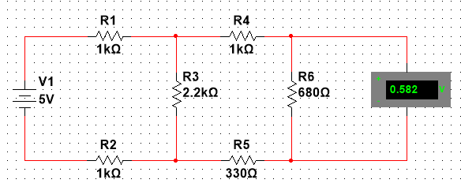

**Vin = 10 v**

**Vin = 15 v**

**Table 1:** **Theoretical and practical output voltages for different input voltages.**

|  |  |  |  |
| --- | --- | --- | --- |
| **Vin** | **Vout (by MULTISIM)** | **Vout (Measured in lab)** |  |
| **5 V** | **0.582 v** | **0.58 v** | **0.116** |
| **10 V** | **1.15 v** | **1.14 v** | **0.114** |
| **15 V** | **1.747 v** | **1.69 v** | **0.112** |

* 1. **Discuss the results in table 1 above to verify the proportionality theorem:**

When doubled the value of the input voltage source the value of output voltage source is doubled too on proportionality theorem this can be represented as , k is constant and represent by () ,Also Its values are equal in the circuit because it depends in the values of the resistors .

Note: we used 680 Ohm resistor in lab instead of 560 Ohm.

***Second: Verify the Superposition Theorem:***

* 1. **Connect the circuit shown below and then fill in Table 2 as required.**

Due to V1

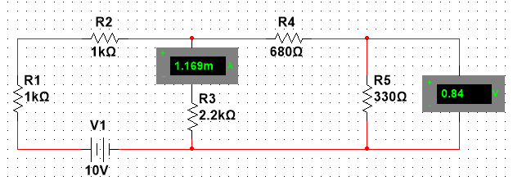

Due to V2

Due to both sources

**Table (2): Theoretical and practical output voltage and current due to different sources**

|  |  |  |
| --- | --- | --- |
|  | **Calculated by Multisim** | **Measured in Lab** |
| **Vout due to V1** | **0.84 v** | **0.853 v** |
| **I due to V1** | **1.169 mA** | **1.149 mA** |
| **Vout due to V2** | **-2.406 v** | **-2.38 v** |
| **I due to V2** | **3.471 mA** | **3.48 mA** |
| **Vout due to both sources** | **-1.566 v** | **-1.559 v** |
| **I due to both sources** | **4.64 mA** | * 1. **A** |

**2. Discuss the results in table 2 above to verify the superposition theorem:**

We can see that the voltage of the circuit due to both sources can be measured by finding the voltage due to the each source alone and the same for current (Vout due to V1 + Vout due to V2 = Vout due to both sources => 0.84 + -2.406 = -1.566 v), (I due to V1 + I due to V2 = I due to both sources => 1.169 + 3.471 = 4.64 mA).

Note: When we need to find the value of output voltage due to voltage source we make the other voltage source short circuit.

***Third: Verify the ∆-Y Transformation:***

* 1. **Connect the circuit shown below and then fill in Table 3 as required.**

For I & Vab

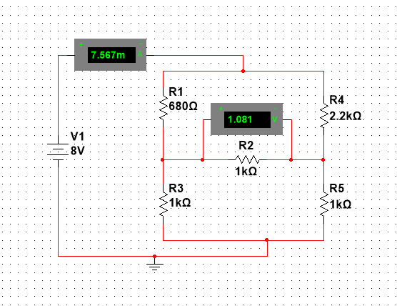

For Rin

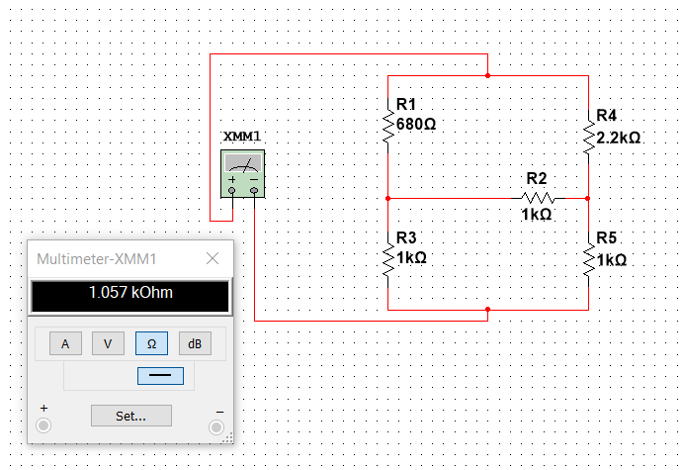

**Table (3): Theoretical and practical voltage and current in the original circuit**

|  |  |  |  |  |  |
| --- | --- | --- | --- | --- | --- |
| **Vab**  **(by Multisim)** | **Vab**  **(Measured)** | **I**  **(by Multisim)** | **I**  **(Measured)** | **Rin**  **(by Multisim)** | **Rin**  **(Measured)** |
| **1.081 v** | **1.146 v** | **7.567 mA** | **7.4 mA** | **1.057 kOhm** | **1.05 kOhm** |

**4. Do the** **∆-Y Transformation for the above circuit and tabulate your result in the table below.**

For I & Vab

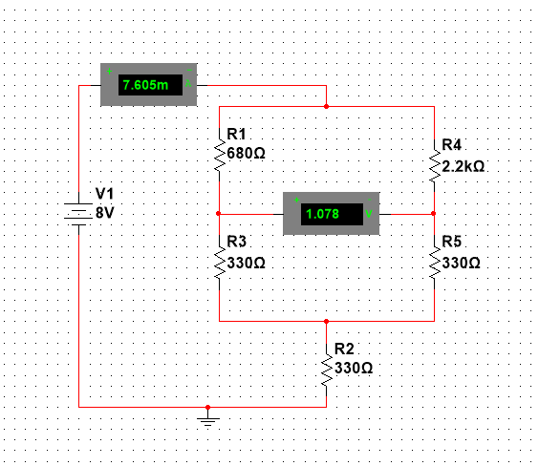

For Rin

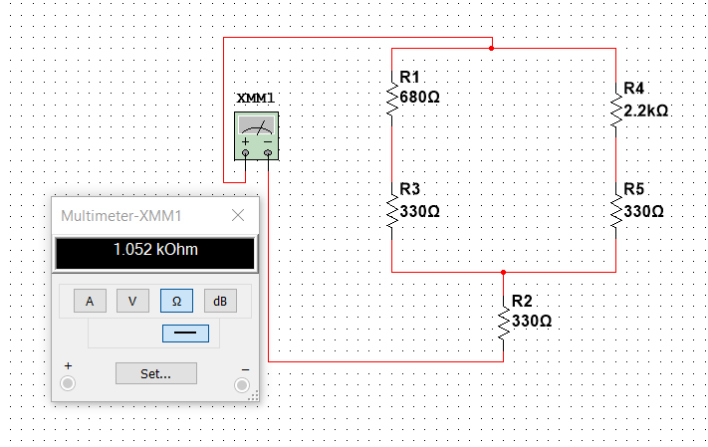

**Table (4): Theoretical and practical voltage and current in the ∆-Y transformed circuit**

|  |  |  |  |  |  |
| --- | --- | --- | --- | --- | --- |
| **Vab**  **(by Multisim)** | **Vab**  **(Measured)** | **I**  **(by Multisim)** | **I**  **(Measured)** | **Rin**  **(by Multisim)** | **Rin**  **(Measured)** |
| **1.078 v** | **1.11 v** | **7.605 mA** | **7.7 mA** | **1.052 kOhm** | **1.04 kOhm** |

* 1. **Discuss the results in tables 3 & 4 above to verify the ∆-Y transformation technique:**

As we can see from the tables above, we perform the ∆-Y concepts and find the equivalent resistance easily, the resulting values for both remains equals.

***Conclusion:***

In this experiment we learned about proportionality theorem, and it is very useful to deal with electrical circuits and analyze them.

We also learned about super position theorem it is good if we have more than one source in the circuit and used to analyze and solve linear electrical circuits.

∆-Y Transformation too, it is an excellent method to obtain the equivalent resistance especially when the circuit complex and we can perform conversions between the two shapes based on the equations we have learned.

Note: It is possible that the results that appeared with us in the laboratory will differ very slightly from those obtained from Multisim due to the wires having resistors, and the device may also have an error rate, as well as the difference in resistances from one company to another.