___________________________________________________________________________

*Faculty of Information Technology and Engineering*

*Electrical Circuit Lab*

|  |  |
| --- | --- |
| Students ID: 202110795, 202112300 | Students Name: Sama Haitham Sammar, Arein Zaid |
| Experiment #: 5 | Experiment Name: Thevenin’s & Norton’s Theorems |
| Section: 3 | Supervisor Name: Dr Amjad Abu Jazar |
| Date: 2 May 2024 | Day: Thursday |

***Objective:***

1. To verify the Thevenin theorem.
2. To verify the Norton theorem.
3. To verify the Maximum power transfer theorem.

***Apparatus Required:***

* DC power supply.
* Digital Multimeter.
* Components (Resistors, Cables and Breadboard).

***Theory and Background:***

In this experiment we will study two theorems that greatly simplify analysis of many linear circuits. The first of these theorems is named after a French engineer working in telegraphy, M. L. Thevenin. He first published a statement of his theorem in 1883. The second theorem, credited to E. L. Norton, may be considered as a corollary to the Thevenin's theorem. Using Thevenin's theorem it is possible to obtain an equivalent circuit of any linear circuit composed of an independent voltage source in series with a resistor.

1. Thevenin equivalent circuit b. Norton equivalent circuit

**Figure (1):** Thevenin and Norton equivalents connected with RL

In the laboratory, to find and apply the **Thevenin equivalent** circuit **(VTh and RTh**), follow the steps below:

1. **To find VTh**: Remove the load resistance (RL) and measure the open circuit voltage (VTh) using multimeter.
2. **To find RTh**: Still removing RL and shorting all voltage sources (or opening all current sources), measure RTh between terminals **a** and **b**.
3. Connect the Thevenin equivalent circuit and find VL and IL

To find and apply the **Norton equivalent** circuit **(IN and RN**), follow the steps below:

1. **To find IN**: Remove RL and replace it by a short circuit, then measure the short circuit current (IN) using multimeter.
2. **To find RN**: Still removing RL and shorting all voltage sources (or opening all current sources), measure RN between terminals **a** and **b**.

**Maximum Power Transfer Theorem:**

The Maximum Power Transfer Theorem is another useful circuit analysis method to ensure that the maximum amount of power will be dissipated in the load resistance when the value of the load resistance is exactly equal to the resistance of the power source. The relationship between the load resistance and the power transfer to it is shown in the following figure.

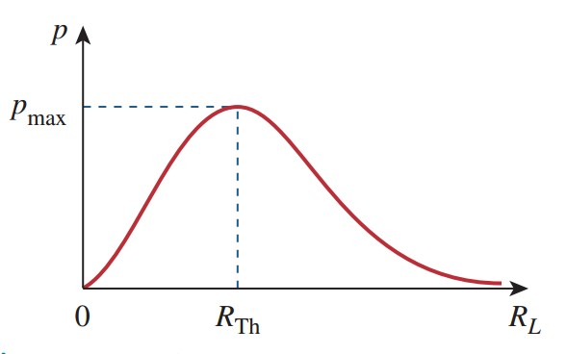

***Experiment Procedure:***

***Part One:***

* 1. **Connect the circuit shown below and use the Multimeter to fill in Table 1 as required.**

**Table 1:**

|  |  |  |
| --- | --- | --- |
|  | **Calculated**  **(By MULTISIM)** | **Measured**  **(Measured in lab)** |
| **Vab (voltage on the terminal of RL)** | **4.701 v** | **4.71 v** |
| **Iab (current through RL)** | **2.137 mA** | **2.16 mA** |

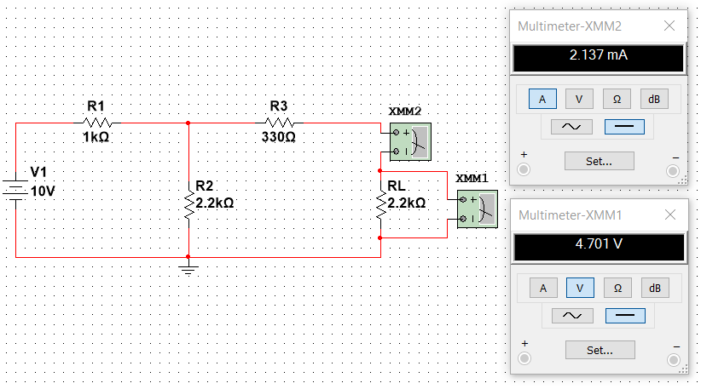

* 1. **Remove RL and use the Multimeter to fill in Table 2 as required.**

**Table 2:**

|  |  |  |
| --- | --- | --- |
|  | **Calculated**  **(By MULTISIM)** | **Measured**  **(Measured in lab)** |
| **VTH** | **6.875 v** | **6.72 v** |
| **IN** | **6.757 mA** | **6.69 mA** |
| **RTH** | **1.017 kOhm** | **1.11 kOhm** |

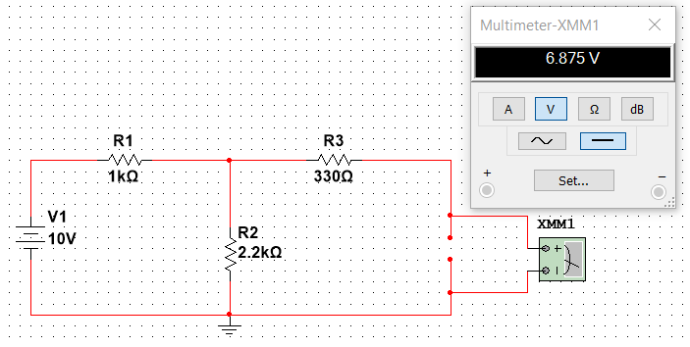

* 1. **Replace the circuit by its Thevenin equivalent (except RL) and use the Multimeter to fill in Table 3 as required.**

**Table 3:**

|  |  |  |
| --- | --- | --- |
|  | **Calculated**  **(By MULTISIM)** | **Measured**  **(Measured in lab)** |
| **Vab** | **4.702 v** | **4.62 v** |
| **Iab** | **2.137 mA** | **2.13 mA** |

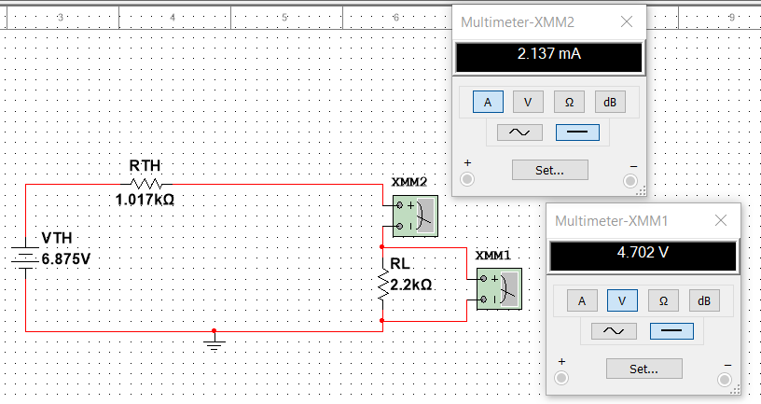

* 1. **Compare the values of tables (1 & 3) and discuss them.**

The values in both tables are equal because of simplification of the circuit into Thevenin equivalent by: Remove the load resistance (RL) and measure the open circuit voltage (VTH) using multimeter ,Still removing RL and shorting all voltage sources (or opening all current sources) instead of the compete circuit.

* 1. **Use the Thevenin equivalent circuit. Replace RL by the values shown in table 4. Then Fill in table 4 as required.**

**Table 4:**

|  |  |  |  |
| --- | --- | --- | --- |
| **RL** | **VL (calculated by MULTISIM)** | **VL (Measured on Lab)** | **PL = VL2/RL** |
| **330 Ω** | **1.684 v** | **1.589 v** | **0.00859350303 w** |
| **680 Ω** | **2.755 v** | **2.63 v** | **0.011161801 w** |
| **1 kΩ** | **3.409 v** | **3.36 v** | **0.011621281 w** |
| **2.2 kΩ** | **4.702 v** | **4.69 v** | **0.010049456 w** |
| **3.9 kΩ** | **5.453 v** | **5.40 v** | **0.007624412564 w** |

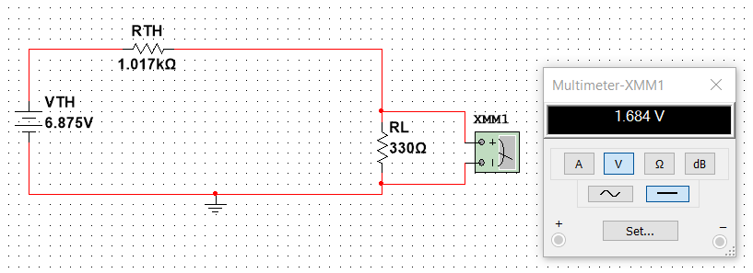

* 1. **Discuss your results of table 4 and comment on them.**

As we increase the load resistor (RL) the power increase until we reached the value that RL=RTH, The power here called (maximum power) after that as we increase RL the power will decreasing.

***Part Two:***

1. **Connect the circuit shown below and use the Multimeter to fill in Table 5 as required.**

**Table 5:**

|  |  |  |
| --- | --- | --- |
|  | **Calculated**  **(By MULTISIM)** | **Measured**  **(Measured in lab)** |
| **Vab (voltage on the terminal of RL)** | **-2.252 v** | **-2.39 v** |
| **Iab (current through RL)** | **-1.024 mA** | **-1.09 mA** |

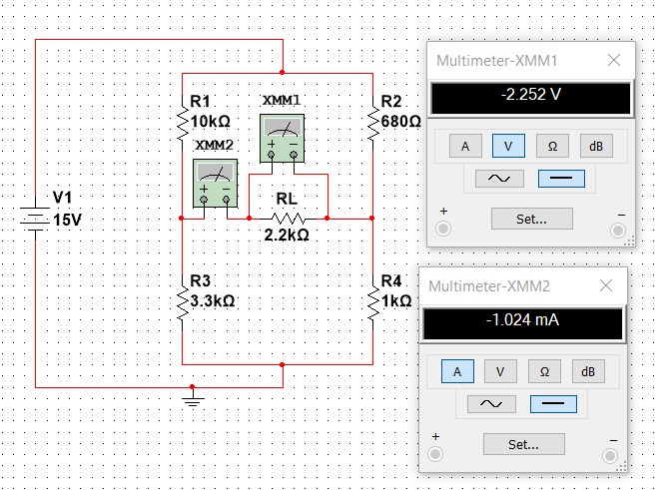

1. **Remove RL and use the Multimeter to fill in Table 6 as required.**

**Table 6:**

|  |  |  |
| --- | --- | --- |
|  | **Calculated**  **(By MULTISIM)** | **Measured**  **(Measured in lab)** |
| **VTH** | **-5.207 v** | **-5.33 v** |
| **IN** | **-1.804 mA** | **-1.90 mA** |
| **RTH** | **3.066 kOhm** | **2.96 kOhm** |

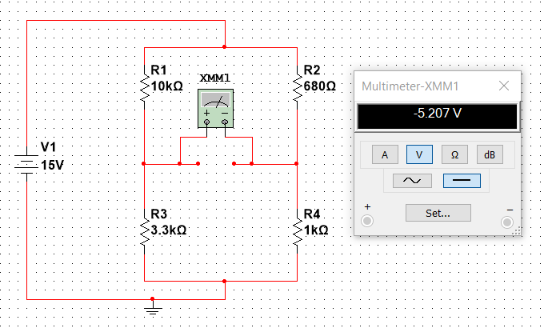

* 1. **Replace the circuit with its Thevenin equivalent (except RL) and use the Multimeter to fill in Table 7 as required.**

**Table 7:**

|  |  |  |
| --- | --- | --- |
|  | **Calculated**  **(By MULTISIM)** | **Measured**  **(Measured in lab)** |
| **Vab** | **-2.175 v** | **-2.25 v** |
| **Iab** | **-988.8 uA = -0.988 mA** | **-1.03 mA** |

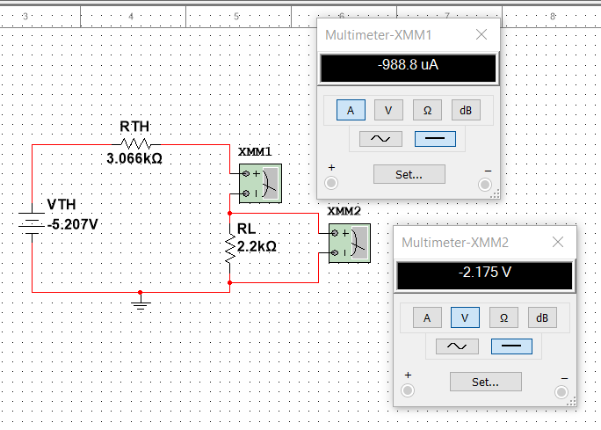

* 1. **Compare the values of tables (5 & 7) and discuss them.**

The values in table (5) are too close to the values in table (7) due to the simplification of the circuit into its Thevenin equivalent. This involves the removal of the load resistance (RL) and measuring the open-circuit voltage (Vth) using a multimeter, while simultaneously eliminating RL and shorting all voltage sources (or opening all current sources). By concentrating on the simplified circuit instead of the full circuit, this method enables us to achieve identical values.

***Part Three:***

**Use the Thevenin equivalent circuit found in Part Two above and a load resistor that withdraws maximum power from the Thevenin equivalent. With this resistor fill in table 8.**

**Table 8:**

|  |  |  |  |
| --- | --- | --- | --- |
| **RL** | **VL (calculated by MULTISIM)** | **VL (Measured on Lab)** | **PL = VL2/RL** |
| **3.066 kOhm** | **-2.603 v** | **-2.66 v** | **0.002209918134 w** |

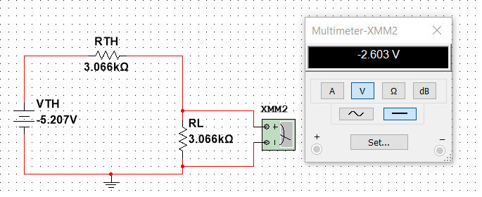

**Discuss the findings of the above table.**

When we want to calculate maximum power, we replace RL value to be equal to RTH=3.066 kOhm, And find VL to use it in the PL= VL^2/RL to find the power so PL = 0.002209918134 Watt is the maximum power.

***Conclusion:***

In this experiment I learnt how to simplify circuit using Thevenin Theorems by replace the circuit around RL by a voltage source and resistor in series,

1. To find VTH: Remove the load resistance (RL) and measure the open circuit voltage (VTH).

2. To find RTH: Still removing RL and shorting all voltage sources (or opening all current sources), measure RTH between terminals of the open circuit.

Also, to find and apply the Norton equivalent circuit (IN and RN),

1. To find IN: Remove RL and replace it by a short circuit, then measure the short circuit current (IN).

2. To find RN: Still removing RL and shorting all voltage sources (or opening all current sources) measure RN between terminals.

And how to calculate maximum power dissipated in the load resistance when the value of the load resistance is exactly equal to the RTH (resistance of the power source), RL=RTH.

Finally, Thevenin's and Norton's theorems and their application in circuit analysis are a good method to calculate voltage and current values when the circuit is complex and it’s difficult to find it using normal method like Ohms low.