___________________________________________________________________________

*Faculty of Information Technology and Engineering*

*Electrical Circuit Lab*

|  |  |
| --- | --- |
| Student ID: 202110795 | Student Name: Sama Haitham Sammar |
| Experiment #: 2 | Experiment Name: Introduction to MULTISIM |
| Section: 3 | Supervisor Name: Dr Amjad Abu Jazar |
| Date: 4 April 2024 | Day: Thursday |

***Objective:***

In this experiment, we introduce the MULTISIM software to the student and how to use it. In addition to drawing some electrical circuits and measuring the current and voltage, etc...

***Apparatus Request:***

* PC computer or Laptop

***Theory and Background:***

1. **Power Supply**

A power supply is an electrical device that supplies electric power to an electrical load. All power supplies have a power input connection, which receives energy in the form of electric current from a source, and one or more power output connections that deliver current to the load. In our lab, we have a DC power supply and an AC power supply as a different equipment.

1. **Digital Multimeter**

We can use the digital Multimeter to measure dc voltage and current, AC as an RMS value of AC voltage and current, also we can use it as an ohmic Meter to measure directly or indirectly the value of a resistance in (Ω) or a conductance.

1. **Oscilloscope**

We can use the oscilloscope to measure the frequency of a wave, the peak - to - peak value and r.m.s of voltage (dc and ac), also to measure the phase between two waves.

If a DC wave is appeared on the screen of oscilloscope, with 2 division’s height value and the scale of ch1 is 5V/div.

The value of voltage = number of squares scale of ch.1 = 2*5 = 10 V.

If two sinusoidal waves appeared on the screen as in fig.1.3(c), where the scale of ch1 is 5V/Div, and the scale of ch2 is 3V/Div. where V1max=4 squares height, V2max=3 square height.

V1 max = 4*5 = 20V. V1 p-p = 2*20= 40V.

V1 rms = 40/(2√2) = 14V. V2 max = 3*3 = 9V.

V2 p-p = 9*2 = 18V. V2 rms = 18/(2√2) = 6.36 V.

* T (period) for each wave = 8*5 = 40 msec, where the complete cycle takes 8 squares.
* f (frequency) for each wave = 1/T = 1/(40 * 10 -3) = 25 Hz
* Each wave takes 360°for one period. Each division = 360°/8 = 45°
* Phase shift = 3(Div) *45°= 135°
* If you put time base on XY mode as in fig 1.3(b) you obtain a shape according to the type of the circuit.

***Experiment Procedure:***

***Exercise 1:***

**Connect the following circuit and fill the table below:**



**For voltages with ground (for each node)**

**For voltages between nodes**

**For current**

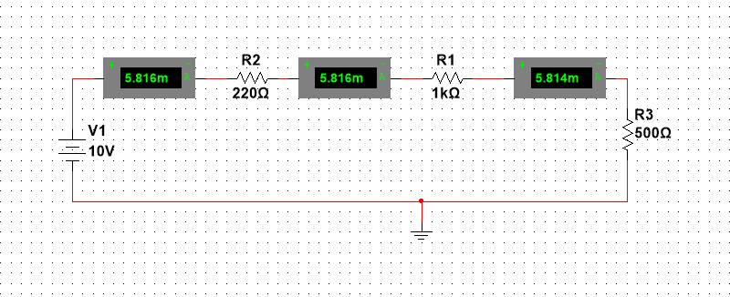

**For equivalent resistance**

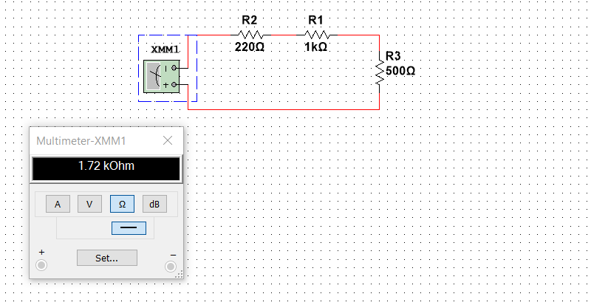

|  |  |  |
| --- | --- | --- |
| I32 = 5.816 mA | V32 = 1.279 v | V3 = 10 v |
| I21 = 5.816 mA | V21 = 5.814 v | V2 = 8.721 v |
| I10 = 5.816 mA | V10 = 2.907 v | V1 = 2.907 v |
| R equivalent = 1.72 kOhm | | |

***Exercise 2:***

**Connect the following circuit and fill the table below:**



**For voltages**

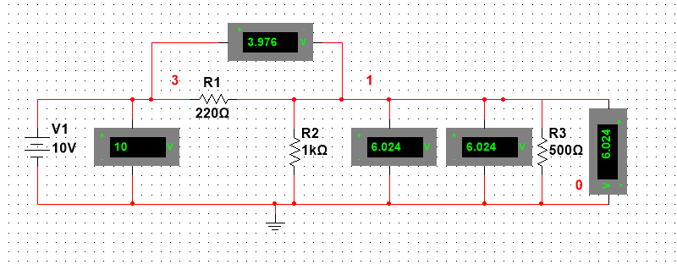

**For currents**

**For equivalent resistance**

|  |  |  |
| --- | --- | --- |
| IR1 = 0.018 A | V31 = 3.976 v | V3 = 10 v |
| IR2 = 6.024 A | V10 = 6.024 v | V1 = 6.024 v |
| IR3 = 0.012 A | VR3 = 6.024 v | R equivalent = 553.333 Ohm |

***Exercise 3:***

**Connect the following circuit and fill the table below:**   
(Using the Oscilloscope channels to be at nodes 1 and 2)



**The circuit**

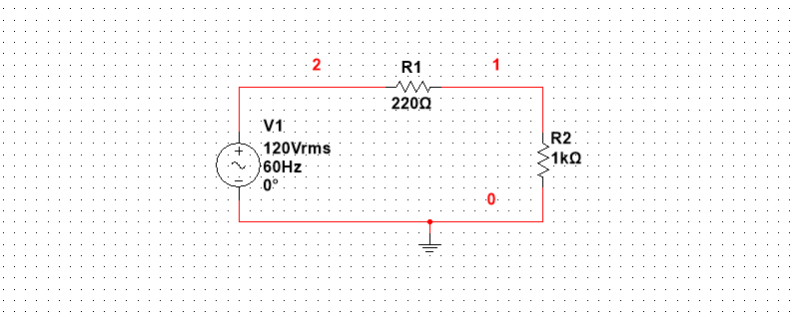

**For table**

**Table**

|  |
| --- |
| **V 21 (rms) = 1.803 v(rms)** |
| **V 10 (rms) = 8.197 v(rms)** |
| **I = 8.197 mA** |

**Draw Ch1 + Ch2 Signal :-**

**Using the Oscilloscope**

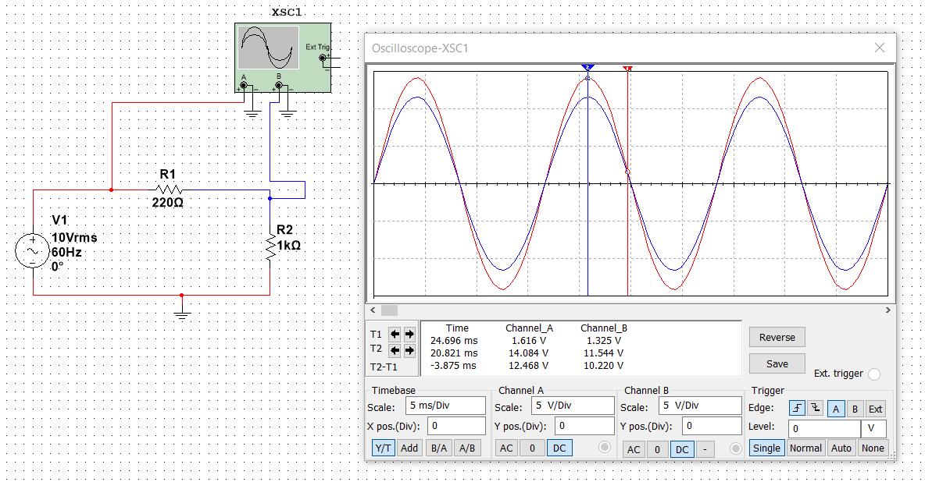

**Using Tektronix Oscilloscope**

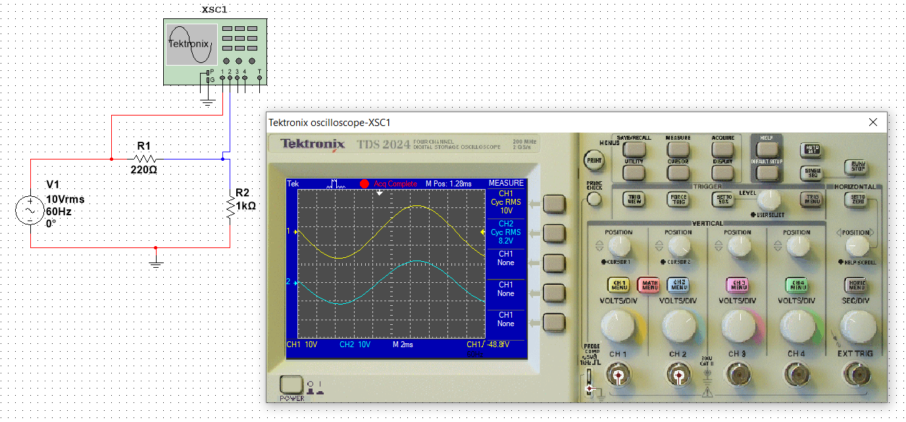

***Conclusion:***

In this experiment, we learned more about the Multisim, we made different electrical circuits, we found values for voltages and currents, and we also learned about the oscilloscope device and its working principle in showing electrical signals.