Software Requirements Specification

for

< Transportation Management System >

Version 1.0 approved

Prepared by <Sama Sammar,

Assala AboSamra,

Aya Zayed,

Malak AbuSaifain>

<Arab American University>

<16/1/2025>

Table of Contents

Table of Contents ii

Revision History ii

1. Introduction 2

1.1 Purpose 2

1.2 Document Conventions 2

1.3 Project Scope 2

1.4 References 2

2. Overall Description 2

2.1 Product Perspective 2

2.2 User Classes and Characteristics 2

2.3 Operating Environment 2

2.4 Design and Implementation Constraints 2

2.5 Assumptions and Dependencies 2

3. System Features 2

3.1 System Feature 1 2

3.2 System Feature 2 (and so on) 2

4. Data Requirements 2

4.1 Logical Data Model 2

4.2 Data Dictionary 2

4.3 Reports 2

4.4 Data Acquisition, Integrity, Retention, and Disposal 2

5. External Interface Requirements 2

5.1 User Interfaces 2

5.2 Software Interfaces 2

5.3 Hardware Interfaces 2

5.4 Communications Interfaces 2

6. Quality Attributes 2

6.1 Usability 2

6.2 Performance 2

6.3 Security 2

6.4 Safety 2

6.5 [Others as relevant] 2

7. Internationalization and Localization Requirements 2

8. Other Requirements 2

Appendix A: Glossary 2

Appendix B: Analysis Models 2

Revision History

|  |  |  |  |
| --- | --- | --- | --- |
| **Name** | **Date** | **Reason For Changes** | **Version** |
|  |  |  |  |
|  |  |  |  |

# Introduction

This document provides detailed specifications for transportation management system requirements. The purpose of this SRS is to provide a comprehensive view of the system's functionality, limitations, and requirements to guide the development process.

## Purpose

*The Transportation Management System (TMS) is designed to improve the management and operation of transportation services. This document outlines the software requirements for the TMS, which is intended to streamline the processes of booking, tracking, and managing transportation resources.*

## Document Conventions

|  |  |
| --- | --- |
| *TMS* | *Transportation Management System* |
| *KPIs* | *Key Performance Indicators* |
| *AWS* | *Amazon Web Services* |
| *APIs* | *Availability of Programming Interfaces* |
| *GPS* | *Global Positioning System* |
| *ETA* | *Estimated Time of Arrival* |
| *GUI* | *Graphical User Interface* |
| *POS* | *Point-Of-Sale* |
| *HTTP* | *Hypertext Transfer Protocol* |

## Project Scope

The Transportation Management System (TMS) aims to enhance the efficiency and reliability of transportation services by providing a platform for users to book, track, and manage their transportation needs. The system will support various stakeholders, including passengers, transportation companies, and drivers, by offering real-time tracking and scheduling.

The primary objectives of the TMS include:

* *Improving user experience: Simplifying the process of booking and tracking transportation.*
* *Enhancing operational efficiency: Enabling transportation companies to manage their resources more effectively.*
* Supporting strategic business goals: Aligning with Transportation Company objectives to provide a competitive edge in the transportation industry.

## References

* Google
* Tanin Buses Company
* Alyamun Taxi Office

## Overview

Section 1- Discusses the purpose and scope of the software.

Section 2- Describes the overall functionalities and constraints of the software and user characteristics.

# Overall Description

## Product Perspective

• **System Overview:**

* *A TMS in this context is a software solution aimed at optimizing and organizing the movement of passengers within cities or between locations. This includes determining optimal routes, scheduling buses or taxis, monitoring performance, and improving the passenger experience*.

• **Integration with Other Systems:**

* *TMS for human transportation often integrates with other systems like:*
  + ***Electronic payment systems*** *to facilitate ticket purchases (such as banking apps or prepaid cards).*
  + ***Transportation Company management systems*** *to track the performance and location of buses, or taxis.*
  + ***Mobile apps*** *that provide real-time information to passengers about routes and schedules.*
  + ***Traffic management systems*** *to improve traffic flow and reduce congestion*.

• **User Interface and Access:**

* *TMS can be provided through user interfaces on mobile apps for citizens or passengers to access route information and schedule details.*
* *Passengers can also access real-time updates on delays, estimated arrival times, and crowded areas.*

• **Features and Functionality:**

* ***Route Optimization****: Determining the best routes for passengers based on time, cost, and congestion.*
* ***Transportation Company Management****: Monitoring the buses, or taxis.*
* ***Data Analytics****: Providing reports and insights on transportation efficiency and passenger traffic to identify peak times and improve service.*
* ***Scheduling Management****: Organizing trip schedules based on passenger demand and availability.*
* ***Emergency Response****: Ensuring fast responses in cases of emergencies or accidents affecting passenger flow.*

• **Deployment Model:**

* *TMS can be deployed as a* ***cloud-based solution****, which offers flexibility and real-time updates.*
* ***On-premises solutions*** *might be suitable for larger cities or systems that need tighter control over infrastructure.*

• **Market and Industry Fit:**

* *TMS for human transportation serves various industries such as:*
  + ***Public transportation*** *(e.g., buses, taxis).*
  + ***Private transport services*** *like ride-sharing apps (e.g., Uber, Lyft).*
  + ***School and Universities transportation*** *and bus management*.

• **Business Goals and Benefits:**

* ***Improved Efficiency*** *by reducing wait times and optimizing routes.*
* ***Enhanced Passenger Satisfaction*** *through providing a smooth, reliable, and user-friendly experience.*
* ***Cost Reduction*** *by optimizing Transportation Company allocation and schedules.*
* ***Reduced Congestion*** *by better managing traffic flows and scheduling to avoid overcrowding.*

## Product Functions

1. **Route Optimization and Scheduling.**

*•Function: Automatically calculates the most efficient routes and schedules based on factors like passenger demand, traffic conditions, and travel times.*

*•Use Case: Minimize delays and reduce operational costs by optimizing travel routes, which improves passenger satisfaction and increases the number of trips completed each time.*

1. **Transportation Company Management.**

*•Function: Manages the real-time location, status, and availability of transport vehicles (buses, taxis).*

*•Use Case: Maximize Transportation Company utilization and ensure vehicles are deployed where most needed, improving service coverage*.

1. **Passenger Information System.**

*•Function: Provides passengers with real-time information on routes, schedules, delays, and availability via mobile app.*

*•Use Case: Enhance the passenger experience by providing up-to-date, accurate information that helps passengers make better travel decisions.*

1. **Ticketing and Payment Integration.**

*•Function: Manages ticket sales and integrates with electronic payment systems for seamless fare collection.*

*•Use Case: Improve revenue collection, reduce fraud, and provide convenience for passengers by enabling online payments and contactless ticketing options.*

1. **Demand Forecasting and Capacity Planning.**

*•Function: Uses historical and real-time data to forecast passenger demand and adjust schedules or Transportation Company deployment accordingly.*

*•Use Case: Ensure the system scales meet demand, reduce overcrowding or under-utilization, and improve service efficiency during peak and off-peak periods.*

1. **Performance Monitoring and Reporting.**

*•Function: Collects and analyzes data on key performance indicators (KPIs), such as on-time performance, passenger load, and vehicle utilization.*

*•Use Case: Provides operators and decision-makers with data-driven insights to improve service quality, monitor operational performance, and make informed business decisions.*

1. **Incident and Emergency Management.**

*•Function: Provides tools to manage incidents or emergencies, including automatic rerouting, communication with passengers, and coordination with emergency services.*

*•Use Case: Enhance passenger safety and minimize disruptions by having an organized system in place to handle incidents quickly and efficiently.*

1. **Customer Feedback and Complaint Management.**

*•Function: Allows passengers to provide feedback or file complaints through an app, with automated tracking and resolution.*

*•Use Case: Improve customer satisfaction by addressing passenger concerns promptly and using feedback to continuously improve the service.*

1. **Reporting and Analytics.**

*•Function: Offers data-driven reports and analytics on various operational aspects, such as Transportation Company efficiency, cost analysis, and passenger satisfaction trends.*

*•Use Case: Enable management to make strategic decisions, optimize resources, and track performance over time to meet organizational goals.*

## User Classes and Characteristics

|  |  |
| --- | --- |
| **User Classes** | **Characteristics** |
| Administrators | Responsible for managing and operating the application and ensuring that services are provided efficiently and quickly. |
| Universities students | Students who need transportation services between their cities and the university. |
| Drivers | Drivers are responsible for providing transportation services using buses and taxis. |
| Transportation Company | To monitor vehicle actions and avoid any issues it approaches in the planning manner how vehicles must act and predict and analyze their actions to make roads better and avoid traffic jams. |
| Universities staff | Employees who need transportation services to move between colleges. |
| Community | People who want to use transportation services. |

## Operating Environment

* **Hardware:** Smartphone, Smart screens
* **Operating System:** Android & IOS
* **Geographical Locations of Users, Servers, and Databases:** *Users of the software system will require the software to be usable from different geographical areas, efficiently and effectively. The application and database are hosted on a server running Amazon Web Services (AWS)*
* **Integration:** *payment gateways, GPS.*

## Design and Implementation Constraints

Software Restrictions:

* A programming language compatible with the target devices, such as Java, must be used.
* The system must be compatible with Android and IOS operating systems.
* The system must support integration with payment gateways and map services.

Hardware Restrictions:

* The system must work efficiently on low spec devices including phones with limited memory.
* The system must be designed to consume minimal battery power.

Security Restrictions:

* The system must commit to global security standards such as data protection and communication encryption.
* All financial transactions must be protected by reliable security protocols.

## User Documentation

The following documents will be provided to users to facilitate the use of the system:

* User Manual: A PDF document containing a detailed explanation of all the system features and how to use them.
* In-app instructions: In-app messages and instructions to guide users as they use the system.
* Video Tutorials: A series of short videos explaining how to perform key operations such as booking and tracking.
* Technical Support: A Frequently Asked Questions Section that provides solutions to common issues and the ability to contact the support team.

## Assumptions and Dependencies

Assumptions:

* It is assumed that users have a stable internet connection to access the system and use its various features.
* It is assumed that the devices used by users support Android and IOS operating systems.
* The system will use reliable payment gateways integrated with the system to ensure ease of conducting financial transactions.

Dependencies:

* The project relies on the availability of programming interfaces (APIs) to integrate the system with services such as Google Maps and payment gateways like Reflect and Visa.
* The project relies on the availability of the necessary infrastructure, including servers and communication networks.
* The success of the project depends on the cooperation of the stakeholders involved, such as transport companies and operators.

# System Features (Functional Requirements)

## User Authentication

### Description

*This feature enables users to securely access the system through a login interface. It includes user registration, login, and logout functionalities.*

### Stimulus/Response Sequences

1. ***Stimulus:*** *User enters their credentials (username and password) on the login page.*
   * ***Response:*** *System validates the credentials and redirects the user to their dashboard upon success or shows an error message if invalid.*
2. ***Stimulus:*** *New user submits the registration form with required details.*
   * ***Response:*** *System creates a new user account and sends a confirmation email.*
3. ***Stimulus:*** *User clicks the "Logout" button.*
   * ***Response:*** *System terminates the session and redirects the user to the homepage.*

### Functional Requirements

* *The system shall validate user credentials against the database.*
* *The system should provide error messages for invalid login attempts.*
* *The system shall prevent access to restricted areas without authentication.*
* *The system shall implement a "Forgot Password" feature to reset credentials.*

## Notifications System

### Description

*This feature allows the system to send notifications to users about important updates, such as order status, promotional offers, or account changes.*

### Stimulus/Response Sequences

1. ***Stimulus:*** *User places an order.*
   * ***Response:*** *System sends an email and in-app notification confirming the order.*
2. ***Stimulus:*** *Admin creates a new promotional campaign.*
   * ***Response:*** *System sends promotional notifications to eligible users.*
3. ***Stimulus:*** *User changes their account password.*
   * ***Response:*** *System sends a confirmation notification to the user's email.*

### Functional Requirements

1. *The system should send email and in-app notifications for order updates.*
2. *The system should allow users to enable or disable specific types of notifications.*
3. *The system shall store a history of notifications for each user.*
4. *The system will ensure that notifications are delivered within 1 minute of the triggering event.*

## Review feedback system

### Description

*This feature enables users to leave reviews and feedback on rides and services.*

### Stimulus/Response Sequences

* ***Stimulus:*** *User submits a review for a purchased ride.*
  + ***Response:*** *System saves the review and displays it on the ride page.*
* ***Stimulus:*** *User rates a ride using a star-rating system.*
  + ***Response:*** *System updates the ride's overall rating.*

### Functional Requirements

1. *The system shall allow users to write text reviews and provide star ratings for products.*
2. *The system shall display the average rating and recent reviews on the ride page.*
3. *The system shall allow admins to moderate and remove inappropriate reviews.*
4. *The system shall notify users when their review is approved or rejected.*

## Location tracking

### Description

*This feature enables the system to use GPS for location tracking, and geofencing.*

### Stimulus/Response Sequences

* ***Stimulus:*** *User enables location services.*
* ***Response:*** *System retrieves and displays the user's current location on the map.*
* ***Stimulus:*** *Admin sets a destination on the map.*
* ***Response:*** *System sends notifications when a delivery vehicle enters or exits the destination.*

### Functional Requirements

*1. The system should retrieve real-time GPS data from users or devices.*

*2. The system shall display the user's or vehicle's location on a map.*

*3. The system shall allow admins to define destination for specific zones.*

*4. The system shall trigger notifications based on destination (entry/exit).*

*5. The system shall calculate the estimated time of arrival (ETA) based on the GPS data.*

# Data Requirements

## Logical Data Model

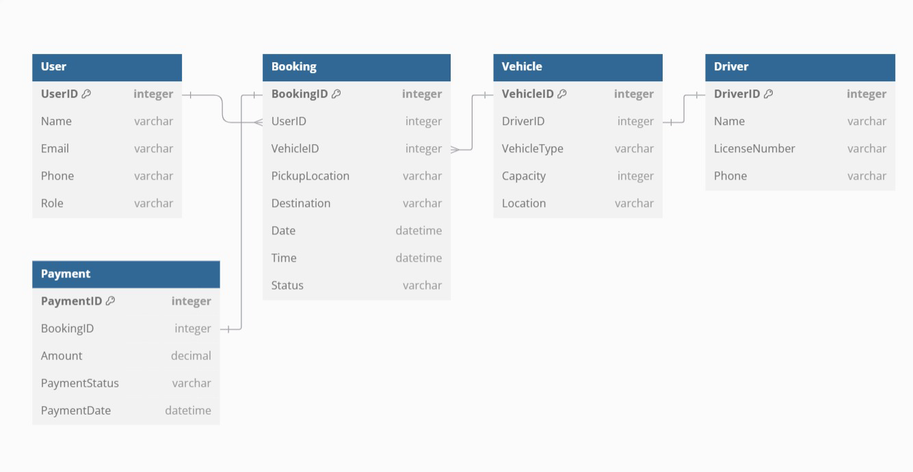 **The Logical ERD Diagram**

**Tables & Attributes:**

**Table User:**

  User ID [primary key]

  Name

  Email

  Phone

  Role

**Table Booking:**

  Booking ID [primary key]

  User ID

  Vehicle ID

  Pickup Location

  Destination

  Date

  Time

  Status

**Table Vehicle:**

  Vehicle ID [primary key]

  Driver ID

  Vehicle Type

  Capacity

  Location

**Table Driver:**

  Driver ID [primary key]

  Name

  License Number

  Phone

**Table Payment:**

  Payment ID [primary key]

  Booking ID

  Amount

  Payment Status

  Payment Date

**Relationships:**

Booking, User [Many to One]

Booking, Vehicle [Many to One]

Vehicle, Driver [One to One]

Payment, Booking [One to One]

**The Use Case Diagram:**

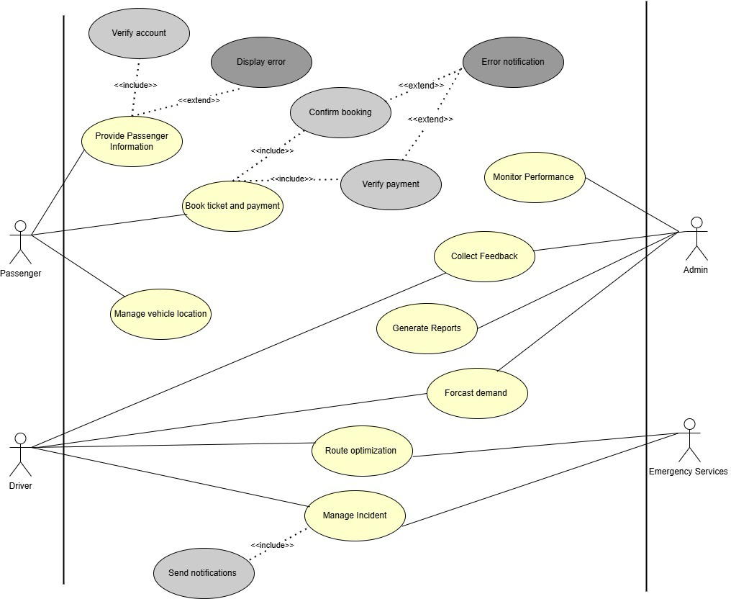

## Reports

* Activity Report: Summarizes all system activities, including the number of transactions, and user activity [Daily, Monthly, yearly].
* Revenue and Profitability Report: This report highlights the total revenue and profitability generated from ticket sales.
* User Engagement Report: This report analyzes the level of user engagement with the system. It helps measure the popularity and overall usage of the system.
* Order Summary Report: Shows a detailed breakdown of orders within a specific time frame. (Order IDs, User IDs associated with the orders, Total amount per order, and Status of each order).
* Customer Feedback and Ratings Report: This report analyzes customer feedback and ratings to assess satisfaction levels.
* Occupancy Rates and Seat Utilization Report: This report tracks seat occupancy rates and utilization for trips or events.
* Performance Metrics Report: This report focuses on key performance indicators (KPIs) such as on-time performance.

## Data Acquisition, Integrity, Retention, and Disposal

* Users provide data inputs for system processing in combination with connections to API-connected systems.
* The system maintains data integrity through daily backups and two supplementary methods that combine data input validation with reference points usage.
* Customer records function as permanent system data that maintains its retention over extended durations but session files subject themselves to immediate 24-hour deletion.
* Security measures for sensitive data disposal management under the system combine rigorous protocols which extend to encryption across all stages of transfer and data storage.

# External Interface Requirements

## User Interfaces

The system will include a graphical user interface (GUI) that allows users to easily access transportation services. The interface will include:

* *A main screen that displays available options, such as searching for a vehicle to the desired destination, reserving seats, selecting a payment method, and selecting a departure point.*
* *A search screen that enables the user to enter the departure point and destination, with the ability to filter results based on time.*
* *An interactive map that shows available routes and trips based on the user’s geographic location.*
* *A notification system to alert users of trip times and potential changes.*
* *Design criteria include the use of consistent colors, clear buttons, and an easy-to-use interface with accessibility for administrators.*
* *Clear error messages will be used when problems occur, such as a failed connection to the server or entering incorrect data.*

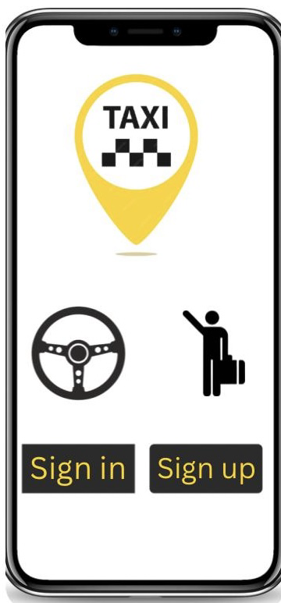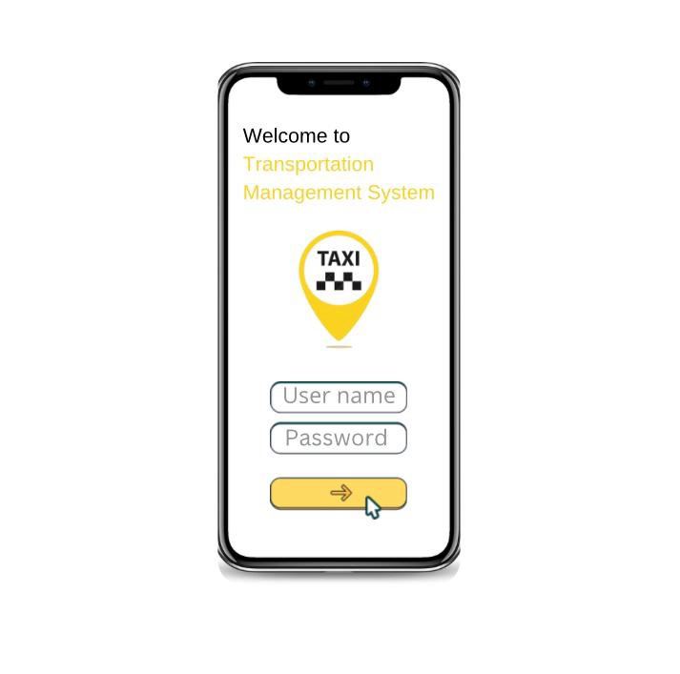

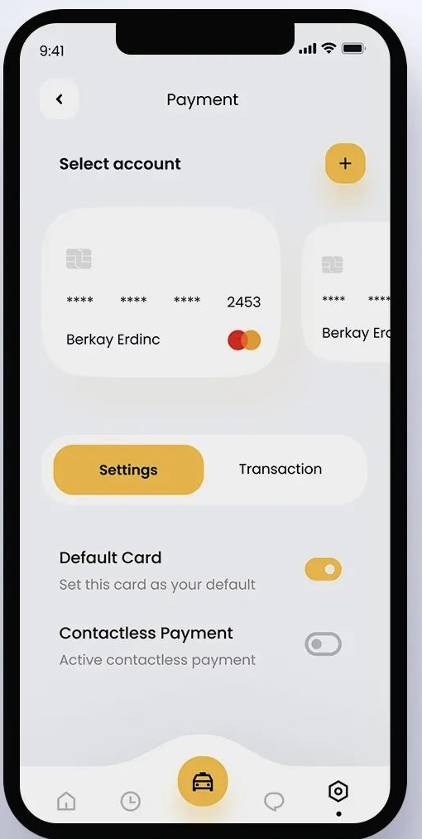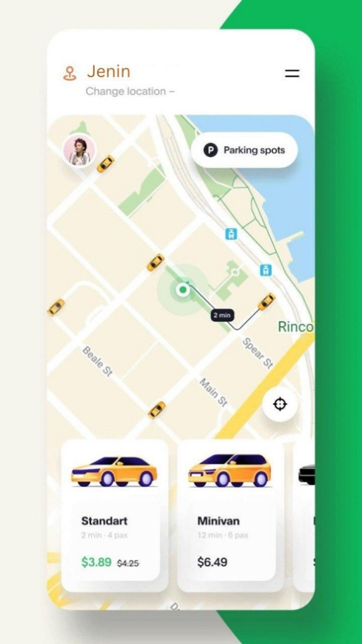

Some interfaces for the application

## Software Interfaces

The system will integrate with several external programs and services, including:

* A database (such as MySQL or Firebase) to store user data, trips, and payments.
* A programming interface (API) for Google Maps or OpenStreetMap to provide routing and map display services.
* A GPS API to enable tracking of the actual location of vehicles and users when needed.
* An electronic payment gateway in case the system requires payment transactions to book tickets.

## Hardware Interfaces

If the system uses GPS devices, they will be connected to the application via appropriate communication protocols (such as HTTP Requests).

* *If there are point-of-sale (POS) devices for payment, integration with payment devices via QR Code will be supported.*
* *Mobile devices running Android and iOS will be supported to ensure the application is compatible with various smart devices.*
* *If there are information screens at transport stations, data will be sent to them via HTTP to display real-time trip schedules.*

# Quality Attributes

## Usability

*The system should have a user-friendly interface that allows users, whether passengers, officials or drivers, to interact with it easily without the need for extensive training. The graphical interface should also be attractive and simple, with clear instructions for easy navigation. Additionally, a quick search feature will be provided that will allow users to easily find routes and schedules, reducing search time. The system should be easy to learn, so that users can quickly understand it through visual instructions or hands-on experience. Finally, to ensure a smooth experience, error prevention and correction mechanisms will be included, such as instant alerts when incorrect data is entered or errors occur in processes, with options to easily correct them.*

## Performance

The system must ensure optimal performance by responding to user requests within 2 seconds for standard operations and 5 seconds for transactions such as booking and payment. It should support up to 1,000 concurrent users without performance degradation and maintain 99.9% uptime. Reports should be generated within 10 seconds, and database queries should be completed in 1 second on average to ensure a smooth user experience.

## Security

The system must be secure to protect user data from unauthorized access. Data will be encrypted during transmission and storage, and strong passwords with two-factor authentication will be used. User permissions will be limited to ensure that only the appropriate person has access, with accounts locked after multiple failed login attempts. All activities will be logged to monitor for any hacking attempts, and protection against common attacks such as malicious link hacking will be implemented. In addition, the system will adhere to privacy protection regulations and automatic backups will be performed to protect data from loss.

## Safety

*This system functions efficiently in various unexpected situations compared to specified needs while preserving environmental safety.*

## Response time

*Users experience improvement requires servers to react promptly to deliver efficient quick services. After these thresholds are exceeded, users experience frustration. Caching technology and optimized algorithms connected to speed-up networks enable faster request-response periods which results in enhanced application performance.*

## Maintainability

*The focus is on ensuring that the system can be easily maintained and developed over time. This includes designing the system to be flexible and scalable. Code clarity is ensured through comments and proper documentation for code refectory, and unit tests and integration tests are implemented to ensure stability after changes. Error monitoring and performance analysis mechanisms are in place, along with regular updates and patches.*

Appendix A: Glossary

<Define any specialized terms that a reader needs to know to understand the SRS, including acronyms and abbreviations. Spell out each acronym and provide its definition. Consider building a reusable enterprise-level glossary that spans multiple projects and incorporating by reference any terms that pertain to this project.>

Appendix B: Analysis Models

<This optional section includes or points to pertinent analysis models such as data flow diagrams, feature trees, state-transition diagrams, or entity-relationship diagrams. You might prefer to insert certain models into the relevant sections of the specification instead of collecting them at the end.>