Panorama Stitching and Homography

What is Panorama Stitching?
Panorama stitching is a multi-image matching problem that involves combining a series of overlapping photographs into a single, high quality image. The process mathematically aligns images taken from different angles, times, or sensors into a unified coordinate system. It is one of the most commonly used algorithms in computer vision, which finds where images fit together by detecting common key features or patterns within the overlapping areas of photographs (like edges, corners, or blobs). The matched features are used as references that allow the images to be aligned relative to each other.^{[1]}

1.1 Why Panorama Stitching?
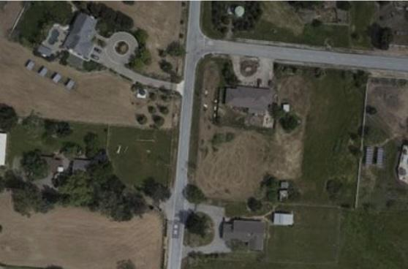
Panorama stitching helps overcome the physical limitations of standard cameras, allowing for the creation of high-resolution and wide-angle images that a single lens can’t capture^{[2]}.The primary reason for using this technique is expanding the field of view. Standard cameras are limited by their hardware in how much of a scene they can capture in one frame. Stitching allows multiple overlapping photos to be combined, effectively increasing the camera’s horizontal field of view up to 360 degrees^{[1][3]}.
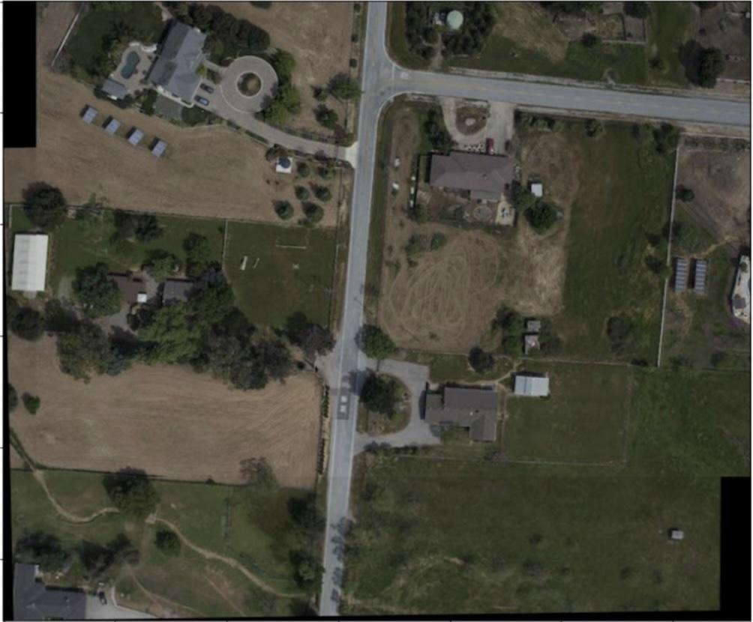

Image Pair 1
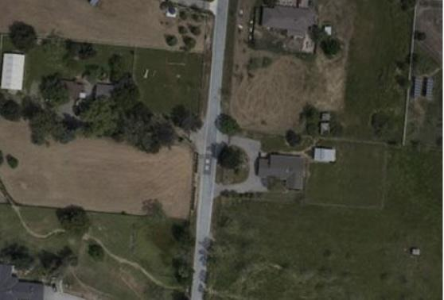

Figure 1:Stitched Image [Demidov, Khattak & Rahman]

Image Pair 2

1.2 The Core Pipeline
Panorama stitching works through a multi-stage pipeline designed to mathematically align and merge overlapping images. The main steps in this process include:
- Feature Detection and Description: the algorithm scans every image to identify unique keypoints, and creates mathematical descriptors that represent the visual information around those points.
- Feature Matching: the descriptors are compared across images to identify pairs of points that represent the same physical location in the scene.

- Homography Estimation (Alignment): the algorithm calculates a mathematical transformation called a homography to determine how one image should be overlaid on another. RANSAC is used during this step to ignore outliers that would ruin the alignment.
- Image Wrapping: using the homography matrix, the algorithm mathematically transforms each image’s pixels into a common coordinate frame.
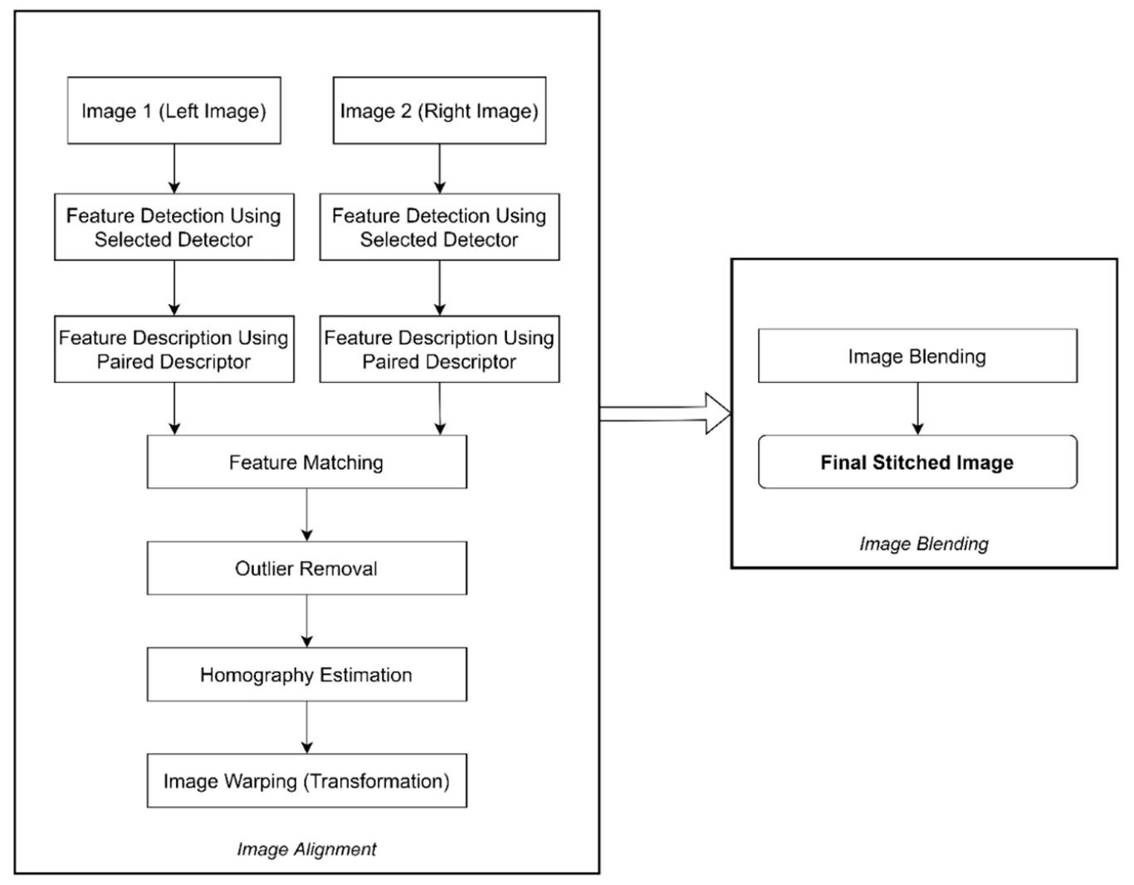
- Image Blending: to ensure the final panorama is seamless, the algorithm merges pixel values in the overlapping regions, smoothing out differences in exposure, lighting, or slight misalignments^{[4]}.

Figure 2: Workflow adopted for image stitching [Sharma, Jain & Shukla, 2023]

Feature Detection and Description

2.1 What Makes a Good Feature
A good feature in image stitching is a unique pattern within an image, such as a corner, edge, or blob. It can be identified and matched across multiple overlapping photographs. According to [Sharma, Jain & Shukla, 2023], a high-quality feature usually has the following characteristics:
- Invariance: a good feature must be invariant to rotation, scale, and illumination changes.
- Repeatability and Stability: the feature must be consistently detectable across images taken from different viewpoints.
- Discriminativeness: features must be distinct enough to be distinguished from one another.
- Localization Accuracy: a feature has a precise spatial location that can be identified accurately.
- Spatial Distribution: features should be spread throughout the image, not clustered in one area.

2.2 SIFT - Scale Invariant Feature Transform
SIFT is a robust algorithm used to detect and describe local features in images, and it is the primary detector used in the canonical panorama stitching pipeline. SIFT is very much known for being robust against scale, rotation, illumination, and viewpoint changes. It can match features even if the camera moves closer or farther away, identify features regardless of camera orientation, and remains partially invariant to affine changes and viewpoints shifts^{[1]}.

The process of establishing local features by SIFT requires detecting unique points within a mathematical scale space as follows:
- Scale Space and Difference of Gaussian (DoG): the algorithm repeatedly blurs an image at different scales and subtracts consecutive levels to find a Difference of Gaussian (DoG). If $L(x,y,σ)$ represents a blurred image at scale $σ$, the DoG function is:
$D(x,y,σ)=L(x,y,kσ)-L(x,y,σ)$
This identifies potential features that exist at various zoom levels^{[1]}.

- Keypoint Localization (Maxima and Minima): Once the DoG images are generated, the algorithm identifies potential keypoints by searching for local extrema (points that are either maximum or minimum compared to their surrounding neighbors). Each candidate pixel in the DoG scale-space is then compared to its 26 neighbors in a $3×3$ region: 8 neighbors in the same scale, 9 neighbors in the scale below and 9 neighbors in the scale above. A point is selected as a keypoint only if its DoG value is greater than or smaller than all 26 neighbors^{[1]}.
$D(x,y,σ)> D(all 26 neighbors) or D(x,y,σ)< D(all 26 neighbors)$

- Similarity-Invariant Measurement Frame: once SIFT finds a keypoint, it gives it a scale and orientation. This helps the feature stay recognizable even if the image is zoomed in, zoomed out, or rotated. The keypoint is represented as:
$(x,y,σ)$
Where $x$ and $y$ show the location of the feature, and $σ$ shows the scale where it was detected. Then, SIFT finds the main direction of the feature using image gradients:
$m(x,y)=\sqrt{G_{x}^{2}+G_{y}^{2}}$ $Θ(x,y)=\tan^{-1}(\frac{G_{y}}{G_{x}})$
Where $m(x,y)$ is the strength of the gradient, and $Θ(x,y)$ is its direction. By using this scale, SIFT can match the same feature even when the image changes in size or orientation^{[1]}.

- The SIFT Descriptor - 128 Dimensional Vector: After assigning an orientation, SIFT creates a local descriptor around each keypoint. It samples a $16×16$ pixel neighborhood aligned with the keypoint’s dominant orientation and divides it into a $4×4$ grid. Each cell stores an 8-direction gradient histogram, producing a $4×4×8=128$ values known as the SIFT descriptor vector. Keypoints are matched by comparing their nearest neighbours in this 128-dimensional space. Because the descriptor is high-dimensional, SIFT is highly discriminative, making random keypoints unlikely to match by chance^{[1]}.

2.3 Other Feature Detectors
A variety of detectors have been proposed over the years, each offering different trade-offs between speed, accuracy, and invariance.

Table 1: Key feature detectors for panorama stitching [Sharma, Jain & Shukla, 2023]
Detector | Key Strength | Primary Use Case
AKAZE | Highest accuracy and robustness across diverse datasets. | High-quality general purpose panorama stitching.
ORB | Extreme speed; computationally efficient binary alternative. | Real-time applications or low-power devices.
SIFT | Highest invariance to scale, rotation, and illumination. | General panorama stitching-the canonical baseline algorithm.

2.4 Feature Matching
Once descriptors are extracted from all images, they must be matched. Because multiple images may overlap a single ray, each feature is matched to its k nearest neighbors in feature space. This is done in $O(n log n)$ time using K-d tree (an axis aligned binary space partition that recursively partitions feature space at the mean in the highest-variance dimension)^{[1]}.

- Lowe’s Ratio Test:
To eliminate false-positive matches, Lowe’s ratio test is applied: a match is accepted only if the distance to the best match divided by the distance to the second-best match is less than 0.75.
For a descriptor $f_{i}$, let its nearest neighbor be $f_{1}$and its second-nearest neighbor be $f_{2}$​. The match is accepted only if:
$\frac{d(f_{i},f_{1})}{d(f_{i},f_{2})}<0.75 d(f_{i},f_{j})=\sqrt{\sum_{k=1}^{n}{}{(f_{i}^{(k)}-f_{j}^{(k)})}^{2}}$
Here $d(f_{i},f_{j})$ is the Euclidean distance between two feature descriptors^{[1]}.

The Homography Matrix

3.1 What is Homography?
A homography is a projective transformation between two image planes that mathematically maps every point in one image to its corresponding location in another. In computer vision, it is used to mathematically align overlapping photographs by modelling perspective distortion, scale, rotation, translation and shear^{[1][4]}.

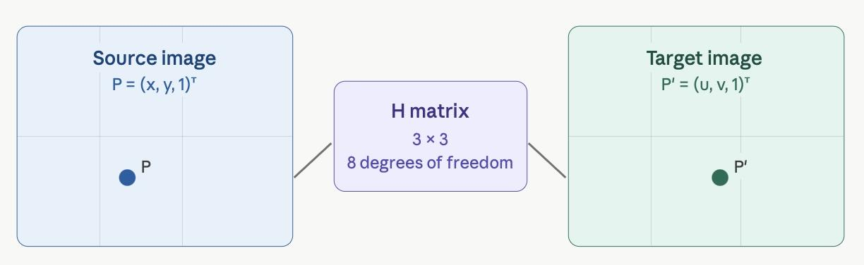
- The Homography Matrix: the relationship is expressed in homogeneous coordinates as $\underline{P }$$=HP$where $H$ is a $3×3$ transformation matrix that defines the geometric relationship between two views, $P$ is a point in the source image and $\underline{P}$ is the corresponding point in the target image^{[4]}. While the transformation matrix contains 9 elements, it is a homogeneous matrix with only 8 degrees of freedom (one element is used for scale and eight unknowns must be solved for).

Figure 3: Homography mapping P to P’ via the H matrix. Generated using Claude AI

- Homogeneous Coordinates:
In homogeneous coordinates, if $P={(x,y,1)}^{T}$and $\underline{P}={(u,v,1)}^{T}$then:

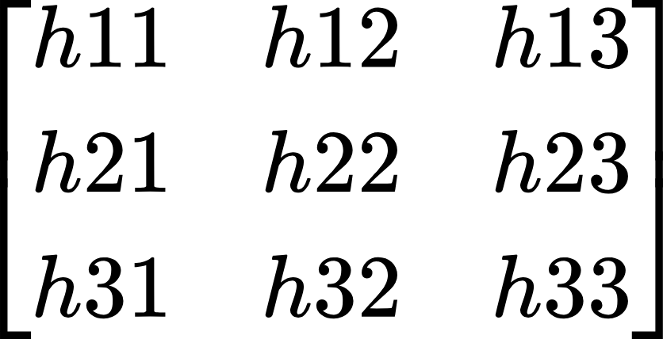


$C×$ $=$ → $u=(h_{11}x+h_{12}y+h_{13}) / (h_{31}x+h_{32}y+h_{33})$
→ $v=(h_{21}x+h_{22}y+h_{23}) / (h_{31}x+h_{32}y+h_{33})$

Where C is a scale factor divided out to recover the actual pixel coordinates (u,v). Since H has 8 unknown, a minimum of 4 corresponding point pairs are required (each pair contributes 2 equations). The matrix is typically solved using the Direct Linear Transformation (DLT) method^{[1][4]}.

3.2 Why Homography Works for Panoramas?
Homography is specially suited for panoramic stitching because:
- Modeling Distortion: It can model perspective distortion, scale, rotation, and translation.
- Camera Motion Assumption: it represents transformations when a camera rotates about its optical center.
- Mathematical Efficiency: It needs only four matching point correspondences, making it computationally viable.

3.3 Worked Numerical Example: Computing H from 4 Points Correspondences
This section demonstrates the step-by-step computation of a homography matrix H using four matched point correspondences between two images. The method applies the Direct Linear Transform (DLT) algorithm, culminating in a Singular Value Decomposition (SVD) to extract the solution.

Step 0: Input — Matched Point Pairs
The following four point correspondences are given between Image A (source) and Image B (target):

Table 2: Four matched point pairs used to estimate H
Point | Image A (x, y) | Image B (u, v)
P1 | (100, 150) | (85, 160)
P2 | (300, 150) | (282, 162)
P3 | (100, 400) | (84, 415)
P4 | (300, 400) | (281, 418)

Step 1: Formulate Two Equations per Point Pair
For each matched pair, the homogeneous transformation $\underline{P }$$=HP$ (after eliminating the scale factor c) yields two linear equations in the nine unknown entries of H. Using the standard DLT formulation:
$u-row: [-x, -y, -1, 0, 0, 0, u⋅x, u⋅y, u]$
$v-row: [0, 0, 0, -x, -y, -1, v⋅x, v⋅y, v]$

For point $P_{1}(x=100,y=150,u=85,v=160)$:
$u-row: [-100, -150, -1, 0, 0, 0, 8500, 12750, 85]$
$v-row: [0, 0, 0, -100, -150, -1, 16000, 24000, 160]$

Step 2: Assemble the 8×9 Matrix A
Repeating Step 1 for all four point pairs produces a system of 8 equations in 9 unknowns, assembled into matrix A:
$-x$ | $-y$ | $-1$ | $0$ | $0$ | $0$ | $u⋅x$ | $u⋅y$ | $u$ | $Row$
-100 | -150 | -1 | 0 | 0 | 0 | 8500 | 12750 | 85 | ← P1 u
0 | 0 | 0 | -100 | -150 | -1 | 16000 | 24000 | 160 | ← P1 v
-300 | -150 | -1 | 0 | 0 | 0 | 84600 | 42300 | 282 | ← P2 u
0 | 0 | 0 | -300 | -150 | -1 | 48600 | 24300 | 162 | ← P2 v
-100 | -400 | -1 | 0 | 0 | 0 | 8400 | 33600 | 84 | ← P3 u
0 | 0 | 0 | -100 | -400 | -1 | 41500 | 166000 | 415 | ← P3 v
-300 | -400 | -1 | 0 | 0 | 0 | 84300 | 112400 | 281 | ← P4 u
0 | 0 | 0 | -300 | -400 | -1 | 125400 | 167200 | 418 | ← P4 v
Table 3: Full 8x9 matrix A constructed from 4 point correspondence

Step 3: Solve Ah = 0 via Singular Value Decomposition (SVD)
The homography vector $h={[h_{11},h_{12},...,h_{33}]}^{T}$is the solution to the homogeneous system Ah = 0. This is solved by decomposing A using SVD:
$A=U⋅\sum{}V^{T}$
The eight singular values obtained are:
$\sum{}=diag( 316709.5, 80999.3, 695.1, 293.4, 207.5, 71.9, 4.9, 0.23)$
The solution h corresponds to the last column of V, which is associated with the smallest singular value (0.23). This is the null space vector of A, which is the least-squares solution to Ah = 0.

Step 4: Reshape and Normalise to Obtain H
The 9-element solution vector h is reshaped into a 3×3 matrix and normalised by dividing all entries by h[2,2], so that the bottom-right element equals 1:

Table 4: Estimated homography matrix H, normalized so that h33=1
0.9776 | -0.0040 | -12.324
0.0068 | 1.0180 | 6.309
0.0000 | 0.0000 | 1.000

Step 5: Verification — Reprojecting a Source Point
To verify H, the transformation is applied to each source point and the result is compared with the known target. For P1 (x = 100, y = 150):
$H⋅{[100,150,1]}^{T}=[0.9776⋅100+(-0.0040)⋅150+(-12.324)]$
$[0.0068⋅100+ 1.0180⋅150 + 6.309 ]$
$[0.0000⋅100+ 0.0000⋅150 + 1.000 ]$
$={ [ 84.836 , 159.689, 1.000 ]}^{T}$

Dividing by the scale factor $w=1$:
$\underline{u }$$=84.836/1 ≃85.00$ (actual: 85) ✓ $\underline{v }$$=159.689/1 ≃160.00$ (actual: 160) ✓

Step 6: Verification — All Four Point Correspondences
Applying H to all four source points yields reprojections that match the target coordinates with zero pixel error, confirming that H is correct:

Table 5: Reprojection results for all four point correspondences
Point | Source (x, y) | Predicted (u', v') | Actual (u, v) | Match
P1 | (100, 150) | (85.00, 160.00) | (85, 160) | ✓
P2 | (300, 150) | (282.00, 162.00) | (282, 162) | ✓
P3 | (100, 400) | (84.00, 415.00) | (84, 415) | ✓
P4 | (300, 400) | (281.00, 418.00) | (281, 418) | ✓

The zero reprojection error across all four points confirms that H is correctly estimated. This result is expected when using exactly four noise-free point pairs, as the system is perfectly determined. In practice, more than four points are used and small residual errors are acceptable.

RANSAC - Robust Homography Estimation

4.1 The Problem with Outliers
Feature matching always produces some outliers, which are incorrect correspondences where two keypoints appear similar but actually describe different scene points. If the outliers are included in the homography computation, the estimated H will be wrong.A single bad point can corrupt the solution^{[1]}.

4.2 How RANSAC Works
RANSAC (Random Sample Consensus) is a robust iterative algorithm used to find the best mathematical fit for a set of data that contains a significant number of outliers (false or noisy matches). In panorama stitching, it is the primary tool used to ensure images align correctly even when initial feature matching produces many errors. RANSAC uses a simple “hypothesize-and-verify” framework:
- Hypothesize: randomly select a minimal subset of 4 matching point pairs, to calculate a trial homography.
- Verify: test the trial model against the rest of the dataset and label points as inliers or outliers.
- Repeat: repeat the process for many trials, often 500 or more, to increase the probability of choosing clean data.
- Select: choose the model with the maximum number of inliers, using a “voting system” to find the best geometric fit while ignoring noise.

Analogy: Think of it like asking 500 strangers for directions to the train station: even if a handful give wrong directions, the consistent majority answer always points the right way. RANSAC finds the geometric truth by ignoring the outlier noise.

4.3 How Many Iterations are Needed?
Brown & Lowe (2007) use n=500 RANSAC iterations. The probability that the correct homography is not found after n trials is:
$P(H is wrong)={(1-P_{i}^{r})}^{n}$
Where $P_{i}$ is the inlier probability and r=4 (minimum points needed). For an inlier probability of $P_{i}=0.5$ (half the matches are correct), after n=500 trials:
$P(failure)={(1-{0.5}^{4})}^{500}={(1-0.0625)}^{500}≃1×{10}^{-14}$
This is a very small failure probability, making RANSAC extremely reliable in practice.

4.4 Image Match Verification
After RANSAC, Brown & Lowe (2007) apply a probabilistic verification model to confirm that a pair of images genuinely overlaps. Given $n_{f}$ total features in the overlap area and $P_{i}$ RANSAC inliers, an image match is accepted if:
$n_{i}>α+β×n_{f}$where $α=8.0,β=0.3$
This threshold ensures that only image pairs with matching features are accepted, rejecting false or accidental matches^{[1]}.

Image Warping and Blending

5.1 Perspective Warping
Image warping means transforming one image so that it aligns with another image. In panorama stitching, after calculating the homography matrix, it is used to move, rotate, scale, or stretch the image so that the matching points overlap correctly^{[2][4]}.

Using the $3×3$ homography matrix, the algorithm performs a projective transformation that maps every point in a source image to a corresponding point in a destination image. This corrects perspective distortion, scale, and rotation, ensuring overlapping features physically line up^{[5]}.

5.2 Image Blending
Once images are warped and aligned, visible seams often remain due to differences in exposure, lighting, or slight misregistrations. Blending combines the overlapping pixel values to create an invisible transition^{[2]}.
- Linear Blending: mixes pixel values in overlapping areas, but small alignment errors can make the result blurry^{[1]}.
- Feathering: gradually mixes the images so the seam between them becomes less visible^{[3]}.
- Multi-band Blending: smooths brightness differences while keeping sharp details clear, making the panorama look seamless^{[1]}.

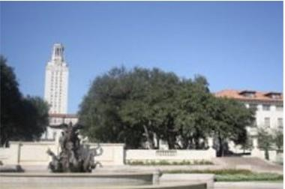

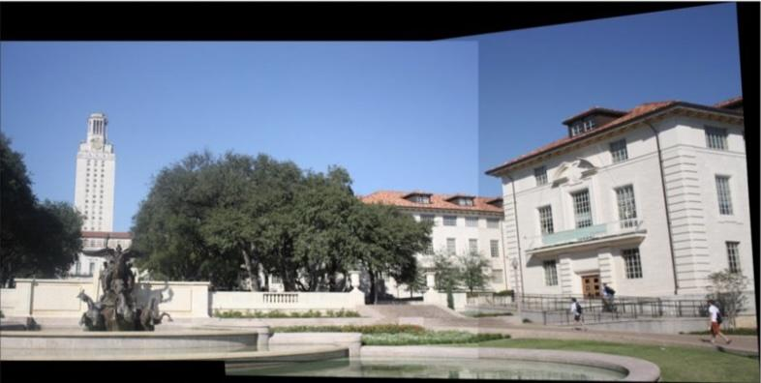
Image Pair 1 Image Pair 2

Figure 4: Stitched Image [Demidov, Khattak & Rahman]

Analogy: Think of blending like mixing two paint swatches at their boundary: a hard edge looks artificial, but a smooth gradient transition becomes invisible to the eye — multi-band blending achieves this at every spatial scale simultaneously.

Real-World Applications and Failure Modes
6.1 Applications
Panorama stitching is widely used in real-world systems where multiple images need to be combined into one wider, clearer, and more complete view. These applications include:
- Digital Maps and Satellite Imagery: modern maps and high-resolution satellite photos are created by stitching together thousands of overlapping frames.
- Real Estate and Virtual Tours: it is used to create broad views for virtual walkthroughs.
- Disaster Monitoring: stitched monitoring images provide accurate data for post-disaster rescue by giving responders a complete view of the affected areas^{[1]}.

6.2 Failure Modes
Understanding when panorama stitching fails is as important as understanding when it works:
- Parallax Errors: When the camera translates (not just rotates), objects at different depths produce parallax, which a homography cannot model. Brown & Lowe (2007) note this as a key limitation requiring future work on plane-plus-parallax models.
- Moving Objects: Dynamic scene content (people, cars) creates ghosting artefacts in the blended output, as the same object appears in different positions across overlapping images^{[4]}.
- Radial Distortion: The homography model assumes straight lines are preserved (projective camera). Radial lens distortion violates this, causing visible misregistration artefacts. Brown & Lowe (2007) demonstrate that significant distortion (κ = ±0.5) still allows matching but degrades rendering quality.
- Insufficient overlap: Images need at least 15-30% overlap to provide enough feature correspondences for reliable homography estimation^{[2]}.
- Rolling Shutters: a method of image acquisition common in consumer CMOS cameras where pixels are exposed row by row, typically from the top to the bottom of the sensor. This sequential exposure creates a time delay between the lines, which results in specific visual distortions (known as rolling shutter effects) if the camera moves during the capture process. Because standard computer vision algorithms often assume a "global shutter" where the entire frame is captured at once, ignoring these effects can lead to performance degradation or total failure in tasks like image stitching and 3D reconstruction^{[6]}.

Quick Reference - Cheat Sheet
7.1 Key Equations
Concept | Equation / Formula
DoG (Scale Space) | $D(x,y,σ)=L(x,y,kσ)-L(x,y,σ)$
Keypoint Criterion | $D(x,y,σ)> D(all 26 neighbors) or D(x,y,σ)< D(all 26 neighbors)$
Gradient Magnitude | $m(x,y)=\sqrt{G_{x}^{2}+G_{y}^{2}}$
Gradient Orientation | $Θ(x,y)=\tan^{-1}(\frac{G_{y}}{G_{x}})$
SIFT Descriptor | 4×4 grid × 8-bin orientation histograms = 128-D vector
Homography | $\underline{P }$$=HP$, H is 3×3, 8 degrees of freedom
Projection (u) | $u=(h_{11}x+h_{12}y+h_{13}) / (h_{31}x+h_{32}y+h_{33})$
Projection (v) | $v=(h_{21}x+h_{22}y+h_{23}) / (h_{31}x+h_{32}y+h_{33})$
Lowe's Ratio Test | $\frac{d(f_{i},f_{1})}{d(f_{i},f_{2})}<0.75$
RANSAC Failure Prob. | $P(H is wrong)={(1-P_{i}^{r})}^{n}$≈ 1×10⁻¹⁴ for Pᵢ=0.5, n=500
Match Threshold | $n_{i}>α+β×n_{f}$where $α=8.0,β=0.3$

7.2 Key Terminology
Key Term | Meaning
Panorama Stitching | Combining overlapping images into one wide image.
SIFT | Detects and describes key points that remain reliable under scale, rotation, and lighting changes.
Keypoint | An important point in an image, such as a corner, edge, or blob.
Feature Matching | Finding similar keypoints between images.
Homography | A transformation used to align images.
RANSAC | Removes incorrect matches before alignment.
Image Warping | Moves image pixels into the correct position.
Image Blending | Smooths overlap to create a seamless panorama.

7.3 Common Misconceptions
Key Term | Meaning
Panorama Stitching just places images side by side | Combining overlapping images into one wide image.
Homography always works perfectly for any scene | Homography works best when images have enough overlap and matching features, but wrong matches or strong viewpoint changes can cause errors.

Key Papers
[1] Brown, M., & Lowe, D. G. (2007). Automatic Panoramic Image Stitching using Invariant Features. International Journal of Computer Vision, 74(1), 59–73.
URL: https://www.cs.ubc.ca/~lowe/papers/07brown.pdf
Summary: This paper was mainly used as the foundation for the panorama stitching pipeline in the notes. It supports the idea of stitching as a multi-image matching problem, using SIFT features to detect and match keypoints despite changes in rotation, scale, zoom, and illumination. It was also used to explain k-d tree feature matching, RANSAC-based homography estimation, automatic panorama recognition, and multi-band blending for seamless results. The notes also rely on it for the SIFT descriptor and why invariant features are important in automatic stitching.

[2] Sharma, S. K., Jain, K., & Shukla, A. K. (2023). A Comparative Analysis of Feature Detectors and Descriptors for Image Stitching. Applied Sciences, 13(10), 6015.
URL: https://www.mdpi.com/2076-3417/13/10/6015
Summary: This paper was used mainly for the section comparing different feature detectors and descriptors, such as SIFT, ORB, AKAZE. It supported the table showing each detector’s strengths and best use cases.

[3] Wu, K. (2023). Creating Panoramic Images Using ORB Feature Detection and RANSAC-based Image Alignment. Advances in Computer and Communication, 4(4), 220–224.
URL: https://www.hillpublisher.com/ArticleDetails/2084
Summary: This paper was used to support the explanation of ORB as a faster alternative to SIFT, especially for real-time or efficient panorama stitching. It also helped explain the use of RANSAC with homography to align overlapping images and remove incorrect feature matches.

[4] Demidov, D., Khattak, M. U., & Rahman, U. Image Stitching Using Homography Techniques: Feature Extraction and Photometric Correction Methods Overview. MBZUAI Technical Report. ResearchGate.
URL: https://www.researchgate.net/publication/361747671
Summary: This paper was used to explain the general homography-based stitching pipeline, including keypoint detection, descriptor matching, homography estimation, image warping, blending, and photometric correction. It also supported the discussion of illumination differences and seam reduction.

[5] Elan Dubrofsky. Homography Estimation. Master’s Essay, University of British Columbia, Department of Computer Science, 2009.
URL: https://www.cs.ubc.ca/sites/default/files/2022-12/Dubrofsky_Elan.pdf
Summary: This paper was used to support the homography theory part of the notes. It explains what a homography is as a 3×3 projective transformation with 8 degrees of freedom, and how it relates to simpler transformations such as isometry, similarity, and affine transformations. It was also useful for explaining DLT homography estimation, the need for at least four point correspondences, normalization for stability, and robust estimation methods such as RANSAC for removing outlier matches before alignment.

[6] Yizhen Lao, Omar Ait Aider. Rolling Shutter Homography and its Applications. IEEE Transactions on Pattern
Analysis and Machine Intelligence, 2020, pp.1-1.
URL: https://hal.science/hal-03032637v1/document
Summary: This paragraph was used to explain a failure mode of standard panorama stitching. It shows that rolling shutter cameras capture the image row by row, so camera movement during capture can distort the frame.

