**Web Services**

**Lab 1: Creating Dynamic Web Project in Eclipse using Java Jakarta EE Platform**

**1. Creating Servlet in Dynamic Web Project: WebHelloWorldProject** 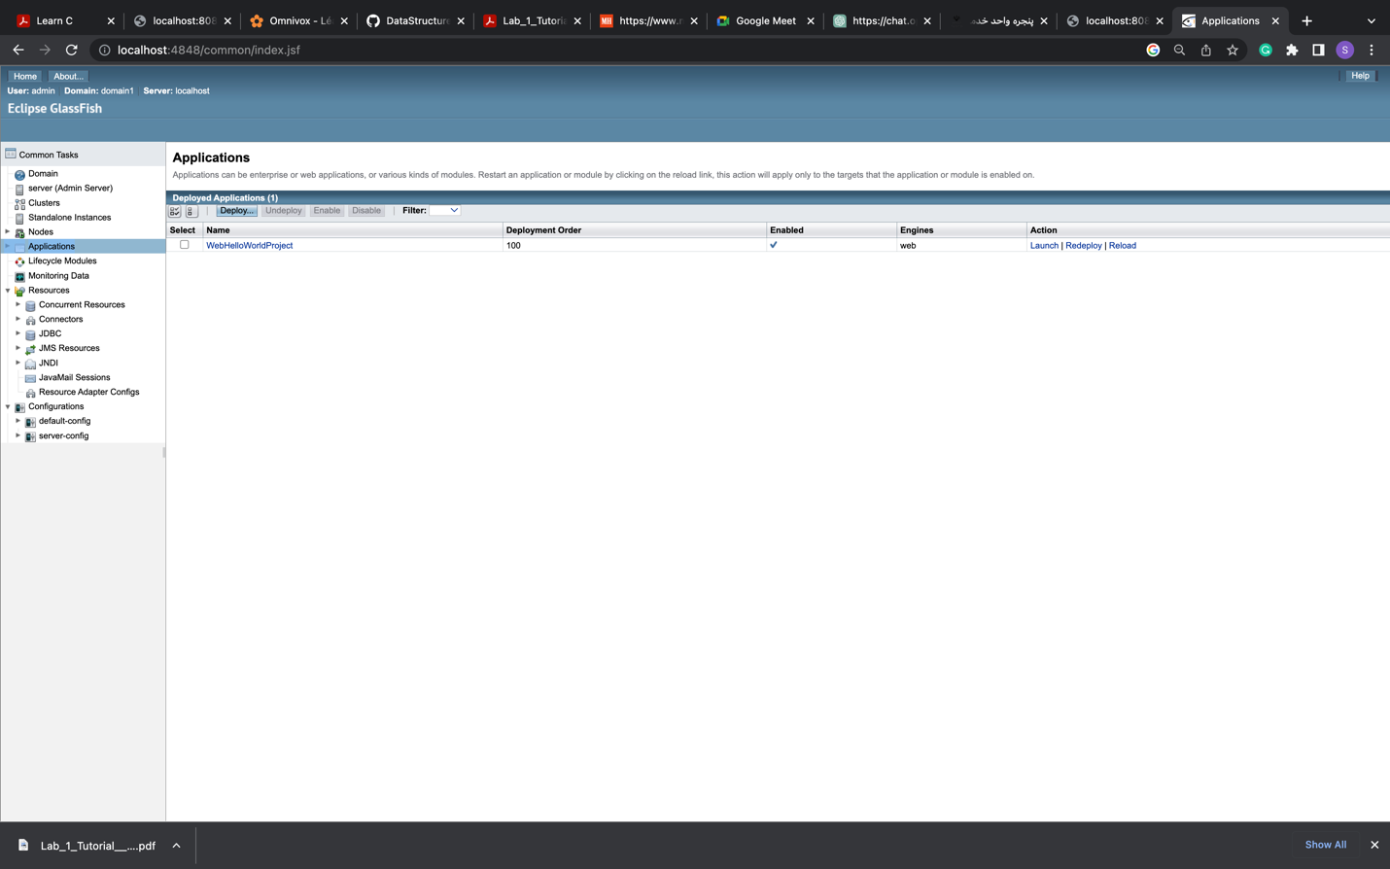

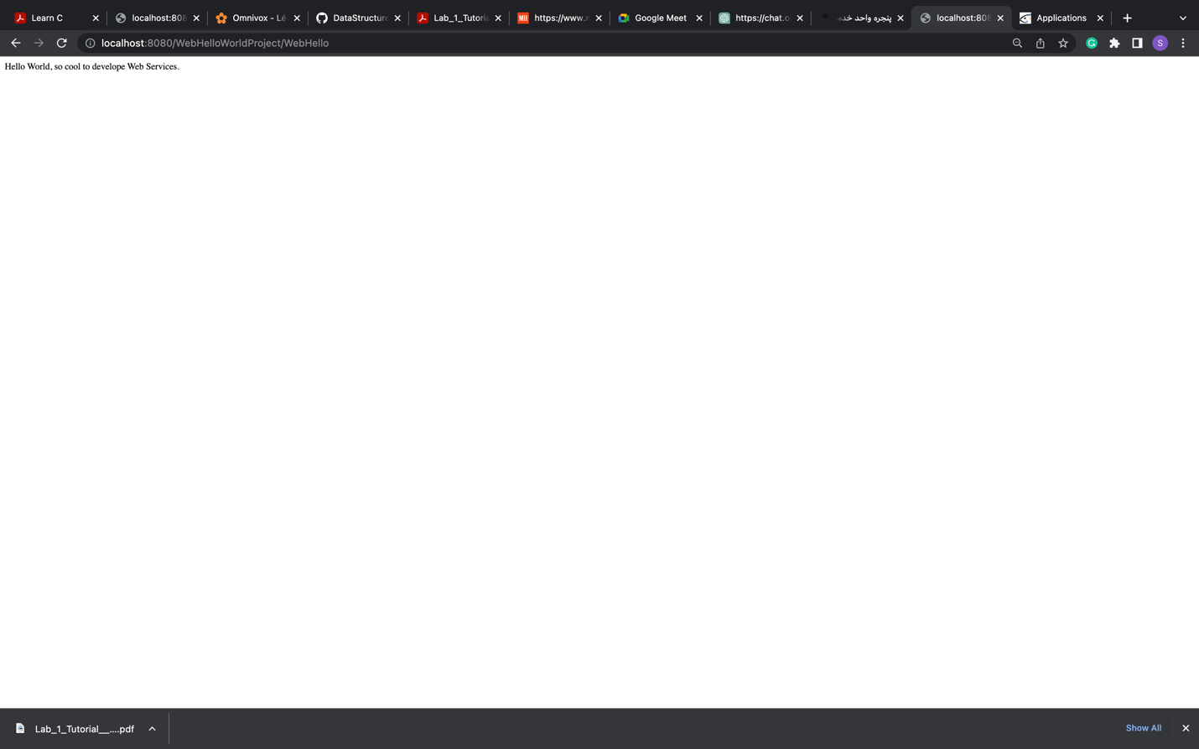

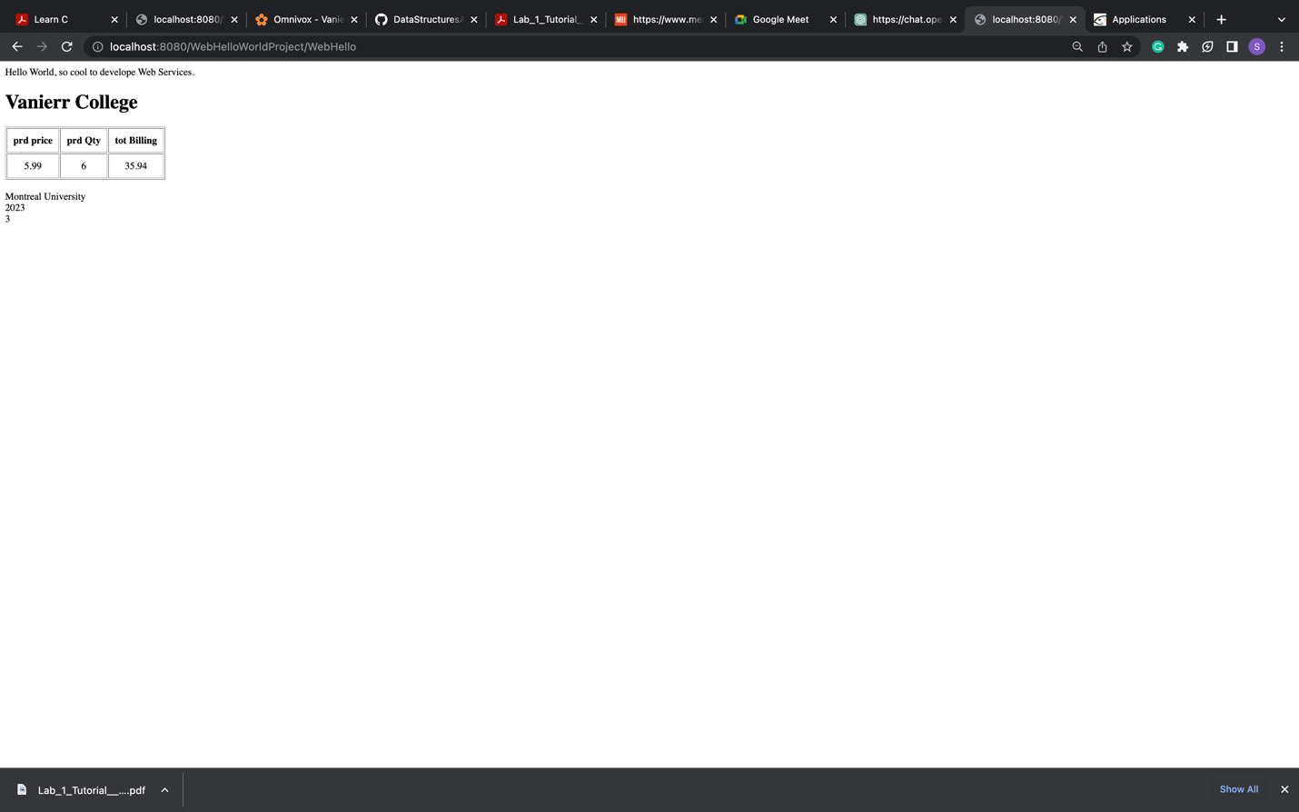

**2. Dynamic Web Project: WebBillingProject**

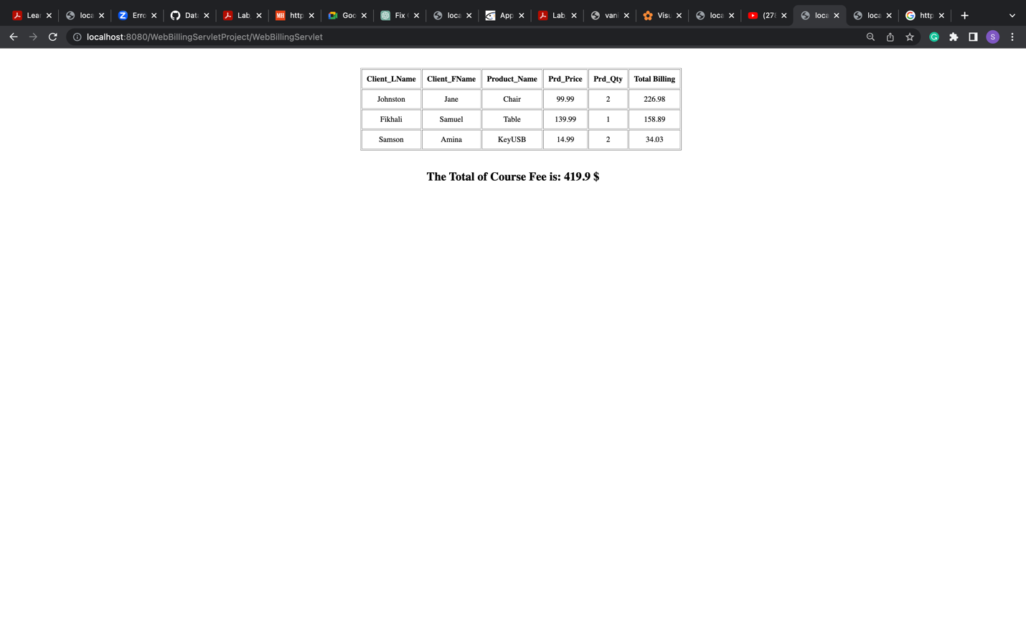

**3. Dynamic Web Project: WebCourseProject**

