**Lab 3: Web Services using REST Implementation**

**Hello Professor Samir,**

**I couldn’t compress the files, so I have attached the link in the file.  
Please find the files in the following GitHub Link in Master branch.  
Best Regards.**

<https://github.com/SamaDabagh/Lab3WebServicesSamanehDabbaghchi.git>

**1. Creating Dynamic Web Project and Convert it into Maven Project**

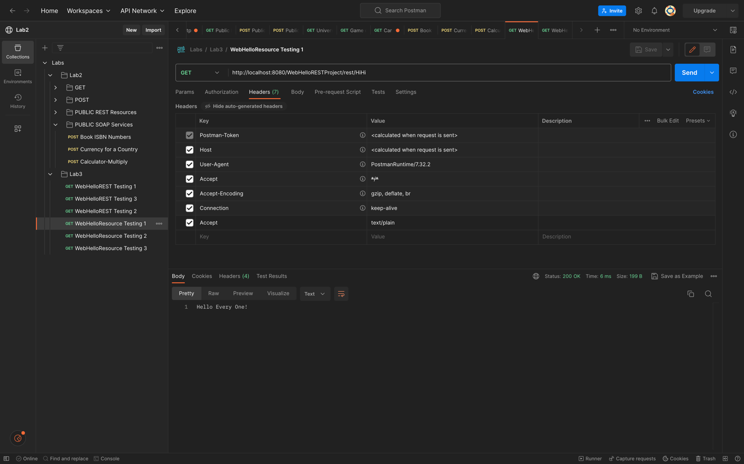



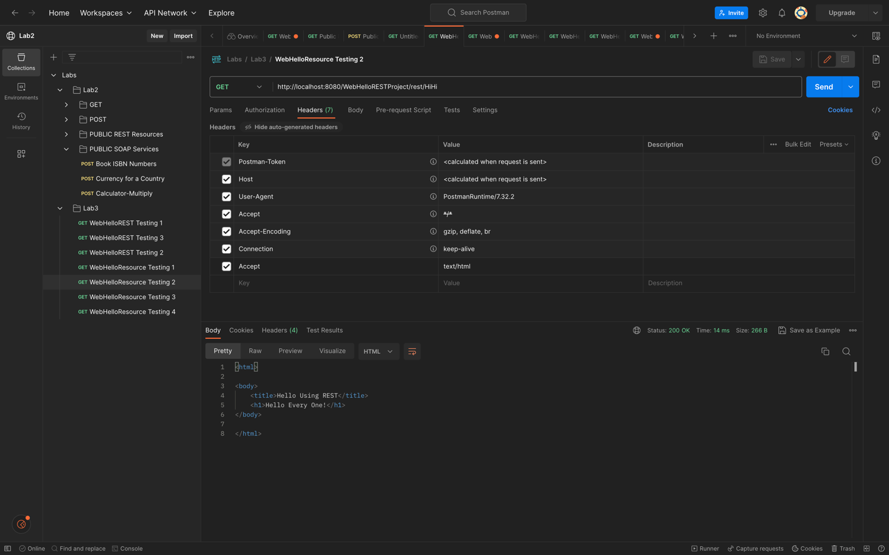

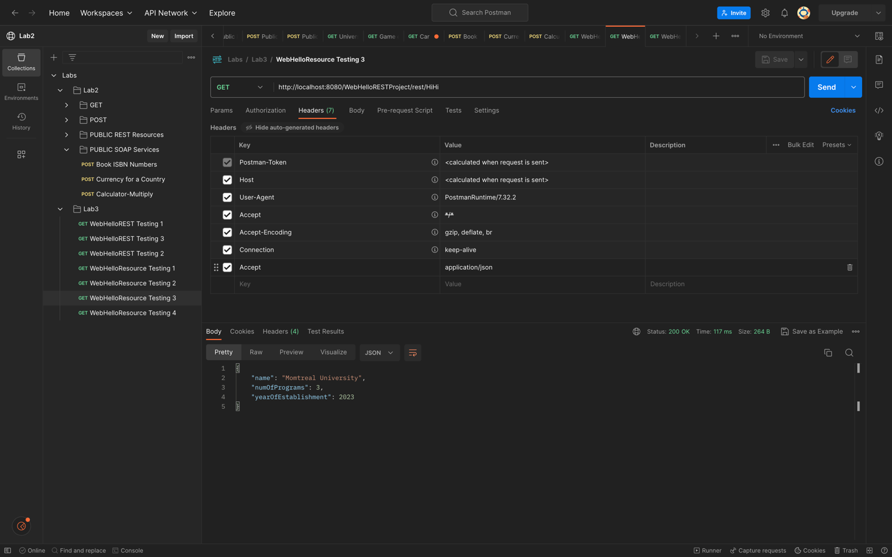

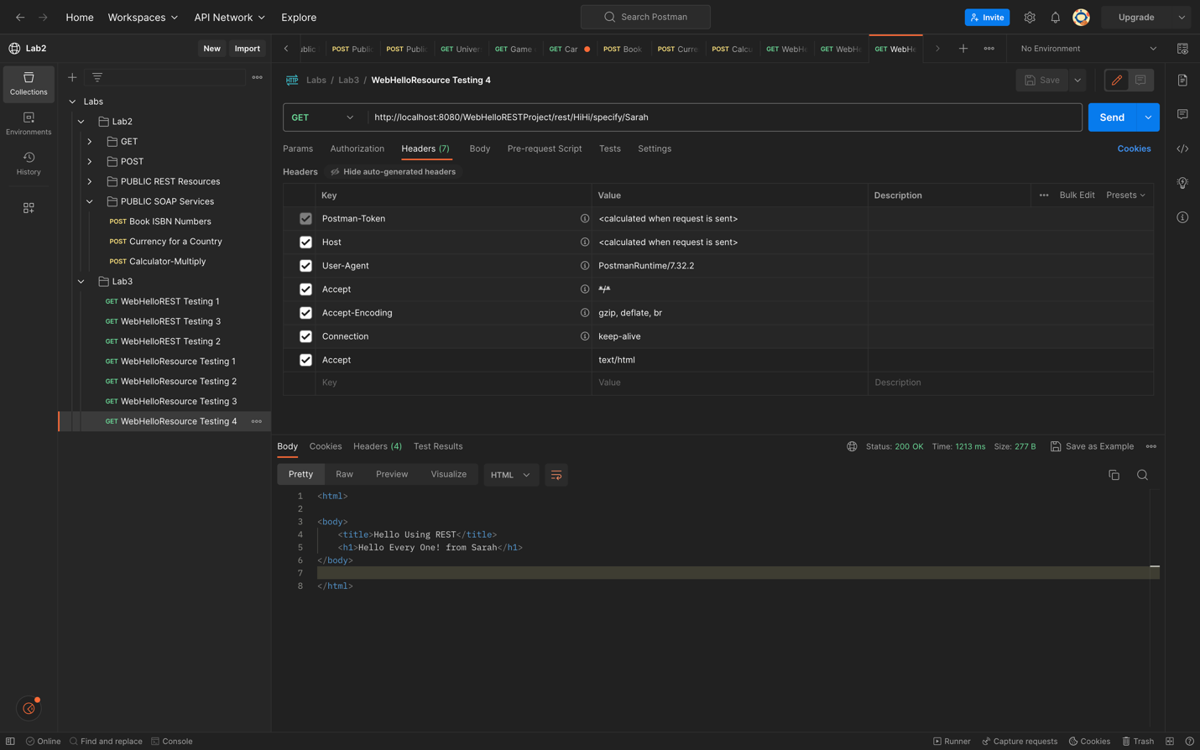

**2. Maven Dynamic Web Project: WebBillingRESTProject**

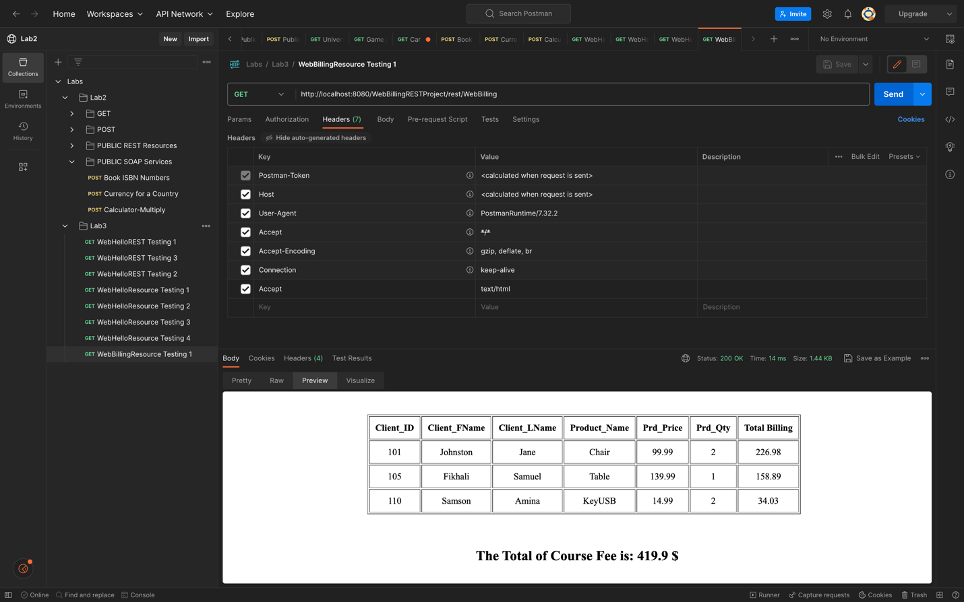

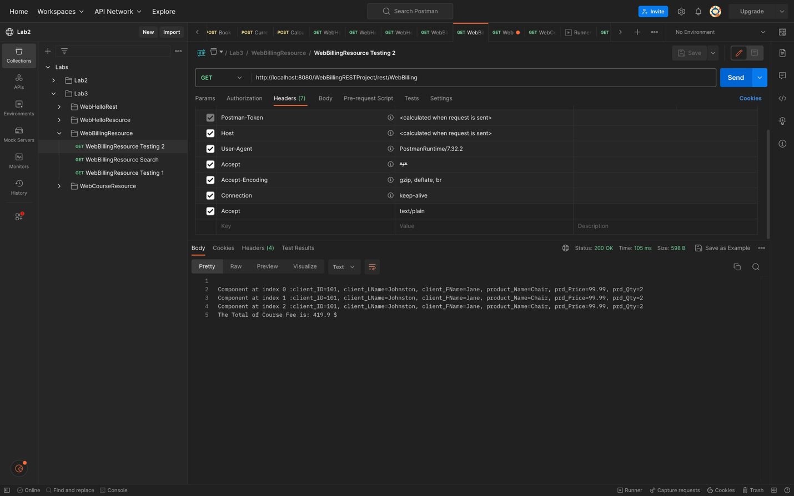

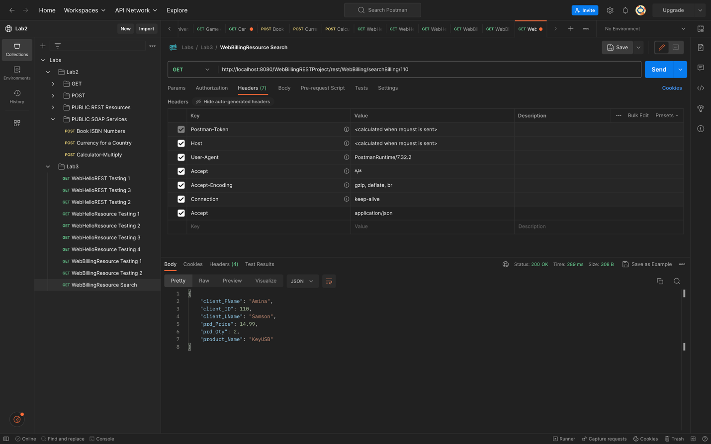

**3. Maven Dynamic Web Project: WebCourseRESTProject**

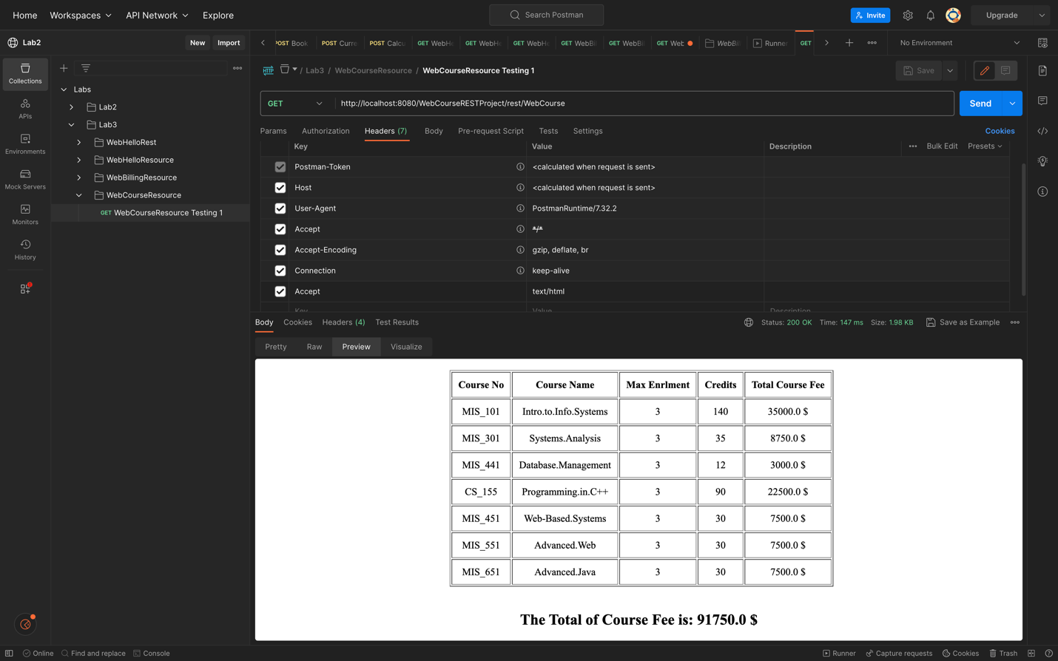

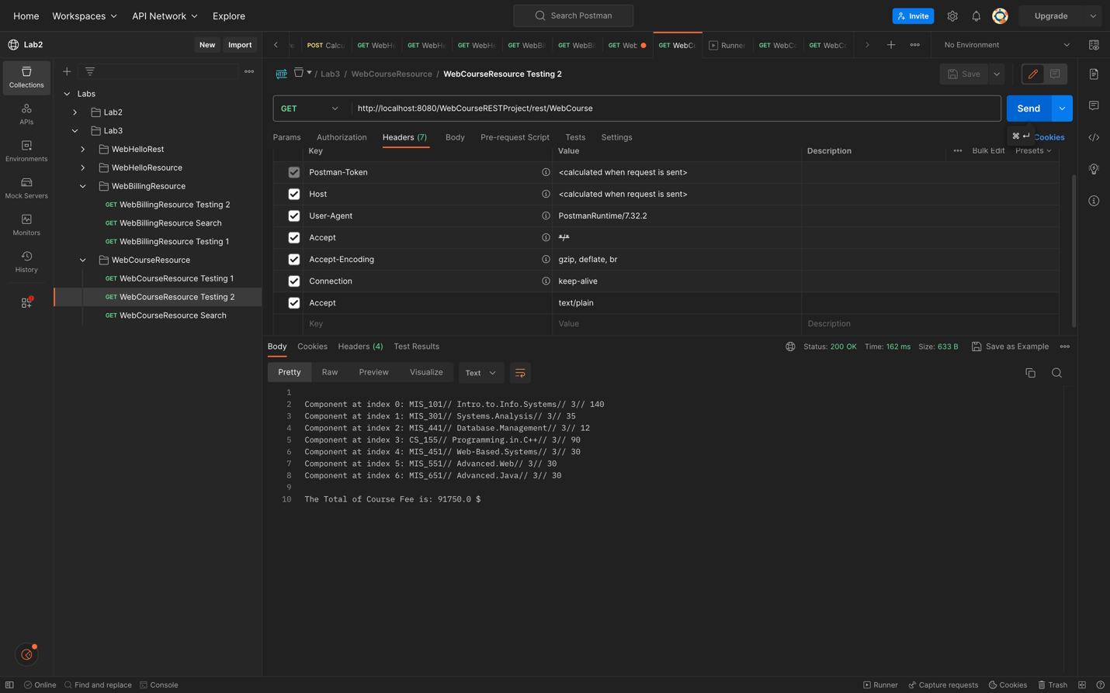

**4. Maven Dynamic Web Project: WebCarRESTProject**

