Lab 4: Jersey Client Consuming REST Web Services

**Hello Professor Samir,**

**I couldn’t compress the files, so I have attached the link in the file.  
Please find the files in the following GitHub Link in Master branch.  
Best Regards.**

<https://github.com/SamaDabagh/Lab4WebServicesSamanehDabbaghchi.git>

1. Creating Client Maven Project

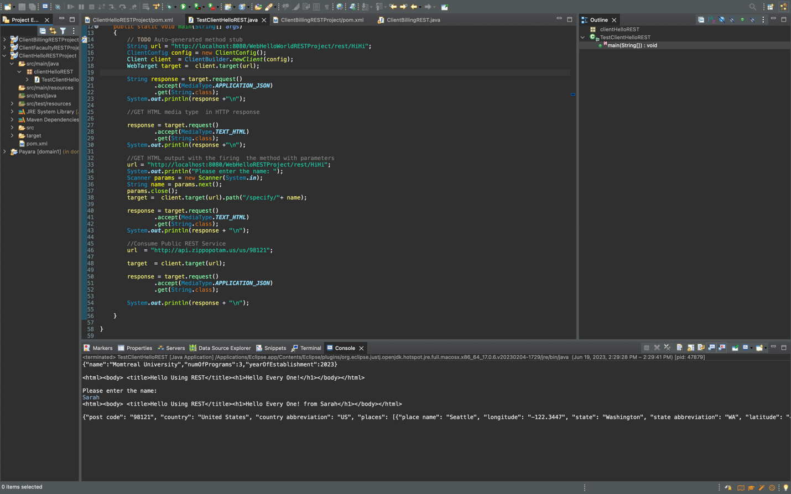

2. Maven Project: ClientBillingRESTProject

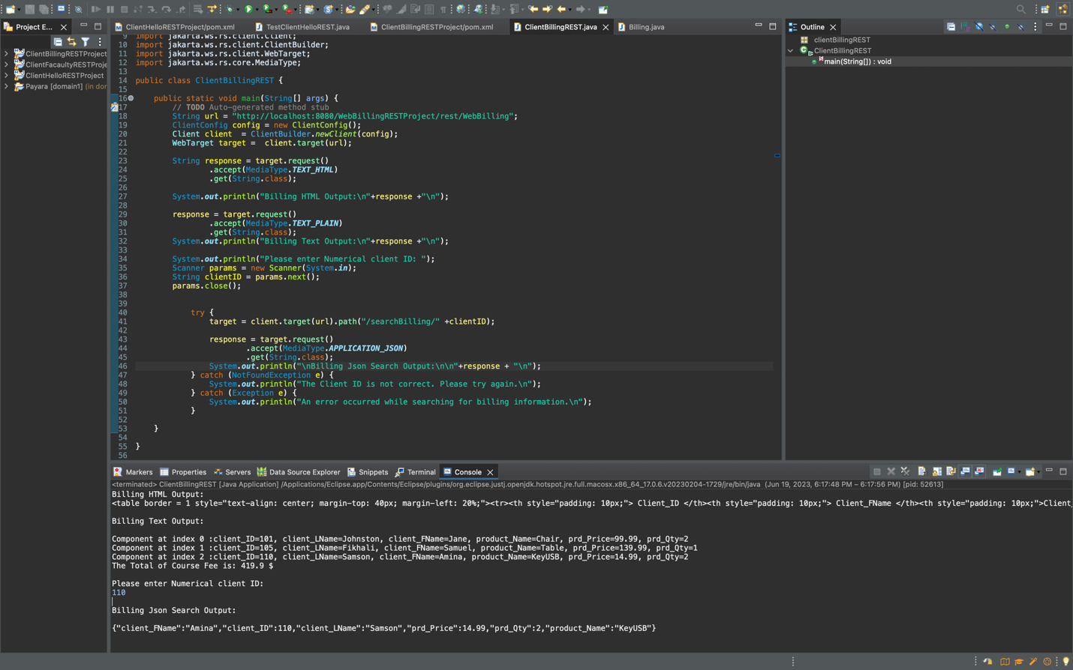

3. Maven Project: ClientCourseRESTProject

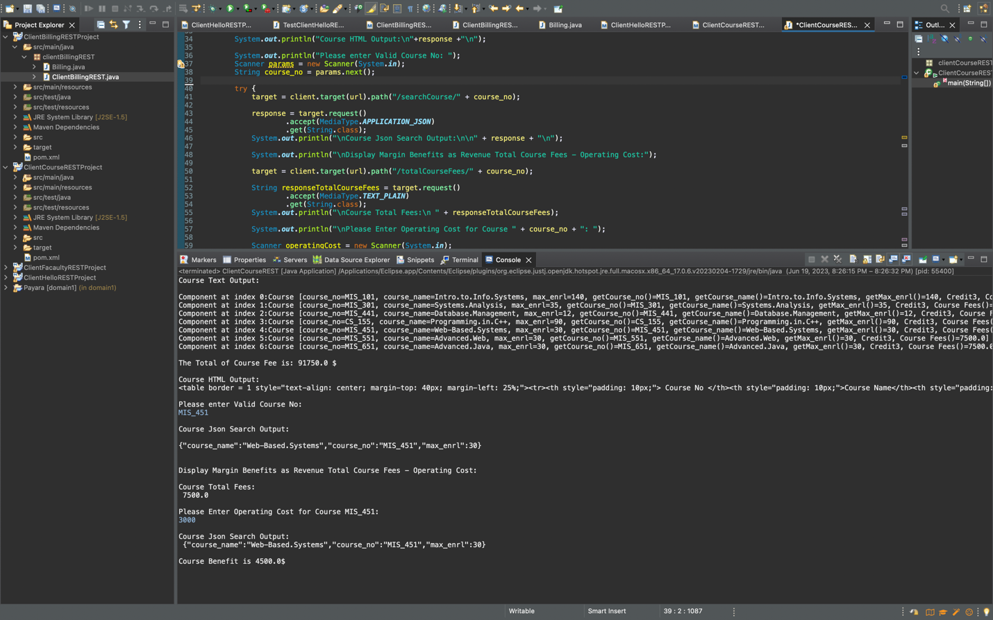

4. Maven Project: ClientCarRESTProject

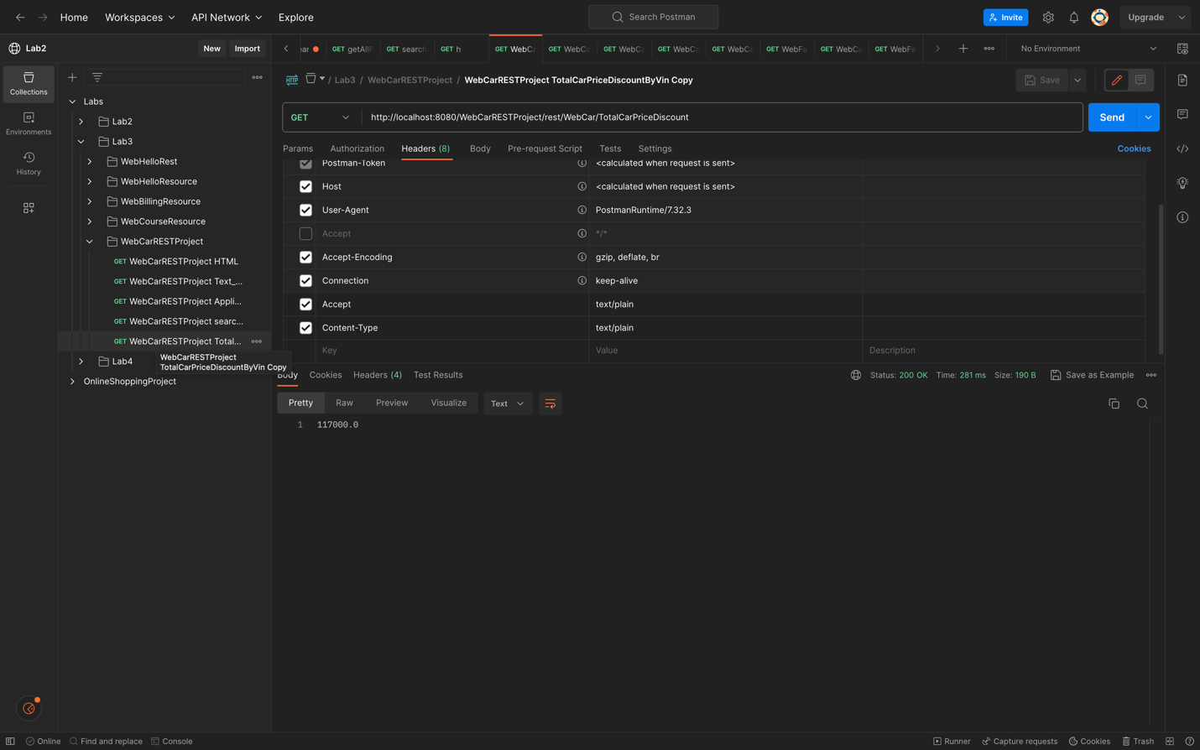

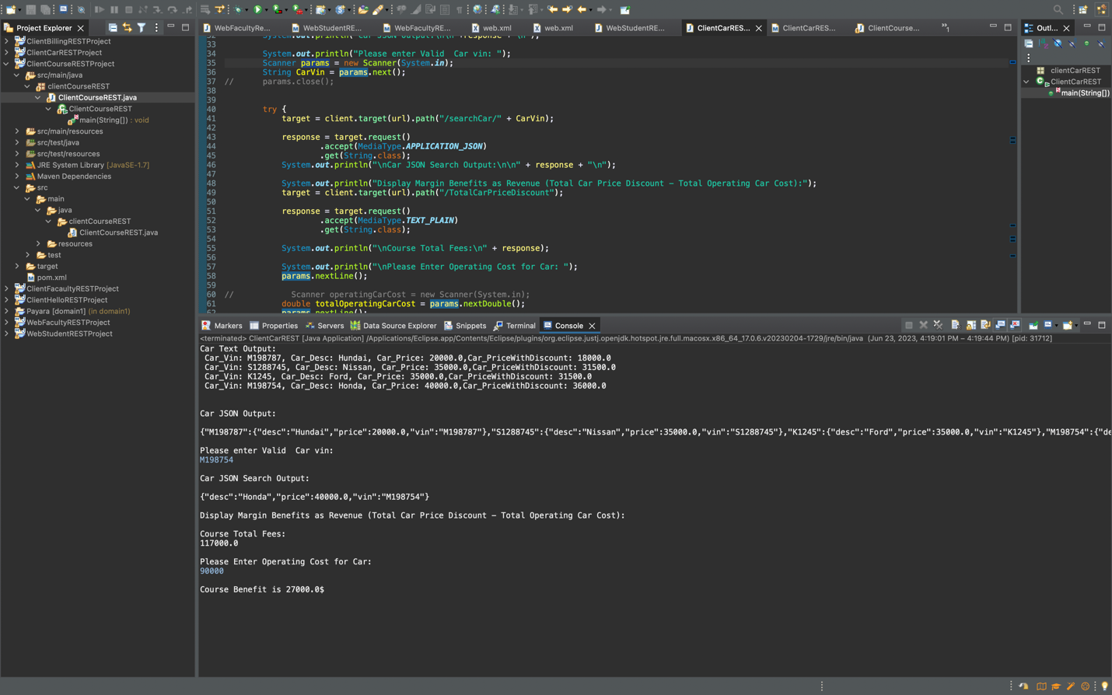

**5. Maven Dynamic Web Project: WebFacultyRESTProject**



