Lab 5: REST Web Services Using different

**Hello Professor Samir,**

**I couldn’t compress the files, so I have attached the link in the file.  
Please find the files in the following GitHub Link in Master branch.  
Best Regards.**

HTTP Methods and HTML Form Processing

<https://github.com/SamaDabagh/Lab5WebServicesSamanehDabbaghchi.git>

1. Using Parameters: Query String Parameters and Form Parameters



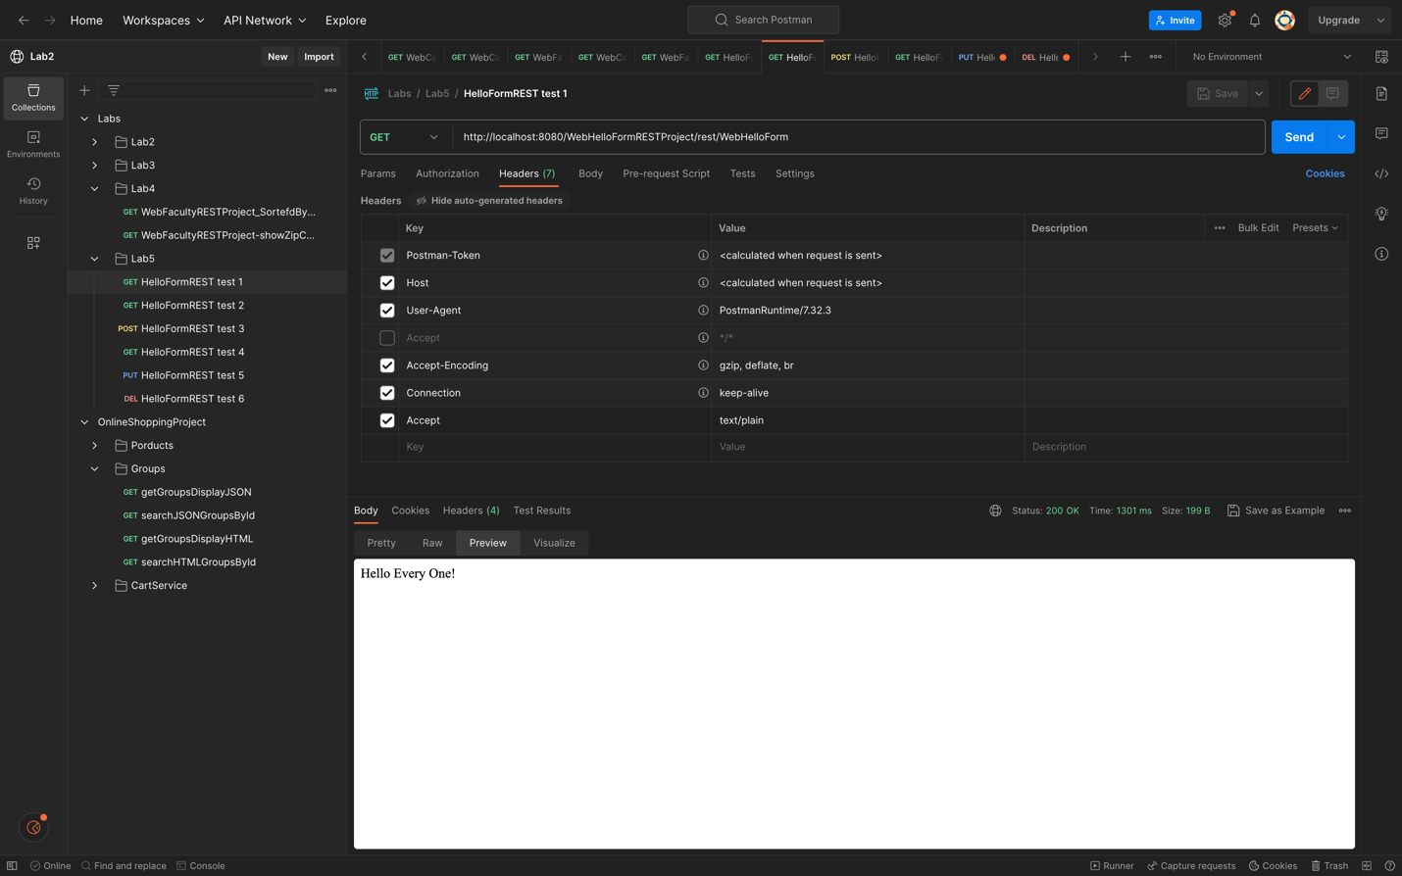

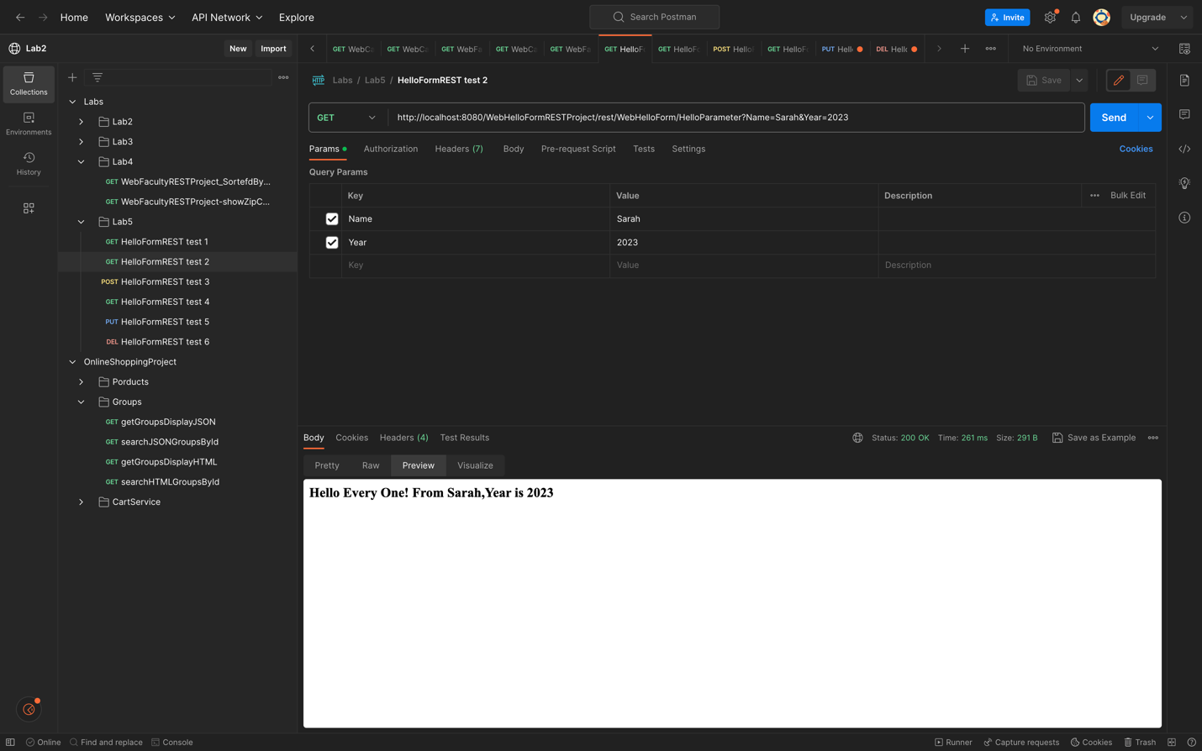

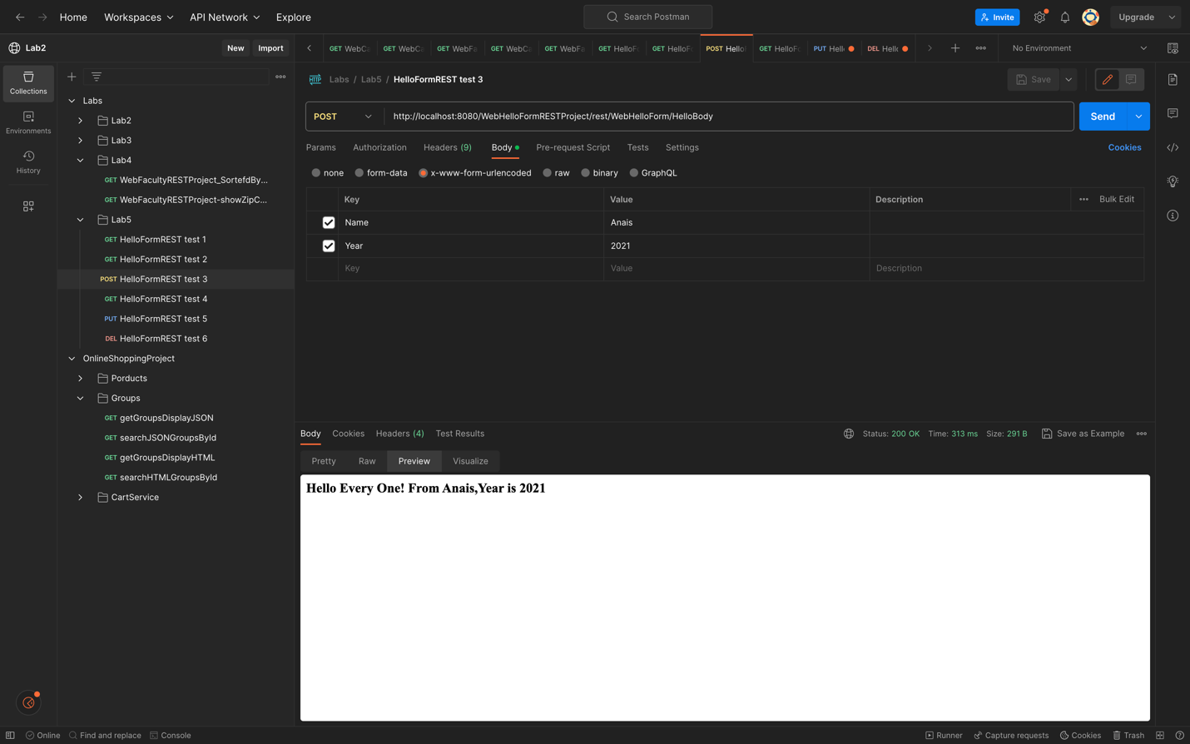

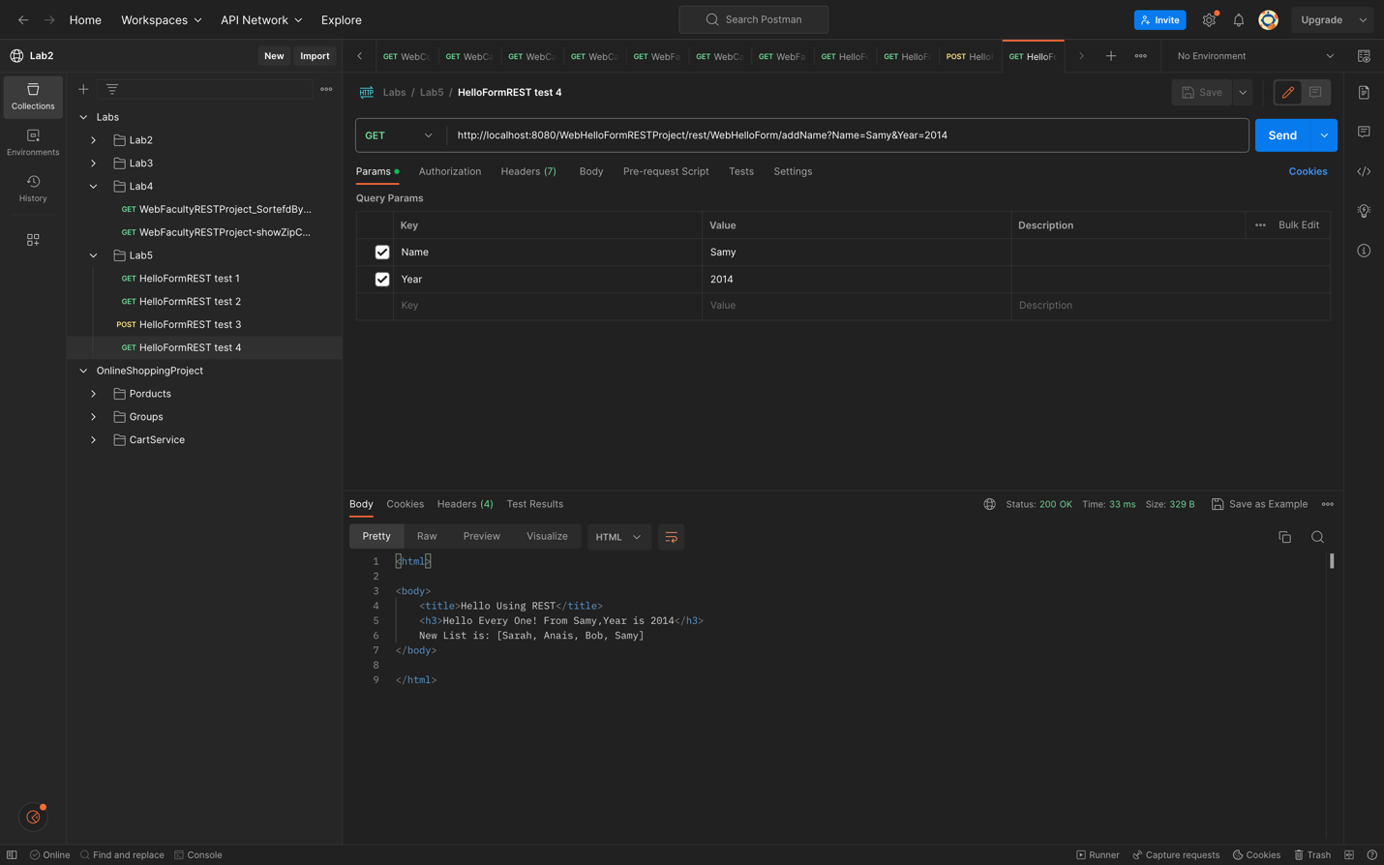

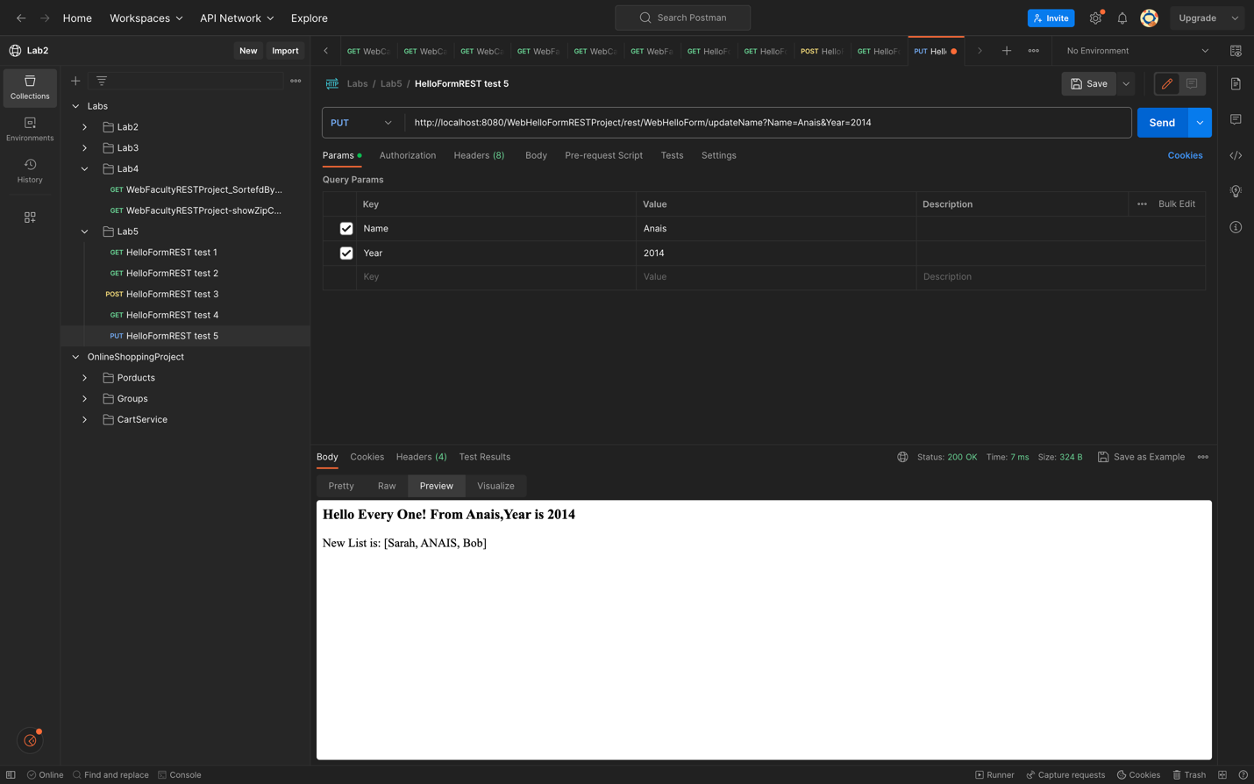

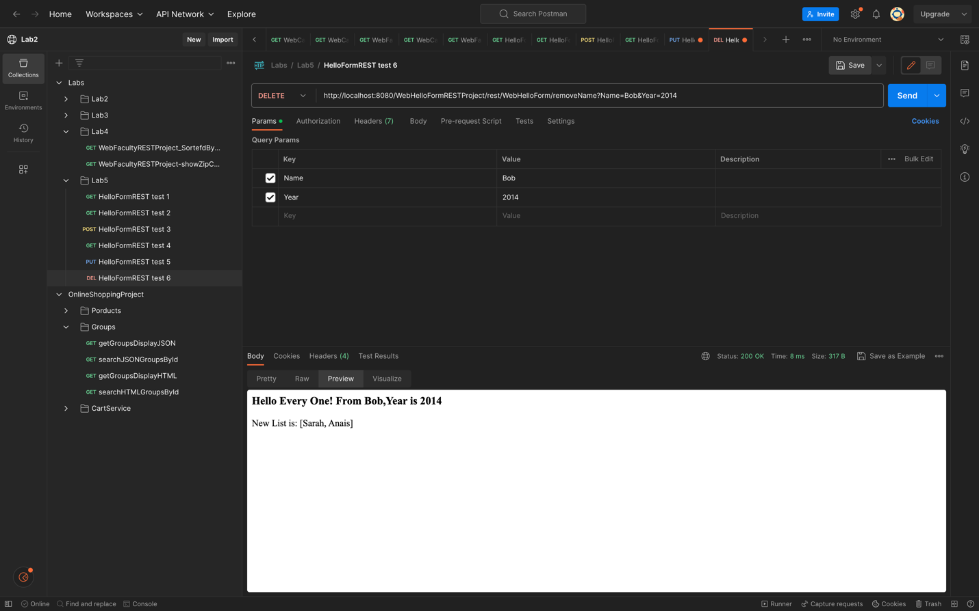

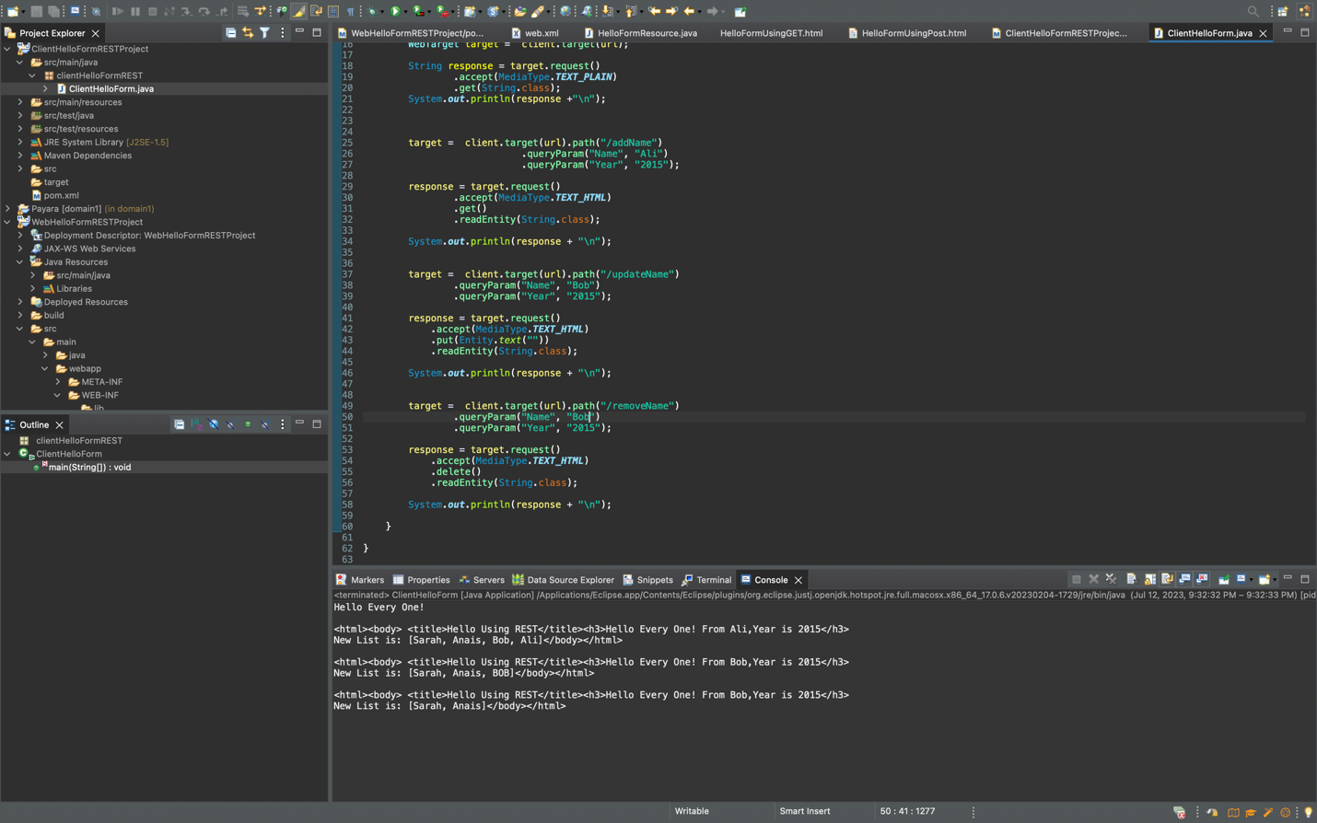

2. Complete Maven Dynamic Web Project: WebBillingRESTProject from Lab 3

