|  |
| --- |
| **Visualization**  **Report** |
|  |

|  |
| --- |
| *BIO48* |
| *Youmna Atef Abd-Elmonem*  20191701264  *Sama Medhat Farouk*  20191701106  *Nouran Ahmed Ibrahim*  20191701241 |

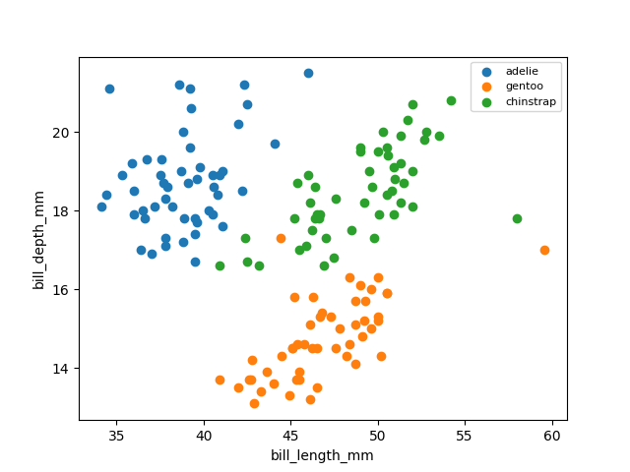f

These two features are linear separable between Adelie and gentoo, and between Adelie and chinstrap but are non-linear between gentoo and chinstrap.

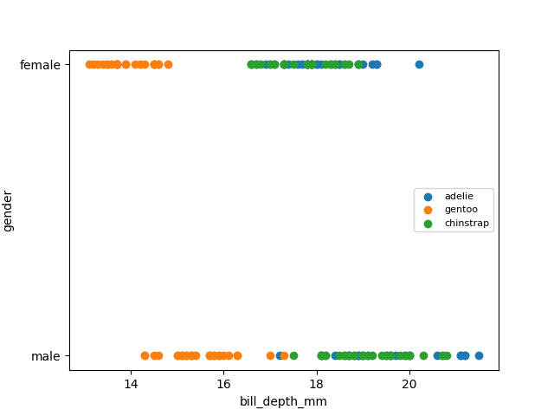

These two features are linear separable between gentoo and chinstrap but are not separable between Adelie and chinstrap and between Adelie and gentoo.

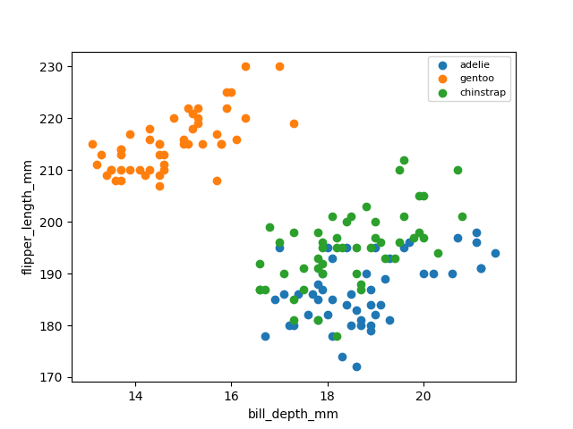j

These two features are linear separable between gentoo and Adelie and between gentoo and chinstrap but are not separable between Adelie and chinstrap.

These two features are linear separable between gentoo and Adelie and between gentoo and chinstrap but are not separable between Adelie and chinstrap

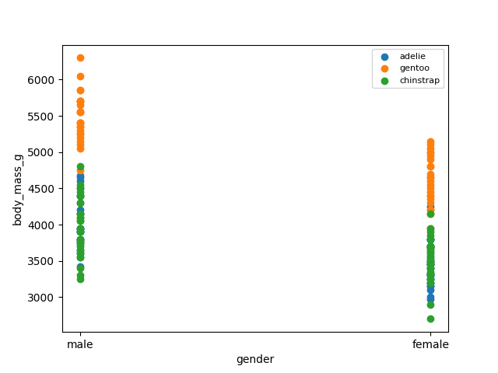

These two features are not separable between three species.

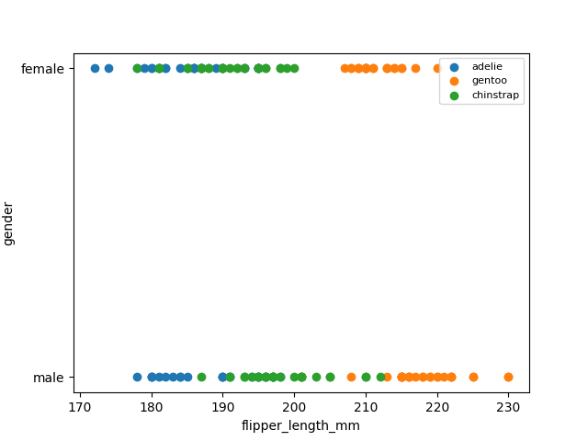

These two features are not separable between Adelie and chinstrap and between chinstrap and gentoo but are linear separable between Adelie and gentoo.

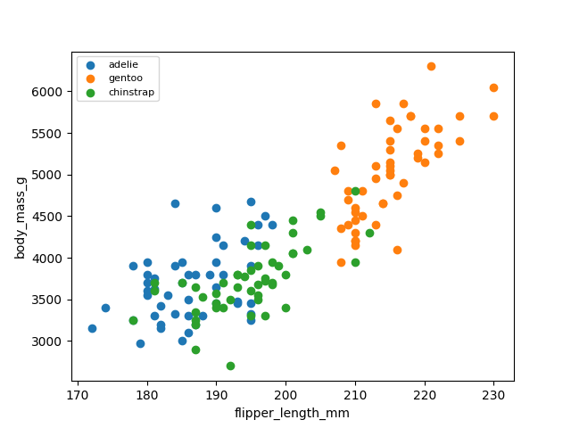

These two features are not separable between Adelie and chinstrap and between chinstrap and gentoo but are linear separable between Adelie and gentoo.

These two features are not separable between three species.

**Features got highest score:**

* bill_length_mm & bill_depth_mm
* bill_depth_mm & flipper_length_mm

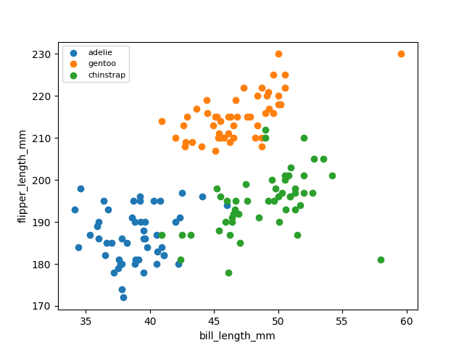

These two features are not separable between gentoo and chinstrap and between Adelie and chinstrap but are linear separable between gentoo and Adelie.

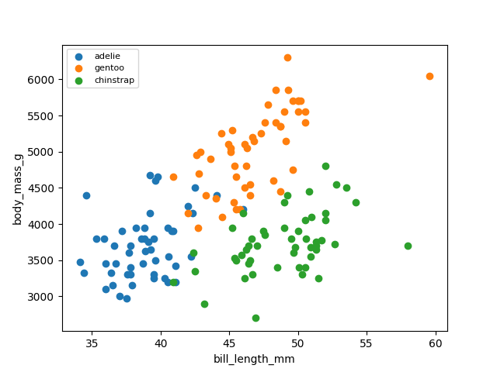

These two features are not separable between gentoo and Adelie, and between Adelie and chinstrap but are non-linear separable between gentoo and chinstrap.