NAME : SAMA MOHAMED SALAH

DATE : 9/6/2021

B.N : 21

ID : 361

APPLICATION BREIF : Notepad++ is a free (as in “free speech” and also as in “free beer”) source code

editor and Notepad replacement that supports several languages. Running in the MS Windows environment,

its use is governed by [GNU General Public License](https://www.gnu.org/licenses/old-licenses/gpl-2.0.html).

SCREENSHOTS :

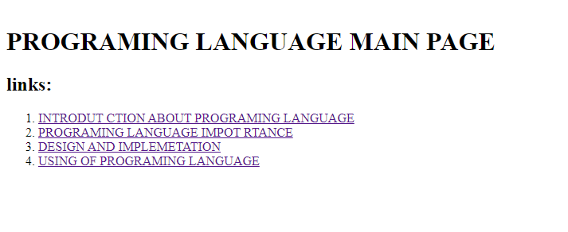

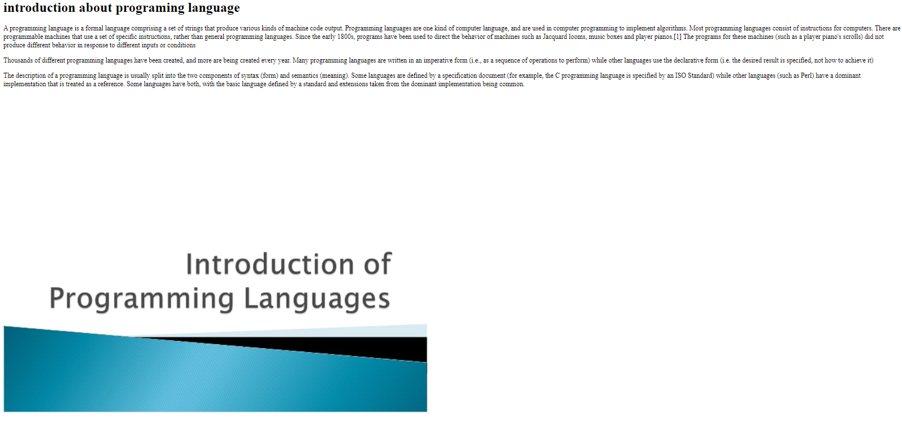

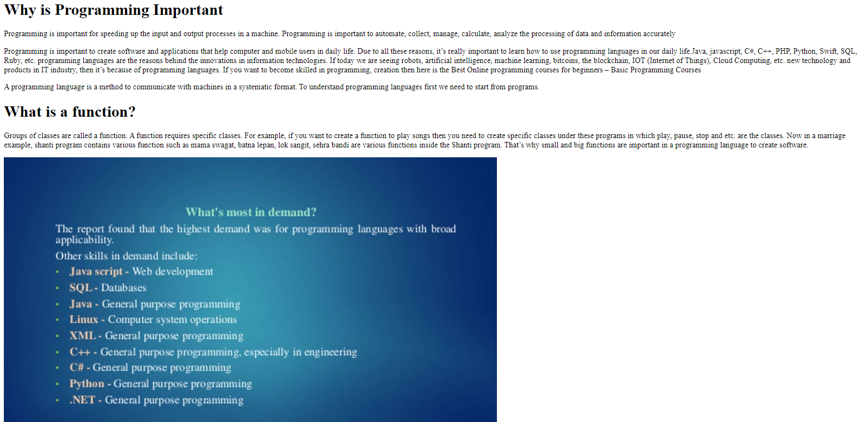

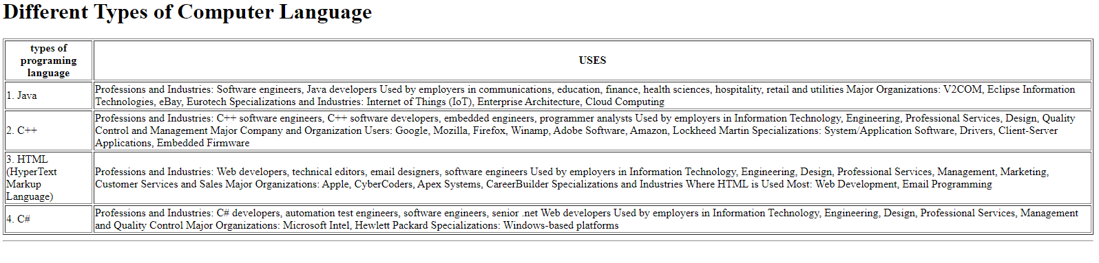

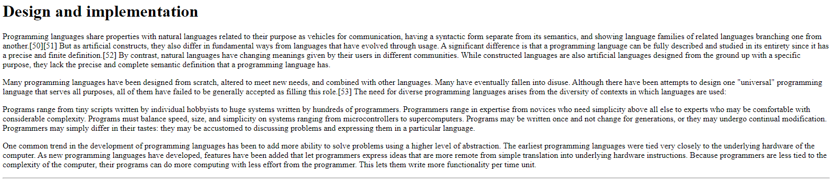

SOURCE CODE :

