**SQA Project 3**

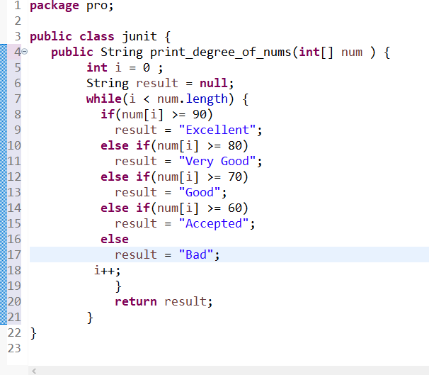**الاسم : سما عبدالله صالح نصرالله .  
الرقم الجامعي : 220201214 .**

1. **Use Junit to apply test cases to cover all code.**

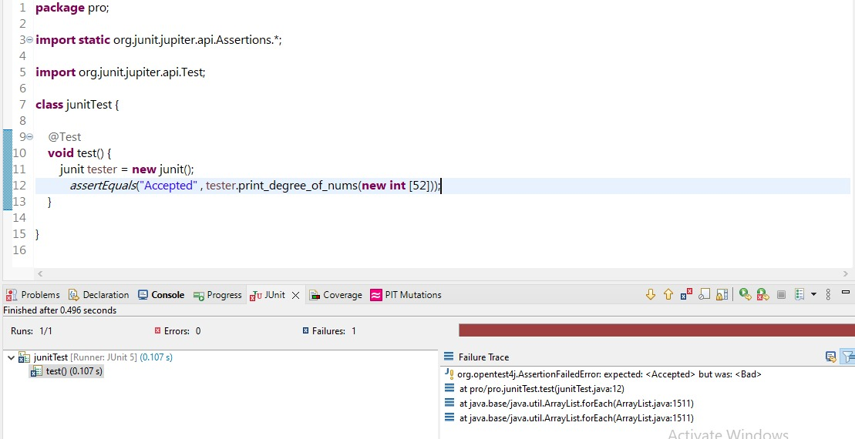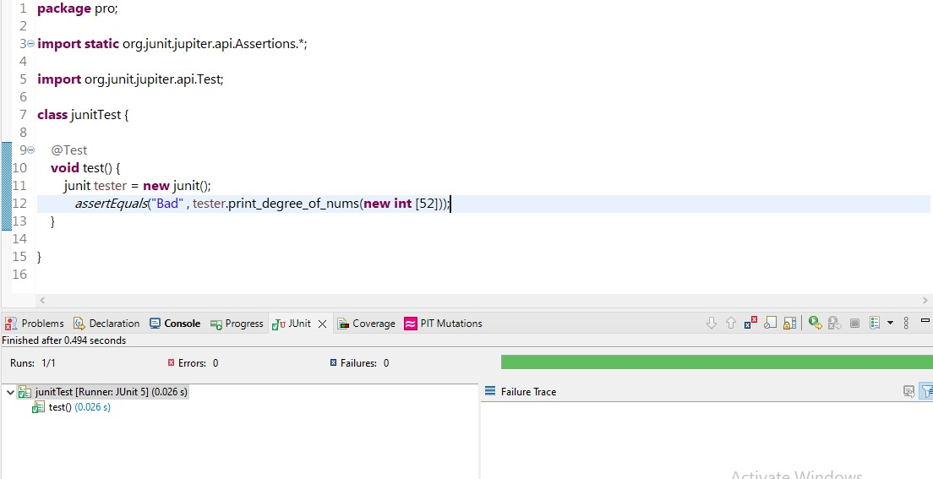**Success :   
Failure :   
2) Use code coverage to ensure that your test cases cover all code.**

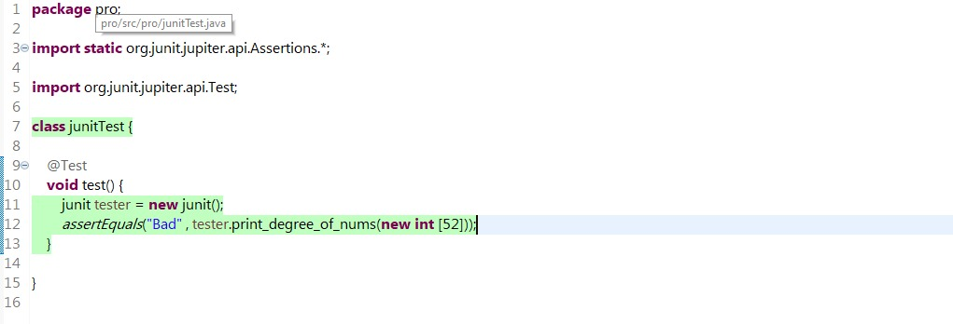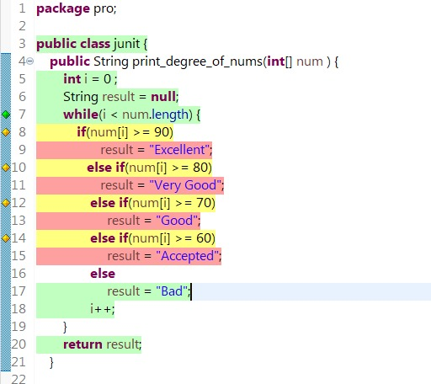



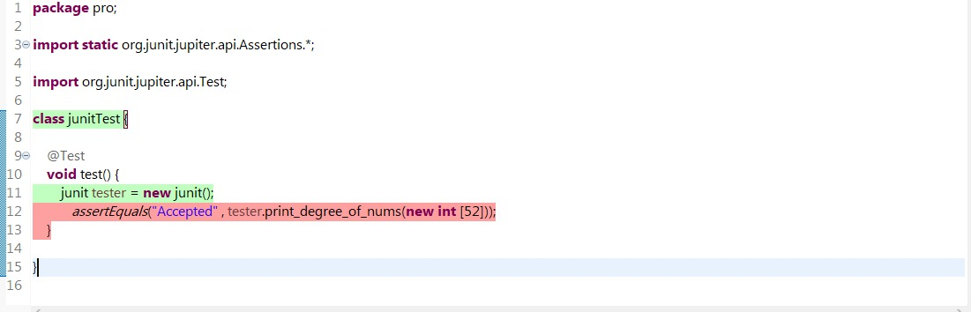



1. 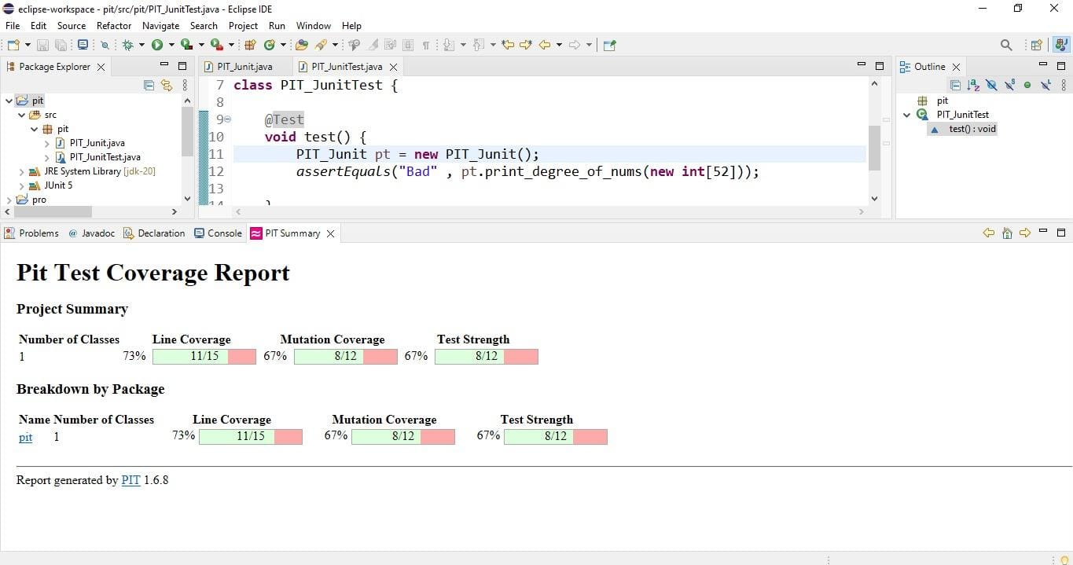**Use PIT for mutation test**