**DATA MINING LAB**

**EXP 1:- CREATE .ARFF FILE:-**

**STEPS:**

**Step1:** Open the notepad.

**Step2:** To create a table with attributes and datawrite as follows:

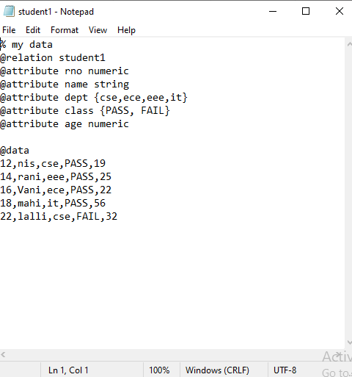

* Here relations are declared as @relation along with relation name.
* Attributes are declared as @attributes along with name and data type.
* Data are declared as @data.

**Step3:** save the file as “filename.arff” extension.

**Step 4:** Open Weka. Go to explorer -> open file -> location where .arff file saved. -> open it.

**To open a new dataset:**

**Step 1:** Select ‘C’ drive -> program files -> data -> chooses dataset.

**Step 2:** Load the file in Weka**.**