Lab 1 - Register File Implementation

Name | ID
Nour-Eldin Akram | 22011309
Samaa Ibrahim El-Hakmy | 22010820

1. Design Overview

1.1 Interface Specification
The register file entity has the following ports:

Port | Direction | Description
clk | Input | Clock signal — write on falling edge, read combinatorially
reg_write | Input | Write enable; when '1' the write operation is performed
read_reg1 [4:0] | Input | 5-bit address selecting the first register to read
read_reg2 [4:0] | Input | 5-bit address selecting the second register to read
write_reg [4:0] | Input | 5-bit address selecting the register to write into
write_data [31:0] | Input | 32-bit data to be written to the selected register
read_data1 [31:0] | Output | 32-bit data read from the register addressed by read_reg1
read_data2 [31:0] | Output | 32-bit data read from the register addressed by read_reg2

1.2 Behavioral Description
Write: data is written to the register file only on the falling edge of the clock, and only when RegWrite = '1'. If RegWrite = '0', no write occurs regardless of clock activity.

Read: data is read asynchronously at all times — read_data1 and read_data2 are continuously and combinatorially driven by the contents of the registers addressed by read_reg1 and read_reg2. No clock edge is needed to read.

This means a write that occurs on the falling edge is immediately visible on the read outputs in the same cycle — there is no need to wait for the next clock edge to observe the written value.

2. VHDL Implementation

2.1 Register File (register_file.vhd)
library ieee;
use ieee.std_logic_1164.all;
USE ieee.numeric_std.ALL;

entity register_file is
Port (
clk : in std_logic;
reg_write : in std_logic;
read_reg1 : in std_logic_vector(4 downto 0);
read_reg2 : in std_logic_vector(4 downto 0);
write_reg : in std_logic_vector(4 downto 0);
write_data: in std_logic_vector(31 downto 0);
read_data1: out std_logic_vector(31 downto 0);
read_data2: out std_logic_vector(31 downto 0)
);
end register_file;

ARCHITECTURE reg_behavior OF register_file IS

type reg_file is array(0 to 31) of std_logic_vector(31 downto 0);
SIGNAL reg: reg_file := (others => (others => '0'));
signal temp1, temp2: std_logic_vector(31 downto 0) := (others => '0');

BEGIN

process(clk)
BEGIN
if(reg_write = '1' AND falling_edge(clk)) then
reg(to_integer(unsigned(write_reg))) <= write_data;
end if;
END PROCESS;

read_data1 <= reg(to_integer(unsigned(read_reg1)));
read_data2 <= reg(to_integer(unsigned(read_reg2)));

END reg_behavior;

2.2 Testbench (tb_register_file.vhd)
library ieee;
use ieee.std_logic_1164.all;
USE ieee.numeric_std.ALL;

entity tb_register_file is
end tb_register_file;

architecture behavior of tb_register_file is
component register_file is
Port (
clk : in std_logic;
reg_write : in std_logic;
read_reg1 : in std_logic_vector(4 downto 0);
read_reg2 : in std_logic_vector(4 downto 0);
write_reg : in std_logic_vector(4 downto 0);
write_data: in std_logic_vector(31 downto 0);
read_data1: out std_logic_vector(31 downto 0);
read_data2: out std_logic_vector(31 downto 0)
);
end component;

signal clk: std_logic := '1';
signal reg_write: std_logic := '0';
signal read_reg1, read_reg2, write_reg: std_logic_vector(4 downto 0) := (others => '0');
signal write_data: std_logic_vector(31 downto 0) := (others => '0');
signal read_data1, read_data2: std_logic_vector(31 downto 0) := (others => '0');

begin
reg_test : register_file port map(
clk, reg_write, read_reg1, read_reg2,
write_reg, write_data, read_data1, read_data2
);

-- Clock process: 200 ps period (100 ps high, 100 ps low)
process
begin
while true loop
clk <= '1'; wait for 100 ps;
clk <= '0'; wait for 100 ps;
end loop;
end process;

-- Stimulus process
process
begin
reg_write <= '1';

-- CASE 1: Write R1=0x11111111, Read R1 and R0
write_reg <= "00001"; write_data <= x"11111111";
read_reg1 <= "00001"; read_reg2 <= "00000";
wait for 200 ps;
assert read_data1 = x"11111111" report "CASE1 failed: R1 read-after-write incorrect";
assert read_data2 = x"00000000" report "CASE1 failed: R0 must be zero";

-- CASE 2: Write R2=0x22222222, Read R2 and R1
write_reg <= "00010"; write_data <= x"22222222";
read_reg1 <= "00010"; read_reg2 <= "00001";
wait for 200 ps;
assert read_data1 = x"22222222" report "CASE2 failed: R2 read-after-write incorrect";
assert read_data2 = x"11111111" report "CASE2 failed: R1 should remain previous value";

-- Writing is disabled
reg_write <= '0';

-- CASE 3: Attempt write R3 (RegWrite=0, ignored)
write_reg <= "00011"; write_data <= x"33333333";
read_reg1 <= "00011"; read_reg2 <= "00010";
wait for 200 ps;
assert read_data1 = x"00000000" report "CASE3 failed: R3 must not change";
assert read_data2 = x"22222222" report "CASE3 failed: R2 must remain unchanged";

-- CASE 4: Attempt write R1 (RegWrite=0, ignored)
write_reg <= "00001"; write_data <= x"44444444";
read_reg1 <= "00001"; read_reg2 <= "00010";
wait for 200 ps;
assert read_data1 = x"11111111" report "CASE4 failed: R1 must remain unchanged";
assert read_data2 = x"22222222" report "CASE4 failed: R2 must remain unchanged";

wait;
end process;
end behavior;

3. Test Cases
The testbench exercises four distinct scenarios to verify correct functionality of the register file across different RegWrite states and register addresses.

Case | RegWrite | Operation | Expected read_data1 | Expected read_data2
1 | '1' | Write 0x11111111 to R1; Read R1, R0 | 0x11111111 (R1 written) | 0x00000000 (R0 = zero)
2 | '1' | Write 0x22222222 to R2; Read R2, R1 | 0x22222222 (R2 written) | 0x11111111 (R1 retained)
3 | '0' | Attempt write 0x33333333 to R3; Read R3, R2 | 0x00000000 (write ignored) | 0x22222222 (R2 retained)
4 | '0' | Attempt write 0x44444444 to R1; Read R1, R2 | 0x11111111 (write ignored) | 0x22222222 (R2 retained)

4. Simulation Results
The following waveform was captured from ModelSim after compiling and simulating the VHDL design. The simulation runs for 800 ps, covering all four test cases. The waveform confirms that the register file correctly writes data on the falling clock edge when RegWrite is asserted, reads data combinatorially, and ignores write operations when RegWrite is deasserted.

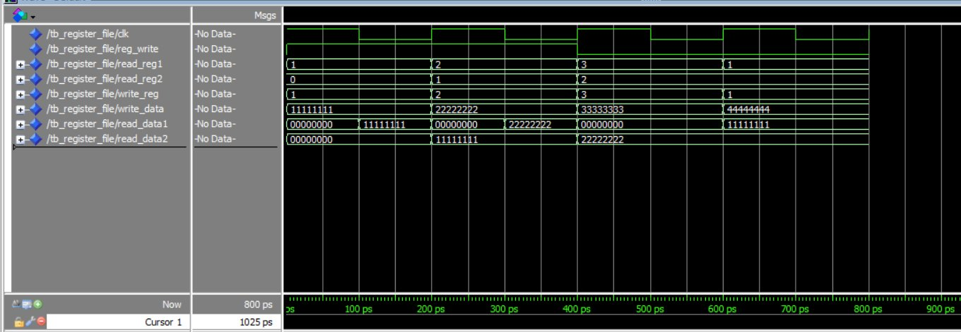
Figure 1: ModelSim Waveform — Register File Simulation (0–800 ps)

4.1 Waveform Analysis
The waveform confirms the following observations:

Case 1 (0–200 ps): reg_write='1', write_reg=1, write_data=0x11111111. After the falling edge at 100 ps, R1 is updated. read_data1 reflects 0x11111111 and read_data2 shows 0x00000000 (R0 remains zero).

Case 2 (200–400 ps): reg_write='1', write_reg=2, write_data=0x22222222. R2 is written; read_data1 shows 0x22222222 and read_data2 correctly retains 0x11111111 from R1.

Case 3 (400–600 ps): reg_write='0'. Despite write_data=0x33333333 being presented on the input, R3 is not modified. read_data1 returns 0x00000000 confirming the write is blocked.

Case 4 (600–800 ps): reg_write='0'. Attempting to overwrite R1 with 0x44444444 is similarly blocked. read_data1 continues to return 0x11111111, validating the RegWrite guard.

Source Code: https://gist.github.com/SamaaIbrahim/63a12ea9cb965a3f83f56520739efa5d

