
FOUNDER’S DAY TECHNO CULTURAL FEST PROJECT EXPO 2026
(27th & 28th Aug 2026)

KEC Models - Project Expo
Project Title:  Environment Waste Management System  Team Members:  22ISR017- Kiruthikbairavan C  22ISR036 - Ragavi T  22ISR026 - Mohamed Athik R  22ISR046 - Shandeep S 22ISR051 - Subiksha P.R Mentor/ Co-mentor:  Ms. S. Deepa AP(SrG)/EIE  Abstract: (Max 200 Words)  EASE is an AI-powered mobile application that redefines waste management through intelligent sorting, user engagement, and rewardbased incentives. Using image recognition technology, the application allows users to scan and appropriately sort waste, thereby channeling them to the appropriate disposal channels. It has encouraged an environmentally friendly behaviour. The app offers instant access to local recycling centers, offers direct waste reporting, and encourages sustainability through gamification and multilingual interfaces. The app is intended for residential, office, academic, and municipal stakeholders to act as a bridge between citizens and governments in the quest for a cleaner and greener world. The app is projected to attain national adoption, thus making community waste disposal an effortless experience.  Cost: Rs.50,000 | Output/Geo-Tagged Project Photograph:  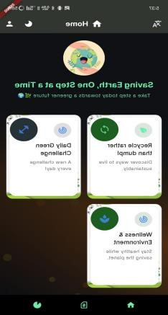
Project Title:  Environment Waste Management System  Team Members:  22ISR017- Kiruthikbairavan C  22ISR036 - Ragavi T  22ISR026 - Mohamed Athik R  22ISR046 - Shandeep S 22ISR051 - Subiksha P.R Mentor/ Co-mentor:  Ms. S. Deepa  Abstract: (Max 200 Words)  EASE is an AI-powered mobile application that redefines waste management through intelligent sorting, user engagement, and rewardbased incentives. Using image recognition technology, the application allows users to scan and appropriately sort waste, thereby channeling them to the appropriate disposal channels. It has encouraged an environmentally friendly behaviour. The app offers instant access to local recycling centers, offers direct waste reporting, and encourages sustainability through gamification and multilingual interfaces. The app is intended for residential, office, academic, and municipal stakeholders to act as a bridge between citizens and governments in the quest for a cleaner and greener world. The app is projected to attain national adoption, thus making community waste disposal an effortless experience.  Cost: Rs.50,000 |   Output/Geo-Tagged Project Photograph:

Founder’s Day Techno cultural Fest-2026- EIE Models-Abstracts Page 1


FOUNDER’S DAY TECHNO CULTURAL FEST PROJECT EXPO 2026
(27th & 28th Aug 2026)
KEC Models - Project Expo

Founder’s Day Techno cultural Fest-2026- EIE Models-Abstracts Page 2

