Module | Lack Of Understanding | Newly Develop
POS | Barcode Scanner (Incomplete )
Inventory | Internal Transfers, Manufacturing
CRM | OK
HRM | http://3.8.61.121:8069/jobs our all jobs post company wise not showing
Attendance | OK
Time OFF | Pending (Access Errors)
Roster | Server Not Update

Time OFF

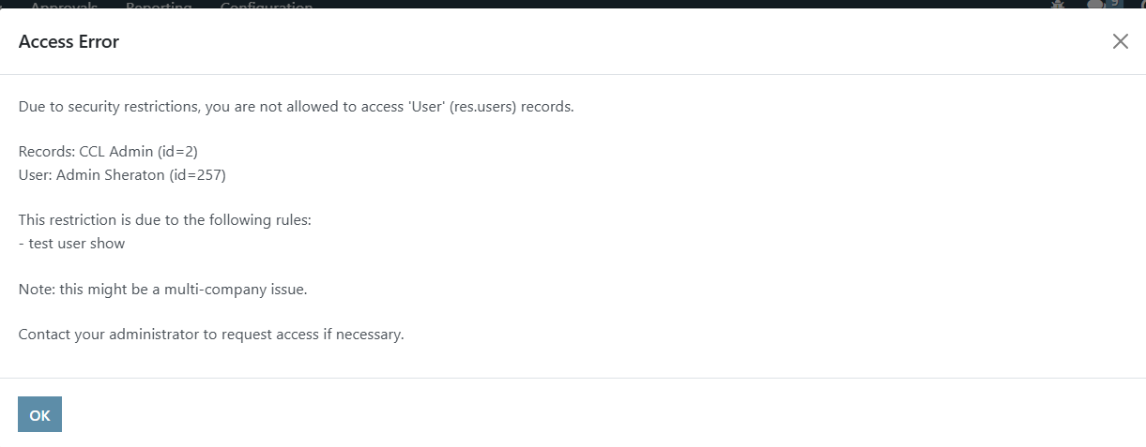

Roster
