**DEP INTERN**

**Task 2**

* **Introduction:**

My website is a portfolio website where I have used Three.JS for the animation and React for the user Interface. The Website portrays my skills and expertise and portrays my previous work for the client to get the idea of cliché of my work.

* **Initial Analysis:**

The initial work for my Project gives me the performance of 34% which is quite low due to my separate JavaScript handling and complex 3d features my website workload is quite heavy.

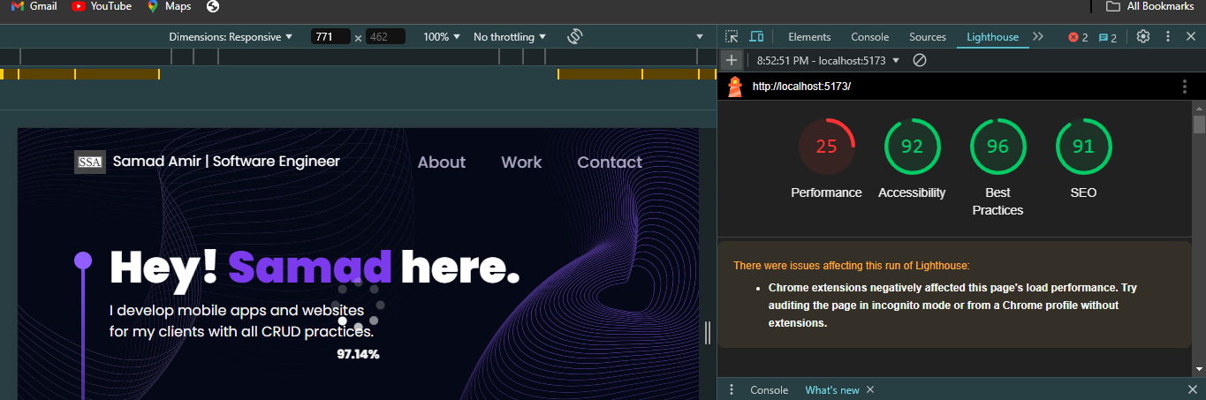

* **Optimization Steps:**

For the Optimization I embedded my CSS code with JavaScript code making use of DOM for the maximum level to make sure my number of files and the number code will be minimum so my project can run with ease.

* **Final Analysis:**

With the changes I made my website now performs better than the last one and give better performance to due to less workload I can further enhance it by removing 3d models.

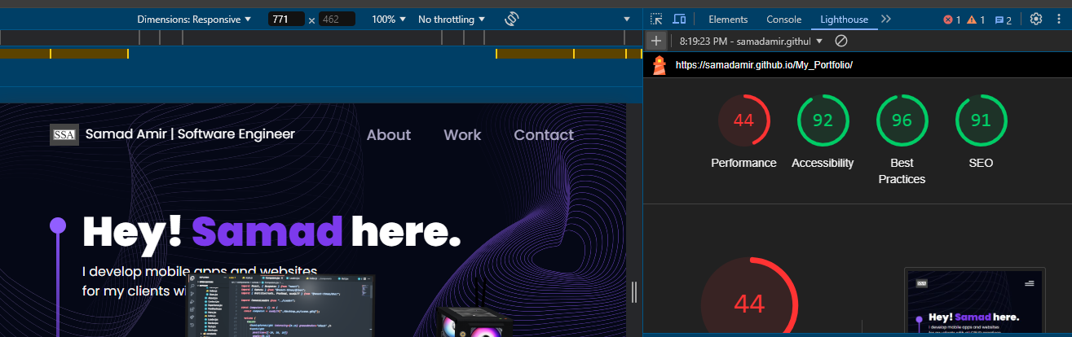

* **Conclusion:**

For the website to work more efficient with better performance the developer should use efficient ways to build a website like using less redered pictures or using DOM to effectively implement the CSS with JavaScript.