**Samad Amir**

**21k-3873**

**BSE-6A**

**Instructions to run:**

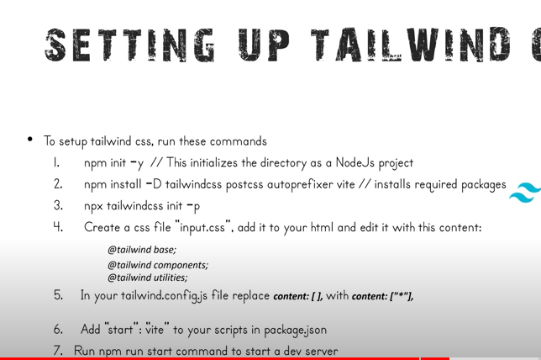

**Task01:**

**Code:**

<!DOCTYPE html>

<html lang="en">

<head>

    <meta charset="UTF-8">

    <meta name="viewport" content="width=device-width, initial-scale=1.0">

    <link rel="stylesheet" href="input.css">

    <title>www.SamadAmir.com</title>

</head>

<body>

    <div class="bg-cyan-400 text-white h-24">

        <div class="mx-5 py-5">

        <h1 class="text-4xl font-bold">Welcome to my Teal Website</h1>

        <p >Explore our content in a fresh teal theme</p>

    </div>

    <div class="flex justify-center items-center">

        <button type="button" class="text-white bg-blue-700 hover:bg-blue-800 focus:ring-4 focus:ring-blue-300 font-medium rounded-lg text-sm px-5 py-2.5 me-2 mb-2 dark:bg-blue-600 dark:hover:bg-blue-700 focus:outline-none dark:focus:ring-blue-800 ">Click me!</button>

    </div>

    <div class="bg-pink-500 h-16 py-2 px-5 bg-gradient-to-br from-pink-500 to-purple-600">

        <p class="text-4xl">Gradient text</p>

    </div>

    <div class="flex text-black p-5">

        <h1 class="font-serif text-4xl w-80">Heading in serif font</h1>

        <h3 class="text-2xl font-sans w-64 mx-5">Body text in sans-Serif font</h3>

        <p class="text font-mono mx-10 w-56">Code snippet in monospace font</p>

    </div>

    <div class="text-black px-5 py-5">

        <p class="font-bold text-xl">Text is larger and semi-bold</p>

        <p>Text is base size</p>

        <p class="text-xs">Text is smaller and light</p>

    </div>

    <div class="mx-auto flex justify-center text-black">

        <h1 class="text-4xl">Heading size adjust responsively</h1>

    </div>

</div>

</body>

</html>

**Output:**

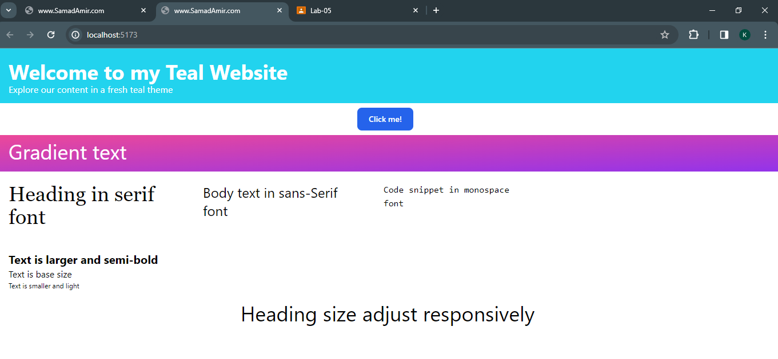

**Task02:**

**Code:**

<!DOCTYPE html>

<html lang="en">

<head>

    <meta charset="UTF-8">

    <meta name="viewport" content="width=device-width, initial-scale=1.0">

    <title>www.SamadAmir.com</title>

    <link href="input.css" rel="stylesheet">

    <style>

        @media (max-width: 768px) {

            .hidden-mobile {

                display: none;

            }

        }

    </style>

</head>

<body class="bg-gray-100 text-gray-800">

    <div class="container mx-auto p-4">

        <div class="max-w-md mx-auto bg-white rounded-lg shadow-lg p-6 transition duration-500 ease-in-out transform hover:scale-105">

            <h2 class="text-2xl mb-4 text-center">Registration Form</h2>

            <form>

                <div class="mb-4">

                    <label for="name" class="block text-gray-700">Name:</label>

                    <input type="text" id="name" name="name" class="form-input border focus:border-red-500 w-full py-2 px-3">

                </div>

                <div class="mb-4">

                    <label for="email" class="block text-gray-700">Email:</label>

                    <input type="email" id="email" name="email" class="form-input border focus:border-red-500 w-full py-2 px-3">

                </div>

                <div class="mb-4">

                    <label for="password" class="block text-gray-700">Password:</label>

                    <input type="password" id="password" name="password" class="form-input border focus:border-red-500 w-full py-2 px-3">

                </div>

                <div class="mb-6">

                    <button type="submit" class="btn bg-black text-white hover:bg-green-600 hover:text-white py-2 px-4 rounded">Register</button>

                </div>

            </form>

        </div>

    </div>

</body>

</html>

**Output:**

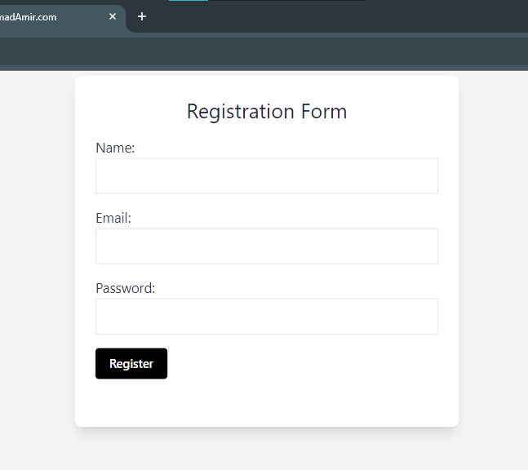

**Task3:**

**Code:**

<!DOCTYPE html>

<html lang="en">

<head>

    <meta charset="UTF-8">

    <meta name="viewport" content="width=device-width, initial-scale=1.0">

    <title>www.SamadAmir.com</title>

    <link href="input.css" rel="stylesheet">

</head>

<body class="bg-gray-100">

    <div class="container mx-auto p-8">

        <table class="bg-white shadow-lg rounded-lg overflow-hidden">

            <thead class="bg-gray-200 text-gray-700">

                <tr>

                    <th class="py-2 px-4 w-20">Product</th>

                    <th class="py-2 w-52 px-4">Description</th>

                    <th class="py-2 px-4 text-center">Price</th>

                    <th class="py-2 px-4">Stock</th>

                    <th class="py-2 px-4"></th>

                </tr>

            </thead>

            <tbody class="text-gray-700">

                <tr>

                    <td class="py-4 px-4">T-shirt</td>

                    <td class="py-4 px-4">Comfortable and stylish t-shirts in various colors</td>

                    <td class="py-4 px-4 justify-center text-green-500">$19.99</td>

                    <td class="py-4 px-4">25</td>

                    <td><button type="button" class="text-white rounded-lg bg-gradient-to-r from-blue-500 via-blue-600 to-blue-700 hover:bg-gradient-to-br text-sm px-5 py-2.5 text-center w-24">Add to Cart</button></td>

                </tr>

                <tr>

                    <td class="py-4 px-4">Hoodie</td>

                    <td class="py-4 px-4">Warm and cozy hoodie for cool weather</td>

                    <td class="py-4 px-4  justify-center text-green-500">$39.99</td>

                    <td class="py-4 px-4">10</td>

                    <td><button type="button" class="text-white rounded-lg bg-gradient-to-r from-blue-500 via-blue-600 to-blue-700 hover:bg-gradient-to-br text-sm px-5 py-2.5 text-center w-24">Add to Cart</button></td>

                </tr>

            </tbody>

        </table>

    </div>

</body>

</html>

**Output:**

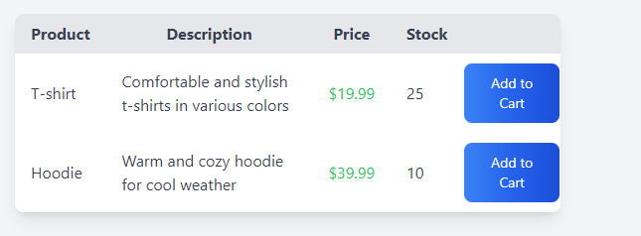

**Task4:**

**Code:**

<!DOCTYPE html>

<html lang="en">

<head>

    <meta charset="UTF-8">

    <meta name="viewport" content="width=device-width, initial-scale=1.0">

    <title>www.SamadAmir.com</title>

    <link href="input.css" rel="stylesheet">

</head>

<body class="bg-gray-100">

    <div class="container mx-auto p-8">

        <h1 class="text-3xl font-bold mb-4">Sample Webpage</h1>

        <h2 class="text-xl font-bold mb-2">Colorful Unordered List:</h2>

        <ul class="list-disc">

            <li class="text-red-500">Red</li>

            <li class="text-teal-500">Teal</li>

            <li class="text-purple-500">Purple</li>

        </ul>

        <hr class="my-6">

        <h2 class="text-xl font-bold mb-2">Numbered Ordered List:</h2>

        <ol class="list-decimal list-inside">

            <li>Item 1</li>

            <li>Item 2</li>

            <li>Item 3</li>

        </ol>

        <hr class="my-6">

        <h2 class="text-xl font-bold mb-2">Indented Nested Lists:</h2>

        <ul>

            <li>Item 1

                <ul class="ml-4">

                    <li>Subitem 1</li>

                    <li>Subitem 2</li>

                </ul>

            </li>

            <li>Item 2</li>

        </ul>

        <hr class="my-6">

        <h2 class="text-xl font-bold mb-2">Iconic Description List:</h2>

        <dl>

            <dt class="text-blue-500">Term 1</dt>

            <dd>Description 1</dd>

            <dt class="text-green-500">Term 2</dt>

            <dd>Description 2</dd>

            <dt class="text-yellow-500">Term 3</dt>

            <dd>Description 3</dd>

        </dl>

        <hr class="my-6">

        <h2 class="text-xl font-bold mb-2">Horizontal List with Spacing:</h2>

        <div class="flex">

            <a href="#" class="mr-4 bg-blue-500 text-white px-4 py-2 rounded">Link 1</a>

            <a href="#" class="mr-4 bg-green-500 text-white px-4 py-2 rounded">Link 2</a>

            <a href="#" class="mr-4 bg-yellow-500 text-white px-4 py-2 rounded">Link 3</a>

        </div>

    </div>

</body>

</html>

**Output:**

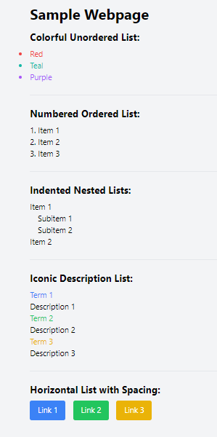

**Task05:**

**Code:**

<!DOCTYPE html>

<html lang="en">

<head>

    <meta charset="UTF-8">

    <meta name="viewport" content="width=device-width, initial-scale=1.0">

    <title>www.SamadAmir.com</title>

    <link href="input.css" rel="stylesheet">

    <style>

        .zoom-container {

            overflow: hidden;

            position: relative;

        }

        .zoom-image {

            transition: transform 0.2s;

        }

        .zoom-image:hover {

            transform: scale(1.1);

        }

    </style>

</head>

<body class="bg-gray-100">

    <div class="container mx-auto p-8">

        <h2 class="text-2xl font-bold mb-4">Responsive Image Gallery</h2>

        <div class="grid grid-cols-1 sm:grid-cols-2 md:grid-cols-3 gap-4">

            <div class="bg-gray-200 h-48 sm:h-64 md:h-80 rounded-lg overflow-hidden">

                <img src="https://source.unsplash.com/random/400x400?sig=1" alt="Image 1" class="w-full h-full object-cover">

            </div>

            <div class="bg-gray-200 h-48 sm:h-64 md:h-80 rounded-lg overflow-hidden">

                <img src="https://source.unsplash.com/random/400x400?sig=2" alt="Image 2" class="w-full h-full object-cover">

            </div>

            <div class="bg-gray-200 h-48 sm:h-64 md:h-80 rounded-lg overflow-hidden">

                <img src="https://source.unsplash.com/random/400x400?sig=3" alt="Image 3" class="w-full h-full object-cover">

            </div>

        </div>

        <hr class="my-8">

        <h2 class="text-2xl font-bold mb-4">Product Image with Zoom on Hover</h2>

        <div class="zoom-container">

            <img src="https://source.unsplash.com/random/400x400?sig=4" alt="Product Image" class="zoom-image transition duration-200 hover:scale-110">

        </div>

    </div>

</body>

</html>

**Output:**

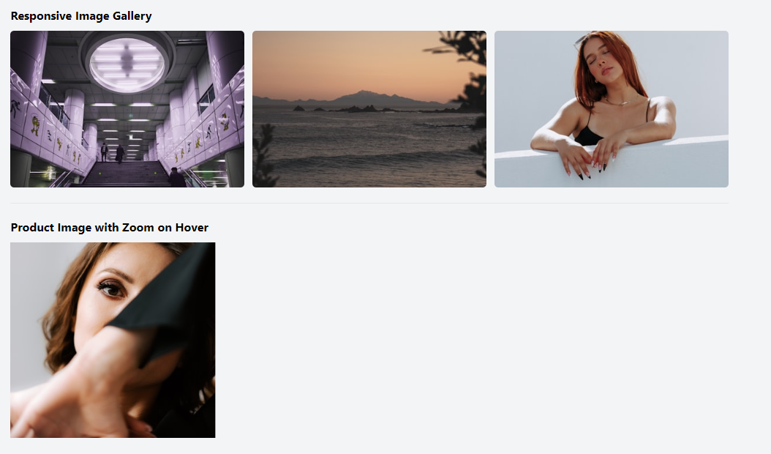

**Task06:**

**Code:**

<!DOCTYPE html>

<html lang="en">

<head>

    <meta charset="UTF-8">

    <meta name="viewport" content="width=device-width, initial-scale=1.0">

    <title>www.SamadAmir.com</title>

    <link href="https://cdn.jsdelivr.net/npm/tailwindcss@2.2.19/dist/tailwind.min.css" rel="stylesheet">

    <style>

        @media (min-width: 0px) and (max-width: 332px) {

            .image-1 {

                display: block;

            }

            .image-2,

            .image-3,

            .image-4,

            .image-5,

            .image-6 {

                display: none;

            }

        }

        @media (min-width: 333px) and (max-width: 632px) {

            .image-2 {

                display: block;

            }

            .image-1,

            .image-3,

            .image-4,

            .image-5,

            .image-6 {

                display: none;

            }

        }

        @media (min-width: 633px) and (max-width: 832px) {

            .image-3 {

                display: block;

            }

            .image-1,

            .image-2,

            .image-4,

            .image-5,

            .image-6 {

                display: none;

            }

        }

        @media (min-width: 833px) and (max-width: 1032px) {

            .image-4 {

                display: block;

            }

            .image-1,

            .image-2,

            .image-3,

            .image-5,

            .image-6 {

                display: none;

            }

        }

        @media (min-width: 1033px) and (max-width: 1232px) {

            .image-5 {

                display: block;

            }

            .image-1,

            .image-2,

            .image-3,

            .image-4,

            .image-6 {

                display: none;

            }

        }

        @media (min-width: 1233px) and (max-width: 1432px) {

            .image-6 {

                display: block;

            }

            .image-1,

            .image-2,

            .image-3,

            .image-4,

            .image-5 {

                display: none;

            }

        }

    </style>

</head>

<body class="bg-gray-100">

    <div class="container mx-auto p-8">

        <h2 class="text-2xl font-bold mb-4">Responsive Image Grid</h2>

        <div class="grid grid-cols-1 sm:grid-cols-2 md:grid-cols-3 lg:grid-cols-4 xl:grid-cols-5 gap-4">

            <div class="image-1">

                <img src="https://source.unsplash.com/random/400x400?sig=1" alt="Image 1" class="w-full h-auto">

            </div>

            <div class="image-2">

                <img src="https://source.unsplash.com/random/400x400?sig=2" alt="Image 2" class="w-full h-auto">

            </div>

            <div class="image-3">

                <img src="https://source.unsplash.com/random/400x400?sig=3" alt="Image 3" class="w-full h-auto">

            </div>

            <div class="image-4">

                <img src="https://source.unsplash.com/random/400x400?sig=4" alt="Image 4" class="w-full h-auto">

            </div>

            <div class="image-5">

                <img src="https://source.unsplash.com/random/400x400?sig=5" alt="Image 5" class="w-full h-auto">

            </div>

            <div class="image-6">

                <img src="https://source.unsplash.com/random/400x400?sig=6" alt="Image 6" class="w-full h-auto">

            </div>

        </div>

    </div>

</body>

</html>

**Output:**

**Images on different Dimensions:**

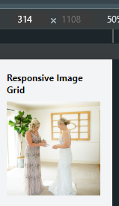 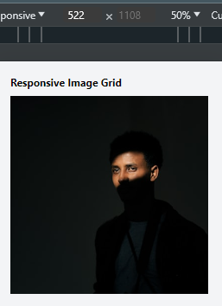 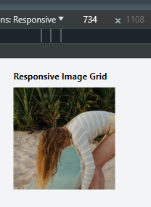

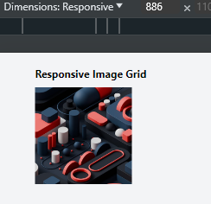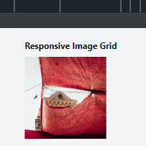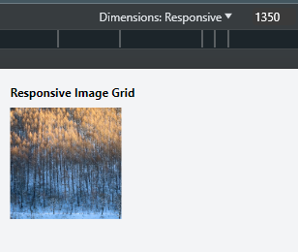

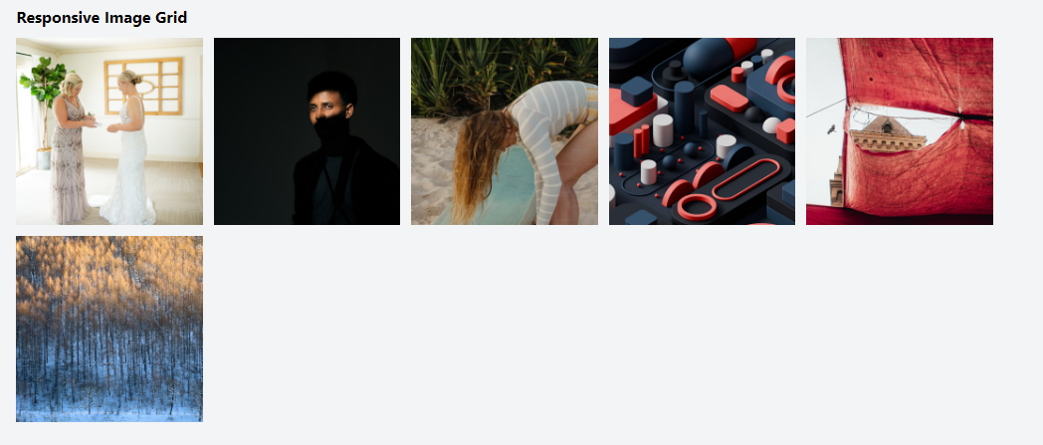

**Task07:**

**Code:**

<!DOCTYPE html>

<html lang="en">

<head>

    <meta charset="UTF-8">

    <meta name="viewport" content="width=device-width, initial-scale=1.0">

    <title>www.SamadAmir.com</title>

    <link href="input.css" rel="stylesheet">

</head>

<body class="bg-gray-100">

    <div class="container mx-auto p-8">

        <div class="grid grid-cols-1 lg:grid-cols-3 gap-4">

            <div class="lg:col-span-2 bg-slate-600 rounded-lg p-6 sm:bg-white sm:text-black text-white">

                <h2 class="text-2xl font-bold mb-4">Form</h2>

                <form>

                    <div class="mb-4">

                        <label for="name" class="block text-sm font-semibold mb-1">Name</label>

                        <input type="text" id="name" name="name" class="w-full px-4 py-2 border rounded-lg focus:border-blue-500 focus:outline-none">

                    </div>

                    <div class="mb-4">

                        <label for="email" class="block text-sm font-semibold mb-1">Email</label>

                        <input type="email" id="email" name="email" class="w-full px-4 py-2 border rounded-lg focus:border-blue-500 focus:outline-none">

                    </div>

                    <button type="submit" class="bg-blue-500 text-white px-4 py-2 rounded-lg hover:bg-blue-600">Submit</button>

                </form>

            </div>

            <div class="lg:col-span-1 bg-slate-600 rounded-lg p-6 sm:bg-white sm:text-black text-white">

                <h2 class="text-2xl font-bold mb-4">Table</h2>

                <table class="w-full">

                    <thead>

                        <tr>

                            <th class="px-4 py-2">Column 1</th>

                            <th class="px-4 py-2">Column 2</th>

                        </tr>

                    </thead>

                    <tbody>

                        <tr>

                            <td class="px-4 py-2">Data 1</td>

                            <td class="px-4 py-2">Data 2</td>

                        </tr>

                    </tbody>

                </table>

            </div>

        </div>

    </div>

</body>

</html>

**Output:**

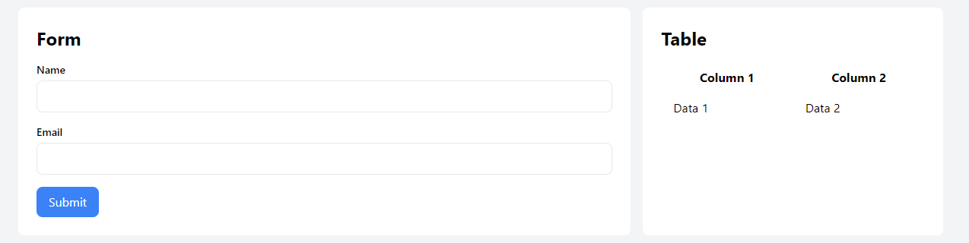

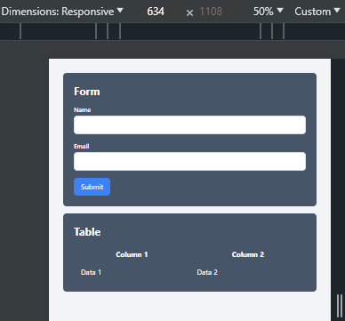

**Task08:**

**Code:**

<!DOCTYPE html>

<html lang="en">

<head>

    <meta charset="UTF-8">

    <meta name="viewport" content="width=device-width, initial-scale=1.0">

    <link rel="stylesheet" href="input.css">

    <title>www.SamadAmir.com</title>

</head>

<body class="bg-slate-200">

    <div class="container my-10 md:px-6 relative rounded-2xl">

        <section class="mb-16 text-center">

          <div class="grid gap-x-6 md:grid-cols-3 lg:gap-x-12">

            <div class="mb-8 md:mb-0">

              <div class="bg-white rounded-lg shadow-md p-4">

                <div class="mb-4 flex justify-center">

                  <img src="https://mdbcdn.b-cdn.net/img/Photos/Avatars/img%20(1).jpg"

                    class="w-24 rounded-full shadow-lg dark:shadow-black/20" />

                </div>

                <h5 class="mb-2 text-lg font-bold">Courtney Henry</h5>

                <h6 class="mb-2 font-medium text-primary dark:text-primary-400">

                  Microsoft Corp

                </h6>

                <p class="mb-4 text-sm">

                  Lorem ipsum dolor sit amet, consectetur adipisicing elit. Quod eos

                  id officiis hic tenetur quae quaerat ad velit ab hic.

                </p>

                <ul class="mb-0 flex justify-center">

                  <li><svg xmlns="http://www.w3.org/2000/svg" viewBox="0 96 960 960" class="w-4 text-warning"><path fill="bg-orange-600" d="m233 976 65-281L80 506l288-25 112-265 112 265 288 25-218 189 65 281-247-149-247 149Z"/></svg></li>

                  <li><svg xmlns="http://www.w3.org/2000/svg" viewBox="0 96 960 960" class="w-4 text-warning"><path fill="bg-orange-600" d="m233 976 65-281L80 506l288-25 112-265 112 265 288 25-218 189 65 281-247-149-247 149Z"/></svg></li>

                  <li><svg xmlns="http://www.w3.org/2000/svg" viewBox="0 96 960 960" class="w-4 text-warning"><path fill="bg-orange-600" d="m233 976 65-281L80 506l288-25 112-265 112 265 288 25-218 189 65 281-247-149-247 149Z"/></svg></li>

                  <li><svg xmlns="http://www.w3.org/2000/svg" viewBox="0 96 960 960" class="w-4 text-warning"><path fill="bg-orange-600" d="m233 976 65-281L80 506l288-25 112-265 112 265 288 25-218 189 65 281-247-149-247 149Z"/></svg></li>

                </ul>

              </div>

            </div>

            <div class="mb-8 md:mb-0">

              <div class="bg-white rounded-lg shadow-md p-4">

                <div class="mb-4 flex justify-center">

                  <img src="https://mdbcdn.b-cdn.net/img/Photos/Avatars/img%20(2).jpg"

                    class="w-24 rounded-full shadow-lg dark:shadow-black/20" />

                </div>

                <h5 class="mb-2 text-lg font-bold">Ronald Richards</h5>

                <h6 class="mb-2 font-medium text-primary dark:text-primary-400">

                  Meta Limited

                </h6>

                <p class="mb-4 text-sm">

                  Ut enim ad minima veniam, quis nostrum exercitationem ullam

                  corporis suscipit laboriosam, nisi ut aliquid commodi.

                </p>

                <ul class="mb-0 flex justify-center">

                  <li><svg xmlns="http://www.w3.org/2000/svg" viewBox="0 96 960 960" class="w-4 text-warning"><path fill="bg-orange-600" d="m233 976 65-281L80 506l288-25 112-265 112 265 288 25-218 189 65 281-247-149-247 149Z"/></svg></li>

                  <li><svg xmlns="http://www.w3.org/2000/svg" viewBox="0 96 960 960" class="w-4 text-warning"><path fill="bg-orange-600" d="m233 976 65-281L80 506l288-25 112-265 112 265 288 25-218 189 65 281-247-149-247 149Z"/></svg></li>

                  <li><svg xmlns="http://www.w3.org/2000/svg" viewBox="0 96 960 960" class="w-4 text-warning"><path fill="bg-orange-600" d="m233 976 65-281L80 506l288-25 112-265 112 265 288 25-218 189 65 281-247-149-247 149Z"/></svg></li>

                  <li><svg xmlns="http://www.w3.org/2000/svg" viewBox="0 96 960 960" class="w-4 text-warning"><path fill="bg-orange-600" d="m233 976 65-281L80 506l288-25 112-265 112 265 288 25-218 189 65 281-247-149-247 149Z"/></svg></li>

                </ul>

              </div>

            </div>

            <div class="mb-0">

              <div class="bg-white rounded-lg shadow-md p-4">

                <div class="mb-4 flex justify-center">

                  <img src="https://mdbcdn.b-cdn.net/img/Photos/Avatars/img%20(9).jpg"

                    class="w-24 rounded-full shadow-lg dark:shadow-black/20" />

                </div>

                <h5 class="mb-2 text-lg font-bold">Bessie Cooper</h5>

                <h6 class="mb-2 font-medium text-primary dark:text-primary-400">

                  Apple Inc. Ltd

                </h6>

                <p class="mb-4 text-sm">

                  At vero eos et accusamus et iusto odio dignissimos ducimus qui

                  blanditiis praesentium voluptatum deleniti atque.

                </p>

                <ul class="mb-0 flex justify-center">

                  <li><svg xmlns="http://www.w3.org/2000/svg" viewBox="0 96 960 960" class="w-4 text-warning"><path fill="bg-orange-600" d="m233 976 65-281L80 506l288-25 112-265 112 265 288 25-218 189 65 281-247-149-247 149Z"/></svg></li>

                  <li><svg xmlns="http://www.w3.org/2000/svg" viewBox="0 96 960 960" class="w-4 text-warning"><path fill="bg-orange-600" d="m233 976 65-281L80 506l288-25 112-265 112 265 288 25-218 189 65 281-247-149-247 149Z"/></svg></li>

                  <li><svg xmlns="http://www.w3.org/2000/svg" viewBox="0 96 960 960" class="w-4 text-warning"><path fill="bg-orange-600" d="m233 976 65-281L80 506l288-25 112-265 112 265 288 25-218 189 65 281-247-149-247 149Z"/></svg></li>

                  <li><svg xmlns="http://www.w3.org/2000/svg" viewBox="0 96 960 960" class="w-4 text-warning"><path fill="bg-orange-600" d="m233 976 65-281L80 506l288-25 112-265 112 265 288 25-218 189 65 281-247-149-247 149Z"/></svg></li>

                </ul>

              </div>

            </div>

          </div>

        </section>

        <div class="flex justify-center space-x-2">

          <span class="inline-block w-4 h-4 border border-black rounded-full bg-orange-600"></span>

          <span class="inline-block w-4 h-4 border border-black rounded-full"></span>

          <span class="inline-block w-4 h-4 border border-black rounded-full"></span>

        </div>

      </div>

      <div class="h-80 bg-gradient-to-br from-pink-600 to-orange-600 text-white flex rounded-2xl mx-5">

        <div class="m-14 py-8 px-8 space-y-6">

            <h1 class="w-72 text-4xl">Helping teams in the world with focus</h1>

            <button type="button" class="bg-white text-black rounded-lg w-48">Download the Theme</button>

        </div>

        <div class="m-14 py-8 px-8 space-y-6">

            <p>Lorem, ipsum dolor sit amet consectetur adipisicing elit. Rerum consectetur deleniti, cum voluptatem doloribus ducimus accusamus possimus, perspiciatis sed sit molestiae tempora laudantium voluptate at ullam explicabo voluptates aperiam voluptatum?</p>

        </div>

    </div>

</body>

</html>

**Output:**

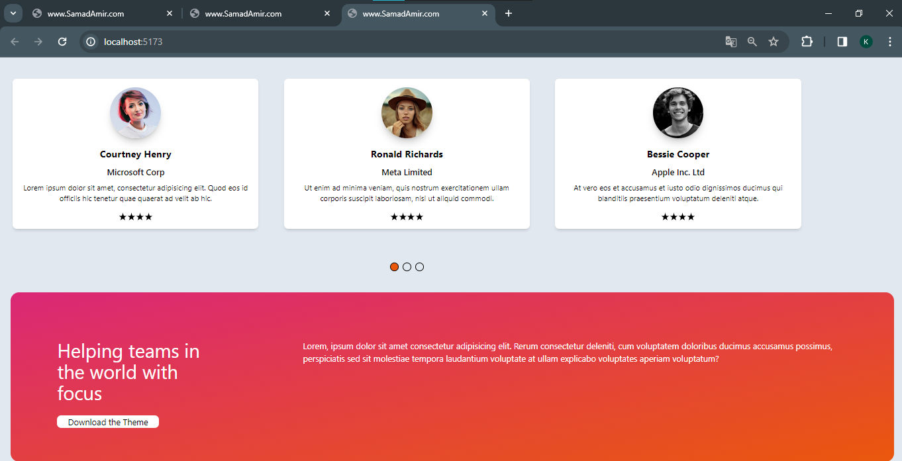

**Task09:**

**Code:**

<!DOCTYPE html>

<html lang="en">

<head>

  <meta charset="UTF-8">

  <meta name="viewport" content="width=device-width, initial-scale=1.0">

  <link rel = "stylesheet" href="input.css">

  <title>www.SamadAmir.com</title>

</head>

<body>

  <table class="m-5 space-x-5 space-y-5">

    <tr class="m-10">

      <td class="w-1/2">

        <div class="max-w-sm w-full lg:max-w-full lg:flex">

          <img src="https://source.unsplash.com/random/250x250?sig=1" alt="Slide 1" class="h-full w-auto lg:w-30">

          <div class="border border-gray-400 bg-white rounded-b lg:rounded-b-none lg:rounded-r p-4 flex flex-col justify-between leading-normal">

            <div class="mb-8">

              <span class="text-xs font-semibold inline-block py-1 px-2 uppercase rounded text-red-600 bg-red-200 uppercase last:mr-0 mr-1">

                Development

              </span>

              <h2 class="text-gray-900 font-bold text-xl mb-2">The Ultimate Guide To Google My Business</h2>

              <p class="text-gray-700 text-base">Lorem ipsum dolor sit amet, consectetur adipisicing elit. Voluptatibus quia, nulla! Maiores et perferendis eaque, exercitationem praesentium nihil.</p>

            </div>

            <div class="flex items-center space-x-2">

              <svg xmlns="http://www.w3.org/2000/svg" viewBox="0 0 448 512" width="20" height="20">

                <!--!Font Awesome Free 6.5.1 by @fontawesome - https://fontawesome.com License - https://fontawesome.com/license/free Copyright 2024 Fonticons, Inc.-->

                <path d="M152 24c0-13.3-10.7-24-24-24s-24 10.7-24 24V64H64C28.7 64 0 92.7 0 128v16 48V448c0 35.3 28.7 64 64 64H384c35.3 0 64-28.7 64-64V192 144 128c0-35.3-28.7-64-64-64H344V24c0-13.3-10.7-24-24-24s-24 10.7-24 24V64H152V24zM48 192H400V448c0 8.8-7.2 16-16 16H64c-8.8 0-16-7.2-16-16V192z"/>

              </svg>

              <p class="text-gray-900 leading-none">21st Sep 2020</p>

              <svg width="24" height="24" xmlns="http://www.w3.org/2000/svg" width="20" height="20" fill-rule="evenodd" clip-rule="evenodd"><path d="M12 0c6.623 0 12 5.377 12 12s-5.377 12-12 12-12-5.377-12-12 5.377-12 12-12zm0 1c6.071 0 11 4.929 11 11s-4.929 11-11 11-11-4.929-11-11 4.929-11 11-11zm0 11h6v1h-7v-9h1v8z"/></svg>

              <p class="text-gray-600">0 min to read</p>

            </div>

          </div>

        </div>

      </td>

      <td>

        <div class="max-w-sm w-full lg:max-w-full lg:flex">

          <img src="https://source.unsplash.com/random/250x250?sig=2" alt="Slide 1" class="h-full w-auto lg:w-30">

          <div class="border border-gray-400 bg-white rounded-b lg:rounded-b-none lg:rounded-r p-4 flex flex-col justify-between leading-normal">

            <div class="mb-8">

              <span class="text-xs font-semibold inline-block py-1 px-2 uppercase rounded text-red-600 bg-red-200 uppercase last:mr-0 mr-1">

                Development

              </span>

              <h2 class="text-gray-900 font-bold text-xl mb-2">The Ultimate Guide To Redirects Explained</h2>

              <p class="text-gray-700 text-base">Lorem ipsum dolor sit amet, consectetur adipisicing elit. Voluptatibus quia, nulla! Maiores et perferendis eaque, exercitationem praesentium nihil.</p>

            </div>

            <div class="flex items-center space-x-2">

              <svg xmlns="http://www.w3.org/2000/svg" viewBox="0 0 448 512" width="20" height="20">

                <!--!Font Awesome Free 6.5.1 by @fontawesome - https://fontawesome.com License - https://fontawesome.com/license/free Copyright 2024 Fonticons, Inc.-->

                <path d="M152 24c0-13.3-10.7-24-24-24s-24 10.7-24 24V64H64C28.7 64 0 92.7 0 128v16 48V448c0 35.3 28.7 64 64 64H384c35.3 0 64-28.7 64-64V192 144 128c0-35.3-28.7-64-64-64H344V24c0-13.3-10.7-24-24-24s-24 10.7-24 24V64H152V24zM48 192H400V448c0 8.8-7.2 16-16 16H64c-8.8 0-16-7.2-16-16V192z"/>

              </svg>

              <p class="text-gray-900 leading-none">21st Sep 2020</p>

              <svg width="24" height="24" xmlns="http://www.w3.org/2000/svg" width="20" height="20" fill-rule="evenodd" clip-rule="evenodd"><path d="M12 0c6.623 0 12 5.377 12 12s-5.377 12-12 12-12-5.377-12-12 5.377-12 12-12zm0 1c6.071 0 11 4.929 11 11s-4.929 11-11 11-11-4.929-11-11 4.929-11 11-11zm0 11h6v1h-7v-9h1v8z"/></svg>

              <p class="text-gray-600">0 min to read</p>

            </div>

          </div>

        </div>

      </td>

    </tr>

    <tr>

      <td>

        <div class="max-w-sm w-full lg:max-w-full lg:flex">

          <img src="https://source.unsplash.com/random/250x250?sig=3" alt="Slide 1" class="h-full w-auto lg:w-30">

          <div class="border border-gray-400 bg-white rounded-b lg:rounded-b-none lg:rounded-r p-4 flex flex-col justify-between leading-normal">

            <div class="mb-8">

              <span class="text-xs font-semibold inline-block py-1 px-2 uppercase rounded text-red-600 bg-red-200 uppercase last:mr-0 mr-1">

                Development

              </span>

              <h2 class="text-gray-900 font-bold text-xl mb-2">6 Product launch Theif Example</h2>

              <p class="text-gray-700 text-base">Lorem ipsum dolor sit amet, consectetur adipisicing elit. Voluptatibus quia, nulla! Maiores et perferendis eaque, exercitationem praesentium nihil.</p>

            </div>

            <div class="flex items-center space-x-2">

              <svg xmlns="http://www.w3.org/2000/svg" viewBox="0 0 448 512" width="20" height="20">

                <!--!Font Awesome Free 6.5.1 by @fontawesome - https://fontawesome.com License - https://fontawesome.com/license/free Copyright 2024 Fonticons, Inc.-->

                <path d="M152 24c0-13.3-10.7-24-24-24s-24 10.7-24 24V64H64C28.7 64 0 92.7 0 128v16 48V448c0 35.3 28.7 64 64 64H384c35.3 0 64-28.7 64-64V192 144 128c0-35.3-28.7-64-64-64H344V24c0-13.3-10.7-24-24-24s-24 10.7-24 24V64H152V24zM48 192H400V448c0 8.8-7.2 16-16 16H64c-8.8 0-16-7.2-16-16V192z"/>

              </svg>

              <p class="text-gray-900 leading-none">21st Sep 2020</p>

              <svg width="24" height="24" xmlns="http://www.w3.org/2000/svg" width="20" height="20" fill-rule="evenodd" clip-rule="evenodd"><path d="M12 0c6.623 0 12 5.377 12 12s-5.377 12-12 12-12-5.377-12-12 5.377-12 12-12zm0 1c6.071 0 11 4.929 11 11s-4.929 11-11 11-11-4.929-11-11 4.929-11 11-11zm0 11h6v1h-7v-9h1v8z"/></svg>

              <p class="text-gray-600">0 min to read</p>

            </div>

          </div>

        </div>

      </td>

      <td>

        <div class="max-w-sm w-full lg:max-w-full lg:flex">

          <img src="https://source.unsplash.com/random/250x250?sig=4" alt="Slide 1" class="h-full w-auto lg:w-30">

          <div class="border border-gray-400 bg-white rounded-b lg:rounded-b-none lg:rounded-r p-4 flex flex-col justify-between leading-normal">

            <div class="mb-8">

              <span class="text-xs font-semibold inline-block py-1 px-2 uppercase rounded text-red-600 bg-red-200 uppercase last:mr-0 mr-1">

                Development

              </span>

              <h2 class="text-gray-900 font-bold text-xl mb-2">Keep on Top of your With Felix's Slick New</h2>

              <p class="text-gray-700 text-base">Lorem ipsum dolor sit amet, consectetur adipisicing elit. Voluptatibus quia, nulla! Maiores et perferendis eaque, exercitationem praesentium nihil.</p>

            </div>

            <div class="flex items-center space-x-2">

              <svg xmlns="http://www.w3.org/2000/svg" viewBox="0 0 448 512" width="20" height="20">

                <!--!Font Awesome Free 6.5.1 by @fontawesome - https://fontawesome.com License - https://fontawesome.com/license/free Copyright 2024 Fonticons, Inc.-->

                <path d="M152 24c0-13.3-10.7-24-24-24s-24 10.7-24 24V64H64C28.7 64 0 92.7 0 128v16 48V448c0 35.3 28.7 64 64 64H384c35.3 0 64-28.7 64-64V192 144 128c0-35.3-28.7-64-64-64H344V24c0-13.3-10.7-24-24-24s-24 10.7-24 24V64H152V24zM48 192H400V448c0 8.8-7.2 16-16 16H64c-8.8 0-16-7.2-16-16V192z"/>

              </svg>

              <p class="text-gray-900 leading-none">21st Sep 2020</p>

              <svg width="24" height="24" xmlns="http://www.w3.org/2000/svg" width="20" height="20" fill-rule="evenodd" clip-rule="evenodd"><path d="M12 0c6.623 0 12 5.377 12 12s-5.377 12-12 12-12-5.377-12-12 5.377-12 12-12zm0 1c6.071 0 11 4.929 11 11s-4.929 11-11 11-11-4.929-11-11 4.929-11 11-11zm0 11h6v1h-7v-9h1v8z"/></svg>

              <p class="text-gray-600">0 min to read</p>

            </div>

          </div>

        </div>

      </td>

    </tr>

  </table>

</body>

</html>

**Output:**

