# SAMADHI DISSANAYAKE

+94 75 600 2304

[s.viduravee@gmail.com](mailto:s.viduravee@gmail.com)

[Samadhi Dissanayake | LinkedIn](https://www.linkedin.com/in/samadhi-dissanayake-745abb338/)

Bogahakumbura,Ambewela Road

[SamadhiViduravi (Samadhi Viduravi Dissanayake)](https://github.com/samadhividuravi)

[Samadhi Viduravi | Software Engineer](https://samadhividuravi.github.io/)

UNDERGRADUATE

# ABOUT ME

**Passionate and motivated Software Engineering undergraduate at the Informatics Institute of Technology (IIT), affiliated with the University of Westminster. I have a solid foundation in programming, software development, and problem-solving, with hands-on experience in building real-world applications using Java and React.** **Eager to contribute to dynamic development teams and build impactful software solutions.**

# TECHNICAL SKILLS

**Languages**

Java, Python, TypeScript, SQL,Dart

**Web Technologies**

HTML, CSS, JavaScript

**Frameworks & Libraries**

React,Spring Boot,Node.js, Flutter, Firebase, Tkinter

**Tools & Platforms**

Git, GitHub, IntelliJ IDEA, VS Code, Postman, Python IDLE,REST APIS

**Databases**

MySQL, Firebase Realtime DB

# PROJECTS

**1. Tudawe Children’s Home Website**

Real-world freelance project for a nonprofit organization

* Built a fully functional website for a child development center using React
* Aimed to raise awareness, improve engagement, and enable donations
* Designed a modern, mobile-responsive UI with accessibility in mind
* Collaborated with a peer for development and deployment
* **Tech Stack:** React, HTML, CSS, JavaScript
* **GitHub:** [Tudawe Website Repo](https://github.com/Dulan19/Thudawa_Website)

**2. PawRescue – Mobile App with IoT Integration**

second Year SDGP project focused on pet support and tracking

* Built a Flutter app to report, track, and support lost/found pets
* Integrated real-time tracking via Arduino-powered smart belt
* Included features like vet services, online pet shop, and medical support
* Used Firebase for authentication, real-time DB, and cloud storage
* **Tech Stack:** Flutter (Dart), Firebase, Arduino IoT
* **Role:** Full-stack Developer
* **GitHub:** [PawRescue Repo](https://github.com/Shribodhi/SDGP-PawRescue)

**3. Student Course Enrollment System**

Mini full-stack project simulating course management

* Backend built in Java using OOP concepts.
* Console-based admin interface for managing courses
* Frontend built with React + Tailwind CSS for modern UI
* Ensured modular structure with clear backend/frontend separation
* **Tech Stack:** Java (OOP), React, Tailwind CSS
* **Role:** Full-stack Developer
* **GitHub:** [SCE System](https://github.com/SamadhiViduravi/student-course-enrollment-java)

**4. Task Tracker & Work Logger – Full-Stack App**

Personal productivity app for task management

* Created a responsive task manager with full CRUD capabilities
* Implemented RESTful API using Node.js and MySQL
* Used React with Tailwind CSS and shadcn/ui for polished UI
* Demonstrated clean separation of client/server logic
* **Tech Stack:** React, Node.js (Express), MySQL, Tailwind CSS
* **Role:** Full-stack Developer
* **GitHub:** [Task Tracker Repo](https://github.com/SamadhiViduravi/Task-Tracker)

**EDUCATION**

# UNIVERSITY OF WESTMINSTER

**Undergraduate BEng(Hons) in Software Engineering** 2024 – Present

# Informatics Institute of Technology

**FULL FOUNDATION** 2023 – 2023

**Advanced Level** 2019 - 2022

**Ordinary Level** 2018

# SOFT SKILLS

Eager to Learn and Grow

Problem-solving & Critical Thinking

Time Management & Adaptability

Team Collaboration & Communication

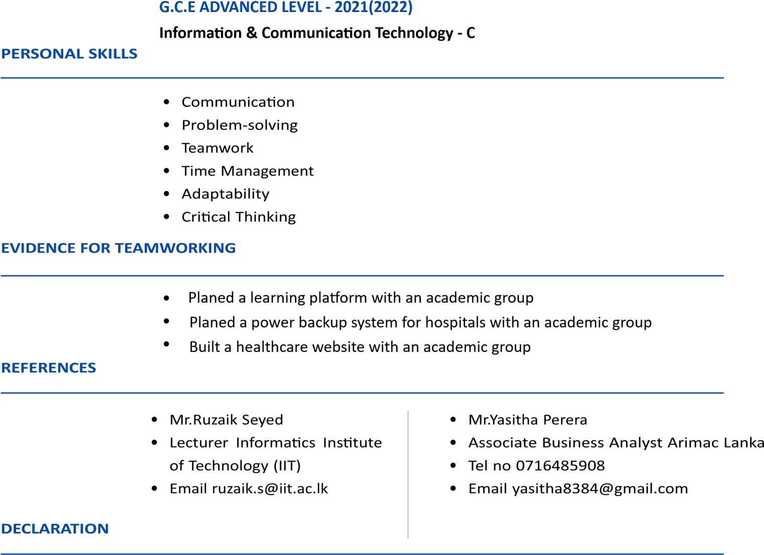

I hereby certify that the above-mentioned information is true and correct to the best of my knowledge.