Lab worksheet 02

CT/2021/024

Q01).

A).

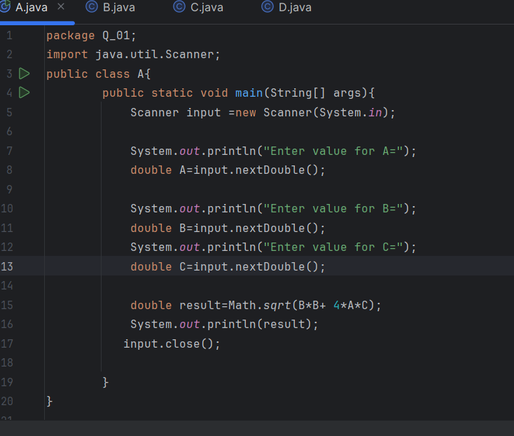

Output

B).

Output

C).

Output

D).

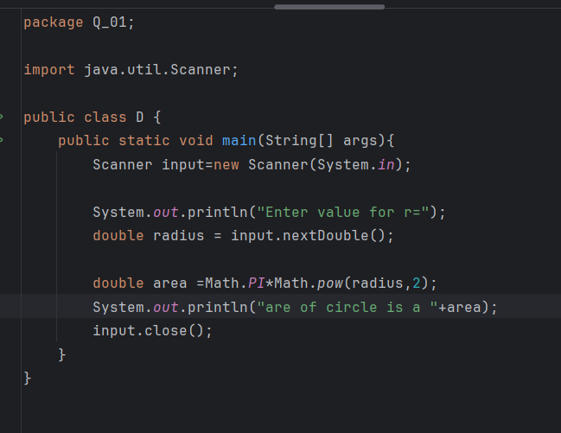

Output

Q02).

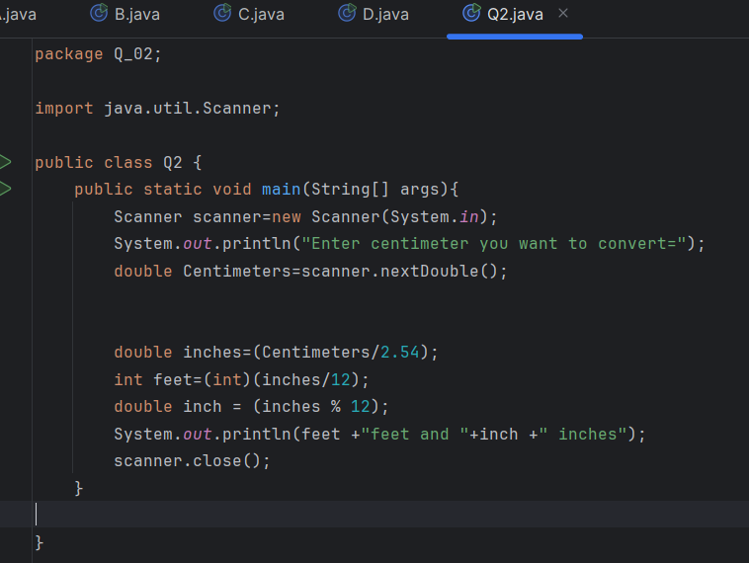

Output

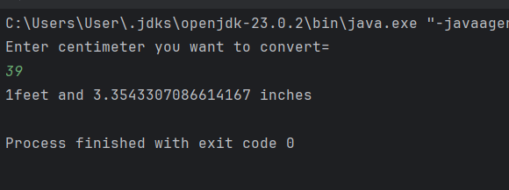

Q03).

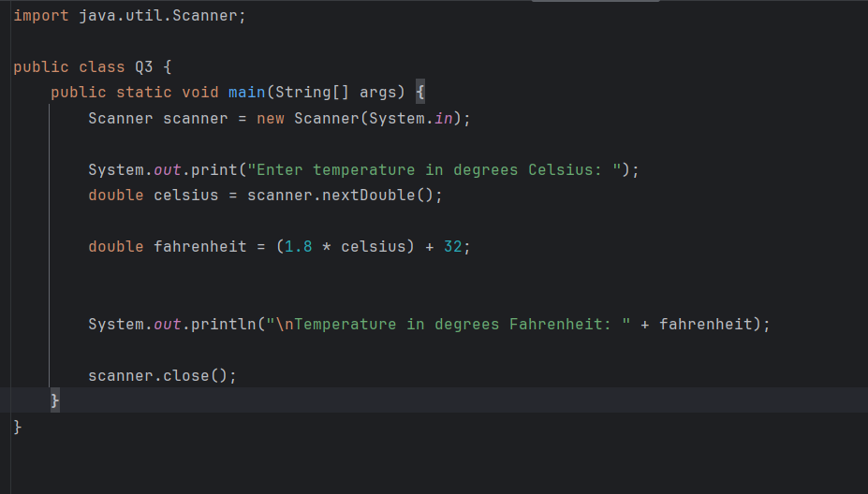

Output

Q04).

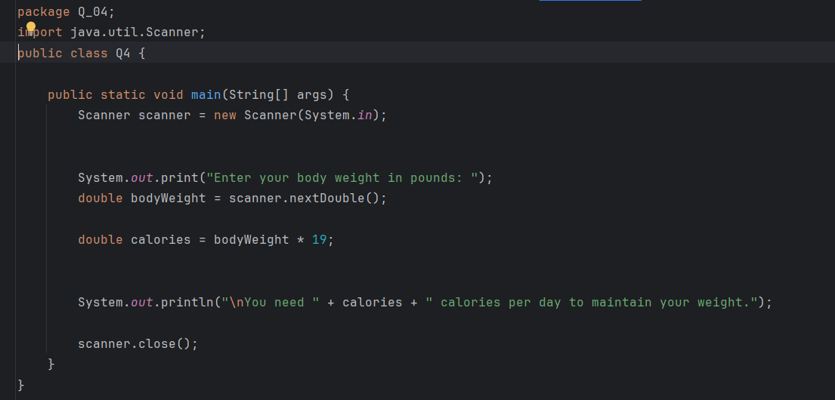

Output

Q05).

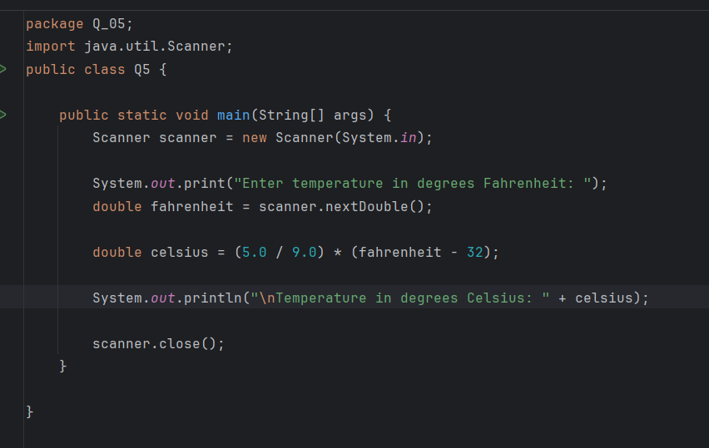

Output

Q06).

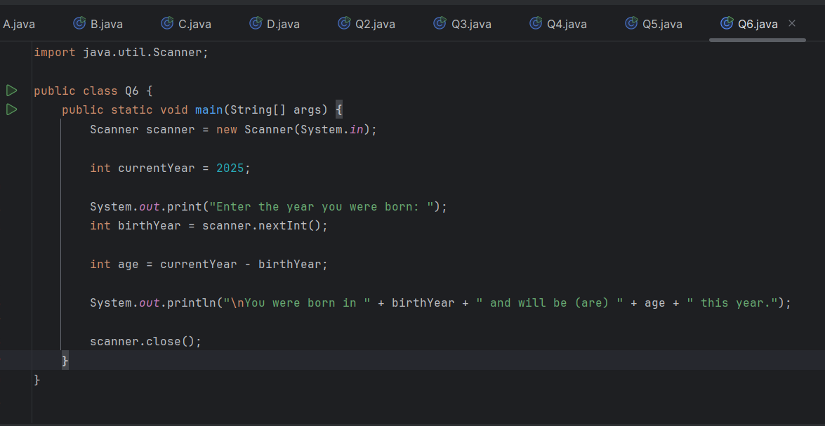

Output

Q07).

Output

Q08).

Output

Q09).

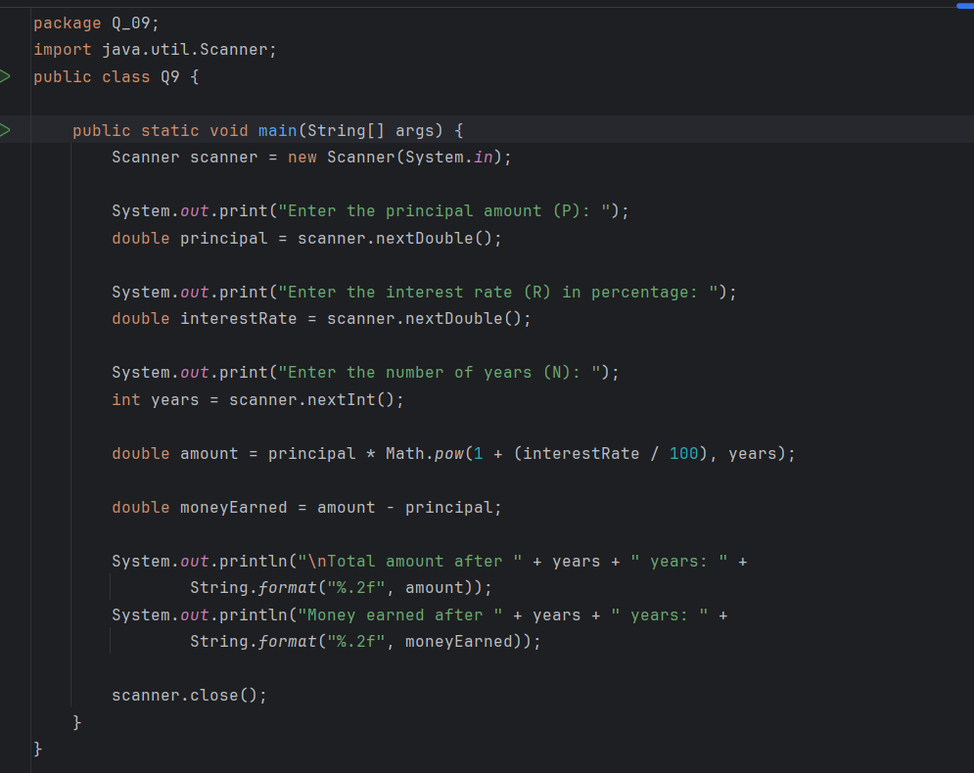

Output

Q10).

Output

