SIMATS ENGINEERING (SAVEETHA SCHOOL OF ENGINEERING)
Department of Computer Science and Engineering
ASSESSMENT TOOL 1 – PSEUDOCODE WRITING
Course Code: | ITA0329 | Course Title: | Mobile Computing
CO Assessed: | CO3 – Precision (BL3) | Assessment: | Assessment Tool 1– Pseudocode
Weightage: | 30 % of CIA | Total Marks: | 100
CO3 Statement: | Implement wireless networking and Mobile IP concepts for routing in cellular and ad hoc networks.. (BTL 3)
Student Name: | S.Dinesh | Reg. No.: | 192311302
Section / Batch: | CSE | Date: | 27/10/26

Code of Conduct
I S.Dinesh/192311302 (Name / Reg No) certify that this submission is my original work and that I have adhered to the guidelines specified for this assessment. I understand that any violation of academic integrity rules will result in disciplinary action.
Signature of the Student: S.Dinesh

Instructions
• Duration: 1 hour
• Answer all Questions
• Write Pseudocode in paper and upload program in GITHUB

Faculty In-charge | Course Coordinator | Head of Department
Signature: _______________ | Signature: _______________ | Signature: _______________
Date: ___________________ | Date: ___________________ | Date: ___________________

Questions
1. Design a health and self-care mobile app that helps users maintain mental wellbeing with meditations and exercises. This case study talks you through the design process of creating a user- friendly mobile app. Design UI with the following requirements.
• User Login
● Register
● Health Routine Blogs
● Self-Care Blogs 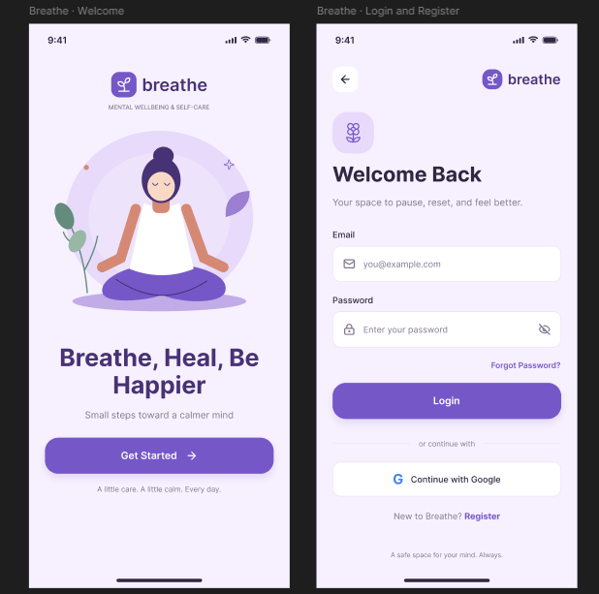
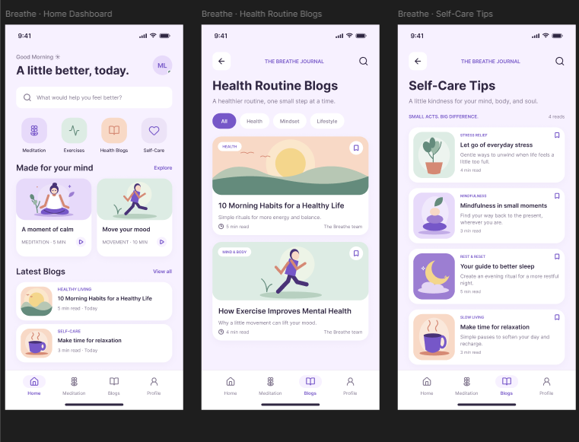

2. This is an intelligent job assistant that helps users find their ideal job and get to all the way to signing a contract faster and more easily. Design UI with the following requirements.
● User Login
● Register Subscription
• Personal Detail
• Resume Upload
• Choosing Job
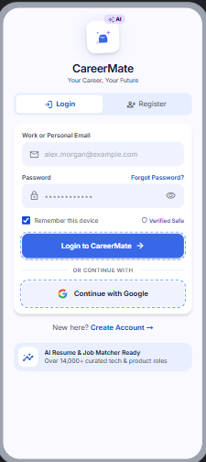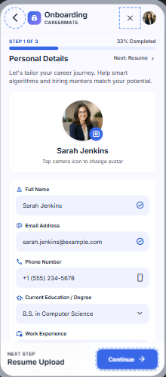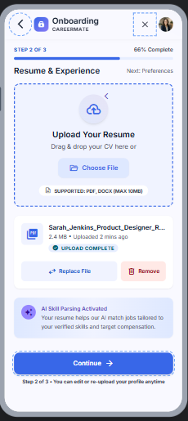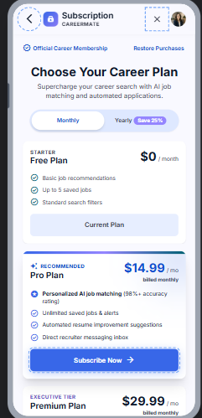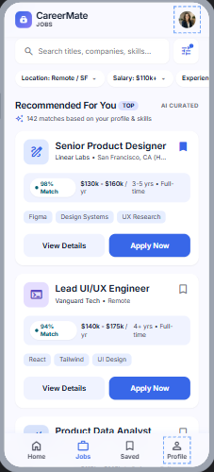
3. This is a mobile app that can help people get parking slots easily even when they travel beyond their normal routes. Design UI with the following requirements.
● UserLogin
● Register Count of Empty Parking
● Free Parking Slots Display
● Booking Parking Slots
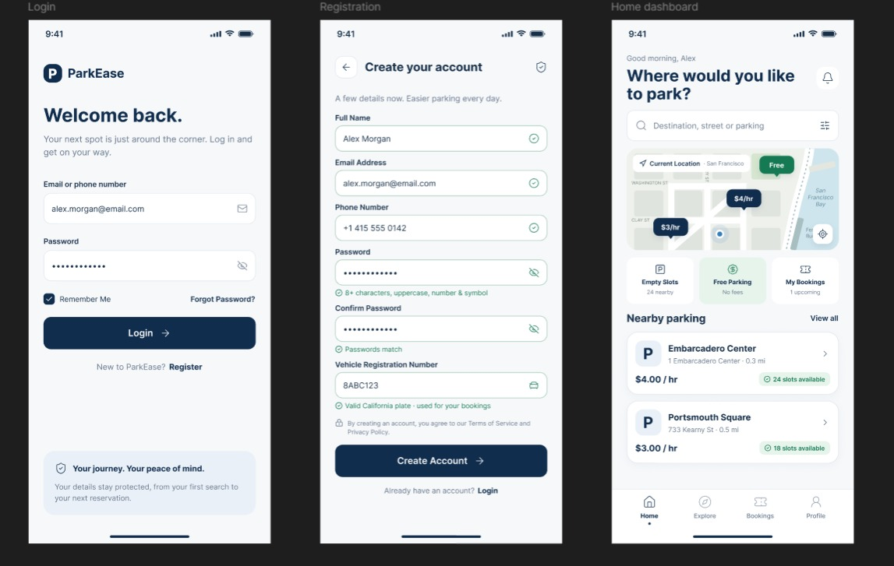
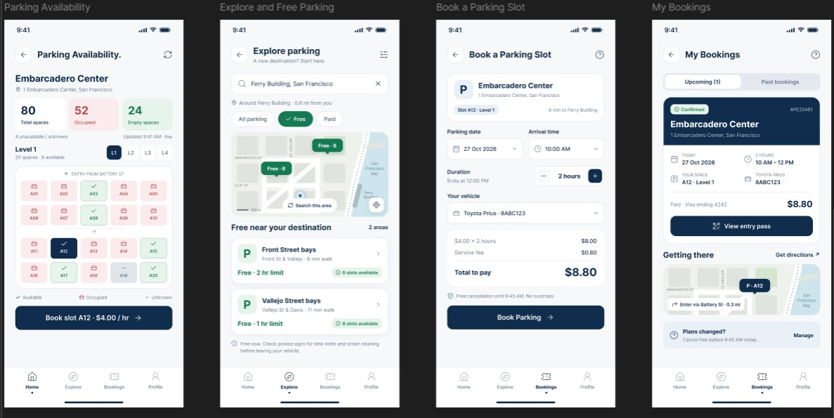

4. Design a mobile app for Online Body Fitness tips and videos for a good daily routine. Contains the following requirements.
User Login
● Register
● Fitness Blog
● Diet Planner
● Fitness Videos
● Payment and Subscription
