**Part 1: Azure Virtual Machine**

**Task 1.2: Create a VM using the Azure Portal. Install a web server and host a simple webpage.**

**1.** **Azure Login from cmd**

**2. Create a resource group in Azure.**

**3.** **Check for all resource groups in azure.**

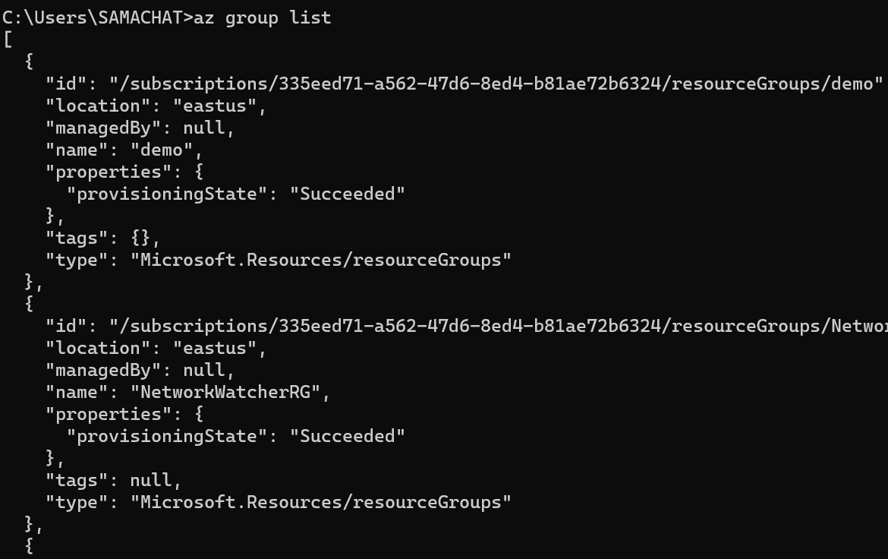

**4. Create a Virtual Machine in the resource group in Azure.**

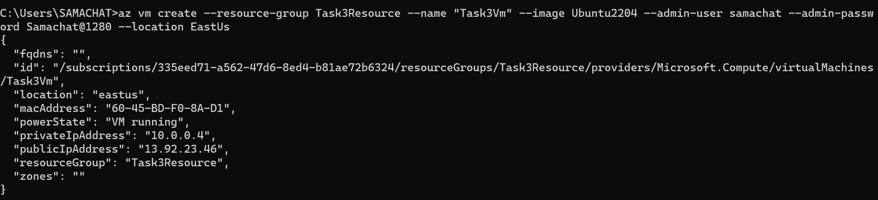

**5.** **Check, if VM created or not**

**6. Login to Linux Vm**

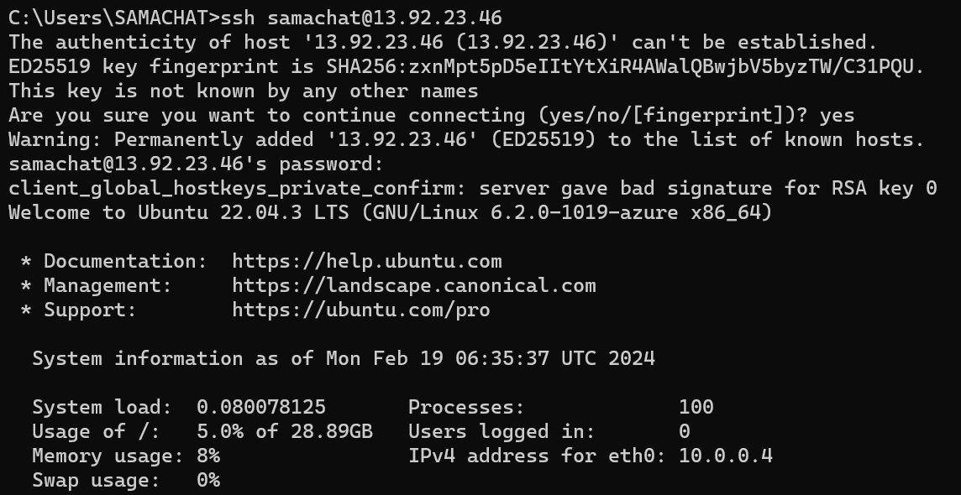

**7.** **Check for packages latest version and update its info.**

**8. Download the nginx software.**

**9.** **Check if nginx working or not.**

**10.** **Add inbound c,which make this vm as web server**

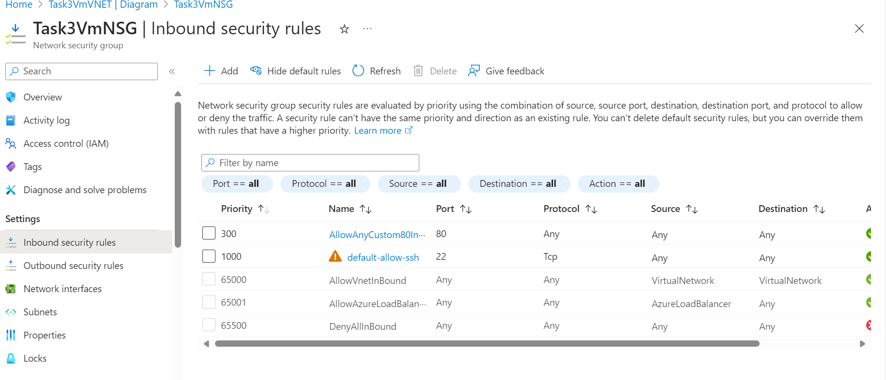

**11. Inbuilt html file in nginx folder, Ip is vm public Ip using which it is running**

**12.** **Html and CSS file in local computer**

**13.** **code to allow access to read and write or modify in html folder of nginx in vm**



**14.** **Exit from vm**



**15.** **Deploy html file from local computer to azure for hosting**

**16.**

**17.**

