data-summarization

Samah Abdelaal

1/31/2020

library(tidyverse)

## -- Attaching packages ------------------------- tidyverse 1.2.1 --

## v ggplot2 3.2.1 v purrr 0.3.3  
## v tibble 2.1.3 v dplyr 0.8.3  
## v tidyr 1.0.0 v stringr 1.4.0  
## v readr 1.3.1 v forcats 0.4.0

## -- Conflicts ---------------------------- tidyverse_conflicts() --  
## x dplyr::filter() masks stats::filter()  
## x dplyr::lag() masks stats::lag()

selfmed <- read.csv("Data/self-medication.csv")  
attach(selfmed)

## The following object is masked from package:base:  
##   
## pi

pie_theme <- theme_minimal()+  
 theme(axis.title.x = element_blank(),  
 axis.text.x = element_blank(),  
 axis.title.y = element_blank(),  
 axis.text.y = element_text(size = 15, face = "bold"),  
 panel.border = element_blank(),  
 panel.grid=element_blank(),  
 axis.ticks = element_blank(),  
 plot.title=element_text(size=14, face="bold"))

#Did you have any disease in the last three months?

selfmed %>%  
 filter(!is.na(Did.you.have.any.disease.in.the.last.three.months.)) %>%  
 group_by(Did.you.have.any.disease.in.the.last.three.months.) %>%  
 summarise(counts = n()) %>%  
 mutate(percentage= round((counts / sum(counts))*100)) %>%  
 ggplot(  
 aes(x= "",  
 y= percentage,  
 fill= Did.you.have.any.disease.in.the.last.three.months.)  
 )+  
 geom_bar(stat = "identity")+   
 coord_polar(theta = "y")+  
 geom_text(  
 aes(label = paste(percentage, "%")),  
 position = position_stack(vjust = 0.5),  
 size = 8  
 ) +  
 labs(fill= "Did you have any disease in the last three months?")+  
 pie_theme +  
 scale_fill_brewer(palette = "Set2")

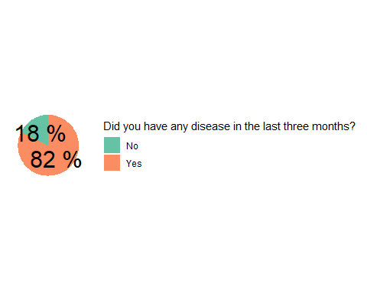

#Have you taken self-medication in the last three months?

selfmed %>%  
 filter(!is.na(Have.you.taken.selfâ..medication.in.last.three.months.)) %>%  
 group_by(Have.you.taken.selfâ..medication.in.last.three.months.) %>%  
 summarise(counts = n()) %>%  
 mutate(percentage= round((counts / sum(counts))*100)) %>%  
 ggplot(  
 aes(x= "",  
 y= percentage,  
 fill= Have.you.taken.selfâ..medication.in.last.three.months.)  
 )+  
 geom_bar(stat = "identity")+   
 coord_polar(theta = "y")+  
 geom_text(  
 aes(label = paste(percentage, "%")),  
 position = position_stack(vjust = 0.5),  
 size = 8  
 ) +  
 labs(fill= "Have you taken self-medication in the last three months?")+  
 pie_theme +  
 scale_fill_brewer(palette = "Set2")

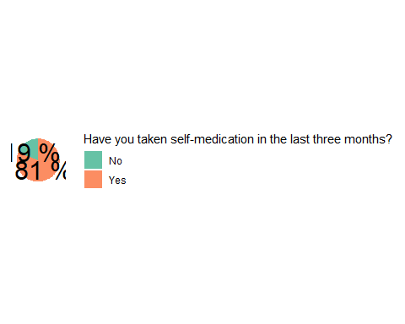

#Reason for self-medication

dcffh: Doctor / clinic far from home

selfmed %>%  
 filter(!is.na(dcffh)) %>%  
 group_by(dcffh) %>%  
 summarise(counts = n()) %>%  
 mutate(percentage= round((counts / sum(counts))*100)) %>%  
 ggplot(aes(x= dcffh,  
 y= percentage,  
 fill= dcffh)) +  
 geom_bar(width = 0.3,  
 stat = "identity") +  
 coord_flip() +  
 geom_text(  
 aes(label = paste(percentage, "%")),  
 size= 5,  
 vjust = -2,  
 hjust= 0.7  
 ) +  
 labs(title = "Reason for self-medication:",  
 subtitle = "Doctor / clinic far from home") +  
 pie_theme +  
 theme(legend.position = "none",  
 plot.subtitle = element_text(face = "bold",  
 size = 20,  
 vjust = -1.5)) +  
 scale_fill_brewer(palette = "Set1")

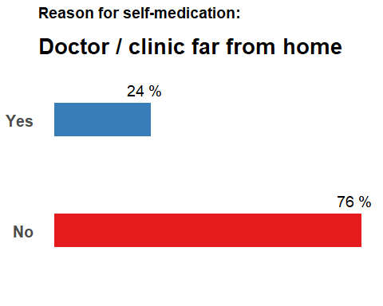

st: Saves time

selfmed %>%  
 filter(!is.na(st)) %>%  
 group_by(st) %>%  
 summarise(counts = n()) %>%  
 mutate(percentage= round((counts / sum(counts))*100)) %>%  
 ggplot(aes(x= st,  
 y= percentage,  
 fill= st)) +  
 geom_bar(width = 0.3,  
 stat = "identity") +  
 coord_flip() +  
 geom_text(  
 aes(label = paste(percentage, "%")),  
 size= 5,  
 vjust = -2,  
 hjust= 0.7  
 ) +  
 labs(title = "Reason for self-medication:",  
 subtitle = "Saves time") +  
 pie_theme +  
 theme(legend.position = "none",  
 plot.subtitle = element_text(face = "bold",  
 size = 20,  
 vjust = -1.5)) +  
 scale_fill_brewer(palette = "Set1")

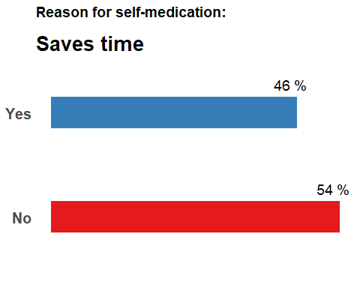

hfod: high fees of doctor

selfmed %>%  
 filter(!is.na(hfod)) %>%  
 group_by(hfod) %>%  
 summarise(counts = n()) %>%  
 mutate(percentage= round((counts / sum(counts))*100)) %>%  
 ggplot(aes(x= hfod,  
 y= percentage,  
 fill= hfod)) +  
 geom_bar(width = 0.3,  
 stat = "identity") +  
 coord_flip() +  
 geom_text(  
 aes(label = paste(percentage, "%")),  
 size= 5,  
 vjust = -2,  
 hjust= 0.7  
 ) +  
 labs(title = "Reason for self-medication:",  
 subtitle = "High fees of doctors") +  
 pie_theme +  
 theme(legend.position = "none",  
 plot.subtitle = element_text(face = "bold",  
 size = 20,  
 vjust = -1.5)) +  
 scale_fill_brewer(palette = "Set1")

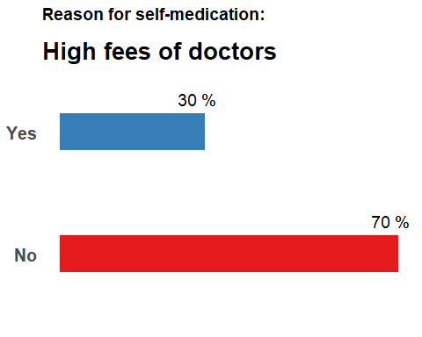

ihop: I have old prescription

selfmed %>%  
 filter(!is.na(ihop)) %>%  
 group_by(ihop) %>%  
 summarise(counts = n()) %>%  
 mutate(percentage= round((counts / sum(counts))*100)) %>%  
 ggplot(aes(x= ihop,  
 y= percentage,  
 fill= ihop)) +  
 geom_bar(width = 0.3,  
 stat = "identity") +  
 coord_flip() +  
 geom_text(  
 aes(label = paste(percentage, "%")),  
 size= 5,  
 vjust = -2,  
 hjust= 0.7  
 ) +  
 labs(title = "Reason for self-medication:",  
 subtitle = "I have old prescription") +  
 pie_theme +  
 theme(legend.position = "none",  
 plot.subtitle = element_text(face = "bold",  
 size = 20,  
 vjust = -1.5)) +  
 scale_fill_brewer(palette = "Set1")

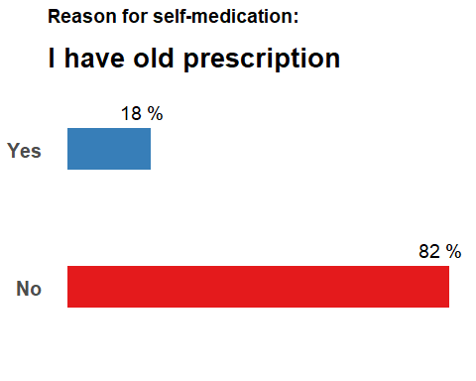

dibwmp: Doctor is busy with many patients

selfmed %>%  
 filter(!is.na(dibwmp)) %>%  
 group_by(dibwmp) %>%  
 summarise(counts = n()) %>%  
 mutate(percentage= round((counts / sum(counts))*100)) %>%  
 ggplot(aes(x= dibwmp,  
 y= percentage,  
 fill= dibwmp)) +  
 geom_bar(width = 0.3,  
 stat = "identity") +  
 coord_flip() +  
 geom_text(  
 aes(label = paste(percentage, "%")),  
 size= 5,  
 vjust = -2,  
 hjust= 0.7  
 ) +  
 labs(title = "Reason for self-medication:",  
 subtitle = "Doctor is busy with many patients") +  
 pie_theme +  
 theme(legend.position = "none",  
 plot.subtitle = element_text(face = "bold",  
 size = 20,  
 vjust = -1.5)) +  
 scale_fill_brewer(palette = "Set1")

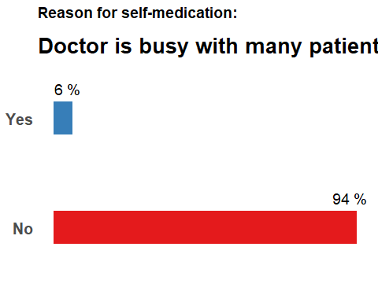

ihmofm: I have medicine of family members

selfmed %>%  
 filter(!is.na(ihmofm)) %>%  
 group_by(ihmofm) %>%  
 summarise(counts = n()) %>%  
 mutate(percentage= round((counts / sum(counts))*100)) %>%  
 ggplot(aes(x= ihmofm,  
 y= percentage,  
 fill= ihmofm)) +  
 geom_bar(width = 0.3,  
 stat = "identity") +  
 coord_flip() +  
 geom_text(  
 aes(label = paste(percentage, "%")),  
 size= 5,  
 vjust = -2,  
 hjust= 0.7  
 ) +  
 labs(title = "Reason for self-medication:",  
 subtitle = "I have medicine of family members") +  
 pie_theme +  
 theme(legend.position = "none",  
 plot.subtitle = element_text(face = "bold",  
 size = 20,  
 vjust = -1.5)) +  
 scale_fill_brewer(palette = "Set1")

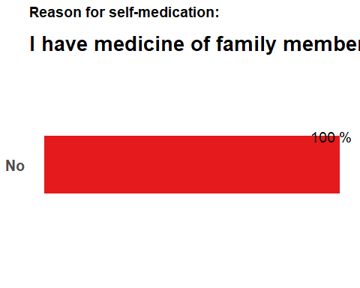

ntid: No trust in doctor

selfmed %>%  
 filter(!is.na(ntid)) %>%  
 group_by(ntid) %>%  
 summarise(counts = n()) %>%  
 mutate(percentage= round((counts / sum(counts))*100)) %>%  
 ggplot(aes(x= ntid,  
 y= percentage,  
 fill= ntid)) +  
 geom_bar(width = 0.3,  
 stat = "identity") +  
 coord_flip() +  
 geom_text(  
 aes(label = paste(percentage, "%")),  
 size= 5,  
 vjust = -2,  
 hjust= 0.7  
 ) +  
 labs(title = "Reason for self-medication:",  
 subtitle = "No trust in doctor") +  
 pie_theme +  
 theme(legend.position = "none",  
 plot.subtitle = element_text(face = "bold",  
 size = 20,  
 vjust = -1.5)) +  
 scale_fill_brewer(palette = "Set1")

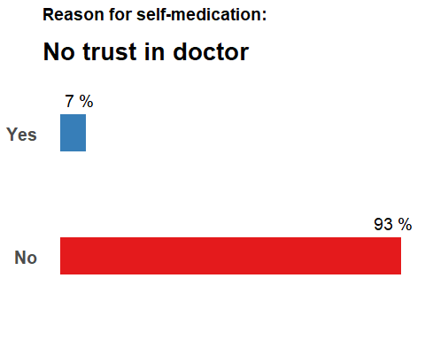

pa: Pharmacist advice

selfmed %>%  
 filter(!is.na(pa)) %>%  
 group_by(pa) %>%  
 summarise(counts = n()) %>%  
 mutate(percentage= round((counts / sum(counts))*100)) %>%  
 ggplot(aes(x= pa,  
 y= percentage,  
 fill= pa)) +  
 geom_bar(width = 0.3,  
 stat = "identity") +  
 coord_flip() +  
 geom_text(  
 aes(label = paste(percentage, "%")),  
 size= 5,  
 vjust = -2,  
 hjust= 0.7  
 ) +  
 labs(title = "Reason for self-medication:",  
 subtitle = "Pharmacist advice") +  
 pie_theme +  
 theme(legend.position = "none",  
 plot.subtitle = element_text(face = "bold",  
 size = 20,  
 vjust = -1.5)) +  
 scale_fill_brewer(palette = "Set1")

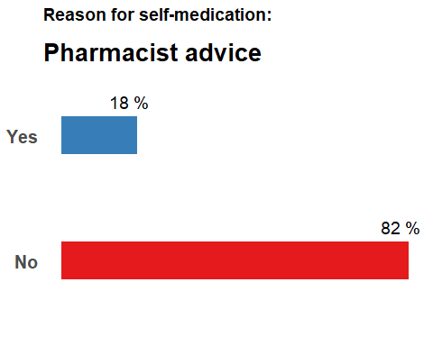

#For which disease have you taken self-medication in the last three months?

headache : Headache

selfmed %>%  
 filter(!is.na(headache)) %>%  
 group_by(headache) %>%  
 summarise(counts = n()) %>%  
 mutate(percentage= round((counts / sum(counts))*100)) %>%  
 ggplot(aes(x= headache,  
 y= percentage,  
 fill= headache)) +  
 geom_bar(width = 0.3,  
 stat = "identity") +  
 coord_flip() +  
 geom_text(  
 aes(label = paste(percentage, "%")),  
 size= 5,  
 vjust = -2,  
 hjust= 0.7  
 ) +  
 labs(title = "For which disease have you taken self-medication in the last three months?",  
 subtitle = "Headache") +  
 pie_theme +  
 theme(legend.position = "none",  
 plot.subtitle = element_text(face = "bold",  
 size = 20,  
 vjust = -1.5)) +  
 scale_fill_brewer(palette = "Dark2")

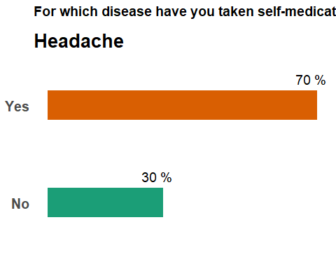

eyeinf : Eye infection

selfmed %>%  
 filter(!is.na(eyeinf)) %>%  
 group_by(eyeinf) %>%  
 summarise(counts = n()) %>%  
 mutate(percentage= round((counts / sum(counts))*100)) %>%  
 ggplot(aes(x= eyeinf,  
 y= percentage,  
 fill= eyeinf)) +  
 geom_bar(width = 0.3,  
 stat = "identity") +  
 coord_flip() +  
 geom_text(  
 aes(label = paste(percentage, "%")),  
 size= 5,  
 vjust = -2,  
 hjust= 0.7  
 ) +  
 labs(title = "For which disease have you taken self-medication in the last three months?",  
 subtitle = "Eye infection") +  
 pie_theme +  
 theme(legend.position = "none",  
 plot.subtitle = element_text(face = "bold",  
 size = 20,  
 vjust = -1.5)) +  
 scale_fill_brewer(palette = "Dark2")

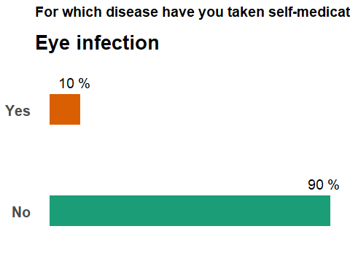

dandruff : Dandruff

selfmed %>%  
 filter(!is.na(dandruff)) %>%  
 group_by(dandruff) %>%  
 summarise(counts = n()) %>%  
 mutate(percentage= round((counts / sum(counts))*100)) %>%  
 ggplot(aes(x= dandruff,  
 y= percentage,  
 fill= dandruff)) +  
 geom_bar(width = 0.3,  
 stat = "identity") +  
 coord_flip() +  
 geom_text(  
 aes(label = paste(percentage, "%")),  
 size= 5,  
 vjust = -2,  
 hjust= 0.7  
 ) +  
 labs(title = "For which disease have you taken self-medication in the last three months?",  
 subtitle = "Dandruff") +  
 pie_theme +  
 theme(legend.position = "none",  
 plot.subtitle = element_text(face = "bold",  
 size = 20,  
 vjust = -1.5)) +  
 scale_fill_brewer(palette = "Dark2")

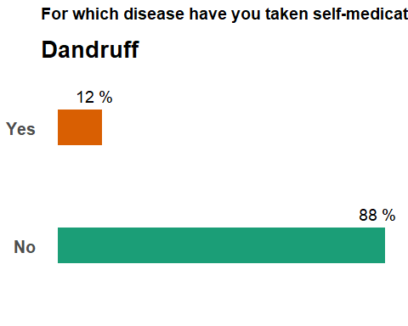

runnose : Running nose

selfmed %>%  
 filter(!is.na(runnose)) %>%  
 group_by(runnose) %>%  
 summarise(counts = n()) %>%  
 mutate(percentage= round((counts / sum(counts))*100)) %>%  
 ggplot(aes(x= runnose,  
 y= percentage,  
 fill= runnose)) +  
 geom_bar(width = 0.3,  
 stat = "identity") +  
 coord_flip() +  
 geom_text(  
 aes(label = paste(percentage, "%")),  
 size= 5,  
 vjust = -2,  
 hjust= 0.7  
 ) +  
 labs(title = "For which disease have you taken self-medication in the last three months?",  
 subtitle = "Running nose") +  
 pie_theme +  
 theme(legend.position = "none",  
 plot.subtitle = element_text(face = "bold",  
 size = 20,  
 vjust = -1.5)) +  
 scale_fill_brewer(palette = "Dark2")

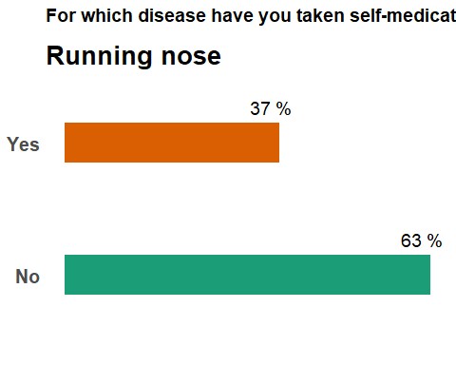

hairfall : Hair fall

selfmed %>%  
 filter(!is.na(hairfall)) %>%  
 group_by(hairfall) %>%  
 summarise(counts = n()) %>%  
 mutate(percentage= round((counts / sum(counts))*100)) %>%  
 ggplot(aes(x= hairfall,  
 y= percentage,  
 fill= hairfall)) +  
 geom_bar(width = 0.3,  
 stat = "identity") +  
 coord_flip() +  
 geom_text(  
 aes(label = paste(percentage, "%")),  
 size= 5,  
 vjust = -2,  
 hjust= 0.7  
 ) +  
 labs(title = "For which disease have you taken self-medication in the last three months?",  
 subtitle = "Hair fall") +  
 pie_theme +  
 theme(legend.position = "none",  
 plot.subtitle = element_text(face = "bold",  
 size = 20,  
 vjust = -1.5)) +  
 scale_fill_brewer(palette = "Dark2")

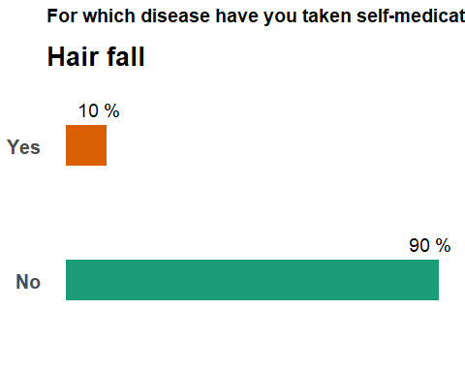

earpain : Ear pain

selfmed %>%  
 filter(!is.na(earpain)) %>%  
 group_by(earpain) %>%  
 summarise(counts = n()) %>%  
 mutate(percentage= round((counts / sum(counts))*100)) %>%  
 ggplot(aes(x= earpain,  
 y= percentage,  
 fill= earpain)) +  
 geom_bar(width = 0.3,  
 stat = "identity") +  
 coord_flip() +  
 geom_text(  
 aes(label = paste(percentage, "%")),  
 size= 5,  
 vjust = -2,  
 hjust= 0.7  
 ) +  
 labs(title = "For which disease have you taken self-medication in the last three months?",  
 subtitle = "Ear pain") +  
 pie_theme +  
 theme(legend.position = "none",  
 plot.subtitle = element_text(face = "bold",  
 size = 20,  
 vjust = -1.5)) +  
 scale_fill_brewer(palette = "Dark2")

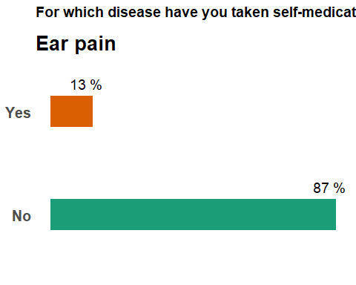

faints : Faints

selfmed %>%  
 filter(!is.na(faints)) %>%  
 group_by(faints) %>%  
 summarise(counts = n()) %>%  
 mutate(percentage= round((counts / sum(counts))*100)) %>%  
 ggplot(aes(x= faints,  
 y= percentage,  
 fill= faints)) +  
 geom_bar(width = 0.3,  
 stat = "identity") +  
 coord_flip() +  
 geom_text(  
 aes(label = paste(percentage, "%")),  
 size= 5,  
 vjust = -2,  
 hjust= 0.7  
 ) +  
 labs(title = "For which disease have you taken self-medication in the last three months?",  
 subtitle = "Faints") +  
 pie_theme +  
 theme(legend.position = "none",  
 plot.subtitle = element_text(face = "bold",  
 size = 20,  
 vjust = -1.5)) +  
 scale_fill_brewer(palette = "Dark2")

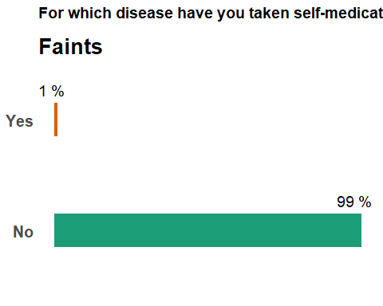

mouthulcer : Mouth ulcer

selfmed %>%  
 filter(!is.na(mouthulcer)) %>%  
 group_by(mouthulcer) %>%  
 summarise(counts = n()) %>%  
 mutate(percentage= round((counts / sum(counts))*100)) %>%  
 ggplot(aes(x= mouthulcer,  
 y= percentage,  
 fill= mouthulcer)) +  
 geom_bar(width = 0.3,  
 stat = "identity") +  
 coord_flip() +  
 geom_text(  
 aes(label = paste(percentage, "%")),  
 size= 5,  
 vjust = -2,  
 hjust= 0.7  
 ) +  
 labs(title = "For which disease have you taken self-medication in the last three months?",  
 subtitle = "Mouth ulcer") +  
 pie_theme +  
 theme(legend.position = "none",  
 plot.subtitle = element_text(face = "bold",  
 size = 20,  
 vjust = -1.5)) +  
 scale_fill_brewer(palette = "Dark2")

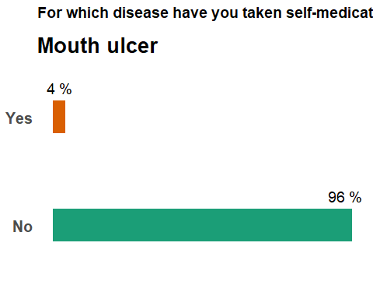

dentalpain : Dental pain

selfmed %>%  
 filter(!is.na(dentalpain)) %>%  
 group_by(dentalpain) %>%  
 summarise(counts = n()) %>%  
 mutate(percentage= round((counts / sum(counts))*100)) %>%  
 ggplot(aes(x= dentalpain,  
 y= percentage,  
 fill= dentalpain)) +  
 geom_bar(width = 0.3,  
 stat = "identity") +  
 coord_flip() +  
 geom_text(  
 aes(label = paste(percentage, "%")),  
 size= 5,  
 vjust = -2,  
 hjust= 0.7  
 ) +  
 labs(title = "For which disease have you taken self-medication in the last three months?",  
 subtitle = "Dental pain") +  
 pie_theme +  
 theme(legend.position = "none",  
 plot.subtitle = element_text(face = "bold",  
 size = 20,  
 vjust = -1.5)) +  
 scale_fill_brewer(palette = "Dark2")

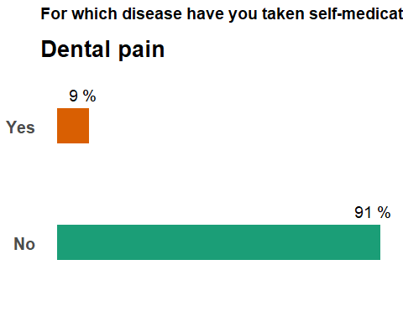

migraine : Migraine

selfmed %>%  
 filter(!is.na(migraine)) %>%  
 group_by(migraine) %>%  
 summarise(counts = n()) %>%  
 mutate(percentage= round((counts / sum(counts))*100)) %>%  
 ggplot(aes(x= migraine,  
 y= percentage,  
 fill= migraine)) +  
 geom_bar(width = 0.3,  
 stat = "identity") +  
 coord_flip() +  
 geom_text(  
 aes(label = paste(percentage, "%")),  
 size= 5,  
 vjust = -2,  
 hjust= 0.7  
 ) +  
 labs(title = "For which disease have you taken self-medication in the last three months?",  
 subtitle = "Migraine") +  
 pie_theme +  
 theme(legend.position = "none",  
 plot.subtitle = element_text(face = "bold",  
 size = 20,  
 vjust = -1.5)) +  
 scale_fill_brewer(palette = "Dark2")

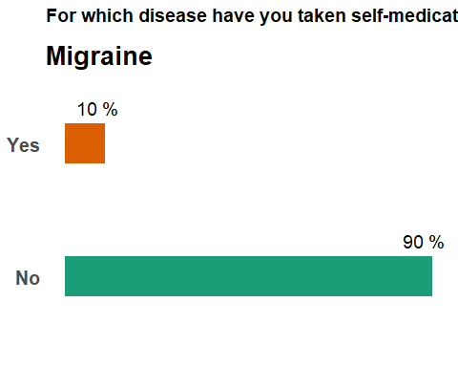

cough : Cough

selfmed %>%  
 filter(!is.na(cough)) %>%  
 group_by(cough) %>%  
 summarise(counts = n()) %>%  
 mutate(percentage= round((counts / sum(counts))*100)) %>%  
 ggplot(aes(x= cough,  
 y= percentage,  
 fill= cough)) +  
 geom_bar(width = 0.3,  
 stat = "identity") +  
 coord_flip() +  
 geom_text(  
 aes(label = paste(percentage, "%")),  
 size= 5,  
 vjust = -2,  
 hjust= 0.7  
 ) +  
 labs(title = "For which disease have you taken self-medication in the last three months?",  
 subtitle = "Cough") +  
 pie_theme +  
 theme(legend.position = "none",  
 plot.subtitle = element_text(face = "bold",  
 size = 20,  
 vjust = -1.5)) +  
 scale_fill_brewer(palette = "Dark2")

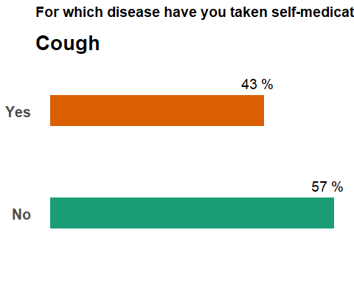

acidity : Acidity

selfmed %>%  
 filter(!is.na(acidity)) %>%  
 group_by(acidity) %>%  
 summarise(counts = n()) %>%  
 mutate(percentage= round((counts / sum(counts))*100)) %>%  
 ggplot(aes(x= acidity,  
 y= percentage,  
 fill= acidity)) +  
 geom_bar(width = 0.3,  
 stat = "identity") +  
 coord_flip() +  
 geom_text(  
 aes(label = paste(percentage, "%")),  
 size= 5,  
 vjust = -2,  
 hjust= 0.7  
 ) +  
 labs(title = "For which disease have you taken self-medication in the last three months?",  
 subtitle = "Acidity") +  
 pie_theme +  
 theme(legend.position = "none",  
 plot.subtitle = element_text(face = "bold",  
 size = 20,  
 vjust = -1.5)) +  
 scale_fill_brewer(palette = "Dark2")

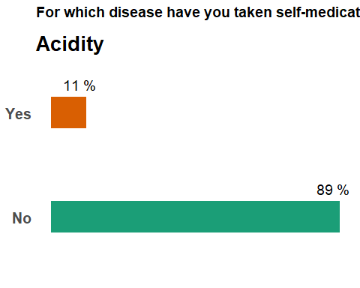

rash : Rash

selfmed %>%  
 filter(!is.na(rash)) %>%  
 group_by(rash) %>%  
 summarise(counts = n()) %>%  
 mutate(percentage= round((counts / sum(counts))*100)) %>%  
 ggplot(aes(x= rash,  
 y= percentage,  
 fill= rash)) +  
 geom_bar(width = 0.3,  
 stat = "identity") +  
 coord_flip() +  
 geom_text(  
 aes(label = paste(percentage, "%")),  
 size= 5,  
 vjust = -2,  
 hjust= 0.7  
 ) +  
 labs(title = "For which disease have you taken self-medication in the last three months?",  
 subtitle = "Rash") +  
 pie_theme +  
 theme(legend.position = "none",  
 plot.subtitle = element_text(face = "bold",  
 size = 20,  
 vjust = -1.5)) +  
 scale_fill_brewer(palette = "Dark2")

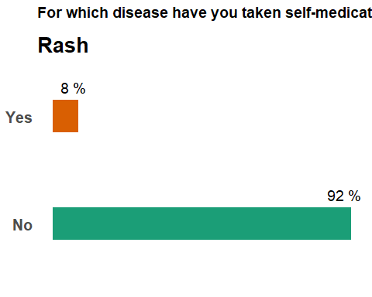

vomiting : Vomiting

selfmed %>%  
 filter(!is.na(vomiting)) %>%  
 group_by(vomiting) %>%  
 summarise(counts = n()) %>%  
 mutate(percentage= round((counts / sum(counts))*100)) %>%  
 ggplot(aes(x= vomiting,  
 y= percentage,  
 fill= vomiting)) +  
 geom_bar(width = 0.3,  
 stat = "identity") +  
 coord_flip() +  
 geom_text(  
 aes(label = paste(percentage, "%")),  
 size= 5,  
 vjust = -2,  
 hjust= 0.7  
 ) +  
 labs(title = "For which disease have you taken self-medication in the last three months?",  
 subtitle = "Vomiting") +  
 pie_theme +  
 theme(legend.position = "none",  
 plot.subtitle = element_text(face = "bold",  
 size = 20,  
 vjust = -1.5)) +  
 scale_fill_brewer(palette = "Dark2")

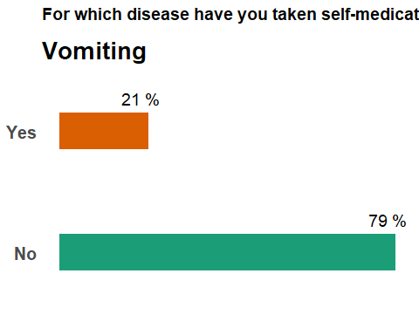

fever : Fever

selfmed %>%  
 filter(!is.na(fever)) %>%  
 group_by(fever) %>%  
 summarise(counts = n()) %>%  
 mutate(percentage= round((counts / sum(counts))*100)) %>%  
 ggplot(aes(x= fever,  
 y= percentage,  
 fill= fever)) +  
 geom_bar(width = 0.3,  
 stat = "identity") +  
 coord_flip() +  
 geom_text(  
 aes(label = paste(percentage, "%")),  
 size= 5,  
 vjust = -2,  
 hjust= 0.7  
 ) +  
 labs(title = "For which disease have you taken self-medication in the last three months?",  
 subtitle = "Fever") +  
 pie_theme +  
 theme(legend.position = "none",  
 plot.subtitle = element_text(face = "bold",  
 size = 20,  
 vjust = -1.5)) +  
 scale_fill_brewer(palette = "Dark2")

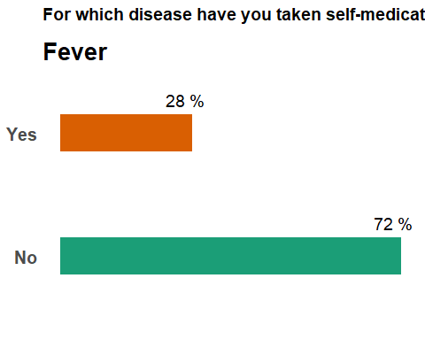

nausea : Nauseea

selfmed %>%  
 filter(!is.na(nausea)) %>%  
 group_by(nausea) %>%  
 summarise(counts = n()) %>%  
 mutate(percentage= round((counts / sum(counts))*100)) %>%  
 ggplot(aes(x= nausea,  
 y= percentage,  
 fill= nausea)) +  
 geom_bar(width = 0.3,  
 stat = "identity") +  
 coord_flip() +  
 geom_text(  
 aes(label = paste(percentage, "%")),  
 size= 5,  
 vjust = -2,  
 hjust= 0.7  
 ) +  
 labs(title = "For which disease have you taken self-medication in the last three months?",  
 subtitle = "Nausea") +  
 pie_theme +  
 theme(legend.position = "none",  
 plot.subtitle = element_text(face = "bold",  
 size = 20,  
 vjust = -1.5)) +  
 scale_fill_brewer(palette = "Dark2")

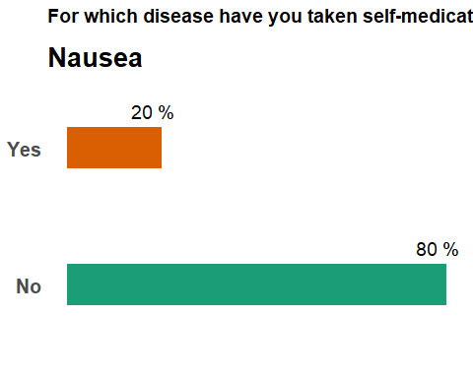

skinop : Skin disease on open areas

selfmed %>%  
 filter(!is.na(skinop)) %>%  
 group_by(skinop) %>%  
 summarise(counts = n()) %>%  
 mutate(percentage= round((counts / sum(counts))*100)) %>%  
 ggplot(aes(x= skinop,  
 y= percentage,  
 fill= skinop)) +  
 geom_bar(width = 0.3,  
 stat = "identity") +  
 coord_flip() +  
 geom_text(  
 aes(label = paste(percentage, "%")),  
 size= 5,  
 vjust = -2,  
 hjust= 0.7  
 ) +  
 labs(title = "For which disease have you taken self-medication in the last three months?",  
 subtitle = "Skin disease on open areas") +  
 pie_theme +  
 theme(legend.position = "none",  
 plot.subtitle = element_text(face = "bold",  
 size = 20,  
 vjust = -1.5)) +  
 scale_fill_brewer(palette = "Dark2")

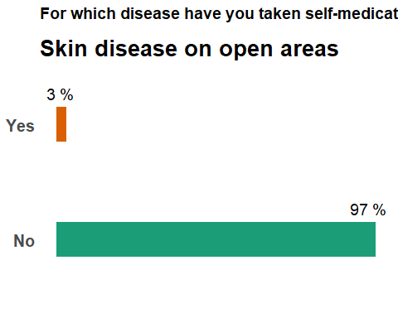

asthma : Asthma

selfmed %>%  
 filter(!is.na(asthma)) %>%  
 group_by(asthma) %>%  
 summarise(counts = n()) %>%  
 mutate(percentage= round((counts / sum(counts))*100)) %>%  
 ggplot(aes(x= asthma,  
 y= percentage,  
 fill= asthma)) +  
 geom_bar(width = 0.3,  
 stat = "identity") +  
 coord_flip() +  
 geom_text(  
 aes(label = paste(percentage, "%")),  
 size= 5,  
 vjust = -2,  
 hjust= 0.7  
 ) +  
 labs(title = "For which disease have you taken self-medication in the last three months?",  
 subtitle = "Asthma") +  
 pie_theme +  
 theme(legend.position = "none",  
 plot.subtitle = element_text(face = "bold",  
 size = 20,  
 vjust = -1.5)) +  
 scale_fill_brewer(palette = "Dark2")

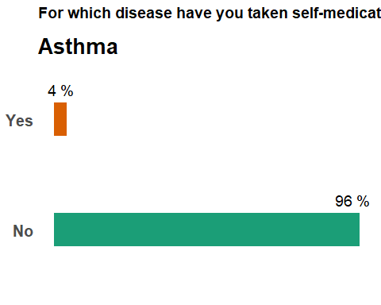

diarrhea : Diarrhea

selfmed %>%  
 filter(!is.na(diarrhea)) %>%  
 group_by(diarrhea) %>%  
 summarise(counts = n()) %>%  
 mutate(percentage= round((counts / sum(counts))*100)) %>%  
 ggplot(aes(x= diarrhea,  
 y= percentage,  
 fill= diarrhea)) +  
 geom_bar(width = 0.3,  
 stat = "identity") +  
 coord_flip() +  
 geom_text(  
 aes(label = paste(percentage, "%")),  
 size= 5,  
 vjust = -2,  
 hjust= 0.7  
 ) +  
 labs(title = "For which disease have you taken self-medication in the last three months?",  
 subtitle = "Diarrhea") +  
 pie_theme +  
 theme(legend.position = "none",  
 plot.subtitle = element_text(face = "bold",  
 size = 20,  
 vjust = -1.5)) +  
 scale_fill_brewer(palette = "Dark2")

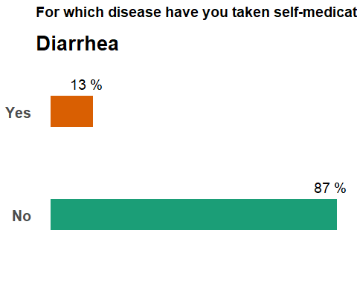

jointpain : Pain in joints

selfmed %>%  
 filter(!is.na(jointpain)) %>%  
 group_by(jointpain) %>%  
 summarise(counts = n()) %>%  
 mutate(percentage= round((counts / sum(counts))*100)) %>%  
 ggplot(aes(x= jointpain,  
 y= percentage,  
 fill= jointpain)) +  
 geom_bar(width = 0.3,  
 stat = "identity") +  
 coord_flip() +  
 geom_text(  
 aes(label = paste(percentage, "%")),  
 size= 5,  
 vjust = -2,  
 hjust= 0.7  
 ) +  
 labs(title = "For which disease have you taken self-medication in the last three months?",  
 subtitle = "Joint pain") +  
 pie_theme +  
 theme(legend.position = "none",  
 plot.subtitle = element_text(face = "bold",  
 size = 20,  
 vjust = -1.5)) +  
 scale_fill_brewer(palette = "Dark2")

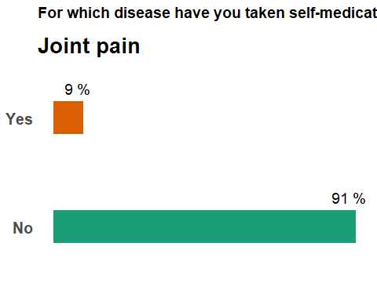

menstrual : Menstrual Problems

selfmed %>%  
 filter(!is.na(menstrual)) %>%  
 group_by(menstrual) %>%  
 summarise(counts = n()) %>%  
 mutate(percentage= round((counts / sum(counts))*100)) %>%  
 ggplot(aes(x= menstrual,  
 y= percentage,  
 fill= menstrual)) +  
 geom_bar(width = 0.3,  
 stat = "identity") +  
 coord_flip() +  
 geom_text(  
 aes(label = paste(percentage, "%")),  
 size= 5,  
 vjust = -2,  
 hjust= 0.7  
 ) +  
 labs(title = "For which disease have you taken self-medication in the last three months?",  
 subtitle = "Menstrual problems") +  
 pie_theme +  
 theme(legend.position = "none",  
 plot.subtitle = element_text(face = "bold",  
 size = 20,  
 vjust = -1.5)) +  
 scale_fill_brewer(palette = "Dark2")

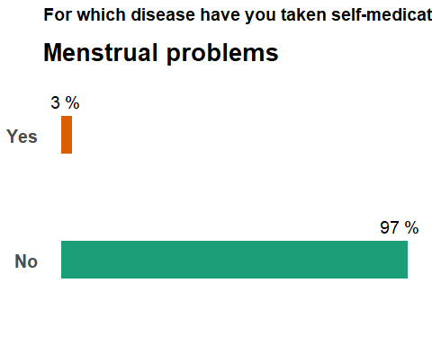

genitalinf : Genital Infection

selfmed %>%  
 filter(!is.na(genitalinf)) %>%  
 group_by(genitalinf) %>%  
 summarise(counts = n()) %>%  
 mutate(percentage= round((counts / sum(counts))*100)) %>%  
 ggplot(aes(x= genitalinf,  
 y= percentage,  
 fill= genitalinf)) +  
 geom_bar(width = 0.3,  
 stat = "identity") +  
 coord_flip() +  
 geom_text(  
 aes(label = paste(percentage, "%")),  
 size= 5,  
 vjust = -2,  
 hjust= 0.7  
 ) +  
 labs(title = "For which disease have you taken self-medication in the last three months?",  
 subtitle = "Genital infection") +  
 pie_theme +  
 theme(legend.position = "none",  
 plot.subtitle = element_text(face = "bold",  
 size = 20,  
 vjust = -1.5)) +  
 scale_fill_brewer(palette = "Dark2")

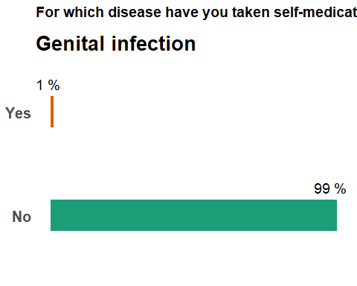

musclepain : Muscle pain

selfmed %>%  
 filter(!is.na(musclepain)) %>%  
 group_by(musclepain) %>%  
 summarise(counts = n()) %>%  
 mutate(percentage= round((counts / sum(counts))*100)) %>%  
 ggplot(aes(x= musclepain,  
 y= percentage,  
 fill= musclepain)) +  
 geom_bar(width = 0.3,  
 stat = "identity") +  
 coord_flip() +  
 geom_text(  
 aes(label = paste(percentage, "%")),  
 size= 5,  
 vjust = -2,  
 hjust= 0.7  
 ) +  
 labs(title = "For which disease have you taken self-medication in the last three months?",  
 subtitle = "Muscle pain") +  
 pie_theme +  
 theme(legend.position = "none",  
 plot.subtitle = element_text(face = "bold",  
 size = 20,  
 vjust = -1.5)) +  
 scale_fill_brewer(palette = "Dark2")

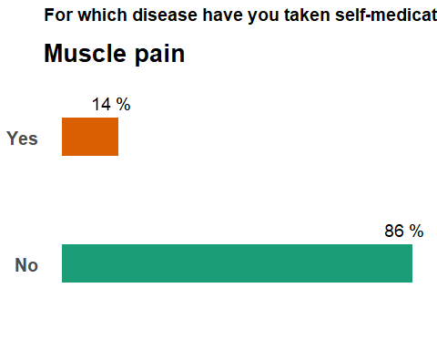

urination : Urination problems

selfmed %>%  
 filter(!is.na(urination)) %>%  
 group_by(urination) %>%  
 summarise(counts = n()) %>%  
 mutate(percentage= round((counts / sum(counts))*100)) %>%  
 ggplot(aes(x= urination,  
 y= percentage,  
 fill= urination)) +  
 geom_bar(width = 0.3,  
 stat = "identity") +  
 coord_flip() +  
 geom_text(  
 aes(label = paste(percentage, "%")),  
 size= 5,  
 vjust = -2,  
 hjust= 0.7  
 ) +  
 labs(title = "For which disease have you taken self-medication in the last three months?",  
 subtitle = "Urination problems") +  
 pie_theme +  
 theme(legend.position = "none",  
 plot.subtitle = element_text(face = "bold",  
 size = 20,  
 vjust = -1.5)) +  
 scale_fill_brewer(palette = "Dark2")

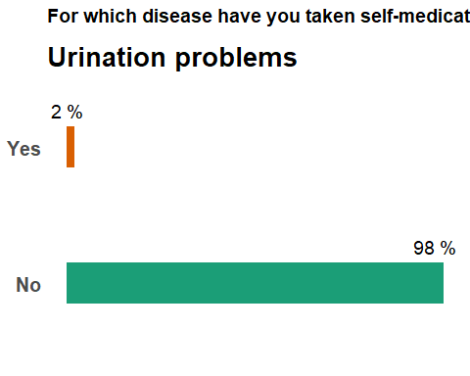

wounds : Wounds

selfmed %>%  
 filter(!is.na(wounds)) %>%  
 group_by(wounds) %>%  
 summarise(counts = n()) %>%  
 mutate(percentage= round((counts / sum(counts))*100)) %>%  
 ggplot(aes(x= wounds,  
 y= percentage,  
 fill= wounds)) +  
 geom_bar(width = 0.3,  
 stat = "identity") +  
 coord_flip() +  
 geom_text(  
 aes(label = paste(percentage, "%")),  
 size= 5,  
 vjust = -2,  
 hjust= 0.7  
 ) +  
 labs(title = "For which disease have you taken self-medication in the last three months?",  
 subtitle = "Wounds") +  
 pie_theme +  
 theme(legend.position = "none",  
 plot.subtitle = element_text(face = "bold",  
 size = 20,  
 vjust = -1.5)) +  
 scale_fill_brewer(palette = "Dark2")

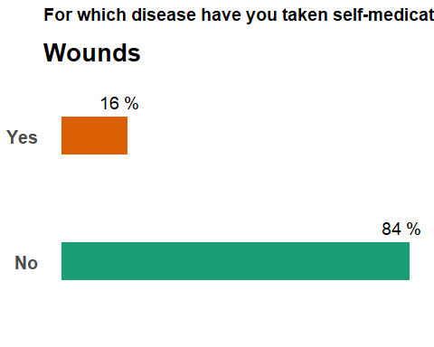

#What do you consider while selecting the drug for self-medication?

price : Price

selfmed %>%  
 filter(!is.na(price)) %>%  
 group_by(price) %>%  
 summarise(counts = n()) %>%  
 mutate(percentage= round((counts / sum(counts))*100)) %>%  
 ggplot(aes(x= price,  
 y= percentage,  
 fill= price)) +  
 geom_bar(width = 0.3,  
 stat = "identity") +  
 coord_flip() +  
 geom_text(  
 aes(label = paste(percentage, "%")),  
 size= 5,  
 vjust = -2,  
 hjust= 0.7  
 ) +  
 labs(title = "What do you consider while selecting the drug for self-medication?",  
 subtitle = "Price") +  
 pie_theme +  
 theme(legend.position = "none",  
 plot.subtitle = element_text(face = "bold",  
 size = 20,  
 vjust = -1.5)) +  
 scale_fill_brewer(palette = "Set1")

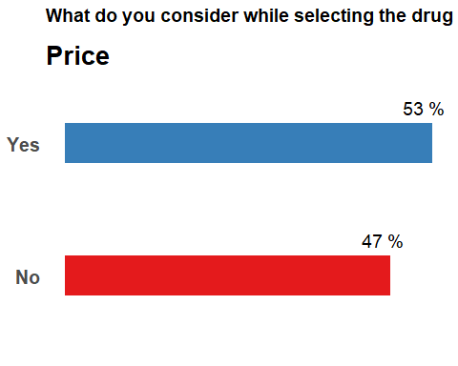

company : Pharmaceutical Company

selfmed %>%  
 filter(!is.na(company)) %>%  
 group_by(company) %>%  
 summarise(counts = n()) %>%  
 mutate(percentage= round((counts / sum(counts))*100)) %>%  
 ggplot(aes(x= company,  
 y= percentage,  
 fill= company)) +  
 geom_bar(width = 0.3,  
 stat = "identity") +  
 coord_flip() +  
 geom_text(  
 aes(label = paste(percentage, "%")),  
 size= 5,  
 vjust = -2,  
 hjust= 0.7  
 ) +  
 labs(title = "What do you consider while selecting the drug for self-medication?",  
 subtitle = "Pharmaceutical company") +  
 pie_theme +  
 theme(legend.position = "none",  
 plot.subtitle = element_text(face = "bold",  
 size = 20,  
 vjust = -1.5)) +  
 scale_fill_brewer(palette = "Set1")

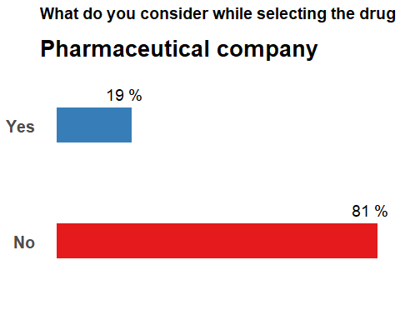

type : Type of medicine

selfmed %>%  
 filter(!is.na(type)) %>%  
 group_by(type) %>%  
 summarise(counts = n()) %>%  
 mutate(percentage= round((counts / sum(counts))*100)) %>%  
 ggplot(aes(x= type,  
 y= percentage,  
 fill= type)) +  
 geom_bar(width = 0.3,  
 stat = "identity") +  
 coord_flip() +  
 geom_text(  
 aes(label = paste(percentage, "%")),  
 size= 5,  
 vjust = -2,  
 hjust= 0.7  
 ) +  
 labs(title = "What do you consider while selecting the drug for self-medication?",  
 subtitle = "Type of medicine") +  
 pie_theme +  
 theme(legend.position = "none",  
 plot.subtitle = element_text(face = "bold",  
 size = 20,  
 vjust = -1.5)) +  
 scale_fill_brewer(palette = "Set1")

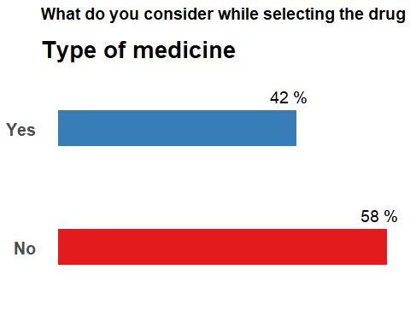

#Where do you obtain your drugs for self-medication?

ps : Pharmacy shop

selfmed %>%  
 filter(!is.na(ps)) %>%  
 group_by(ps) %>%  
 summarise(counts = n()) %>%  
 mutate(percentage= round((counts / sum(counts))*100)) %>%  
 ggplot(aes(x= ps,  
 y= percentage,  
 fill= ps)) +  
 geom_bar(width = 0.3,  
 stat = "identity") +  
 coord_flip() +  
 geom_text(  
 aes(label = paste(percentage, "%")),  
 size= 5,  
 vjust = -2,  
 hjust= 0.7  
 ) +  
 labs(title = "Where do you obtain your drugs for self-medication?",  
 subtitle = "Pharmacy shop") +  
 pie_theme +  
 theme(legend.position = "none",  
 plot.subtitle = element_text(face = "bold",  
 size = 20,  
 vjust = -1.5)) +  
 scale_fill_brewer(palette = "Set1")

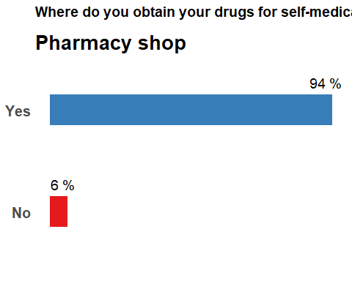

os : Online shopping

selfmed %>%  
 filter(!is.na(os)) %>%  
 group_by(os) %>%  
 summarise(counts = n()) %>%  
 mutate(percentage= round((counts / sum(counts))*100)) %>%  
 ggplot(aes(x= os,  
 y= percentage,  
 fill= os)) +  
 geom_bar(width = 0.3,  
 stat = "identity") +  
 coord_flip() +  
 geom_text(  
 aes(label = paste(percentage, "%")),  
 size= 5,  
 vjust = -2,  
 hjust= 0.7  
 ) +  
 labs(title = "Where do you obtain your drugs for self-medication?",  
 subtitle = "Online shopping") +  
 pie_theme +  
 theme(legend.position = "none",  
 plot.subtitle = element_text(face = "bold",  
 size = 20,  
 vjust = -1.5)) +  
 scale_fill_brewer(palette = "Set1")

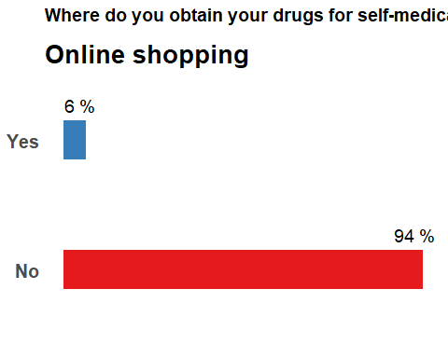

mr : Medical representatives

selfmed %>%  
 filter(!is.na(mr)) %>%  
 group_by(mr) %>%  
 summarise(counts = n()) %>%  
 mutate(percentage= round((counts / sum(counts))*100)) %>%  
 ggplot(aes(x= mr,  
 y= percentage,  
 fill= mr)) +  
 geom_bar(width = 0.3,  
 stat = "identity") +  
 coord_flip() +  
 geom_text(  
 aes(label = paste(percentage, "%")),  
 size= 5,  
 vjust = -2,  
 hjust= 0.7  
 ) +  
 labs(title = "Where do you obtain your drugs for self-medication?",  
 subtitle = "Medical representatives") +  
 pie_theme +  
 theme(legend.position = "none",  
 plot.subtitle = element_text(face = "bold",  
 size = 20,  
 vjust = -1.5)) +  
 scale_fill_brewer(palette = "Set1")

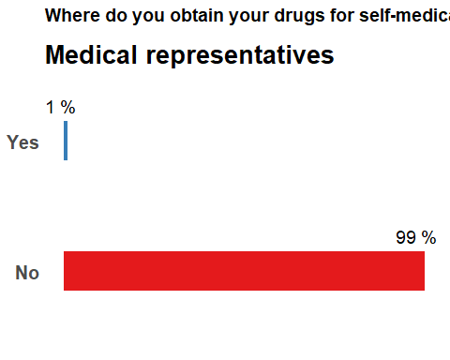

phc : Primary health care centre

selfmed %>%  
 filter(!is.na(phc)) %>%  
 group_by(phc) %>%  
 summarise(counts = n()) %>%  
 mutate(percentage= round((counts / sum(counts))*100)) %>%  
 ggplot(aes(x= phc,  
 y= percentage,  
 fill= phc)) +  
 geom_bar(width = 0.3,  
 stat = "identity") +  
 coord_flip() +  
 geom_text(  
 aes(label = paste(percentage, "%")),  
 size= 5,  
 vjust = -2,  
 hjust= 0.7  
 ) +  
 labs(title = "Where do you obtain your drugs for self-medication?",  
 subtitle = "Primary healthcare center") +  
 pie_theme +  
 theme(legend.position = "none",  
 plot.subtitle = element_text(face = "bold",  
 size = 20,  
 vjust = -1.5)) +  
 scale_fill_brewer(palette = "Set1")

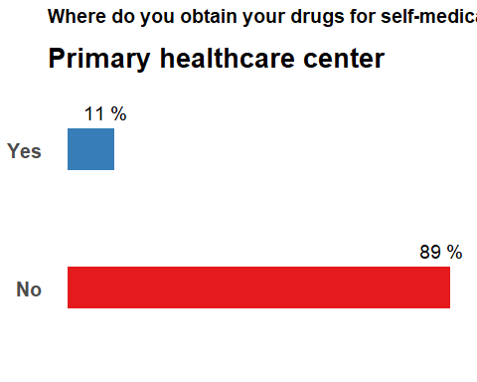

ff : Friends / family

selfmed %>%  
 filter(!is.na(ff)) %>%  
 group_by(ff) %>%  
 summarise(counts = n()) %>%  
 mutate(percentage= round((counts / sum(counts))*100)) %>%  
 ggplot(aes(x= ff,  
 y= percentage,  
 fill= ff)) +  
 geom_bar(width = 0.3,  
 stat = "identity") +  
 coord_flip() +  
 geom_text(  
 aes(label = paste(percentage, "%")),  
 size= 5,  
 vjust = -2,  
 hjust= 0.7  
 ) +  
 labs(title = "Where do you obtain your drugs for self-medication?",  
 subtitle = "Friends / family") +  
 pie_theme +  
 theme(legend.position = "none",  
 plot.subtitle = element_text(face = "bold",  
 size = 20,  
 vjust = -1.5)) +  
 scale_fill_brewer(palette = "Set1")

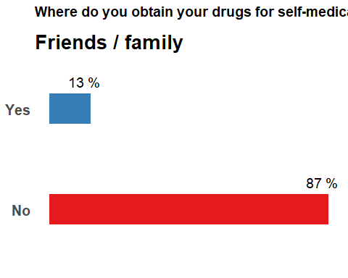

#Do you check the prescribing information before self-medication?

selfmed %>%  
 filter(!is.na(Do.you.check.the.prescribing.information.before.selfâ..medicating.)) %>%  
 group_by(Do.you.check.the.prescribing.information.before.selfâ..medicating.) %>%  
 summarise(counts = n()) %>%  
 mutate(percentage= round((counts / sum(counts))*100)) %>%  
 ggplot(  
 aes(x= "",  
 y= percentage,  
 fill= Do.you.check.the.prescribing.information.before.selfâ..medicating.)  
 )+  
 geom_bar(stat = "identity")+   
 coord_polar(theta = "y")+  
 geom_text(  
 aes(label = paste(percentage, "%")),  
 position = position_stack(vjust = 0.5),  
 , size = 8  
 ) +  
 labs(fill= "Do you check the prescribing information before self-medication?")+  
 pie_theme +  
 scale_fill_brewer(palette = "Set2")

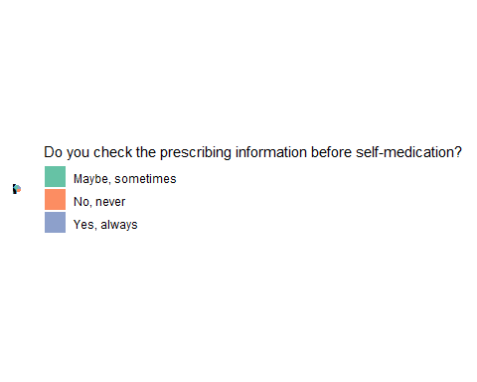

#If answer is yes or maybe, how much did you understand from the instructions?

selfmed %>%  
 filter(!is.na(If.your.answer.is.Yes..always.or.Yes..sometimes.then..How.much.did.you.understand.from.the.instructions.of.prescribing.information.)) %>%  
 group_by(If.your.answer.is.Yes..always.or.Yes..sometimes.then..How.much.did.you.understand.from.the.instructions.of.prescribing.information.) %>%  
 summarise(counts = n()) %>%  
 mutate(percentage= round((counts / sum(counts))*100)) %>%  
 ggplot(aes(x= If.your.answer.is.Yes..always.or.Yes..sometimes.then..How.much.did.you.understand.from.the.instructions.of.prescribing.information.,  
 y= percentage,  
 fill= If.your.answer.is.Yes..always.or.Yes..sometimes.then..How.much.did.you.understand.from.the.instructions.of.prescribing.information.)) +  
 geom_bar(width = 0.3,  
 stat = "identity") +  
 coord_flip() +  
 geom_text(  
 aes(label = paste(percentage, "%")),  
 size= 5,  
 vjust = -2,  
 hjust= 0.7  
 ) +  
 labs(title = "If answer is yes or maybe, how much did you understand from the instructions?") +  
 pie_theme +  
 theme(legend.position = "none",  
 plot.subtitle = element_text(face = "bold",  
 size = 20,  
 vjust = -1.5)) +  
 scale_fill_brewer(palette = "Dark2")

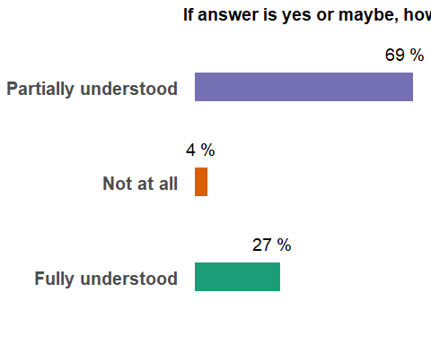

#Have you ever experienced adverse events with self-medication?

selfmed %>%  
 filter(!is.na(X9..Have.you.ever.experienced.adverse.events.with.selfâ..medication.)) %>%  
 group_by(X9..Have.you.ever.experienced.adverse.events.with.selfâ..medication.) %>%  
 summarise(counts = n()) %>%  
 mutate(percentage= round((counts / sum(counts))*100)) %>%  
 ggplot(  
 aes(x= "",  
 y= percentage,  
 fill= X9..Have.you.ever.experienced.adverse.events.with.selfâ..medication.)  
 )+  
 geom_bar(stat = "identity")+   
 coord_polar(theta = "y")+  
 geom_text(  
 aes(label = paste(percentage, "%")),  
 position = position_stack(vjust = 0.5),  
 , size = 8  
 ) +  
 labs(fill= "Have you ever experienced adverse events with self-medication?")+  
 pie_theme +  
 scale_fill_brewer(palette = "Set2")

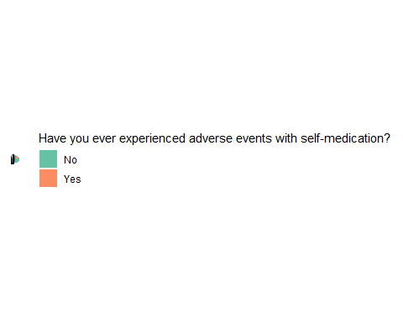

#If yes, Explain

selfmed %>%  
 filter(!is.na(If.yes...Explain)) %>%  
 select(If.yes...Explain)

## If.yes...Explain  
## 1 Headache nausea  
## 2 nausea and vomiting  
## 3 Nausia, headache  
## 4 Headache, nausea and vomiting  
## 5 Headache, fever, nausea, anorexia and diarrhea  
## 6 Dizziness and headache  
## 7 Some abdominal pain

#If answer is yes, what did you do for the adverse event you experienced?

gtpd : Go to private doctor

selfmed %>%  
 filter(!is.na(gtpd)) %>%  
 group_by(gtpd) %>%  
 summarise(counts = n()) %>%  
 mutate(percentage= round((counts / sum(counts))*100)) %>%  
 ggplot(  
 aes(x= "",  
 y= percentage,  
 fill= gtpd)  
 )+  
 geom_bar(stat = "identity")+   
 coord_polar(theta = "y")+  
 geom_text(  
 aes(label = paste(percentage, "%")),  
 position = position_stack(vjust = 0.6),  
 , size = 8  
 ) +  
 labs(title = "What did you do for the adverse event you experienced?",  
 fill= "Go to private doctor")+  
 pie_theme +  
 scale_fill_brewer(palette = "Set2")

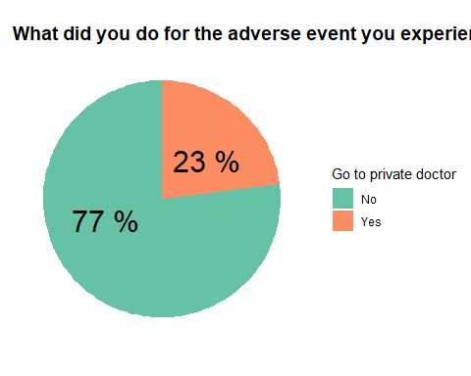

gtph : Go to pharmacist

selfmed %>%  
 filter(!is.na(gtph)) %>%  
 group_by(gtph) %>%  
 summarise(counts = n()) %>%  
 mutate(percentage= round((counts / sum(counts))*100)) %>%  
 ggplot(  
 aes(x= "",  
 y= percentage,  
 fill= gtph)  
 )+  
 geom_bar(stat = "identity")+   
 coord_polar(theta = "y")+  
 geom_text(  
 aes(label = paste(percentage, "%")),  
 position = position_stack(vjust = 0.5),  
 , size = 5  
 ) +  
 labs(title = "What did you do for the adverse event you experienced?",  
 fill= "Go to pharmacist")+  
 pie_theme +  
 scale_fill_brewer(palette = "Set2")

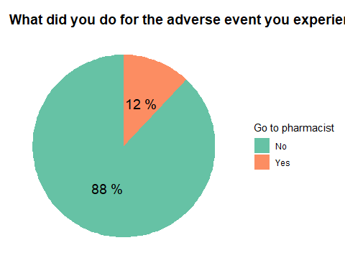

gtphc : Go to primary health care center

selfmed %>%  
 filter(!is.na(gtphc)) %>%  
 group_by(gtphc) %>%  
 summarise(counts = n()) %>%  
 mutate(percentage= round((counts / sum(counts))*100)) %>%  
 ggplot(  
 aes(x= "",  
 y= percentage,  
 fill= gtphc)  
 )+  
 geom_bar(stat = "identity")+   
 coord_polar(theta = "y")+  
 geom_text(  
 aes(label = paste(percentage, "%")),  
 position = position_stack(vjust = 0.5),  
 , size = 5  
 ) +  
 labs(title = "What did you do for the adverse event you experienced?",  
 fill= "Go to primary healthcare center")+  
 pie_theme +  
 scale_fill_brewer(palette = "Set2")

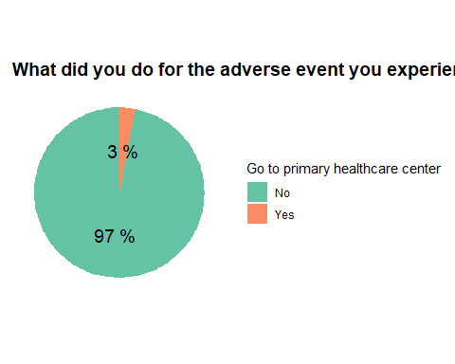

stm : Stop taking medication

selfmed %>%  
 filter(!is.na(stm)) %>%  
 group_by(stm) %>%  
 summarise(counts = n()) %>%  
 mutate(percentage= round((counts / sum(counts))*100)) %>%  
 ggplot(  
 aes(x= "",  
 y= percentage,  
 fill= stm)  
 )+  
 geom_bar(stat = "identity")+   
 coord_polar(theta = "y")+  
 geom_text(  
 aes(label = paste(percentage, "%")),  
 position = position_stack(vjust = 0.5),  
 , size = 5  
 ) +  
 labs(title = "What did you do for the adverse event you experienced?",  
 fill= "Stop taking medication")+  
 pie_theme +  
 scale_fill_brewer(palette = "Set2")

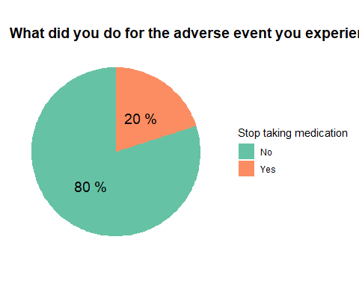

#Are you taking self-medication for any chronic disease?

selfmed %>%  
 filter(!is.na(Are.you.taking.selfâ..medication.for.any.chronic.disease.)) %>%  
 group_by(Are.you.taking.selfâ..medication.for.any.chronic.disease.) %>%  
 summarise(counts = n()) %>%  
 mutate(percentage= round((counts / sum(counts))*100)) %>%  
 ggplot(  
 aes(x= "",  
 y= percentage,  
 fill= Are.you.taking.selfâ..medication.for.any.chronic.disease.)  
 )+  
 geom_bar(stat = "identity")+   
 coord_polar(theta = "y")+  
 geom_text(  
 aes(label = paste(percentage, "%")),  
 position = position_stack(vjust = 0.5),  
 , size = 5  
 ) +  
 labs(fill= "Are you taking self-medication for any chronic disease?")+  
 pie_theme +  
 scale_fill_brewer(palette = "Set2")

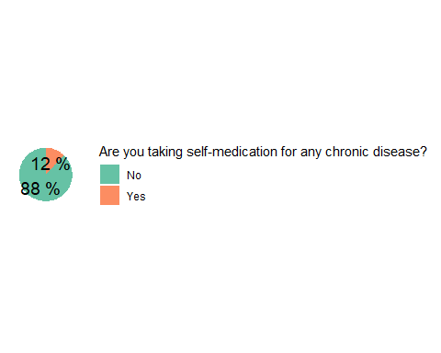

#If answer to the question above is yes, then How long you have been taking self‐medication for any chronic disease?

selfmed %>%  
 filter(!is.na(If.answer.to.the.question.above.is.yes..then..How.long.you.have.been.taking.selfâ..medication.for.any.chronic.disease.)) %>%  
 select(If.answer.to.the.question.above.is.yes..then..How.long.you.have.been.taking.selfâ..medication.for.any.chronic.disease.)

## If.answer.to.the.question.above.is.yes..then..How.long.you.have.been.taking.selfâ..medication.for.any.chronic.disease.  
## 1 Dm  
## 2 2 months  
## 3 6month  
## 4 5month  
## 5 Gout - 3 months  
## 6 Diarrhea- 1 month  
## 7 Diarrhea- 2 months  
## 8 2years

#Did you have any infection in the last three months?

selfmed %>%  
 filter(!is.na(Did.you.have.any.infection.in.last.three.months.)) %>%  
 group_by(Did.you.have.any.infection.in.last.three.months.) %>%  
 summarise(counts = n()) %>%  
 mutate(percentage= round((counts / sum(counts))*100)) %>%  
 ggplot(  
 aes(x= "",  
 y= percentage,  
 fill=Did.you.have.any.infection.in.last.three.months.)  
 )+  
 geom_bar(stat = "identity")+   
 coord_polar(theta = "y")+  
 geom_text(  
 aes(label = paste(percentage, "%")),  
 position = position_stack(vjust = 0.5),  
 , size = 5  
 ) +  
 labs(fill= "Did you have any infection in the last three months?")+  
 pie_theme +  
 scale_fill_brewer(palette = "Set2")

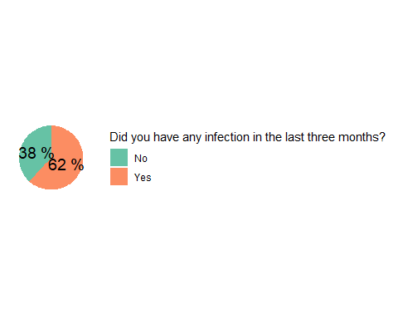

#Have you ever self‐medicated yourself with anti‐infective?

selfmed %>%  
 filter(!is.na(Have.you.ever.selfâ..medicated.yourself.with.antiâ..infective.)) %>%  
 group_by(Have.you.ever.selfâ..medicated.yourself.with.antiâ..infective.) %>%  
 summarise(counts = n()) %>%  
 mutate(percentage= round((counts / sum(counts))*100)) %>%  
 ggplot(  
 aes(x= "",  
 y= percentage,  
 fill=Have.you.ever.selfâ..medicated.yourself.with.antiâ..infective.)  
 )+  
 geom_bar(stat = "identity")+   
 coord_polar(theta = "y")+  
 geom_text(  
 aes(label = paste(percentage, "%")),  
 position = position_stack(vjust = 0.5),  
 , size = 5  
 ) +  
 labs(fill= "Have you ever self‐medicated yourself with anti‐infective")+  
 pie_theme +  
 scale_fill_brewer(palette = "Set2")

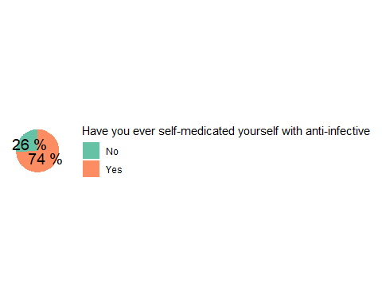

#For which of the following diseases did you self‐medicate with anti‐infectives?

eyeinf2 : Eye infection

selfmed %>%  
 filter(!is.na(eyeinf2)) %>%  
 group_by(eyeinf2) %>%  
 summarise(counts = n()) %>%  
 mutate(percentage= round((counts / sum(counts))*100)) %>%  
 ggplot(  
 aes(x= "",  
 y= percentage,  
 fill=eyeinf2)  
 )+  
 geom_bar(stat = "identity")+   
 coord_polar(theta = "y")+  
 geom_text(  
 aes(label = paste(percentage, "%")),  
 position = position_stack(vjust = 0.5),  
 , size = 5  
 ) +  
 labs(title = "For which of the following diseases did you self‐medicate with anti‐infectives?",  
 fill= "Eye infection")+  
 pie_theme +  
 scale_fill_brewer(palette = "BrBG")

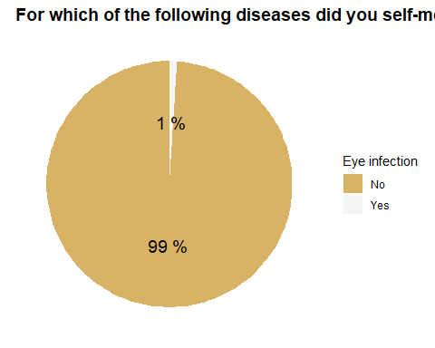

skinop2 : Skin infection of open areas

selfmed %>%  
 filter(!is.na(skinop2)) %>%  
 group_by(skinop2) %>%  
 summarise(counts = n()) %>%  
 mutate(percentage= round((counts / sum(counts))*100)) %>%  
 ggplot(  
 aes(x= "",  
 y= percentage,  
 fill=skinop2)  
 )+  
 geom_bar(stat = "identity")+   
 coord_polar(theta = "y")+  
 geom_text(  
 aes(label = paste(percentage, "%")),  
 position = position_stack(vjust = 0.5),  
 , size = 5  
 ) +  
 labs(title = "For which of the following diseases did you self‐medicate with anti‐infectives?",  
 fill= "Skin infection of open areas")+  
 pie_theme +  
 scale_fill_brewer(palette = "BrBG")

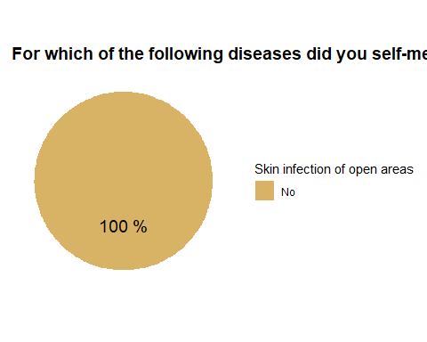

skinco : Skin infection of covered areas

selfmed %>%  
 filter(!is.na(skinco)) %>%  
 group_by(skinco) %>%  
 summarise(counts = n()) %>%  
 mutate(percentage= round((counts / sum(counts))*100)) %>%  
 ggplot(  
 aes(x= "",  
 y= percentage,  
 fill=skinco)  
 )+  
 geom_bar(stat = "identity")+   
 coord_polar(theta = "y")+  
 geom_text(  
 aes(label = paste(percentage, "%")),  
 position = position_stack(vjust = 0.5),  
 , size = 5  
 ) +  
 labs(title = "For which of the following diseases did you self‐medicate with anti‐infectives?",  
 fill= "Skin infection of covered areas")+  
 pie_theme +  
 scale_fill_brewer(palette = "BrBG")

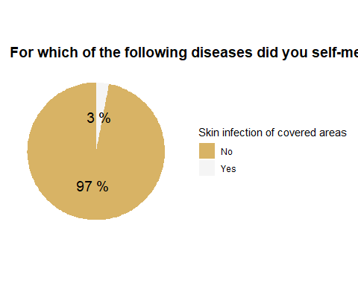

runnose2 : Running nose

selfmed %>%  
 filter(!is.na(runnose2)) %>%  
 group_by(runnose2) %>%  
 summarise(counts = n()) %>%  
 mutate(percentage= round((counts / sum(counts))*100)) %>%  
 ggplot(  
 aes(x= "",  
 y= percentage,  
 fill=runnose2)  
 )+  
 geom_bar(stat = "identity")+   
 coord_polar(theta = "y")+  
 geom_text(  
 aes(label = paste(percentage, "%")),  
 position = position_stack(vjust = 0.5),  
 , size = 5  
 ) +  
 labs(title = "For which of the following diseases did you self‐medicate with anti‐infectives?",  
 fill= "Running nose")+  
 pie_theme +  
 scale_fill_brewer(palette = "BrBG")

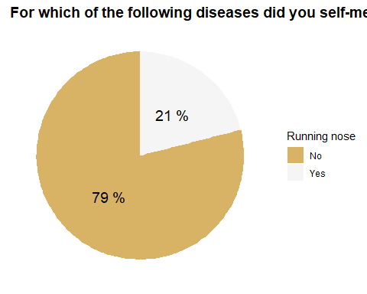

earpain2 : Ear pain

selfmed %>%  
 filter(!is.na(earpain2)) %>%  
 group_by(earpain2) %>%  
 summarise(counts = n()) %>%  
 mutate(percentage= round((counts / sum(counts))*100)) %>%  
 ggplot(  
 aes(x= "",  
 y= percentage,  
 fill=earpain2)  
 )+  
 geom_bar(stat = "identity")+   
 coord_polar(theta = "y")+  
 geom_text(  
 aes(label = paste(percentage, "%")),  
 position = position_stack(vjust = 0.5),  
 , size = 5  
 ) +  
 labs(title = "For which of the following diseases did you self‐medicate with anti‐infectives?",  
 fill= "Ear pain")+  
 pie_theme +  
 scale_fill_brewer(palette = "BrBG")

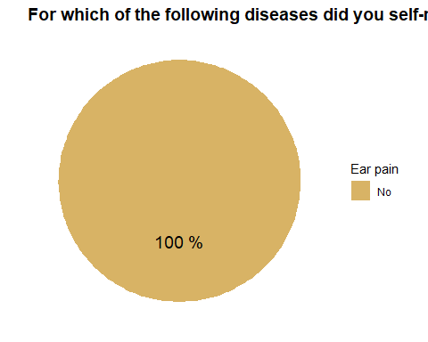

genitalinf2 : Genital infection

selfmed %>%  
 filter(!is.na(genitalinf2)) %>%  
 group_by(genitalinf2) %>%  
 summarise(counts = n()) %>%  
 mutate(percentage= round((counts / sum(counts))*100)) %>%  
 ggplot(  
 aes(x= "",  
 y= percentage,  
 fill=genitalinf2)  
 )+  
 geom_bar(stat = "identity")+   
 coord_polar(theta = "y")+  
 geom_text(  
 aes(label = paste(percentage, "%")),  
 position = position_stack(vjust = 0.5),  
 , size = 5  
 ) +  
 labs(title = "For which of the following diseases did you self‐medicate with anti‐infectives?",  
 fill= "Genital infection")+  
 pie_theme +  
 scale_fill_brewer(palette = "BrBG")

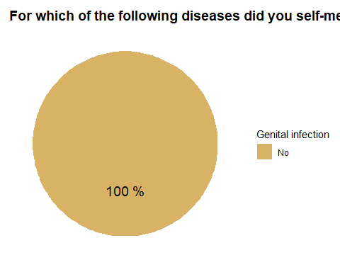

cough2 : Cough

selfmed %>%  
 filter(!is.na(cough2)) %>%  
 group_by(cough2) %>%  
 summarise(counts = n()) %>%  
 mutate(percentage= round((counts / sum(counts))*100)) %>%  
 ggplot(  
 aes(x= "",  
 y= percentage,  
 fill=cough2)  
 )+  
 geom_bar(stat = "identity")+   
 coord_polar(theta = "y")+  
 geom_text(  
 aes(label = paste(percentage, "%")),  
 position = position_stack(vjust = 0.5),  
 , size = 5  
 ) +  
 labs(title = "For which of the following diseases did you self‐medicate with anti‐infectives?",  
 fill= "Cough")+  
 pie_theme +  
 scale_fill_brewer(palette = "BrBG")

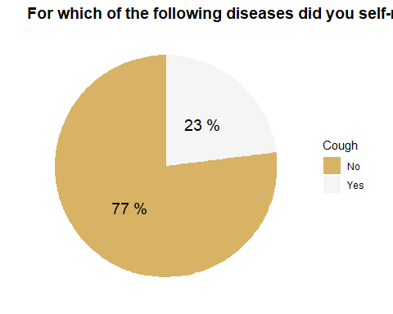

soarthroat : sore throat

selfmed %>%  
 filter(!is.na(soarthroat)) %>%  
 group_by(soarthroat) %>%  
 summarise(counts = n()) %>%  
 mutate(percentage= round((counts / sum(counts))*100)) %>%  
 ggplot(  
 aes(x= "",  
 y= percentage,  
 fill=soarthroat)  
 )+  
 geom_bar(stat = "identity")+   
 coord_polar(theta = "y")+  
 geom_text(  
 aes(label = paste(percentage, "%")),  
 position = position_stack(vjust = 0.5),  
 , size = 5  
 ) +  
 labs(title = "For which of the following diseases did you self‐medicate with anti‐infectives?",  
 fill= "Sore throat")+  
 pie_theme +  
 scale_fill_brewer(palette = "BrBG")

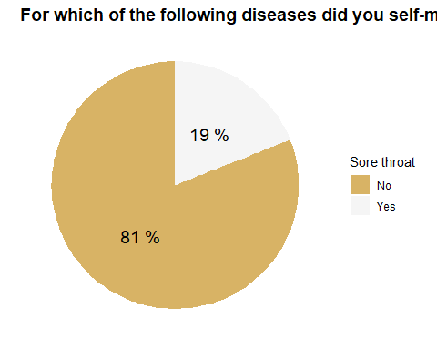

urination2 : Urinary problem

selfmed %>%  
 filter(!is.na(urination2)) %>%  
 group_by(urination2) %>%  
 summarise(counts = n()) %>%  
 mutate(percentage= round((counts / sum(counts))*100)) %>%  
 ggplot(  
 aes(x= "",  
 y= percentage,  
 fill=urination2)  
 )+  
 geom_bar(stat = "identity")+   
 coord_polar(theta = "y")+  
 geom_text(  
 aes(label = paste(percentage, "%")),  
 position = position_stack(vjust = 0.5),  
 , size = 5  
 ) +  
 labs(title = "For which of the following diseases did you self‐medicate with anti‐infectives?",  
 fill= "Urinary problem")+  
 pie_theme +  
 scale_fill_brewer(palette = "BrBG")

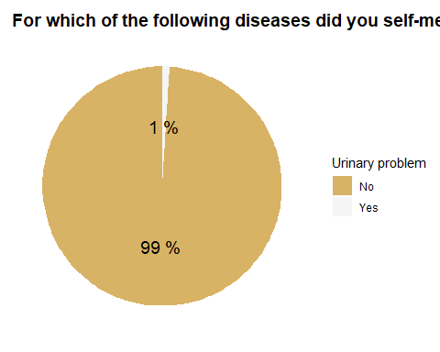

dentalpain2 : Dental pain

selfmed %>%  
 filter(!is.na(dentalpain2)) %>%  
 group_by(dentalpain2) %>%  
 summarise(counts = n()) %>%  
 mutate(percentage= round((counts / sum(counts))*100)) %>%  
 ggplot(  
 aes(x= "",  
 y= percentage,  
 fill=dentalpain2)  
 )+  
 geom_bar(stat = "identity")+   
 coord_polar(theta = "y")+  
 geom_text(  
 aes(label = paste(percentage, "%")),  
 position = position_stack(vjust = 0.5),  
 , size = 5  
 ) +  
 labs(title = "For which of the following diseases did you self‐medicate with anti‐infectives?",  
 fill= "Dental pain")+  
 pie_theme +  
 scale_fill_brewer(palette = "BrBG")

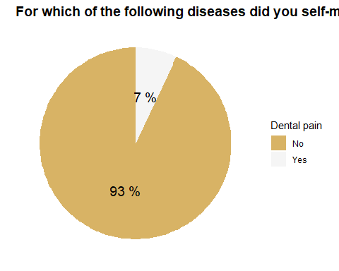

menstrual2 : Menstrual problems

selfmed %>%  
 filter(!is.na(menstrual2)) %>%  
 group_by(menstrual2) %>%  
 summarise(counts = n()) %>%  
 mutate(percentage= round((counts / sum(counts))*100)) %>%  
 ggplot(  
 aes(x= "",  
 y= percentage,  
 fill= menstrual2)  
 )+  
 geom_bar(stat = "identity")+   
 coord_polar(theta = "y")+  
 geom_text(  
 aes(label = paste(percentage, "%")),  
 position = position_stack(vjust = 0.5),  
 , size = 5  
 ) +  
 labs(title = "For which of the following diseases did you self‐medicate with anti‐infectives?",  
 fill= "Menstrual problems")+  
 pie_theme +  
 scale_fill_brewer(palette = "BrBG")

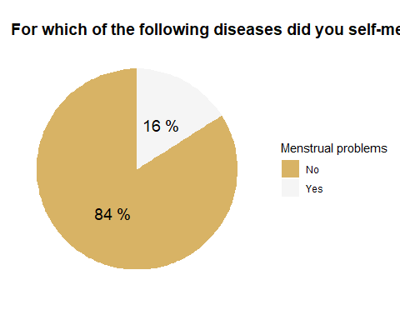

vomiting2 : vomiting

selfmed %>%  
 filter(!is.na(vomiting2)) %>%  
 group_by(vomiting2) %>%  
 summarise(counts = n()) %>%  
 mutate(percentage= round((counts / sum(counts))*100)) %>%  
 ggplot(  
 aes(x= "",  
 y= percentage,  
 fill=vomiting2)  
 )+  
 geom_bar(stat = "identity")+   
 coord_polar(theta = "y")+  
 geom_text(  
 aes(label = paste(percentage, "%")),  
 position = position_stack(vjust = 0.5),  
 , size = 5  
 ) +  
 labs(title = "For which of the following diseases did you self‐medicate with anti‐infectives?",  
 fill= "Vomiting")+  
 pie_theme +  
 scale_fill_brewer(palette = "BrBG")

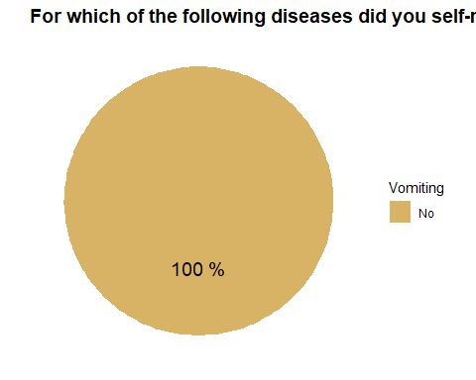

diarrhea2 : Diarrhea

selfmed %>%  
 filter(!is.na(diarrhea2)) %>%  
 group_by(diarrhea2) %>%  
 summarise(counts = n()) %>%  
 mutate(percentage= round((counts / sum(counts))*100)) %>%  
 ggplot(  
 aes(x= "",  
 y= percentage,  
 fill= diarrhea2)  
 )+  
 geom_bar(stat = "identity")+   
 coord_polar(theta = "y")+  
 geom_text(  
 aes(label = paste(percentage, "%")),  
 position = position_stack(vjust = 0.5),  
 , size = 5  
 ) +  
 labs(title = "For which of the following diseases did you self‐medicate with anti‐infectives?",  
 fill= "Diarrhea")+  
 pie_theme +  
 scale_fill_brewer(palette = "BrBG")

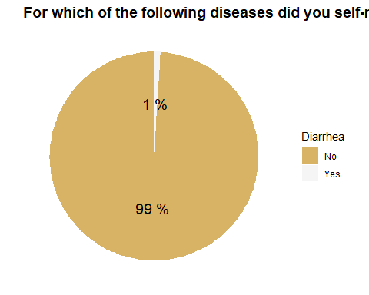

fever2 : Fever

selfmed %>%  
 filter(!is.na(fever2)) %>%  
 group_by(fever2) %>%  
 summarise(counts = n()) %>%  
 mutate(percentage= round((counts / sum(counts))*100)) %>%  
 ggplot(  
 aes(x= "",  
 y= percentage,  
 fill= fever2)  
 )+  
 geom_bar(stat = "identity")+   
 coord_polar(theta = "y")+  
 geom_text(  
 aes(label = paste(percentage, "%")),  
 position = position_stack(vjust = 0.5),  
 , size = 5  
 ) +  
 labs(title = "For which of the following diseases did you self‐medicate with anti‐infectives?",  
 fill= "Fever")+  
 pie_theme +  
 scale_fill_brewer(palette = "BrBG")

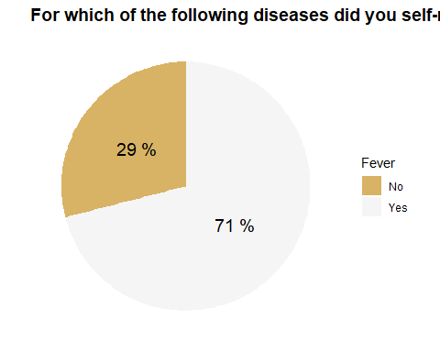

wounds2 : Wounds

selfmed %>%  
 filter(!is.na(wounds2)) %>%  
 group_by(wounds2) %>%  
 summarise(counts = n()) %>%  
 mutate(percentage= round((counts / sum(counts))*100)) %>%  
 ggplot(  
 aes(x= "",  
 y= percentage,  
 fill= wounds2)  
 )+  
 geom_bar(stat = "identity")+   
 coord_polar(theta = "y")+  
 geom_text(  
 aes(label = paste(percentage, "%")),  
 position = position_stack(vjust = 0.5),  
 , size = 5  
 ) +  
 labs(title = "For which of the following diseases did you self‐medicate with anti‐infectives?",  
 fill= "Wounds")+  
 pie_theme +  
 scale_fill_brewer(palette = "BrBG")

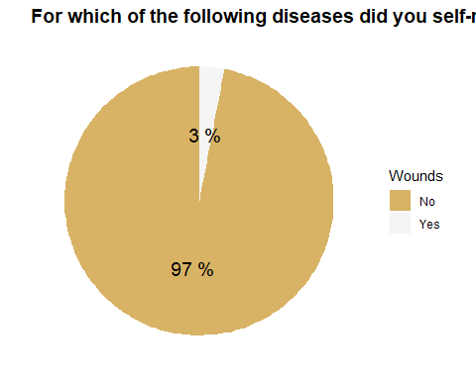

#From the above Which was the most recent infection for which you self medicated?

selfmed %>%  
 filter(!is.na(From.the.above..Which.was.the.most.recent.infection.for.which.you.self.medicated.)) %>%  
 select(From.the.above..Which.was.the.most.recent.infection.for.which.you.self.medicated.)

## From.the.above..Which.was.the.most.recent.infection.for.which.you.self.medicated.  
## 1 Sore throat  
## 2 Urinary problem  
## 3 Dental pain  
## 4 Runny nose  
## 5 Ear  
## 6 Diarrhea  
## 7 fever  
## 8 urinary proplem  
## 9 Fever  
## 10 Running nose  
## 11 Diarrhea  
## 12 Common cold  
## 13 Cough

#How did you know the dosage of anti‐infectives?

ai_dose

selfmed %>%  
 filter(!is.na(ai_dose)) %>%  
 group_by(ai_dose) %>%  
 summarise(counts = n()) %>%  
 mutate(percentage= round((counts / sum(counts))*100)) %>%  
 ggplot(aes(x= ai_dose,  
 y= percentage,  
 fill= ai_dose)) +  
 geom_bar(width = 0.3,  
 stat = "identity") +  
 coord_flip() +  
 geom_text(  
 aes(label = paste(percentage, "%")),  
 size= 5,  
 vjust = -2,  
 hjust= 0.7  
 ) +  
 labs(title = "How did you know the dosage of anti‐infectives?") +  
 pie_theme +  
 theme(legend.position = "none",  
 plot.subtitle = element_text(face = "bold",  
 size = 20,  
 vjust = -1.5)) +  
 scale_fill_brewer(palette = "Dark2")

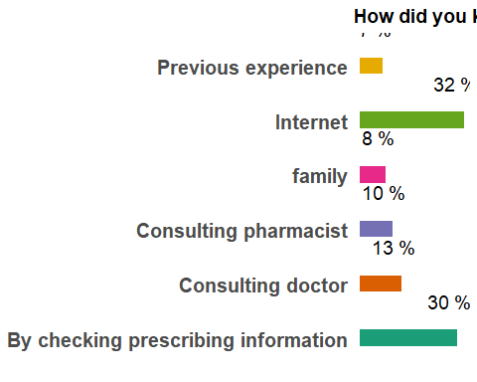

#Did you ever change the dosage of anti‐infectives during the course of self‐medication?

selfmed %>%  
 filter(!is.na(Did.you.ever.change.the.dosage.of.antiâ..infectives.during.the.course.of.selfâ..medication.)) %>%  
 group_by(Did.you.ever.change.the.dosage.of.antiâ..infectives.during.the.course.of.selfâ..medication.) %>%  
 summarise(counts = n()) %>%  
 mutate(percentage= round((counts / sum(counts))*100)) %>%  
 ggplot(aes(x= Did.you.ever.change.the.dosage.of.antiâ..infectives.during.the.course.of.selfâ..medication.,  
 y= percentage,  
 fill= Did.you.ever.change.the.dosage.of.antiâ..infectives.during.the.course.of.selfâ..medication.)) +  
 geom_bar(width = 0.3,  
 stat = "identity") +  
 coord_flip() +  
 geom_text(  
 aes(label = paste(percentage, "%")),  
 size= 5,  
 vjust = -2,  
 hjust= 0.7  
 ) +  
 labs(title = "Did you ever change the dosage of anti‐infectives during the course of self‐medication") +  
 pie_theme +  
 theme(legend.position = "none",  
 plot.subtitle = element_text(face = "bold",  
 size = 20,  
 vjust = -1.5)) +  
 scale_fill_brewer(palette = "Dark2")

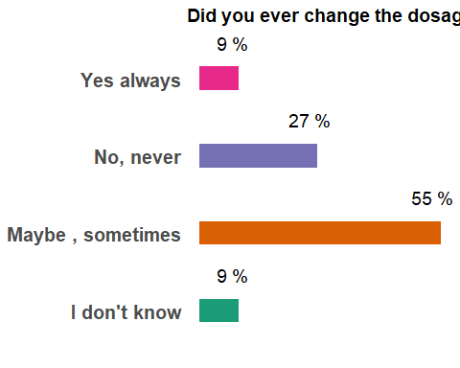

#Why did you change the dosage of anti‐infectives during the course of self‐medication?

dose_change

selfmed %>%  
 filter(!is.na(dose_change)) %>%  
 group_by(dose_change) %>%  
 summarise(counts = n()) %>%  
 mutate(percentage= round((counts / sum(counts))*100)) %>%  
 ggplot(aes(x= dose_change,  
 y= percentage,  
 fill= dose_change)) +  
 geom_bar(width = 0.3,  
 stat = "identity") +  
 coord_flip() +  
 geom_text(  
 aes(label = paste(percentage, "%")),  
 size= 5,  
 vjust = -2,  
 hjust= 0.7  
 ) +  
 labs(title = "Why did you change the dosage of anti‐infectives during the course of self‐medication?") +  
 pie_theme +  
 theme(legend.position = "none",  
 plot.subtitle = element_text(face = "bold",  
 size = 20,  
 vjust = -1.5)) +  
 scale_fill_brewer(palette = "Dark2")

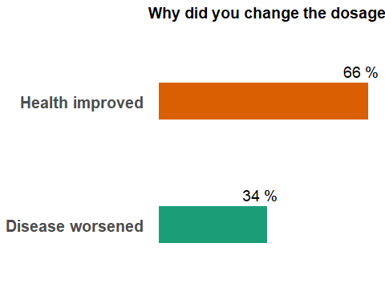

#Last time when you used anti‐infective, did you change that anti‐infective/s during self-medication?

selfmed %>%  
 filter(!is.na(Last.time.when.you.used.antiâ..infective..did.you.change.that.antiâ..infective.s.during.self.medication..)) %>%  
 group_by(Last.time.when.you.used.antiâ..infective..did.you.change.that.antiâ..infective.s.during.self.medication..) %>%  
 summarise(counts = n()) %>%  
 mutate(percentage= round((counts / sum(counts))*100)) %>%  
 ggplot(aes(x= Last.time.when.you.used.antiâ..infective..did.you.change.that.antiâ..infective.s.during.self.medication..,  
 y= percentage,  
 fill= Last.time.when.you.used.antiâ..infective..did.you.change.that.antiâ..infective.s.during.self.medication..)) +  
 geom_bar(width = 0.3,  
 stat = "identity") +  
 coord_flip() +  
 geom_text(  
 aes(label = paste(percentage, "%")),  
 size= 5,  
 vjust = -2,  
 hjust= 0.7  
 ) +  
 labs(title = "Last time when you used anti‐infective, did you change that anti‐infective/s during self-medication?") +  
 pie_theme +  
 theme(legend.position = "none",  
 plot.subtitle = element_text(face = "bold",  
 size = 20,  
 vjust = -1.5)) +  
 scale_fill_brewer(palette = "Dark2")

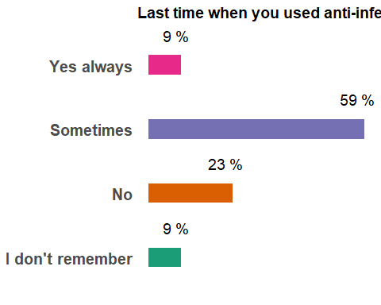

#If yes: Why did you change anti‐infectives during self‐medication?

ai_change

selfmed %>%  
 filter(!is.na(ai_change)) %>%  
 group_by(ai_change) %>%  
 summarise(counts = n()) %>%  
 mutate(percentage= round((counts / sum(counts))*100)) %>%  
 ggplot(aes(x= ai_change,  
 y= percentage,  
 fill= ai_change)) +  
 geom_bar(width = 0.3,  
 stat = "identity") +  
 coord_flip() +  
 geom_text(  
 aes(label = paste(percentage, "%")),  
 size= 5,  
 vjust = -2,  
 hjust= 0.7  
 ) +  
 labs(title = "Why did you change anti‐infectives during self‐medication?") +  
 pie_theme +  
 theme(legend.position = "none",  
 plot.subtitle = element_text(face = "bold",  
 size = 20,  
 vjust = -1.5)) +  
 scale_fill_brewer(palette = "Dark2")

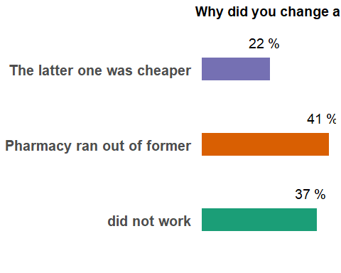

#When did you stop taking anti‐infectives?

ai_stop

selfmed %>%  
 filter(!is.na(ai_stop)) %>%  
 group_by(ai_stop) %>%  
 summarise(counts = n()) %>%  
 mutate(percentage= round((counts / sum(counts))*100)) %>%  
 ggplot(aes(x= ai_stop,  
 y= percentage,  
 fill= ai_stop)) +  
 geom_bar(width = 0.3,  
 stat = "identity") +  
 coord_flip() +  
 geom_text(  
 aes(label = paste(percentage, "%")),  
 size= 5,  
 vjust = -2,  
 hjust= 0.7  
 ) +  
 labs(title = "When did you stop taking anti-infectives?") +  
 pie_theme +  
 theme(legend.position = "none",  
 plot.subtitle = element_text(face = "bold",  
 size = 20,  
 vjust = -1.5)) +  
 scale_fill_brewer(palette = "Dark2")

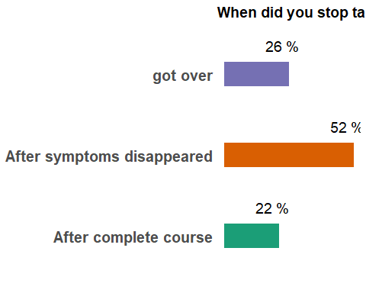

#Where did you get the knowledge about the course of anti‐infectives?

pi : Prescribing information

selfmed %>%  
 filter(!is.na(pi)) %>%  
 group_by(pi) %>%  
 summarise(counts = n()) %>%  
 mutate(percentage= round((counts / sum(counts))*100)) %>%  
 ggplot(  
 aes(x= "",  
 y= percentage,  
 fill= pi)  
 )+  
 geom_bar(stat = "identity")+   
 coord_polar(theta = "y")+  
 geom_text(  
 aes(label = paste(percentage, "%")),  
 position = position_stack(vjust = 0.5),  
 , size = 5  
 ) +  
 labs(title = "Where did you get the knowledge about the course of anti‐infectives?",  
 fill = "Prescribing information")+  
 pie_theme +  
 scale_fill_brewer(palette = "Set2")

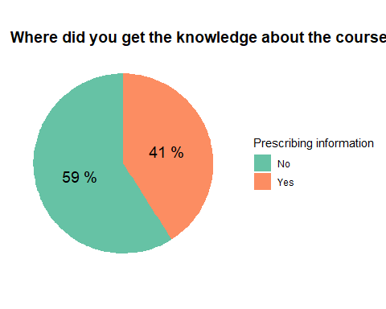

ph : Pharmacist

selfmed %>%  
 filter(!is.na(ph)) %>%  
 group_by(ph) %>%  
 summarise(counts = n()) %>%  
 mutate(percentage= round((counts / sum(counts))*100)) %>%  
 ggplot(  
 aes(x= "",  
 y= percentage,  
 fill= ph)  
 )+  
 geom_bar(stat = "identity")+   
 coord_polar(theta = "y")+  
 geom_text(  
 aes(label = paste(percentage, "%")),  
 position = position_stack(vjust = 0.5),  
 , size = 5  
 ) +  
 labs(title = "Where did you get the knowledge about the course of anti‐infectives?",  
 fill = "Pharmacist")+  
 pie_theme +  
 scale_fill_brewer(palette = "Set2")

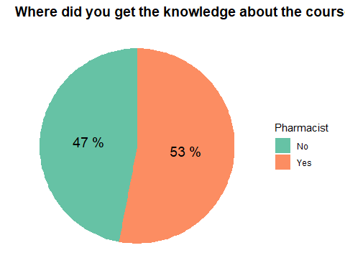

phcc : Primary health care center

selfmed %>%  
 filter(!is.na(phcc)) %>%  
 group_by(phcc) %>%  
 summarise(counts = n()) %>%  
 mutate(percentage= round((counts / sum(counts))*100)) %>%  
 ggplot(  
 aes(x= "",  
 y= percentage,  
 fill= phcc)  
 )+  
 geom_bar(stat = "identity")+   
 coord_polar(theta = "y")+  
 geom_text(  
 aes(label = paste(percentage, "%")),  
 position = position_stack(vjust = 0.5),  
 , size = 5  
 ) +  
 labs(title = "Where did you get the knowledge about the course of anti‐infectives?",  
 fill = "Primary healthcare center")+  
 pie_theme +  
 scale_fill_brewer(palette = "Set2")

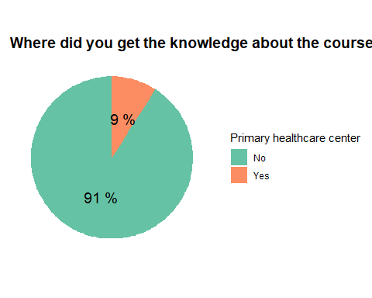

doc : Doctors

selfmed %>%  
 filter(!is.na(doc)) %>%  
 group_by(doc) %>%  
 summarise(counts = n()) %>%  
 mutate(percentage= round((counts / sum(counts))*100)) %>%  
 ggplot(  
 aes(x= "",  
 y= percentage,  
 fill= doc)  
 )+  
 geom_bar(stat = "identity")+   
 coord_polar(theta = "y")+  
 geom_text(  
 aes(label = paste(percentage, "%")),  
 position = position_stack(vjust = 0.5),  
 , size = 5  
 ) +  
 labs(title = "Where did you get the knowledge about the course of anti‐infectives?",  
 fill = "Doctors")+  
 pie_theme +  
 scale_fill_brewer(palette = "Set2")

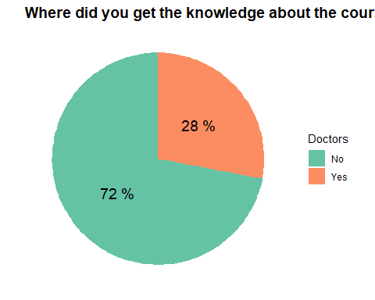

pff : Peers- Family/ Friends

selfmed %>%  
 filter(!is.na(pff)) %>%  
 group_by(pff) %>%  
 summarise(counts = n()) %>%  
 mutate(percentage= round((counts / sum(counts))*100)) %>%  
 ggplot(  
 aes(x= "",  
 y= percentage,  
 fill= pff)  
 )+  
 geom_bar(stat = "identity")+   
 coord_polar(theta = "y")+  
 geom_text(  
 aes(label = paste(percentage, "%")),  
 position = position_stack(vjust = 0.5),  
 , size = 5  
 ) +  
 labs(title = "Where did you get the knowledge about the course of anti‐infectives?",  
 fill = "Peers- Family / friends")+  
 pie_theme +  
 scale_fill_brewer(palette = "Set2")

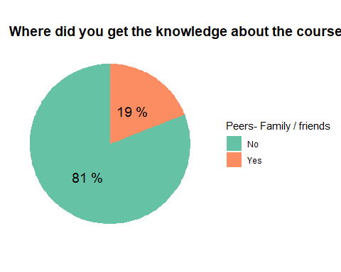

#Health insurance

selfmed %>%  
 filter(!is.na(What.kind.of.health.insurance.do.you.have.this.year.)) %>%  
 group_by(What.kind.of.health.insurance.do.you.have.this.year.) %>%  
 summarise(counts = n()) %>%  
 mutate(percentage= round((counts / sum(counts))*100)) %>%  
 ggplot(aes(x= What.kind.of.health.insurance.do.you.have.this.year.,  
 y= percentage,  
 fill= What.kind.of.health.insurance.do.you.have.this.year.)) +  
 geom_bar(width = 0.3,  
 stat = "identity") +  
 coord_flip() +  
 geom_text(  
 aes(label = paste(percentage, "%")),  
 size= 5,  
 vjust = -2,  
 hjust= 0.7  
 ) +  
 labs(title = "Health insurance") +  
 pie_theme +  
 theme(legend.position = "none",  
 plot.subtitle = element_text(face = "bold",  
 size = 20,  
 vjust = -1.5)) +  
 scale_fill_brewer(palette = "Dark2")

