Contents

**FER13 Dataset** 2

**Plan 1** 2

**Plan 2** 5

**Plan 3** 8

**Plan 4** 10

**Plan 8** 12

**CKPLUS Dataset** 13

**Plan 1** 13

**Plan 2** 17

**Plan 8** 20

**FER2013+ Dataset** 21

**Origin Code** 21

**Plan 3** 23

**A.** **Part 1** 23

**B.** **Part 2** 25

**C.** **Part 3** 27

**D.** **Part 4** 29

**Plan 4** 31

**A.** **Part 1** 31

**B.** **Part 2** 33

# **FER13 Dataset**

## **Plan 1**

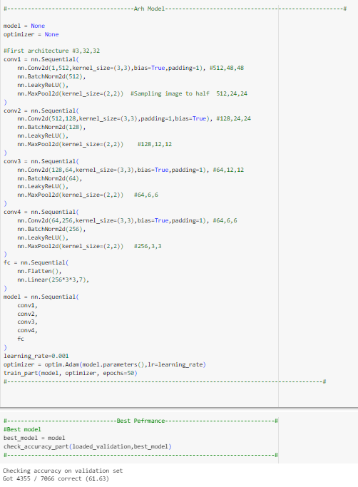

Figure 1 – 1.2

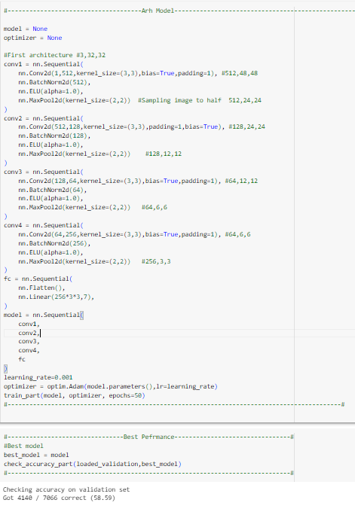

Figure 2 – 1.3

Figure 3 – 1.6

## **Plan 2**

**

Figure 1 – 2.1

Figure 2 – 2.2

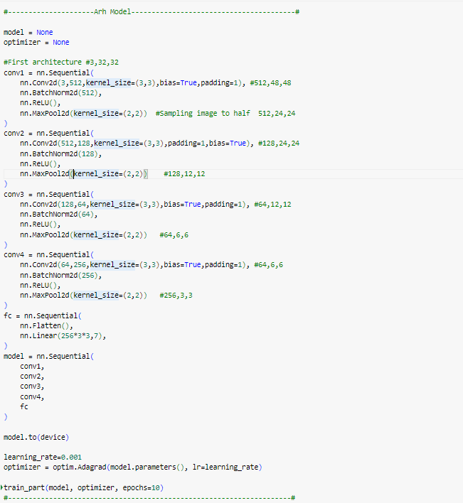

Figure 3 – 2.3

## **Plan 3**

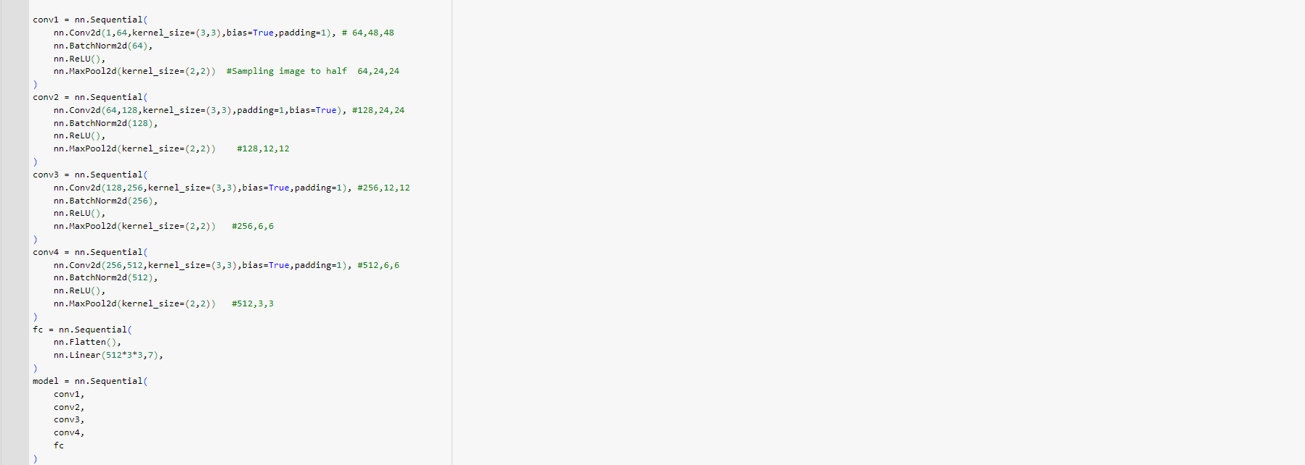

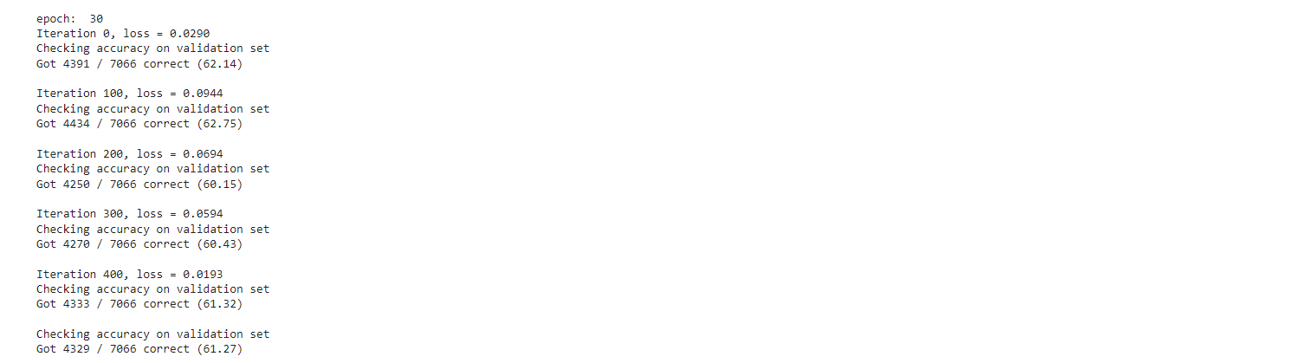

Figure 1 - 3.1

Figure 2 - 3.2

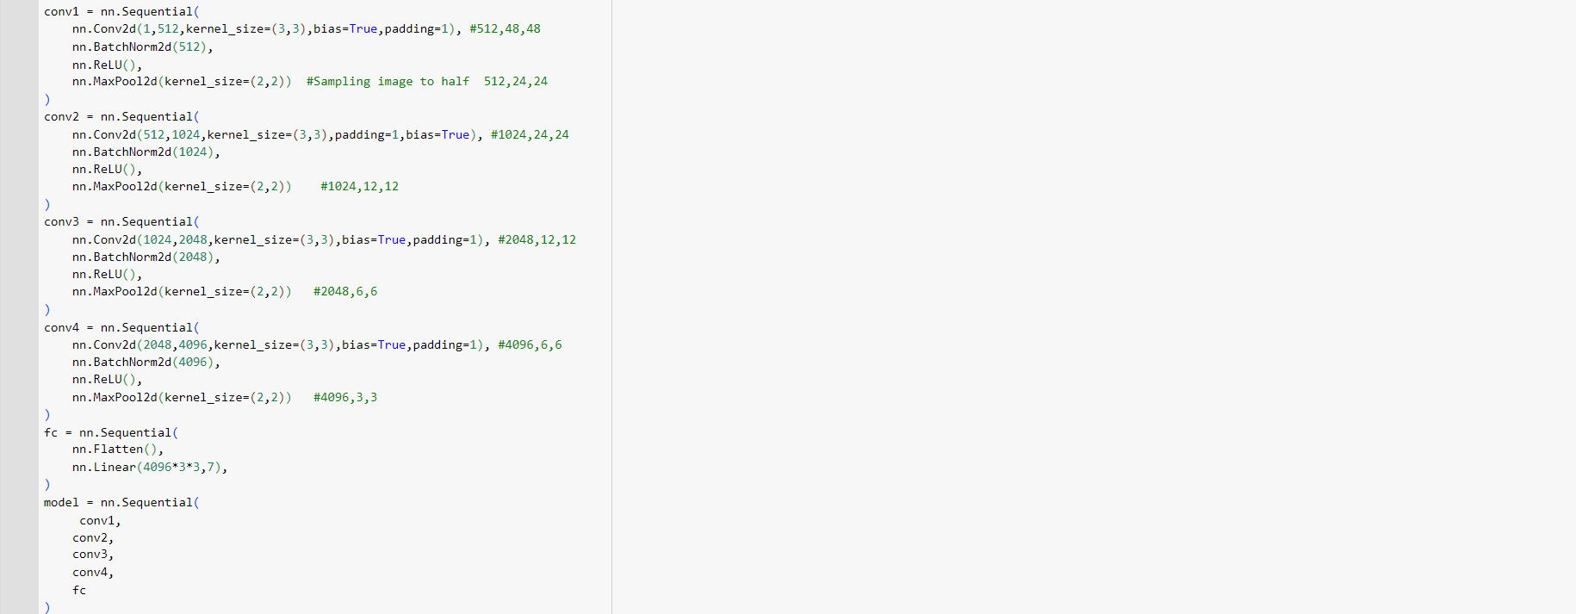

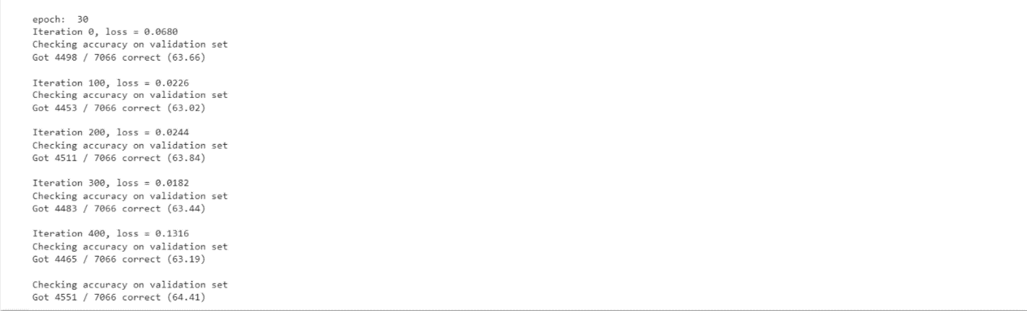

Figure 3 - 3.3

Figure 4 - 3.4

## **Plan 4**

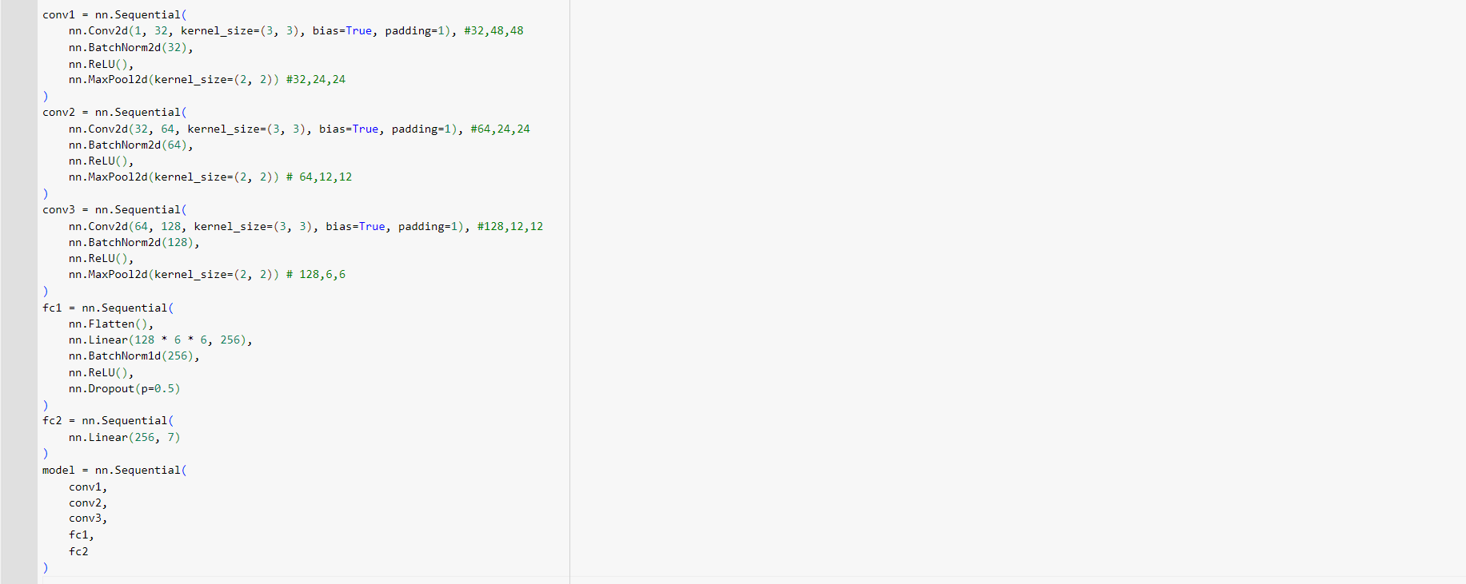

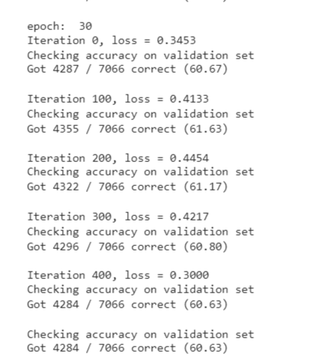

Figure 1 - 4.1

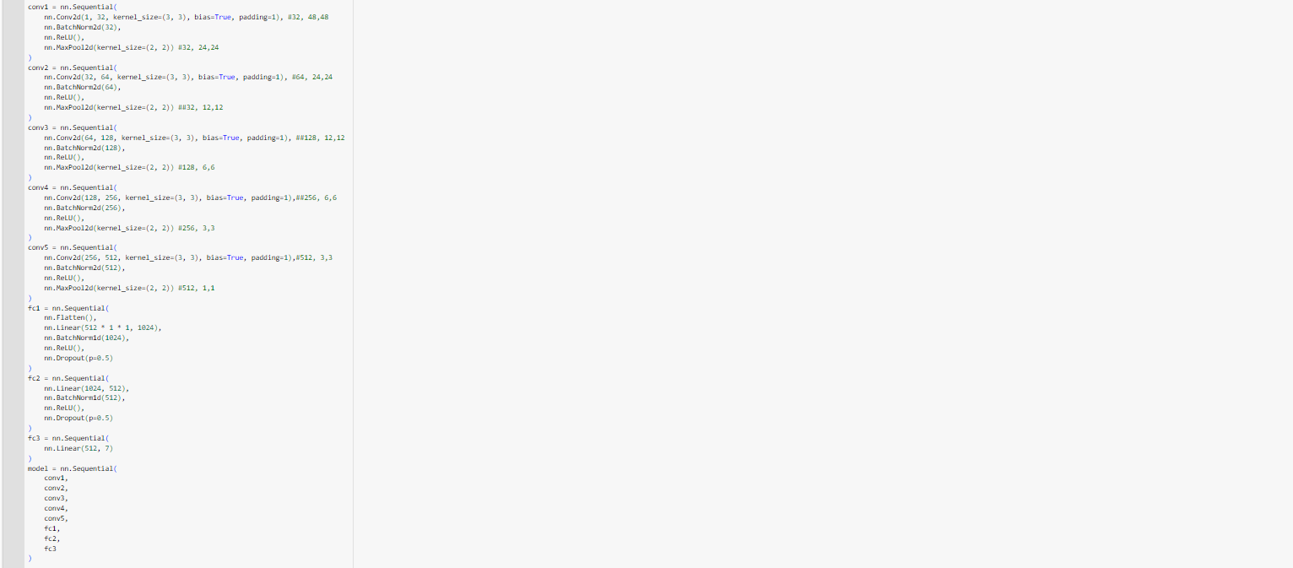

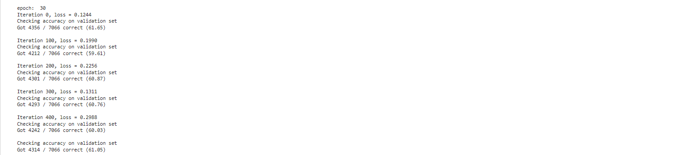

Figure 2 - 4.2

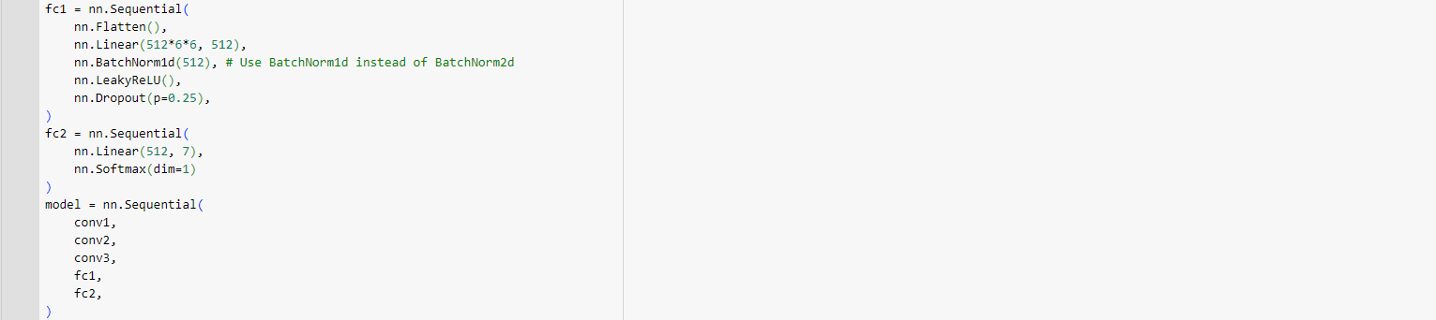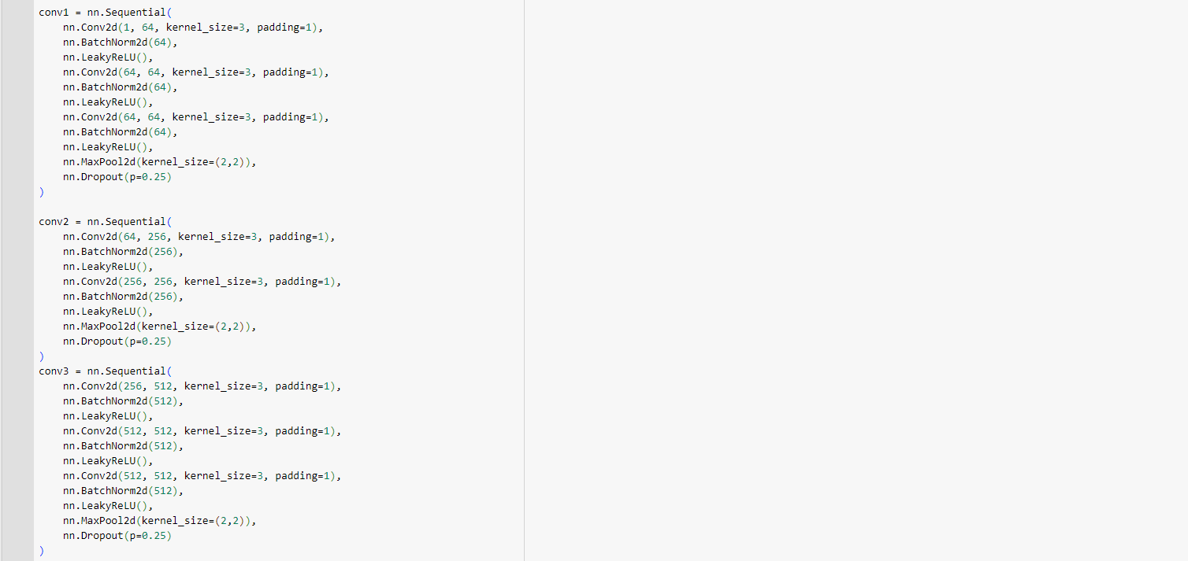

Figure 3 - 4.3

## **Plan 8**

Figure 1 – 8.1

# **CKPLUS Dataset**

## **Plan 1**

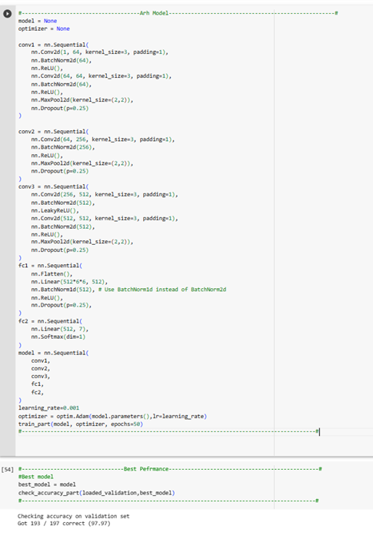

Figure 1 – 1.1

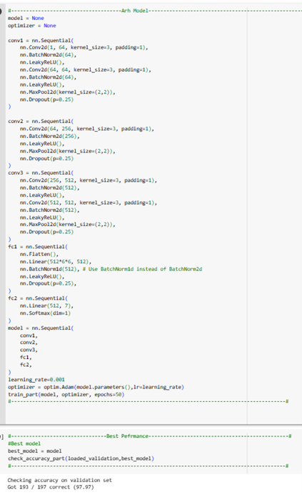

Figure 2 – 1.2

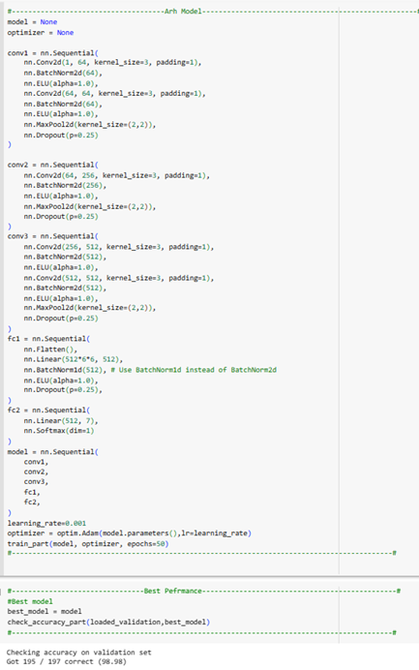

Figure 3 – 1.3

Figure 4 – 1.6

## **Plan 2**

**

Figure 1 – 2.1

Figure 2 – 2.2

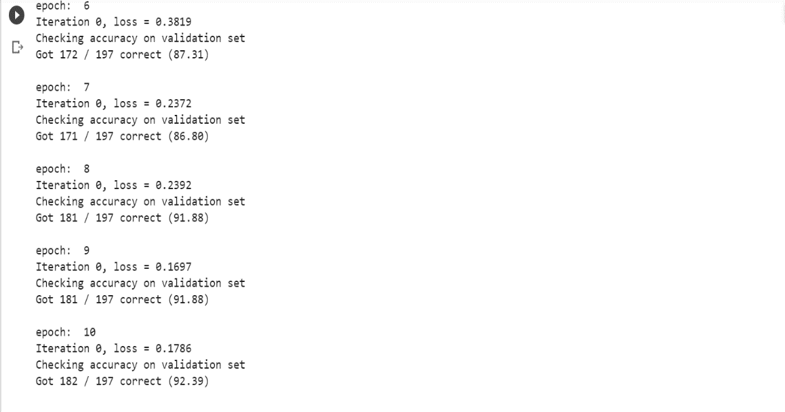

Figure 2 – 2.3

## **Plan 8**

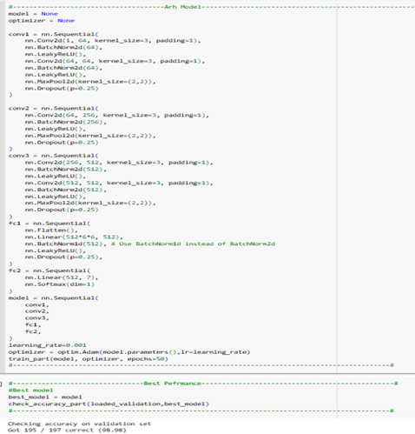

Figure 1 – 8.1

# **FER2013+ Dataset**

## **Origin Code**

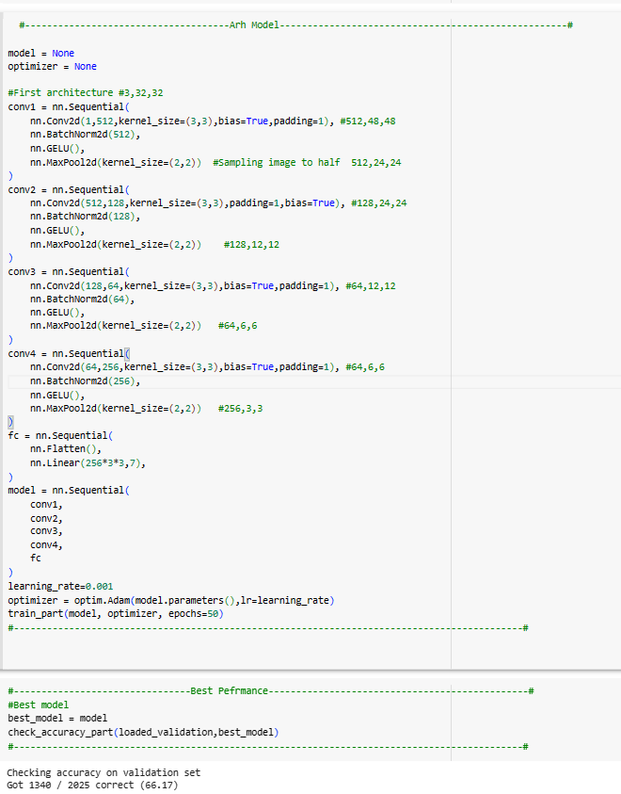

Figure 1 – Training

Figure 2 – Testing

## **Plan 3**

### **Part 1**

Figure 3 – Testing

Figure 4 – Testing

### **Part 2**

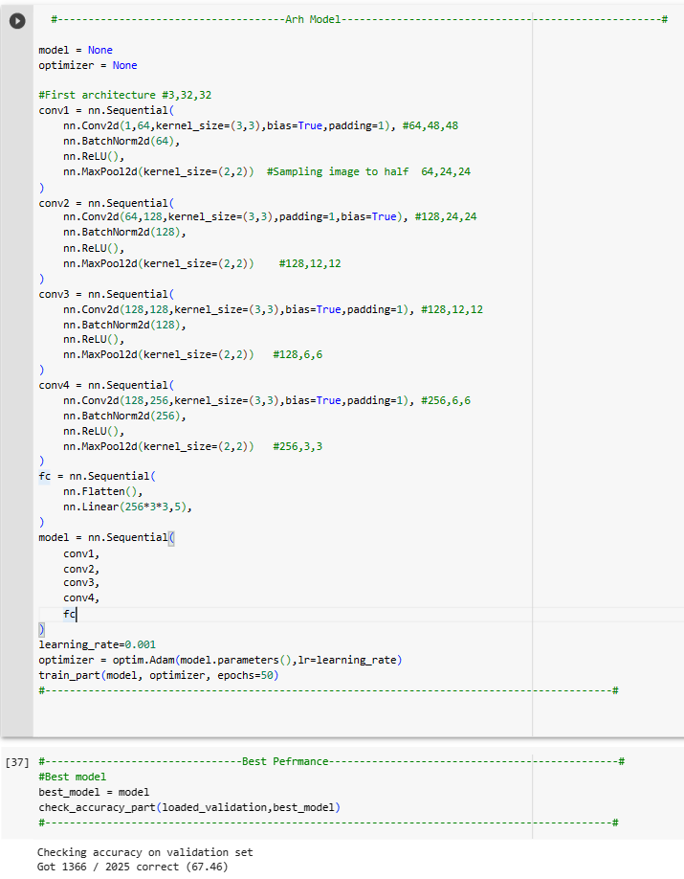

Figure 5– Training

Figure 6 – Testing

### **Part 3**

Figure 7– Training

Figure 8– Testing

### **Part 4**

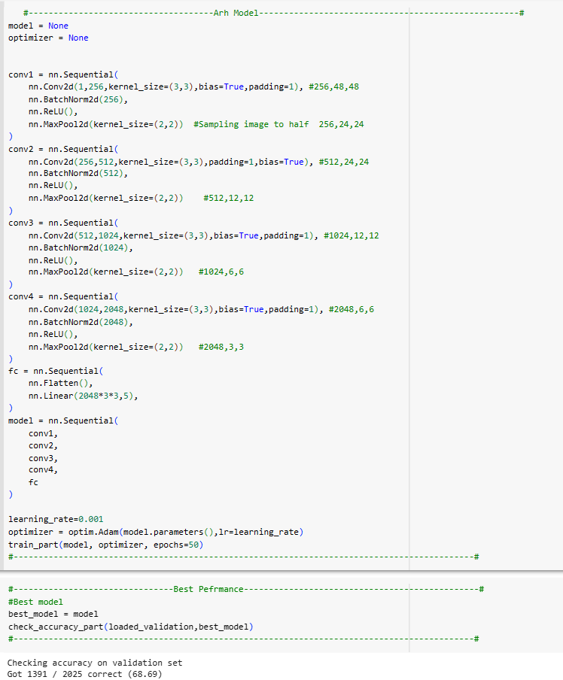

Figure 9– Training

Figure 10– Testing

## **Plan 4**

### **Part 1**

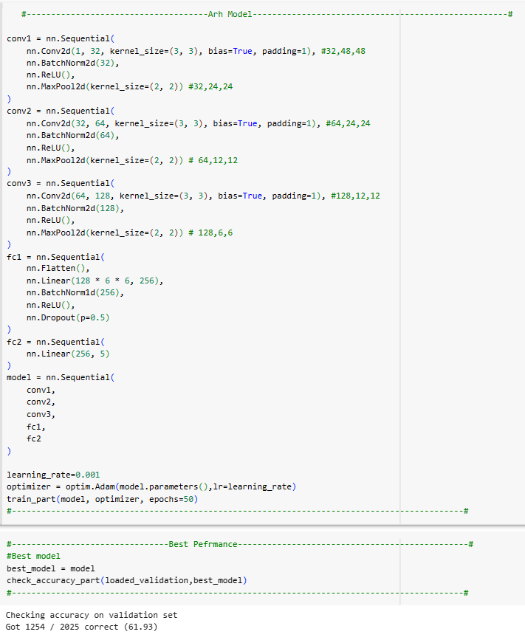

Figure 11– Training

Figure 12– Testing

### **Part 2**

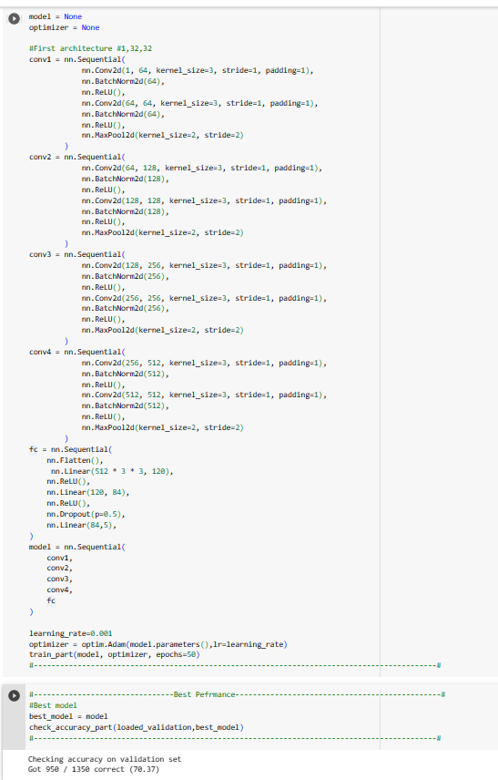

Figure 13– Training

Figure 14– Testing