**CAR RECOMMENDER**

**by**

**Amrit Majhi, Akshat Pandey, Samaksh Bansal**

Section: KI9PG

Roll Numbers: 13, 40, 50



**Department of Intelligent Systems,**

**School of Computer Science Engineering,**

**Lovely Professional University, Jalandhar**

November, 2020

**Student Declaration**

This is to declare that this report has been written by us. No part of the report is copied from other sources. All information included from other sources have been duly acknowledged. We aver that if any part of the report is found to be copied, we shall take full responsibility for it.

**Name:** Amrit Majhi

Akshat Pandey

Samaksh Bansal

**Roll Number:** 13, 40, 50

**Place:** Jalandhar

**Date:** 25 Oct 2020

**TABLE OF CONTENT**

|  |  |
| --- | --- |
| **TITLE** | **PAGE NO.** |
| 1. Background and objectives of the project assigned    1. Introduction    2. Goals and Objectives    3. Outcomes of Car Recommender | 1  1  1  2 |
| 1. Description of Project    1. Component of car recommender    2. Type of Recommender System    3. Design | 3  3  4  4 |
| 1. Division of work | 5 |
| 1. Implementation of work of project   4.1 Snapshot of Car Recommender System | 5  6 |
| 1. Technology and Framework used    1. Framework and execution of algorithms    2. Working of Algorithms | 7  7  7 |
| 1. SWOT Analysis achieved in project   6.1 Opportunities and drawbacks | 8  8 |

**BONAFIDE CERTIFICATE**

Certified that this project report “**CAR RECOMMENDER”** is the Bonafide work of Amrit Majhi, Akshat Pandey, Samaksh Bansal who carried out the project work under my supervision.

<<Signature of the

Supervisor>> (Due to COVID-19

, signature is exempted)

Supervisor – Dr Dhanpratap Singh

Associate Professor,

Department: Intelligence System

LPU, Phagwara, Punjab

**INTRODUCTION**

Recommendation systems are taking more importance in online businesses, where the ability to propose a new item or product that a user will like can increase sales substantially. In this project, we propose to implement a web page where users can view certain types of items, for example cars, and give their feedback about them implicitly (clicking on item, spending time reading its description, sharing it.) Then, the system will run algorithms to come up with similar items to show to the user.

**Recommender System (RS)**

It is a software tool, which is used to recommend an item of interest for the user. By its design, RS is a personalized system for the user. Generally, RS is of great use for the users who lack experience / knowledge of choosing multiple alternatives and to evaluate the alternatives, which is more relevant than the others. There are two types of RSs. The first one is personalized RS and the second one is non-personalized RS. The more research is towards Personalized RS as its counterpart will be very generic in nature. Some of the examples of personalized RS include, movie RS, Item RS from Amazon, book recommendation, music recommendation etc. Individuals may seek the opinion (regarding book, music, CD, movie etc.) from others in order to make decisions. The core idea of the design of the RS revolves around this theme

**Goals and Objectives**

* To increase the sales

* To sell more diverse items

* To improve the user satisfaction

* To increase the user loyalty

* To better understand the user requirement

**Outcome of Car Recommender Project**

It suggests the design of web-based car recommender system. User model is designed based on the feedback about the car, likes and preferences about the car-user clicks and keyword search items. Item model is designed with all appropriate features of the car, which include mileage, price, power, transmission, brand etc. By matching the user model with item model, appropriate recommendations are generated in the system.

**Various steps involved in this process are**

1. Data collection

2. Data pre-processing

3. Execution of the recommender algorithms

4. Evaluation of the results

5. Interpretation of the results

|  |  |  |  |
| --- | --- | --- | --- |
| **CAPACITY**  Seating Capacity  No. of Doors  Length  Width  Height  Rear  Fuel Tank  Volume  Tyre Size  Tyre Type  Wheel Size | **ENGINE & TRANSMISSION**  Top Speed  Acceleration (0-100 kmph)  Engine  Displacement(cc)  Maximum Power  Maximum Torque  Engine  Description  Turning Radius | **COMFORT**  Air Conditioner  Power Steering  Rear A/C Vents  Engine Start/Stop Button  Remote Trunk Opener  Remote Fuel Lid Opener  Accessory Power Outlet  Foldable Rear Seat | **SAFETY**  Anti-Lock Braking System  Parking Sensors  Central Locking  Driver Airbag  Passenger Airbag  Side Airbag-Front  Rear Seat Belts  Smart Access Card Entry  Seat Belt Warning |

**Components of RS**

Users, Items, Transactions (Relations between user and RS) are the core components of a RS.

**Items**

Items are represented by a set of properties and features. Features of the items can be represented as a list representation, or as a set of attributes or as agnotological representation of the domain.

**Users**

RS can have multiple diverse Users. In order to achieve personalization, different parameters like ratings of the user, de-myographic attributes like age, gender, profession, income etc., behavior attributes like browsing patterns, click stream data,

search pattern etc. of the users are involved in the design of user models.

New User

Session Creation

User Clicks (Hyperlinks)

**Transactions.**

It is a recorded interaction between a user and the RS. In general, transaction is a feedback (usually ratings) provided by the user. These ratings may be collected explicitly or implicitly. recommender associated with Amazon.com.

• Ordinal ratings such as “strongly agree, agree, neutral, disagree,

strongly disagree” can indicate user opinion regarding an item

(usually via questionnaire).

• Binary ratings indicate if a certain item is good or bad.

• Unary ratings indicate that a user has observed or purchased an

• Numerical ratings such as the 1-5 stars provided in the book

• tags indicated by the user with the items

In transactions, implicit ratings are collected based on the user’s

actions (search key, clicks, browse pages etc.)

**Types of Recommender System (RS)**

**Content-Based:**

This system recommends items that are similar to the other items that the user liked in the past. The similarity of items is calculated based on the features associated with the compared items.

**Collaborative Filtering:**

This system is called as “people-to-people correlation.” Collaborative filtering is considered to be the most popular and widely implemented technique in RS. It works

on Neighborhood methods, which is focused on relationships between items or between users.

**Demographic:**

This system recommends items based on the demographic profile of the user.

**Community-Based**

This system recommends items based on the preferences of the user’s friends.

**Knowledge-Based:**

This system recommends items based on specific domain knowledge about how certain item features meet users’ needs and preferences of the user. This system will work better than others at the beginning. But if they are not fully equipped with learning components, then it may fail.

**Constraint-Based Systems:**

This system is similar to Knowledge based RS. This system recommends based on explicit rules about how to relate customer requirements with item features.

**DESIGN**

It suggests the design of web-based car recommender system. User model is designed based on the feedback about the car, likes and preferences about the car, user clicks and keyword search items. Item model is designed with all appropriate features of the car, which include mileage, price, power, transmission, brand etc. By matching the user model with item model, appropriate recommendations are generated in the system.

User model(feedback,likes,preferances and keyword search items)

Item profile(mileage,power,price,transmission,brand etc.)

Recommender

System

**Division of Work**

**\*Amrit:**

Report making for the project “Car Recommender”

**\*Akshat:**

Provided excel sheet containing data regarding varieties of cars

\***Samaksh:**

Provided the required code for the project with successful implementation

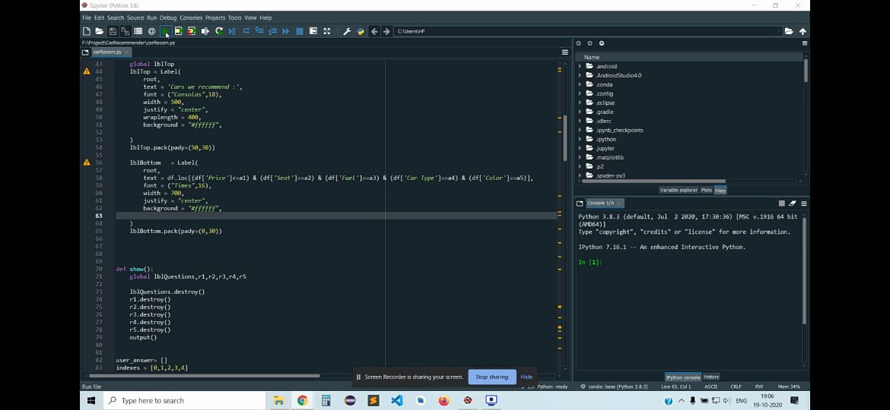**Implementation and Screenshots of Our Project**

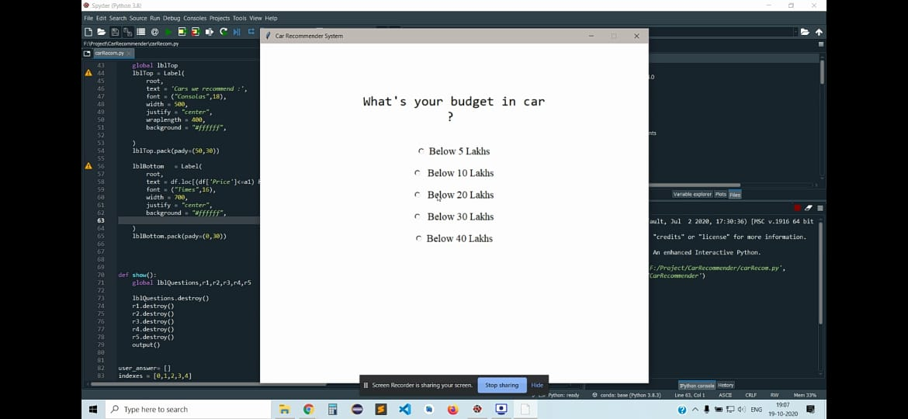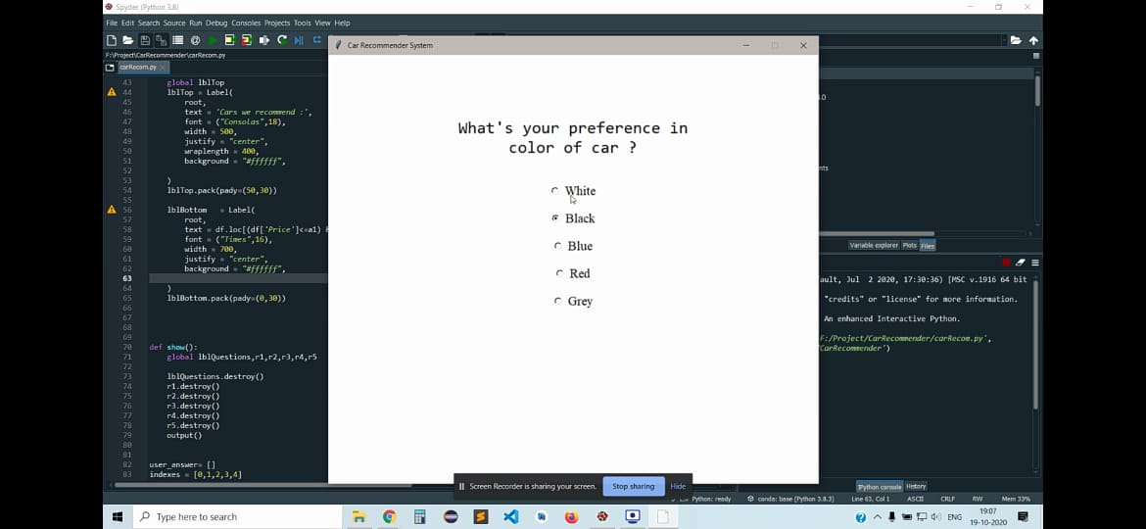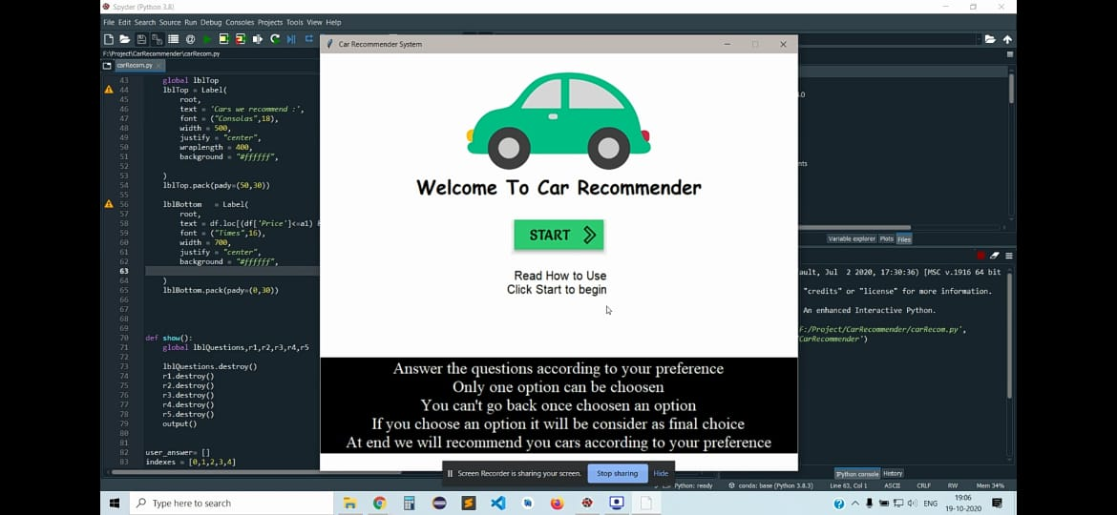

**Framework and** **Execution of Algorithm**

Execution of the Recommender Algorithms In this project work, the item-to-item collaborative filtering algorithm is combined with user-to-user collaborative filtering algorithm to generate effective recommendations. The proposed algorithm works as shown in below figure. Similarity between the items (cars) is calculated using item to item Collaborative filtering recommender algorithm. The total number of clicks for every item (car) by each user in a session is recorded. Similarity between the items is calculated based on the probability of occurrence clicks for each item. Similarity between the users is calculated using user to user Collaborative filtering recommender algorithm. Similarity with respect to demographic features, user clicks and browsing history (search keywords) is calculated between users. The output of item-to-item recommender algorithm is combined with the output of user to user recommender algorithm to generate the final recommendations.

**\*Platform Used: Pandas**

Working of Algorithm

Click count

Calculating user-user cosine similarity using user-user CF

Recommend items user-user

User constrains

Calculating item-item cosine similarity and probability measure using item-item CF.

Recommend Items

user-user

Recommended Cars

**SWOT ANALYSIS**

**Opportunities:**

As the global market rises and the demand of new brands on Indian economy leads to arrival of new models. All outside car manufacturers see Indian market as their place to grow in their share on global car economy. As world moves to the peak of a new era, recommendation become an unavoidable fact. Almost all the technical and non-technical things in today’s world wave hands to recommendation. The main fact that the recommendations got deeply rooted in new technology is due to its accuracy, precision and reliability. Recommendation gives a personalized choice to user’s requirements. In the proposed approach, the hybrid algorithm, which is the combination of user-to-user and item to item based collaborative filtering recommendation algorithm is efficient in suggesting recommendations.

**Drawbacks:**

The main problem with car dataset is that they are dynamic data because it is difficult to predict the car model that will be expelled from their brand. Further, the performance of the proposed system can be improved by using a real time network which allows to build websites and access the session details. This research work can be further extended as Knowledge based recommender systems by using different knowledge representations. Expert recommendations using expert system can also be considered using knowledge bases. In this current research work, 2D models are used to define user model and item profile which can be enhanced to ontological based user model and item profile